Motion in a Plane: Projectiles & Relative Velocity
Solutions to Worksheet 04MIP
How to use these solutions. Each problem is in layers. Open them one at a time.
Hint: a nudge at the point where most students get stuck. Read it, close the page, and try again.
Think it through: the solution as a teacher would talk it through, with no writing. Each step follows from the one before for a stated reason. Aim to have the whole path in your head before you pick up the pen. Another way gives a different route, and No-pen route is one you can finish in your head.
Worked solution: the solution as you would write it in an exam, with figures, ending with the answer and the traps to watch out for.
The “Notes” line at the end of each problem points to the section of the Kinematics revision notes that the problem draws on. Take g = 10 m/s² unless a problem says otherwise.

2D/3D Motion in Vector & Calculus Form

Q1 · Speed after 10 s with a constant acceleration vector
ID 04MIP-0405-afef · Code 0405 · Worksheet 04MIP_v2 Q1

Problem
A particle with initial velocity $3\hat{i}+4\hat{j}$ has an acceleration of $0.4\hat{i}+0.3\hat{j}$. Its speed after 10 sec is?
(A) 10 units (B) 7 units (C) 7$\sqrt{2}$ units (D) 8.5 units

Hint
Velocity is a vector, so add the change $\vec{a}t$ to $\vec{u}$ component by component before you take any magnitude.

Think it through
- Asked: the speed (magnitude of velocity) at t = 10 s. The acceleration is a constant vector, so each component changes independently and uniformly.
- In 10 s the x-component gains 0.4 × 10 = 4 and the y-component gains 0.3 × 10 = 3.
- So the x-component goes from 3 to 7 and the y-component from 4 to 7.
- Equal components of 7 make the velocity point at 45°, and its magnitude is 7√2 ≈ 9.9 units. (C)
- Check: adding the two speeds, 5 + 5 = 10 (option A), would be right only if $\vec{u}$ and $\vec{a}t$ were parallel. Here they are not (3:4 against 4:3), so the answer must be less than 10, as 9.9 is.

Why the other options are there
(A) 10 adds the magnitudes |u| = 5 and |at| = 5 as if they were parallel. (B) 7 is one component only. (D) 8.5 has no route; it is a distractor between the two.

Worked solution
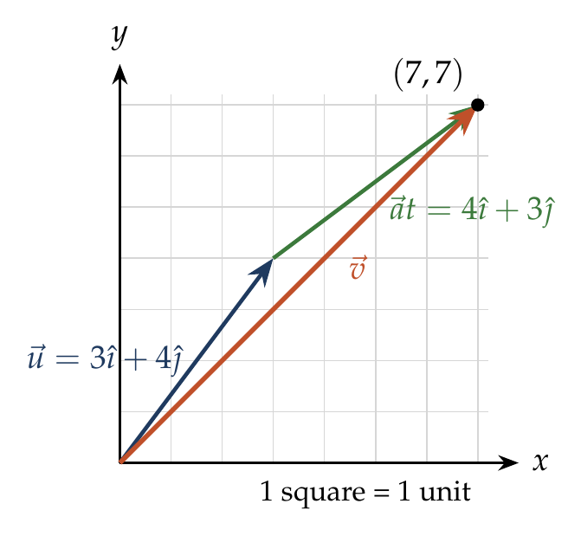
With constant acceleration, $\vec{v}=\vec{u}+\vec{a}t$:
$$\vec{v}=\left(3\hat{ı}+4\hat{ȷ}\right)+\left(0.4\hat{ı}+0.3\hat{ȷ}\right)\left(10\right)=7\hat{ı}+7\hat{ȷ}.$$
$$\left|\vec{v}\right|=\sqrt{7^{2}+7^{2}}=7\sqrt{2}≈9.9 units.$$

Answer
(C) $7\sqrt{2}$ units.

Watch out
• |u| + |at| = 10 is wrong: magnitudes add only for parallel vectors.
• Add the components first, then take the magnitude, never the other way round.
Notes: Sec. 7 (constant acceleration vector).

Q2 · Acceleration at 60° to the initial velocity
ID 04MIP-0405-d66c · Code 0405 · Worksheet 04MIP_v2 Q2

Problem
Velocity of a particle at time t = 0 is 2 m/s. A constant acceleration of 2 m/$s^{2}$ acts on the particle for 2 seconds at an angle of 60° with its initial velocity. Find the magnitude of velocity and displacement of particle at the end of t = 2 s.
(A) $2\sqrt{7} m/s, 2\sqrt{3}m$ (B) $2\sqrt{7} m/s, 4\sqrt{3}m$ (C) $4\sqrt{7} m/s, 2\sqrt{3}m$ (D) $\sqrt{7} m/s, 2\sqrt{3}m$

Hint
Choose the x-axis along the initial velocity. Then write the acceleration as two components and treat x and y as two separate straight-line motions.

Think it through
- Asked: the speed and the magnitude of displacement after 2 s. The acceleration is constant, so the vector equations of motion apply component by component.
- Put x along the initial velocity: $\vec{u}$ = 2 along x. The acceleration of 2 at 60° has components 2 cos 60° = 1 along x and 2 sin 60° = √3 along y.
- Velocity after 2 s: x goes 2 → 2 + 1 × 2 = 4; y goes 0 → √3 × 2 = 2√3. Speed = √(16 + 12) = √28 = 2√7 m/s.
- Displacement: with constant acceleration the average velocity is the mean of the start and end velocities, (3, √3). Times 2 s gives (6, 2√3).
- Its magnitude is √(36 + 12) = √48 = 4√3 m. (B)
- Check: the speed grows from 2 to about 5.3, so the distance covered must exceed 2 × 2 = 4 m but be less than 5.3 × 2 = 10.6 m; 4√3 ≈ 6.9 m fits.

Another way: average velocity
For constant $\vec{a}$, ${\vec{v}}_{avg}=\left(\vec{u}+\vec{v}\right)/2=\left(3\hat{ı}+\sqrt{3}\hat{ȷ}\right)$ m/s, so $\vec{s}=2{\vec{v}}_{avg}=6\hat{ı}+2\sqrt{3}\hat{ȷ}$ m. This is the route in the worksheet hint.

Worked solution
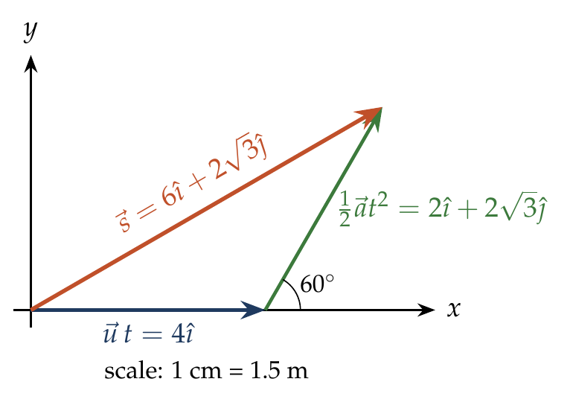
Take $\hat{ı}$ along the initial velocity. Then $\vec{u}=2\hat{ı}$ and $\vec{a}=2cos{60}^{∘} \hat{ı}+2sin{60}^{∘} \hat{ȷ}=\hat{ı}+\sqrt{3} \hat{ȷ}$ (in m/s²).
$$\vec{v}=\vec{u}+\vec{a}t=2\hat{ı}+2\left(\hat{ı}+\sqrt{3}\hat{ȷ}\right)=4\hat{ı}+2\sqrt{3} \hat{ȷ}, \left|\vec{v}\right|=\sqrt{16+12}=2\sqrt{7} m/s.$$
$$\vec{s}=\vec{u}t+\frac{1}{2}\vec{a}t^{2}=4\hat{ı}+2\left(\hat{ı}+\sqrt{3}\hat{ȷ}\right)=6\hat{ı}+2\sqrt{3} \hat{ȷ}, \left|\vec{s}\right|=\sqrt{36+12}=4\sqrt{3} m.$$

Answer
(B) $2\sqrt{7}$ m/s and $4\sqrt{3}$ m.

Watch out
• Using |s| = ut + ½at² = 4 + 4 = 8 m treats u and a as parallel. They are at 60°.
• (A) pairs the right speed with 2√3, which is only the y-part of the displacement.
Notes: Sec. 7 (constant acceleration vector).

Q3 · Distance from the origin after 2 s [JEE Main 2019, 11 Jan, Shift 2]
ID 04MIP-0405-1d55 · Code 0405 · Worksheet 04MIP_v2 Q3

Problem
A particle moves from the point $\left(2\hat{i}+4\hat{j}\right)$m, at t = 0 with initial velocity $\left(5\hat{i}+4\hat{j}\right)ms^{−1}$. It is acted upon by a constant force which produces a constant acceleration $\left(4\hat{i}+4\hat{j}\right)ms^{−2}$. What is the distance of the particle from the origin at time 2 s?
(A) 20 $\sqrt{2}$ m (B) 10 $\sqrt{2}$ m (C) 5 m (D) 15 m

Hint
The particle does not start at the origin. Find its position vector at t = 2 s, including the starting position, and only then take its length.

Think it through
- Asked: the distance from the origin at t = 2 s, which is the magnitude of the position vector then, not of the displacement.
- Acceleration is constant, so position = start + ut + ½at², component by component.
- x: 2 + 5 × 2 + ½ × 4 × 4 = 2 + 10 + 8 = 20 m. y: 4 + 4 × 2 + ½ × 4 × 4 = 4 + 8 + 8 = 20 m.
- So the particle is at (20, 20), whose distance from the origin is 20√2 m. (A)
- Check: forgetting the start gives (18, 16), length about 24 m, which is none of the options; dropping the ½ gives (28, 28). The clean 20√2 confirms the bookkeeping.

Worked solution
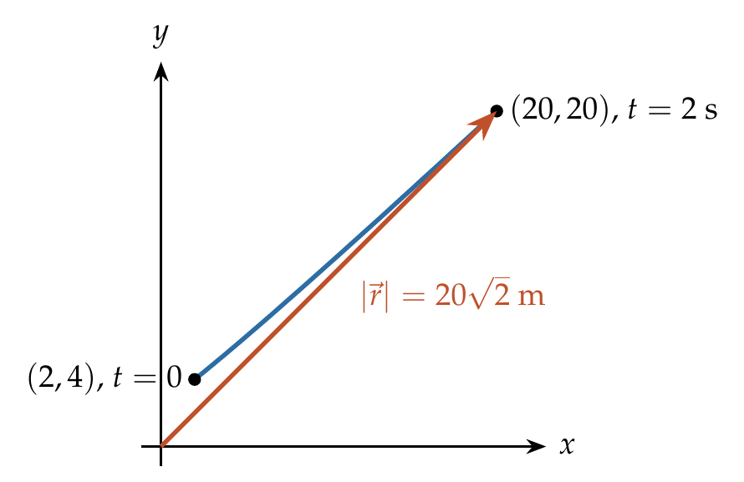
$$\vec{r}={\vec{r}}_{0}+\vec{u}t+\frac{1}{2}\vec{a}t^{2}=\left(2\hat{ı}+4\hat{ȷ}\right)+\left(5\hat{ı}+4\hat{ȷ}\right)\left(2\right)+\frac{1}{2}\left(4\hat{ı}+4\hat{ȷ}\right){\left(2\right)}^{2}$$
$$\vec{r}=20\hat{ı}+20\hat{ȷ} m, \left|\vec{r}\right|=20\sqrt{2} m.$$

Answer
(A) $20\sqrt{2}$ m.

Watch out
• Distance from the origin needs $\vec{r}$, not the displacement $\vec{r}−{\vec{r}}_{0}$.
• The force is irrelevant here: only the acceleration it produces is used.
Notes: Sec. 7 (constant acceleration vector).

Q4 · Direction of a 3-D velocity [JEE Main 2021, 16 Mar, Shift 2]
ID 04MIP-0405-bc22 · Code 0405 · Worksheet 04MIP_v2 Q4

Problem
A mosquito is moving with a velocity $\vec{v}=0.5t^{2}\hat{i}+3t\hat{j}+9\hat{k}$m/s and accelerating in uniform conditions. What will be the direction of mosquito after 2 s ?
(A) $\tan^{−1}\left(\frac{2}{3}\right)$from y-axis (B) $\tan^{−1}\left(\frac{\sqrt{117}}{2}\right)$from x-axis
(C) $\tan^{−1}\left(\frac{5}{2}\right)$from x-axis (D) $\tan^{−1}\left(\frac{2}{3}\right)$from x-axis

Hint
Find $\vec{v}$ at t = 2 s first. The angle with the x-axis comes from a right triangle: one leg along x, the other leg is everything perpendicular to x.

Think it through
- Asked: the direction of motion at t = 2 s, which is the direction of the velocity vector then.
- Substitute t = 2: v_x = 0.5 × 4 = 2, v_y = 3 × 2 = 6, v_z = 9.
- The angle with the x-axis compares the part along x (2) with the part perpendicular to x. That perpendicular part combines v_y and v_z: √(36 + 81) = √117.
- So tan α = √117 / 2, measured from the x-axis. (B)
- Check the decoys: tan⁻¹(2/3) and tan⁻¹(5/2) use only two of the three components, which cannot fix a direction in 3-D.

Why the other options are there
(A) and (D) use 2 and 3, the x-component and the coefficient “3t” before substituting t. (C) uses 5/2, an arbitrary pair. Only (B) uses all three components.

Worked solution
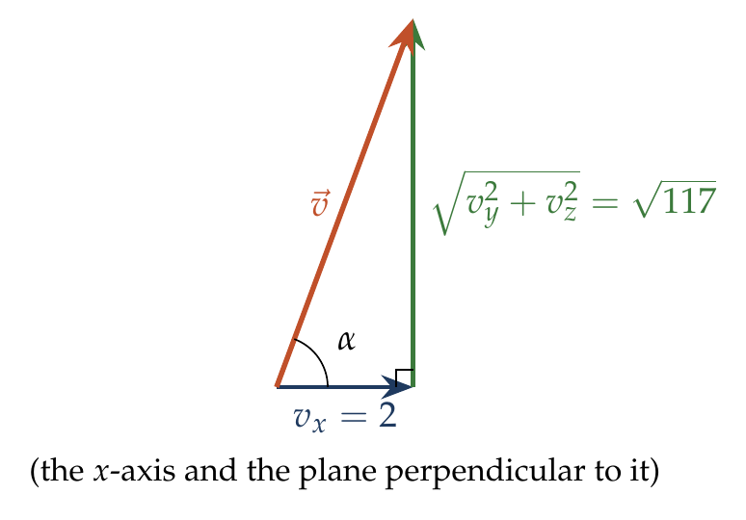
$$\vec{v}\left(2\right)=0.5{\left(2\right)}^{2}\hat{ı}+3\left(2\right)\hat{ȷ}+9\hat{k}=2\hat{ı}+6\hat{ȷ}+9\hat{k} m/s.$$
The angle α with the x-axis satisfies
$$tanα=\frac{\sqrt{v_{y}^{2}+v_{z}^{2}}}{v_{x}}=\frac{\sqrt{36+81}}{2}=\frac{\sqrt{117}}{2}.$$

Answer
(B) $\tan^{−1}\left(\sqrt{117}/2\right)$ from the x-axis.

Watch out
• In 3-D, the side opposite the angle with the x-axis is $\sqrt{v_{y}^{2}+v_{z}^{2}}$, not just $v_{y}$.
• “Accelerating in uniform conditions” is filler: the velocity is already given as a function of time.
Notes: Sec. 7 (direction from the x-axis in 3-D).

Q5 · Reaching x = 20 m [JEE Main 2020, 4 Sep, Shift 1]
ID 04MIP-0405-99f6 · Code 0405 · Worksheet 04MIP_v2 Q5

Problem
A particle at origin is moving with initial velocity $\vec{u}=5 m/s\hat{j}$ and a constant acceleration $10\hat{i}+4\hat{j} m/s^{2}$. At time t, its co-ordinates are $\left(20 m, y_{0} m\right)$. The value of t and $y_{0}$ respectively are:
(A) 2 s and 18 m (B) 5 s and 25 m (C) 2 s and 24 m (D) 4 s and 52 m

Hint
The x-motion starts from zero x-velocity, so use it alone to find t. Then put that t into the y-equation.

Think it through
- Asked: the time to reach x = 20 m and the y-coordinate then. The two components are independent motions sharing the same clock.
- Along x: no initial velocity, acceleration 10, so x = 5t². Setting 5t² = 20 gives t = 2 s.
- Along y: initial velocity 5, acceleration 4, so y = 5t + 2t². At t = 2: 10 + 8 = 18 m.
- So t = 2 s and y₀ = 18 m. (A)
- Check: (C) has the right time but y = 24 would need 5t + 2t² with the ½ dropped (10 + 16 = 26) or similar slips; only 18 follows from the equations.

Worked solution
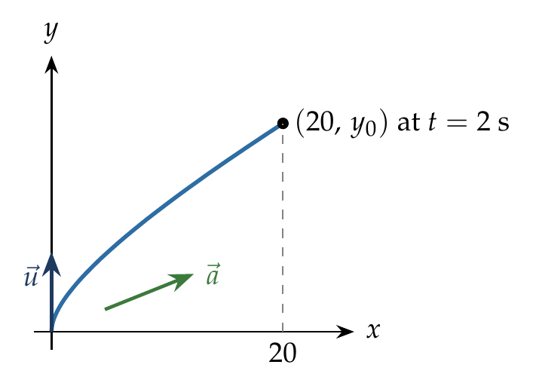
$$x=\frac{1}{2}a_{x}t^{2}=5t^{2}=20 ⇒ t=2 s.$$
$$y_{0}=u_{y}t+\frac{1}{2}a_{y}t^{2}=5\left(2\right)+\frac{1}{2}\left(4\right){\left(2\right)}^{2}=18 m.$$

Answer
(A) 2 s and 18 m.

Watch out
• The initial velocity is entirely along y, so it does not appear in the x-equation.
• Keep the ½ in ½at² for both components.
Notes: Sec. 7 (constant acceleration vector).

Q6 · Position at the maximum x-coordinate
ID 04MIP-0405-ac69 · Code 0405 · Worksheet 04MIP_v2 Q6

Problem
A particle leaves the origin with an initial velocity $\vec{u}=3\hat{i}$ m/s and a constant acceleration $\vec{a}=−\hat{i}+0.5\hat{j}$ m/$s^{2}$. Its position vector $\vec{r}$ when it reaches its maximum x–co–ordinate are?
(A) $\frac{9}{2}\hat{i}+\frac{9}{4}\hat{j}$ (B) $\frac{9}{4}\hat{i}+\frac{9}{4}\hat{j}$ (C) $\frac{5}{2}\hat{i}+\frac{5}{2}\hat{j}$ (D) $\frac{5}{2}\hat{i}+\frac{5}{4}\hat{j}$

Hint
A coordinate stops increasing at the instant its own velocity component becomes zero. When is $v_{x}=0$?

Think it through
- Asked: the position vector when x is largest. x grows while v_x > 0 and shrinks after v_x < 0, so x is largest when v_x = 0.
- v_x starts at 3 and falls by 1 each second, so v_x = 0 at t = 3 s.
- x then: 3 × 3 − ½ × 1 × 9 = 9 − 4.5 = 4.5 m (= 9/2). This is the stopping distance u²/2a = 9/2 of the x-motion.
- y has no initial velocity and acceleration 0.5: y = ½ × 0.5 × 9 = 9/4 m.
- So $\vec{r}$ = (9/2) î + (9/4) ĵ. (A)

No-pen route
The x-motion is a body thrown at 3 against a retardation of 1: it stops after 3 s, having gone 3²/(2 × 1) = 4.5. The y-motion is a start from rest at 0.5: in 3 s it covers ¼ × 9 = 2.25. Only (A) has 9/2 and 9/4.

Worked solution
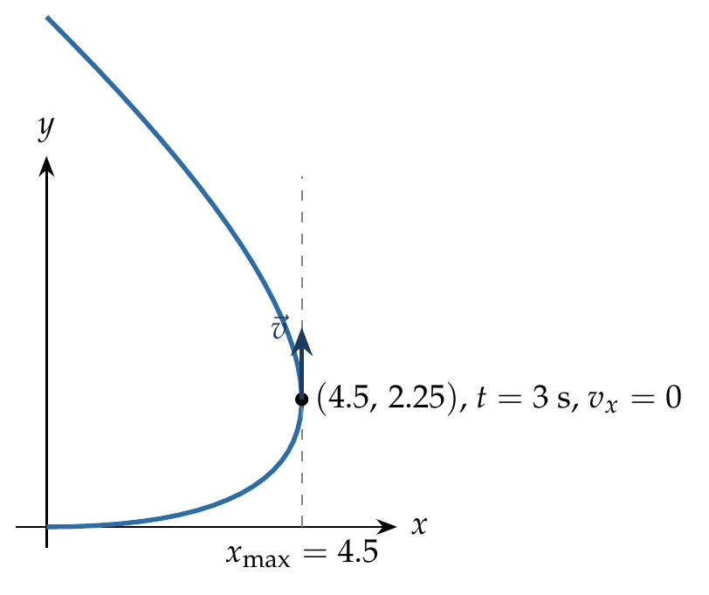
$$v_{x}=u_{x}+a_{x}t=3−t=0 ⇒ t=3 s.$$
$$x=3\left(3\right)−\frac{1}{2}\left(1\right){\left(3\right)}^{2}=9/2 m, y=\frac{1}{2}\left(0.5\right){\left(3\right)}^{2}=9/4 m.$$
$$\vec{r}=9/2\hat{ı}+9/4\hat{ȷ} m.$$

Answer
(A) $\frac{9}{2}\hat{ı}+\frac{9}{4}\hat{ȷ}$ m.

Watch out
• Maximum x means $v_{x}=0$, not $\left|\vec{v}\right|=0$: the particle is still moving (along y) at that instant.
• (B) halves x by mistake; check x = u²/2a = 9/2.
Notes: Sec. 7 (constant acceleration vector); Sec. 3.2 (retardation to rest).

Q7 · Acceleration from x(t) and y(t)
ID 04MIP-0405-9e1f · Code 0405 · Worksheet 04MIP_v2 Q7

Problem
The x and y coordinates of a particle at any time t are given by x = 7t + 4t² and y = 5t, where x and y are in m and t in s. The acceleration of the particle at t = 5 s is?
(A) $8\hat{i}+5\hat{j}$ (B) $4\hat{i}+5\hat{j}$ (C) $8\hat{i}+2\hat{j}$ (D) $8\hat{i}$

Hint
Differentiate each coordinate twice. What does a coordinate that is linear in t contribute to the acceleration?

Think it through
- Asked: the acceleration vector at t = 5 s. Acceleration is the second time-derivative of position, component by component.
- x = 7t + 4t²: the second derivative is 8, the same at every instant.
- y = 5t is linear in t: its velocity is a constant 5 and its acceleration is 0.
- So $\vec{a}$ = 8 î at all times, including t = 5 s. (D)
- Check: “t = 5 s” is a decoy, since neither second derivative contains t.

Why the other options are there
(A) adds the y-velocity 5 as if it were an acceleration. (B) uses the coefficient 4 instead of 2 × 4. (C) invents a y-acceleration of 2.

Worked solution
$$\vec{v}=\frac{dx}{dt}\hat{ı}+\frac{dy}{dt}\hat{ȷ}=\left(7+8t\right)\hat{ı}+5\hat{ȷ},$$
$$\vec{a}=\frac{d\vec{v}}{dt}=8\hat{ı} {m/s}^{2} \left(for all t, including t=5 s\right).$$

Answer
(D) $8\hat{ı}$ m/s².

Watch out
• The second derivative of 4t² is 8, not 4.
• A constant velocity component (5 m/s along y) gives zero acceleration along y.
Notes: Sec. 7 (velocity and acceleration from components).

Q8 · When are velocity and acceleration perpendicular?
ID 04MIP-0405-ab8c · Code 0405 · Worksheet 04MIP_v2 Q8

Problem
The position vector of a particle is given as $\vec{r}=\left(t^{2}−4t+6\right)\hat{i}+\left(t^{2}\right)\hat{j}$. The time ‘t’ when the velocity vector and acceleration vector become perpendicular to each other is?
(A) 1 sec (B) 1.5 sec (C) 2 sec (D) never

Hint
Perpendicular vectors have zero dot product. Write $\vec{v}\left(t\right)$ and $\vec{a}$, then ask when $\vec{v}⋅\vec{a}=0$.

Think it through
- Asked: the instant when $\vec{v}⊥\vec{a}$. Two vectors are perpendicular exactly when their dot product is zero.
- Differentiate: $\vec{v}$ = (2t − 4) î + 2t ĵ; differentiate again: $\vec{a}$ = 2 î + 2 ĵ, a constant.
- Dot product: 2(2t − 4) + 2(2t) = 8t − 8. This is zero at t = 1 s. (A)
- Meaning: at t = 1 s the speed is momentarily not changing. Before it the velocity has a component against $\vec{a}$ (speed falling); after it, along $\vec{a}$ (speed rising). So t = 1 s is the instant of minimum speed.
- Check: at t = 1, $\vec{v}$ = (−2, 2) and $\vec{a}$ = (2, 2): clearly at right angles.

Another way: minimum speed
Speed² = (2t − 4)² + 4t² = 8t² − 16t + 16 = 8(t − 1)² + 8. It is least at t = 1 s, and at the minimum of speed the acceleration has no component along $\vec{v}$, so $\vec{v}⊥\vec{a}$.

Worked solution
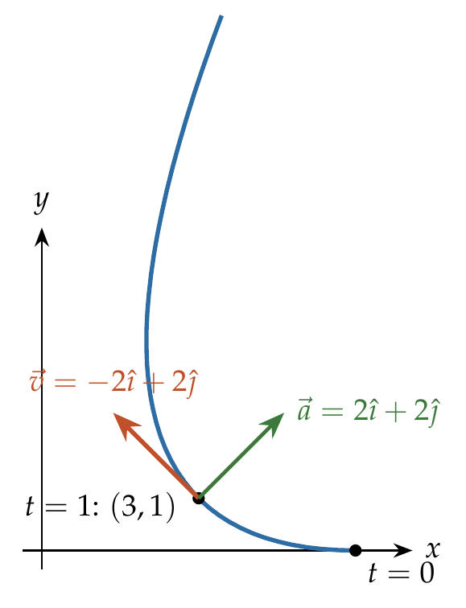
$$\vec{v}=\frac{d\vec{r}}{dt}=\left(2t−4\right)\hat{ı}+2t \hat{ȷ}, \vec{a}=\frac{d\vec{v}}{dt}=2\hat{ı}+2\hat{ȷ}.$$
$$\vec{v}⋅\vec{a}=2\left(2t−4\right)+2\left(2t\right)=8t−8=0 ⇒ t=1 s.$$

Answer
(A) 1 s.

Watch out
• Setting $\vec{v}=0$ (no solution, since the y-part 2t and x-part 2t − 4 never vanish together) is not the condition.
• t = 2 s makes only $v_{x}$ zero; then $\vec{v}$ = 4 ĵ, which is not perpendicular to 2 î + 2 ĵ.
Notes: Sec. 7.1 (v perpendicular to a: speed momentarily constant).

Q9 · y-coordinate and speed when x = 32 m
ID 04MIP-0405-3d11 · Code 0405 · Worksheet 04MIP_v2 Q9

Problem
A particle starts from the origin at t = 0 with a velocity of $\vec{u}=8\hat{j}$ m/s and moves in the xy plane with a constant acceleration of $\vec{a}=4\hat{i}+2\hat{j}$ m/s². At the instant the particle’s x–coordinate is 32 m, what are (i) its y–coordinate and (ii) its speed?

Hint
The x-motion alone fixes the time. Use that time in the y-motion and in both velocity components.

Think it through
- Asked: y and the speed at the instant x = 32 m. The time is shared by both components, so find it from x first.
- x starts at rest with acceleration 4: x = 2t². 2t² = 32 gives t = 4 s.
- y: initial 8, acceleration 2: y = 8 × 4 + ½ × 2 × 16 = 32 + 16 = 48 m.
- Velocity: v_x = 4 × 4 = 16; v_y = 8 + 2 × 4 = 16. Speed = 16√2 ≈ 22.6 m/s.
- Check: the velocity is now at 45°, having started along y; that fits an acceleration that is mostly along x.

Worked solution
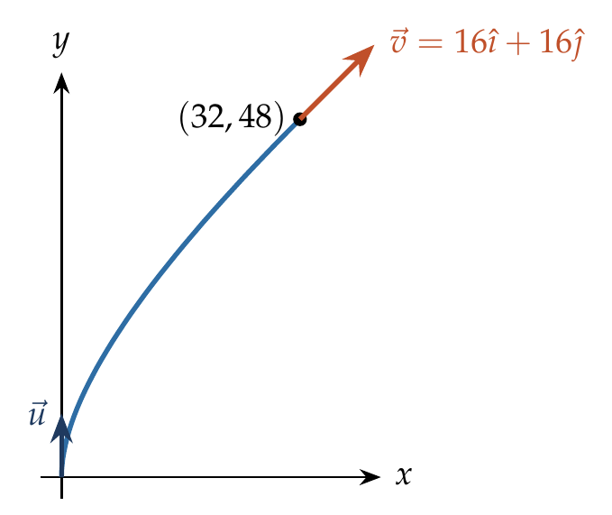
$$x=\frac{1}{2}\left(4\right)t^{2}=32 ⇒ t=4 s.$$
$$y=8\left(4\right)+\frac{1}{2}\left(2\right){\left(4\right)}^{2}=48 m.$$
$$\vec{v}=\vec{u}+\vec{a}t=8\hat{ȷ}+\left(4\hat{ı}+2\hat{ȷ}\right)\left(4\right)=16\hat{ı}+16\hat{ȷ}, \left|\vec{v}\right|=16\sqrt{2} m/s.$$

Answer
(i) y = 48 m; (ii) speed = $16\sqrt{2}$ m/s ≈ 22.6 m/s.

Watch out
• The initial velocity is along y; it plays no part in finding t from x.
• Speed needs both components at t = 4 s; 16 m/s alone is only $v_{x}$.
Notes: Sec. 7 (constant acceleration vector).

Q10 · Coordinates after 4 s under a constant force [JEE Main 2021, 16 Mar, Shift 2]
ID 04MIP-0405-54a9 · Code 0405 · Worksheet 04MIP_v2 Q10

Problem
A body of mass 2 kg moves under a force of 2$\hat{i}+3\hat{j}+5\hat{k}N$. It starts from rest and was at the origin initially. After 4 s, its new coordinates are (8, b, 20). The value of b is _____(Round off to the nearest Integer)

Hint
Turn the force into an acceleration first. Starting from rest at the origin, each coordinate is ½ × (its acceleration) × t².

Think it through
- Asked: the y-coordinate b after 4 s. A constant force on a constant mass gives a constant acceleration, $\vec{a}=\vec{F}/m$.
- $\vec{a}$ = (2, 3, 5)/2 = (1, 1.5, 2.5) m/s².
- From rest at the origin, every coordinate is ½ a t² = ½ a × 16 = 8a.
- So the coordinates are (8, 12, 20). The given 8 and 20 agree, which checks the setup, and b = 12.

No-pen route: proportions
From rest, displacement points along the force and each coordinate is proportional to its force component. x : y : z = 2 : 3 : 5 = 8 : b : 20, so b = 12.

Worked solution
$$\vec{a}=\frac{\vec{F}}{m}=\frac{2\hat{ı}+3\hat{ȷ}+5\hat{k}}{2}=\hat{ı}+1.5\hat{ȷ}+2.5\hat{k} {m/s}^{2}.$$
$$\vec{r}=\frac{1}{2}\vec{a}t^{2}=\frac{1}{2}\left(\hat{ı}+1.5\hat{ȷ}+2.5\hat{k}\right){\left(4\right)}^{2}=8\hat{ı}+12\hat{ȷ}+20\hat{k} m.$$

Answer
b = 12.

Watch out
• Divide by the mass: using $\vec{F}$ as $\vec{a}$ gives (16, 24, 40), which contradicts the given x = 8.
• Starting from rest means the path is a straight line along $\vec{F}$.
Notes: Sec. 7 (constant acceleration vector).

Q11 · Trajectory and velocity from (2t, t²)
ID 04MIP-0405-17b1 · Code 0405 · Worksheet 04MIP_v2 Q11

Problem
The co-ordinates of a particle moving in x-y plane at any time t are (2t, t²). Find (i) the trajectory of the particle (ii) velocity of particle at time t?

Hint
The trajectory is a relation between x and y with no t in it. Which equation lets you write t in terms of x?

Think it through
- Asked: (i) the path y(x), (ii) the velocity at time t.
- From x = 2t, t = x/2. Put it into y = t²: y = x²/4, a parabola through the origin opening upward.
- Velocity is the time-derivative of each coordinate: dx/dt = 2, dy/dt = 2t.
- So $\vec{v}$ = 2 î + 2t ĵ. Check: the slope of the path, dy/dx = x/2 = t, equals v_y/v_x = 2t/2 = t, as it must.

Worked solution
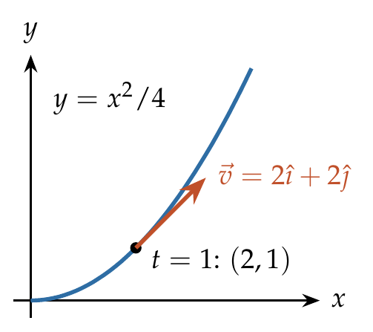
(i) From $x=2t$, $t=x/2$, so
$$y=t^{2}=\frac{x^{2}}{4}.$$
(ii)
$$\vec{v}=\frac{dx}{dt}\hat{ı}+\frac{dy}{dt}\hat{ȷ}=2\hat{ı}+2t \hat{ȷ}.$$

Answer
(i) $y=x^{2}/4$ (a parabola); (ii) $\vec{v}=2\hat{ı}+2t \hat{ȷ}$.

Watch out
• Writing y = x² forgets that x = 2t, not t.
• The velocity is a vector: give both components, not only the speed $2\sqrt{1+t^{2}}$.
Notes: Sec. 7 (trajectory: eliminate t).

Q12 · Acceleration on the surface z = ax³ + by²
ID 04MIP-0405-14c8 · Code 0405 · Worksheet 04MIP_v2 Q12

Problem
A particle moves in space along the path $z=ax^{3}+by^{2}$ in such a way that $\frac{dx}{dt}=c=\frac{dy}{dt};$ where a, b and c are constants. The acceleration of the particle is?

Hint
x and y change at a constant rate, so their accelerations vanish. For z, differentiate z = ax³ + by² with respect to time using the chain rule, then differentiate again.

Think it through
- Asked: the acceleration vector. The particle stays on the surface, so z is tied to x and y at every instant.
- dx/dt = dy/dt = c (constants), so the x- and y-accelerations are zero. Only z can accelerate.
- Differentiate z = ax³ + by² in time (chain rule): dz/dt = 3ax² (dx/dt) + 2by (dy/dt) = 3acx² + 2bcy.
- Differentiate again, again using dx/dt = dy/dt = c: d²z/dt² = 6acx · c + 2bc · c = 6ac²x + 2bc².
- So $\vec{a}$ = (6ac²x + 2bc²) k̂, along z only, and it depends on x.

Worked solution
Since $\dot{x}=\dot{y}=c$ are constant, $\ddot{x}=\ddot{y}=0$.
$$\dot{z}=3ax^{2}\dot{x}+2by \dot{y}=3acx^{2}+2bcy,$$
$$\ddot{z}=6acx \dot{x}+2bc \dot{y}=6ac^{2}x+2bc^{2}.$$
$$\vec{a}=\left(6ac^{2}x+2bc^{2}\right)\hat{k}.$$

Answer
$\vec{a}=\left(6ac^{2}x+2bc^{2}\right)\hat{k}$.

Watch out
• Differentiating with respect to x instead of t (giving 6ax) drops the factors of c.
• The acceleration is not constant: it varies with x.
Notes: Sec. 7 (velocity and acceleration from components).

Q13 · Speed on a helix [JEE Main 2019, 9 Jan, Shift 2]
ID 04MIP-0405-2a31 · Code 0405 · Worksheet 04MIP_v2 Q13

Problem
In three dimensional system, the position coordinates of a particle (in motion) are given as: $x=acosωt, y=asinωt, z=aωt$. The speed of the particle will be:
(A) $\sqrt{2} aω$ (B) $2aω$ (C) $aω$ (D) $\sqrt{3} aω$

Hint
Differentiate each coordinate. The x and y parts together describe a circle; what speed does that circle contribute, and what does z add at right angles to it?

Think it through
- Asked: the speed, the magnitude of $\vec{v}$.
- x = a cos ωt and y = a sin ωt are uniform circular motion of radius a: speed aω around the circle.
- z = aωt rises uniformly at aω, which is perpendicular to the circle’s plane.
- The two parts are at right angles, so the speed is √((aω)² + (aω)²) = √2 aω, the same at every instant. (A)
- The path is a helix, climbing one pitch 2πa every turn.

Worked solution
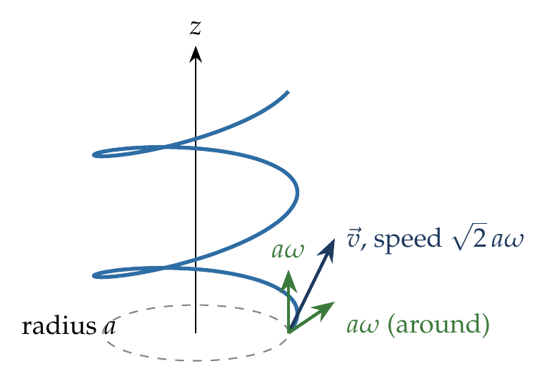
$$\vec{v}=−aωsinωt \hat{ı}+aωcosωt \hat{ȷ}+aω \hat{k}.$$
$$\left|\vec{v}\right|=\sqrt{a^{2}ω^{2}\left(\sin^{2}ωt+\cos^{2}ωt\right)+a^{2}ω^{2}}=\sqrt{2} aω.$$

Answer
(A) $\sqrt{2} aω$.

Watch out
• aω is only the speed around the circle; the rise along z adds to it at right angles.
• Adding the parts as 2aω treats perpendicular components as parallel.
Notes: Sec. 7.1 (uniform circular motion); Sec. 7 (velocity from components).

Q14 · Trajectory from a velocity field [L2] [JEE Main 2019, 9 Jan, Shift 1]
ID 04MIP-0405-3353 · Code 0405 · Worksheet 04MIP_v2 Q14

Problem
The velocity of a particle 𝑣⃗ at any instant is $\vec{v}=K(y\hat{i}+x\hat{j}$); where K is a constant. The equation of trajectory of the particle is:
(A) 𝑦=𝑥²+ constant (B) 𝑦²= x + constant (C) y² = x² + constant (D) xy = constant

Hint
The path’s slope at any point is the direction of the velocity there. Write dy/dx as $v_{y}/v_{x}$ and separate the variables.

Think it through
- Asked: the equation of the path. Velocity is given as a function of position, not of time, so the time route is closed.
- Along the path, dy/dx = v_y/v_x = Kx/(Ky) = x/y.
- Separate: y dy = x dx. Integrate: y²/2 = x²/2 + const, so y² = x² + constant. (C)
- Check at one point: on y² − x² = c, the slope is x/y; at (1, √2) the velocity K(√2, 1) also has slope 1/√2 = x/y. It matches.

Worked solution
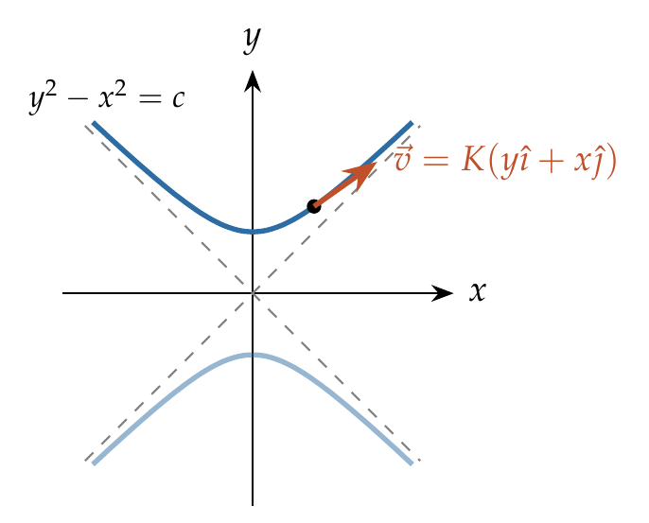
$$\frac{dy}{dx}=\frac{v_{y}}{v_{x}}=\frac{Kx}{Ky}=\frac{x}{y} ⇒ y dy=x dx.$$
$$∫y dy=∫x dx ⇒ y^{2}=x^{2}+constant.$$
The paths are rectangular hyperbolas $y^{2}−x^{2}=c$.

Answer
(C) $y^{2}=x^{2}+$ constant.

Watch out
• dy/dx is $v_{y}/v_{x}$ = x/y. Inverting it to y/x gives y ∝ x, a straight line, which is none of the options.
• K cancels: the path does not depend on how fast the particle moves.
Notes: Sec. 7 (trajectory from v as a function of position).

Q15 · Moving along y = 0.5x² [L2]
ID 04MIP-0405-3c69 · Code 0405 · Worksheet 04MIP_v2 Q15

Problem
At time t = 0; a particle starts moving along the path defined by the parabola y = 0.5x². If the component of velocity along the x-axis is $v_{x}=4 m/s$. Find the y-component of velocity at t = 1 sec?
(A) 4 m/s (B) 8 m/s
(C) 12 m/s (D) 16 m/s

Hint
On a fixed path, the velocity is always along the tangent. How does the path’s slope dy/dx relate $v_{y}$ to $v_{x}$?

Think it through
- Asked: v_y at t = 1 s. The particle is held on the parabola, so its velocity always points along the tangent.
- The tangent slope is dy/dx = x. Since the velocity is along the tangent, v_y/v_x = x, so v_y = x · v_x.
- With v_x = 4 constant and x = 0 at t = 0, x = 4t; at t = 1 s, x = 4 m.
- So v_y = 4 × 4 = 16 m/s. (D)
- Check by time: y = 0.5(4t)² = 8t², so v_y = 16t = 16 m/s at t = 1 s.

Another way: substitute x(t)
x = 4t, so y = 0.5x² = 8t². Then v_y = dy/dt = 16t = 16 m/s at t = 1 s.

Worked solution
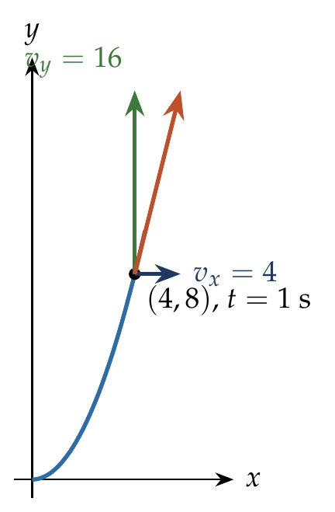
Differentiate the path with respect to time:
$$y=0.5x^{2} ⇒ v_{y}=\frac{dy}{dt}=x\frac{dx}{dt}=x v_{x}.$$
With $v_{x}=4$ m/s and $x\left(0\right)=0$, $x=4t$, so at $t=1$ s, $x=4$ m and
$$v_{y}=4×4=16 m/s.$$

Answer
(D) 16 m/s.

Watch out
• v_y = slope × v_x uses the slope at the current x (4 m), not at the start (where it is 0).
• (B) 8 m/s is y at t = 1 s, a position, not a velocity.
Notes: Sec. 7 (slope of the trajectory equals vy/vx).

Ground-to-Ground Projectile

Q16 · Greatest height to greatest range
ID 04MIP-0410-3b70 · Code 0410 · Worksheet 04MIP_v2 Q16

Problem
The greatest height to which a man can throw a stone is h. The greatest distance to which he can throw will be:

Hint
Both “greatest” throws use the man’s full speed u. Which direction gives the greatest height, and which angle gives the greatest range?

Think it through
- The man has one throwing speed u; “greatest height” and “greatest distance” are two throws with that same speed.
- Greatest height comes from throwing straight up: h = u²/2g.
- Greatest range on level ground comes at 45°: R = u²/g.
- So R = 2 × (u²/2g) = 2h.
- Check: at 45° the stone rises only to h/2 (since u_y² = u²/2), so the 45° throw is far lower than the vertical one, as expected.

Worked solution
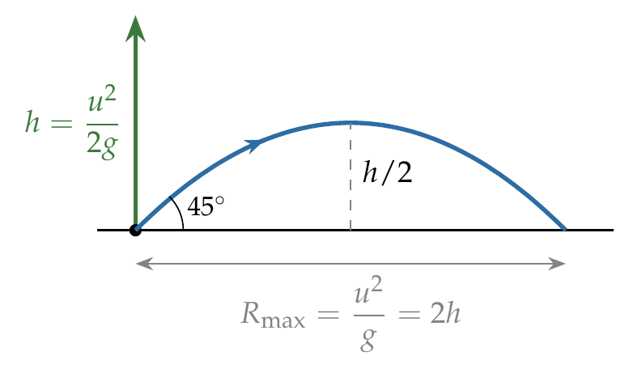
Throwing vertically up with speed $u$: $h=\frac{u^{2}}{2g}$, so $u^{2}=2gh$.
The greatest range on level ground is at ${45}^{∘}$:
$$R_{max}=\frac{u^{2}sin{90}^{∘}}{g}=\frac{u^{2}}{g}=\frac{2gh}{g}=2h.$$

Answer
$2h$.

Watch out
• “Greatest height” is the vertical throw, not the 45° throw; at 45° the height is only h/2.
• The same speed u is used for both throws.
Notes: Sec. 8.3 (greatest height h gives greatest range 2h).

Q17 · Football at 45°: maximum height and time to the top [JEE Main 2021, 27 Aug, Shift 2]
ID 04MIP-0410-878b · Code 0410 · Worksheet 04MIP_v2 Q17

Problem
A player kicks the football with initial speed of 25 m/s at an angle of $45​^{∘}$ from the ground. What are the maximum height and the time taken by the football to reach the highest point during motion?
(A) $H_{m}=10m, T=2.5s$ (B) $H_{m}=15.625m, T=3.54s$
(C) $H_{m}=15.625m, T=1.77s$ (D) $H_{m}=3.54m, T=0.125s$

Hint
Only the vertical component of the kick decides both answers. How long does it take for that component to fall to zero?

Think it through
- Both the maximum height and the time to reach it depend only on the vertical motion.
- The vertical component is 25 sin 45° = 25/√2 ≈ 17.7 m/s.
- It falls at 10 m/s each second, so it reaches zero after 17.7/10 ≈ 1.77 s. That is the time to the top, not the time of flight.
- Height: u_y²/2g = (625/2)/20 = 15.625 m. (C)
- Check: (B) gives 3.54 s, which is the whole time of flight; the question asks for the time to the highest point.

Worked solution
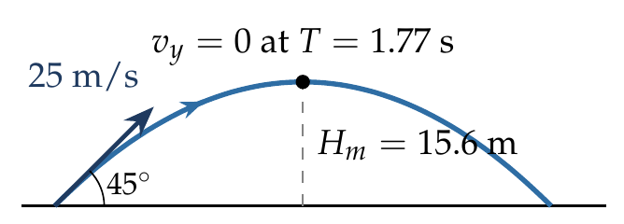
$u_{y}=25sin{45}^{∘}=\frac{25}{\sqrt{2}}$ m/s.
$$T_{top}=\frac{u_{y}}{g}=\frac{25}{10\sqrt{2}}≈1.77 s, H_{m}=\frac{u_{y}^{2}}{2g}=\frac{625/2}{20}=15.625 m.$$

Answer
(C) $H_{m}$ = 15.625 m, T = 1.77 s.

Watch out
• 3.54 s is the full time of flight, twice the time to the top.
• Use $usinθ$ for the height, not the full 25 m/s.
Notes: Sec. 8.2 (time of flight and maximum height).

Q18 · Range at 15° from the maximum range
ID 04MIP-0410-c4ff · Code 0410 · Worksheet 04MIP_v2 Q18

Problem
The maximum range of a projectile is 28 m. When it is thrown at an angle of $15​^{∘}$ with horizontal, its range will be?
(A) 56 m (B) 16 m (C) 14 m (D) 20 m

Hint
The maximum range tells you u²/g directly. How does the range at any angle compare with it?

Think it through
- Range on level ground is (u²/g) sin 2θ. The maximum, at 45°, is u²/g itself.
- So u²/g = 28 m.
- At 15°, sin 2θ = sin 30° = ½, so the range is 28 × ½ = 14 m. (C)
- Check: 15° is a low throw, so its range must be well below 28 m, which rules out (A) at once.

Worked solution
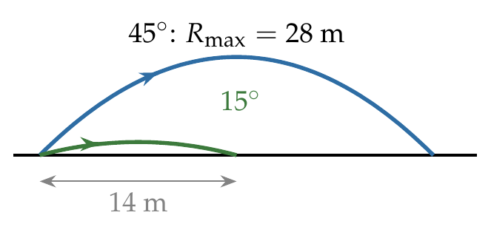
$$R_{max}=\frac{u^{2}}{g}=28 m, R_{{15}^{∘}}=\frac{u^{2}}{g}sin{30}^{∘}=28×\frac{1}{2}=14 m.$$

Answer
(C) 14 m.

Watch out
• Use sin 2θ = sin 30°, not sin 15°.
• The launch speed is the same for both throws; only the angle changes.
Notes: Sec. 8.2 (range); Sec. 8.3 (maximum range u squared over g).

Q19 · Range from the velocity components
ID 04MIP-0410-9d42 · Code 0410 · Worksheet 04MIP_v2 Q19

Problem
A projectile is projected from ground with initial velocity $\vec{u}=u_{0}\hat{i}+v_{0}\hat{j}$. If acceleration due to gravity (g) is along the negative y-direction then find its horizontal range:
(A) $\frac{u_{0}^{2}}{2g}$ (B)$\frac{2u_{0}v_{0}}{g}$ (C) $\frac{v_{0}^{2}}{2g}$ (D) $\frac{{4u}_{0}v_{0}}{g}$

Hint
The vertical component decides how long the projectile stays up. What does the horizontal component do during that time?

Think it through
- Range = horizontal speed × time of flight, because the horizontal velocity never changes.
- Time of flight depends on the vertical component v₀ only: up and back down takes 2v₀/g.
- So range = u₀ × 2v₀/g = 2u₀v₀/g. (B)
- Check: this is the familiar u² sin 2θ/g, since u₀ = u cos θ and v₀ = u sin θ.

No-pen route: units and limits
If u₀ = 0 (straight up) the range must be 0, which rules out (C). If v₀ = 0 there is no flight time and the range is 0, which rules out (A). Between (B) and (D), the time of flight is 2v₀/g, not 4v₀/g.

Worked solution
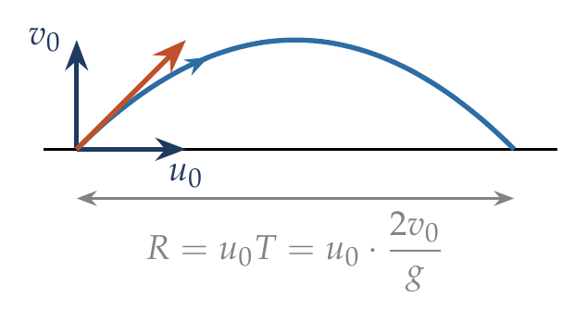
$$T=\frac{2v_{0}}{g}, R=u_{0}T=\frac{2u_{0}v_{0}}{g}.$$

Answer
(B) $\frac{2u_{0}v_{0}}{g}$.

Watch out
• (C) is the maximum height, not the range.
• Do not use u₀ in the time of flight: horizontal velocity does not affect how long it stays up.
Notes: Sec. 8.2 (range: R = 2uxuy/g).

Q20 · Range from 6î + 8ĵ
ID 04MIP-0410-58d3 · Code 0410 · Worksheet 04MIP_v2 Q20

Problem
A projectile is projected with initial velocity 6$\hat{i}+8\hat{j}$ m/s. Find its horizontal range.
(A) 4.8 m (B) 9.6 m (C) 8 m (D) 16 m

Hint
Which component decides the time in the air? Then the other component is carried along for that time.

Think it through
- Time of flight comes from the vertical component 8 m/s: 2 × 8/10 = 1.6 s.
- During 1.6 s the horizontal component 6 m/s carries it 6 × 1.6 = 9.6 m. (B)
- Check with R = 2u_xu_y/g = 2 × 6 × 8/10 = 9.6 m.

  - 4.8 m uses the time to the top (0.8 s) instead of the whole flight.

Worked solution
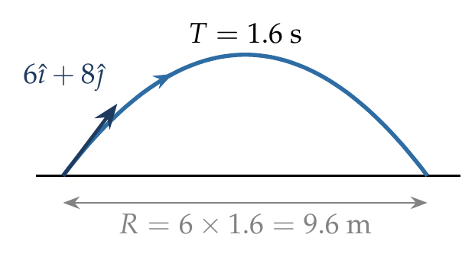
$$T=\frac{2u_{y}}{g}=\frac{2\left(8\right)}{10}=1.6 s, R=u_{x}T=6\left(1.6\right)=9.6 m.$$

Answer
(B) 9.6 m.

Watch out
• 4.8 m is the distance to the point below the top, half the range.
• Do not use the speed 10 m/s in R = 2u_xu_y/g; use the components.
Notes: Sec. 8.2 (range: R = 2uxuy/g).

Q21 · Speed at the top is half the launch speed
ID 04MIP-0410-d9bf · Code 0410 · Worksheet 04MIP_v2 Q21

Problem
The speed of a projectile at its maximum height is half of its initial speed. The angle of projection is :-
(A) 15° (B) 30° (C) 45° (D) 60°

Hint
At the highest point, what is the only part of the velocity that is left?

Think it through
- At the top the vertical velocity is zero, so the speed there is just the horizontal component u cos θ.
- The horizontal component never changes, so u cos θ = u/2.
- cos θ = ½ gives θ = 60°. (D)
- Check: a steep throw keeps little horizontal speed, so a speed at the top only half the launch speed needs a steep angle. 60° fits.

Worked solution
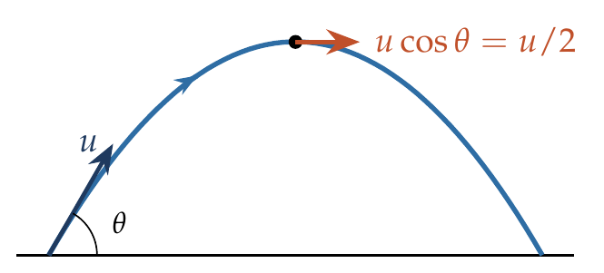
At the highest point $v_{y}=0$, so the speed is $v_{x}=ucosθ$:
$$ucosθ=\frac{u}{2} ⇒ cosθ=\frac{1}{2} ⇒ θ={60}^{∘}.$$

Answer
(D) 60°.

Watch out
• Writing u sin θ = u/2 (giving 30°) uses the vertical component, which is zero at the top.
• The speed at the top is not zero; only $v_{y}$ is.
Notes: Sec. 8.3 (minimum speed u cos θ at the top).

Q22 · Range equals maximum height
ID 04MIP-0410-98c4 · Code 0410 · Worksheet 04MIP_v2 Q22

Problem
The horizontal range and the maximum height of a projectile are equal. The angle of projection of the projectile is:
(A) $θ=\tan^{−1}\left(2 \right)$ (B) $θ=45​^{∘}$ (C) $θ=\tan^{−1}\left(1/4\right)$ (D) $θ=\tan^{−1}\left(4\right)$

Hint
Write R and H with the same factors, u_x and u_y. Setting them equal fixes the ratio u_y/u_x.

Think it through
- Range = 2u_xu_y/g and height = u_y²/2g. Both share u_y and g, so their ratio involves only u_x and u_y.
- Equal: 2u_xu_y/g = u_y²/2g, so u_y = 4u_x.
- So tan θ = u_y/u_x = 4, θ = tan⁻¹ 4 ≈ 76°. (D)
- Check: at 45° the range is four times the height, so making them equal needs a much steeper throw, as 76° is.

Another way: R = 4H cot θ
Dividing R = 2u²sinθcosθ/g by H = u²sin²θ/2g gives R/H = 4 cot θ. R = H means cot θ = ¼, tan θ = 4.

Worked solution
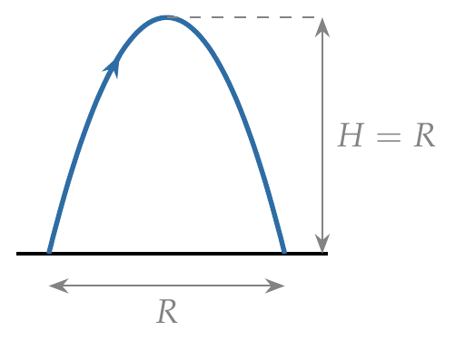
$$R=H ⇒ \frac{2u_{x}u_{y}}{g}=\frac{u_{y}^{2}}{2g} ⇒ u_{y}=4u_{x} ⇒ tanθ=4.$$

Answer
(D) $θ=\tan^{−1}4$.

Watch out
• (C) tan⁻¹(¼) inverts the ratio: that angle would make the range 16 times the height.
• At 45° R = 4H, not R = H.
Notes: Sec. 8.3 (R = 4H cot θ).

Q23 · Same height at 45° and 60°
ID 04MIP-0410-b673 · Code 0410 · Worksheet 04MIP_v2 Q23

Problem
Two bodies are thrown up at angles of 45° and 60° respectively, with the horizontal. If both bodies attain same vertical height, then the ratio of speeds with which these are thrown is?
(A) $3/2$ (B)$\sqrt{3/2}$ (C) $\sqrt{3}$ (D) $1/\sqrt{3}$

Hint
Maximum height depends on only one component of the launch velocity. If the heights are equal, which component is equal?

Think it through
- Maximum height = u_y²/2g, so equal heights mean equal vertical components.
- u₁ sin 45° = u₂ sin 60°.
- u₁/u₂ = sin 60°/sin 45° = (√3/2)/(1/√2) = √3/√2 = √(3/2). (B)
- Check: the 45° body has the less steep launch, so it needs the greater speed to reach the same height: the ratio u₁/u₂ must exceed 1. √1.5 ≈ 1.22 does.

Worked solution
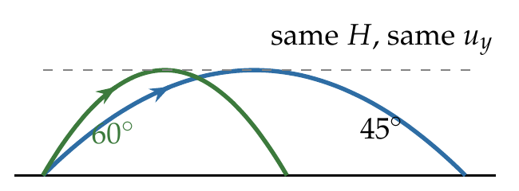
$$\frac{u_{1}^{2}\sin^{2}{45}^{∘}}{2g}=\frac{u_{2}^{2}\sin^{2}{60}^{∘}}{2g} ⇒ \frac{u_{1}}{u_{2}}=\frac{sin{60}^{∘}}{sin{45}^{∘}}=\sqrt{\frac{3}{2}}.$$

Answer
(B) $\sqrt{3/2}$.

Watch out
• (A) 3/2 is the ratio of the squares; take the square root.
• Equal heights means equal $usinθ$, not equal speeds.
Notes: Sec. 8.2 (maximum height depends on uy only).

Q24 · Three trajectories with the same height
ID 04MIP-0410-b7ae · Code 0410 · Worksheet 04MIP_v2 Q24

Problem
Three projectiles A, B and C are thrown from the same point in the same plane. Their trajectories are shown in the figure. Which of the following statement is true?
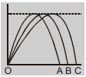
(A) The time of flight is the same for all the three
(B) The launch speed is largest for particle C
(C) The horizontal velocity component is largest for particle C
(D) All of the above

Hint
Look at what the three paths share. The same maximum height fixes one velocity component for all three; then compare the ranges.

Think it through
- All three paths reach the same maximum height (the dashed line). Height depends only on the vertical launch component, so all three have the same u_y.
- Time of flight is 2u_y/g, so it is the same for all three: (A) is true.
- In that same time, C goes farthest, so C has the largest horizontal component: (C) is true.
- Launch speed is √(u_x² + u_y²). With u_y equal, the largest u_x gives the largest speed, so C is fastest at launch: (B) is true.
- All three statements hold. (D)

Worked solution
Equal maximum heights $H=u_{y}^{2}/2g$ mean equal $u_{y}$ for A, B and C. Hence
$$T=\frac{2u_{y}}{g} is the same for all three;$$
$$R=u_{x}T ⇒ u_{x}∝R, largest for C; u=\sqrt{u_{x}^{2}+u_{y}^{2}} largest for C.$$

Answer
(D) All of the above.

Watch out
• A longer range with the same height does not mean a longer time; the time is set by the height alone.
• Read the figure: the common peak height is the key data.
Notes: Sec. 8.2 (time of flight and height depend on uy only).

Q25 · Area covered by two guns [JEE Main 2019, 10 Jan, Shift 1]
ID 04MIP-0410-25f6 · Code 0410 · Worksheet 04MIP_v2 Q25

Problem
Two guns A and B can fire bullets at speeds 1 km/s and 2 km/s respectively. From a point on a horizontal ground, they are fired in all possible directions. The ratio of maximum areas covered by the bullets fired by the two guns, on the ground is :
(A) 1 : 2 (B) 1 : 4 (C) 1 : 8 (D) 1 : 16

Hint
Firing in all directions, the bullets land anywhere inside a circle. What sets its radius, and how does that radius grow with speed?

Think it through
- Fired in every direction, the bullets land anywhere within a circle whose radius is the maximum range u²/g.
- Area = π(u²/g)², which grows as u⁴.
- B is twice as fast as A, so its area is 2⁴ = 16 times larger.
- Ratio A : B = 1 : 16. (D)
- Check: doubling the speed quadruples the range, and area goes as range squared, so 4² = 16.

Worked solution
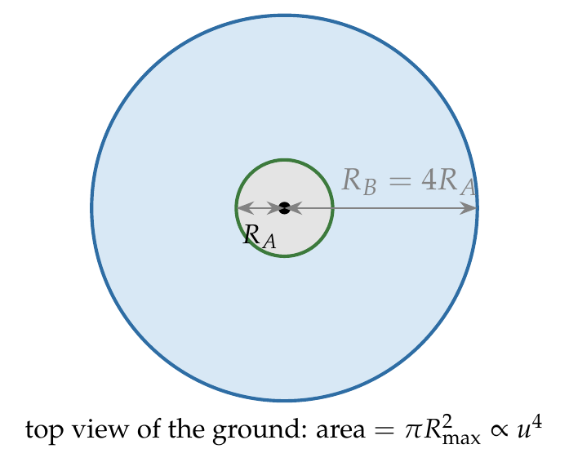
$$R_{max}=\frac{u^{2}}{g}, A=πR_{max}^{2}=\frac{πu^{4}}{g^{2}}.$$
$$\frac{A_{A}}{A_{B}}={\left(\frac{u_{A}}{u_{B}}\right)}^{4}={\left(\frac{1}{2}\right)}^{4}=\frac{1}{16}.$$

Answer
(D) 1 : 16.

Watch out
• Range goes as u², and area as range², so area goes as u⁴; 1 : 4 stops one step too early.
• The “area covered” is a filled disc on the ground, not the area under one trajectory.
Notes: Sec. 8.3 (maximum range u squared over g).

Q26 · Projectiles at 42° and 48° [JEE Main 2021, 1 Sep, Shift 2]
ID 04MIP-0410-3dca · Code 0410 · Worksheet 04MIP_v2 Q26

Problem
The ranges and heights of two projectiles projected with the same initial velocity at angles $42​^{∘}$ and $48​^{∘}$ with the horizontal are $R_{1}$, $R_{2}$ and $H_{1}$, $H_{2}$ respectively. Choose the correct option:
(A) $R_{1}>R_{2}$ and $H_{1}=H_{2}$ (B) $R_{1}=R_{2}$ and $H_{1}<H_{2}$
(C) $R_{1}<R_{2}$ and $H_{1}<H_{2}$ (D) $R_{1}=R_{2}$ and $H_{1}=H_{2}$

Hint
42° and 48° add up to 90°. What do complementary angles share, and which of the two climbs higher?

Think it through
- Range depends on sin 2θ: sin 84° = sin 96°, so R₁ = R₂. (42° and 48° are 45° ∓ 3°.)
- Height depends on sin²θ, which grows with θ for angles up to 90°. So the 48° projectile rises higher: H₁ < H₂.
- So R₁ = R₂ and H₁ < H₂. (B)
- Check: the steeper throw also stays up longer, which is why it can rise higher and still land at the same place.

Worked solution
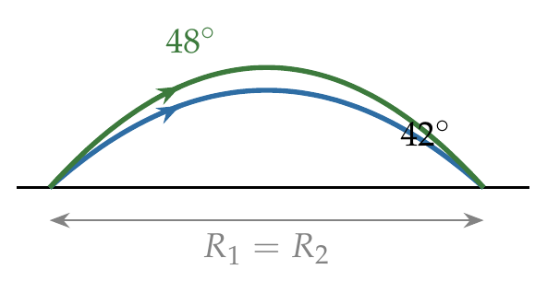
$$R_{1}=\frac{u^{2}sin{84}^{∘}}{g}, R_{2}=\frac{u^{2}sin{96}^{∘}}{g}=\frac{u^{2}sin{84}^{∘}}{g} ⇒ R_{1}=R_{2}.$$
$$H∝\sin^{2}θ: \sin^{2}{42}^{∘}<\sin^{2}{48}^{∘} ⇒ H_{1}<H_{2}.$$

Answer
(B) $R_{1}=R_{2}$ and $H_{1}<H_{2}$.

Watch out
• Equal ranges do not mean equal heights: the steeper of the pair always goes higher.
• Ranges are equal for θ and 90° − θ only on level ground.
Notes: Sec. 8.3 (complementary angles and 45 ± δ).

Q27 · Same range, two heights [JEE Main 2019, 12 Apr, Shift 2]
ID 04MIP-0410-5b05 · Code 0410 · Worksheet 04MIP_v2 Q27

Problem
Two particles are projected from the same point with the same speed u such that they have the same range R but different maximum heights $h_{1}$and $h_{2}$. Which of the following is correct:
(A) $R^{2}={4h}_{1}h_{2}$ (B) $R^{2}={16h}_{1}h_{2}$ (C) $R^{2}={2h}_{1}h_{2}$ (D) $R^{2}=h_{1}h_{2}$

Hint
Same speed and same range means the two launch angles are complementary. Write each height using sin² of its angle and multiply them.

Think it through
- Same speed and same range on level ground means the angles are θ and 90° − θ.
- h₁ = u² sin²θ/2g and h₂ = u² cos²θ/2g. Their product is u⁴ sin²θ cos²θ/4g².
- R = u² sin 2θ/g = 2u² sinθ cosθ/g, so R² = 4u⁴ sin²θ cos²θ/g².
- Comparing, R² = 16 h₁h₂. (B)
- Check at 45°, where both throws coincide: R = 4h, so R² = 16h² = 16h₁h₂. That matches the worksheet’s own hint.

No-pen route: the 45° case
Any correct relation must hold when the two throws coincide at 45°, where h₁ = h₂ = h and R = 4h. Then R² = 16h², which picks (B) at once.

Worked solution
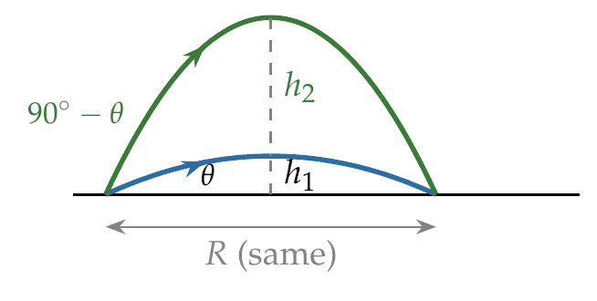
With angles $θ$ and ${90}^{∘}−θ$:
$$h_{1}h_{2}=\frac{u^{2}\sin^{2}θ}{2g}⋅\frac{u^{2}\cos^{2}θ}{2g}=\frac{u^{4}\sin^{2}θ\cos^{2}θ}{4g^{2}}, R^{2}=\frac{4u^{4}\sin^{2}θ\cos^{2}θ}{g^{2}}.$$
$$∴ R^{2}=16h_{1}h_{2}.$$

Answer
(B) $R^{2}=16h_{1}h_{2}$.

Watch out
• Square R correctly: (2 sinθ cosθ)² = 4 sin²θ cos²θ.
• (A) R² = 4h₁h₂ would make R = 2h at 45°; it is 4h.
Notes: Sec. 8.3 (complementary angles: R squared = 16 H1 H2).

Q28 · Two times of flight to the same target [JEE Main 2019, 12 Apr, Shift 1]
ID 04MIP-0410-2099 · Code 0410 · Worksheet 04MIP_v2 Q28

Problem
A shell is fired from a fixed artillery gun with an initial speed of u such that it hits the target on the ground at a distance R from it. If $t_{1}$ and $t_{2}$are the values of time taken by it to hit the target in two possible ways, then the product $t_{1}t_{2}$ is:
(A) $Rg$ (B) $R/g$ (C) $\frac{R}{2g}$ (D) $\frac{2R}{g}$

Hint
The two ways of hitting the target are complementary angles. Write each time of flight and compare their product with the range formula.

Think it through
- Two ways to hit a target at range R with the same speed: angles θ and 90° − θ.
- t₁ = 2u sinθ/g and t₂ = 2u cosθ/g. Product = 4u² sinθ cosθ/g².
- R = 2u² sinθ cosθ/g, so the product is (2/g) × R = 2R/g. (D)
- Check units: R/g has units of s², as a product of two times must. (A) Rg fails this test.

Worked solution
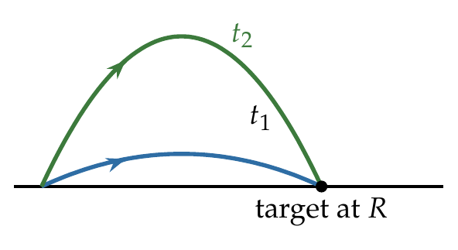
$$t_{1}t_{2}=\frac{2usinθ}{g}⋅\frac{2ucosθ}{g}=\frac{2}{g}⋅\frac{2u^{2}sinθcosθ}{g}=\frac{2R}{g}.$$

Answer
(D) $2R/g$.

Watch out
• Rg has units of m²/s², not s²: check units on product-of-times answers.
• The product is independent of u and θ once R is fixed.
Notes: Sec. 8.3 (complementary angles: T1T2 = 2R/g).

Q29 · Reading θ and H from y = αx − βx² [JEE Main 2021, 26 Feb, Shift 2]
ID 04MIP-0410-eaa4 · Code 0410 · Worksheet 04MIP_v2 Q29

Problem
The trajectory of a projectile in a vertical plane is y = $αx−βx^{2}$, where α and β are constants and x & y are respectively the horizontal and vertical distance of the projectile from the point of projection. The angle of projection θ and the maximum height attained H are respectively given by:
(A) $\tan^{−1}α,\frac{4α^{2}}{β}$ (B) $\tan^{−1}β,\frac{α^{2}}{2β}$ (C) $\tan^{−1}\left(\frac{α}{β}\right),\frac{α^{2}}{β}$ (D) $\tan^{−1}α,\frac{α^{2}}{4β}$

Hint
Compare y = αx − βx² with the standard trajectory y = x tan θ − gx²/(2u²cos²θ). What is the slope at x = 0, and where is the top?

Think it through
- The slope of the path at the launch point is the launch direction. dy/dx = α − 2βx is α at x = 0, so tan θ = α.
- The path meets the ground again where αx − βx² = 0, at x = α/β: that is the range.
- The top is midway, at x = α/2β. There y = α(α/2β) − β(α/2β)² = α²/2β − α²/4β = α²/4β.
- So θ = tan⁻¹ α and H = α²/4β. (D)

Another way: complete the square
y = −β(x − α/2β)² + α²/4β. The largest value of y is α²/4β, reached at x = α/2β.

Worked solution
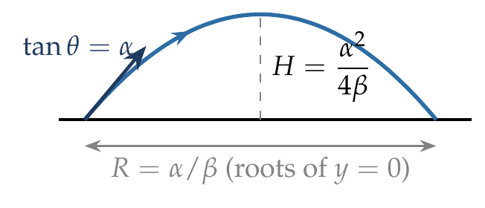
$${\left.\frac{dy}{dx}\right|}_{x=0}=α ⇒ tanθ=α.$$
The maximum is where $dy/dx=α−2βx=0$, at $x=α/2β$:
$$H=α⋅\frac{α}{2β}−β⋅\frac{α^{2}}{4β^{2}}=\frac{α^{2}}{4β}.$$

Answer
(D) $\tan^{−1}α, \frac{α^{2}}{4β}$.

Watch out
• (B) α²/2β is y at the top before subtracting βx².
• The launch angle comes from the slope at x = 0, not from α/β (which is the range).
Notes: Sec. 8.2 (given y = αx − βx squared).

Q30 · Elevation of the highest point at 45°
ID 04MIP-0410-bc2b · Code 0410 · Worksheet 04MIP_v2 Q30

Problem
A projectile is fired at an angle of 45° with the horizontal. Elevation angle of the projectile at its highest point as seen from the point of projection, is :
(A) 45° (B) 60° (C) $\tan^{−1 }\left(\frac{1}{2}\right)$ (D) $\tan^{−1 }\left(\frac{\sqrt{3}}{2}\right)$

Hint
The highest point is directly above the middle of the range. Compare its height with half the range.

Think it through
- From the launch point, the top is at horizontal distance R/2 and height H.
- At 45°, R = 4H, so R/2 = 2H.
- The elevation angle φ has tan φ = H/(R/2) = H/2H = ½. (C)
- Check: the elevation of the top is always smaller than the launch angle (the path bends down), so 45° and 60° are out at once.

Worked solution
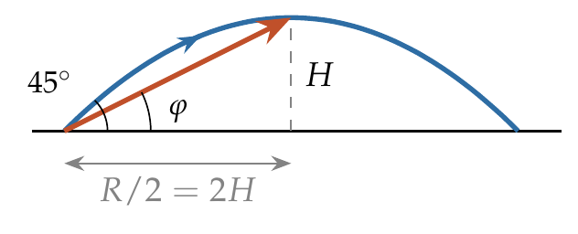
$$tanφ=\frac{H}{R/2}=\frac{u^{2}\sin^{2}θ/2g}{u^{2}sinθcosθ/g}=\frac{1}{2}tanθ=\frac{1}{2}tan{45}^{∘}=\frac{1}{2}.$$

Answer
(C) $\tan^{−1}\left(1/2\right)$.

Watch out
• φ is the angle of the line joining the launch point to the top, not the launch angle.
• tan φ = H/(R/2), not H/R.
Notes: Sec. 8.3 (elevation of the highest point: tan φ = ½ tan θ).

Q31 · Elevation of the highest point: general θ
ID 04MIP-0410-c93e · Code 0410 · Worksheet 04MIP_v2 Q31

Problem
A projectile is fired from level ground at an angle θ above the horizontal. The elevation angle $φ$ of the highest point as seen from the launch point is related to θ by the relation?
(A) $tanφ=tanθ$ (B) $tanφ=2tanθ$ (C) $tanφ=\frac{1}{2}tanθ$ (D) $2tanφ=tanθ$

Hint
Write H and R/2 in terms of u_x and u_y. Their ratio leaves just u_y/u_x.

Think it through
- The top is at height H = u_y²/2g and at horizontal distance R/2 = u_xu_y/g.
- tan φ = H/(R/2) = (u_y²/2g)/(u_xu_y/g) = u_y/2u_x = ½ tan θ.
- So tan φ = ½ tan θ. (C)
- Reason in words: the vertical position at the top has risen at the average vertical speed u_y/2, while the horizontal position has moved at the full u_x. So the line to the top is half as steep as the launch.

No-pen route: average velocity
Up to the top, the average vertical velocity is u_y/2 (it falls uniformly from u_y to 0), and the horizontal velocity is u_x throughout. The displacement to the top therefore has slope (u_y/2)/u_x = ½ tan θ.

Worked solution
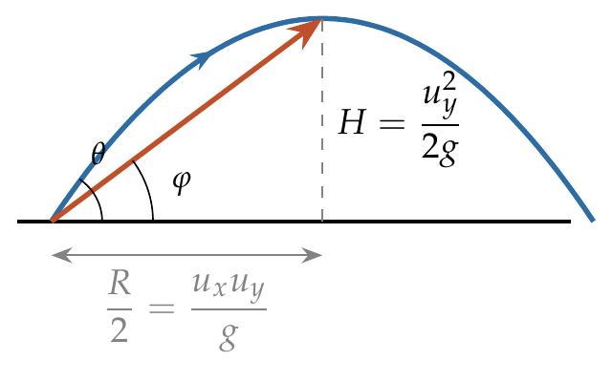
$$tanφ=\frac{H}{R/2}=\frac{u_{y}^{2}/2g}{u_{x}u_{y}/g}=\frac{u_{y}}{2u_{x}}=\frac{1}{2}tanθ.$$

Answer
(C) $tanφ=\frac{1}{2}tanθ$.

Watch out
• (B) tan φ = 2 tan θ would put the top above the launch line, which is impossible.
• Use half the range, not the full range.
Notes: Sec. 8.3 (elevation of the highest point: tan φ = ½ tan θ).

Q32 · Launch angle from the position at t = 2 s
ID 04MIP-0410-77da · Code 0410 · Worksheet 04MIP_v2 Q32

Problem
A particle launched from the origin at time t = 0. Its position is given by$\vec{r}=40\hat{i}+50\hat{j}$ m at t = 2sec. If the projectile was launched at an angle θ, then find its value
(A) tan⁻¹(4/5) (B) tan⁻¹(3/2) (C) tan⁻¹(2/3) (D) tan⁻¹(7/4)

Hint
Average velocity over 0–2 s is (40, 50)/2. Horizontally that is u_x itself. Vertically, the average over an interval with constant acceleration is the velocity at its middle instant.

Think it through
- Horizontal motion is uniform: u_x = 40/2 = 20 m/s.
- Vertical motion has constant acceleration, so the average vertical velocity over 0–2 s equals v_y at the mid-time, t = 1 s. That average is 50/2 = 25 m/s.
- v_y falls by 10 each second, so at t = 0 it was 25 + 10 = 35 m/s.
- tan θ = u_y/u_x = 35/20 = 7/4. (D)
- Check: y = 35 × 2 − 5 × 4 = 50 m. ✓

Another way: equation of motion
50 = u_y(2) − ½(10)(2)² gives u_y = 35 m/s; with u_x = 20 m/s, tan θ = 7/4.

Worked solution
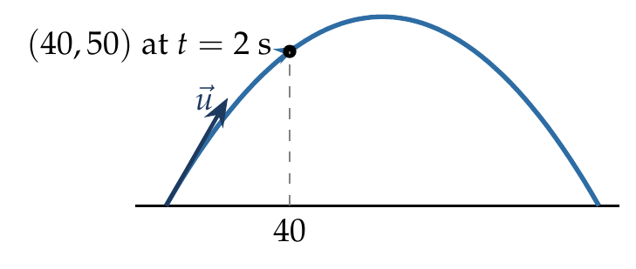
$$u_{x}=\frac{40}{2}=20 m/s.$$
$$y=u_{y}t−\frac{1}{2}gt^{2} ⇒ 50=2u_{y}−20 ⇒ u_{y}=35 m/s.$$
$$tanθ=\frac{u_{y}}{u_{x}}=\frac{35}{20}=\frac{7}{4}.$$

Answer
(D) $\tan^{−1}\left(7/4\right)$.

Watch out
• (A) 4/5 = 40/50 inverts the position ratio and ignores gravity.
• The position direction (50/40) is not the launch direction: gravity has bent the path below the launch line.
Notes: Sec. 8.3 (example b: position at t = 2 s gives the launch angle).

Q33 · When v_x first equals v_y
ID 04MIP-0410-64fa · Code 0410 · Worksheet 04MIP_v2 Q33

Problem
A projectile is projected at an angle α(>45°) with an initial velocity u. The time t, at which its horizontal component of velocity will equal the vertical component for the first time?
(A) $\frac{u}{g}\left(sinα+cosα\right)$ (B) $\frac{u}{g}\left(sinα−cosα\right)$ (C) $\frac{2u}{g}\left(sinα−cosα\right)$ (D) $\frac{u}{g}\left(cosα−sinα\right)$

Hint
The horizontal component stays u cos α. When does the falling vertical component come down to that value?

Think it through
- v_x = u cos α throughout. v_y = u sin α − gt decreases steadily.
- With α > 45°, v_y starts larger than v_x. They first become equal when u sin α − gt = u cos α (the velocity is then at 45°, still rising).
- t = u(sin α − cos α)/g. (B)
- Check: at α = 45° this gives t = 0, as it should (the components are equal at launch). (D) would be negative for α > 45°.

Worked solution
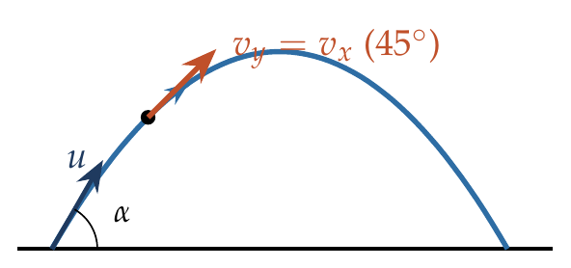
$$v_{y}=v_{x}: usinα−gt=ucosα ⇒ t=\frac{u}{g}\left(sinα−cosα\right).$$

Answer
(B) $\frac{u}{g}\left(sinα−cosα\right)$.

Watch out
• The second time, on the way down, is when v_y = −v_x: t = u(sin α + cos α)/g, option (A).
• Equal components means 45° to the horizontal, not the top.
Notes: Sec. 8.3 (vx = vy for the first time).

Q34 · 30° at 2 s, horizontal at 3 s
ID 04MIP-0410-4b53 · Code 0410 · Worksheet 04MIP_v2 Q34

Problem
Two seconds after projection, a projectile is travelling in a direction inclined at 30° to the horizon. After one more second it is travelling horizontally. Then find the velocity of projection?
(A) $10\sqrt{3}\hat{i}+30\hat{j}$ (B) $20\sqrt{3}\hat{i}+30\hat{j}$ (C) $30\hat{i}+30\hat{j}$ (D) $10\sqrt{3}\hat{i}+20\hat{j}$

Hint
“Horizontal at t = 3 s” means v_y = 0 then. How large was v_y one second earlier?

Think it through
- At t = 3 s the velocity is horizontal, so v_y = 0 then. v_y changes by 10 each second.
- So at t = 2 s, v_y = 10 m/s, and at t = 0, v_y = 30 m/s.
- At t = 2 s the velocity is at 30° to the horizontal: tan 30° = v_y/v_x = 10/v_x, so v_x = 10√3 m/s (constant).
- Velocity of projection = 10√3 î + 30 ĵ m/s. (A)

Worked solution
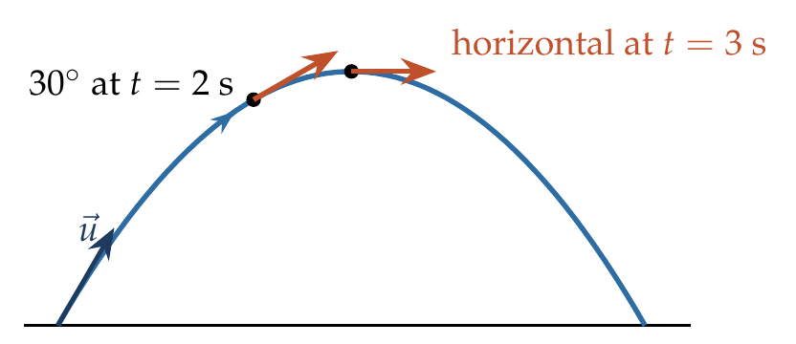
At $t=3$ s, $v_{y}=0$, so $u_{y}=g\left(3\right)=30$ m/s and $v_{y}\left(2\right)=30−20=10$ m/s.
$$tan{30}^{∘}=\frac{v_{y}\left(2\right)}{u_{x}} ⇒ u_{x}=\frac{10}{1/\sqrt{3}}=10\sqrt{3} m/s.$$
$$\vec{u}=10\sqrt{3} \hat{ı}+30 \hat{ȷ} m/s.$$

Answer
(A) $10\sqrt{3} \hat{ı}+30\hat{ȷ}$ m/s.

Watch out
• tan 30° = v_y/v_x, so v_x = v_y√3, not v_y/√3.
• The 30° is at t = 2 s, not at launch.
Notes: Sec. 8.2 (velocity: vx constant, vy = uy − gt).

Q35 · Change in momentum from P to Q [JEE Main 2021, 18 Mar, Shift 2]
ID 04MIP-0410-c679 · Code 0410 · Worksheet 04MIP_v2 Q35

Problem
The projectile motion of a particle of mass 5 g is shown in the figure. The initial velocity of the particle is $5\sqrt{2}$ m/s and the air resistance is assumed to be negligible. The magnitude of change in momentum between points P and Q is $x×{10}^{−2}$ kg m/s. The value of x to the nearest integer is:
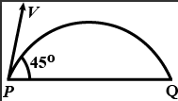

Hint
Between P and Q, which component of the velocity is unchanged and which one reverses?

Think it through
- P and Q are the launch and landing points on level ground. The horizontal component is the same at both; the vertical component has the same size but has reversed.
- u_y = 5√2 sin 45° = 5 m/s up at P, 5 m/s down at Q. So the change in velocity is 10 m/s, straight down.
- Change in momentum = m × 10 = 0.005 × 10 = 0.05 kg m/s = 5 × 10⁻² kg m/s.
- x = 5.
- Check by impulse: gravity acts for the time of flight 2u_y/g = 1 s, giving mg × 1 = 0.005 × 10 = 0.05. ✓

Another way: impulse of gravity
The only force is mg, for the time of flight T = 2u sin45°/g = 1 s. Δp = mgT = 0.005 × 10 × 1 = 0.05 kg m/s.

Worked solution
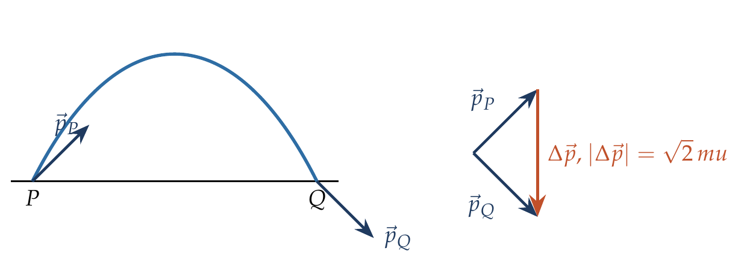
$u_{x}=u_{y}=5\sqrt{2}⋅\frac{1}{\sqrt{2}}=5$ m/s. At Q, $v_{x}=5$, $v_{y}=−5$ m/s.
$$Δ\vec{p}=m\left({\vec{v}}_{Q}−{\vec{v}}_{P}\right)=0.005 \left[\left(5\hat{ı}−5\hat{ȷ}\right)−\left(5\hat{ı}+5\hat{ȷ}\right)\right]=−0.05 \hat{ȷ} kg m/s.$$
$$\left|Δ\vec{p}\right|=5×{10}^{−2} kg m/s ⇒ x=5.$$

Answer
x = 5 (Δp = 0.05 kg m/s, vertically downward).

Watch out
• The speeds at P and Q are equal, but the momentum change is not zero: it is a vector change.
• Use the mass in kg: 5 g = 0.005 kg.
Notes: Sec. 8.3 (change in velocity always vertical: launch to landing 2mu sin θ).

Q36 · Change in velocity in 0.5 s
ID 04MIP-0410-6f0d · Code 0410 · Worksheet 04MIP_v2 Q36

Problem
A particle is projected from the ground with an initial velocity of 20 m/s at an angle of 30° with horizontal. The magnitude of change in velocity in 0.5 second is:
(A) $10\sqrt{2} m/s$ (B) $5\sqrt{2} m/s$ (C) $5 m/s$ (D) $5/\sqrt{2}$ m/s

Hint
With constant acceleration $\vec{g}$, how is the change in velocity over any interval related to $\vec{g}$ and the time?

Think it through
- The acceleration is constant ($\vec{g}$, downward), so the change in velocity over Δt is $\vec{g}$Δt, whatever the launch speed or angle.
- |Δv| = 10 × 0.5 = 5 m/s, directed vertically downward. (C)
- The launch data (20 m/s at 30°) are not needed. They only check that the body is still in the air at 0.5 s: its flight lasts 2 s.

Worked solution
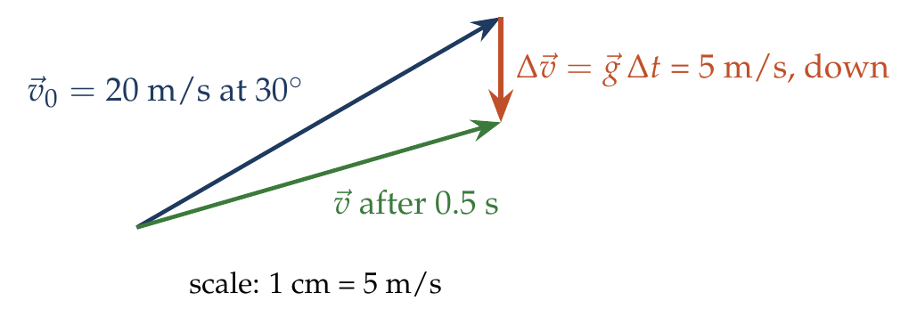
$$Δ\vec{v}=\vec{a} Δt=\vec{g} Δt ⇒ \left|Δ\vec{v}\right|=10×0.5=5 m/s (downward).$$

Answer
(C) 5 m/s.

Watch out
• Δv is not the change in speed; the speed changes by less than 5 m/s here.
• The launch speed and angle are distractors (they only confirm the flight lasts more than 0.5 s).
Notes: Sec. 8.3 (change in velocity = g Δt).

Q37 · Displacement during the 4th second
ID 04MIP-0410-2df1 · Code 0410 · Worksheet 04MIP_v2 Q37

Problem
An oblique projectile on a horizontal plane has a range of 105 m and has a time of flight of 7 sec. Find the displacement of the projectile in the 4th second of its motion.
(A) 10$\sqrt{2} m$ (B) $5\sqrt{3}$ m (C) 15 m (D) 5 m

Hint
The time of flight is 7 s, so where in time is the top? Where is the 4th second relative to it?

Think it through
- Time of flight 7 s means the top is at 3.5 s.
- The 4th second runs from t = 3 s to t = 4 s, which is symmetric about 3.5 s. So the body is at the same height at its start and end: the vertical displacement is zero.
- The horizontal speed is 105/7 = 15 m/s, so in that second it moves 15 m horizontally.
- Displacement = 15 m. (C)

Worked solution
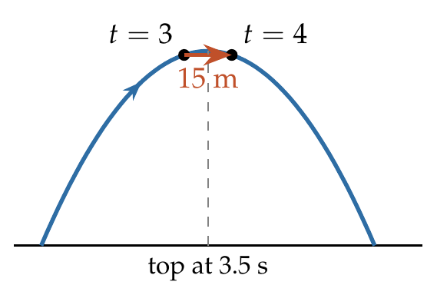
$T=7$ s, so $u_{y}=gT/2=35$ m/s and $u_{x}=105/7=15$ m/s.
$$y\left(4\right)−y\left(3\right)=\left[35\left(4\right)−5\left(16\right)\right]−\left[35\left(3\right)−5\left(9\right)\right]=60−60=0,$$
$$x\left(4\right)−x\left(3\right)=15 m ⇒ \left|Δ\vec{r}\right|=15 m (horizontal).$$

Answer
(C) 15 m (horizontal).

Watch out
• The 4th second is t = 3 to t = 4, not t = 4 to t = 5.
• Distance along the curved path is slightly more than 15 m; the question asks for the displacement.
Notes: Sec. 8.3 (two equal-height points: symmetric about the top).

Q38 · Horizontal wind acceleration
ID 04MIP-0410-cb6c · Code 0410 · Worksheet 04MIP_v2 Q38

Problem
The horizontal range and maximum height attained by a projectile are R = 90 m and H = 45 m respectively. If a constant horizontal acceleration a = g/10 is imparted to the projectile due to wind in the direction of its horizontal component of motion, then its horizontal range and maximum height will be?
(A) 99 m and 45 m (B) 99 m and 42 m (C) 108 m and 45 m (D) 116 m and 50 m

Hint
Which quantities depend only on the vertical motion? The wind changes only the horizontal motion, from uniform to uniformly accelerated.

Think it through
- H = 45 m gives u_y = √(2 × 10 × 45) = 30 m/s and a time of flight of 6 s.
- R = 90 m in 6 s gives u_x = 15 m/s.
- The wind adds a horizontal acceleration only. Time of flight and maximum height depend only on the vertical motion, so they stay 6 s and 45 m.
- New range = u_xT + ½aT² = 90 + ½ × 1 × 36 = 108 m. (C)
- Check: (A) and (B) add only 9 m (half the extra), and (B) wrongly changes H.

Worked solution
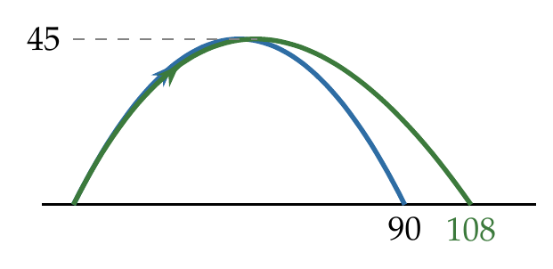
$$H=\frac{u_{y}^{2}}{2g}=45⇒u_{y}=30 m/s, T=\frac{2u_{y}}{g}=6 s, u_{x}=\frac{90}{6}=15 m/s.$$
With $a_{x}=g/10=1$ m/s²:
$$R′=u_{x}T+\frac{1}{2}a_{x}T^{2}=90+\frac{1}{2}\left(1\right)\left(36\right)=108 m, H′=H=45 m.$$

Answer
(C) 108 m and 45 m.

Watch out
• A horizontal wind does not change the height or the time of flight.
• Add ½aT², not ½aT² with T = 3 s (the time to the top).
Notes: Sec. 8.3 (horizontal wind acceleration).

Q39 · Average velocity from launch to the top [L2]
ID 04MIP-0410-0161 · Code 0410 · Worksheet 04MIP_v2 Q39

Problem
A particle is projected from the ground with an initial speed of $v$ at an angle θ with horizontal. The average velocity of the particle between its point of projection and highest point of trajectory is?
(A) $\frac{v}{2}\sqrt{1+\cos^{2}θ}$ (B) $\frac{v}{2}\sqrt{1+{3cos}^{2}θ}$ (C) $\frac{v}{2}\sqrt{1+{3sin}^{2}θ}$ (D) $\frac{v}{2}\sqrt{1+\tan^{2}θ}$

Hint
Average velocity is displacement ÷ time. Where is the top relative to the launch point, and how long does it take to get there?

Think it through
- Displacement to the top has a horizontal part R/2 and a vertical part H. The time is T/2.
- Divide each part by T/2. Horizontal: (R/2)/(T/2) = u_x = v cos θ. Vertical: H/(T/2) = average of v sin θ and 0 = (v sin θ)/2.
- Average velocity magnitude = √(v²cos²θ + v²sin²θ/4) = (v/2)√(4cos²θ + sin²θ) = (v/2)√(1 + 3cos²θ). (B)
- Check limits: θ = 90° gives v/2 (average of v and 0 for a vertical throw) ✓; θ → 0 gives v ✓.

No-pen route: limiting cases
At θ = 90° the answer must be v/2 (vertical throw). (A) gives v/2, (B) v/2, (C) v, (D) is infinite. As θ → 0 the motion is almost uniform at v: (A) gives v/√2, (B) gives v. Only (B) passes both.

Worked solution
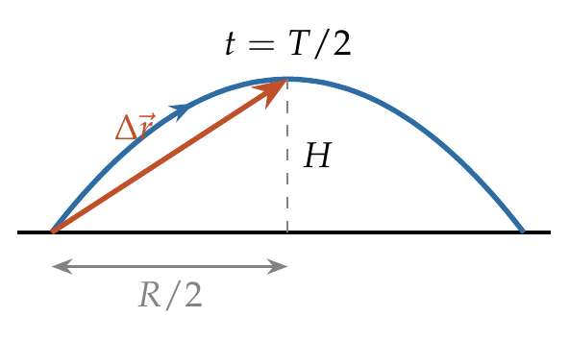
Over the time $T/2$, the horizontal component of velocity is constant and the vertical one falls uniformly from $vsinθ$ to 0:
$${\overset{‾}{v}}_{x}=vcosθ, {\overset{‾}{v}}_{y}=\frac{vsinθ+0}{2}.$$
$$\left|\overset{‾}{\vec{v}}\right|=\sqrt{v^{2}\cos^{2}θ+\frac{v^{2}\sin^{2}θ}{4}}=\frac{v}{2}\sqrt{4\cos^{2}θ+\sin^{2}θ}=\frac{v}{2}\sqrt{1+3\cos^{2}θ}.$$

Answer
(B) $\frac{v}{2}\sqrt{1+3\cos^{2}θ}$.

Watch out
• Averaging the speeds at launch (v) and top (v cos θ) is not the average velocity.
• Use the displacement √(H² + (R/2)²), not the path length.
Notes: Sec. 8.3 (average velocity from launch to top).

Q40 · Two perpendicular velocities: least KE [L2]
ID 04MIP-0410-b1a1 · Code 0410 · Worksheet 04MIP_v2 Q40

Problem
A projectile of mass 2 kg has velocities 3 m/s and 4 m/s at two points during its flight in the uniform gravitational field of the earth. If these two velocities are perpendicular to each other, then find the minimum kinetic energy of the particle during its flight.
(A) 9 J (B) 16J (C) 4.5 J (D) 5.76 J

Hint
Kinetic energy is least where the speed is least, at the top. What stays the same at every point of the flight, and how can two perpendicular velocities share it?

Think it through
- Least KE is at the top, where the speed equals the horizontal component, which is the same throughout the flight.
- So both given velocities, 3 m/s and 4 m/s, have the same horizontal component, and they are perpendicular.
- If the 3 m/s velocity is at α to the horizontal, the 4 m/s velocity is at 90° − α (on the other side). Equal horizontal parts: 3 cos α = 4 sin α, so tan α = ¾, cos α = 4/5.
- Horizontal component = 3 × 4/5 = 2.4 m/s. Least KE = ½ × 2 × 2.4² = 5.76 J. (D)
- Check: 2.4 is less than both 3 and 4, as the minimum speed must be.

Another way: right triangle
Place the two velocities tail to tail: they are perpendicular legs 3 and 4, and the line joining their tips is vertical (their difference is gΔt). The horizontal component is the altitude from the right angle to the hypotenuse: 3 × 4/5 = 2.4 m/s.

Worked solution
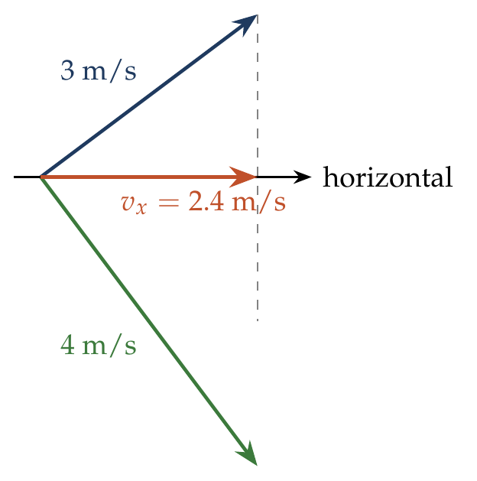
Let the 3 m/s velocity make angle $α$ above the horizontal; the 4 m/s velocity is then at ${90}^{∘}−α$ below it. Equal horizontal components:
$$3cosα=4sinα ⇒ tanα=\frac{3}{4}, cosα=\frac{4}{5}, v_{min}=3cosα=\frac{12}{5} m/s.$$
$$K_{min}=\frac{1}{2}\left(2\right){\left(\frac{12}{5}\right)}^{2}=5.76 J.$$

Answer
(D) 5.76 J.

Watch out
• 9 J is the KE at 3 m/s; that point is not the top.
• The minimum speed is u cos θ (at the top), not zero.
Notes: Sec. 8.3 (example c: perpendicular velocities 3 and 4 m/s).

Q41 · Launch angle from the velocity at 0.4 m [L2]
ID 04MIP-0410-4ed6 · Code 0410 · Worksheet 04MIP_v2 Q41

Problem
At a height 0.4 m from the ground, the velocity of a projectile projected from ground in vector form is $\vec{v}=6\hat{i}+2\hat{j}$ m/s (the x-axis is horizontal and y is vertically upwards). The angle of projection is
(A) $\tan^{−1}\left(\frac{1}{3}\right)$ (B) $\tan^{−1}\left(\frac{2}{3}\right)$ (C) $30​^{∘}$ (D) $37​^{∘}$

Hint
The horizontal component is the same as at launch. For the vertical component, how does v_y² change with height?

Think it through
- Horizontal component is unchanged: u_x = 6 m/s.
- Vertically, v_y² falls by 2g for every metre risen. So u_y² = v_y² + 2gh = 4 + 2 × 10 × 0.4 = 12, u_y = 2√3 m/s.
- tan θ = 2√3/6 = 1/√3, θ = 30°. (C)
- Check: (A) tan⁻¹(⅓) = tan⁻¹(2/6) uses the velocity at 0.4 m, not at launch; the launch is steeper.

Worked solution
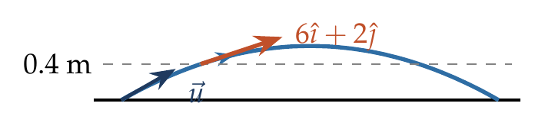
$$u_{x}=6 m/s, u_{y}^{2}=v_{y}^{2}+2gh=2^{2}+2\left(10\right)\left(0.4\right)=12 ⇒ u_{y}=2\sqrt{3} m/s.$$
$$tanθ=\frac{2\sqrt{3}}{6}=\frac{1}{\sqrt{3}} ⇒ θ={30}^{∘}.$$

Answer
(C) 30°.

Watch out
• The given velocity is at 0.4 m, not at launch: correct v_y for the height.
• Do not change the horizontal component; only v_y changes.
Notes: Sec. 8.3 (speed at height y).

Q42 · Throwing into a horizontal wind [L2]
ID 04MIP-0410-c076 · Code 0410 · Worksheet 04MIP_v2 Q42

Problem
A boy throws a ball upwards with velocity v₀ = 20 m/s. The wind imparts a horizontal acceleration of 4 m/s² to the west. The angle θ with the vertical the ball must be thrown so that the ball returns to the boy’s hand is?
(A) $\tan^{−1}5$ (B) $\tan^{−1}\left(0.2\right)$ (C) $\tan^{−1}\left(0.4\right)$ (D) $\tan^{−1}\left(0.25\right)$

Hint
Combine gravity and the wind into one constant acceleration. For a body to come back to its starting point under a constant acceleration, how must its initial velocity be aimed?

Think it through
- The ball must leave the hand towards the east (against the wind), so that the wind can bring it back.
- Vertically: up-and-down time with u cos θ = 20 cos θ: T = 2(20 cos θ)/10 = 4 cos θ.
- Horizontally: it goes out at 20 sin θ and is pulled back at 4 m/s². It returns to x = 0 after 2(20 sin θ)/4 = 10 sin θ.
- Both returns must happen together: 4 cos θ = 10 sin θ, so tan θ = 0.4. (C)
- Check: the answer is just (wind acceleration)/g = 4/10. The path is a straight line out and back, aimed opposite the net acceleration.

No-pen route: one net acceleration
Gravity and wind together give a constant net acceleration of 4 (west) and 10 (down). A body comes back to its start under a constant acceleration only if it is thrown straight against that acceleration, moving out and back along one line. So the throw must be 4 east for every 10 up: tan θ (from the vertical) = 4/10 = 0.4.

Worked solution
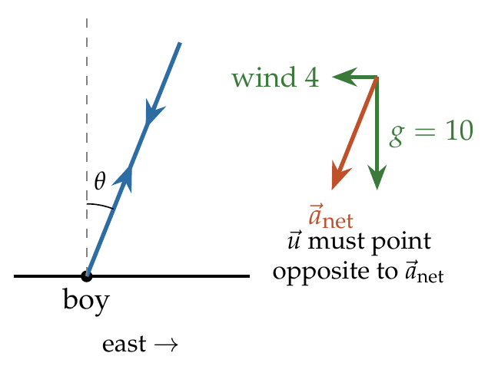
Take x east and y up. $u_{x}=20sinθ$, $a_{x}=−4$; $u_{y}=20cosθ$, $a_{y}=−10$.
Return to the hand: $x=0$ and $y=0$ at the same time $T≠0$:
$$T=\frac{2\left(20cosθ\right)}{10}=\frac{2\left(20sinθ\right)}{4} ⇒ tanθ=\frac{4}{10}=0.4.$$

Answer
(C) $\tan^{−1}\left(0.4\right)$ with the vertical (towards the east, against the wind).

Watch out
• θ is measured from the vertical here; tan θ = a_wind/g, not g/a_wind (option A).
• The ball must be thrown into the wind, not with it.
Notes: Sec. 8.3 (horizontal wind: returns to the thrower).

Q43 · Velocity perpendicular to the launch velocity at 60° [L2]
ID 04MIP-0410-fdfa · Code 0410 · Worksheet 04MIP_v2 Q43

Problem
A particle is projected at an angle of $60​^{∘}$ from the horizontal with speed u. Find the time ‘t’ when its velocity will be perpendicular to the velocity of projection?

Hint
At the required instant $\vec{v}⋅\vec{u}=0$. Since $\vec{v}=\vec{u}+\vec{g}t$, the change $\vec{g}t$ must cancel all of $\vec{u}$’s length along $\vec{u}$.

Think it through
- Asked: when the velocity is at 90° to the launch velocity. Then $\vec{v}⋅\vec{u}$ = 0.
- $\vec{v}=\vec{u}+\vec{g}t$, so $\vec{v}⋅\vec{u}$ = u² + ($\vec{g}⋅\vec{u}$)t = u² − g u sin 60° t.
- Setting it to zero: t = u/(g sin 60°) = 2u/(√3 g).
- Check this is before landing: the time of flight is 2u sin 60°/g = √3u/g ≈ 1.73u/g, more than 1.15u/g. ✓ (This needs θ > 45°.)
- Same answer as Q65, and for the same reason: in both, the component of $\vec{g}$ along the initial direction must cancel the initial speed.

Another way: tilted axes
Take one axis along $\vec{u}$. Along it, the velocity starts at u and decreases at g sin 60° (the part of g along $\vec{u}$). It is zero, so the velocity is perpendicular to $\vec{u}$, after u/(g sin 60°).

Worked solution
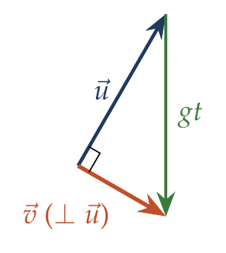
$$\vec{v}⋅\vec{u}=\left(\vec{u}+\vec{g}t\right)⋅\vec{u}=u^{2}−gt usin{60}^{∘}=0 ⇒ t=\frac{u}{gsin{60}^{∘}}=\frac{2u}{\sqrt{3} g}.$$
Time of flight $=\frac{2usin{60}^{∘}}{g}=\frac{\sqrt{3}u}{g}>\frac{2u}{\sqrt{3}g}$, so this happens in flight.

Answer
$t=\frac{2u}{\sqrt{3} g}$.

Watch out
• Use sin 60° (the component of g along $\vec{u}$), not cos 60°.
• For launch angles below 45° this never happens before landing.
Notes: Sec. 8.3 (velocity perpendicular to u).

Horizontal Projection from a Height

Q44 · Angle at impact after a 10 s fall
ID 04MIP-0415-62e2 · Code 0415 · Worksheet 04MIP_v2 Q44

Problem
A plane flying horizontally at 100 ms⁻¹ releases an object which reaches the ground in 10 s. At what angle with horizontal it hits the ground?

Hint
The object keeps the plane’s horizontal velocity. What vertical velocity has it gained after 10 s of falling?

Think it through
- Released from a plane flying horizontally, the object starts with the plane’s velocity: 100 m/s horizontal, zero vertical.
- Its horizontal velocity stays 100 m/s. Its vertical velocity grows by 10 m/s each second, reaching 100 m/s after 10 s.
- Equal horizontal and vertical components mean the velocity is at 45° below the horizontal at impact.
- Check: the height must have been ½ × 10 × 100 = 500 m, a sensible altitude.

Worked solution
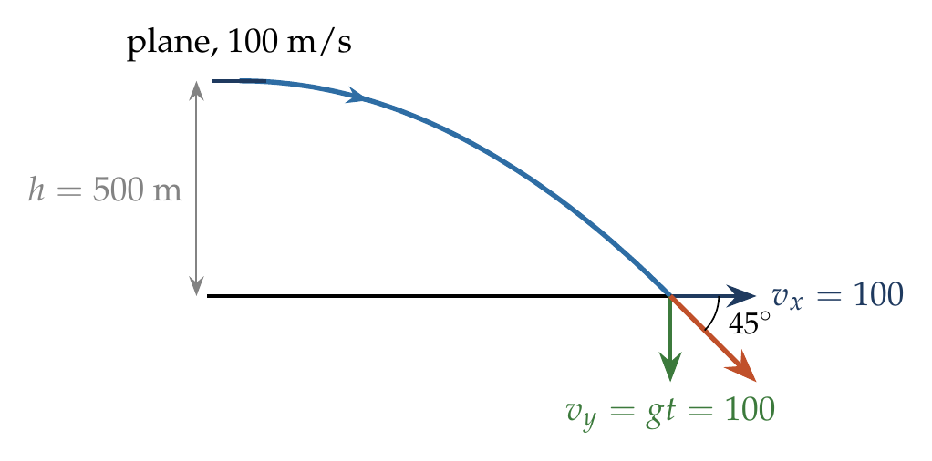
$$v_{x}=100 m/s, v_{y}=gt=10\left(10\right)=100 m/s.$$
$$tanβ=\frac{v_{y}}{v_{x}}=1 ⇒ β={45}^{∘} below the horizontal.$$

Answer
45° below the horizontal.

Watch out
• The object does not fall straight down: it keeps the plane’s 100 m/s forward.
• tan β uses velocities, not the height and horizontal distance (500 m and 1000 m would give 26.6°).
Notes: Sec. 8.4 (horizontal projection: angle at impact).

Q45 · Releasing a food packet from a helicopter [JEE Main 2021, 31 Aug, Shift 1]
ID 04MIP-0415-ff39 · Code 0415 · Worksheet 04MIP_v2 Q45

Problem
A helicopter is flying horizontally with a speed v at an altitude h has to drop a food packet for a man on the ground. What is the distance of the helicopter from the man when the food packet is dropped?
(A) $\sqrt{\frac{2ghv^{2}+1}{h^{2}}}$ (B) $\sqrt{2ghv^{2}+h^{2}}$ (C) $\sqrt{\frac{2v^{2}h}{g}+h^{2}}$ (D) $\sqrt{\frac{2v^{2}h}{g}}+h^{2}$

Hint
The packet keeps the helicopter’s horizontal speed. How far forward does it travel while falling h? The question asks for the straight-line distance from the helicopter to the man.

Think it through
- The packet falls h in time √(2h/g), the same as if dropped from rest, because it starts with no vertical velocity.
- Meanwhile it moves forward at v, a horizontal distance v√(2h/g). So the man must be that far ahead horizontally at release.
- The helicopter is h above the ground, so its straight-line distance to the man is √(x² + h²) = √(2v²h/g + h²). (C)
- Check units: 2v²h/g has units of m², matching h². (A) and (B) fail this test, and (D) adds m to m².

Worked solution
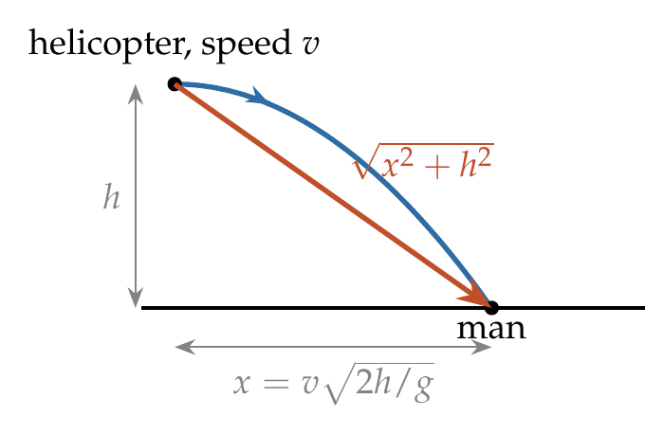
$$t=\sqrt{\frac{2h}{g}}, x=vt=v\sqrt{\frac{2h}{g}}.$$
$$d=\sqrt{x^{2}+h^{2}}=\sqrt{\frac{2v^{2}h}{g}+h^{2}}.$$

Answer
(C) $\sqrt{\frac{2v^{2}h}{g}+h^{2}}$.

Watch out
• “Distance of the helicopter from the man” is the line-of-sight distance, not the horizontal distance x.
• (D) puts h² outside the root: check units.
Notes: Sec. 8.4 (packet dropped from a plane: line-of-sight distance).

Q46 · When is the velocity at 45°?
ID 04MIP-0415-015e · Code 0415 · Worksheet 04MIP_v2 Q46

Problem
A body is thrown horizontally from a tower, 100 m high with a velocity 10 ms⁻¹. After what time interval will it be moving at an angle 45° with the horizontal?

Hint
45° with the horizontal means the vertical component has grown to equal the horizontal one. How long does that take?

Think it through
- The horizontal component stays 10 m/s. The vertical component starts at zero and grows by 10 m/s each second.
- 45° means they are equal: v_y = 10 m/s, after 1 s.
- Check: in 1 s it falls only 5 m, far less than 100 m, so it is still in the air. The tower height is not needed except for this check.

Worked solution
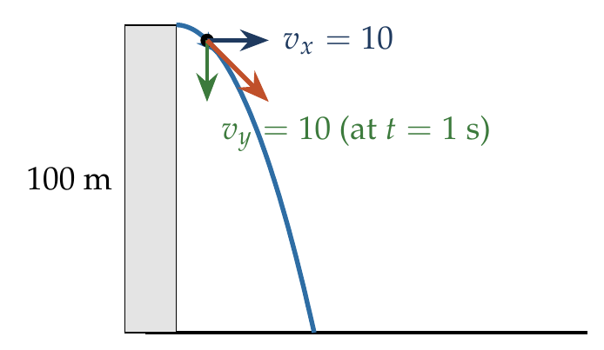
$$tan{45}^{∘}=\frac{v_{y}}{v_{x}}=\frac{gt}{10}=1 ⇒ t=1 s.$$
In 1 s it falls $\frac{1}{2}g{\left(1\right)}^{2}=5$ m < 100 m, so it is still in flight.

Answer
1 s.

Watch out
• Equal velocity components, not equal displacements: x = y happens at 2 s, not 1 s.
• The 100 m height is a distractor, used only to confirm the body has not landed.
Notes: Sec. 8.4 (horizontal projection).

Q47 · Ball thrown into a window across the street
ID 04MIP-0415-c398 · Code 0415 · Worksheet 04MIP_v2 Q47

Problem
Two tall buildings are 30 m apart. The speed with which a ball must be thrown horizontally from a window 150 m above the ground in one building so that it enters a window 25 m above from the ground in the other building?
(A) 4 m/s (B) 6 m/s (C) 8 m/s (D) 9 m/s

Hint
The fall from 150 m to 25 m fixes the time. The ball must cover the 30 m gap in exactly that time.

Think it through
- Thrown horizontally, the ball starts with no vertical velocity, so its fall is like a drop from rest.
- It must fall 150 − 25 = 125 m: ½ × 10 × t² = 125 gives t = 5 s.
- In those 5 s it must cross 30 m horizontally, so u = 30/5 = 6 m/s. (B)
- Check: a slower throw drops below the window before arriving; a faster one hits the wall above it.

Worked solution
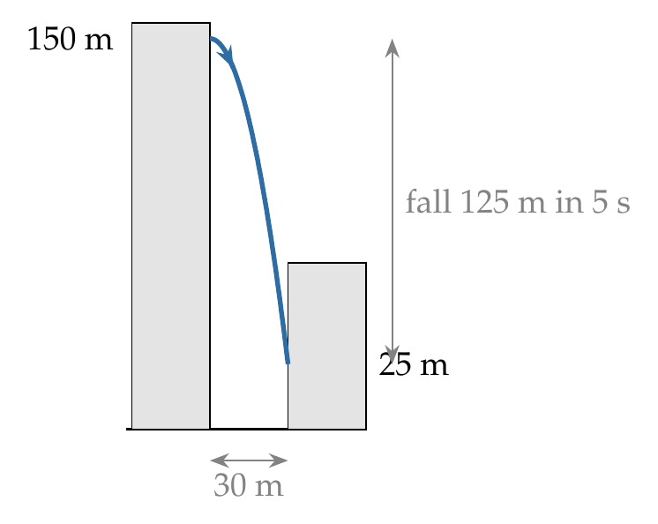
$$150−25=\frac{1}{2}gt^{2} ⇒ 125=5t^{2} ⇒ t=5 s.$$
$$u=\frac{30}{5}=6 m/s.$$

Answer
(B) 6 m/s.

Watch out
• The fall is 125 m (150 − 25), not 150 m.
• Using 150 m gives t = √30 s and u ≈ 5.5 m/s, close to but not equal to any option.
Notes: Sec. 8.4 (horizontal projection: time from the drop).

Q48 · Just clearing the obstruction at B
ID 04MIP-0415-d682 · Code 0415 · Worksheet 04MIP_v2 Q48

Problem
With what minimum horizontal velocity u can a boy throw a ball at A and have it just clear the obstruction at B? (g = 9.8 m/s²)
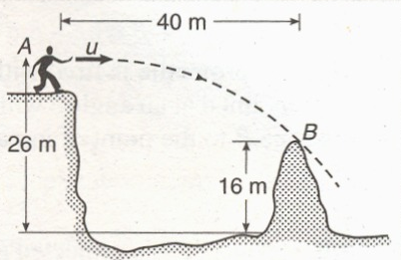
(A) 20 m/s (B) 25 m/s (C) 28 m/s (D) 30 m/s

Hint
Read the figure: by the time the ball has gone 40 m forward, how far below A may it be? That vertical drop fixes the time.

Think it through
- A is 26 m above the ground and the top of B is 16 m up, so the ball may drop at most 10 m by the time it is 40 m forward.
- Thrown horizontally, the drop is like a fall from rest: ½ × 9.8 × t² = 10 gives t = √(20/9.8) = 1/0.7 ≈ 1.43 s.
- It must cover 40 m in that time: u = 40 × 0.7 = 28 m/s. (C)
- “Minimum”: any slower and the ball drops more than 10 m before reaching B and hits it.

Worked solution
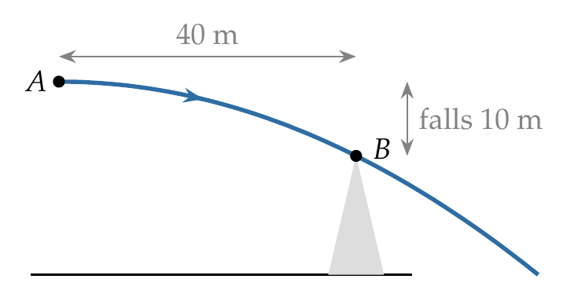
Drop allowed: $26−16=10$ m over a horizontal distance of 40 m.
$$10=\frac{1}{2}\left(9.8\right)t^{2} ⇒ t=\sqrt{\frac{20}{9.8}}=\frac{1}{0.7} s.$$
$$u_{min}=\frac{40}{t}=40×0.7=28 m/s.$$

Answer
(C) 28 m/s.

Watch out
• Use the drop of 10 m (26 − 16), not the full 26 m.
• This problem uses g = 9.8 m/s²; with g = 10 the answer would come out as 28.3 m/s.
Notes: Sec. 8.4 (horizontal projection: path y = gx squared over 2u squared).

Q49 · How high to aim a rifle
ID 04MIP-0415-2add · Code 0415 · Worksheet 04MIP_v2 Q49

Problem
A rifle shoots a bullet with a muzzle velocity of 400 m/s at a small target 400 metre away. The height above the target at which the bullet must be aimed to hit the target is:
(A) 5 m (B) 0.5 m (C) 0.1 m (D) 0.4 m

Hint
How long is the bullet in flight? During that time, how far does gravity pull it below the line it was aimed along?

Think it through
- The bullet moves almost horizontally at 400 m/s, so it takes 400/400 = 1 s to reach the target.
- During that second gravity pulls it down ½ × 10 × 1² = 5 m below the straight line of aim.
- So aim 5 m above the target. (A)
- This is the “bullet drop”: the line of aim and the actual path separate by ½gt², whatever the (small) aiming angle.

Worked solution
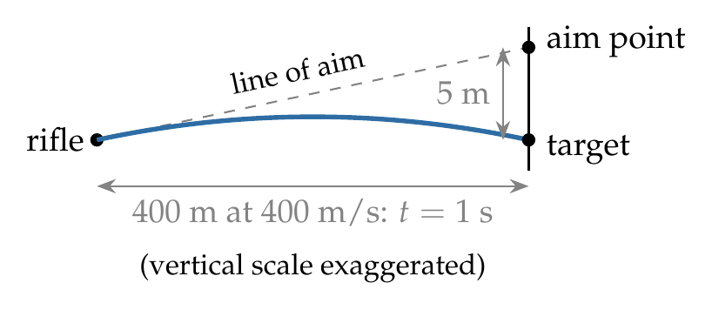
$$t=\frac{d}{u}=\frac{400}{400}=1 s, drop=\frac{1}{2}gt^{2}=\frac{1}{2}\left(10\right){\left(1\right)}^{2}=5 m.$$
The rifle must be aimed 5 m above the target.

Answer
(A) 5 m.

Watch out
• The drop grows as t², so a farther or slower shot needs a much higher aim.
• 0.5 m comes from using g/2 = 5 with t = 0.1 s; check t = d/u = 1 s.
Notes: Sec. 8.4 (bullet drop).

Q50 · Twice the height, twice the range
ID 04MIP-0415-ddbf · Code 0415 · Worksheet 04MIP_v2 Q50

Problem
A body of mass m is projected horizontally with a velocity v from the top of a tower of height h and it reaches the ground at a distance x from the foot of the tower. If a second body of mass 2 m is projected horizontally from the top of a tower of height 2h, it reaches the ground at a distance 2x from the foot of the tower. Find the horizontal velocity of the second body?
(A) $v$ (B) $\sqrt{2}v$ (C) $2v$ (D) $v/2$

Hint
Range = speed × fall time, and the fall time depends only on the height. How does the fall time change when the height doubles?

Think it through
- Range = v × √(2h/g). The mass plays no part.
- Doubling the height multiplies the fall time by √2.
- To get twice the range with √2 times the time, the speed must be 2/√2 = √2 times as large: √2 v. (B)
- Check: with the same speed v it would reach only √2 x, short of 2x.

Worked solution
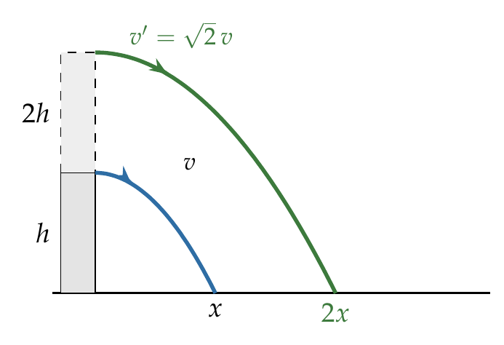
$$x=v\sqrt{\frac{2h}{g}}, 2x=v′\sqrt{\frac{2\left(2h\right)}{g}}=\sqrt{2} v′\sqrt{\frac{2h}{g}}.$$
Dividing: $2=\sqrt{2} v′/v$, so $v′=\sqrt{2} v$.

Answer
(B) $\sqrt{2} v$.

Watch out
• The mass 2m is a distractor: projectile motion does not depend on mass.
• Doubling the height does not double the time; it multiplies it by √2.
Notes: Sec. 8.4 (horizontal projection: T and R).

Q51 · Ball rolling down a staircase [L2]
ID 04MIP-0415-9fe7 · Code 0415 · Worksheet 04MIP_v2 Q51

Problem
A ball rolls off the top of a staircase with a horizontal velocity of 4.5 m s^{–1}. If the steps are 20 cm high and 30 cm broad, then the ball will strike the nth step then $n$?

Hint
Imagine the line joining the edges of all the steps. Where does the ball’s path cross that line? The first step whose edge lies beyond the crossing is the one it hits.

Think it through
- The ball leaves the top horizontally at 4.5 m/s. Each step drops 0.2 m and goes out 0.3 m, so the step edges lie on a line of slope 0.2/0.3 = 2/3.
- The ball’s path y = gx²/2u² starts flatter than that line and curves below it. It crosses the line where gx²/2u² = (2/3)x, i.e. x = (2/3)(2u²/g) = (2/3)(2 × 20.25/10) = 2.7 m.
- 2.7 m is exactly 9 step-widths (9 × 0.3), and the drop there is 1.8 m = 9 step-heights.
- So the ball just reaches the edge of the 9th step: it clears steps 1 to 8 and strikes the 9th at its edge. n = 9.
- Using the notes’ rule: n is the smallest integer with n ≥ 2u²a/(gb²) = 2 × 20.25 × 0.2/(10 × 0.09) = 9.

Another way: step by step
To fall to the level of step n takes t = √(2 × 0.2n/10) = 0.2√n, in which time the ball moves 4.5 × 0.2√n = 0.9√n forward. It has not yet passed the end of step n if 0.9√n ≤ 0.3n, i.e. √n ≥ 3, n ≥ 9. The smallest such n is 9, with equality: it lands on the edge of step 9.

Worked solution
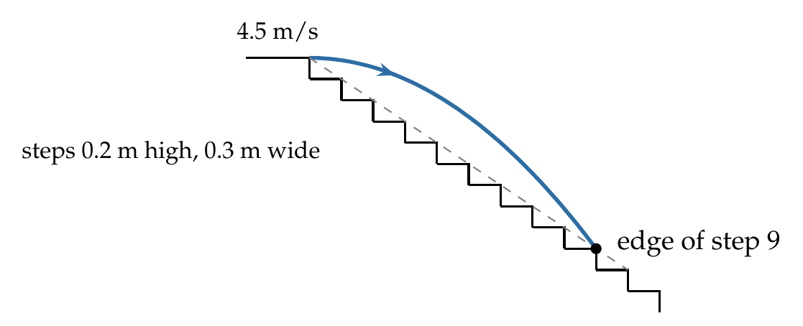
Take the origin at the top edge, x forward and y downward. Path: $y=\frac{gx^{2}}{2u^{2}}$. The step edges lie on $y=\frac{a}{b}x=\frac{2}{3}x$.
The ball reaches the step-edge line where
$$\frac{gx^{2}}{2u^{2}}=\frac{2}{3}x ⇒ x=\frac{2}{3}⋅\frac{2u^{2}}{g}=\frac{2}{3}⋅\frac{2{\left(4.5\right)}^{2}}{10}=2.7 m.$$
$$n=\frac{x}{b}=\frac{2.7}{0.3}=9.$$
The crossing falls exactly at the edge of the 9th step, so the ball strikes the 9th step (at its edge).

Answer
n = 9 (the ball strikes the edge of the 9th step).

Watch out
• The answer is a whole step: if 2u²a/(gb²) had come out as 8.1, the ball would hit step 9, not step 8.
• Measure the steps as the ball does: step 1 is the first one below the top.
Notes: Sec. 8.4 (ball rolling off stairs).

Oblique Projection from a Height or to a Target

Q52 · Height at which the ball hits a wall
ID 04MIP-0420-04b5 · Code 0420 · Worksheet 04MIP_v2 Q52

Problem
A ball is projected from ground with a speed of 20 m/s at an angle of 45° with horizontal. There is a wall of 25 m height at a distance of 10 m from the projection point. The ball will hit the wall at a height of?

Hint
The wall is 10 m away. When is the ball 10 m out horizontally, and how high is it then?

Think it through
- The ball reaches the wall when its horizontal distance is 10 m; its height then is where it hits (if that is below the 25 m top, which it will be).
- Components: 20 cos 45° = 20 sin 45° = 10√2 ≈ 14.1 m/s.
- Time to the wall: 10/(10√2) = 1/√2 s ≈ 0.71 s.
- Height: 10√2 × (1/√2) − 5 × ½ = 10 − 2.5 = 7.5 m.
- Check: 7.5 m is below the 25 m top, so the ball does hit the wall. (Its maximum height would be 10 m, reached beyond the wall.)

Another way: trajectory equation
y = x tan θ − gx²/(2u²cos²θ) = 10(1) − 10 × 100/(2 × 400 × ½) = 10 − 2.5 = 7.5 m. This is the route in the worksheet hint.

Worked solution
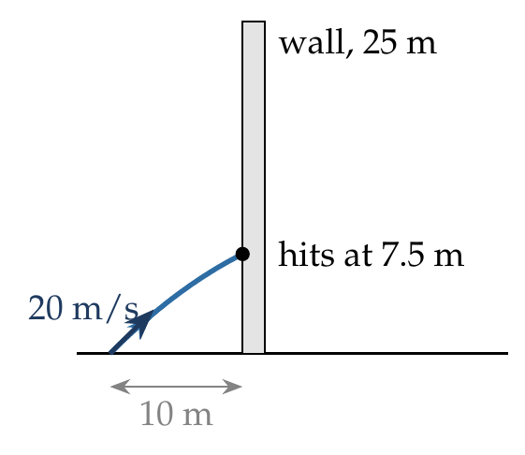
$$y=xtanθ−\frac{gx^{2}}{2u^{2}\cos^{2}θ}=10tan{45}^{∘}−\frac{10{\left(10\right)}^{2}}{2{\left(20\right)}^{2}\left(1/2\right)}=10−2.5=7.5 m.$$
Since 7.5 m < 25 m, the ball strikes the wall 7.5 m above the ground.

Answer
7.5 m above the ground.

Watch out
• Check that the hit point is below the top of the wall; otherwise the ball would pass over it.
• Do not use the maximum height (10 m): the ball reaches the wall before its top, which is 20 m out.
Notes: Sec. 8.2 (trajectory equation).

Q53 · Grazing the ceiling of a hall
ID 04MIP-0420-7f07 · Code 0420 · Worksheet 04MIP_v2 Q53

Problem
A big hall is 5 m high and 60 m long. A cricket ball is thrown along the length of the hall from one end such that it hits the other end of the hall just grazing the ceiling. What must be the speed of projection of the ball?
(A) 30 m/s (B) 40 m/s (C) 10$\sqrt{6}$ m/s (D) 10$\sqrt{10}$m/s

Hint
“Just grazing the ceiling” fixes the maximum height. That alone gives the vertical component and the time of flight.

Think it through
- Grazing the ceiling means the maximum height is 5 m. So u_y² = 2 × 10 × 5 = 100, u_y = 10 m/s.
- Time of flight = 2u_y/g = 2 s.
- It must cover the 60 m length in 2 s: u_x = 30 m/s.
- Speed = √(30² + 10²) = √1000 = 10√10 ≈ 31.6 m/s. (D)
- Check: the ball grazes the ceiling at mid-hall (30 m), its top, as it should.

Worked solution
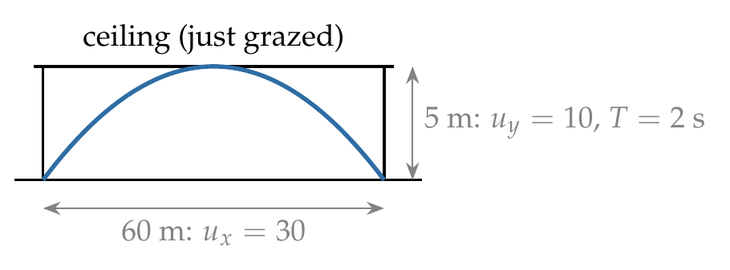
$$H=\frac{u_{y}^{2}}{2g}=5⇒u_{y}=10 m/s, T=\frac{2u_{y}}{g}=2 s, u_{x}=\frac{60}{2}=30 m/s.$$
$$u=\sqrt{u_{x}^{2}+u_{y}^{2}}=\sqrt{900+100}=10\sqrt{10} m/s.$$

Answer
(D) $10\sqrt{10}$ m/s.

Watch out
• (A) 30 m/s is only the horizontal component.
• The ball lands at the far end at floor level, so the full 60 m is the range.
Notes: Sec. 8.2 (time of flight and maximum height).

Q54 · Two poles of equal height at 1 s and 3 s
ID 04MIP-0420-7bb1 · Code 0420 · Worksheet 04MIP_v2 Q54

Problem
A projectile thrown with velocity v making an angle θ with the horizontal. It just crosses the top of two poles, each of identical height h, after 1 s and 3 s respectively. The time of flight of the projectile will be?
(A) 6 sec (B) 5 sec (C) 4 sec (D) 3.5 sec

Hint
The path is symmetric about its top. If the projectile is at the same height at 1 s and 3 s, when is it at the top?

Think it through
- The two pole tops are at the same height, so the projectile passes that height at 1 s (going up) and 3 s (coming down).
- By symmetry the top is midway in time, at 2 s.
- The whole flight is twice the time to the top: 4 s. (C)
- Equivalently, from the second pole to the ground takes as long as from the ground to the first pole (1 s), so T = 3 + 1 = 4 s.

Worked solution
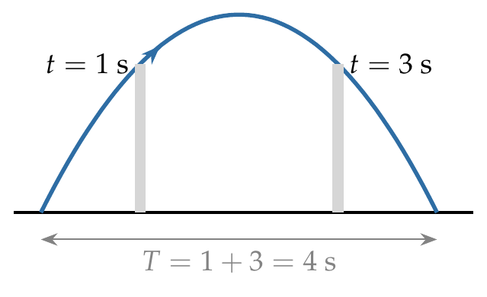
Both instants solve $h=u_{y}t−\frac{1}{2}gt^{2}$, i.e. $\frac{1}{2}gt^{2}−u_{y}t+h=0$. The sum of the roots is
$$t_{1}+t_{2}=\frac{2u_{y}}{g}=T ⇒ T=1+3=4 s.$$
(Also $h=\frac{1}{2}gt_{1}t_{2}=15$ m, which is not needed.)

Answer
(C) 4 s.

Watch out
• The time to the top is 2 s, not 3 s; the flight is twice that.
• v and θ are not needed: the two times alone fix T.
Notes: Sec. 8.3 (two equal-height points: T = t1 + t2).

Q55 · Projectile from a height: ratio h/H
ID 04MIP-0420-f25c · Code 0420 · Worksheet 04MIP_v2 Q55

Problem
If a projectile is fired from a height h with an inclination of θ from the horizontal. It takes time T to reach a maximum height of H measured from the point of projection. It takes further time 2T to hit the ground, Then ratio h/H ?

Hint
From the top, the projectile falls like a body dropped from rest. It rose H in time T; how far does it fall in 2T?

Think it through
- Rising to the top in time T is the reverse of falling from the top for time T. So H = ½gT².
- From the top the vertical motion starts from rest. In 2T it falls ½g(2T)² = 4 × ½gT² = 4H.
- That fall takes it from H above the launch point to the ground, h below it: H + h = 4H.
- So h = 3H and h/H = 3.

Worked solution
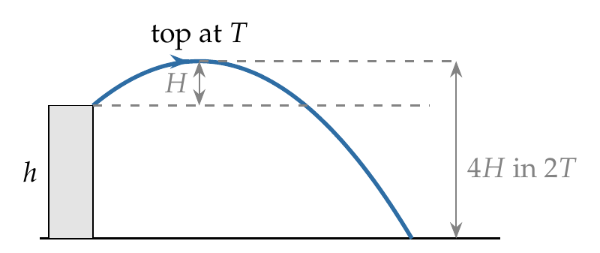
$$H=\frac{1}{2}gT^{2}.$$
From the top (vertical velocity zero), in time $2T$ it falls
$$\frac{1}{2}g{\left(2T\right)}^{2}=4\left(\frac{1}{2}gT^{2}\right)=4H=H+h ⇒ \frac{h}{H}=3.$$

Answer
h/H = 3.

Watch out
• The fall from the top is H + h, not h.
• Distance from rest goes as t²: doubling the time quadruples the fall.
Notes: Sec. 8.4 (oblique projection from height); Sec. 3.2 (starting from rest: s proportional to t squared).

Q56 · Thrown 15° up and 15° down from a tower
ID 04MIP-0420-2d15 · Code 0420 · Worksheet 04MIP_v2 Q56

Problem
Two particles are projected from top of a tower of height 25 m. The speed of projection is 10 m/s for either of them but one is projected at angle of 15° above the horizontal while other at 15° below as shown. Find the difference in the range of two particles.
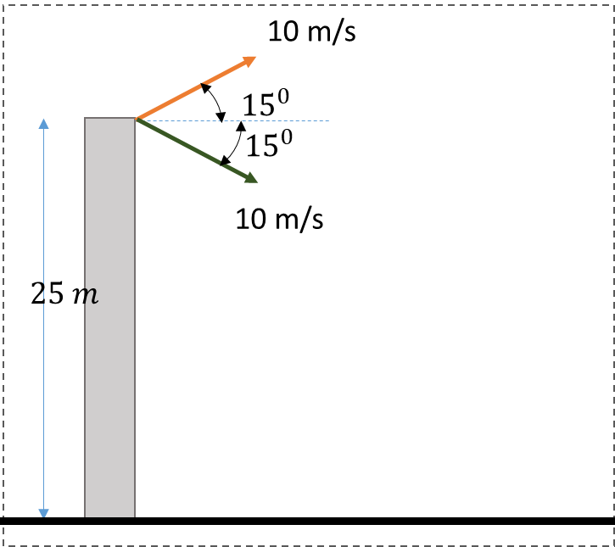

Hint
Follow the particle thrown upward until it comes back to the top of the tower. What is its velocity then, compared with the other particle’s launch velocity?

Think it through
- The upward particle rises and comes back to the tower-top level, landing on that level a short distance out (its level-ground range).
- At that moment its velocity is 10 m/s at 15° below the horizontal, exactly the other particle’s launch velocity.
- From then on its motion is a copy of the other particle’s, only shifted forward by that level-ground range.
- So the difference in ranges is the level-ground range at 15°: u² sin 30°/g = 100 × ½/10 = 5 m.
- The height 25 m does not matter. Check numerically: 24.24 m − 19.24 m = 5.0 m.

Another way: solve both flights
Up-throw: −25 = 2.588t − 5t² gives t = 2.510 s, x = 9.659 × 2.510 = 24.24 m. Down-throw: −25 = −2.588t − 5t² gives t = 1.992 s, x = 19.24 m. Difference = 5.0 m.

Worked solution
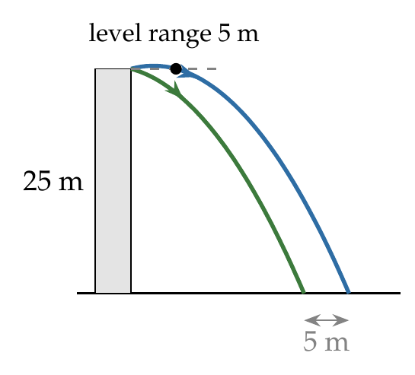
The particle thrown at ${15}^{∘}$ above the horizontal returns to the level of the tower top after $2usin{15}^{∘}/g$, a horizontal distance
$$R_{0}=\frac{u^{2}sin{30}^{∘}}{g}=\frac{100×0.5}{10}=5 m,$$
with velocity 10 m/s at ${15}^{∘}$ below the horizontal. From there its motion is identical to that of the second particle, so
$$R_{up}−R_{down}=R_{0}=5 m.$$

Answer
5 m (the upward-thrown particle lands 5 m farther).

Watch out
• The tower height drops out: the difference is the same for any height.
• Use sin 2θ = sin 30° for the level range, not sin 15°.
Notes: Sec. 8.4 (two stones at plus and minus θ from a tower).

Projectile on an Inclined Plane

Q57 · Speed when the velocity is parallel to the incline
ID 04MIP-0425-5262 · Code 0425 · Worksheet 04MIP_v2 Q57

Problem
A particle is projected from the bottom of an inclined plane of inclination 30° with velocity of 30 m/s at an angle of 60° with horizontal. Find the speed of the particle when its velocity vector is parallel to the plane.
(A) $30\sqrt{3}$ m/s (B) $20\sqrt{3}$ m/s (C) 20 m/s (D) $10\sqrt{3}$ m/s

Hint
The horizontal component never changes. If the velocity points along the incline, at what angle is it to the horizontal, and what does that make the speed?

Think it through
- Velocity parallel to the plane means it points 30° above the horizontal (up the slope, since the particle is still moving forward).
- The horizontal component is constant: 30 cos 60° = 15 m/s.
- A velocity at 30° to the horizontal with horizontal part 15 has magnitude 15/cos 30° = 30/√3 = 10√3 ≈ 17.3 m/s. (D)
- Check: this is the instant the particle is farthest from the incline, halfway through its flight; its speed must be less than 30 m/s, and 17.3 is.

Another way: tilted axes
Along the incline the launch velocity has 30 cos 30° = 15√3 and across it 30 sin 30° = 15. The velocity is parallel to the plane when the across part is zero, at t = 15/(g cos 30°) = √3 s. Then the along part is 15√3 − (g sin 30°)(√3) = 15√3 − 5√3 = 10√3 m/s.

Worked solution
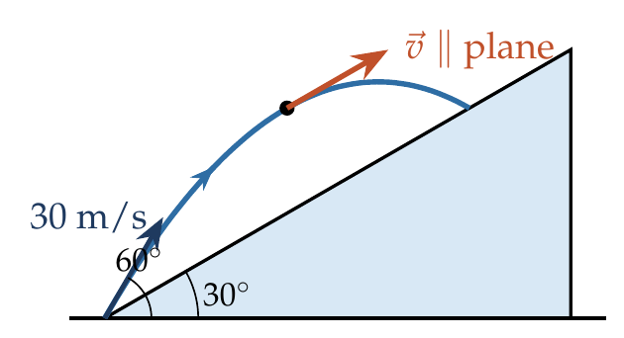
$u_{x}=30cos{60}^{∘}=15$ m/s, unchanged. When $\vec{v}$ is parallel to the incline it makes ${30}^{∘}$ with the horizontal, so
$$v=\frac{v_{x}}{cos{30}^{∘}}=\frac{15}{\sqrt{3}/2}=10\sqrt{3} m/s.$$
(Then $v_{y}=15tan{30}^{∘}=5\sqrt{3}$ m/s, as in the worksheet hint.)

Answer
(D) $10\sqrt{3}$ m/s.

Watch out
• Parallel to the plane means at 30° to the horizontal, not horizontal.
• (C) 20 m/s divides by cos 30° wrongly as 15 × 4/3; check 15/0.866 = 17.3.
Notes: Sec. 9 (method B: tilted axes).

Q58 · Distance AB along the incline
ID 04MIP-0425-6936 · Code 0425 · Worksheet 04MIP_v2 Q58

Problem
Time taken by the projectile to reach from A to B is t. Then the distance AB is equal to?
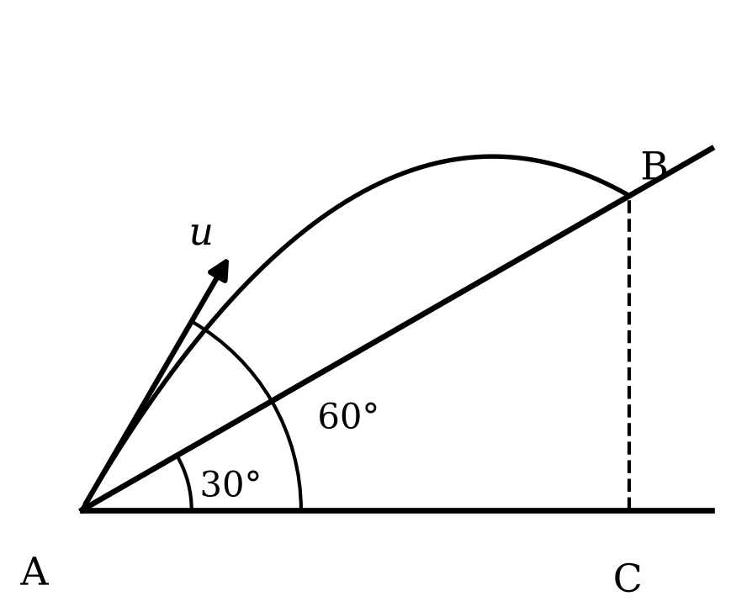
(A) $ut$ (B) $\sqrt{2} ut$ (C) $\sqrt{3} ut$ (D) $\frac{ut}{\sqrt{3}}$

Hint
The horizontal motion is uniform, so AC (the horizontal distance to below B) is easy. How is AB related to AC in the right triangle ABC?

Think it through
- From the figure, the projectile is launched at 60° to the horizontal and the incline is at 30°.
- Its horizontal speed is u cos 60° = u/2, constant, so in time t it covers AC = ut/2.
- B is on the incline directly above C, so AB is the hypotenuse of triangle ABC with angle 30° at A: AB = AC/cos 30° = (ut/2)(2/√3) = ut/√3. (D)
- Check: AB must exceed AC = 0.5ut; ut/√3 ≈ 0.58ut does, while still being less than the full launch distance ut.

Worked solution
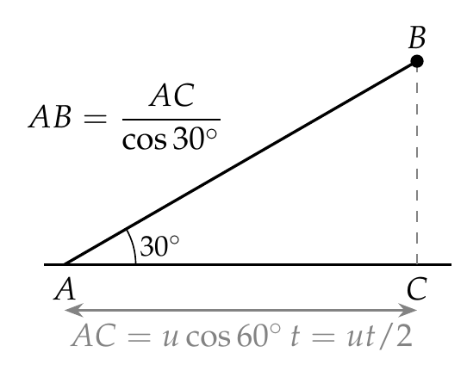
$$AC=ucos{60}^{∘}⋅t=\frac{ut}{2}, AB=\frac{AC}{cos{30}^{∘}}=\frac{ut/2}{\sqrt{3}/2}=\frac{ut}{\sqrt{3}}.$$

Answer
(D) $\frac{ut}{\sqrt{3}}$.

Watch out
• ut would be the distance at constant velocity u; gravity bends the path, so use only the horizontal part.
• AB is a hypotenuse: divide AC by cos 30°, do not multiply.
Notes: Sec. 9 (method A: normal axes).

Q59 · Striking a 45° incline horizontally
ID 04MIP-0425-32a2 · Code 0425 · Worksheet 04MIP_v2 Q59

Problem
A particle is projected from the base of a plane inclined at an angle of 45° with the horizontal. The initial velocity of projection is u making an angle of θ with the horizontal as shown. If the particle strikes the inclined plane horizontally, then what is the value of tan θ?
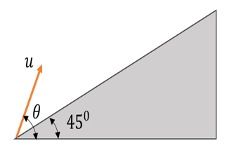
(A) $1/\sqrt{2}$ (B) $\sqrt{2}$ (C) 1 (D) 2

Hint
When is a projectile’s velocity horizontal? So where on its path must it meet the incline?

Think it through
- The velocity is horizontal only at the top of the trajectory, so the particle must meet the incline exactly at its highest point.
- From the launch point, the top is seen at elevation φ with tan φ = ½ tan θ.
- The top lies on the incline, so φ = 45°: ½ tan θ = 1, tan θ = 2. (D)
- Check: tan θ = 2 means θ ≈ 63°, steeper than the incline, as it must be for the particle to rise above the slope at all.

Another way: coordinates of the top
The top is at (u_xu_y/g, u_y²/2g). It lies on y = x tan 45° = x when u_y²/2g = u_xu_y/g, i.e. u_y = 2u_x, tan θ = 2.

Worked solution
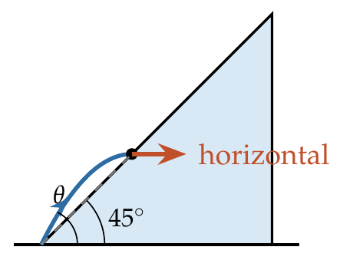
The particle strikes horizontally only at the top of its path, $\left(\frac{u_{x}u_{y}}{g}, \frac{u_{y}^{2}}{2g}\right)$. This point is on the incline:
$$tan{45}^{∘}=\frac{u_{y}^{2}/2g}{u_{x}u_{y}/g}=\frac{u_{y}}{2u_{x}}=\frac{1}{2}tanθ ⇒ tanθ=2.$$

Answer
(D) 2.

Watch out
• Horizontal at impact means the top of the path, not that θ equals the incline angle.
• (C) tan θ = 1 is the incline itself: a particle launched along the plane never leaves it.
Notes: Sec. 9.1 (strikes the incline horizontally: tan θ = 2 tan α).

Q60 · Range when projected perpendicular to a 37° incline
ID 04MIP-0425-b546 · Code 0425 · Worksheet 04MIP_v2 Q60

Problem
A particle is projected perpendicularly from a long inclined plane as shown. The inclined plane makes an angle θ = 37° with the horizontal. Find the range of the projectile measured along the incline?
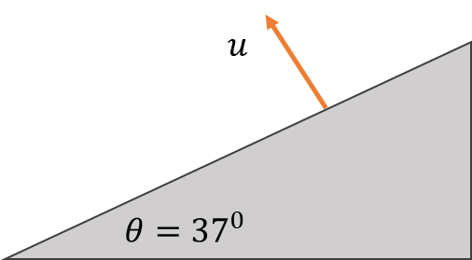
(A) $\frac{5u^{2}}{8g}$ (B) $\frac{7u^{2}}{4g}$ (C) $\frac{15u^{2}}{8g}$ (D) $\frac{5u^{2}}{4g}$

Hint
Use axes along and across the incline. Across it, the particle goes out and comes back like a vertical throw; along it, it starts from rest. What does each component of g do?

Think it through
- Tilt the axes: x down the slope, y perpendicular to it. Gravity has components g sin 37° = 3g/5 along x and g cos 37° = 4g/5 into the plane.
- Across the plane the particle starts with u and is pulled back at 4g/5, so it returns to the plane after 2u/(4g/5) = 5u/2g.
- Along the plane it starts from rest and accelerates at 3g/5. In that time it slides ½ × (3g/5) × (5u/2g)² = ½ × 3g/5 × 25u²/4g² = 15u²/8g. (C)
- Check: it lands down the slope (it has no up-slope velocity at all), and the answer grows with sin θ, as it should.

Worked solution
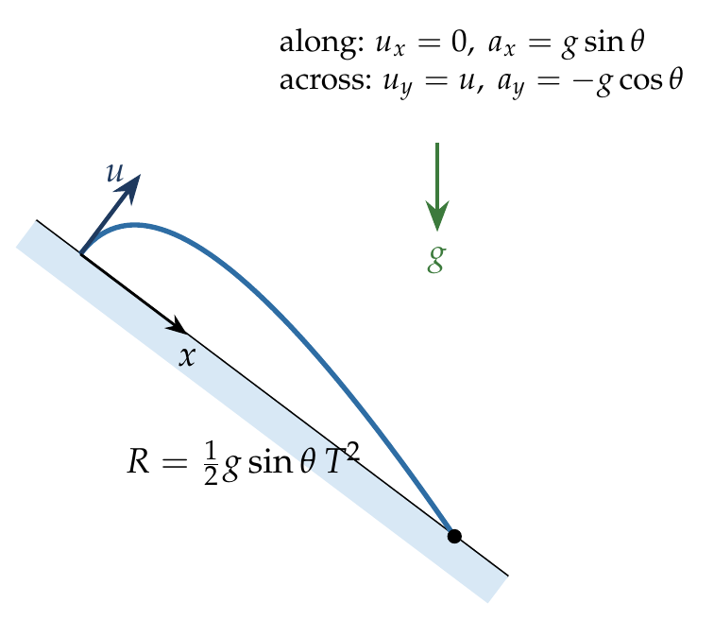
Take x along the incline (down) and y perpendicular to it. Then $u_{x}=0$, $a_{x}=gsin{37}^{∘}=\frac{3}{5}g$; $u_{y}=u$, $a_{y}=−gcos{37}^{∘}=−\frac{4}{5}g$.
$$T=\frac{2u_{y}}{\left|a_{y}\right|}=\frac{2u}{4g/5}=\frac{5u}{2g}.$$
$$R=\frac{1}{2}a_{x}T^{2}=\frac{1}{2}⋅\frac{3g}{5}⋅\frac{25u^{2}}{4g^{2}}=\frac{15u^{2}}{8g}.$$

Answer
(C) $\frac{15u^{2}}{8g}$.

Watch out
• The along-slope motion is accelerated even though it starts from zero.
• Use g cos θ (not g) for the time of flight: only the perpendicular component brings it back.
Notes: Sec. 9.1 (projected perpendicular to the incline).

Q61 · Hitting a 30° incline when launched at 15° to it [JEE Main 2019, 10 Apr, Shift 2]
ID 04MIP-0425-c6b2 · Code 0425 · Worksheet 04MIP_v2 Q61

Problem
A plane is inclined at an angle α = 30° with respect to the horizontal. A particle is projected with a speed u = 2 m/s from the base of the plane, making an angle of θ = 15° with respect to the plane as shown in the figure. The distance from the base at which the particle hits the plane is close to:
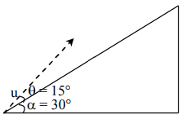
(A) 26 cm (B) 20 cm (C) 18 cm (D) 14 cm

Hint
The launch is at 15° to the plane, which is 45° to the horizontal. Find when the position vector makes 30° with the horizontal, or use tilted axes.

Think it through
- Launch angle to the horizontal = 30° + 15° = 45°, so u_x = u_y = √2 m/s.
- The particle is on the incline when its position vector makes 30° with the horizontal: y/x = tan 30°.
- y/x = (√2t − 5t²)/(√2t) = 1 − 5t/√2. Setting this to 1/√3 gives t = √2(1 − 1/√3)/5 ≈ 0.120 s.
- Then x = √2 × 0.120 ≈ 0.169 m, and the distance along the plane is x/cos 30° ≈ 0.195 m ≈ 20 cm. (B)
- Check by the incline formula below; both give 19.5 cm.

Another way: incline range formula
With β = 15° (to the plane) and α = 30°: R = 2u² sin β cos(β + α)/(g cos² α) = 2(4)(0.2588)(0.7071)/(10 × 0.75) = 0.195 m ≈ 20 cm.

Worked solution
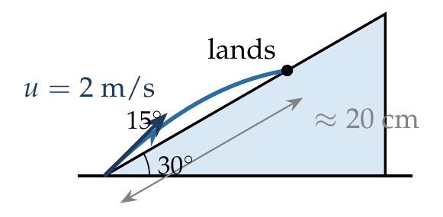
Normal axes: $u_{x}=u_{y}=2cos{45}^{∘}=\sqrt{2}$ m/s. The particle strikes the plane when
$$tan{30}^{∘}=\frac{\sqrt{2}t−5t^{2}}{\sqrt{2}t}=1−\frac{5t}{\sqrt{2}} ⇒ t=\frac{\sqrt{2}}{5}\left(1−\frac{1}{\sqrt{3}}\right)≈0.120 s.$$
$$x=\sqrt{2}t≈0.169 m, AB=\frac{x}{cos{30}^{∘}}≈0.195 m≈20 cm.$$

Answer
(B) 20 cm (19.5 cm).

Watch out
• 15° is measured from the plane; the angle to the horizontal is 45°.
• The level-ground range at 45° (40 cm) ignores the rising slope.
Notes: Sec. 9 (method A: normal axes; range up the incline).

Q62 · Sphere on a smooth incline: when is x largest?
ID 04MIP-0425-5300 · Code 0425 · Worksheet 04MIP_v2 Q62

Problem
A small sphere is projected with a velocity of 3 m/s in a direction 60° from the horizontal y-axis, on the smooth inclined plane. The motion of sphere takes place in the x-y plane. Find time when the x-coordinate is maximum?
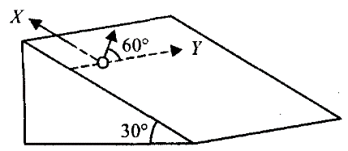
(A) $\frac{\sqrt{3}}{g}$ (B) $\frac{2\sqrt{3}}{g}$ (C) $\frac{\sqrt{3}}{2g}$ (D) $\frac{3\sqrt{3}}{g}$

Hint
Inside the plane, the sphere behaves like a projectile with a weaker “gravity”. What is that effective gravity, and along which axis does it act?

Think it through
- On a smooth incline the in-plane acceleration is g sin 30° = g/2, down the line of greatest slope. In the figure that is along −x (X points up the slope; Y is horizontal along the plane).
- So within the plane the sphere is a projectile with “gravity” g/2 along −x.
- The velocity component along x (up the slope) is 3 sin 60° = 3√3/2.
- x is largest when that component falls to zero: t = (3√3/2)/(g/2) = 3√3/g. (D)

Worked solution
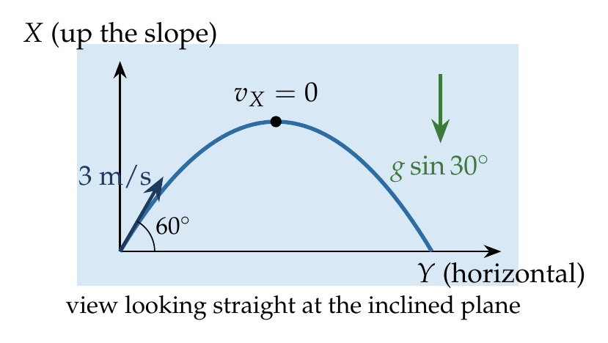
Effective gravity in the plane: $g_{e}=gsin{30}^{∘}=g/2$, along $−x$.
$$u_{x}=3sin{60}^{∘}=\frac{3\sqrt{3}}{2}, v_{x}=u_{x}−g_{e}t=0 ⇒ t=\frac{3\sqrt{3}/2}{g/2}=\frac{3\sqrt{3}}{g}.$$

Answer
(D) $\frac{3\sqrt{3}}{g}$.

Watch out
• Use g sin 30°, not g: the plane supports the rest of gravity.
• 60° is from the horizontal y-axis, so the up-slope component is 3 sin 60°, not 3 cos 60°.
Notes: Sec. 7.2 (motion on a smooth inclined plane: effective gravity g sin θ).

Q63 · Speed after 1 s on a smooth incline
ID 04MIP-0425-bcdf · Code 0425 · Worksheet 04MIP_v2 Q63

Problem
A particle is projected on a smooth inclined plane horizontally with a velocity of 8 m/s. Find its speed after 1 sec?
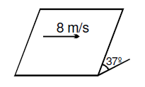
(A) 8 m/s (B) 6 m/s (C) $8\sqrt{2}$ m/s (D) 10 m/s

Hint
Inside the plane, what is the acceleration and in which direction? Compare that direction with the initial velocity.

Think it through
- On the smooth 37° incline the in-plane acceleration is g sin 37° = 6 m/s², down the line of greatest slope.
- The initial velocity is horizontal (along the plane), which is perpendicular to the line of greatest slope.
- After 1 s the particle has gained 6 m/s down the slope while keeping 8 m/s across.
- Speed = √(8² + 6²) = 10 m/s. (D)

Worked solution
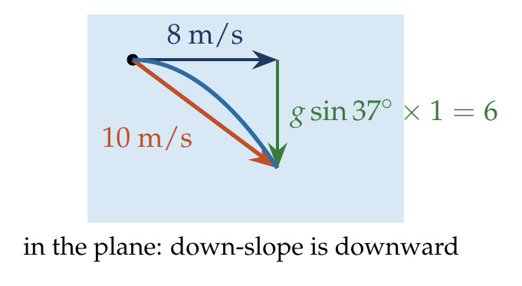
$$a=gsin{37}^{∘}=6 {m/s}^{2} \left(⊥ to the initial velocity\right).$$
$$v=\sqrt{8^{2}+{\left(6×1\right)}^{2}}=10 m/s.$$

Answer
(D) 10 m/s.

Watch out
• The acceleration is g sin θ = 6, not g = 10 (which would give √164).
• The two components are perpendicular: add them by Pythagoras, not as 8 + 6.
Notes: Sec. 7.2 (motion on a smooth inclined plane).

Q64 · Thrown horizontally down a 37° slope [L2]
ID 04MIP-0425-1ca5 · Code 0425 · Worksheet 04MIP_v2 Q64

Problem
A particle is projected horizontally from a long inclined plane down the slope as shown. The inclined plane makes an angle θ = 37° with the horizontal. Find the time taken by the particle to strike the inclined plane?
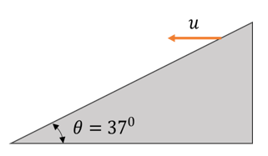
(A) $\frac{3u}{g}$ (B) $\frac{3u}{4g}$ (C) $\frac{3u}{2g}$ (D) $\frac{4u}{3g}$

Hint
The particle lands when its drop and its horizontal distance are in the ratio of the slope. Write both in terms of t.

Think it through
- From the launch point, the slope falls 3 for every 4 across (tan 37° = ¾).
- After time t the particle has moved ut across and fallen ½gt².
- It reaches the slope when ½gt²/(ut) = ¾, so gt/(2u) = ¾ and t = 3u/2g. (C)
- Same result as Q59 run backwards: the particle would have been launched from the landing point at tan⁻¹(2 tan 37°) = tan⁻¹(3/2) to strike horizontally at the top; its vertical speed at landing, 3u/2, takes 3u/2g to build up.

Another way: reversal of Q59
Run the film backwards: the particle leaves the landing point and arrives at the launch point moving horizontally, so the launch point is the top of its path. Then tan(launch angle) = 2 tan 37° = 3/2, the vertical speed is 3u/2, and the time is (3u/2)/g. This is the worksheet hint’s route.

Worked solution
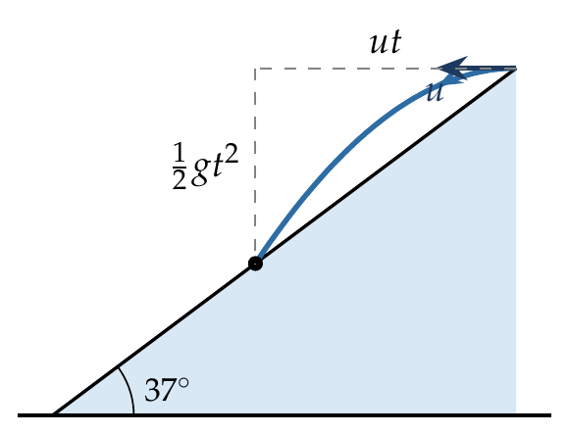
$$tan{37}^{∘}=\frac{\frac{1}{2}gt^{2}}{ut}=\frac{gt}{2u} ⇒ t=\frac{2utan{37}^{∘}}{g}=\frac{2u\left(3/4\right)}{g}=\frac{3u}{2g}.$$

Answer
(C) $\frac{3u}{2g}$.

Watch out
• The ratio is drop : horizontal = tan θ, not cot θ (which gives 8u/3g).
• Do not use g sin θ or g cos θ here: in normal axes, the drop is just ½gt².
Notes: Sec. 9.1 (projected horizontally down an incline).

Q65 · From one surface to another, perpendicular at both ends [L2]
ID 04MIP-0425-3b88 · Code 0425 · Worksheet 04MIP_v2 Q65

Problem
Two surfaces A and B are placed as shown in the figure. A particle is projected perpendicularly from the surface A with a velocity u such that it hits the surface B perpendicularly. Find the time taken by the projectile in terms of u and g?
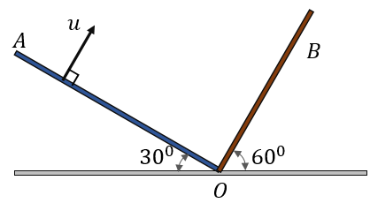
(A) $\frac{2u}{g\sqrt{3}}$ (B) $\frac{u}{g\sqrt{3}}$ (C) $\frac{u}{g\sqrt{2}}$ (D) $\frac{\sqrt{3}u}{g}$

Hint
The two surfaces are at right angles. So the launch direction (perpendicular to A) is parallel to B, and the final direction (perpendicular to B) is parallel to A. Which velocity component must vanish by the end?

Think it through
- A is at 30° and B at 60° on opposite sides of O, so the angle between them is 180° − 30° − 60° = 90°: the surfaces are perpendicular.
- Launched perpendicular to A means launched parallel to OB, with speed u. Hitting B perpendicularly means the final velocity is parallel to AO.
- Take an axis along OB. At the start the whole velocity, u, lies along it. At the end the velocity is perpendicular to it (parallel to AO), so its component along OB is zero.
- Along OB, gravity contributes g sin 60° = √3g/2 against the motion. So that component falls from u to 0 in t = u/(g sin 60°) = 2u/(√3g). (A)
- This is the same as Q43: there too the velocity had to turn perpendicular to its starting direction, with g at 60° to it.

Worked solution
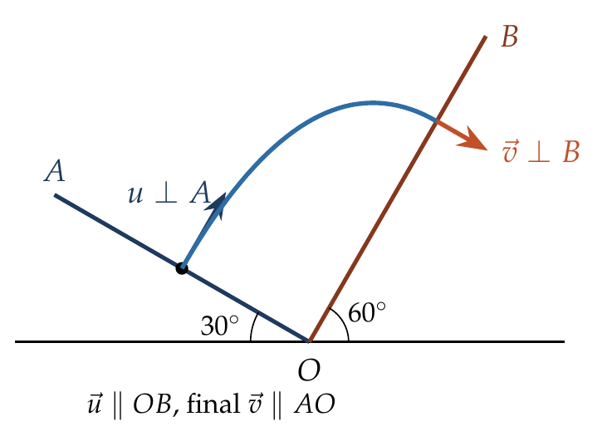
Since $∠AOB={90}^{∘}$, take the $x$-axis along $OB$ and $y$ along $AO$. Then $u_{x}=u$, $u_{y}=0$, and the components of $\vec{g}$ are $a_{x}=−gsin{60}^{∘}$, $a_{y}=−gcos{60}^{∘}$.
Striking B perpendicularly means $v_{x}=0$:
$$u−gsin{60}^{∘} t=0 ⇒ t=\frac{u}{gsin{60}^{∘}}=\frac{2u}{\sqrt{3} g}.$$

Answer
(A) $\frac{2u}{g\sqrt{3}}$.

Watch out
• The worksheet hint writes this as u/(g cos 30°): the same number, since cos 30° = sin 60°.
• Do not set the whole velocity to zero; only its component along OB vanishes.
Notes: Sec. 9.1 (hits another surface perpendicularly); Sec. 8.3 (velocity perpendicular to u).

Relative Motion of Projectiles & Moving Frames

Q66 · Bullet and a block released from a pole
ID 04MIP-0430-6e9c · Code 0430 · Worksheet 04MIP_v2 Q66

Problem
A bullet is fired at a speed of 50 m/s at an angle of $37​^{∘}$ with the horizontal. At the same instant, a wooden block is released from the top of a vertical pole. The bullet strikes the block at a height of 45 m from the ground. What is the horizontal distance of the pole from the point where the bullet was fired?
(A) 120 m (B) 80 m (C) 150 m (D) 90 m

Hint
When does the bullet reach a height of 45 m? Its horizontal speed then gives the distance.

Think it through
- Bullet components: 50 cos 37° = 40 m/s horizontal, 50 sin 37° = 30 m/s vertical.
- Height 45 m: 30t − 5t² = 45, i.e. t² − 6t + 9 = 0, so t = 3 s (a double root: 45 m is the bullet’s maximum height, reached at 3 s).
- Horizontal distance in 3 s: 40 × 3 = 120 m. (A)
- Consistency with the block: both fall under g, so relative to the block the bullet moves in a straight line along its aim. It must be aimed at the block, so the pole top is 120 tan 37° = 90 m high; the block has fallen 45 m in 3 s, to 45 m. ✓

Another way: relative motion
Bullet and block have the same acceleration g, so relative to the block the bullet moves at a steady 50 m/s along its line of aim. It hits only if aimed at the block. After 3 s (from the height condition) each has fallen the same extra ½gt² below its “no-gravity” position, so the meeting is directly where the aim line and the falling block coincide: 40 × 3 = 120 m away.

Worked solution
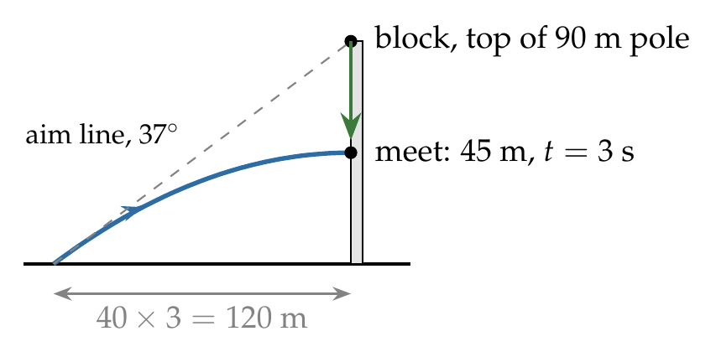
$u_{x}=50cos{37}^{∘}=40$ m/s, $u_{y}=50sin{37}^{∘}=30$ m/s.
$$45=30t−5t^{2} ⇒ t^{2}−6t+9=0 ⇒ t=3 s.$$
$$x=u_{x}t=40×3=120 m.$$

Answer
(A) 120 m.

Watch out
• 45 m is the bullet’s maximum height, so there is only one time, t = 3 s.
• Use the bullet’s horizontal component (40 m/s), not 50 m/s.
Notes: Sec. 10.2 (two bodies under gravity: relative motion uniform).

Q67 · Ball thrown up in an accelerating train
ID 04MIP-0430-4be1 · Code 0430 · Worksheet 04MIP_v2 Q67

Problem
A train is moving with an acceleration of 3 m$s^{−2}.$A ball is projected vertically upwards from the floor with a velocity of 5 m/s. How far from the point of projection will the ball hit the floor?
(A) zero (B) 1.5 m in front (C) 1.5 m behind (D) 0.75 m behind

Hint
Work in the train’s frame. The ball goes up and down as usual, but what extra acceleration does it seem to have along the floor?

Think it through
- Once released, the ball has only g; the train keeps accelerating at 3 m/s² forward. So, relative to the train, the ball has an extra 3 m/s² backward.
- Vertically it goes up at 5 m/s and returns after 2 × 5/10 = 1 s.
- Relative to the train it starts with zero horizontal velocity (it shared the train’s velocity at release) and drifts backward ½ × 3 × 1² = 1.5 m.
- So it lands 1.5 m behind the point of projection. (C)

Another way: ground frame
Let the train’s speed at launch be V. The ball keeps V horizontally for 1 s, covering V × 1. The floor point covers V × 1 + ½ × 3 × 1². The difference is 1.5 m, with the floor ahead: the ball lands 1.5 m behind.

Worked solution
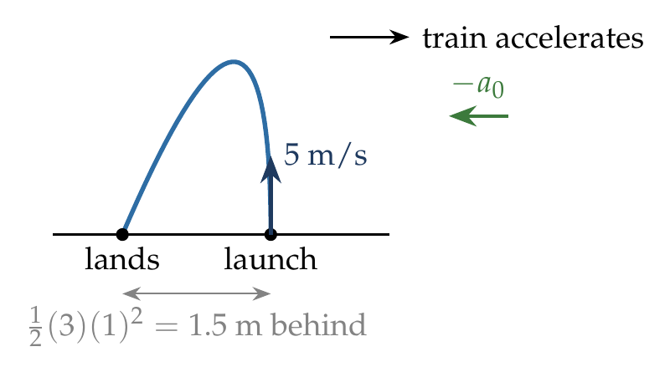
In the train frame: $u_{y}=5$ m/s, $a_{y}=−10$ m/s², $u_{x}=0$, $a_{x}=−3$ m/s² (backward).
$$T=\frac{2u_{y}}{g}=1 s, x=\frac{1}{2}a_{x}T^{2}=−\frac{1}{2}\left(3\right){\left(1\right)}^{2}=−1.5 m.$$

Answer
(C) 1.5 m behind.

Watch out
• The ball does not keep accelerating with the train after release.
• In a train moving at constant velocity it would land at the same spot (option A).
Notes: Sec. 10.3 (train accelerating: ball lands half a0 T squared behind).

Q68 · Two particles colliding after 0.5 s
ID 04MIP-0430-9302 · Code 0430 · Worksheet 04MIP_v2 Q68

Problem
Two particles A and B are projected simultaneously in the directions shown with velocities $V_{A}$ = 20 m/s and $V_{B}$ = 10 m/s respectively. If they collide in air after 0.5 s, then the angle θ and distance x respectively are:
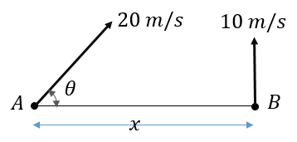
(A) 30° and $10\sqrt{3}$ (B) 60° and $5\sqrt{3}$ (C) 30° and $5\sqrt{2}$ (D) 30° and $5\sqrt{3}$

Hint
Both particles fall with the same g, so relative to each other they move in straight lines at constant velocity. For B to be hit, which way must A’s velocity relative to B point?

Think it through
- Both have acceleration g, so their relative motion is uniform and straight.
- They start on the same level, a distance x apart. To meet, A’s velocity relative to B must point along AB, i.e. horizontally. So the vertical components must be equal: 20 sin θ = 10, θ = 30°.
- The relative velocity is then purely horizontal: 20 cos 30° − 0 = 10√3 m/s.
- In 0.5 s it closes x = 10√3 × 0.5 = 5√3 m. (D)

Worked solution
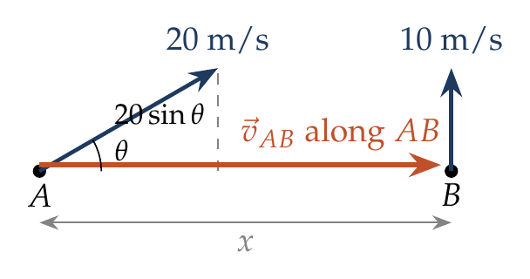
Collision condition (equal vertical components): $20sinθ=10⇒θ={30}^{∘}$.
$$v_{AB}=20cos{30}^{∘}=10\sqrt{3} m/s, x=v_{AB} t=10\sqrt{3}×0.5=5\sqrt{3} m.$$

Answer
(D) 30° and $5\sqrt{3}$ m.

Watch out
• Gravity drops out of the relative motion; do not add ½gt² to either particle when comparing them.
• (A) 10√3 is the relative speed, not the distance covered in 0.5 s.
Notes: Sec. 10.2 (collision test: equal vertical components).

Q69 · When do A and B collide?
ID 04MIP-0430-7369 · Code 0430 · Worksheet 04MIP_v2 Q69

Problem
Two particles A and B are projected simultaneously as shown in the figure: A with a speed of 20 m/s at an angle θ with the horizontal, and B vertically upward with a speed of 10 m/s. The horizontal distance between them is x = 10 m. If the particles collide in air, how many seconds after projection does the collision occur?
(A) 1 s (B) 0.5 s (C) $\sqrt{3}$ s (D) $\frac{1}{\sqrt{3}}$ s

Hint
Since they do collide, what must be true of their vertical components? That fixes θ, and then the closing speed.

Think it through
- Both fall under g, so relative motion is uniform and straight. A collision means A’s velocity relative to B is along the horizontal line AB.
- So the vertical components match: 20 sin θ = 10, θ = 30°.
- Closing speed = A’s horizontal component = 20 cos 30° = 10√3 m/s.
- Time = 10/(10√3) = 1/√3 s ≈ 0.58 s. (D)
- Check: in that time each rises 10/√3 − 5/3 ≈ 4.1 m, so they meet in the air, as required.

Worked solution
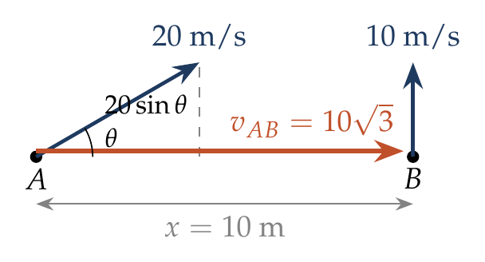
$$20sinθ=10 ⇒ θ={30}^{∘}, t=\frac{x}{20cos{30}^{∘}}=\frac{10}{10\sqrt{3}}=\frac{1}{\sqrt{3}} s.$$

Answer
(D) $\frac{1}{\sqrt{3}}$ s.

Watch out
• (B) 0.5 s uses the full 20 m/s as the closing speed; only the horizontal part closes the gap.
• “Collide in air” is a condition, not extra data: it forces the equal vertical components.
Notes: Sec. 10.2 (collision test: t = separation over relative speed).

Q70 · Colliding at C just before landing
ID 04MIP-0430-1efd · Code 0430 · Worksheet 04MIP_v2 Q70

Problem
Two particles are projected simultaneously as shown with B being vertically above A. What should be height of projection of particle B, if the two particles collide at C (just before they hit the ground).
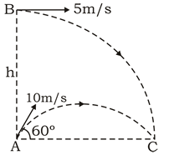

Hint
Compare the two horizontal velocities. What does that tell you about where B is relative to A at every instant?

Think it through
- A: 10 m/s at 60°, so horizontal 5 m/s and vertical 5√3 m/s. B: 5 m/s horizontal from height h.
- Both have the same horizontal velocity, 5 m/s, so B stays directly above A all the time. They collide when the vertical gap closes.
- Relative to A, B moves straight down at 5√3 m/s (gravity cancels in the relative motion).
- They meet at C, where A lands: A’s time of flight is 2 × 5√3/10 = √3 s. So h = 5√3 × √3 = 15 m.
- Check: B falls 15 m from rest vertically in √3 s: ½ × 10 × 3 = 15 m. ✓

Another way: B alone
B must reach the ground at C at the same instant as A, after A’s flight time √3 s. Thrown horizontally, B falls ½gt² = ½ × 10 × 3 = 15 m in that time, so h = 15 m.

Worked solution
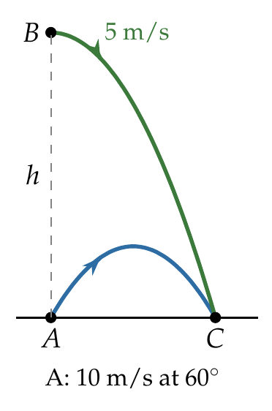
A: $u_{x}=10cos{60}^{∘}=5$ m/s, $u_{y}=10sin{60}^{∘}=5\sqrt{3}$ m/s, time of flight $T=\frac{2u_{y}}{g}=\sqrt{3}$ s.
B is thrown horizontally at 5 m/s, so it stays vertically above A. It must reach C at time $T$:
$$h=\frac{1}{2}gT^{2}=\frac{1}{2}\left(10\right)\left(3\right)=15 m.$$

Answer
h = 15 m.

Watch out
• The collision at C is at ground level, so B must fall the whole h in A’s time of flight.
• Equal horizontal velocities are what make B stay above A; check them first.
Notes: Sec. 10.2 (two bodies under gravity: relative motion uniform).

Q71 · Anti-aircraft gun and a fighter plane
ID 04MIP-0430-f77f · Code 0430 · Worksheet 04MIP_v2 Q71

Problem
A fighter plane flying horizontally at an altitude of 1.5 km with speed of 720 km/h passes directly overhead an antiaircraft gun. At what angle from the vertical should the gun be fired for the shell with muzzle speed 400 m/s to hit the plane? What should be the minimum muzzle speed for gun to strike the fighter plane when it is vertically above?

Hint
Seen from the plane, the shell must rise straight up to it. What must the shell’s horizontal component be? For the minimum speed, what is the least vertical component that still reaches 1.5 km?

Think it through
- 720 km/h = 200 m/s. To hit the plane, the shell must keep pace with it horizontally (relative to the plane it then rises straight up): horizontal component 200 m/s.
- With muzzle speed 400 m/s: sin(angle from vertical) = 200/400 = ½, so the gun points 30° from the vertical, towards the plane’s direction of motion.
- Its vertical component is 400 cos 30° ≈ 346 m/s, which can reach up to 346²/20 ≈ 6 km, enough for 1.5 km.
- Minimum speed: the vertical component must at least reach 1.5 km: u_y² = 2 × 10 × 1500 = 30 000. With u_x = 200 m/s still needed, u² = 40 000 + 30 000 = 70 000, so u = 100√7 ≈ 265 m/s.

Worked solution
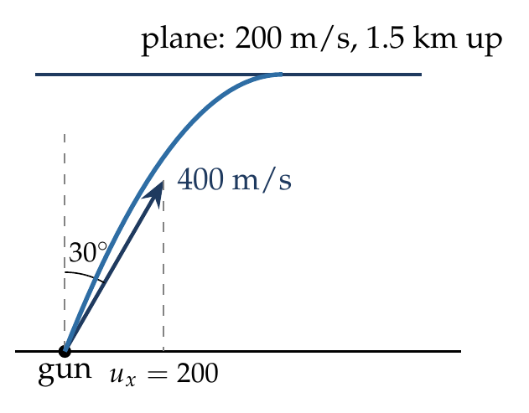
$v_{p}=720×\frac{5}{18}=200$ m/s. Horizontal match: $usinθ=200$, with θ from the vertical.
$$sinθ=\frac{200}{400}=\frac{1}{2} ⇒ θ={30}^{∘} from the vertical.$$
For the least muzzle speed, the shell just reaches 1500 m (vertical velocity zero there):
$$u_{y}^{2}=2gh=2\left(10\right)\left(1500\right)=3×{10}^{4}, u_{min}=\sqrt{{200}^{2}+3×{10}^{4}}=100\sqrt{7}≈265 m/s.$$

Answer
30° from the vertical (tilted towards the plane’s motion); minimum muzzle speed $100\sqrt{7}$ ≈ 265 m/s.

Watch out
• The angle is from the vertical, so use sin θ = 200/400, giving 30°, not 60°.
• The minimum speed still needs the 200 m/s horizontal component; √(2gh) ≈ 173 m/s alone is not enough.
Notes: Sec. 10.2 (collision test: relative velocity along the line joining).

Q72 · Relative position of two stones thrown up from a cliff
ID 04MIP-0430-7e8a · Code 0430 · Worksheet 04MIP_v2 Q72

Problem
Two stones are thrown up simultaneously from the edge of a cliff 240 m high with initial speed of 10 m/s and 40 m/s respectively. Which of the following graph best represents the time variation of relative position of the second stone with respect to the first? (Assume stones do not rebound after hitting the ground and neglect air resistance.) (The figures are schematic and not drawn to scale.)
Option (A):
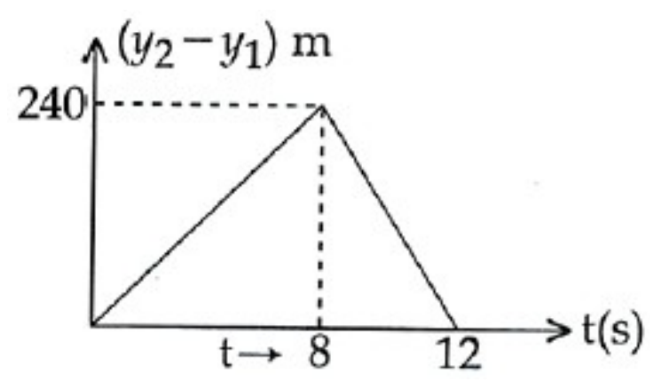
Option (B):
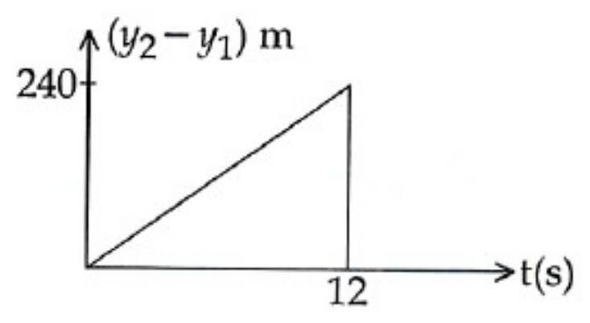
Option (C):
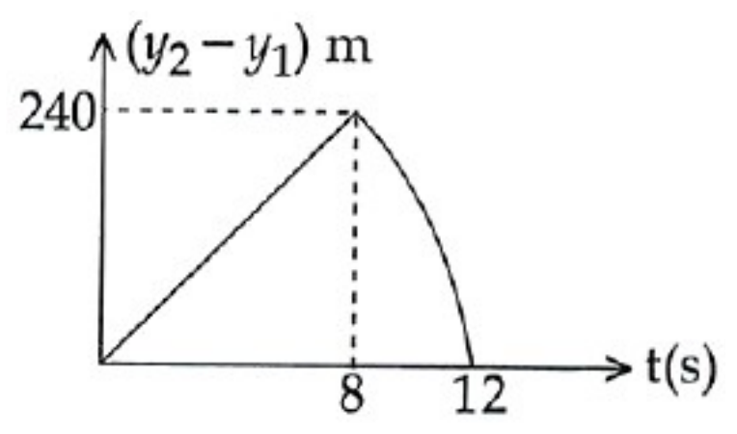
Option (D):
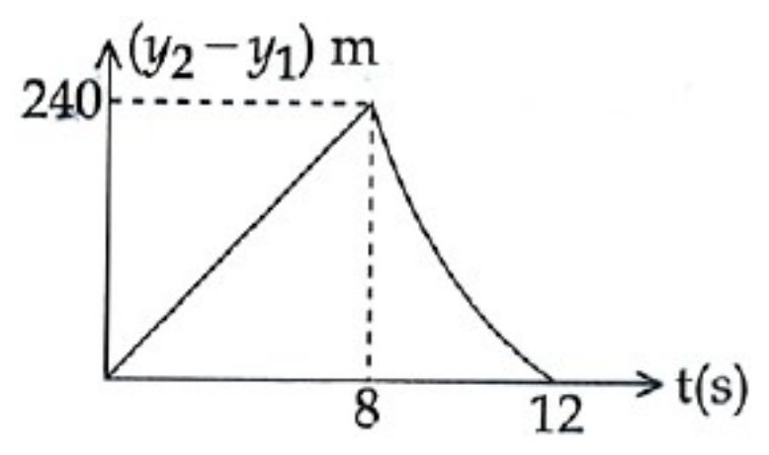

Hint
While both stones are in the air, what is their relative acceleration? Then ask what changes once the first stone has landed.

Think it through
- While both are in flight they have the same acceleration g, so the relative position grows uniformly: y₂ − y₁ = (40 − 10)t = 30t, a straight line.
- Stone 1 (10 m/s) lands when 10t − 5t² = −240, at t = 8 s. Then y₂ − y₁ = 240 m. So the straight line rises to 240 at 8 s.
- After that stone 1 is at rest on the ground, and y₂ − y₁ is just stone 2’s height above the ground: 240 + 40t − 5t². That is a parabola, concave down (stone 2 is accelerating downward), reaching 0 when stone 2 lands at t = 12 s.
- Straight to (8, 240), then a downward-curving arc steepening to 0 at 12 s: graph (C).
- Why not (D): (D) curves the other way (concave up), which would need an upward acceleration.

Why the other options are there
(A) continues with a straight line after 8 s, as if stone 2 kept a constant velocity. (B) drops vertically at 12 s, as if stone 1 had stayed in the air until then. (D) bends the wrong way: after 8 s the curve must be concave down, since stone 2 accelerates downward.

Worked solution
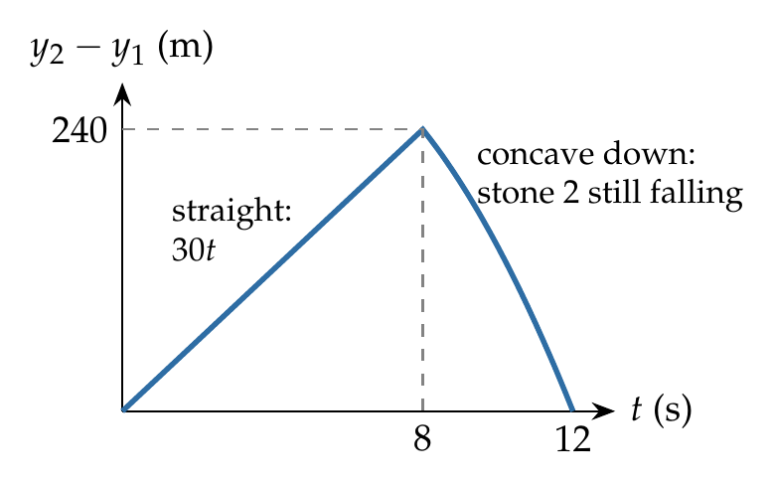
While both are in flight, ${\vec{a}}_{21}=0$, so $y_{2}−y_{1}=\left(40−10\right)t=30t$.
Stone 1 lands when $10t−5t^{2}=−240$, i.e. $t^{2}−2t−48=0$, $t=8$ s; then $y_{2}−y_{1}=240$ m.
Stone 2 lands when $40t−5t^{2}=−240$, i.e. $t^{2}−8t−48=0$, $t=12$ s.
For $8≤t≤12$ s: $y_{2}−y_{1}=240+40t−5t^{2}$, with $\frac{d^{2}}{dt^{2}}\left(y_{2}−y_{1}\right)=−10<0$ (concave down), falling to 0 at 12 s.

Answer
(C).

Watch out
• Relative motion is uniform only while both bodies are in flight; once one lands, its acceleration is no longer g.
• Concave down, not up: after 8 s the slope becomes steadily more negative.
Notes: Sec. 10.2 (two bodies under gravity: relative motion uniform); Sec. 6.1 (reading shapes).

Q73 · Two projectiles on an incline, launched towards each other
ID 04MIP-0430-ce89 · Code 0430 · Worksheet 04MIP_v2 Q73

Problem
Two projectiles are projected at an angle α from two points on a plane inclined at an angle θ with the horizontal as shown. Which of the statements are correct:
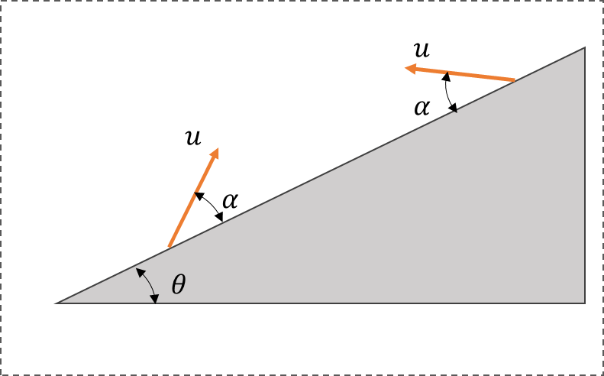
(A) The particles will collide in mid-air
(B) The time of flight for each particle is same.
(C) Both particles will strike the plane perpendicularly
(D) The range of projectiles measured along the inclined surface is same.

Hint
Use axes along and perpendicular to the incline. Which component of each launch velocity, and which component of g, decides the time of flight?

Think it through
- Take x along the incline and y perpendicular to it. Each particle is launched at α to the plane with speed u (the figure shows the same u), so each has u sin α perpendicular to the plane.
- Perpendicular to the plane both have acceleration g cos θ back towards it. So both return to the plane after 2u sin α/(g cos θ): (B) is true.

  - is false: one particle goes up the slope (slowed by g sin θ along it) and the other down (speeded by it), so their ranges differ.

  - is false in general: striking perpendicularly needs the special condition cot α = 2 tan θ, and it cannot hold for both directions at once.

  - is not guaranteed. The two stay at equal heights above the plane and close the gap along it at 2u cos α, so they meet only if the gap is short enough to close before they land. So the statement that is always correct is (B).

Worked solution
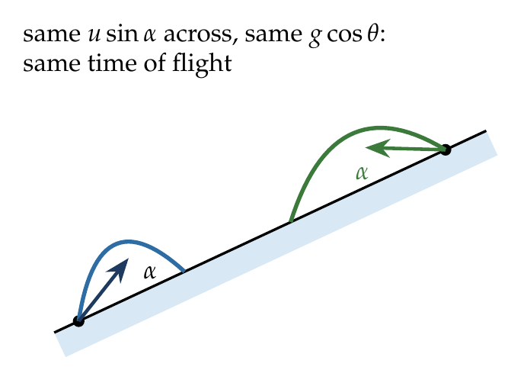
With $x$ along the incline and $y$ perpendicular to it, each particle has $u_{y}=usinα$ and $a_{y}=−gcosθ$:
$$T=\frac{2usinα}{gcosθ} for both.$$
Along the incline the accelerations are both $−gsinθ$ (down the slope), but one particle moves up the slope and the other down, so
$$R_{up}=\frac{2u^{2}sinαcos\left(α+θ\right)}{g\cos^{2}θ}≠R_{down}=\frac{2u^{2}sinαcos\left(α−θ\right)}{g\cos^{2}θ}.$$

Answer
(B) The time of flight is the same for both.

Watch out
• Time of flight on an incline depends only on the perpendicular components: u sin α and g cos θ.
• Their relative velocity is along the plane, so they could meet in mid-air, but only if they start close enough; the figure gives no distance.
Notes: Sec. 9 (time of flight: only the perpendicular component matters).

Q74 · Gun on a moving trolley
ID 04MIP-0430-55a2 · Code 0430 · Worksheet 04MIP_v2 Q74

Problem
An artillery gun is mounted on a trolley moving with a speed of 10 m/s. The gun can fire shells at a speed of 50 m/s. It is placed with its barrel making an angle of 53° with the horizontal. If a shell is fired then what will be its range as observed from the ground?
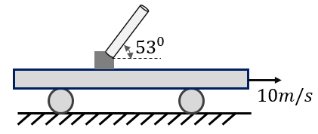
(A) 240 m (B) 280 m (C) 300 m (D) 320 m

Hint
50 m/s at 53° is the velocity relative to the gun. Add the trolley’s velocity to get the shell’s velocity relative to the ground; which component does the trolley change?

Think it through
- The shell leaves the barrel at 50 m/s along it (53°), relative to the trolley: 30 m/s horizontal, 40 m/s vertical.
- Relative to the ground, add the trolley’s 10 m/s forward: 40 m/s horizontal, 40 m/s vertical.
- Time of flight depends on the vertical part only: 2 × 40/10 = 8 s.
- Ground range = 40 × 8 = 320 m. (D)
- Check: from a stationary gun the range would be 2 × 30 × 40/10 = 240 m (option A); the moving trolley adds 10 × 8 = 80 m.

Worked solution
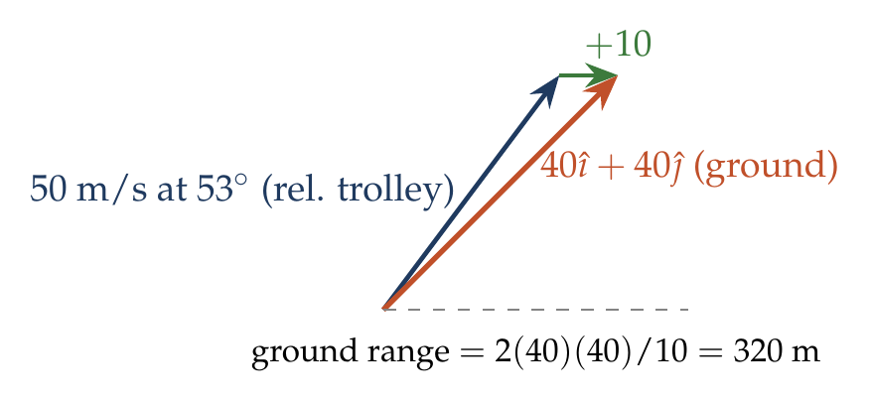
$${\vec{v}}_{shell, ground}={\vec{v}}_{shell, trolley}+{\vec{v}}_{trolley}=\left(30\hat{ı}+40\hat{ȷ}\right)+10\hat{ı}=40\hat{ı}+40\hat{ȷ} m/s.$$
$$R=\frac{2u_{x}u_{y}}{g}=\frac{2\left(40\right)\left(40\right)}{10}=320 m.$$

Answer
(D) 320 m.

Watch out
• The trolley changes only the horizontal component; the time of flight is unchanged (8 s).
• (A) 240 m ignores the trolley’s velocity.
Notes: Sec. 10.1 (firing from a moving platform).

Q75 · Toy gun in an upward-accelerating lift
ID 04MIP-0430-d86c · Code 0430 · Worksheet 04MIP_v2 Q75

Problem
A toy gun fires a plastic bullet at a speed of 10 m/s. It is placed in a high lift at an angle of $30​^{∘}$ with the horizontal. The lift is moving with constant upwards acceleration of 2 m$s^{−2}$. Find the time of flight of the plastic bullet fired by the gun?
(A) 1 sec (B) 6/5 sec (C) 5/6 sec (D) $\sqrt{3}/2$ sec

Hint
In the lift’s frame, what is the effective gravity? Then it is an ordinary projectile.

Think it through
- In the frame of a lift accelerating up at 2 m/s², every free body seems to have a downward acceleration g + a = 12 m/s².
- Relative to the lift the bullet leaves at 10 m/s at 30°, so its vertical component is 5 m/s.
- Time of flight (back to the floor level of the gun) = 2 × 5/12 = 5/6 s. (C)
- Check: in a lift at rest it would be 1 s (option A); the upward acceleration of the lift shortens it.

Worked solution
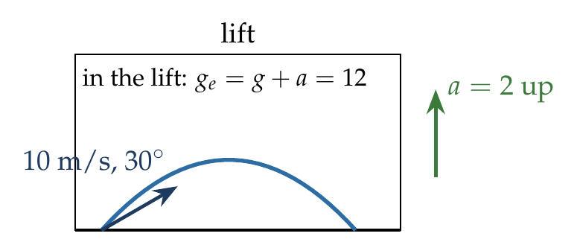
$$g_{e}=g+a=12 {m/s}^{2}, T=\frac{2usin{30}^{∘}}{g_{e}}=\frac{2\left(10\right)\left(0.5\right)}{12}=\frac{5}{6} s.$$

Answer
(C) 5/6 s.

Watch out
• An upward-accelerating lift increases the effective g (to g + a), not decreases it.
• The lift’s velocity is irrelevant; only its acceleration matters.
Notes: Sec. 10.3 (lift accelerating up: effective gravity g + a).

Q76 · Bullet through a moving rail coach
ID 04MIP-0430-df98 · Code 0430 · Worksheet 04MIP_v2 Q76

Problem
A rail coach is moving with a constant velocity of v m/s. Its length is 15 m, height 5 m, and width 3 m. A small bullet moving horizontally and perpendicular to the direction of coach motion with speed u enters through its top corner and then finally hits the diagonally opposite corner. Find value of v and u?
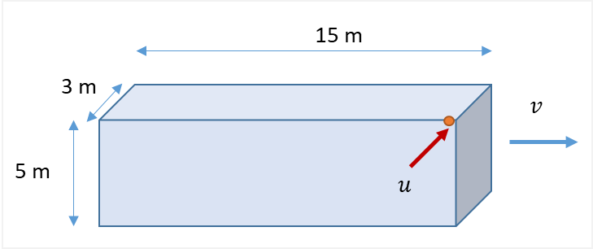

Hint
Work in the coach’s frame. How long does the bullet take to fall 5 m? In that time it must cross the width and also travel the whole length of the coach relative to the coach.

Think it through
- The bullet moves horizontally at u across the track and has no velocity along the track (relative to the ground).
- From the top corner to the diagonally opposite bottom corner, it must drop 5 m, cross 3 m, and shift 15 m along the coach.
- Dropping 5 m from zero vertical velocity takes 1 s.
- Across: 3 m in 1 s gives u = 3 m/s.
- Along: in the coach’s frame the bullet moves backward at v (the coach moves forward under it). Covering 15 m in 1 s gives v = 15 m/s.

Worked solution
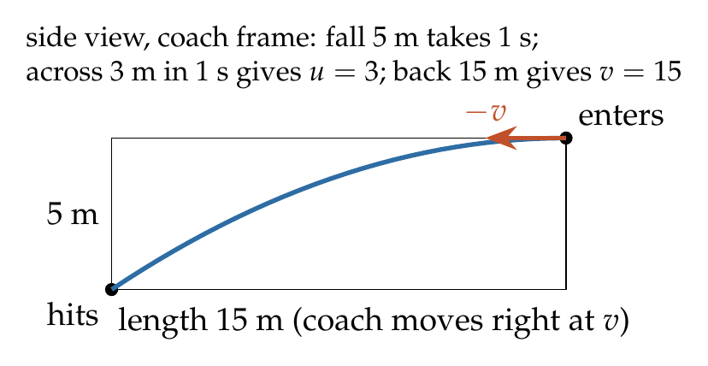
Fall of 5 m: $5=\frac{1}{2}\left(10\right)t^{2}⇒t=1$ s.
In the coach frame the bullet has velocity $u$ across the coach and $−v$ along it:
$$u=\frac{3}{1}=3 m/s, v=\frac{15}{1}=15 m/s.$$

Answer
v = 15 m/s and u = 3 m/s.

Watch out
• The bullet has no velocity along the track; its apparent motion along the coach is entirely due to the coach moving.
• All three displacements happen in the same 1 s fall time.
Notes: Sec. 10.1 (velocity on a moving surface: same rule for a moving coach).

Q77 · Gum balls dropped from an accelerating train [L2]
ID 04MIP-0430-d4f4 · Code 0430 · Worksheet 04MIP_v2 Q77

Problem
A boy is sitting in a train which starts accelerating at $2 ms^{−2}$ at t = 0. The boy drops a gum ball every second, starting from t =0, from the window at the height of 0.8 m. The gum balls stick to the ground at the point of impact. Find the distance between the first and the second ball on the ground?
(A) 1 m (B) 0.8 m (C) 1.2 m (D) 1.8 m

Hint
At the instant each ball is let go, it has the train’s velocity at that instant, and from then on only g. Where is the train, and how fast is it going, when the second ball is dropped?

Think it through
- Each ball falls 0.8 m, taking √(2 × 0.8/10) = 0.4 s.
- Ball 1 is dropped at t = 0 with the train at rest, so it lands directly below the drop point: x = 0.
- Ball 2 is dropped at t = 1 s. The train has then moved ½ × 2 × 1² = 1 m and is moving at 2 m/s.
- Ball 2 keeps 2 m/s horizontally while falling for 0.4 s: 0.8 m more. It lands at 1 + 0.8 = 1.8 m.
- Distance between the balls on the ground = 1.8 m. (D)

Worked solution
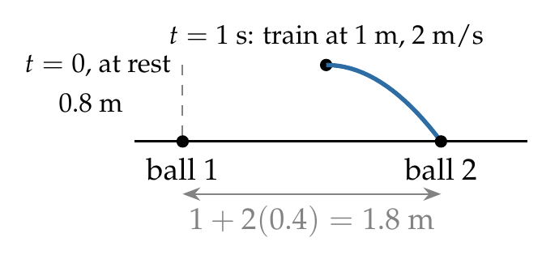
Fall time: $t_{f}=\sqrt{2\left(0.8\right)/10}=0.4$ s.
Ball 1: dropped at rest from $x=0$, lands at $x_{1}=0$.
Ball 2: dropped at $t=1$ s from $x=\frac{1}{2}\left(2\right){\left(1\right)}^{2}=1$ m with $v=2\left(1\right)=2$ m/s:
$$x_{2}=1+2\left(0.4\right)=1.8 m, x_{2}−x_{1}=1.8 m.$$

Answer
(D) 1.8 m.

Watch out
• After release, the ball does not share the train’s acceleration: it keeps the velocity it had (2 m/s).
• (A) 1 m forgets the forward drift during the fall; (B) 0.8 m forgets the train’s 1 m.
Notes: Sec. 10.3 (released from an accelerating carrier: keeps its velocity, not its acceleration).

Q78 · Bullet fired sideways from a moving train [L2]
ID 04MIP-0430-a852 · Code 0430 · Worksheet 04MIP_v2 Q78

Problem
A boy is travelling in a train moving at 10 m/s towards north. He holds a toy gun horizontally at a height of 0.8 m above the ground directed towards east. If he shoots a bullet at a speed of 5 m/s, then what will be its speed when it hits the ground?
(A) 15 m/s (B) $\sqrt{116} m/s$ (C) $\sqrt{141} m/s$ (D) $\sqrt{156} m/s$

Hint
Relative to the ground, the bullet has the train’s velocity plus its own. What vertical velocity does it gain in falling 0.8 m?

Think it through
- Take x east, y north, z up. Relative to the ground the bullet starts with 5 m/s east (from the gun) and 10 m/s north (from the train).
- Neither horizontal component changes in flight.
- Falling 0.8 m from zero vertical velocity gives v_z² = 2 × 10 × 0.8 = 16, v_z = 4 m/s downward.
- Speed = √(5² + 10² + 4²) = √141 ≈ 11.9 m/s. (C)

Worked solution
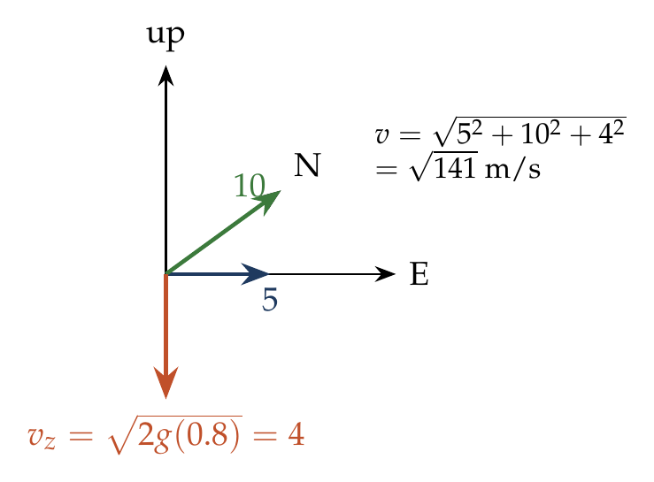
$$\vec{v}=5\hat{ı}+10\hat{ȷ}−\sqrt{2gh} \hat{k}=5\hat{ı}+10\hat{ȷ}−4\hat{k} m/s.$$
$$\left|\vec{v}\right|=\sqrt{25+100+16}=\sqrt{141} m/s.$$

Answer
(C) $\sqrt{141}$ m/s.

Watch out
• (B) √116 = √(100 + 16) forgets the gun’s 5 m/s; all three components count.
• 15 m/s adds the speeds as if parallel.
Notes: Sec. 10.1 (velocity on a moving surface).

Relative Velocity in 2D: Rain, Wind & Closest Approach

Q79 · Heading to fly due north in a west wind
ID 04MIP-0435-b385 · Code 0435 · Worksheet 04MIP_v2 Q79

Problem
Airport Y is 400 km N of airport X. Wind blows from West at 60 km/h. Aircraft can maintain a speed of 500 km/h in still air. With respect to North at what angle the pilot should direct the aircraft so as to reach airport Y from X?
(A) $\cos^{−1}\frac{3}{25}$ (B) $\sin^{−1}\frac{4}{25}$ (C) $\tan^{−1}\frac{3}{\sqrt{616}}$ (D) $\tan^{−1}\frac{3}{25}$

Hint
The ground track must be due north. Which part of the plane’s own velocity has to cancel the wind?

Think it through
- The wind blows from the west, i.e. towards the east at 60 km/h.
- To travel due north, the plane’s velocity relative to the air must have a westward part that cancels the 60 km/h east wind.
- With an air speed of 500 km/h, the heading θ west of north has sin θ = 60/500 = 3/25.
- Then cos θ = √(625 − 9)/25 = √616/25, so tan θ = 3/√616. (C)
- Check against the options: (B) sin⁻¹(4/25) has the wrong number; (D) tan⁻¹(3/25) uses the sine ratio as a tangent.

Worked solution
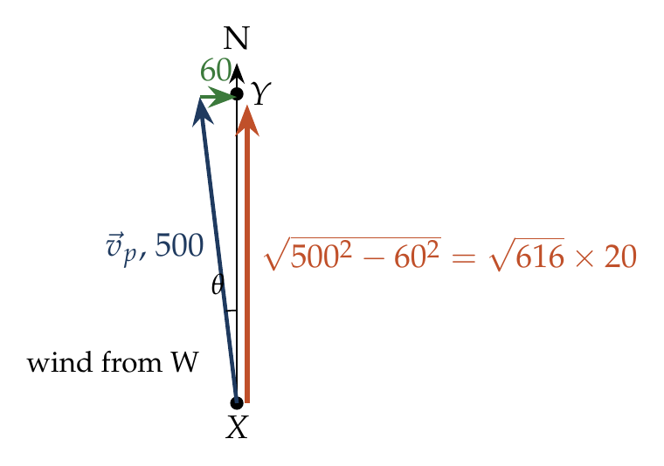
Let the heading be θ west of north. For the resultant to point north:
$$500sinθ=60 ⇒ sinθ=\frac{3}{25}, tanθ=\frac{3}{\sqrt{{25}^{2}−3^{2}}}=\frac{3}{\sqrt{616}}.$$
Ground speed $=500cosθ=20\sqrt{616}≈496$ km/h (not needed).

Answer
(C) $\tan^{−1}\frac{3}{\sqrt{616}}$ (west of north), i.e. $\sin^{−1}\left(3/25\right)$.

Watch out
• “Wind from the west” blows towards the east, so the plane heads slightly west.
• sin θ = 3/25, not tan θ = 3/25: the 500 km/h is the hypotenuse.
Notes: Sec. 11 (aeroplane and wind: cancel the cross-wind).

Q80 · Flying round a square in a steady east wind
ID 04MIP-0435-e202 · Code 0435 · Worksheet 04MIP_v2 Q80

Problem
An airplane can travel at a speed of 100 m/s in still air. There is steady wind of 60 m/s towards East. The airplane travels along the sides of a square of side 16 km which are along N-S and E-W direction. Find the time taken to complete one round of the square?
(A) 640 s (B) 800 sec (C) 400$\sqrt{2}$ sec (D) 900 sec

Hint
Treat the four sides separately. On which sides does the wind simply add or subtract, and on which must the plane head into it at an angle?

Think it through
- Air speed 100 m/s, wind 60 m/s towards the east. Side = 16 km.
- Eastward leg: speeds add, 160 m/s: 16 000/160 = 100 s. Westward leg: 40 m/s: 400 s.
- North and south legs: the plane must cancel the 60 m/s cross-wind, leaving √(100² − 60²) = 80 m/s along the side: 200 s each.
- Total: 100 + 400 + 200 + 200 = 900 s. (D)
- Check: in still air it would take 4 × 160 = 640 s (option A). Wind always lengthens a round trip.

Worked solution
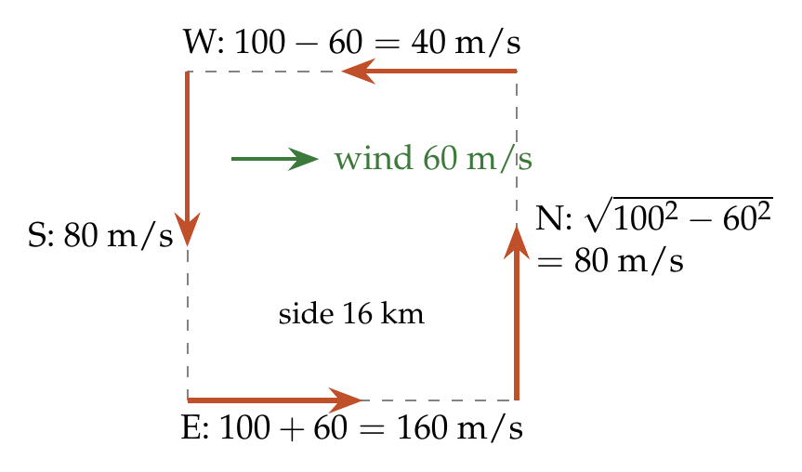
$$t_{E}=\frac{16000}{100+60}=100 s, t_{W}=\frac{16000}{100−60}=400 s,$$
$$t_{N}=t_{S}=\frac{16000}{\sqrt{{100}^{2}−{60}^{2}}}=\frac{16000}{80}=200 s each.$$
$$T=100+400+200+200=900 s.$$

Answer
(D) 900 s.

Watch out
• On the N and S legs the ground speed is 80 m/s, not 100 m/s.
• 640 s is the still-air time; the wind’s gains on one leg never make up for the losses.
Notes: Sec. 11 (aeroplane and wind; round trip along the river).

Q81 · Butterfly in a north-to-south breeze [JEE Main 2021, 20 Jul, Shift 1]
ID 04MIP-0435-6f9c · Code 0435 · Worksheet 04MIP_v2 Q81

Problem
A butterfly is flying with a velocity $4\sqrt{2}$ m/s in north-east direction. Wind is slowly blowing at 1 m/s from North to South. The resultant displacement of the butterfly in 3 s is:
(A) 3 m (B) 20 m (C) $12\sqrt{2}$ m (D) 15 m

Hint
Write the butterfly’s own velocity and the wind as vectors and add them.

Think it through
- 4√2 m/s towards the north-east has components 4 east and 4 north.
- Wind from north to south: 1 m/s south, i.e. −1 north.
- Resultant: 4 east, 3 north, speed 5 m/s.
- In 3 s: 15 m. (D)

Worked solution
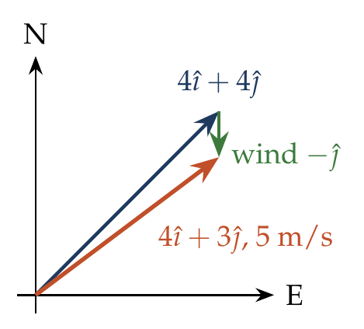
$$\vec{v}=\left(4\hat{ı}+4\hat{ȷ}\right)+\left(−\hat{ȷ}\right)=4\hat{ı}+3\hat{ȷ}, \left|\vec{v}\right|=5 m/s.$$
$$s=5×3=15 m.$$

Answer
(D) 15 m.

Watch out
• “From north to south” means the wind blows towards the south.
• $12\sqrt{2}$ m ignores the wind.
Notes: Sec. 10.1 (velocity on a moving medium: vector sum).

Q82 · Wind seen by a walking woman at two speeds
ID 04MIP-0435-19cf · Code 0435 · Worksheet 04MIP_v2 Q82

Problem
A woman travelling N at 10 km/h finds that wind appears to blow from West. When woman trebles her speed, the wind appears to blow from NW. Find the velocity of the wind. Assume $\hat{i}$along east and $\hat{j}$ along north.
(A) $20\hat{i}+10\hat{j}$ (B) $−20\hat{i}+10\hat{j}$ (C) $10\hat{i}+10\hat{j}$ (D) $20\hat{i}−10\hat{j}$

Hint
Write the wind as $p\hat{ı}+q\hat{ȷ}$. Each observation tells you the direction of (wind − woman’s velocity). Which component does each observation fix?

Think it through
- Let the wind be p î + q ĵ. Walking north at 10, the apparent wind is p î + (q − 10) ĵ.
- It seems to come from the west, i.e. it blows purely towards the east: q − 10 = 0, so q = 10, and p > 0.
- At 30 km/h north, the apparent wind is p î + (10 − 30) ĵ = p î − 20 ĵ.
- From the north-west means blowing towards the south-east, equal east and south parts: p = 20.
- So the wind is 20 î + 10 ĵ km/h. (A)

Worked solution
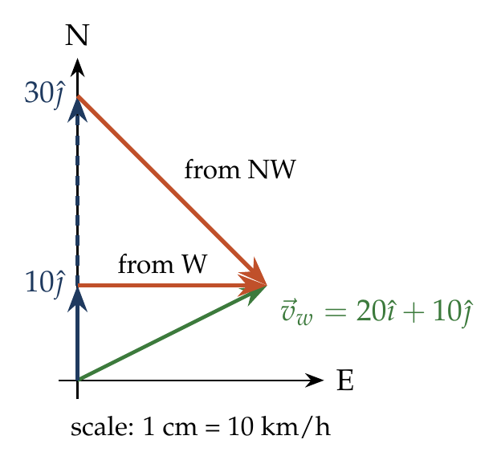
Let ${\vec{v}}_{w}=p\hat{ı}+q\hat{ȷ}$.
(i) ${\vec{v}}_{w}−10\hat{ȷ}=p\hat{ı}+\left(q−10\right)\hat{ȷ}$ points east $⇒q=10$.
(ii) ${\vec{v}}_{w}−30\hat{ȷ}=p\hat{ı}−20\hat{ȷ}$ points south-east $⇒p=20$.
$${\vec{v}}_{w}=20\hat{ı}+10\hat{ȷ} km/h.$$

Answer
(A) $20\hat{ı}+10\hat{ȷ}$ km/h.

Watch out
• “From the west” is the direction the wind comes from; it blows towards the east.
• The apparent wind is wind minus observer, not wind plus observer.
Notes: Sec. 12 (C: two observations, unknown velocity; wind–man problems).

Q83 · Umbrella at 53° for a man walking at 4 km/h
ID 04MIP-0435-5c33 · Code 0435 · Worksheet 04MIP_v2 Q83

Problem
A man at rest observes the rain falling vertically. When he walks at 4 km/h, he has to hold his umbrella at an angle of 53° from the vertical. What is the velocity of raindrops?
(A) 5 km/h (B) 4$\sqrt{3}$ km/h (C) 4 km/h (D) 3 km/h

Hint
Draw the rain’s velocity relative to the man: the real rain velocity plus the reverse of his. The umbrella lies along that relative velocity.

Think it through
- The rain falls vertically (he sees it vertical when at rest). Walking at 4 km/h, he sees the rain coming at him with an extra 4 km/h towards him horizontally.
- He holds the umbrella along the apparent direction: tan 53° = 4/v_R.
- tan 53° = 4/3, so v_R = 3 km/h. (D)
- Check: the apparent rain speed is then 5 km/h, the hypotenuse of a 3-4-5 triangle.

Worked solution
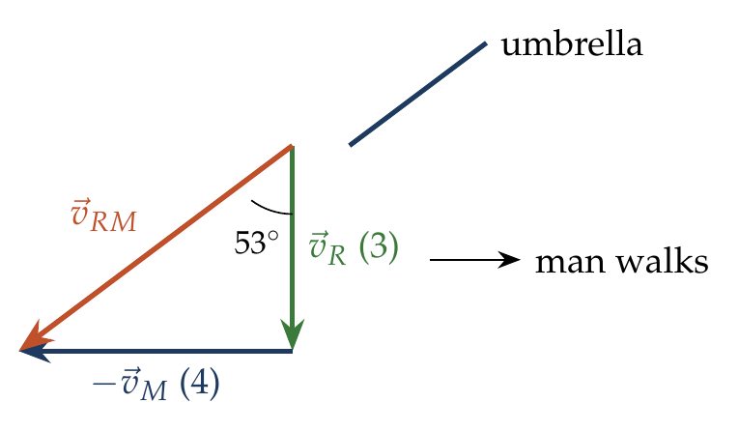
$${\vec{v}}_{RM}={\vec{v}}_{R}−{\vec{v}}_{M}, tan{53}^{∘}=\frac{v_{M}}{v_{R}}=\frac{4}{v_{R}} ⇒ v_{R}=\frac{4}{4/3}=3 km/h.$$

Answer
(D) 3 km/h.

Watch out
• The 53° is from the vertical: tan 53° = horizontal/vertical = 4/v_R.
• (A) 5 km/h is the apparent rain speed, not the real one.
Notes: Sec. 12 (B: rain falls vertically: tan α = vM/vR).

Q84 · Rain that looks vertical at 3 km/h
ID 04MIP-0435-209c · Code 0435 · Worksheet 04MIP_v2 Q84

Problem
To a man walking at the rate of 3 km/h, the rain appears to fall vertically. When he increases his speed to 6 km/h it appears to meet him at an angle of 45° with the vertical. What is the speed of the rain?

Hint
If the rain looks vertical when he walks at 3 km/h, what is the rain’s own horizontal component? Then use the second observation for the vertical one.

Think it through
- Rain appears vertical at 3 km/h, so the rain’s horizontal component equals his speed: 3 km/h, in his direction of walking.
- At 6 km/h, the apparent horizontal part is 3 − 6 = −3 km/h (towards him), and the vertical part is the rain’s own v_y.
- 45° with the vertical means equal parts: v_y = 3 km/h.
- Rain speed = √(3² + 3²) = 3√2 ≈ 4.24 km/h.

Worked solution
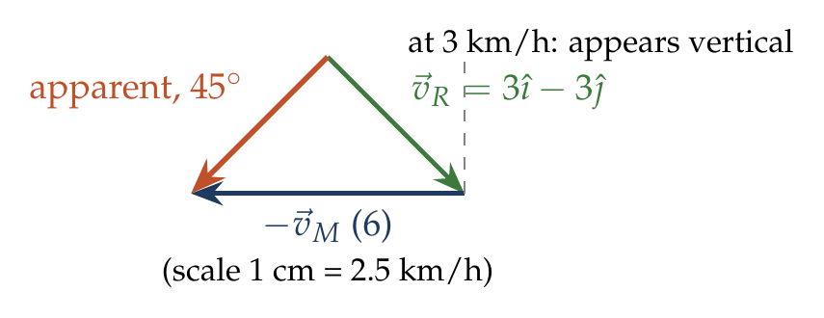
Let ${\vec{v}}_{R}=p\hat{ı}−q\hat{ȷ}$ (x along his walk, y up).
(i) ${\vec{v}}_{R}−3\hat{ı}$ vertical $⇒p=3$.
(ii) ${\vec{v}}_{R}−6\hat{ı}=−3\hat{ı}−q\hat{ȷ}$ at ${45}^{∘}$ $⇒q=3$.
$$\left|{\vec{v}}_{R}\right|=\sqrt{3^{2}+3^{2}}=3\sqrt{2} km/h.$$

Answer
$3\sqrt{2}$ km/h (at 45° to the vertical, slanting forward).

Watch out
• The real rain is not vertical here: it has a horizontal part of 3 km/h.
• 3 km/h alone is only one component.
Notes: Sec. 12 (A: rain appears vertical when vM = horizontal component).

Q85 · Car in vertical rain at two speeds [JEE Main 2020, 6 Sep, Shift 2]
ID 04MIP-0435-76e2 · Code 0435 · Worksheet 04MIP_v2 Q85

Problem
When a car is at rest, its driver sees rain drops falling on it vertically. When driving the car with speed v, he sees that the rain drops are coming at an angle of $60​^{∘}$from the horizontal. On further increasing the speed of the car to $\left(1+β\right)v$, this angle changes to $45​^{∘}$. The value of β is close to:
(A) 0.5 (B) 0.41 (C) 0.37 (D) 0.73

Hint
Write the apparent angle from the horizontal in terms of the rain speed and the car’s speed for each case, then divide.

Think it through
- The rain falls vertically at v_R. At car speed v, the apparent rain has horizontal part v and vertical part v_R.
- 60° from the horizontal: tan 60° = v_R/v, so v_R = √3 v.
- At (1 + β)v, the angle is 45°: v_R = (1 + β)v.
- So 1 + β = √3, β = 0.732 ≈ 0.73. (D)

Worked solution
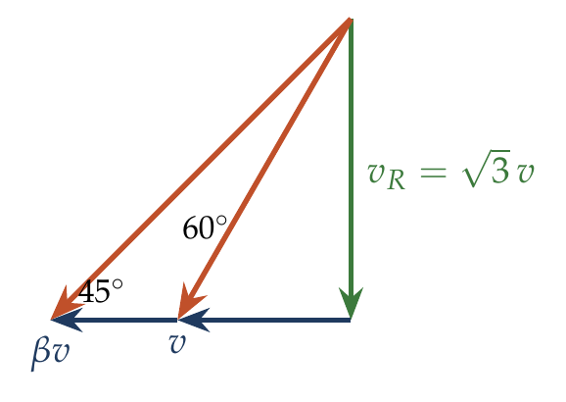
$$tan{60}^{∘}=\frac{v_{R}}{v}, tan{45}^{∘}=\frac{v_{R}}{\left(1+β\right)v} ⇒ 1+β=\frac{tan{60}^{∘}}{tan{45}^{∘}}=\sqrt{3}.$$
$$β=\sqrt{3}−1≈0.73.$$

Answer
(D) 0.73.

Watch out
• The angles are from the horizontal, so tan = v_R/v_car (not the inverse).
• (B) 0.41 = √2 − 1 comes from using sines instead of tangents.
Notes: Sec. 12 (B: rain falls vertically).

Q86 · Collision after 2 s
ID 04MIP-0435-86ad · Code 0435 · Worksheet 04MIP_v2 Q86

Problem
Two particles having position vectors $\vec{r_{1}}=\left(3 \hat{i}+5 \hat{j}\right)$ and $\vec{r_{2}}=\left(−5 \hat{i}−3 \hat{j}\right)$m are moving with velocities $\vec{v_{1}}=\left(4 \hat{i}+3 \hat{j}\right)$m/s and $\vec{v_{2}}=\left(a \hat{i}+7 \hat{j}\right)$ m/s. If they collide after 2 sec, the value of ‘a’ is?

Hint
Colliding means being at the same place at the same time. Write both positions at t = 2 s and set them equal.

Think it through
- Position of each particle at time t: start + velocity × t.
- Particle 1 at t = 2: (3 + 8, 5 + 6) = (11, 11).
- Particle 2 at t = 2: (−5 + 2a, −3 + 14) = (−5 + 2a, 11). The y-coordinates already agree, a good check.
- Matching x: −5 + 2a = 11, so a = 8.

Another way: relative velocity
Relative position r₁ − r₂ = (8, 8) must be closed in 2 s, so v₂ − v₁ = (4, 4): a − 4 = 4 and 7 − 3 = 4 ✓. So a = 8.

Worked solution
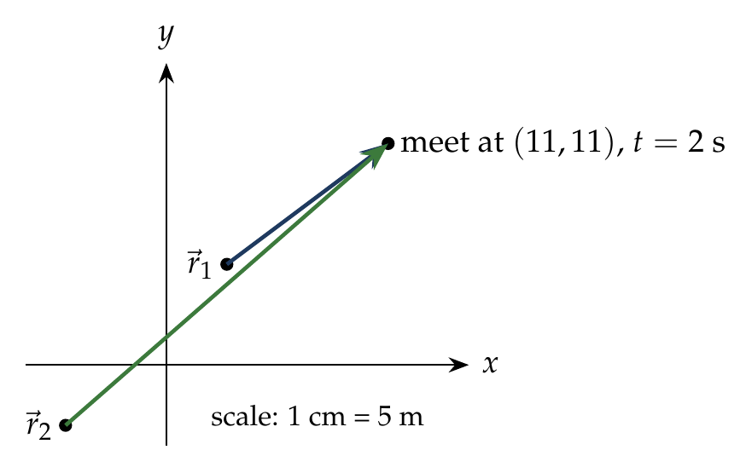
$${\vec{r}}_{1}+2{\vec{v}}_{1}={\vec{r}}_{2}+2{\vec{v}}_{2}: \left(3+8\right)\hat{ı}+\left(5+6\right)\hat{ȷ}=\left(−5+2a\right)\hat{ı}+\left(−3+14\right)\hat{ȷ}.$$
$$11=−5+2a ⇒ a=8.$$

Answer
a = 8 m/s.

Watch out
• Always check the other component: here both y-coordinates are 11 at t = 2 s, so a collision is possible.
• Do not equate velocities; equate positions at the same instant.
Notes: Sec. 10.4 (collision of bodies moving with constant velocities).

Q87 · Moving at a fixed 60° to the line towards O
ID 04MIP-0435-8b74 · Code 0435 · Worksheet 04MIP_v2 Q87

Problem
A point P is moving with constant speed 10 m/s such that the velocity vector always maintains an angle of 60⁰ with the line OP where O is a fixed point in the space. The time for P to reach O if the initial distance of P from O is 100m?

Hint
Split the velocity into a part along PO and a part across it. Which part changes the distance OP, and is it constant?

Think it through
- Only the component of velocity along the line PO changes the distance OP; the component across it only turns the line.
- The velocity always makes 60° with PO (pointing towards O), so the closing component is always 10 cos 60° = 5 m/s.
- The distance therefore shrinks at a steady 5 m/s, whatever the path looks like.
- From 100 m: 100/5 = 20 s.
- The path is a spiral (P circles O ever faster as it closes in), but the time is simple because the closing rate is constant.

Worked solution
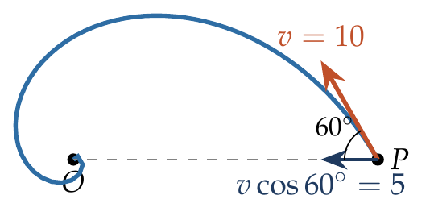
$$\frac{d\left(OP\right)}{dt}=−vcos{60}^{∘}=−5 m/s \left(constant\right).$$
$$t=\frac{100}{5}=20 s.$$

Answer
20 s.

Watch out
• The path is not a straight line, so 100/10 = 10 s is wrong.
• Read 60° as the angle with the line from P towards O; if it were with OP pointing away, P would never reach O.
Notes: Sec. 10.4 (approach: rate of closing along the joining line).

Q88 · When are two ships closest? [JEE Main 2019, 8 Apr, Shift 1]
ID 04MIP-0435-a74c · Code 0435 · Worksheet 04MIP_v2 Q88

Problem
Ship A is sailing towards north-east with velocity $\vec{v}=30\hat{i}+50\hat{j}$ km/h; where $\hat{i}$ points east and $\hat{j}$ north. Ship B is at a distance of 80 km east and 150 km north of ship A and is sailing towards west at 10 km/h. A will be at minimum distance from B in:
(A) 4.2 h (B) 2.6 h (C) 3.2 h (D) 2.2 h

Hint
Sit on ship A. Then B moves in a straight line with velocity ${\vec{v}}_{B}−{\vec{v}}_{A}$. When is that straight line nearest to A?

Think it through
- In A’s frame, A is fixed and B starts at (80, 150) km with velocity (−10, 0) − (30, 50) = (−40, −50) km/h.
- B then moves in a straight line. It is closest to A when its relative position is perpendicular to its relative velocity.
- t* = −(r·v)/|v|² = (80 × 40 + 150 × 50)/(40² + 50²) = 10 700/4100 ≈ 2.6 h. (B)
- Check: the minimum distance is |r × v|/|v| = |80(−50) − 150(−40)|/64.0 = 2000/64.0 ≈ 31 km, a sensible near miss.

Another way: minimise the distance squared
r(t) = (80 − 40t, 150 − 50t). d² = (80 − 40t)² + (150 − 50t)². Setting d(d²)/dt = 0: −80(80 − 40t) − 100(150 − 50t) = 0, so 4100t = 10 700, t ≈ 2.6 h.

Worked solution
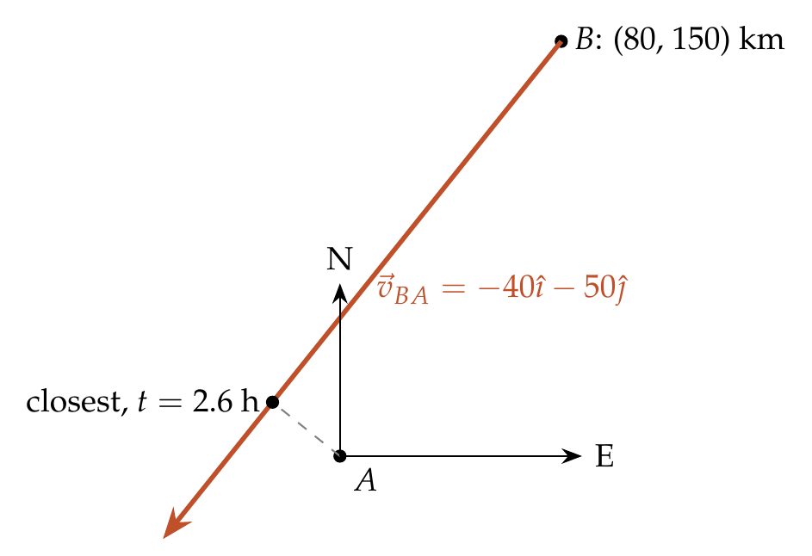
$${\vec{r}}_{BA}\left(0\right)=80\hat{ı}+150\hat{ȷ} km, {\vec{v}}_{BA}=−10\hat{ı}−\left(30\hat{ı}+50\hat{ȷ}\right)=−40\hat{ı}−50\hat{ȷ} km/h.$$
$$t^{*}=−\frac{{\vec{r}}_{BA}⋅{\vec{v}}_{BA}}{{\left|{\vec{v}}_{BA}\right|}^{2}}=\frac{3200+7500}{1600+2500}=\frac{10700}{4100}≈2.6 h.$$

Answer
(B) 2.6 h.

Watch out
• Use the relative velocity ${\vec{v}}_{B}−{\vec{v}}_{A}$, including B’s own 10 km/h west.
• A’s velocity (30, 50) is not exactly north-east; use the components given, not 45°.
Notes: Sec. 10.4 (minimum distance: closest approach).

Q89 · Rain seen by a man walking down and up a 37° incline [L2]
ID 04MIP-0435-c3c6 · Code 0435 · Worksheet 04MIP_v2 Q89

Problem
When a man moves down an inclined plane with a constant speed of 5 m/s which makes an angle of 37° with the horizontal, he finds that the rain is falling vertically downwards. When he moves up the same inclined plane with the same speed, he finds that the rain makes an angle $θ= \tan^{−1}\left(\frac{7}{8}\right)$ with the horizontal. The speed of the rain is?
(A) 4 m/s (B) 4$\sqrt{2}$ m/s (C) 7 m/s (D) 5 m/s

Hint
The man’s velocity on the incline has a vertical part too. Subtract his full velocity vector from the rain’s in each case.

Think it through
- Take x horizontal (the direction of walking down) and y up. Walking down the 37° incline at 5 m/s: velocity (4, −3). Walking up: (−4, 3).
- Let the rain be (p, −q). Walking down, the apparent rain (p − 4, −q + 3) is vertical, so p = 4.
- Walking up, the apparent rain is (4 + 4, −q − 3) = (8, −(q + 3)). Its angle with the horizontal has tan = (q + 3)/8 = 7/8, so q = 4.
- Rain = (4, −4): speed 4√2 m/s at 45°. (B)
- Check: q must be positive (rain falls); the other root of the angle condition gives q = −10, rising rain, so it is rejected.

Worked solution
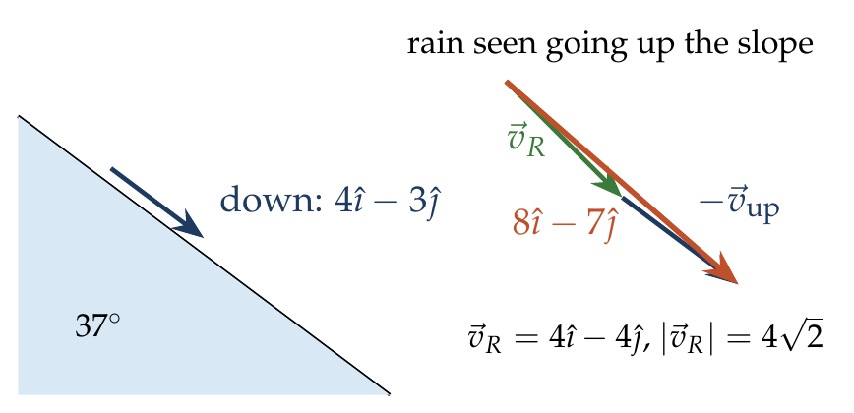
${\vec{v}}_{down}=5\left(cos{37}^{∘}\hat{ı}−sin{37}^{∘}\hat{ȷ}\right)=4\hat{ı}−3\hat{ȷ}$, ${\vec{v}}_{up}=−4\hat{ı}+3\hat{ȷ}$. Let ${\vec{v}}_{R}=p\hat{ı}−q\hat{ȷ}$.
Down: ${\vec{v}}_{R}−{\vec{v}}_{down}=\left(p−4\right)\hat{ı}+\left(3−q\right)\hat{ȷ}$ is vertical $⇒p=4$.
Up: ${\vec{v}}_{R}−{\vec{v}}_{up}=8\hat{ı}−\left(q+3\right)\hat{ȷ}$, with $\frac{q+3}{8}=\frac{7}{8}⇒q=4$.
$$\left|{\vec{v}}_{R}\right|=\sqrt{4^{2}+4^{2}}=4\sqrt{2} m/s.$$

Answer
(B) $4\sqrt{2}$ m/s.

Watch out
• On an incline the man’s velocity has a vertical part (±3 m/s); leaving it out gives the wrong vertical component.
• tan⁻¹(7/8) is with the horizontal: (q + 3)/8, not 8/(q + 3).
Notes: Sec. 12 (man on an incline: subtract the full vector).

Q90 · Shortest distance between two ships [L2]
ID 04MIP-0435-239b · Code 0435 · Worksheet 04MIP_v2 Q90

Problem
Two ships are initially at rest, with ship B 1000 m east of ship A. Both ships start moving simultaneously, with ‘A’ having a velocity of 10 m/s SE and B having a velocity of 20 m/s in SW. What would be shortest possible distance between the two ships?
(A) 100 m (B) 100$\sqrt{3} m$ (C) 100$\sqrt{5} m$ (D) 100$\sqrt{10} m$

Hint
In A’s frame, B moves along a straight line. Find B’s velocity relative to A, then the perpendicular distance from A to that line.

Think it through
- Take x east, y north. A: 10 m/s SE = (7.07, −7.07). B: 20 m/s SW = (−14.14, −14.14).
- Relative velocity of B with respect to A: (−21.21, −7.07) m/s, of magnitude √500 = 10√5 ≈ 22.4 m/s.
- B starts 1000 m east of A. The closest distance is the perpendicular from A to B’s relative path: d = |r × v|/|v| = 1000 × 7.07/22.36 ≈ 316 m.
- 316 = 100√10. (D)
- Check the time: t* = (1000 × 21.21)/500 ≈ 42 s, positive, so the closest approach does happen.

Worked solution
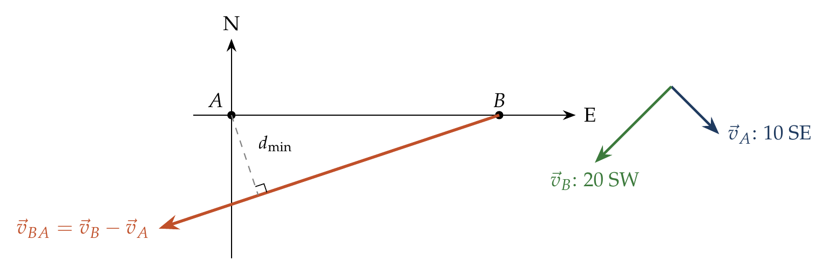
$${\vec{v}}_{A}=5\sqrt{2}\left(\hat{ı}−\hat{ȷ}\right), {\vec{v}}_{B}=10\sqrt{2}\left(−\hat{ı}−\hat{ȷ}\right), {\vec{v}}_{BA}=−15\sqrt{2} \hat{ı}−5\sqrt{2} \hat{ȷ}, \left|{\vec{v}}_{BA}\right|=10\sqrt{5}.$$
With ${\vec{r}}_{BA}\left(0\right)=1000\hat{ı}$:
$$d_{min}=\frac{\left|{\vec{r}}_{BA}×{\vec{v}}_{BA}\right|}{\left|{\vec{v}}_{BA}\right|}=\frac{1000×5\sqrt{2}}{10\sqrt{5}}=100\sqrt{10} m≈316 m.$$

Answer
(D) $100\sqrt{10}$ m.

Watch out
• Use the cross-product (perpendicular) part of the separation, not the full 1000 m.
• SE and SW both have southward parts; only their difference (5√2 m/s) enters the cross product.
Notes: Sec. 10.4 (minimum distance: closest approach).

River–Boat Crossing

Q91 · Five questions on one river
ID 04MIP-0440-8882 · Code 0440 · Worksheet 04MIP_v2 Q91

Problem
A boat can row at speed of 5 m/s in still water. It is crossing a 500 m wide river flowing with a speed of 3 m/s. Find:
(i) Minimum time to cross the river and the corresponding drift
(ii) Minimum time to cross the river and come back to the starting point
(iii) Time to travel a distance of 500 m along the river and come back to the starting point.
(iv) Direction in which boat should be rowed to reach the opposite point on the river
(v) Time taken to cross the river if boat maintains its direction at $120​^{∘}$ with the direction of river flow

Hint
For every part, split the boat’s velocity into a part across the river and a part along it. The across part alone sets the crossing time; the along part (plus the river) sets the drift.

Think it through
- Data: boat 5 m/s in still water, river 3 m/s, width 500 m. Crossing time = width ÷ (across component); drift = (along component) × time.

  - Least time: point straight across, so all 5 m/s is across: 500/5 = 100 s. The river carries the boat 3 × 100 = 300 m downstream.

  - Cross and come back to the start: each crossing must have zero net drift, so head upstream with 3 m/s of the 5 cancelling the river, leaving 4 m/s across: 2 × 500/4 = 250 s. (A numerical check confirms that no pair of unequal headings does better.)

  - 500 m along the river and back: 500/(5 + 3) + 500/(5 − 3) = 62.5 + 250 = 312.5 s.

  - To reach the point opposite: sin θ = 3/5 upstream of the normal, θ = 37°, i.e. 90° + 37° = 127° with the direction of flow.

  - Heading at 120° to the flow: the across component is 5 sin 120° = 2.5√3 m/s, so t = 500/(2.5√3) = 200/√3 ≈ 115 s.

Worked solution
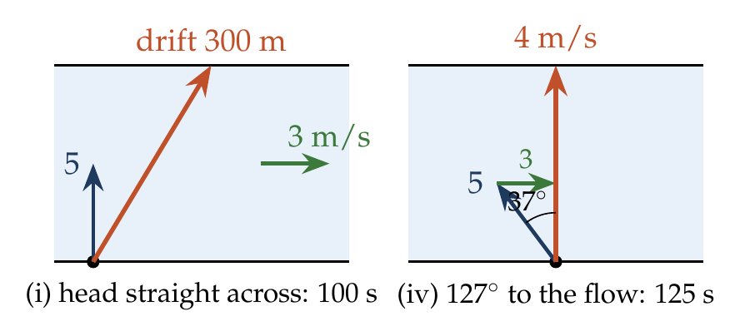
Let $v_{b}=5$ m/s, $v_{r}=3$ m/s, $W=500$ m.
(i) $t_{min}=\frac{W}{v_{b}}=100$ s; drift $=v_{r}t_{min}=300$ m.
(ii) $t=\frac{2W}{\sqrt{v_{b}^{2}−v_{r}^{2}}}=\frac{1000}{4}=250$ s.
(iii) $t=\frac{500}{5+3}+\frac{500}{5−3}=62.5+250=312.5$ s.
(iv) $sinθ=\frac{v_{r}}{v_{b}}=\frac{3}{5}⇒θ={37}^{∘}$ upstream of the normal, i.e. ${127}^{∘}$ with the flow.
(v) $t=\frac{W}{v_{b}sin{120}^{∘}}=\frac{500}{5\left(\sqrt{3}/2\right)}=\frac{200}{\sqrt{3}}≈115$ s.

Answer
(i) 100 s, 300 m; (ii) 250 s; (iii) 312.5 s; (iv) 127° with the direction of flow (37° upstream of the normal); (v) $200/\sqrt{3}$ s ≈ 115 s.

Watch out
• In (iii), going downstream and back takes longer than 2 × 500/5 = 200 s: the slow leg dominates.
• In (iv) and (v), angles “with the flow” are measured from the downstream direction; 127° and 120° both point partly upstream.
Notes: Sec. 11 (three standard crossings; round trip along the river).

Q92 · Swimming across in the least time
ID 04MIP-0440-2de9 · Code 0440 · Worksheet 04MIP_v2 Q92

Problem
A river flows from east to west with a speed of 5m/min. A man on south bank of river, capable of swimming at the rate of 10 m/min in still water, wants to swim across the river in shortest time; he should swim :
(A) Due north (B) Due north-east (C) $30​^{∘}$ east of North (D) $60​^{∘}$ east of North

Hint
Which direction of swimming makes the across component of your velocity as large as possible?

Think it through
- Crossing time = width ÷ across component of the swimmer’s velocity (relative to the water). The river’s flow is along the banks and does not help or hinder crossing.
- The across component is largest when the swimmer heads straight across, due north, giving 10 m/min across.
- So he should swim due north (he will drift west with the river, but that does not slow the crossing). (A)

Worked solution
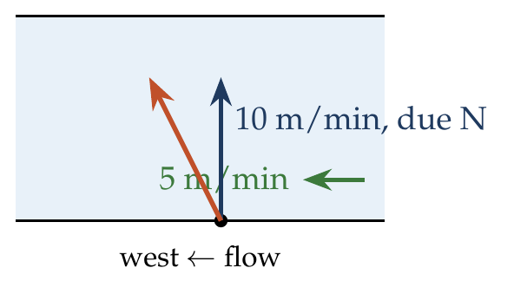
$$t=\frac{W}{v_{s}cosθ} is least for θ=0, i.e. heading due north: t_{min}=\frac{W}{10} min.$$

Answer
(A) Due north.

Watch out
• Heading upstream (east of north) to cancel the drift reduces the across component and takes longer.
• Least time and least drift are different crossings.
Notes: Sec. 11 (minimum time: head straight across).

Q93 · 8 km upstream and back
ID 04MIP-0440-6dff · Code 0440 · Worksheet 04MIP_v2 Q93

Problem
A boat takes 2 hours to go 8 km and come back in a still lake. The time taken for going 8 km upstream a river and coming back with water velocity of 4 km/h is :
(A) 140 min (B) 150 min (C) 160 min (D) 170 min

Hint
Find the boat’s speed in still water from the lake trip, then add and subtract the river speed for the two legs.

Think it through
- In the lake: 16 km in 2 h, so the boat’s still-water speed is 8 km/h.
- Upstream: 8 − 4 = 4 km/h, taking 8/4 = 2 h. Downstream: 8 + 4 = 12 km/h, taking 8/12 = ⅔ h.
- Total = 2⅔ h = 160 min. (C)
- Check: any current lengthens a round trip compared with still water (120 min), so 160 min is sensible.

Worked solution
$$v_{b}=\frac{16}{2}=8 km/h, t=\frac{8}{8−4}+\frac{8}{8+4}=2+\frac{2}{3}=\frac{8}{3} h=160 min.$$

Answer
(C) 160 min.

Watch out
• The lake trip is 8 km each way, 16 km in all: v_b = 8 km/h, not 4 km/h.
• The gain downstream never makes up for the loss upstream.
Notes: Sec. 11 (round trip along the river).

Q94 · Two boats at 20° either side of north
ID 04MIP-0440-4664 · Code 0440 · Worksheet 04MIP_v2 Q94

Problem
A river flows from East to West. Two boats start from the southern bank of the river simultaneously. The boat A rows towards $20​^{∘}$ east of north, whereas boat B rows towards $20​^{∘}$ west of north. Both boats have same speed in still water. Which of the two boats will reach the northern bank first? The width of river is uniform.
(A) Boat A (B) Boat B (C) Both will reach at the same time (D) will depend on speed of river flow

Hint
What decides the crossing time, and how do the two boats’ across components compare?

Think it through
- Crossing time depends only on the across component of each boat’s velocity relative to the water.
- Both head 20° from north, one to each side, with the same speed: both have v cos 20° across.
- The river flows along the banks and adds nothing across. So they reach the northern bank together. (C)
- They land at different points (one drifts more than the other), but at the same time.

Worked solution
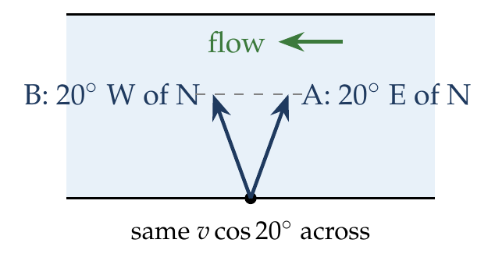
$$t_{A}=\frac{W}{vcos{20}^{∘}}=t_{B}.$$

Answer
(C) Both reach at the same time.

Watch out
• The river speed changes where they land, not when they land.
• “Rowing towards” a direction means the heading relative to the water.
Notes: Sec. 11 (crossing time depends only on the across-component).

Q95 · Drift when heading 37° upstream
ID 04MIP-0440-cd74 · Code 0440 · Worksheet 04MIP_v2 Q95

Problem
A boat can row at a speed of 5 m/s in still water. It sets its course at 37° with the normal to river bank as shown. The velocity of the river is 2 m/s and its width is 50 m. The boat starts from A and B is directly opposite point. What will be the drift of the boat when it reaches the other side?
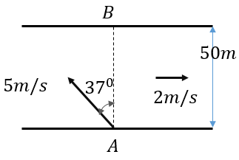
(A) 10 m upstream of B (B) 12.5 m upstream of B (C) 10 m downstream of B (D) 12.5 m downstream of B

Hint
From the figure, the boat heads upstream. Find its across and along components, then compare the along component with the river speed.

Think it through
- From the figure, the heading is 37° from the normal, tilted upstream (against the 2 m/s flow).
- Across: 5 cos 37° = 4 m/s, so crossing takes 50/4 = 12.5 s.
- Along: the boat pushes 5 sin 37° = 3 m/s upstream; the river carries it 2 m/s downstream. Net: 1 m/s upstream.
- Drift = 1 × 12.5 = 12.5 m upstream of B. (B)

Worked solution
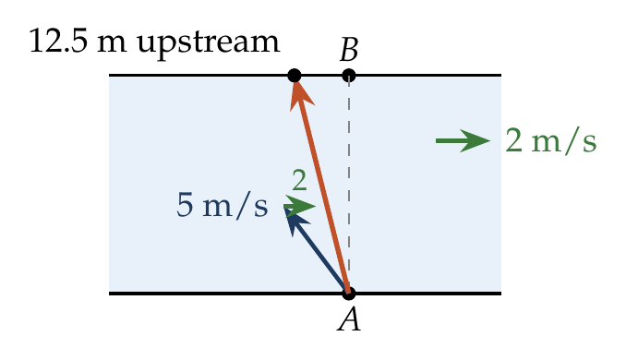
$$t=\frac{50}{5cos{37}^{∘}}=\frac{50}{4}=12.5 s, v_{along}=2−5sin{37}^{∘}=2−3=−1 m/s.$$
$$drift=\left(−1\right)\left(12.5\right)=−12.5 m, i.e. 12.5 m upstream of B.$$

Answer
(B) 12.5 m upstream of B.

Watch out
• The boat’s upstream push (3 m/s) exceeds the river (2 m/s), so the drift is upstream.
• 10 m comes from using the time 50/5 = 10 s, as if the boat headed straight across.
Notes: Sec. 11 (heading at θ upstream: T and drift).

Q96 · Swimmer reaching the opposite point [JEE Main 2021, 16 Mar, Shift 2]
ID 04MIP-0440-d399 · Code 0440 · Worksheet 04MIP_v2 Q96

Problem
A swimmer can swim with velocity of 12 km/h in still water. Water flowing in the river has a velocity of 6 km/h. The direction with respect to the direction of flow of river water he should swim in order to reach the point on the other bank just opposite to his starting point is … (in degrees to the nearest integer)?

Hint
To land straight opposite, the swimmer’s upstream component must cancel the river. What angle does that need, measured from the flow direction?

Think it through
- To reach the point opposite, the along-river part of the swimmer’s velocity must cancel the river: 12 sin θ = 6, where θ is measured upstream from the normal.
- sin θ = ½, θ = 30° from the normal, upstream.
- Measured from the direction of flow, that is 90° + 30° = 120°.
- Answer: 120°.

Worked solution
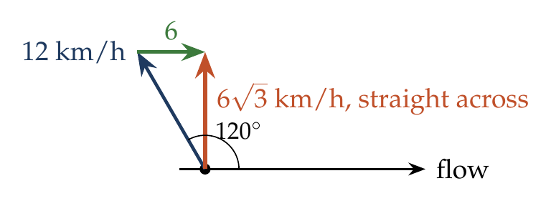
$$12sinθ=6⇒θ={30}^{∘} (upstream of the normal), angle with the flow={90}^{∘}+{30}^{∘}={120}^{∘}.$$

Answer
120° with the direction of flow.

Watch out
• 30° is measured from the normal; the question asks for the angle with the flow.
• 60° would point downstream.
Notes: Sec. 11 (zero drift: sin θ = vr/vb).

Q97 · Time along the shortest path
ID 04MIP-0440-7f94 · Code 0440 · Worksheet 04MIP_v2 Q97

Problem
A boat-man can row a boat to make it move with a speed of 10 km/h in still water. River flows steadily at the rate of 5 km/h. and the width of the river is 2 km. If the boat man cross the river along the shortest path then time elapsed in rowing the boat will be?
(A) $\frac{2}{5\sqrt{3}}$hrs (B) $\frac{4}{5\sqrt{3}}$hrs (C) $\frac{2\sqrt{3}}{5}$hrs (D) $\frac{3\sqrt{2}}{5}$hrs

Hint
The shortest path is straight across. What is the boat’s speed along that path once part of its velocity is used to cancel the river?

Think it through
- The boat (10 km/h) is faster than the river (5 km/h), so the shortest path, straight across, is possible.
- Part of the boat’s velocity cancels the river; the rest, √(10² − 5²) = √75 = 5√3 km/h, carries it across.
- Time = 2/(5√3) h ≈ 0.23 h ≈ 14 min. (A)

Worked solution
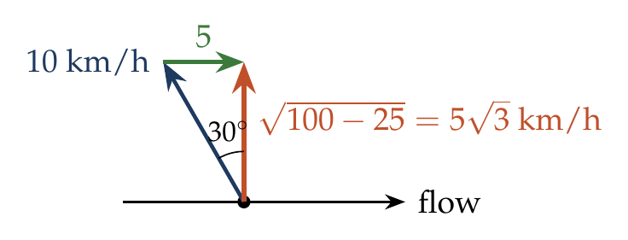
$$t=\frac{W}{\sqrt{v_{b}^{2}−v_{r}^{2}}}=\frac{2}{\sqrt{100−25}}=\frac{2}{5\sqrt{3}} h.$$

Answer
(A) $\frac{2}{5\sqrt{3}}$ h.

Watch out
• The shortest-path crossing is slower than the fastest crossing (0.2 h).
• Use √(v_b² − v_r²), not v_b − v_r.
Notes: Sec. 11 (zero drift: T = W over root of vb squared minus vr squared).

Q98 · Ratio of shortest-route time to least time
ID 04MIP-0440-5b02 · Code 0440 · Worksheet 04MIP_v2 Q98

Problem
A boat can travel at 13m/min in still water. The width of the river is 78 m flowing with a velocity of 5 m/min. What is the ratio of time taken to cross by shortest route to minimum time to cross the river?
(A) 12/13 (B) 13/12 (C) 13/11 (D) 13/10

Hint
Both times have the same width on top. What is the across speed in each case?

Think it through
- Least time: head straight across at 13 m/min. Time = 78/13 = 6 min.
- Shortest route: cancel the 5 m/min river, leaving √(169 − 25) = 12 m/min across. Time = 78/12 = 6.5 min.
- Ratio = 6.5/6 = 13/12. (B)
- The width cancels: the ratio is just 13/12, the ratio of the across speeds inverted.

Worked solution
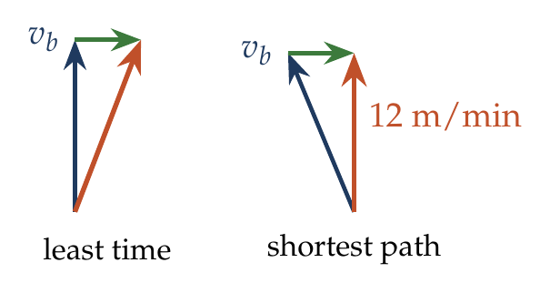
$$\frac{t_{shortest}}{t_{min}}=\frac{W/\sqrt{v_{b}^{2}−v_{r}^{2}}}{W/v_{b}}=\frac{13}{\sqrt{169−25}}=\frac{13}{12}.$$

Answer
(B) 13/12.

Watch out
• The shortest route takes longer, so the ratio is more than 1: (A) is inverted.
• 5-12-13 is a Pythagorean triple: the across speed is exactly 12 m/min.
Notes: Sec. 11 (three standard crossings).

Q99 · Boat speed from two crossings
ID 04MIP-0440-bd24 · Code 0440 · Worksheet 04MIP_v2 Q99

Problem
A man wishes to cross a river in a boat. If he crosses the river in minimum time, then he takes 10 min with a drift of 120 m. If he crosses the river taking shortest route, he takes 12.5 min, find the velocity of the boat with respect to water (in m/min)?
(A) 12 (B) 15 (C) 16 (D) 20

Hint
The least-time crossing gives you two facts: width ÷ boat speed = 10 min, and river speed × 10 min = 120 m. The shortest-route time gives a third.

Think it through
- Least time: heading straight across, 10 min, with drift 120 m. So the river speed is 120/10 = 12 m/min, and the width is 10 v_b.
- Shortest route: across speed √(v_b² − 144), time 12.5 min: 10 v_b = 12.5 √(v_b² − 144).
- Square: 100 v_b² = 156.25 (v_b² − 144), so 56.25 v_b² = 22 500, v_b² = 400, v_b = 20 m/min. (D)
- Check: across speed √(400 − 144) = 16; width 200 m; 200/16 = 12.5 min ✓.

No-pen route: ratio of times
The ratio of the two times is v_b/√(v_b² − v_r²) = 12.5/10 = 5/4, so the across speed is ⅘ of v_b and the river is ⅗ of v_b (a 3-4-5 triangle). With v_r = 12 m/min, v_b = 20 m/min.

Worked solution
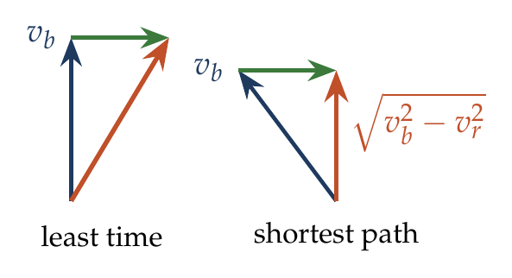
$$v_{r}=\frac{120}{10}=12 m/min, W=10v_{b}.$$
$$\frac{10v_{b}}{\sqrt{v_{b}^{2}−144}}=12.5 ⇒ \frac{v_{b}}{\sqrt{v_{b}^{2}−144}}=\frac{5}{4} ⇒ v_{b}=20 m/min.$$

Answer
(D) 20 m/min.

Watch out
• The drift in the least-time crossing is v_r × t, which gives the river speed directly.
• Do not assume the width; it follows from W = 10 v_b.
Notes: Sec. 11 (minimum time; zero drift).

Q100 · Flow speed from a 120° heading [JEE Main 2021, 18 Mar, Shift 1]
ID 04MIP-0440-af8d · Code 0440 · Worksheet 04MIP_v2 Q100

Problem
A person is swimming with a speed of 10 m/s at an angle of $120​^{∘}$ with the flow and reaches a point directly opposite on the other side of the river. The speed of the flow is x m/s. The value of x to the nearest integer is:

Hint
Reaching the opposite point means no net motion along the river. What is the swimmer’s component along the flow when he swims at 120° to it?

Think it through
- Swimming at 120° to the flow, his component along the flow is 10 cos 120° = −5 m/s, i.e. 5 m/s upstream.
- He lands directly opposite, so this must exactly cancel the river: x = 5.
- Answer: 5.

Worked solution
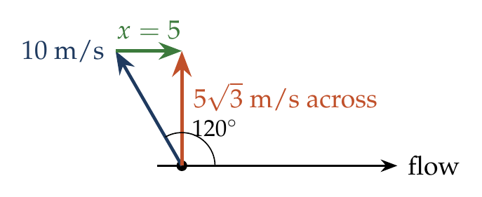
$$v_{r}+10cos{120}^{∘}=0 ⇒ x=v_{r}=5 m/s.$$

Answer
x = 5.

Watch out
• cos 120° is negative: the 120° heading is partly upstream.
• 10 sin 120° (≈ 8.7) is the across component, not the one that cancels the flow.
Notes: Sec. 11 (zero drift: upstream component cancels the river).

Q101 · Swimmer as fast as the river, aiming along AB [L2] [JEE Main 2021, 27 Jul, Shift 2]
ID 04MIP-0440-0ac0 · Code 0440 · Worksheet 04MIP_v2 Q101

Problem
A swimmer wants to cross a river from point A to point B. Line AB makes an angle of 30° with the flow of river. The magnitude of the velocity of the swimmer is same as that of the river. The angle θ with the line AB should be ____°, so that the swimmer reaches point B?
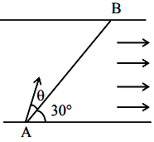

Hint
The resultant (swimmer + river) must point along AB. Draw the triangle of velocities: what kind of triangle is it when the two speeds are equal?

Think it through
- The swimmer’s velocity (relative to the water) plus the river’s velocity must point along AB.
- Equivalently, the parts perpendicular to AB must cancel: the river has v sin 30° perpendicular to AB, so the swimmer needs v sin θ the other way, where θ is his angle with AB.
- Equal speeds: v sin θ = v sin 30°, so θ = 30°.
- The triangle of velocities is isosceles (two sides of length v), so its two base angles are equal: both 30°.
- Answer: θ = 30°, measured from AB on the side away from the flow.

Worked solution
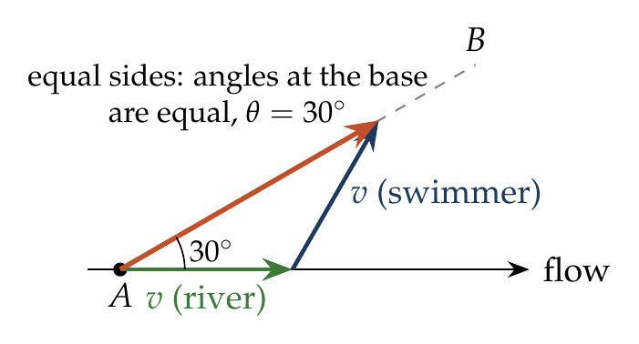
For the resultant to lie along AB, the velocity components perpendicular to AB must cancel:
$$vsinθ=vsin{30}^{∘} ⇒ θ={30}^{∘}.$$
The swimmer heads at ${30}^{∘}$ to AB on the upstream side, i.e. ${60}^{∘}$ to the flow.

Answer
θ = 30°.

Watch out
• θ is measured from AB, not from the flow or the bank.
• This works because AB points partly downstream; with equal speeds, a point directly opposite could not be reached.
Notes: Sec. 11 (aeroplane and wind: to move along a desired line, cancel the perpendicular component).

Q102 · River speed growing across the width [L2]
ID 04MIP-0440-e353 · Code 0440 · Worksheet 04MIP_v2 Q102

Problem
A river is flowing towards East with speed which varies as distance from the bank as $\left(5+0.05y\right)$ m/s, where $y$ is the distance from the bank. A boat having speed of 10 m/s in still water is rowed, always aiming towards North, starting from the bank. Find the drift it will have by the time it is 100 m from the bank?
(A) 25 m (B) 30 m (C) 50 m (D) 75 m

Hint
The boat heads due north at 10 m/s, so its distance from the bank grows uniformly. How much does the river carry it sideways while it moves from y to y + dy?

Think it through
- Heading due north at 10 m/s, the boat’s distance from the bank is y = 10t, whatever the river does.
- The river carries it east at (5 + 0.05y) m/s, which grows as it moves out.
- Sideways drift per metre across = (river speed)/(10). Add this up from y = 0 to 100 m: drift = (1/10) × ∫(5 + 0.05y) dy = (1/10)(500 + 250) = 75 m. (D)
- Check with the average river speed: it rises linearly from 5 to 10 m/s, average 7.5 m/s, for 10 s: 75 m.

No-pen route: average flow
The river speed rises linearly with y, and y rises uniformly in time, so the average river speed over the trip is (5 + 10)/2 = 7.5 m/s. The trip takes 100/10 = 10 s, so the drift is 75 m.

Worked solution
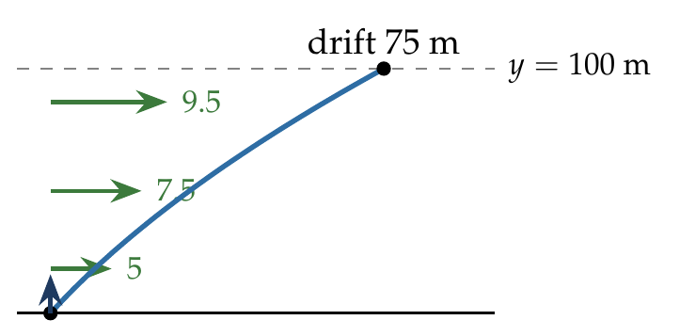
$y=10t$, so $dt=dy/10$ and
$$x=∫v_{r} dt=\frac{1}{10}\int_{0}^{100}{\left(5+0.05y\right)} dy=\frac{1}{10}{\left[5y+0.025y^{2}\right]}_{0}^{100}=\frac{500+250}{10}=75 m.$$

Answer
(D) 75 m.

Watch out
• Using the speed at the start (5 m/s) gives 50 m; at the far side (10 m/s), 100 m. The average applies only because the speed varies linearly in time.
• The boat aims north throughout, so its across speed stays 10 m/s.
Notes: Sec. 11 (river speed varying across the width).

Q103 · Swimmer accelerating across a river [L2]
ID 04MIP-0440-ab05 · Code 0440 · Worksheet 04MIP_v2 Q103

Problem
The velocity of the river water is $v$. Width of the river is d. A swimmer swims, with reference to the water, perpendicular to the current with an acceleration of a = 2t, starting from rest. The equation of the trajectory of the path followed by the swimmer is?
(A) $y=x^{2}/2v$ (B) $y=x^{3}/2v$ (C) $y=x^{3}/3v$ (D) $y=x^{3}/3v^{3}$

Hint
Take x along the current and y across it. Find x(t) and y(t) separately, then eliminate t.

Think it through
- Take x along the current and y across. The swimmer’s acceleration relative to the water is 2t across, starting from rest.
- Across: v_y = t², so y = t³/3.
- Along: the water carries the swimmer at v, and he has no velocity of his own along the current, so x = vt.
- Eliminate t = x/v: y = (x/v)³/3 = x³/(3v³). (D)
- Check: early on the swimmer has almost no velocity across, so the path must leave the bank tangent to the flow; y ∝ x³ does. Also x/v is a time, so only (D) gives y ∝ t³ as found.

Worked solution
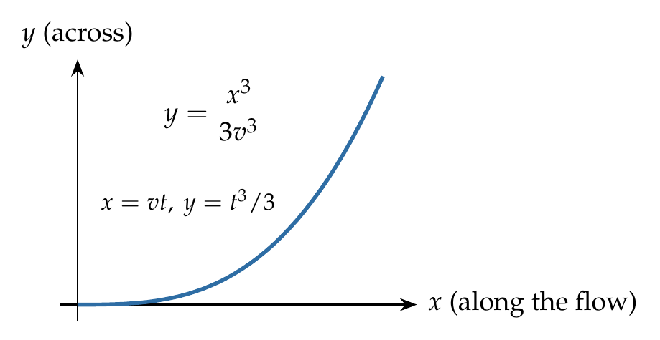
$$\frac{dv_{y}}{dt}=2t, v_{y}\left(0\right)=0⇒v_{y}=t^{2}⇒y=\frac{t^{3}}{3}; x=vt.$$
$$y=\frac{1}{3}{\left(\frac{x}{v}\right)}^{3}=\frac{x^{3}}{3v^{3}}.$$

Answer
(D) $y=\frac{x^{3}}{3v^{3}}$.

Watch out
• Integrate twice from rest: v_y = t², y = t³/3 (not t²).
• Replace t by x/v, so v appears cubed.
Notes: Sec. 7 (trajectory: eliminate t); Sec. 11 (river as a moving surface).

