Friction
Solutions to Worksheet 06FRI
How to use these solutions. Each problem is in layers. Open them one at a time.
Hint: a nudge at the point where most students get stuck. Read it, close the page, and try again.
Think it through: the solution as a teacher would talk it through, with no writing. Each step follows from the one before for a stated reason. Aim to have the whole path in your head before you pick up the pen. Another way gives a different route, and No-pen route is one you can finish in your head.
Worked solution: the solution as you would write it in an exam, with figures, ending with the answer and the traps to watch out for.
The “Notes” line at the end of each problem points to the section of the Laws of Motion revision notes that the problem draws on. Take g = 10 m/s² unless the problem says otherwise.

Laws of Friction; Angle of Friction & Repose

Q1 · Longest overhang of a chain on a rough table
ID 06FRI-0605-bec0 · Code 0605 · Worksheet 06FRI_v1 Q1

Problem
A homogeneous chain of length L lies on a table. The coefficient of friction between the chain and the table is μ. The maximum length which can hang over the table without slipping is? (The vertical portion of the table is smooth.)
(A) $\frac{μ}{1+μ}L$ (B) $\frac{1−μ}{μ}L$ (C) $\frac{1−μ}{1+μ}L$ (D) $μL$

Hint
Which part of the chain pulls it over the edge, and which part supplies the friction? At the largest overhang, friction is at its limit.

Think it through
- The hanging part pulls the chain over the edge with its weight; the part on the table resists with friction.
- The longest overhang is the limiting state: friction on the table part equals μ times its weight.
- If x hangs, the hanging weight is proportional to x and the table part’s weight to L − x. Balance: x = μ(L − x).
- So x = μL/(1 + μ). (A)
- Check: μ → 0 gives no overhang; μ → ∞ lets almost the whole chain hang. (D) μL exceeds L for μ > 1, so it cannot be right.

No-pen route: limiting cases
With μ = 1, the chain balances with half on each side: x = L/2. (A) gives L/2, (B) 0, (C) 0, (D) L. Only (A).

Worked solution
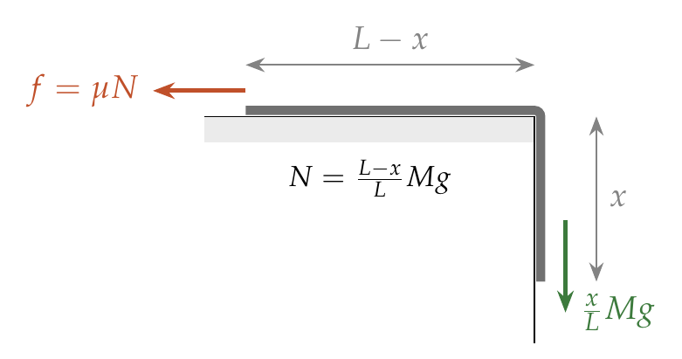
Let $x$ hang. Weights: hanging $\frac{x}{L}Mg$; on the table $\frac{L−x}{L}Mg=N$. Limiting state:
$$\frac{x}{L}Mg=μ\frac{L−x}{L}Mg ⇒ x=\frac{μL}{1+μ}.$$

Answer
(A) $\frac{μ}{1+μ}L$.

Watch out
• Friction acts only on the part lying on the table, so N is the weight of L − x, not of the whole chain.
Notes: Sec. 5.1 (limiting friction: on the verge of slipping, f = μN).

Q2 · Pressing a block against a rough wall [JEE Main 2021, 24 Feb, Shift 1]
ID 06FRI-0605-8a5c · Code 0605 · Worksheet 06FRI_v1 Q2

Problem
The coefficient of static friction between a wooden block of mass 0.5 kg and a vertical rough wall is 0.2. The magnitude of the horizontal force that should be applied on the block to keep it adhered to the wall will be ….. N.

Hint
Which force holds the block up, and what sets its largest possible value?

Think it through
- Only friction can hold the block up against its weight of 5 N.
- The wall’s normal force equals the horizontal push F, so friction can be at most μF = 0.2F.
- For the block not to slide: 0.2F ≥ 5, so F ≥ 25 N.
- A larger F does not increase the friction actually acting: it stays at 5 N, just as much as needed.

Worked solution
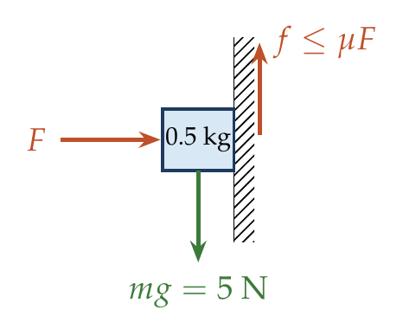
$$N=F, f≤μN. Need f=mg: μF≥mg ⇒ F≥\frac{0.5\left(10\right)}{0.2}=25 N.$$

Answer
25 N (minimum).

Watch out
• The friction is 5 N whatever the push; μF is only its upper limit.
Notes: Sec. 5.1 (static friction is self-adjusting up to μN).

Q3 · Two blocks pressed against a wall [JEE Main 2015 (Offline)]
ID 06FRI-0605-f523 · Code 0605 · Worksheet 06FRI_v1 Q3

Problem
Given in the figure are two blocks A and B of weight 20 N and 100 N, respectively. These are being pressed against a wall by a force F as shown. If the coefficient of friction between the blocks is 0.1 and between block B and the wall is 0.15, the frictional force applied by the wall on block B is:
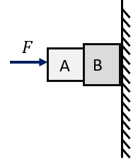
(A) 100 N (B) 80 N (C) 120 N (D) 150 N

Hint
F is not given, so μ cannot be what decides the answer. If nothing slips, what must the wall’s friction balance?

Think it through
- F is not given, so the friction cannot be found from μN. The blocks must be at rest (the worksheet’s own hint says this is implied).
- Take A and B together as the system: the friction between the blocks is internal.
- The only upward force on the system is the wall’s friction, and the weights total 120 N. So the wall’s friction is 120 N. (C)
- Check the parts: A needs 20 N from B; B needs 100 N for itself plus the 20 N with which A drags it down: 120 N.

Worked solution
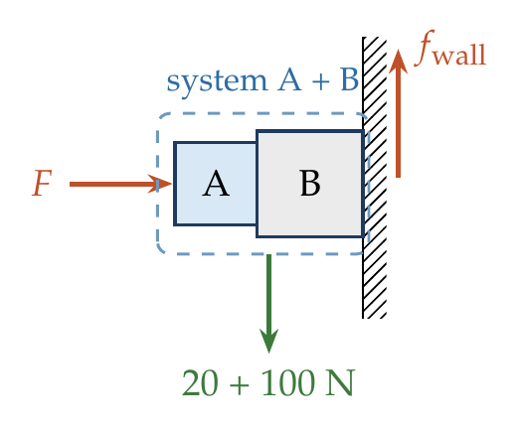
System A + B at rest (friction between A and B is internal):
$$f_{wall}=20+100=120 N, upward.$$
(This needs $0.15F≥120$, i.e. $F≥800$ N, and $0.1F≥20$, which then also holds.)

Answer
(C) 120 N, upward.

Watch out
• Static friction is what equilibrium needs, not μN; F is not even given.
Notes: Sec. 5.1 (static friction is self-adjusting); Sec. 2.1 (choose the system so unwanted forces are internal).

Q4 · Block on a wall with a sideways push
ID 06FRI-0605-a84c · Code 0605 · Worksheet 06FRI_v1 Q4

Problem
A block of mass 0.6 kg is pressed against a vertical wall by a force of 10 N acting perpendicular to the surface. A horizontal force of 8 N is acting on the block. Find the acceleration of the block if the coefficient of friction between the block and the wall is 0.25.
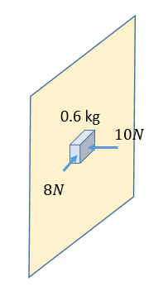
(A) 5 m/s² (B) 10 m/s² (C) 12.5 m/s² (D) zero

Hint
Look at the block face-on, in the plane of the wall. Which forces act in that plane, and in which direction would the block slide?

Think it through
- In the plane of the wall two forces act: the weight 6 N (down) and the 8 N horizontal push. Their resultant is 10 N, at an angle below the horizontal.
- The wall’s normal force is 10 N (balancing the push into the wall), so friction can be at most 0.25 × 10 = 2.5 N.
- 10 N exceeds 2.5 N, so the block slides along the resultant’s direction, and kinetic friction acts directly against it.
- Net force 10 − 2.5 = 7.5 N, so a = 7.5/0.6 = 12.5 m/s². (C)

Worked solution
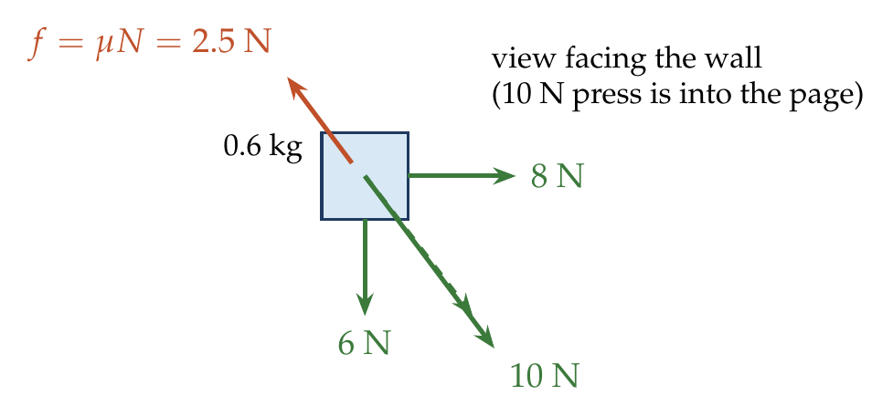
In the plane of the wall: $F_{in-plane}=\sqrt{6^{2}+8^{2}}=10$ N. Normal force $N=10$ N, so $f=μN=2.5$ N, opposite to the motion.
$$a=\frac{10−2.5}{0.6}=12.5 {m/s}^{2}.$$

Answer
(C) 12.5 m/s², along the resultant of the weight and the 8 N force.

Watch out
• Friction opposes the actual direction of sliding (along the 10 N resultant), not just the weight.
Notes: Sec. 5.1 (kinetic friction opposes the relative velocity); Sec. 5.2 (friction as a component of the contact force).

Q5 · Highest point a block can rest on a curved rough surface [JEE Main 2021, 24 Feb, Shift 1]
ID 06FRI-0605-ea3a · Code 0605 · Worksheet 06FRI_v1 Q5

Problem
An inclined plane is bent in such a way that the vertical cross-section is given by $y=\frac{x^{2}}{4}$, where y is in the vertical and x in the horizontal direction. If the upper surface of this curved plane is rough with coefficient of friction μ = 0.5, the maximum height in cm at which a stationary block will not slip downwards is ….. cm.

Hint
Locally the surface is just an incline. At what slope does a block on an incline start to slip?

Think it through
- At each point the block sits on a small incline whose slope is dy/dx.
- It stays at rest as long as the slope does not exceed the angle of repose: tan θ ≤ μ.
- The slope of y = x²/4 is x/2, which grows with x. The highest resting point has x/2 = 0.5, so x = 1 m.
- Height: y = 1/4 m = 25 cm.

Worked solution
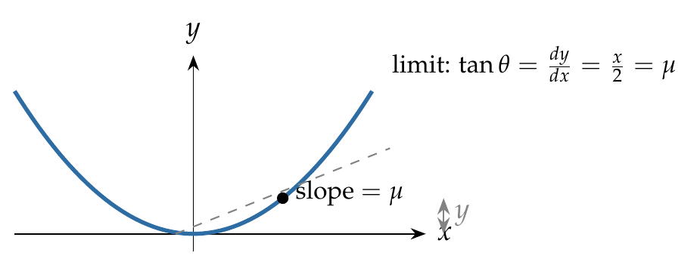
$$tanθ=\frac{dy}{dx}=\frac{x}{2}≤μ=0.5 ⇒ x≤1 m, y_{max}=\frac{1^{2}}{4}=0.25 m=25 cm.$$

Answer
25 cm.

Watch out
• Use the local slope dy/dx, not y/x.
Notes: Sec. 5.2 (angle of repose: tan θ = μ); Sec. 5.4 (critical angle).

Q6 · Insect crawling up a hemispherical bowl [JEE Main 2020, 6 Sep, Shift 1]
ID 06FRI-0605-ee43 · Code 0605 · Worksheet 06FRI_v1 Q6

Problem
An insect is at the bottom of a hemispherical ditch of radius 1 m. It crawls up the ditch but starts slipping after it is at height h from the bottom. If the coefficient of friction between the ground and the insect is 0.75, then h is?
(A) 0.20 m (B) 0.45 m (C) 0.60 m (D) 0.80 m

Hint
At a point on the bowl, how steep is the surface? Relate that slope to the radius’s angle from the vertical.

Think it through
- The surface is steepest where the radius is farthest from the vertical: the slope angle equals the angle θ between the radius and the vertical.
- The insect slips when tan θ reaches μ = 0.75, i.e. θ = 37°, where cos θ = 0.8.
- Its height above the bottom is R(1 − cos θ) = 1 × 0.2 = 0.2 m. (A)
- Check: 0.8 m (D) is R cos θ, the depth below the rim’s centre, a common slip.

Worked solution
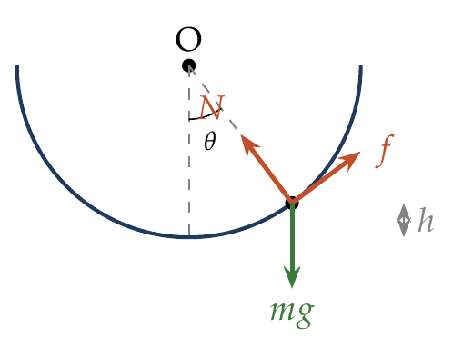
At angle $θ$ from the vertical: $N=mgcosθ$, needed friction $=mgsinθ≤μmgcosθ$, so $tanθ≤0.75$, $cosθ=0.8$.
$$h=R\left(1−cosθ\right)=1\left(1−0.8\right)=0.2 m.$$

Answer
(A) 0.20 m.

Watch out
• h is measured from the bottom: R(1 − cos θ), not R cos θ.
Notes: Sec. 5.4 (block on an incline: critical angle tan θ = μ).

Rough Horizontal Surface; Force at an Angle

Q7 · Friction on a block pushed at an angle but at rest
ID 06FRI-0610-dd62 · Code 0610 · Worksheet 06FRI_v1 Q7

Problem
A block of mass M lies on a rough surface of coefficient of friction μ. A force is applied on it at an angle θ to the horizontal as shown, and the block is at rest. The frictional force acting on the block will be
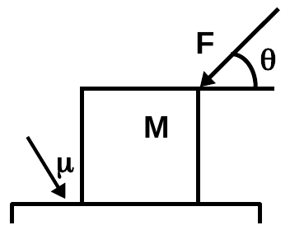
(A) F cos θ (B) μ(mg + F sin θ) (C) μ(mg − F sin θ) (D) μmg

Hint
The block is at rest. Is friction then at its limit, or only as large as needed?

Think it through
- The block is at rest, so friction is static and self-adjusting: it equals whatever balances the horizontal forces.
- The only other horizontal force is F cos θ, so friction = F cos θ, opposite to it. (A)
- (B) is the limiting value for this push (N = mg + F sin θ); friction reaches it only on the verge of slipping. (C) would be the limit for a pull, (D) for no vertical push.

Worked solution
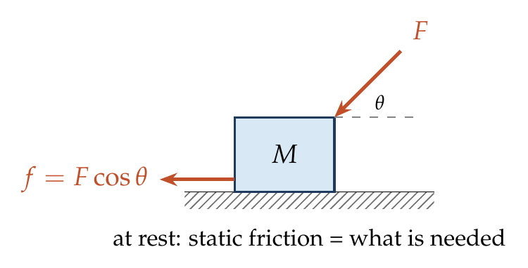
At rest: $∑F_{x}=0 ⇒ f=Fcosθ$ (static, $≤μ\left(Mg+Fsinθ\right)$).

Answer
(A) F cos θ.

Watch out
• Do not write μN for a body at rest unless it is on the verge of slipping.
Notes: Sec. 5.1 (static friction is self-adjusting).

Q8 · Sliding block pulled at an angle [JEE Main 2021, 16 Mar, Shift 1]
ID 06FRI-0610-1b31 · Code 0610 · Worksheet 06FRI_v1 Q8

Problem
A block of mass m slides along a floor while a force of magnitude F is applied to it at an angle θ as shown. The coefficient of kinetic friction is $μ_{K}$. Then the block’s acceleration is given by:
(A) $−\frac{F}{m}cosθ−μ_{K}\left(g−\frac{F}{m}sinθ\right)$ (B) $\frac{F}{m}cosθ−μ_{K}\left(g−\frac{F}{m}sinθ\right)$
(C) $\frac{F}{m}cosθ−μ_{K}\left(g+\frac{F}{m}sinθ\right)$ (D) $\frac{F}{m}cosθ+μ_{K}\left(g−\frac{F}{m}sinθ\right)$

Hint
Find N first: does the force lift the block or press it down? Then friction opposes the sliding.

Think it through
- The figure is missing; the options show N = mg − F sin θ, so the force pulls upward at θ above the horizontal.
- The upward component F sin θ reduces the normal force: N = mg − F sin θ.
- The block slides forward, so kinetic friction μ_K N acts backward.
- a = (F cos θ − μ_K(mg − F sin θ))/m. (B)
- (D) adds friction (it would help motion); (C) is the push-down case; (A) has the driving force backward.

Worked solution
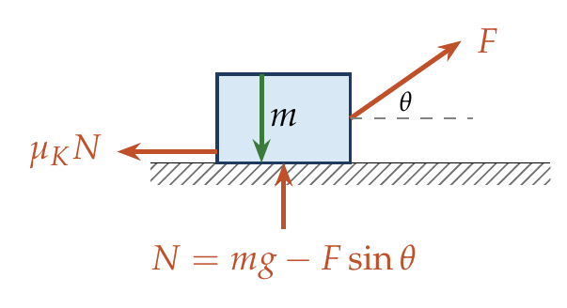
$$N=mg−Fsinθ, ma=Fcosθ−μ_{K}\left(mg−Fsinθ\right).$$
$$a=\frac{F}{m}cosθ−μ_{K}\left(g−\frac{F}{m}sinθ\right).$$

Answer
(B) $\frac{F}{m}cosθ−μ_{K}\left(g−\frac{F}{m}sinθ\right)$.

Watch out
• A pull above the horizontal reduces N; a push below it increases N.
• No figure is printed; the direction of F is read from the options.
Notes: Sec. 5.3 (pulling upward reduces the normal reaction); Sec. 5.1 (kinetic friction).

Q9 · Pushed versus pulled at 30° [JEE Main 2019, 12 Apr, Shift 2]
ID 06FRI-0610-c756 · Code 0610 · Worksheet 06FRI_v1 Q9

Problem
A block of mass 5 kg is (i) pushed in case (A) and (ii) pulled in case (B), by a force F = 20 N, making an angle of 30° with the horizontal, as shown. The coefficient of friction between the block and the floor is 0.2. The difference between the accelerations of the block in case (B) and case (A) will be:
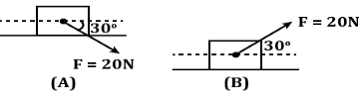
(A) 0.4 m/s² (B) 3.2 m/s² (C) 0.8 m/s² (D) 0 m/s²

Hint
The horizontal parts of the force are the same in both cases. What differs, and by how much?

Think it through
- The forward component F cos 30° is the same in both cases, so only the friction differs.
- Pushing down adds F sin 30° = 10 N to N; pulling up removes 10 N. The normal forces are 60 N and 40 N.
- The friction differs by 0.2 × 20 = 4 N, so the accelerations differ by 4/5 = 0.8 m/s². (C)
- Check that both slide: 17.3 N exceeds 12 N and 8 N, so kinetic friction applies in both cases.

No-pen route
Δa = μ × (difference in N)/m = 0.2 × 2F sin 30°/5 = 0.2 × 20/5 = 0.8 m/s².

Worked solution
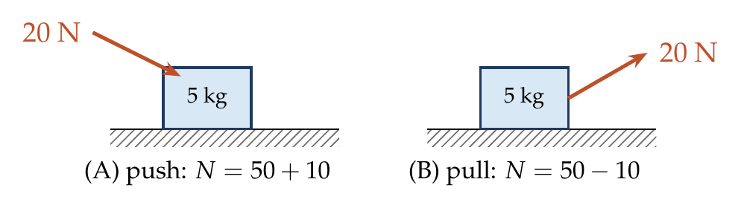
(A) push: $N=50+10=60$ N, $a_{A}=\frac{17.32−12}{5}=1.06$ m/s².
(B) pull: $N=50−10=40$ N, $a_{B}=\frac{17.32−8}{5}=1.86$ m/s².
$$a_{B}−a_{A}=0.8 {m/s}^{2}.$$

Answer
(C) 0.8 m/s².

Watch out
• Check the block slides in both cases before using μN.
Notes: Sec. 5.3 (force at an angle changes the normal reaction).

Q10 · Push at 30° versus pull at 60° [JEE Main 2014, 19 Apr (Online)]
ID 06FRI-0610-1290 · Code 0610 · Worksheet 06FRI_v1 Q10

Problem
A heavy block is to be dragged along a rough horizontal floor. To do so, a person A pushes at an angle of 30° with the horizontal and requires a minimum force of $F_{A}$, while person B pulls the block at an angle of 60° with the horizontal and needs a minimum force of $F_{B}$. If the coefficient of friction between the floor and the block is $\sqrt{3}/5$, then the ratio of $F_{A}$ and $F_{B}$ is?
(A) $\sqrt{3/2}$ (B) $\frac{2}{\sqrt{3}}$ (C) $\frac{5}{\sqrt{3}}$ (D) $\sqrt{3}$

Hint
Write the limiting condition once for a push and once for a pull. Only the denominators differ.

Think it through
- At the limit, the horizontal component equals μN.
- Push at 30°: F_A cos 30° = μ(mg + F_A sin 30°), so F_A = μmg/(cos 30° − μ sin 30°).
- Pull at 60°: F_B cos 60° = μ(mg − F_B sin 60°), so F_B = μmg/(cos 60° + μ sin 60°).
- With μ = √3/5: the push denominator is √3/2 − √3/10 = 2√3/5; the pull denominator is ½ + 3/10 = 4/5.
- F_A/F_B = (4/5)/(2√3/5) = 2/√3. (B)

Worked solution
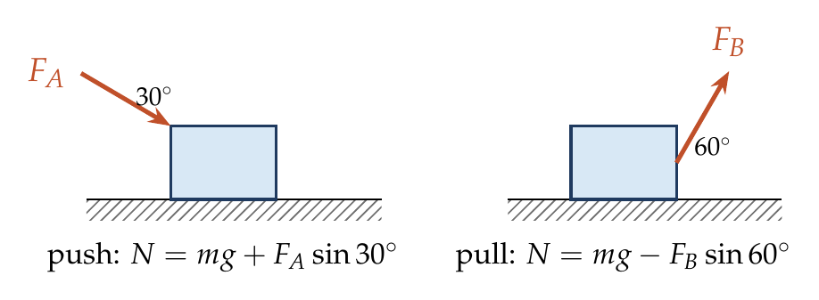
$$F_{A}=\frac{μmg}{cos{30}^{∘}−μsin{30}^{∘}}, F_{B}=\frac{μmg}{cos{60}^{∘}+μsin{60}^{∘}}.$$
$$\frac{F_{A}}{F_{B}}=\frac{cos{60}^{∘}+μsin{60}^{∘}}{cos{30}^{∘}−μsin{30}^{∘}}=\frac{\frac{1}{2}+\frac{3}{10}}{\frac{\sqrt{3}}{2}−\frac{\sqrt{3}}{10}}=\frac{4/5}{2\sqrt{3}/5}=\frac{2}{\sqrt{3}}.$$

Answer
(B) $\frac{2}{\sqrt{3}}$.

Watch out
• For a push the sin term is subtracted in the denominator; for a pull it is added.
Notes: Sec. 5.3 (least force to start a block moving; force at an angle).

Q11 · Critical push on a block at 60° [JEE Main 2021, 26 Feb, Shift 1]
ID 06FRI-0610-c9c2 · Code 0610 · Worksheet 06FRI_v1 Q11

Problem
As shown in the figure, a block of mass √3 kg is kept on a horizontal rough surface of coefficient of friction $1/\left(3\sqrt{3}\right)$. The critical force to be applied on the vertical surface as shown, at an angle of 60° with the horizontal, such that it does not move, will be 3x. The value of x will be?
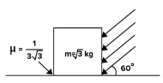

Hint
The push points down into the floor as well as sideways. Write the limiting condition with the larger N.

Think it through
- The force pushes the block sideways with F cos 60° and down into the floor with F sin 60°, so N = mg + F sin 60°.
- At the critical value, F cos 60° = μ(mg + F sin 60°).
- With μ = 1/(3√3): μ sin 60° = 1/6, so F(½ − 1/6) = μmg = (1/(3√3)) × 10√3 = 10/3.
- F/3 = 10/3, so F = 10 N, and 3x = 10 gives x ≈ 3.33.
- Note: if μ were as large as cot 60° = 1/√3, no push at 60° could ever move it (self-locking).

Worked solution
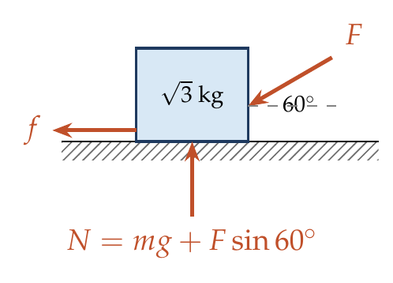
$$Fcos{60}^{∘}=μ\left(mg+Fsin{60}^{∘}\right) ⇒ F=\frac{μmg}{cos{60}^{∘}−μsin{60}^{∘}}=\frac{10/3}{\frac{1}{2}−\frac{1}{6}}=10 N.$$
$$3x=10 ⇒ x=\frac{10}{3}≈3.33.$$

Answer
x ≈ 3.33 (F = 10 N).

Watch out
• A push downward at an angle increases N; do not use N = mg.
Notes: Sec. 5.3 (force at an angle: normal reaction changes).

Q12 · Least force to slide a block
ID 06FRI-0610-4b7b · Code 0610 · Worksheet 06FRI_v1 Q12

Problem
A block of mass m is kept on a rough horizontal surface. The coefficient of static friction between the block and the surface is μ. The block is to be pulled by applying a force to it. What minimum force is needed to slide the block?
(A) $\frac{μ}{\sqrt{1+μ^{2}}}mg$ (B) $\frac{μ}{\sqrt{1−μ^{2}}}mg$ (C) $\sqrt{1+μ^{2}} mg$ (D) $μmg$

Hint
Pulling slightly upward reduces N and so the friction to beat. What angle balances that gain against losing forward pull?

Think it through
- Pulling at θ above the horizontal: limit F cos θ = μ(mg − F sin θ), so F = μmg/(cos θ + μ sin θ).
- F is least when cos θ + μ sin θ is largest, which happens at tan θ = μ (the angle of friction λ); its largest value is √(1 + μ²).
- So F_min = μmg/√(1 + μ²). (A)
- Check: this is less than μmg (option D, a horizontal pull), as it must be.
- Picture: the floor’s contact force leans back at most by λ; with mg, it and F form a triangle, and F is shortest when perpendicular to the contact force, i.e. at λ above the horizontal: F = mg sin λ.

No-pen route: angle of friction
The floor’s total contact force R leans at λ (tan λ = μ) from the vertical. The three forces mg, R and F close a triangle; F is shortest when perpendicular to R, giving F = mg sin λ = μmg/√(1 + μ²).

Worked solution
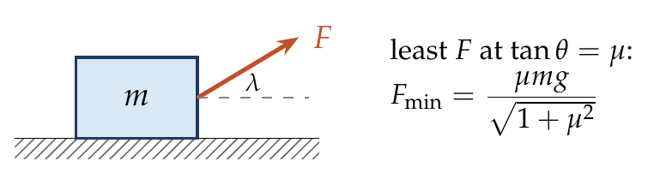
$$F\left(θ\right)=\frac{μmg}{cosθ+μsinθ}.$$
$cosθ+μsinθ=\sqrt{1+μ^{2}}cos\left(θ−λ\right)$ with $tanλ=μ$; its maximum is $\sqrt{1+μ^{2}}$, at $θ=λ$.
$$F_{min}=\frac{μmg}{\sqrt{1+μ^{2}}}.$$

Answer
(A) $\frac{μmg}{\sqrt{1+μ^{2}}}$, applied at $\tan^{−1}μ$ above the horizontal.

Watch out
• A horizontal pull (μmg) is not the least force.
Notes: Sec. 5.3 (least force to start a block moving); Sec. 5.2 (angle of friction).

Q13 · Minimum force to move a 1 kg body [JEE Main 2021, 17 Mar, Shift 2]
ID 06FRI-0610-ae09 · Code 0610 · Worksheet 06FRI_v1 Q13

Problem
A body of mass 1 kg rests on a horizontal floor with which it has a coefficient of static friction $1/\sqrt{3}$. It is desired to make the body move by applying the minimum possible force F newton. The value of F will be (rounded off to the nearest integer)?

Hint
The least force is applied at the angle of friction. What is that angle here?

Think it through
- The least force is applied at the angle of friction above the horizontal, and equals mg sin λ.
- tan λ = 1/√3, so λ = 30°.
- F = 10 × sin 30° = 5 N.

Worked solution
$$F_{min}=\frac{μmg}{\sqrt{1+μ^{2}}}=\frac{\left(1/\sqrt{3}\right)\left(10\right)}{2/\sqrt{3}}=5 N, at {30}^{∘} above the horizontal.$$

Answer
5 N.

Watch out
• μmg = 5.77 N is the horizontal pull, not the minimum.
Notes: Sec. 5.3 (least force at tan θ = μ).

Q14 · Boy pulling a rope tied to his own plank [JEE Main 2021, 17 Mar, Shift 2]
ID 06FRI-0610-e295 · Code 0610 · Worksheet 06FRI_v1 Q14

Problem
A boy of mass 4 kg is standing on a piece of wood having mass of 5 kg. If the coefficient of friction between the wood and the floor is 0.5, the maximum force the boy can exert on the rope so that the piece of wood does not move from its place is ….. N. (Round off to the nearest integer.)
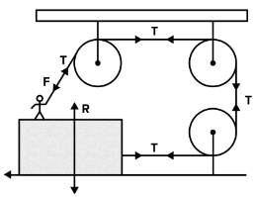

Hint
Take the boy and the wood as one system. Where does the rope cross its boundary, and in which directions does it pull?

Think it through
- Take boy + wood (90 N) as the system. The rope tension T acts on it twice: up at the boy’s hands, and horizontally on the wood.
- The upward pull reduces the floor’s normal force: N = 90 − T.
- The horizontal pull T is resisted by floor friction, at most 0.5(90 − T).
- Limit: T = 0.5(90 − T), so T = 30 N.
- The boy’s force on the rope equals T. Taking the rope at his hands as vertical (as the standard solution does) gives 30 N.

Worked solution
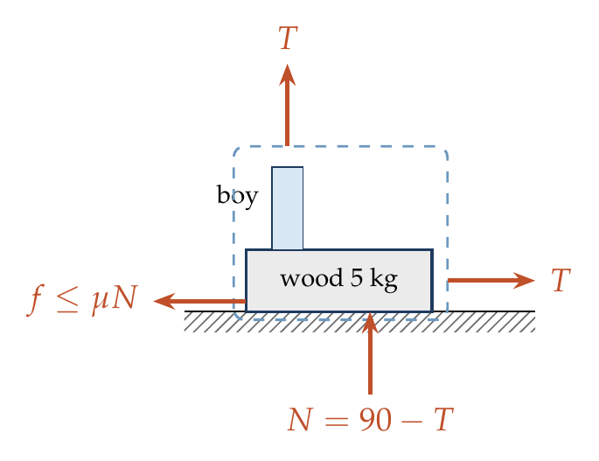
System: boy + wood. Vertical: $N=90−T$. Horizontal, limiting:
$$T=0.5\left(90−T\right) ⇒ T=30 N.$$

Answer
30 N.

Watch out
• The rope’s pull on the boy reduces N, so friction’s limit falls as he pulls harder.
• The figure draws the boy’s rope slightly slanted; the answer takes it as vertical.
Notes: Sec. 5.3 (an upward pull reduces the normal reaction); Sec. 2.1 (choose the system).

Q15 · Spring released between blocks on rough floors
ID 06FRI-0610-7d36 · Code 0610 · Worksheet 06FRI_v1 Q15

Problem
Two blocks of mass m and 2m are connected to the ends of a spring having spring constant k and natural length $l_{0}$. The spring is compressed by x such that |kx| = 0.5mg. The system is placed on a horizontal surface as shown. Find the initial acceleration of blocks m and 2m soon after the system is released.
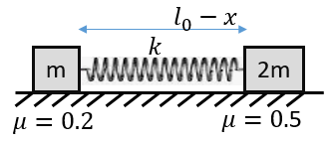
(A) 0.3g, 0.5g (B) 0.5g, 0.5g (C) 0.3g, zero (D) 0.2g, zero

Hint
For each block, compare the spring’s push with the largest static friction it can get. Only then decide whether it moves.

Think it through
- The spring pushes each block outward with 0.5mg.
- Block m: largest static friction 0.2mg, less than 0.5mg, so it slides; kinetic friction 0.2mg opposes, net 0.3mg, a = 0.3g.
- Block 2m: largest static friction 0.5 × 2mg = mg, more than 0.5mg, so it stays put; static friction is just 0.5mg and a = 0.
- So 0.3g and zero. (C)

Worked solution
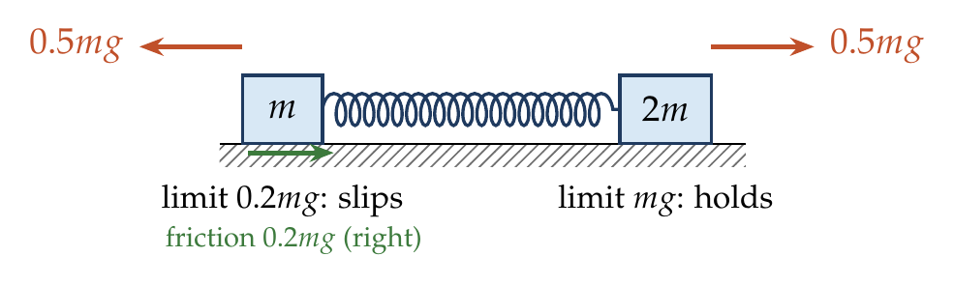
$m$: $0.5mg>0.2mg$ $⇒$ slides, $ma=0.5mg−0.2mg⇒a=0.3g$.
$2m$: $0.5mg<0.5\left(2mg\right)$ $⇒$ at rest, $a=0$.

Answer
(C) 0.3g, zero.

Watch out
• Test each block for slipping before using μN; the heavy block’s friction is only 0.5mg.
Notes: Sec. 5.1 (three states of friction; decide the state first); Sec. 1.1 (spring force).

Rough Inclined Plane

Q16 · Which way does friction act on a pushed block?
ID 06FRI-0615-39cd · Code 0615 · Worksheet 06FRI_v1 Q16

Problem
A small block of mass 0.1 kg lies on a fixed inclined plane PQ which makes an angle θ with the horizontal. A horizontal force of 1 N is applied on the block directed up the slope. The block remains stationary. Choose the INCORRECT statement:
(A) If the surface is smooth, the angle θ = 45°
(B) If the angle is θ < 45°, then the friction force must be acting up the slope
(C) If the angle is θ < 45°, then the friction force must be acting down the slope
(D) If the angle is θ > 45°, then the friction force must be acting up the slope

Hint
Ask “what if there were no friction?” Compare the push’s component up the slope with the weight’s component down it.

Think it through
- The weight is 1 N and the push is 1 N. Along the slope: the push gives 1 × cos θ up, the weight 1 × sin θ down.
- Smooth surface: rest needs cos θ = sin θ, so θ = 45°. (A) is correct.
- θ < 45°: cos θ > sin θ, so without friction the block would move up; friction acts down the slope. (C) is correct, (B) is not.
- θ > 45°: the block would slide down; friction acts up the slope. (D) is correct.
- The incorrect statement is (B).

Worked solution
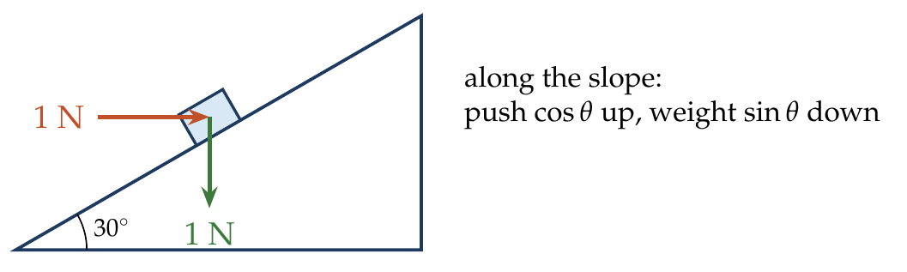
Along the incline (up positive), with $f$ up the slope:
$$1cosθ−\left(0.1\right)\left(10\right)sinθ+f=0 ⇒ f=sinθ−cosθ.$$
$θ<{45}^{∘}$: $f<0$ (down the slope); $θ>{45}^{∘}$: $f>0$ (up); $θ={45}^{∘}$: $f=0$.

Answer
(B) is incorrect.

Watch out
• The question asks for the incorrect statement.
Notes: Sec. 5.4 (force along an incline: direction of friction from “what if there were no friction”).

Q17 · Pressing a block into an incline to hold it
ID 06FRI-0615-83f5 · Code 0615 · Worksheet 06FRI_v1 Q17

Problem
A block A of mass 2 kg is placed on an inclined plane as shown, having μ = 0.5. Find the minimum force F that needs to be applied perpendicular to the inclined surface to prevent the block A from sliding down the slope.
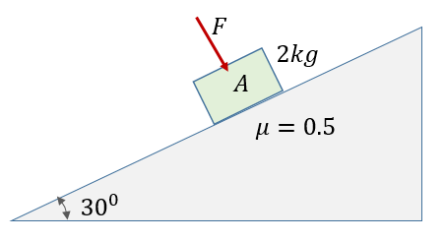
(A) 2.7 N (B) 5.4 N (C) 7.2 N (D) 10 N

Hint
A force into the surface does not push along the slope at all. What does it change?

Think it through
- The block alone would slide: tan 30° ≈ 0.58 exceeds μ = 0.5.
- F, pressing into the incline, adds directly to the normal force: N = mg cos 30° + F.
- Holding it needs μN ≥ mg sin 30° = 10 N, so N ≥ 20 N.
- mg cos 30° = 17.3 N, so F ≥ 2.7 N. (A)

Worked solution
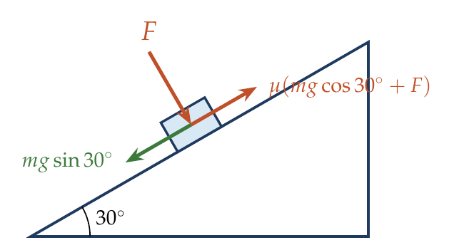
$$μ\left(mgcos{30}^{∘}+F\right)≥mgsin{30}^{∘} ⇒ 0.5\left(17.32+F\right)≥10 ⇒ F≥2.68 N.$$

Answer
(A) 2.7 N.

Watch out
• F works only through friction: it multiplies by μ, so it is not 10 N.
Notes: Sec. 5.4 (block on an incline: N and limiting friction).

Q18 · Block resting on a rough 37° incline
ID 06FRI-0615-11f6 · Code 0615 · Worksheet 06FRI_v1 Q18

Problem
A block of mass 5 kg is placed on a fixed plane inclined at 37° with the horizontal as shown. Find:
(i) the friction force acting on the block;
(ii) the contact force acting on the block;
(iii) the minimum force F acting along the slope required to make the block move down the slope;
(iv) the minimum force F acting along the slope required to make the block move up the slope.
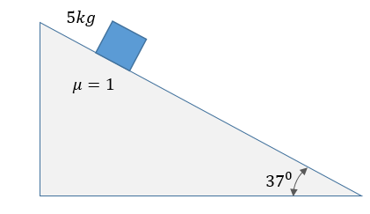

Hint
First decide whether the block slides by itself: compare mg sin 37° with μmg cos 37° (μ = 1 from the figure).

Think it through
- From the figure μ = 1. Down-slope pull: 50 × 0.6 = 30 N. Limiting friction: 1 × 50 × 0.8 = 40 N. 30 < 40, so the block stays at rest.
- (i) At rest, static friction is just enough: 30 N up the slope (not 40 N).
- (ii) The block is in equilibrium under its weight and the contact force alone, so the contact force is 50 N, vertically up (the resultant of N = 40 N and f = 30 N).
- (iii) To start it down, F plus the 30 N gravity pull must overcome the limiting 40 N: F = 10 N.
- (iv) To start it up, F must overcome gravity (30 N) and limiting friction now acting down (40 N): F = 70 N.

Worked solution
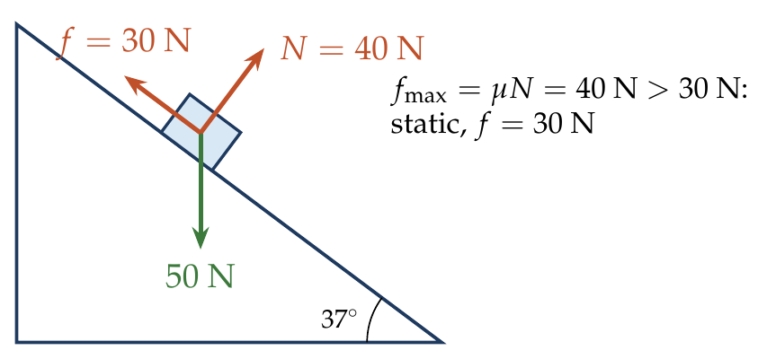
$mgsin{37}^{∘}=30$ N; $N=mgcos{37}^{∘}=40$ N; $f_{max}=μN=40$ N.
(i) $f=30$ N (up the slope). (ii) $R=\sqrt{{40}^{2}+{30}^{2}}=50$ N, vertical.
(iii) $F+30=40⇒F=10$ N. (iv) $F=30+40=70$ N.

Answer
(i) 30 N; (ii) 50 N (vertically up); (iii) 10 N; (iv) 70 N.

Watch out
• At rest the friction is 30 N, not μN = 40 N.
• μ = 1 is given only in the figure.
Notes: Sec. 5.4 (force along the incline: the two limits); Sec. 5.2 (contact force as one resultant).

Q19 · Retardation going up a rough 45° incline
ID 06FRI-0615-d582 · Code 0615 · Worksheet 06FRI_v1 Q19

Problem
A body is projected up a 45° rough incline. If the coefficient of friction is 0.5, then the retardation of the block is
(A) $\frac{g}{2\sqrt{2}}$ (B) $\frac{g}{\sqrt{2}}$ (C) $\frac{3g}{2\sqrt{2}}$ (D) $\frac{g}{2}$

Hint
Going up, which way does friction act relative to gravity’s component?

Think it through
- Moving up the slope, friction acts down the slope, along with gravity’s component.
- Retardation = g(sin 45° + μ cos 45°) = g(1 + 0.5)/√2 = 3g/(2√2). (C)
- (A) is the descending acceleration g(sin − μ cos), with friction reversed.

Worked solution
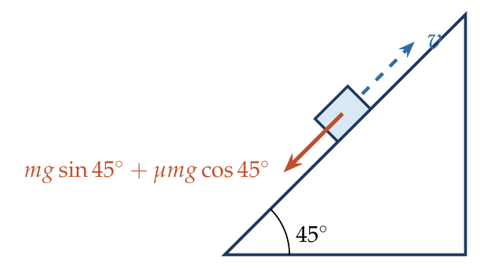
$$a_{up}=g\left(sin{45}^{∘}+μcos{45}^{∘}\right)=\frac{g}{\sqrt{2}}\left(1+0.5\right)=\frac{3g}{2\sqrt{2}}.$$

Answer
(C) $\frac{3g}{2\sqrt{2}}$.

Watch out
• Friction adds to gravity on the way up and opposes it on the way down.
Notes: Sec. 5.4 (block projected up the incline).

Q20 · Ascent takes half the time of descent [JEE Main 2021, 20 Jul, Shift 2]
ID 06FRI-0615-b54a · Code 0615 · Worksheet 06FRI_v1 Q20

Problem
A body of mass m is launched up on a rough inclined plane making an angle of 30° with the horizontal. The coefficient of friction between the body and the plane is $\frac{\sqrt{x}}{5}$. If the time of ascent is half the time of descent, then the value of x is:

Hint
Up and down cover the same distance, each from or to rest. How do the accelerations compare if one takes twice as long?

Think it through
- The block goes up and comes back the same distance, starting or ending at rest each way. So s = ½at², and t ∝ 1/√a.
- t_down = 2t_up means a_down = a_up/4.
- g(sin − μ cos) = ¼ g(sin + μ cos), so 3 sin 30° = 5μ cos 30°, and μ = (3/5) tan 30° = √3/5.
- √x/5 = √3/5, so x = 3.

Worked solution
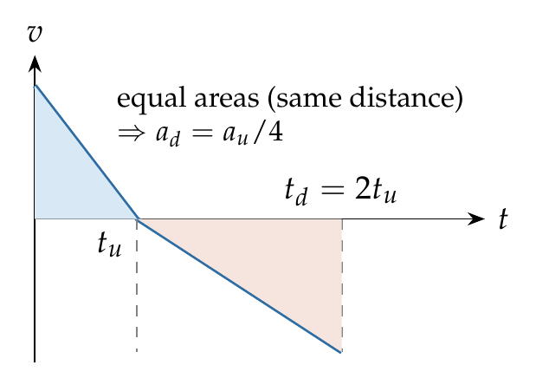
$$\frac{t_{u}}{t_{d}}=\sqrt{\frac{a_{d}}{a_{u}}}=\frac{1}{2} ⇒ \frac{sin{30}^{∘}−μcos{30}^{∘}}{sin{30}^{∘}+μcos{30}^{∘}}=\frac{1}{4} ⇒ μ=\frac{3}{5}tan{30}^{∘}=\frac{\sqrt{3}}{5}.$$
So $x=3$.

Answer
x = 3.

Watch out
• Time goes as 1/√a: half the time means four times the acceleration, not twice.
Notes: Sec. 5.4 (projected up the incline: ratio of times up and down).

Q21 · Sliding takes twice as long with friction
ID 06FRI-0615-a151 · Code 0615 · Worksheet 06FRI_v1 Q21

Problem
Starting from rest, a body slides down a 45° inclined plane in twice the time it takes to slide down the same distance in the absence of friction. The coefficient of friction between the body and the inclined plane is
(A) 0.2 (B) 0.25 (C) 0.75 (D) 0.5

Hint
Same distance from rest: how does the acceleration scale with the time?

Think it through
- From rest over a fixed distance, a ∝ 1/t². Twice the time means a quarter of the acceleration.
- g(sin 45° − μ cos 45°) = ¼ g sin 45°, so 1 − μ = ¼ and μ = 0.75. (C)
- Check: μ must stay below tan 45° = 1, or the body would not slide at all. 0.75 does.

Worked solution
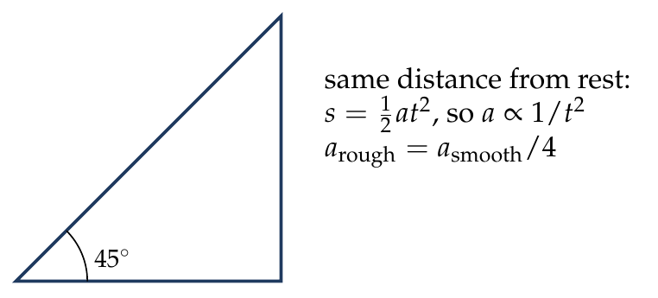
$$sin{45}^{∘}−μcos{45}^{∘}=1/4sin{45}^{∘} ⇒ μ=3/4tan{45}^{∘}=0.75.$$

Answer
(C) 0.75.

Watch out
• a ∝ 1/t², so twice the time gives a quarter of the acceleration.
Notes: Sec. 5.4 (block sliding down an incline).

Q22 · Smooth upper half, rough lower half [AIEEE 2005]
ID 06FRI-0615-4773 · Code 0615 · Worksheet 06FRI_v1 Q22

Problem
The upper half of an inclined plane with inclination φ is perfectly smooth while the lower half is rough. A body starting from rest at the top will again come to rest at the bottom if the coefficient of friction for the lower half is given by
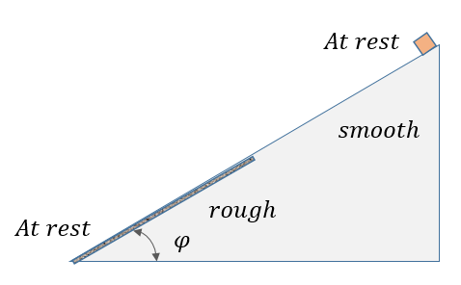
(A) tan φ (B) 2 sin φ (C) 2 tan φ (D) 2 cos φ

Hint
Speed gained on one half must be lost on the other, over the same length. What does that say about the two accelerations?

Think it through
- On the smooth half the body speeds up at g sin φ; on the rough half it must slow down by the same amount over the same length.
- Equal lengths and equal changes in v² mean equal and opposite accelerations: g(μ cos φ − sin φ) = g sin φ.
- So μ cos φ = 2 sin φ, μ = 2 tan φ. (C)
- Energy check: gravity does work over the whole length; friction only over half, so it must be twice gravity’s component.

Another way: work–energy
From rest to rest: mg sin φ × L = μmg cos φ × L/2, so μ = 2 tan φ.

Worked solution
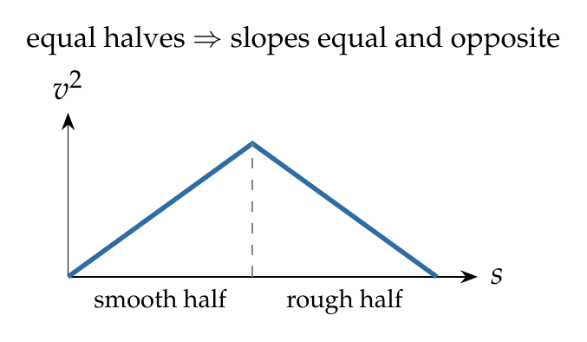
Each half has length $L/2$. Work–energy from rest at the top to rest at the bottom:
$$mgsinφ L−μmgcosφ \frac{L}{2}=0 ⇒ μ=2tanφ.$$

Answer
(C) 2 tan φ.

Watch out
• Friction acts only on half the length, so μ is twice tan φ, not tan φ.
Notes: Sec. 5.4 (block on an incline; sliding with friction).

Q23 · Coming to rest at the bottom of a part-rough incline [JEE Main 2020, 2 Sep, Shift 1]
ID 06FRI-0615-b66b · Code 0615 · Worksheet 06FRI_v1 Q23

Problem
A block of mass m starts slipping from the top of an inclined plane at B and comes to rest when it reaches the lowest point A of the inclined plane. If BC = 2AC and the friction coefficient of part AC is μ = k tan θ, then find the value of k.
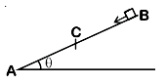
(A) 2 (B) ½ (C) 3 (D) 1/3

Hint
Over which length does gravity act, and over which does friction act? Balance their work.

Think it through
- As in the previous problem, take part BC as smooth (only AC is said to have friction).
- Gravity works over the whole length 3L (with AC = L); friction only over L.
- From rest to rest: mg sin θ × 3L = μmg cos θ × L, so μ = 3 tan θ and k = 3. (C)

Worked solution
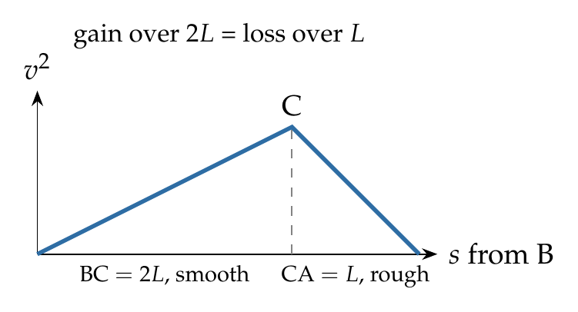
Let $AC=L$, $BC=2L$, BC smooth.
$$mgsinθ\left(3L\right)−μmgcosθ\left(L\right)=0 ⇒ μ=3tanθ, k=3.$$

Answer
(C) 3.

Watch out
• Gravity acts over the full 3L, friction only over L.
• BC is taken as smooth; the problem implies it but does not say so.
Notes: Sec. 5.4 (block on an incline; sliding with friction).

Q24 · Pushing up needs three times the holding force
ID 06FRI-0615-f28b · Code 0615 · Worksheet 06FRI_v1 Q24

Problem
The minimum force required to move a body up an inclined plane is three times the minimum force required to prevent it from sliding down the plane. If the coefficient of friction between the body and the inclined plane is $\frac{1}{2\sqrt{3}}$, the angle of the inclined plane is
(A) 60° (B) 45° (C) 30° (D) 15°

Hint
The two limiting forces differ only in the direction of friction. Write the ratio.

Think it through
- Moving up: friction down the slope, F_up = mg(sin θ + μ cos θ). Holding: friction up the slope, F_hold = mg(sin θ − μ cos θ).
- Ratio 3: sin θ + μ cos θ = 3 sin θ − 3μ cos θ, so tan θ = 2μ = 1/√3.
- θ = 30°. (C)

Worked solution
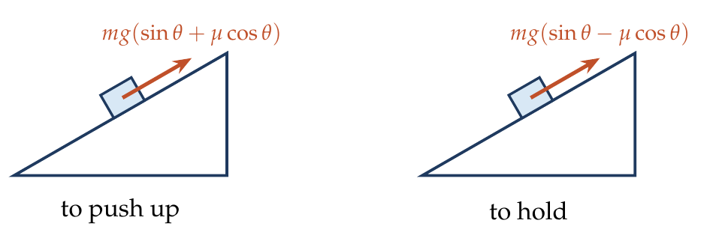
$$\frac{sinθ+μcosθ}{sinθ−μcosθ}=3 ⇒ tanθ=2μ=\frac{1}{\sqrt{3}} ⇒ θ={30}^{∘}.$$

Answer
(C) 30°.

Watch out
• The two forces differ only in friction’s direction; the weight component is the same.
Notes: Sec. 5.4 (force along an incline: the two limiting forces).

Q25 · Holding a block on a 45° incline against an extra push [JEE Main 2019, 9 Jan, Shift 1]
ID 06FRI-0615-3daa · Code 0615 · Worksheet 06FRI_v1 Q25

Problem
A block of mass 10 kg is kept on a rough inclined plane as shown in the figure. A force of 3 N is applied on the block. The coefficient of static friction between the plane and the block is 0.6. What should be the minimum value of force P, such that the block doesn’t move downward?
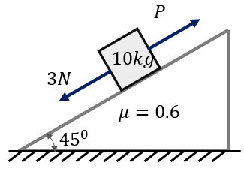
(A) 32 N (B) 25 N (C) 23 N (D) 18 N

Hint
On the verge of moving down, friction helps P. List what pulls down the slope.

Think it through
- Down the slope: gravity’s component mg sin 45° ≈ 70.7 N and the 3 N force.
- On the verge of moving down, friction acts up the slope at its limit: 0.6 × 70.7 ≈ 42.4 N.
- P + 42.4 = 70.7 + 3, so P ≈ 31.3 N.
- The nearest option is 32 N. (A) (With g = 9.8 the value is 30.7 N.)

Worked solution
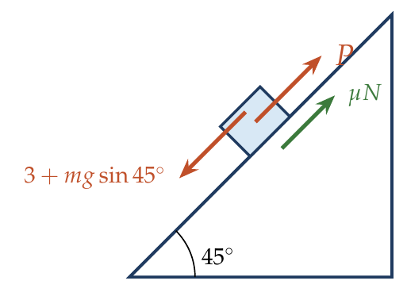
$$P+μmgcos{45}^{∘}=mgsin{45}^{∘}+3 ⇒ P=70.7+3−42.4=31.3 N.$$

Answer
(A) 32 N (exactly 31.3 N with g = 10).

Watch out
• The 3 N acts down the slope here, adding to gravity’s pull.
Notes: Sec. 5.4 (force along an incline: least force to prevent slipping).

Q26 · Same acceleration up as down [JEE Main 2018, 15 Apr, Shift 2]
ID 06FRI-0615-2f6f · Code 0615 · Worksheet 06FRI_v1 Q26

Problem
A body of mass 2 kg slides down with an acceleration of 3 m/s² on a rough inclined plane having a slope of 30°. The external force required to take the same body up the plane with the same acceleration will be:
(A) 14 N (B) 20 N (C) 6 N (D) 4 N

Hint
Use the given downhill motion to find the friction force. Then remember friction reverses when the body goes up.

Think it through
- Sliding down: 2 × 10 × ½ − f = 2 × 3, so f = 4 N.
- Going up at 3 m/s²: F must beat gravity’s 10 N and friction’s 4 N (now down the slope) and supply 6 N: F = 20 N. (B)
- Check: kinetic friction μmg cos 30° = 4 N gives μ ≈ 0.23, the same both ways, since N does not change when the motion reverses.

Worked solution
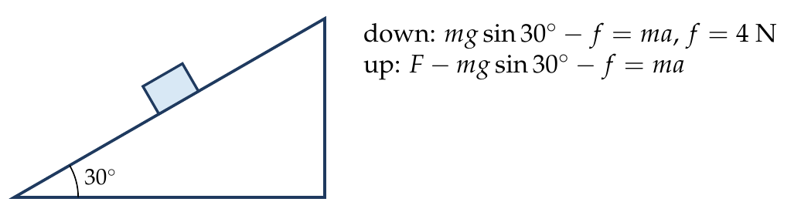
Down: $mgsin{30}^{∘}−f=ma⇒f=10−6=4$ N.
Up: $F−mgsin{30}^{∘}−f=ma⇒F=10+4+6=20$ N.

Answer
(B) 20 N.

Watch out
• Friction changes direction when the motion reverses.
Notes: Sec. 5.4 (kinetic friction on an incline).

Q27 · Returning at half the launch speed [JEE Main 2020, 3 Sep, Shift 2]
ID 06FRI-0615-7aa4 · Code 0615 · Worksheet 06FRI_v1 Q27

Problem
A block goes up a rough inclined plane of inclination 30° with initial speed v, and after some time it reaches back the starting point with speed v/2. The value of the coefficient of friction between the block and the inclined plane is close to N/1000. The nearest integer value of N is?

Hint
Same distance up and down: compare v² with (v/2)². What ratio of accelerations does that give?

Think it through
- Up: v² = 2a_u s. Down: (v/2)² = 2a_d s. So a_d = a_u/4.
- As in Q20, this gives μ = (3/5) tan 30° = √3/5 ≈ 0.3464.
- N = 346.

Worked solution
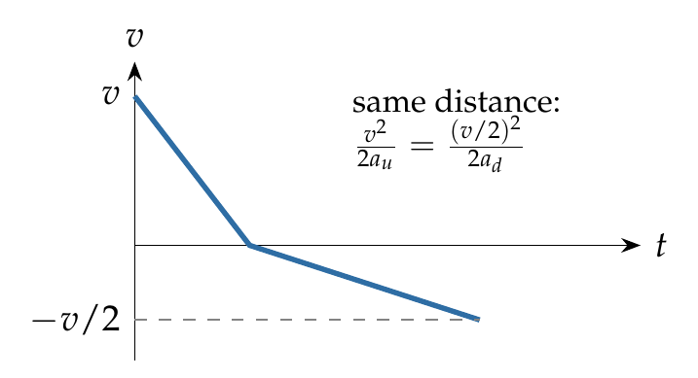
$$\frac{a_{d}}{a_{u}}=\frac{{\left(v/2\right)}^{2}}{v^{2}}=\frac{1}{4} ⇒ μ=\frac{3}{5}tan{30}^{∘}=0.3464 ⇒ N=346.$$

Answer
N = 346.

Watch out
• Speeds halve, so v² falls to a quarter: the accelerations are in the ratio 1 : 4.
Notes: Sec. 5.4 (block projected up the incline).

Q28 · Rough incline takes α times as long [JEE Main 2021, 1 Sep, Shift 1]
ID 06FRI-0615-f6d0 · Code 0615 · Worksheet 06FRI_v1 Q28

Problem
When a body slides down from rest along a smooth inclined plane making an angle of 30° with the horizontal, it takes time T. When the same body slides down from rest along a rough inclined plane making the same angle and through the same distance, it takes time αT, where α is a constant greater than 1. The coefficient of friction between the body and the rough plane is $\frac{1}{\sqrt{x}}\left(\frac{α^{2}−1}{α^{2}}\right)$; then the value of x is?

Hint
Same distance from rest: the accelerations are in the inverse ratio of the squared times.

Think it through
- a_rough = a_smooth/α².
- g(sin 30° − μ cos 30°) = g sin 30°/α², so μ = tan 30° × (α² − 1)/α².
- tan 30° = 1/√3, so x = 3.

Worked solution
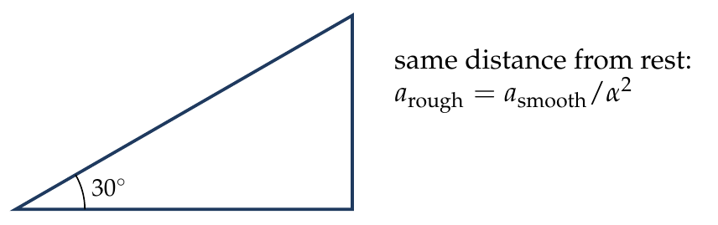
$$sin{30}^{∘}−μcos{30}^{∘}=\frac{sin{30}^{∘}}{α^{2}} ⇒ μ=tan{30}^{∘} \frac{α^{2}−1}{α^{2}}=\frac{1}{\sqrt{3}}\left(\frac{α^{2}−1}{α^{2}}\right).$$

Answer
x = 3.

Watch out
• Use α², not α: distance from rest goes as at².
Notes: Sec. 5.4 (block sliding down an incline).

Q29 · Two blocks in contact sliding down an incline
ID 06FRI-0615-9580 · Code 0615 · Worksheet 06FRI_v1 Q29

Problem
Figure shows two blocks in contact sliding down an inclined surface of inclination 37°. The friction coefficient between the block A of mass 2.0 kg and the incline is $μ_{1}$, and that between the block B of mass 4.0 kg and the incline is $μ_{2}$. Calculate the acceleration of the 2.0 kg block if
(i) $μ_{1}=0.20$ and $μ_{2}=0.30$;
(ii) $μ_{1}=0.30$ and $μ_{2}=0.20$.
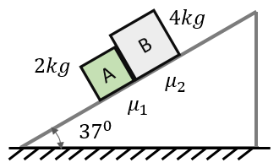

Hint
Imagine the blocks a little apart. Which would slide faster on its own? A push between them exists only if the upper block would catch the lower one.

Think it through
- Alone, each block would accelerate at g(0.6 − 0.8μ). A is the lower block.
- (i) A alone: 10(0.6 − 0.16) = 4.4; B alone: 10(0.6 − 0.24) = 3.6. A runs ahead, so they separate: A’s acceleration is 4.4 m/s².
- (ii) A alone: 3.6; B alone: 4.4. B catches A and pushes it, so they move together.
- Together: driving 6 × 6 = 36 N; friction 0.3 × 16 + 0.2 × 32 = 11.2 N. a = 24.8/6 = 4.13 m/s².
- Check: the contact force on A is 2(4.13) − (12 − 4.8) = 1.07 N > 0, so they do stay in contact.

Worked solution
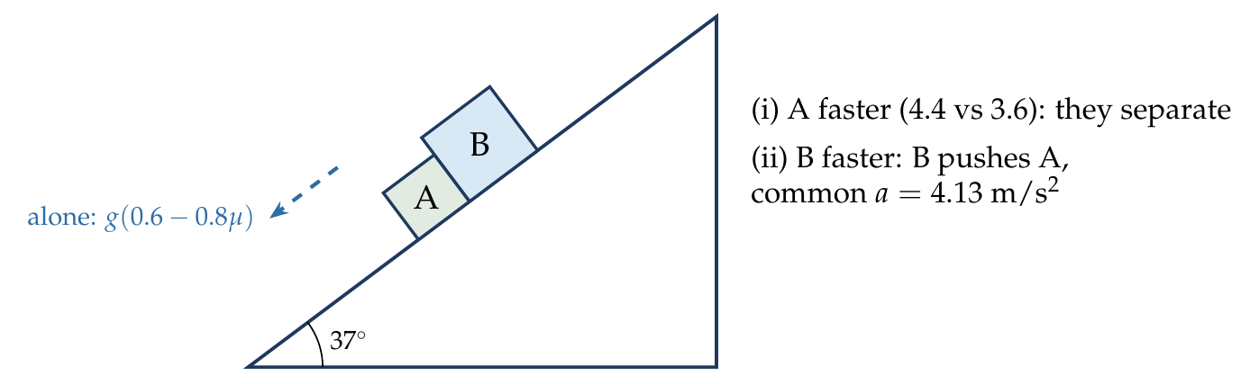
(i) $a_{A}=g\left(sin{37}^{∘}−μ_{1}cos{37}^{∘}\right)=10\left(0.6−0.16\right)=4.4$ m/s² (B lags behind: $a_{B}=3.6$).
(ii) Together:
$$a=gsin{37}^{∘}−\frac{\left(μ_{1}m_{A}+μ_{2}m_{B}\right)gcos{37}^{∘}}{m_{A}+m_{B}}=6−\frac{\left(0.6+0.8\right)\left(8\right)}{6}=4.13 {m/s}^{2}.$$

Answer
(i) 4.4 m/s²; (ii) 4.13 m/s² (both down the slope).

Watch out
• Decide first whether the blocks push each other: they do only if the upper block would go faster alone.
Notes: Sec. 5.4 (block sliding down an incline); Sec. 2.2 (blocks moving together).

Stacked Blocks & Relative Slipping

Q30 · Holding a block up between two pushed blocks
ID 06FRI-0620-49c3 · Code 0620 · Worksheet 06FRI_v1 Q30

Problem
A system of three blocks is being pushed by a horizontal force F as shown. The horizontal surface is smooth, whereas the coefficient of friction between A–B and B–C is μ. Find the minimum value of F to prevent block B from slipping down.
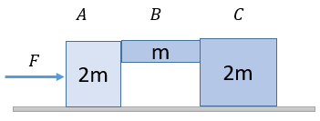
(A) $2mg/μ$ (B) $mg/μ$ (C) $2mg/3μ$ (D) $mg/2μ$

Hint
B is held up by friction on both faces. What normal force acts on each face, given that all three blocks accelerate together?

Think it through
- All three move together: a = F/5m.
- The push of A on B accelerates B and C (3m): N₁ = 3F/5. The push of B on C accelerates C (2m): N₂ = 2F/5.
- B is held up by friction on both faces, at most μ(N₁ + N₂) = μF in total.
- μF ≥ mg, so F ≥ mg/μ. (B)

Worked solution
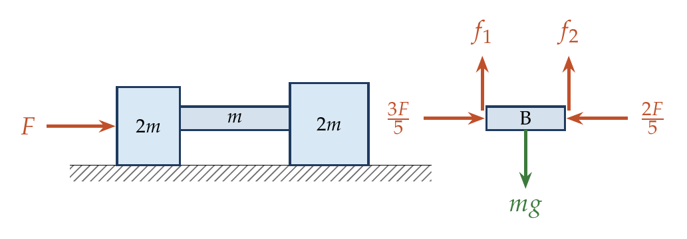
$$a=\frac{F}{5m}, N_{1}=3ma=\frac{3F}{5}, N_{2}=2ma=\frac{2F}{5}.$$
$$μ\left(N_{1}+N_{2}\right)≥mg ⇒ F≥\frac{mg}{μ}.$$

Answer
(B) $\frac{mg}{μ}$.

Watch out
• The two faces carry different normal forces (3F/5 and 2F/5); add both frictions.
Notes: Sec. 2.2 (contact force accelerates the blocks ahead); Sec. 5.1 (limiting friction).

Q31 · Suitcase dropped on a moving belt
ID 06FRI-0620-3295 · Code 0620 · Worksheet 06FRI_v1 Q31

Problem
A suitcase is gently dropped on a conveyor belt moving at 3 m/s. If the coefficient of friction between the belt and the suitcase is 0.5, find the displacement of the suitcase relative to the conveyor belt before the slipping between the two stops.
(A) 2.7 m (B) 1.8 m (C) 0.9 m (D) 1.2 m

Hint
Friction speeds the suitcase up until it matches the belt. Draw both on one v–t graph: the gap between the lines is the relative displacement.

Think it through
- Friction drags the suitcase forward at a = μg = 5 m/s² until it reaches 3 m/s, after 0.6 s.
- In 0.6 s the suitcase moves ½ × 5 × 0.36 = 0.9 m; the belt moves 3 × 0.6 = 1.8 m.
- Relative to the belt the suitcase slips 0.9 m backwards. (C)
- Relative-frame check: in the belt’s frame the suitcase starts at 3 m/s backwards and decelerates at 5 m/s²: 3²/(2 × 5) = 0.9 m.

No-pen route: belt frame
In the belt’s frame the suitcase starts at 3 m/s and stops under 5 m/s²: s = v²/2a = 9/10 = 0.9 m.

Worked solution
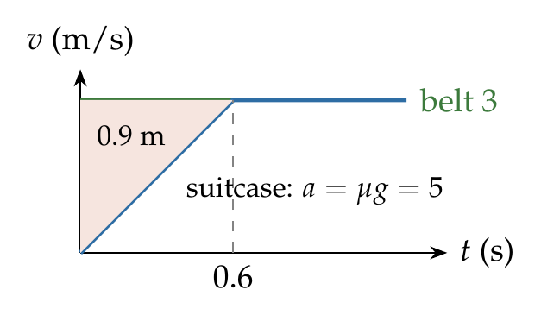
$a=μg=5$ m/s², $t=3/5=0.6$ s.
$$s_{rel}=3\left(0.6\right)−1/2\left(5\right){\left(0.6\right)}^{2}=1.8−0.9=0.9 m (backwards on the belt).$$

Answer
(C) 0.9 m, backwards relative to the belt.

Watch out
• The suitcase’s own ground displacement (0.9 m) happens to equal the relative one here; do not confuse them in general.
Notes: Sec. 5.5 (unequal velocities: friction acts until they are equal); Sec. 4.1 (conveyor belt).

Q32 · Block sliding on a long plank
ID 06FRI-0620-d52c · Code 0620 · Worksheet 06FRI_v1 Q32

Problem
A small block of mass m is placed on the left end of a long plank of mass 4m, which rests on a smooth surface. The coefficient of friction between the block and the plank is 0.1. The block is given a sudden blow which imparts a velocity of 4 m/s. Find:
(i) the initial accelerations of the block and the plank;
(ii) the time taken for the block and plank to acquire the same velocity;
(iii) the friction force acting after this time;
(iv) the distances travelled by the block and the plank till that time;
(v) the minimum length of the plank for the block not to fall off.
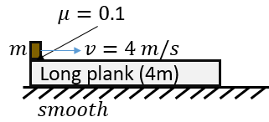

Hint
Friction acts only while the velocities differ: it slows the block and drives the plank. Draw both on one v–t graph.

Think it through
- (i) Kinetic friction μmg = 0.1mg: the block decelerates at 1 m/s²; the plank (4m) accelerates at 0.1mg/4m = 0.25 m/s².
- (ii) Equal velocities: 4 − t = 0.25t, so t = 3.2 s, common velocity 0.8 m/s.
- (iii) After that they move together on a smooth floor with no external horizontal force: friction is zero.
- (iv) Block: 4 × 3.2 − ½ × 3.2² = 7.68 m. Plank: ½ × 0.25 × 3.2² = 1.28 m.
- (v) The block slides 7.68 − 1.28 = 6.4 m along the plank, so the plank must be at least 6.4 m long.
- Check by momentum: 4m = 5m × v gives v = 0.8 m/s, as above.

Another way: plank frame
Relative to the plank the block starts at 4 m/s and decelerates at 1 + 0.25 = 1.25 m/s²: it stops relative to the plank after 4/1.25 = 3.2 s, having slid 4²/(2 × 1.25) = 6.4 m.

Worked solution
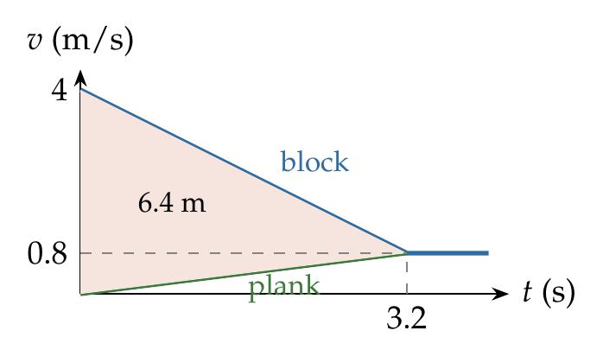
$a_{block}=−μg=−1$ m/s², $a_{plank}=\frac{μmg}{4m}=0.25$ m/s².
$4−t=0.25t⇒t=3.2$ s; $v=0.8$ m/s.
$s_{b}=4\left(3.2\right)−1/2\left(1\right){\left(3.2\right)}^{2}=7.68$ m; $s_{p}=1/2\left(0.25\right){\left(3.2\right)}^{2}=1.28$ m.
Relative slide $=6.4$ m; afterwards $f=0$.

Answer
(i) 1 m/s² (retarding) and 0.25 m/s²; (ii) 3.2 s; (iii) zero; (iv) 7.68 m and 1.28 m; (v) 6.4 m.

Watch out
• Once the velocities are equal, friction is zero (no force tries to make them slip).
Notes: Sec. 5.5 (block on block: unequal velocities).

Q33 · Pulling the lower of two stacked blocks [JEE Main 2021, 26 Aug, Shift 2]
ID 06FRI-0620-aa8c · Code 0620 · Worksheet 06FRI_v1 Q33

Problem
The coefficient of static friction between two blocks is 0.5 and the table is smooth. The maximum horizontal force that can be applied to move the blocks together is ….. N.
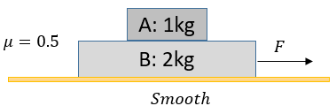

Hint
Which block is moved only by friction? Its largest acceleration sets the limit.

Think it through
- F acts on B (lower). A is moved only by friction from B, at most μ m_A g, so A’s acceleration is at most μg = 5 m/s².
- Moving together, both have 5 m/s²: F = (1 + 2) × 5 = 15 N.
- Check: a larger F would need A to accelerate faster than friction allows, so A would slip back on B.

Worked solution
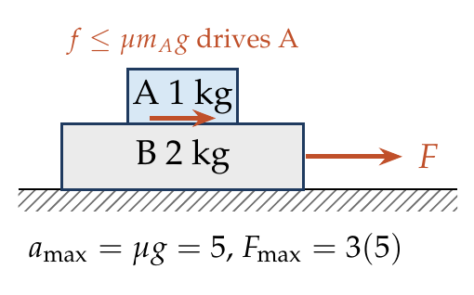
$$a_{max}=μg=5 {m/s}^{2}, F_{max}=\left(m_{A}+m_{B}\right)a_{max}=3\left(5\right)=15 N.$$

Answer
15 N.

Watch out
• With F on the lower block, a_max = μg, independent of the masses.
Notes: Sec. 5.5 (largest common acceleration: force on the lower block).

Q34 · Stacked blocks on a rough table [JEE Main 2019, 10 Apr, Shift 2]
ID 06FRI-0620-aa21 · Code 0620 · Worksheet 06FRI_v1 Q34

Problem
Two blocks A and B of masses 1 kg and 3 kg respectively are kept on the table as shown in the figure. The coefficient of friction between A and B and between B and the surface of the table is also 0.2. The maximum force F that can be applied on B horizontally so that the block A does not slide over block B is:
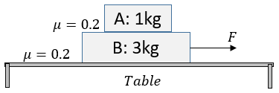
(A) 12 N (B) 16 N (C) 8 N (D) 40 N

Hint
A’s largest acceleration is set as before. Now the floor’s friction on the pair must be beaten as well.

Think it through
- A is driven only by friction: a_max = μg = 2 m/s².
- The table’s friction on the pair (sliding) is 0.2 × 40 = 8 N.
- Whole system: F − 8 = 4 × 2, so F = 16 N. (B)
- (C) 8 N is only the table friction; (A) ignores it in a different way.

Worked solution
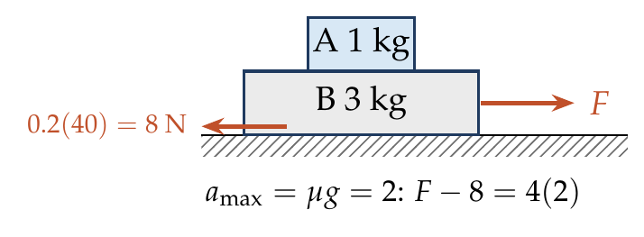
$$a_{max}=μg=2 {m/s}^{2}, F−μ\left(m_{A}+m_{B}\right)g=\left(m_{A}+m_{B}\right)a ⇒ F=8+8=16 N.$$

Answer
(B) 16 N.

Watch out
• The table’s friction uses the total weight (40 N).
Notes: Sec. 5.5 (force on the lower block; largest common acceleration).

Q35 · Pulling the upper of two stacked blocks
ID 06FRI-0620-4767 · Code 0620 · Worksheet 06FRI_v1 Q35

Problem
The maximum value of F so that the blocks do not have relative motion between block A and B:
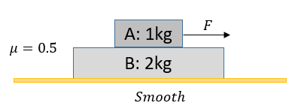
(A) 15 N (B) 10 N (C) 7.5 N (D) 5 N

Hint
F acts on the upper block this time. Which block is now moved only by friction?

Think it through
- F acts on A (upper). B is moved only by friction from A, at most μ m_A g = 0.5 × 10 = 5 N.
- So B’s largest acceleration is 5/2 = 2.5 m/s².
- Moving together: F = 3 × 2.5 = 7.5 N. (C)
- 15 N would be the answer if F acted on B (Q33’s situation).

Worked solution
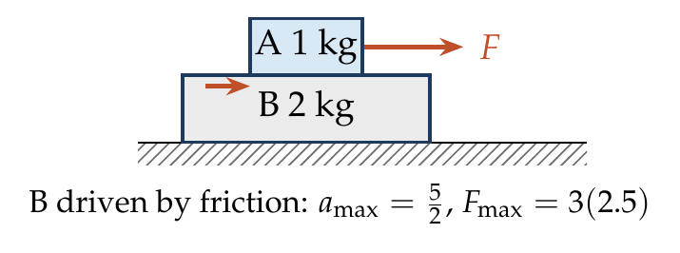
$$a_{max}=\frac{μm_{A}g}{m_{B}}=\frac{5}{2}=2.5 {m/s}^{2}, F_{max}=\left(m_{A}+m_{B}\right)a_{max}=7.5 N.$$

Answer
(C) 7.5 N.

Watch out
• With F on the upper block, the limit is set by the lower block’s acceleration μm_Ag/m_B.
Notes: Sec. 5.5 (largest common acceleration: force on the upper block).

Q36 · From the upper-block limit to the lower-block limit [JEE Main 2014, 9 Apr (Online)]
ID 06FRI-0620-ef7f · Code 0620 · Worksheet 06FRI_v1 Q36

Problem
A block A of mass 4 kg is placed on another block B of mass 5 kg, and the block B rests on a smooth horizontal table. If the minimum force that can be applied on block A so that it slips over B is 12 N, then the maximum force that can be applied on block B for the blocks to move together will be?
(A) 48 N (B) 27 N (C) 15 N (D) 40/3 N

Hint
The friction limit f is the same in both cases. Which block does it drive in each case?

Think it through
- Same limiting friction f = μ m_A g both times.
- Force on A: B is driven by f, so a = f/m_B and F_A = (m_A + m_B) f/m_B = 9f/5 = 12, giving f = 20/3 N.
- Force on B: A is driven by f, so a = f/m_A and F_B = 9f/4 = 9 × (20/3)/4 = 15 N. (C)
- Shortcut: F_B/F_A = m_B/m_A = 5/4, so F_B = 15 N.

No-pen route: ratio
F_B/F_A = m_B/m_A = 5/4, so F_B = 12 × 5/4 = 15 N.

Worked solution
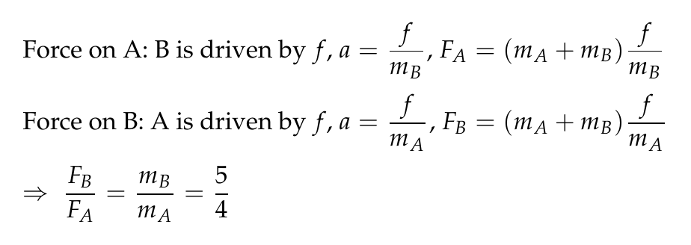
$$μm_{A}g=f, 12=\left(m_{A}+m_{B}\right)\frac{f}{m_{B}}⇒f=\frac{20}{3} N \left(μ=1/6\right).$$
$$F_{B}=\left(m_{A}+m_{B}\right)\frac{f}{m_{A}}=9⋅\frac{20/3}{4}=15 N.$$

Answer
(C) 15 N.

Watch out
• “Minimum force to make A slip” is the same threshold as “maximum force to move together” with F on A.
Notes: Sec. 5.5 (largest common acceleration: both cases).

Friction in Pulley & Connected Systems

Q37 · Largest hanging mass that keeps a block at rest
ID 06FRI-0625-904b · Code 0625 · Worksheet 06FRI_v1 Q37

Problem
The coefficient of static friction between block A of mass 2 kg and the table as shown in the figure is 0.2. What can be the maximum mass of block B so that the two blocks do not move? The string and the pulley are assumed to be smooth and massless.
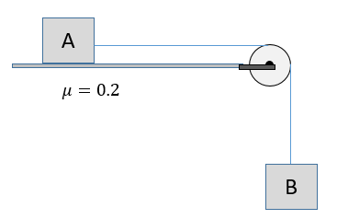
(A) 0.2 kg (B) 0.4 kg (C) 2 kg (D) 4 kg

Hint
At rest, the string tension equals B’s weight. What is the most friction A can supply?

Think it through
- At rest, the tension equals B’s weight, and friction on A balances the tension.
- The most friction A can get is 0.2 × 20 = 4 N.
- So m_B g ≤ 4 N and m_B ≤ 0.4 kg. (B)

Worked solution
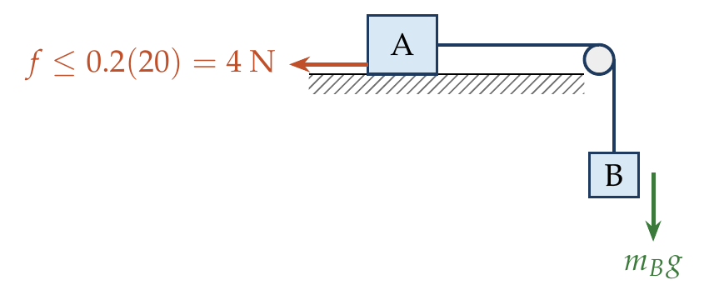
$$m_{B}g=T≤μm_{A}g=0.2\left(2\right)\left(10\right)=4 N ⇒ m_{B}≤0.4 kg.$$

Answer
(B) 0.4 kg.

Watch out
• Friction depends on A’s weight only; B hangs freely.
Notes: Sec. 5.1 (limiting friction); Sec. 3 (ideal pulley: same tension).

Q38 · Finding both friction coefficients from T and a
ID 06FRI-0625-6cdc · Code 0625 · Worksheet 06FRI_v1 Q38

Problem
If the tension in the string in the figure is 16 N and the acceleration of each block is 0.5 m/s², find the friction coefficients $μ_{1}$ and $μ_{2}$ at the two contacts with the blocks.
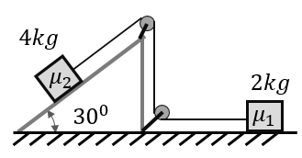
(A) 0.25, 0.06 (B) 0.5, 0.5 (C) 0.6, 0.2 (D) 0.75, 0.06

Hint
With T and a known, each block gives one equation in one unknown. Which way does each block move?

Think it through
- The 4 kg block slides down the 30° incline and drags the 2 kg block along the floor towards the pulley.
- 2 kg block: T − μ₁(20) = 2 × 0.5, so 16 − 20μ₁ = 1 and μ₁ = 0.75.
- 4 kg block: 40 sin 30° − T − μ₂(40 cos 30°) = 4 × 0.5, so 20 − 16 − 34.6μ₂ = 2 and μ₂ ≈ 0.058.
- So μ₁ = 0.75, μ₂ ≈ 0.06. (D)

Worked solution
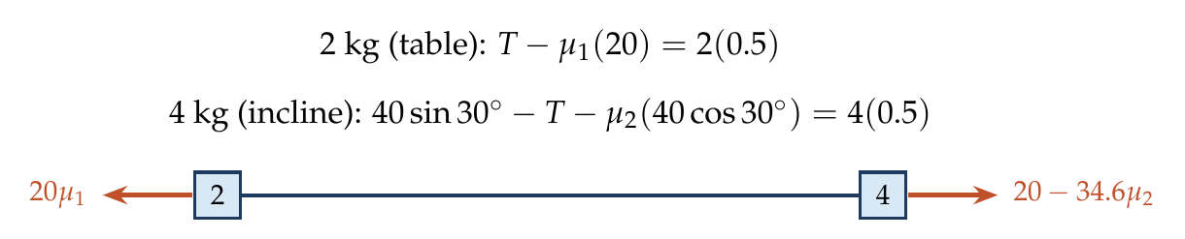
2 kg: $16−20μ_{1}=1⇒μ_{1}=0.75$.
4 kg: $20−16−40cos{30}^{∘} μ_{2}=2⇒μ_{2}=\frac{2}{34.64}≈0.058$.

Answer
(D) μ₁ = 0.75, μ₂ ≈ 0.06.

Watch out
• Each block can be solved alone because T is given; no need to add the equations.
Notes: Sec. 3 (separate FBDs for bodies on opposite sides of a pulley); Sec. 5.4 (friction on an incline).

Q39 · Block on an incline at constant speed
ID 06FRI-0625-b9cf · Code 0625 · Worksheet 06FRI_v1 Q39

Problem
Two blocks are connected over a massless pulley as shown in figure. The mass of block A is 10 kg and the coefficient of kinetic friction is 0.2. Block A slides down the incline at constant speed.
(i) What is the mass of block B?
(ii) What should be the mass of B if A slides up the slope with constant velocity?
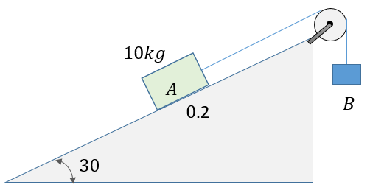

Hint
Constant speed means zero net force. Which way does friction act on A in each case?

Think it through
- Constant velocity: forces balance, and T = m_B g.
- A’s weight component down the slope: 50 N. Kinetic friction: 0.2 × 100 cos 30° = 17.3 N, opposite to A’s motion.
- (i) A moving down: friction up the slope. T = 50 − 17.3 = 32.7 N, so m_B = 3.27 kg.
- (ii) A moving up: friction down the slope. T = 50 + 17.3 = 67.3 N, so m_B = 6.73 kg.

Worked solution
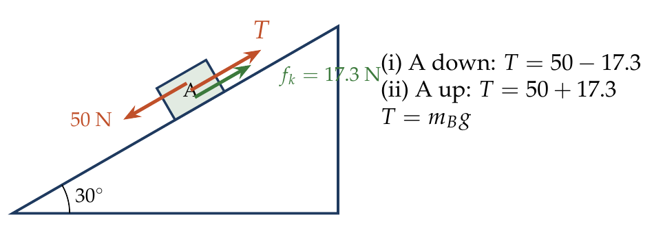
$f_{k}=0.2\left(100\right)cos{30}^{∘}=17.32$ N.
(i) $m_{B}g=50−17.32⇒m_{B}=3.27$ kg. (ii) $m_{B}g=50+17.32⇒m_{B}=6.73$ kg.

Answer
(i) 3.27 kg; (ii) 6.73 kg.

Watch out
• Friction’s direction flips with the direction of motion, so the two answers differ by 2f/g.
Notes: Sec. 5.4 (friction on an incline); Sec. 2 (constant velocity means zero net force).

Q40 · Extra load to stop a sliding system [JEE Main 2018 (Offline)]
ID 06FRI-0625-b9b9 · Code 0625 · Worksheet 06FRI_v1 Q40

Problem
Two masses $m_{1}$ = 5 kg and $m_{2}$ = 10 kg, connected by an inextensible string over a frictionless pulley, are moving as shown in the figure. The coefficient of friction of the horizontal surface is 0.15. The minimum weight m that should be put on top of $m_{2}$ to stop the motion is:
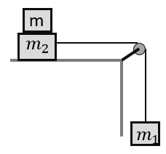
(A) 10.3 kg (B) 23.3 kg (C) 27.3 kg (D) 43.3 kg

Hint
To stop, the friction on the table block must at least match the hanging weight.

Think it through
- The hanging 5 kg pulls with 50 N. To stop the motion, friction on m₂ + m must reach at least 50 N.
- 0.15(10 + m) × 10 ≥ 50, so 10 + m ≥ 33.3 and m ≥ 23.3 kg. (B)
- Strictly, with exactly 23.3 kg the system moves at constant speed; any more makes it slow down and stop.

Worked solution
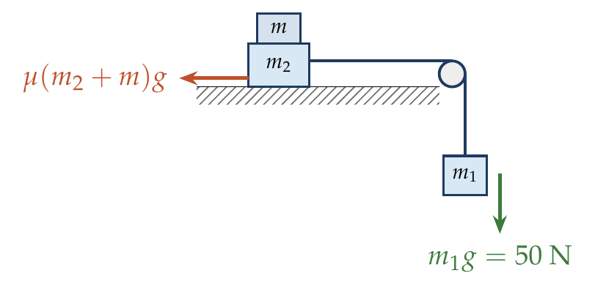
$$μ\left(m_{2}+m\right)g≥m_{1}g ⇒ m≥\frac{m_{1}}{μ}−m_{2}=\frac{5}{0.15}−10=23.3 kg.$$

Answer
(B) 23.3 kg.

Watch out
• The added mass increases N on the table; friction uses m₂ + m.
Notes: Sec. 5.1 (limiting and kinetic friction); Sec. 3 (shortcut: net driving force along the string).

Q41 · Stacked blocks tied over a wall pulley
ID 06FRI-0625-678c · Code 0625 · Worksheet 06FRI_v1 Q41

Problem
Two blocks are placed one above the other as shown and are connected with a string and pulley as shown. The strings are horizontal. The coefficient of friction between the two blocks is 0.1 and 0.2 between the 4 kg block and the floor. Find the minimum force F required to cause slipping.
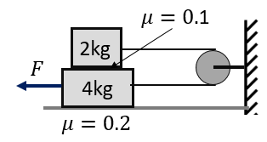
(A) 8 N (B) 12 N (C) 14 N (D) 16 N

Hint
When the 4 kg block moves left, which way does the 2 kg block go? Then list every friction on the 4 kg block.

Think it through
- The string runs from the 2 kg block round the wall pulley to the 4 kg block. If the 4 kg block moves left, the 2 kg block moves right: they slip against each other.
- 2 kg block, on the verge: T = 0.1 × 20 = 2 N.
- 4 kg block: F must beat T (the string pulls it right), the 2 kg block’s friction on it (2 N, right) and the floor’s friction 0.2 × 60 = 12 N (right).
- F = 2 + 2 + 12 = 16 N. (D)

Worked solution
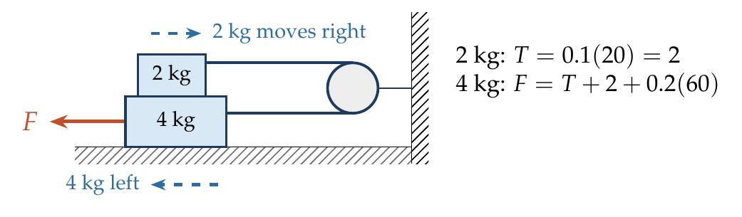
2 kg: $T=0.1\left(2\right)\left(10\right)=2$ N.
4 kg: $F=T+0.1\left(20\right)+0.2\left(60\right)=2+2+12=16$ N.

Answer
(D) 16 N.

Watch out
• The floor’s normal force carries both blocks (60 N).
• The block-on-block friction acts on both blocks, so it appears twice in total (in T and on the 4 kg block).
Notes: Sec. 5.5 (block on block: friction opposes relative slipping); Sec. 3 (constraint: string length constant).

Q42 · Pulling a rough block through a slanting string [L2]
ID 06FRI-0625-6ae3 · Code 0625 · Worksheet 06FRI_v1 Q42

Problem
Two blocks of 2 kg and 4 kg are connected by a massless string which makes an angle of 37° with the horizontal. Both are placed on a horizontal surface such that μ = 0.2 under the 2 kg block. The friction between the 4 kg block and the surface is negligible. Find the minimum horizontal force F needed to make the blocks move.
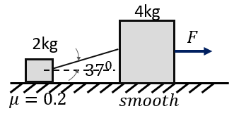
(A) 4 N (B) 1.5 N (C) 6 N (D) 3.5 N

Hint
The slanting string lifts the 2 kg block a little as it pulls. Write the limiting condition with the reduced N.

Think it through
- At the threshold nothing accelerates, so the smooth 4 kg block passes F straight on: T cos 37° = F.
- The string pulls the 2 kg block up at 37°, so N = 20 − 0.6T.
- Limit: 0.8T = 0.2(20 − 0.6T), so 0.92T = 4 and T ≈ 4.35 N.
- F = 0.8T ≈ 3.5 N. (D)

Worked solution
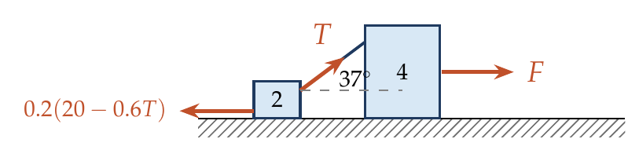
$$Tcos{37}^{∘}=μ\left(mg−Tsin{37}^{∘}\right) ⇒ 0.8T=0.2\left(20−0.6T\right) ⇒ T=4.35 N.$$
$$F=Tcos{37}^{∘}=3.48 N≈3.5 N.$$

Answer
(D) 3.5 N.

Watch out
• The string’s upward component reduces N on the 2 kg block.
Notes: Sec. 5.3 (force at an angle: an upward pull reduces N).

Friction with Variable Forces & Accelerated Frames

Q43 · Box sliding off an accelerating truck
ID 06FRI-0630-3cf8 · Code 0630 · Worksheet 06FRI_v1 Q43

Problem
The rear side of a truck is open and a box of mass 20 kg is placed on the truck 4 m away from the rear end. The truck starts from rest with an acceleration of 2 m/s² on a straight road. What is the distance moved by the truck before the box starts to fall off? (μ = 0.15)
(A) 4 m (B) 8 m (C) 16 m (D) 32 m

Hint
Can friction give the box the truck’s acceleration? If not, work in the truck’s frame: how fast does the box drift back?

Think it through
- Friction can give the box at most μg = 1.5 m/s², less than the truck’s 2 m/s². So the box slips back.
- Relative to the truck, the box accelerates backwards at 2 − 1.5 = 0.5 m/s² from rest.
- It covers the 4 m to the rear end when ½ × 0.5 × t² = 4, i.e. t = 4 s.
- In 4 s the truck moves ½ × 2 × 16 = 16 m. (C)
- In the ground frame the box moves forward 12 m meanwhile; the truck moves 16 m; the difference is the 4 m.

Another way: ground frame
Box: s_b = ½(1.5)t²; truck: s_t = ½(2)t². s_t − s_b = 4 gives t² = 16, and s_t = 16 m.

Worked solution
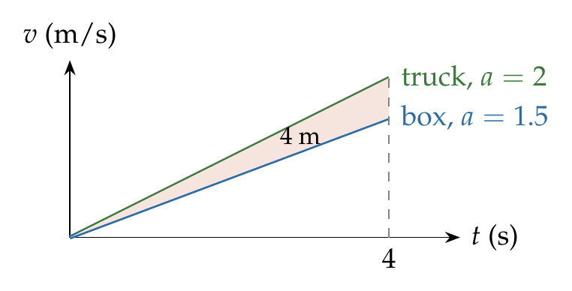
$a_{box}=μg=1.5$ m/s² $<2$ m/s², so the box slips. Truck frame (pseudo force $ma_{0}$ backwards):
$$a_{rel}=2−1.5=0.5 {m/s}^{2}, 4=1/2\left(0.5\right)t^{2} ⇒ t=4 s.$$
$$s_{truck}=1/2\left(2\right){\left(4\right)}^{2}=16 m.$$

Answer
(C) 16 m.

Watch out
• The question asks how far the truck moves, not the box (12 m) or the slip (4 m).
• Check first that the box slips: μg < a.
Notes: Sec. 5.5 (friction drives a body until velocities match; largest acceleration μg); Sec. 7.6 (pseudo force in an accelerated frame).

