Take g = 10 m/s² unless stated otherwise.

Laws of Friction; Angle of Friction & Repose
- A homogeneous chain of length L lies on a table. The coefficient of friction between the chain and the table is μ. The maximum length which can hang over the table without slipping is? (The vertical portion of table is smooth)
(A) $\frac{μ}{1+μ}L$ (B) $\frac{1-μ}{μ}L$ (C) $\frac{1-μ}{1+μ}L$ (D) $μL$
- [JEE Main 2021, 24 Feb, Shift 1] The coefficient of static friction between a wooden block of mass 0.5 kg and a vertical rough wall is 0.2. The magnitude of horizontal force that should be applied on the block to keep it adhered to the wall will be ….. N.
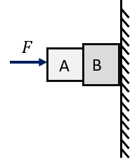
- [JEE Main 2015 (Offline)] Given in the figure are two blocks A and B of weight 20 N and 100 N, respectively. These are being pressed against a wall by a force F as shown. If the coefficient of friction between the blocks is 0.1 and between block B and the wall is 0.15, the frictional force applied by the wall on block B is :
(A) 100 N (B) 80 N
(C) 120 N (D) 150 N

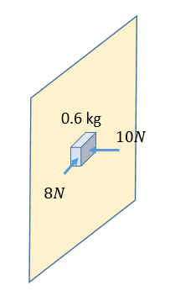
- A block of mass 0.6 kg is pressed against a vertical wall by a force of 10 N acting perpendicular to the surface. A horizontal force of 8 N is acting on the block. Find the acceleration of the block if the coefficient of friction between the block and the wall is 0.25.
(A) 5 $ms^{-2}$ (B) 10 $ms^{-2}$
(C) 12.5 $ms^{-2}$ (D) zero

- [JEE Main 2021, 24 Feb, Shift 1] An inclined plane is bent in such a way that the vertical cross-section is given by $y=\frac{x^{2}}{4}$ where y is in vertical and x in horizontal direction. If the upper surface of this curved plane is rough with coefficient of friction μ = 0.5, the maximum height in cm at which a stationary block will not slip downwards is ….. cm.
- [JEE Main 2020, 6 Sep, Shift 1] An insect is at the bottom of a hemispherical ditch of radius 1 m. It crawls up the ditch but starts slipping after it is at height h from the bottom. If the coefficient of friction between the ground and the insect is 0.75, then h is?
(A) 0.20 m (B) 0.45 m (C) 0.60 m (D) 0.80 m

Rough Horizontal Surface; Force at an Angle
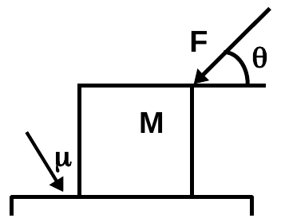
- A block of mass M lies on a rough surface of coefficient of friction μ. A force is applied on it at an angle θ to the horizontal as shown, and the block is at rest. The frictional force acting on the block will be
(A) F cosθ (B) μ(mg + F sinθ)
(C) μ (mg − F sinθ) (D) μmg

- [JEE Main 2021, 16 Mar, Shift 1] A block of mass m slides along a floor while a force of magnitude F is applied to it at an angle θ as shown. The coefficient of kinetic friction is $μ_{K}$. Then the blocks acceleration is given by:
(A) $-\frac{F}{m} cosθ-μ_{K}(g-\frac{F}{m} sinθ)$ (B) $\frac{F}{m} cosθ-μ_{K}(g-\frac{F}{m} sinθ)$
(C) $\frac{F}{m} cosθ-μ_{K}(g+\frac{F}{m} sinθ)$ (D) $\frac{F}{m} cosθ+μ_{K}(g-\frac{F}{m} sinθ)$
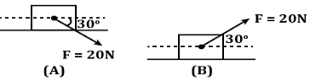
- [JEE Main 2019, 12 Apr, Shift 2] A block of mass 5 kg is (i) pushed in case (A) and (ii) pulled in case (B), by a force F = 20 N, making an angle of $30°$ with the horizontal, as shown. The coefficient of friction between the block and the floor is 0.2. The difference between the accelerations of the block, in case (B) and case (A) will be:
(A) 0.4 m/s² (B) 3.2 m/s² (C) 0.8 m/s² (D) 0 m/s²

- [JEE Main 2014, 19 Apr (Online)] A heavy block is to be dragged along a rough horizontal floor. To do so, a person A pushes at angle of 30° with the horizontal and requires a minimum force of F_{A} while the person B pulls the block at an angle of 60° with the horizontal and needs a minimum force of F_{B}. If the coefficient of friction between the floor and block is $\sqrt{3}$ /5, then the ratio of F_{A} and F_{B} is?
(A) $\sqrt{\frac{3}{2}}$ (B) $\frac{2}{\sqrt{3}}$ (C) $\frac{5}{\sqrt{3}}$ (D) $\sqrt{3}$
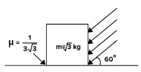
- [JEE Main 2021, 26 Feb, Shift 1] As shown in the figure, a block of mass $\sqrt{3}$ kg is kept on a horizontal rough surface of coefficient of friction of $1/3\sqrt{3}$. The critical force to be applied on the vertical surface as shown at an angle of $60°$ with horizontal such that it does not move will be 3x. The value of x will be?

- A block of mass m is kept on a rough horizontal surface. The coefficient of static friction between the block and the surface is μ. The block is to be pulled by applying a force to it. What minimum force is needed to slide the block?
(A) $\frac{μ}{\sqrt{1+μ^{2}}}mg$ (B) $\frac{μ}{\sqrt{1-μ^{2}}}mg$ (C) $\sqrt{1+μ^{2}}mg$ (D) $μmg$
- [JEE Main 2021, 17 Mar, Shift 2] A body of mass 1 kg rests on a horizontal floor with which it has a coefficient of static friction $1/\sqrt{3}$. It is desired to make the body move by applying minimum possible force F newton. The value of F will be (rounded off to the nearest integer)?
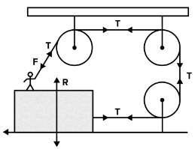
- [JEE Main 2021, 17 Mar, Shift 2] A boy of mass 4 kg is standing on a piece of wood having mass of 5 kg. If the coefficient of friction between the wood and the floor is 0.5, the maximum force the boy can exert on the rope so that the piece of wood does not move from its place is ….. N. (round off to nearest integer)

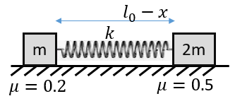
- Two blocks of mass ‘m’ and ‘2m’ are connected to ends of a spring having spring constant of $k$ and natural length of $l_{0}$. The spring is compressed by $x$ such that $\left|kx\right|=0.5mg$. The system is placed on a horizontal surface as shown. Find the initial acceleration of block ‘m’ and ‘2m’ soon after the system is released?
(A) 0.3g, 0.5g (B) 0.5g, 0.5 g
(C) 0.3g, zero (D) 0.2g, zero

Rough Inclined Plane
- A small block of mass 0.1 kg lies on fixed inclined plane PQ which makes an angle θ with the horizontal. A horizontal force of 1 N is applied on the block directed up the slope. The block remains stationary. Choose INCORRECT statement:
(A) If surface is smooth, the angle θ = $45°$
(B) If the angle is θ < $45°$, then the friction force must be acting up the slope
(C) If the angle is θ < $45°$, then the friction force must be acting down the slope
(D) If the angle is θ > $45°$, then the friction force must be acting up the slope
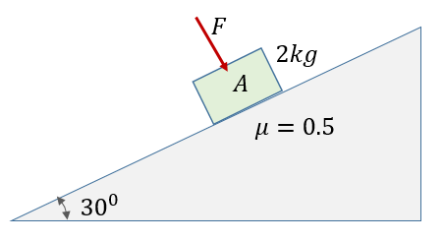
- A block A of mass 2 kg is placed on an inclined plane as shown having $μ$=0.5. Find the minimum force F that need to be applied perpendicular to the inclined surface to prevent the block A from sliding down the slope.
(A) 2.7 N (B) 5.4 N
(C) 7.2 N (D) 10 N

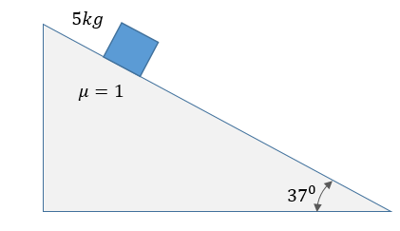
- A block of mass 5 kg is placed on a fixed plane inclined at $37°$ with the horizontal as shown. Find:
(i) Friction force acting on the block
(ii) The contact force acting on the block
(iii) Minimum force F acting along the slope required to make the block move down the slope
(iv) Minimum force F acting along the slope required to make the block move up the slope

- A body is projected up a $45°$ rough incline. If the coefficient of friction is 0.5, then the retardation of the block is
(A) $\frac{g}{2\sqrt{2}}$ (B)$\frac{g}{\sqrt{2}}$ (C) $\frac{3g}{2\sqrt{2}}$ (D) $\frac{g}{2}$
- [JEE Main 2021, 20 Jul, Shift 2] A body of mass m is launched up on a rough inclined plane making an angle of $30°$ with the horizontal. The coefficient of friction between the body and the plane is $\frac{\sqrt{x}}{5}$. If the time of ascent is half the time of descent, then the value of x is:
- Starting from rest, a body slides down an $45°$ incline-plane in twice the time it takes to slide down the same distance in the absence of friction. The co-efficient of friction between the body and the inclined plane is
(A) 0.2 (B) 0.25 (C) 0.75 (D) 0.5
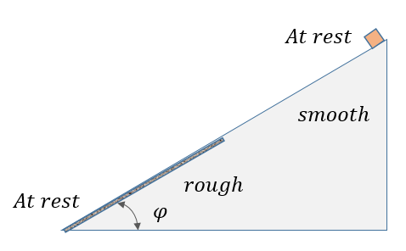
- [AIEEE 2005] The upper half of an inclined plane with inclination $φ$ is perfectly smooth while the lower half is rough. A body starting from rest at the top will again come to rest at the bottom if the coefficient of friction for the lower half is given by
(A) tan φ (B) 2 sin φ
(C) 2 tan φ (D) 2 cos φ

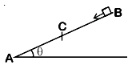
- [JEE Main 2020, 2 Sep, Shift 1] A block of mass m starts slipping from the top of inclined plane at B and comes to rest when reaches the lowest point A of the inclined plane. If BC = 2AC and friction coefficient of part AC is $μ=ktanθ$then find the value of K?
(A) 2 (B)$½$
(C) $3$ (D) $1/3$

- The minimum force required to move a body up an inclined plane is three times the minimum force required to prevent it from sliding down the plane. If the coefficient of friction between the body and the inclined plane is $\frac{1}{2\sqrt{3}}$, the angle of the inclined plane is
(A) 60° (B) 45° (C) 30° (D) 15°
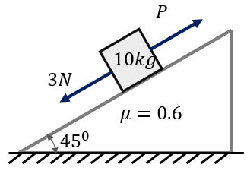
- [JEE Main 2019, 9 Jan, Shift 1] A block of mass 10 kg is kept on a rough inclined plane as shown in the figure. A force of 3 N is applied on the block. The coefficient of static friction between the plane and the block is 0.6. What should be the minimum value of force P, such that the block doesn’t move downward?
(A) 32 N (B) 25 N
(C) 23 N (D) 18 N

- [JEE Main 2018, 15 Apr, Shift 2] A body of mass 2 kg slides down with an acceleration of 3 m/s² on a rough inclined plane having a slope of 30°. The external force required to take the same body up the plane with the same acceleration will be :
(A) 14 N (B) 20 N (C) 6 N (D) 4 N
- [JEE Main 2020, 3 Sep, Shift 2] A block goes up the rough inclined plane of inclination $30°$ with initial speed $v$, and after some time it reaches back the starting point with speed $v/2$. The value of coefficient of friction between the block and the inclined plane is close to N/1000. The nearest integer value of N is?
- [JEE Main 2021, 1 Sep, Shift 2] When a body slides down from rest along a smooth inclined plane making an angle of $30°$ with the horizontal, it takes time T. When the same body slides down from rest along a rough inclined plane making the same angle and through the same distance, it takes time αT, where α is a constant greater than 1. The coefficient of friction between the body and the rough plane is $\frac{1}{\sqrt{x}}\left(\frac{α^{2}-1}{α^{2}}\right);$ then the value of x is?
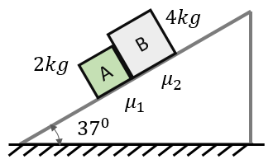
- Figure shows two blocks in contact sliding down an inclined surface of inclination 37°. The friction coefficient between the block A of mass 2.0 kg and the incline is μ₁, and that between the block B of mass 4.0 kg and the incline is μ₂. Calculate the acceleration of the 2.0 kg block if
(i) μ₁ = 0.20 and μ₂ = 0.30,
(ii) μ₁ = 0.30 and μ₂ = 0.20.

Stacked Blocks & Relative Slipping
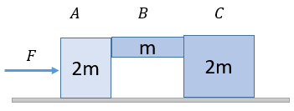
- A system of three blocks is being pushed by a horizontal force F as shown. The horizontal surface is smooth, whereas the coefficient of friction between A-B and B-C is $μ$. Find minimum value of F to prevent block B from slipping down?
(A) $2mg/μ$ (B) $mg/μ$
(C) $2mg/3μ$ (D) $mg/2μ$

- A suitcase is gently dropped on a conveyor belt moving at 3 m/s. If the coefficient of friction between the belt and the suitcase is 0.5. Find the displacement of suitcase relative to conveyor belt before the slipping between the two is stopped
(A) 2.7 m (B) 1.8 m (C) 0.9 m (D) 1.2 m
- A small block of mass ‘m’ is placed on the left-end of a long plank of mass 4 m which rests on a smooth surface. The coefficient of friction between the block and the plank is 0.1. The block is given a sudden blow which imparts a velocity of 4 m/s. Find:
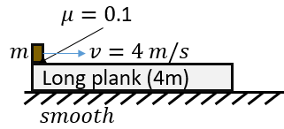
(i) initial acceleration of block and plank
(ii) time taken for slipping block and plank to acquire same velocity
(iii) what will the friction force acting after this time
(iv) the distance travelled by block and plank till that time
(v) what must be the minimum length of plank for the block to not fall off

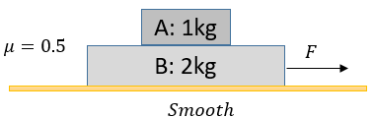
- [JEE Main 2021, 26 Aug, Shift 2] The coefficient of static friction between two blocks is 0.5 and the table is smooth. The maximum horizontal force that can be applied to move the blocks together is ….. N.

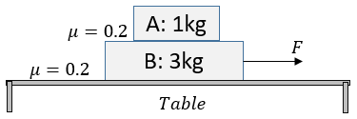
- [JEE Main 2019, 10 Apr, Shift 2] Two blocks A and B of masses 1 kg and 3 kg respectively are kept on the table as shown in the figure. The coefficient of friction between A and B and between B and the surface of the table is also 0.2. The maximum force F that can be applied on B horizontally so that the block A does not slide over block B is:
(A) 12 N (B) 16 N (C) 8 N (D) 40 N

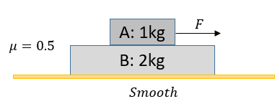
- The maximum value of F so that blocks do not have relative motion between block A and B:
(A) 15 N (B) 10 N
(C) 7.5 N (D) 5 N

- [JEE Main 2014, 9 Apr (Online)] A block A of mass 4 kg is placed on another block B of mass 5 kg, and the block B rests on smooth horizontal table. If the minimum force that can be applied on block A so that it slips over B is 12 N, then the maximum force that can be applied on block B for the blocks to move together will be?
(A) 48 N (B) 27 N (C) 15 N (D) 40/3 N

Friction in Pulley & Connected Systems
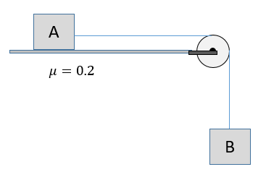
- The coefficient of static friction between block A of mass 2 kg and the table as shown in figure is 0.2. What can be the maximum mass value of the block B so that the two blocks do not move? The string and the pulley are assumed to be smooth and massless.
(A) 0.2 kg (B) 0.4 kg
(C)2 kg (D) 4 kg

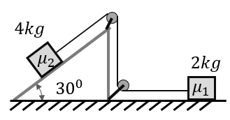
- If the tension in the string in the figure is 16 N and the acceleration of each block is 0.5 m/s², find the friction coefficients at the two contacts with the blocks $μ_{1}$ and $μ_{2}$?
(A) 0.25, 0.06 (B) 0.5, 0.5
(C) 0.6, 0.2 (D) 0.75, 0.06

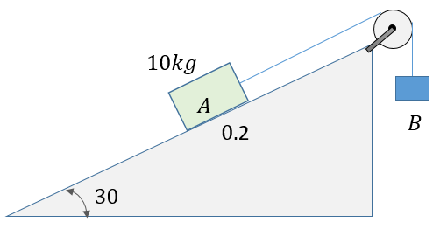
- Two blocks are connected over a massless pulley as shown in figure. The mass of block A is 10 kg and the coefficient of kinetic friction is 0.2. Block A slides down the incline at constant speed.
(i) The mass of the block B in kg is?
(ii) What should be the mass of B if A slides up the slope with constant velocity?

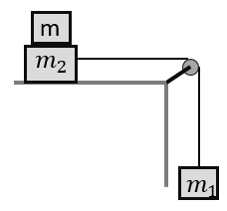
- [JEE Main 2018 (Offline)] Two masses $m_{1}$ = 5 kg and $m_{2}$ = 10 kg, connected by an inextensible string over a frictionless pulley, are moving as shown in the figure. The coefficient of friction of horizontal surface is 0.15. The minimum weight m that should be put on top of $m_{2}$ to stop the motion is:
(A) 10.3 kg (B) 23.3 kg
(C) 27.3 kg (D) 43.3 kg

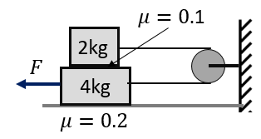
- Two blocks are placed one-above-other as shown and are connected with string and pulley as shown. The strings are horizontal. The coefficient of friction between two blocks is 0.1 and 0.2 between 4 kg block and the floor. Find the minimum force F required to cause slipping?
(A) 8 N (B) 12 N
(C) 14 N (D) 16 N

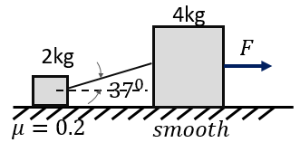
- [L2] Two blocks of 2 kg and 4 kg are connected by a massless string which makes an angle of $37°$ with the horizontal. Both are placed on a horizontal surface such that $μ=0.2$ between 2 kg block. The friction between 4 kg block and the surface is negligible. Find minimum horizontal force F needed to make the block move?
(A) 4 N (B) 1.5 N
(C) 6 N (D) 3.5 N

Friction with Variable Forces & Accelerated Frames
- The rear side of a truck is open and a box of mass 20 kg is placed on the truck 4 m away from the rear end. The truck starts from rest with an acceleration of 2 m/$s^{2}$on a straight road. The distance moved by the truck before the box starts to fall off? ($μ=0.15)$
(A) 4 m (B) 8 m (C) 16 m (D) 32 m

Answer Key
Laws of Friction; Angle of Friction & Repose
Q1 | A | Q2 | 25 | Q3 | C
Q4 | C | Q5 | 25 | Q6 | A
Rough Horizontal Surface; Force at an Angle
Q7 | A | Q8 | B | Q9 | C
Q10 | B | Q11 | 3.33 | Q12 | A
Q13 | 5 | Q14 | 30 | Q15 | C
Rough Inclined Plane
Q16 | B | Q17 | A | Q18 | (i) 30 N (ii) 50 N (iii) 10 N (iv) 70 N
Q19 | C | Q20 | 3 | Q21 | C
Q22 | C | Q23 | C | Q24 | C
Q25 | A | Q26 | B | Q27 | 346
Q28 | 3 | Q29 | (i) 4.4 m/s²; (ii) 4.13 m/s²
Stacked Blocks & Relative Slipping
Q30 | B | Q31 | C | Q32 | (i) 1 $ms^{-2}$, 0.25 $ms^{-2}$, (ii) 3.2 sec; (iii) zero, (iv) 7.68 m and 1.28 m, (v) 6.4 m
Q33 | 15 | Q34 | B | Q35 | C
Q36 | C
Friction in Pulley & Connected Systems
Q37 | B | Q38 | D | Q39 | (i) 3.27 kg (ii) 6.73 kg
Q40 | B | Q41 | D | Q42 | D
Friction with Variable Forces & Accelerated Frames
Q43 | C

Hints & Solutions
Laws of Friction; Angle of Friction & Repose
Q3 Hint
(Though not explicitly mentioned, it is implied that there is no slipping)
Rough Horizontal Surface; Force at an Angle
Q7 Hint
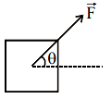
Q12 Think further
(In which direction should this force act? Answer: $\tan^{-1}{μ}$ with horizontal)

