Take g = 10 m/s² unless stated otherwise.

2D/3D Motion in Vector & Calculus Form
- A particle with initial velocity $3\hat{i}+4\hat{j}$ has an acceleration of $0.4\hat{i}+0.3\hat{j}$. Its speed after 10 sec is?
(A) 10 units (B) 7 units (C) 7$\sqrt{2}$ units (D) 8.5 units
- Velocity of a particle at time t = 0 is 2 m/s. A constant acceleration of 2 m/$s^{2}$ acts on the particle for 2 seconds at an angle of 60° with its initial velocity. Find the magnitude of velocity and displacement of particle at the end of t = 2 s.
(A) $2\sqrt{7} m/s, 2\sqrt{3}m$ (B) $2\sqrt{7} m/s, 4\sqrt{3}m$ (C) $4\sqrt{7} m/s, 2\sqrt{3}m$ (D) $\sqrt{7} m/s, 2\sqrt{3}m$
- [JEE Main 2019, 11 Jan, Shift 2] A particle moves from the point $\left(2\hat{i}+4\hat{j}\right)$m, at t = 0 with initial velocity $\left(5\hat{i}+4\hat{j}\right)ms^{-1}$. It is acted upon by a constant force which produces a constant acceleration $\left(4\hat{i}+4\hat{j}\right)ms^{-2}$. What is the distance of the particle from the origin at time 2 s?
(A) 20 $\sqrt{2}$ m (B) 10 $\sqrt{2}$ m (C) 5 m (D) 15 m
- [JEE Main 2021, 16 Mar, Shift 2] A mosquito is moving with a velocity $\vec{v}=0.5t^{2}\hat{i}+3t\hat{j}+9\hat{k}$m/s and accelerating in uniform conditions. What will be the direction of mosquito after 2 s ?
(A) $\tan^{-1}(\frac{2}{3})$from y-axis (B) $\tan^{-1}(\frac{\sqrt{117}}{2})$from x-axis
(C) $\tan^{-1}(\frac{5}{2})$from x-axis (D) $\tan^{-1}(\frac{2}{3})$from x-axis
- [JEE Main 2020, 4 Sep, Shift 1] A particle at origin is moving with initial velocity $\vec{u}=5 m/s\hat{j}$ and a constant acceleration $10\hat{i}+4\hat{j} m/s^{2}$. At time t, its co-ordinates are $(20 m, y_{0} m)$. The value of t and $y_{0}$ respectively are:
(A) 2 s and 18 m (B) 5 s and 25 m (C) 2 s and 24 m (D) 4 s and 52 m
- A particle leaves the origin with an initial velocity $\vec{u}=3\hat{i}$ m/s and a constant acceleration $\vec{a}=-\hat{i}+0.5\hat{j}$ m/$s^{2}$. Its position vector $\vec{r}$ when it reaches its maximum x–co–ordinate are?
(A) $\frac{9}{2}\hat{i}+\frac{9}{4}\hat{j}$ (B) $\frac{9}{4}\hat{i}+\frac{9}{4}\hat{j}$ (C) $\frac{5}{2}\hat{i}+\frac{5}{2}\hat{j}$ (D) $\frac{5}{2}\hat{i}+\frac{5}{4}\hat{j}$
- The x and y coordinates of a particle at any time t are given by x = 7t + 4t² and y = 5t, where x and y are in m and t in s. The acceleration of the particle at t = 5 s is?
(A) $8\hat{i}+5\hat{j}$ (B) $4\hat{i}+5\hat{j}$ (C) $8\hat{i}+2\hat{j}$ (D) $8\hat{i}$
- The position vector of a particle is given as $\vec{r}=\left(t^{2}-4t+6\right)\hat{i}+(t^{2})\hat{j}$. The time ‘t’ when the velocity vector and acceleration vector become perpendicular to each other is?
(A) 1 sec (B) 1.5 sec (C) 2 sec (D) never
- A particle starts from the origin at t = 0 with a velocity of $\vec{u}=8\hat{j}$ m/s and moves in the xy plane with a constant acceleration of $\vec{a}=4\hat{i}+2\hat{j}$ m/s². At the instant the particle’s x–coordinate is 32 m, what are (i) its y–coordinate and (ii) its speed?
- [JEE Main 2021, 16 Mar, Shift 2] A body of mass 2 kg moves under a force of 2$\hat{i}+3\hat{j}+5\hat{k}N$. It starts from rest and was at the origin initially. After 4 s, its new coordinates are (8, b, 20). The value of b is _____(Round off to the nearest Integer)
- The co-ordinates of a particle moving in x-y plane at any time t are (2t, t²). Find (i) the trajectory of the particle (ii) velocity of particle at time t?
- A particle moves in space along the path $z=ax^{3}+by^{2}$ in such a way that $\frac{dx}{dt}=c=\frac{dy}{dt};$ where a, b and c are constants. The acceleration of the particle is?
- [JEE Main 2019, 9 Jan, Shift 2] In three dimensional system, the position coordinates of a particle (in motion) are given as: $x=acosωt, y=asinωt, z=aωt$. The speed of the particle will be:
(A) $\sqrt{2} aω$ (B) $2aω$ (C) $aω$ (D) $\sqrt{3} aω$
- [L2] [JEE Main 2019, 9 Jan, Shift 1] The velocity of a particle 𝑣⃗ at any instant is $\vec{v}=K(y\hat{i}+x\hat{j}$); where K is a constant. The equation of trajectory of the particle is:
(A) 𝑦=𝑥²+ constant (B) 𝑦²= x + constant (C) y² = x² + constant (D) xy = constant
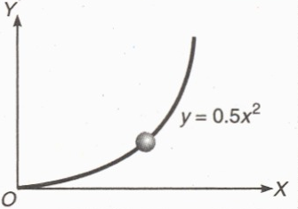
- [L2] At time t = 0; a particle starts moving along the path defined by the parabola y = 0.5x². If the component of velocity along the x-axis is $v_{x}=4 m/s$. Find the y-component of velocity at t = 1 sec?
(A) 4 m/s (B) 8 m/s
(C) 12 m/s (D) 16 m/s

Ground-to-Ground Projectile
- The greatest height to which a man can throw a stone is h. The greatest distance to which he can throw will be:
- [JEE Main 2021, 27 Aug, Shift 2] A player kicks the football with initial speed of 25 m/s at an angle of $45°$ from the ground. What are the maximum height and the time taken by the football to reach the highest point during motion?
(A) $H_{m}=10m, T=2.5s$ (B) $H_{m}=15.625m, T=3.54s$
(C) $H_{m}=15.625m, T=1.77s$ (D) $H_{m}=3.54m, T=0.125s$
- The maximum range of a projectile is 28 m. When it is thrown at an angle of $15°$ with horizontal, its range will be?
(A) 56 m (B) 16 m (C) 14 m (D) 20 m
- A projectile is projected from ground with initial velocity $\vec{u}=u_{0}\hat{i}+v_{0}\hat{j}$. If acceleration due to gravity (g) is along the negative y-direction then find its horizontal range:
(A) $\frac{u_{0}^{2}}{2g}$ (B)$\frac{2u_{0}v_{0}}{g}$ (C) $\frac{v_{0}^{2}}{2g}$ (D) $\frac{{4u}_{0}v_{0}}{g}$
- A projectile is projected with initial velocity 6$\hat{i}+8\hat{j}$ m/s. Find its horizontal range.
(A) 4.8 m (B) 9.6 m (C) 8 m (D) 16 m
- The speed of a projectile at its maximum height is half of its initial speed. The angle of projection is :-
(A) 15° (B) 30° (C) 45° (D) 60°
- The horizontal range and the maximum height of a projectile are equal. The angle of projection of the projectile is:
(A) $θ=\tan^{-1}(2 )$ (B) $θ=45°$ (C) $θ=\tan^{-1}(1/4)$ (D) $θ=\tan^{-1}(4)$
- Two bodies are thrown up at angles of 45° and 60° respectively, with the horizontal. If both bodies attain same vertical height, then the ratio of speeds with which these are thrown is?
(A) $3/2$ (B)$\sqrt{3/2}$ (C) $\sqrt{3}$ (D) $1/\sqrt{3}$
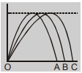
- Three projectiles A, B and C are thrown from the same point in the same plane. Their trajectories are shown in the figure. Which of the following statement is true?
(A) The time of flight is the same for all the three
(B) The launch speed is largest for particle C
(C) The horizontal velocity component is largest for particle C
(D) All of the above

- [JEE Main 2019, 10 Jan, Shift 1] Two guns A and B can fire bullets at speeds 1 km/s and 2 km/s respectively. From a point on a horizontal ground, they are fired in all possible directions. The ratio of maximum areas covered by the bullets fired by the two guns, on the ground is :
(A) 1 : 2 (B) 1 : 4 (C) 1 : 8 (D) 1 : 16
- [JEE Main 2021, 1 Sep, Shift 2] The ranges and heights of two projectiles projected with the same initial velocity at angles $42°$ and $48°$ with the horizontal are $R_{1}$, $R_{2}$ and $H_{1}$, $H_{2}$ respectively. Choose the correct option:
(A) $R_{1}>R_{2}$ and $H_{1}=H_{2}$ (B) $R_{1}=R_{2}$ and $H_{1}<H_{2}$
(C) $R_{1}<R_{2}$ and $H_{1}<H_{2}$ (D) $R_{1}=R_{2}$ and $H_{1}=H_{2}$
- [JEE Main 2019, 12 Apr, Shift 2] Two particles are projected from the same point with the same speed u such that they have the same range R but different maximum heights $h_{1}$and $h_{2}$. Which of the following is correct:
(A) $R^{2}={4h}_{1}h_{2}$ (B) $R^{2}={16h}_{1}h_{2}$ (C) $R^{2}={2h}_{1}h_{2}$ (D) $R^{2}=h_{1}h_{2}$
- [JEE Main 2019, 12 Apr, Shift 1] A shell is fired from a fixed artillery gun with an initial speed of u such that it hits the target on the ground at a distance R from it. If $t_{1}$ and $t_{2}$are the values of time taken by it to hit the target in two possible ways, then the product $t_{1}t_{2}$ is:
(A) $Rg$ (B) $R/g$ (C) $\frac{R}{2g}$ (D) $\frac{2R}{g}$
- [JEE Main 2021, 26 Feb, Shift 2] The trajectory of a projectile in a vertical plane is y = $αx-βx^{2}$, where α and β are constants and x & y are respectively the horizontal and vertical distance of the projectile from the point of projection. The angle of projection θ and the maximum height attained H are respectively given by:
(A) $\tan^{-1}α,\frac{4α^{2}}{β}$ (B) $\tan^{-1}β,\frac{α^{2}}{2β}$ (C) $\tan^{-1}(\frac{α}{β}),\frac{α^{2}}{β}$ (D) $\tan^{-1}α,\frac{α^{2}}{4β}$
- A projectile is fired at an angle of 45° with the horizontal. Elevation angle of the projectile at its highest point as seen from the point of projection, is :
(A) 45° (B) 60° (C) $\tan^{-1 }(\frac{1}{2})$ (D) $\tan^{-1 }(\frac{\sqrt{3}}{2})$
- A projectile is fired from level ground at an angle θ above the horizontal. The elevation angle $φ$ of the highest point as seen from the launch point is related to θ by the relation?
(A) $tanφ=tanθ$ (B) $tanφ=2tanθ$ (C) $tanφ=\frac{1}{2}tanθ$ (D) $2tanφ=tanθ$
- A particle launched from the origin at time t = 0. Its position is given by$\vec{r}=40\hat{i}+50\hat{j}$ m at t = 2sec. If the projectile was launched at an angle θ, then find its value
(A) tan⁻¹(4/5) (B) tan⁻¹(3/2) (C) tan⁻¹(2/3) (D) tan⁻¹(7/4)
- A projectile is projected at an angle α(>45°) with an initial velocity u. The time t, at which its horizontal component of velocity will equal the vertical component for the first time?
(A) $\frac{u}{g}(sinα+cosα)$ (B) $\frac{u}{g}(sinα-cosα)$ (C) $\frac{2u}{g}(sinα-cosα)$ (D) $\frac{u}{g}(cosα-sinα)$
- Two seconds after projection, a projectile is travelling in a direction inclined at 30° to the horizon. After one more second it is travelling horizontally. Then find the velocity of projection?
(A) $10\sqrt{3}\hat{i}+30\hat{j}$ (B) $20\sqrt{3}\hat{i}+30\hat{j}$ (C) $30\hat{i}+30\hat{j}$ (D) $10\sqrt{3}\hat{i}+20\hat{j}$
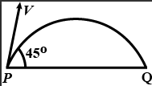
- [JEE Main 2021, 18 Mar, Shift 2] The projectile motion of a particle of mass 5 g is shown in the figure. The initial velocity of the particle is $5\sqrt{2}$ m/s and the air resistance is assumed to be negligible. The magnitude of change in momentum between points P and Q is $x×{10}^{-2} kg-m/s$. The value of x to the nearest integer is:

- A particle is projected from the ground with an initial velocity of 20 m/s at an angle of 30° with horizontal. The magnitude of change in velocity in 0.5 second is:
(A) $10\sqrt{2} m/s$ (B) $5\sqrt{2} m/s$ (C) $5 m/s$ (D) $5/\sqrt{2}$ m/s
- An oblique projectile on a horizontal plane has a range of 105 m and has a time of flight of 7 sec. Find the displacement of the projectile in the 4th second of its motion.
(A) 10$\sqrt{2} m$ (B) $5\sqrt{3}$ m (C) 15 m (D) 5 m
- The horizontal range and maximum height attained by a projectile are R = 90 m and H = 45 m respectively. If a constant horizontal acceleration a = g/10 is imparted to the projectile due to wind in the direction of its horizontal component of motion, then its horizontal range and maximum height will be?
(A) 99 m and 45 m (B) 99 m and 42 m (C) 108 m and 45 m (D) 116 m and 50 m
- [L2] A particle is projected from the ground with an initial speed of $v$ at an angle θ with horizontal. The average velocity of the particle between its point of projection and highest point of trajectory is?
(A) $\frac{v}{2}\sqrt{1+\cos^{2}θ}$ (B) $\frac{v}{2}\sqrt{1+{3cos}^{2}θ}$ (C) $\frac{v}{2}\sqrt{1+{3sin}^{2}θ}$ (D) $\frac{v}{2}\sqrt{1+\tan^{2}θ}$
- [L2] A projectile of mass 2 kg has velocities 3 m/s and 4 m/s at two points during its flight in the uniform gravitational field of the earth. If these two velocities are perpendicular to each other, then find the minimum kinetic energy of the particle during its flight.
(A) 9 J (B) 16J (C) 4.5 J (D) 5.76 J
- [L2] At a height 0.4 m from the ground, the velocity of a projectile projected from ground in vector form is $\vec{v}=6\hat{i}+2\hat{j}$ m/s (the x-axis is horizontal and y is vertically upwards). The angle of projection is
(A) $\tan^{-1}{(\frac{1}{3})}$ (B) $\tan^{-1}{(\frac{2}{3})}$ (C) $30°$ (D) $37°$
- [L2] A boy throws a ball upwards with velocity v₀ = 20 m/s. The wind imparts a horizontal acceleration of 4 m/s² to the west. The angle θ with the vertical the ball must be thrown so that the ball returns to the boy’s hand is?
(A) $\tan^{-1}{5}$ (B) $\tan^{-1}{(0.2)}$ (C) $\tan^{-1}{(0.4)}$ (D) $\tan^{-1}{(0.25)}$
- [L2] A particle is projected at an angle of $60°$ from the horizontal with speed u. Find the time ‘t’ when its velocity will be perpendicular to the velocity of projection?

Horizontal Projection from a Height
- A plane flying horizontally at 100 ms⁻¹ releases an object which reaches the ground in 10 s. At what angle with horizontal it hits the ground?
- [JEE Main 2021, 31 Aug, Shift 1] A helicopter is flying horizontally with a speed v at an altitude h has to drop a food packet for a man on the ground. What is the distance of the helicopter from the man when the food packet is dropped?
(A) $\sqrt{\frac{2ghv^{2}+1}{h^{2}}}$ (B) $\sqrt{2ghv^{2}+h^{2}}$ (C) $\sqrt{\frac{2v^{2}h}{g}+h^{2}}$ (D) $\sqrt{\frac{2v^{2}h}{g}}+h^{2}$
- A body is thrown horizontally from a tower, 100 m high with a velocity 10 ms⁻¹. After what time interval will it be moving at an angle 45° with the horizontal?
- Two tall buildings are 30 m apart. The speed with which a ball must be thrown horizontally from a window 150 m above the ground in one building so that it enters a window 25 m above from the ground in the other building?
(A) 4 m/s (B) 6 m/s (C) 8 m/s (D) 9 m/s
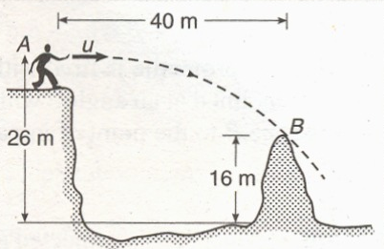
- With what minimum horizontal velocity u can a boy throw a ball at A and have it just clear the obstruction at B? (g = 9.8 m/s²)
(A) 20 m/s (B) 25 m/s
(C) 28 m/s (D) 30 m/s

- A rifle shoots a bullet with a muzzle velocity of 400 m/s at a small target 400 metre away. The height above the target at which the bullet must be aimed to hit the target is:
(A) 5 m (B) 0.5 m (C) 0.1 m (D) 0.4 m
- A body of mass m is projected horizontally with a velocity v from the top of a tower of height h and it reaches the ground at a distance x from the foot of the tower. If a second body of mass 2 m is projected horizontally from the top of a tower of height 2h, it reaches the ground at a distance 2x from the foot of the tower. Find the horizontal velocity of the second body?
(A) $v$ (B) $\sqrt{2}v$ (C) $2v$ (D) $v/2$
- [L2] A ball rolls off the top of a staircase with a horizontal velocity of 4.5 m s^{–1}. If the steps are 20 cm high and 30 cm broad, then the ball will strike the nth step then $n$?

Oblique Projection from a Height or to a Target
- A ball is projected from ground with a speed of 20 m/s at an angle of 45° with horizontal. There is a wall of 25 m height at a distance of 10 m from the projection point. The ball will hit the wall at a height of?
- A big hall is 5 m high and 60 m long. A cricket ball is thrown along the length of the hall from one end such that it hits the other end of the hall just grazing the ceiling. What must be the speed of projection of the ball?
(A) 30 m/s (B) 40 m/s (C) 10$\sqrt{6}$ m/s (D) 10$\sqrt{10}$m/s
- A projectile thrown with velocity v making an angle θ with the horizontal. It just crosses the top of two poles, each of identical height h, after 1 s and 3 s respectively. The time of flight of the projectile will be?
(A) 6 sec (B) 5 sec (C) 4 sec (D) 3.5 sec
- If a projectile is fired from a height h with an inclination of θ from the horizontal. It takes time T to reach a maximum height of H measured from the point of projection. It takes further time 2T to hit the ground, Then ratio h/H ?
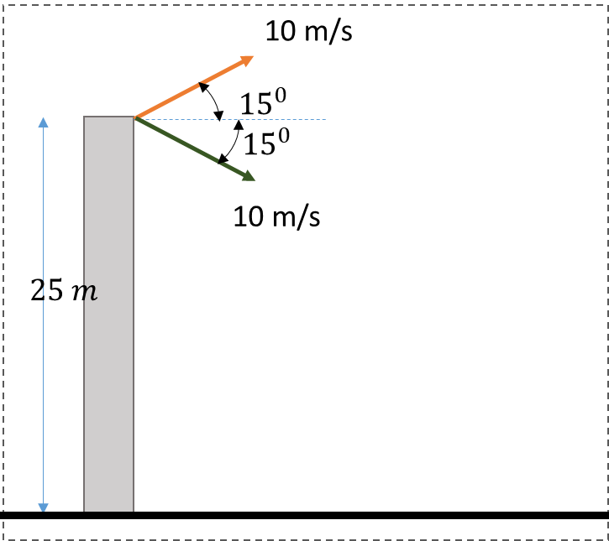
- Two particles are projected from top of a tower of height 25 m. The speed of projection is 10 m/s for either of them but one is projected at angle of $15°$above the horizontal while other at $15°$ below as shown. Find the difference in the range of two particles.

Projectile on an Inclined Plane
- A particle is projected from the bottom of an inclined plane of inclination 30° with velocity of 30 m/s at an angle of 60° with horizontal. Find the speed of the particle when its velocity vector is parallel to the plane.
(A) $30\sqrt{3}$ m/s (B) $20\sqrt{3}$ m/s (C) 20 m/s (D) $10\sqrt{3}$ m/s
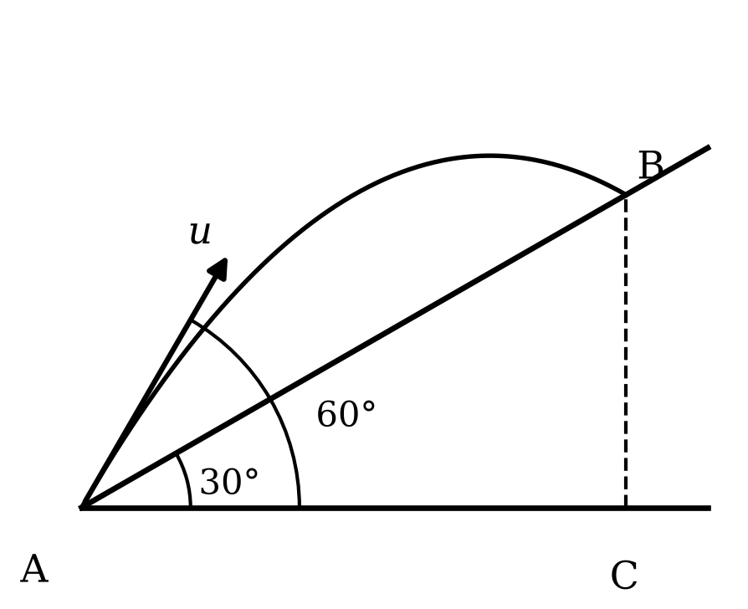
- Time taken by the projectile to reach from A to B is t. Then the distance AB is equal to?
(A) $ut$ (B) $\sqrt{2}ut$
(C) $\sqrt{3}ut$ (D) $\frac{ut}{\sqrt{3}}$

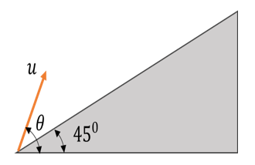
- A particle is projected from the base of a plane inclined at an angle of $45°$ with the horizontal. The initial velocity of projection is $u$ making an angle of $θ$ with the horizontal as shown. If the particle strikes the inclined plane horizontally, then what is the value of $tanθ$?
(A) $1/\sqrt{2}$ (B) $\sqrt{2}$
(C) 1 (D) 2

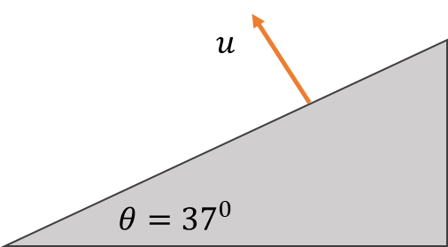
- A particle is projected perpendicularly from a long inclined plane as shown. The inclined plane makes an angle $θ=37°$ with the horizontal. Find the range of the projectile measured along the incline?
(A) $\frac{5u^{2}}{8g}$ (B) $\frac{7u^{2}}{4g}$
(C) $\frac{15u^{2}}{8g}$ (D) $\frac{5u^{2}}{4g}$

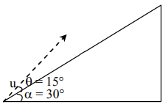
- [JEE Main 2019, 10 Apr, Shift 2] A plane is inclined at an angle $α=30°$ with respect to the horizontal. A particle is projected with a speed u = 2 m/s from the base of the plane, making an angle of $θ=15°$ with respect to the plane as shown in the figure. The distance from the base at which the particle hits the plane is close to:
(A) 26 cm (B) 20 cm (C) 18 cm (D) 14 cm

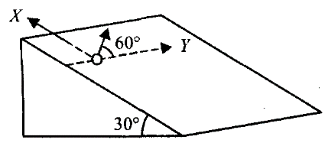
- A small sphere is projected with a velocity of 3 ms⁻¹ in a direction 60° from the horizontal y-axis, on the smooth inclined plane. The motion of sphere takes place in the x-y plane.
Find time when the x-coordinate is maximum?
(A) $\frac{\sqrt{3}}{g}$ (B) $\frac{2\sqrt{3}}{g}$
(C) $\frac{\sqrt{3}}{2g}$ (D) $\frac{3\sqrt{3}}{g}$

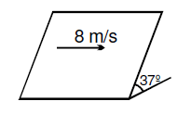
- A particle is projected on a smooth inclined plane horizontally with a velocity of 8 m/s. Find its speed after 1 sec?
(A) 8 m/s (B) 6 m/s
(C) $8\sqrt{2}$ m/s (D) 10 m/s

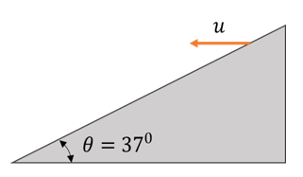
- [L2] A particle is projected horizontally from a long inclined plane down the slope as shown. The inclined plane makes an angle $θ=37°$ with the horizontal. Find the time taken by the particle to strike the inclined plane?
(A) $\frac{3u}{g}$ (B) $\frac{3u}{4g}$
(C) $\frac{3u}{2g}$ (D) $\frac{4u}{3g}$

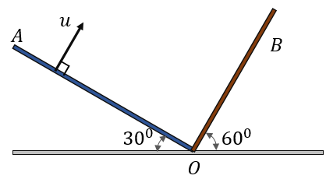
- [L2] Two surfaces A and B are placed as shown in the figure. A particle is projected perpendicularly from the surface A with a velocity ‘u’ such that it hits the surface B perpendicularly. Find the time taken by the projectile in terms of u and g?
(A) $\frac{2u}{g\sqrt{3}}$ (B) $\frac{u}{g\sqrt{3}}$
(C) $\frac{u}{g\sqrt{2}}$ (D) $\frac{\sqrt{3}u}{g}$

Relative Motion of Projectiles & Moving Frames
- A bullet is fired at a speed of 50 m/s at an angle of $37°$ with the horizontal. At the same instant, a wooden block is released from the top of a vertical pole. The bullet strikes the block at a height of 45 m from the ground. What is the horizontal distance of the pole from the point where the bullet was fired?
(A) 120 m (B) 80 m (C) 150 m (D) 90 m
- A train is moving with an acceleration of 3 m$s^{-2}.$A ball is projected vertically upwards from the floor with a velocity of 5 m/s. How far from the point of projection will the ball hit the floor?
(A) zero (B) 1.5 m in front (C) 1.5 m behind (D) 0.75 m behind
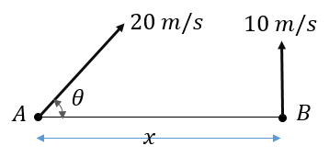
- Two particles A and B are projected simultaneously in the directions shown with velocities V_{A} = 20 m/s and V_{B} = 10 m/s respectively. If they collide in air after 0.5 s, then the angle θ and distance x respectively are:
(A) 30° and 10$\sqrt{3}$ (B) 60° and 5$\sqrt{3}$
(C) 30° and 5$\sqrt{2}$ (D) 30° and 5$\sqrt{3}$

- Two particles A and B are projected simultaneously as shown in the figure: A with a speed of 20 m/s at an angle θ with the horizontal, and B vertically upward with a speed of 10 m/s. The horizontal distance between them is x = 10 m. If the particles collide in air, how many seconds after projection does the collision occur?
(A) 1 sec (B) 0.5 sec
(C) $\sqrt{3}$ sec (D) $\frac{1}{\sqrt{3}}$ sec

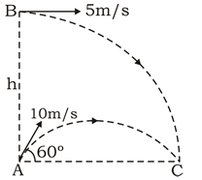
- Two particles are projected simultaneously as shown with B being vertically above A. What should be height of projection of particle B, if the two particles collide at C (just before they hit the ground).

- A fighter plane flying horizontally at an altitude of 1.5 km with speed of 720 km/h passes directly overhead an antiaircraft gun. At what angle from the vertical should the gun be fired for the shell with muzzle speed 400 m/s to hit the plane? What should be the minimum muzzle speed for gun to strike the fighter plane when it is vertically above?
- Two stones are thrown up simultaneously from the edge of a cliff 240 m high with initial speed of 10 m/s and 40 m/s respectively. Which of the following graph best represents the time variation of relative position of the second stone with respect to the first?
(A) (B) (C) (D)
(Assume stones do not rebound after hitting the ground and neglect air resistance). (The figures are schematic and not drawn to scale)

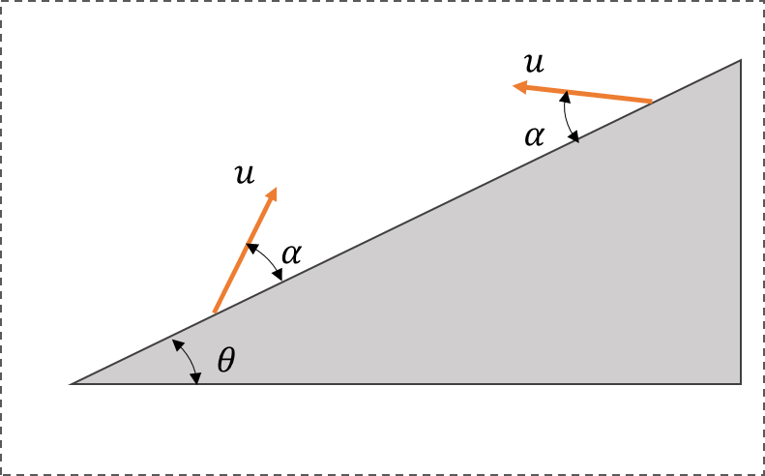
- Two projectiles are projected at an angle α from two points on a plane inclined at an angle θ with the horizontal as shown. Which of the statements are correct:
(A) The particles will collide in mid-air
(B) The time of flight for each particle is same.
(C) Both particles will strike the plane perpendicularly
(D) The range of projectiles measured along the inclined surface is same.

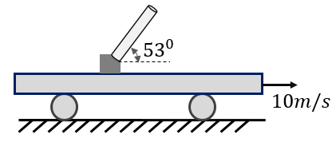
- An artillery gun is mounted on a trolley moving with a speed of 10 m/s. The gun can fire shells at a speed of 50 m/s. It is placed with its barrel making an angle of $53°$ with the horizontal. If a shell is fired then what will be its range as observed from the ground?
(A) 240 m (B) 280 m (C) 300 m
(D) 320 m

- A toy gun fires a plastic bullet at a speed of 10 m/s. It is placed in a high lift at an angle of $30°$ with the horizontal. The lift is moving with constant upwards acceleration of 2 m$s^{-2}$. Find the time of flight of the plastic bullet fired by the gun?
(A) 1 sec (B) 6/5 sec (C) 5/6 sec (D) $\sqrt{3}/2$ sec
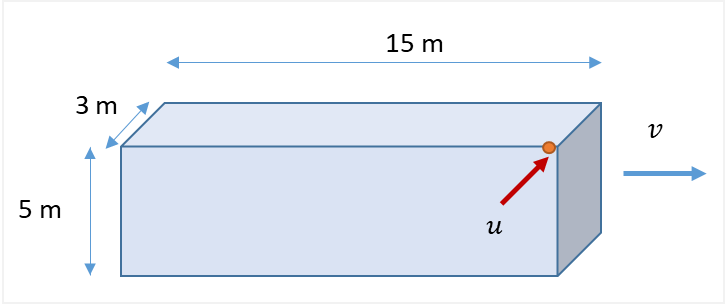
- A rail coach is moving with a constant velocity of $v$ m/s. Its length is 15 m, height 5 m, and width 3 m. A small bullet moving horizontally and perpendicular to the direction of coach motion with speed u enters through its top corner and then finally hits the diagonally opposite corner. Find value of $v$and $u$?

- [L2] A boy is sitting in a train which starts accelerating at $2 ms^{-2}$ at t = 0. The boy drops a gum ball every second, starting from t =0, from the window at the height of 0.8 m. The gum balls stick to the ground at the point of impact. Find the distance between the first and the second ball on the ground?
(A) 1 m (B) 0.8 m (C) 1.2 m (D) 1.8 m
- [L2] A boy is travelling in a train moving at 10 m/s towards north. He holds a toy gun horizontally at a height of 0.8 m above the ground directed towards east. If he shoots a bullet at a speed of 5 m/s, then what will be its speed when it hits the ground?
(A) 15 m/s (B) $\sqrt{116} m/s$ (C) $\sqrt{141} m/s$ (D) $\sqrt{156} m/s$

Relative Velocity in 2D: Rain, Wind & Closest Approach
- Airport Y is 400 km N of airport X. Wind blows from West at 60 km/h. Aircraft can maintain a speed of 500 km/h in still air. With respect to North at what angle the pilot should direct the aircraft so as to reach airport Y from X?
(A) $\cos^{-1}{\frac{3}{25}}$ (B) $\sin^{-1}{\frac{4}{25}}$ (C) $\tan^{-1}{\frac{3}{\sqrt{616}}}$ (D) $\tan^{-1}{\frac{3}{25}}$
- An airplane can travel at a speed of 100 m/s in still air. There is steady wind of 60 m/s towards East. The airplane travels along the sides of a square of side 16 km which are along N-S and E-W direction. Find the time taken to complete one round of the square?
(A) 640 s (B) 800 sec (C) 400$\sqrt{2}$ sec (D) 900 sec
- [JEE Main 2021, 20 Jul, Shift 1] A butterfly is flying with a velocity $4\sqrt{2}$ m/s in north-east direction. Wind is slowly blowing at 1 m/s from North to South. The resultant displacement of the butterfly in 3 s is:
(A) 3 m (B) 20 m (C) $12\sqrt{2}$ m (D) 15 m
- A woman travelling N at 10 km/h finds that wind appears to blow from West. When woman trebles her speed, the wind appears to blow from NW. Find the velocity of the wind. Assume $\hat{i}$along east and $\hat{j}$ along north.
(A) $20\hat{i}+10\hat{j}$ (B) $-20\hat{i}+10\hat{j}$ (C) $10\hat{i}+10\hat{j}$ (D) $20\hat{i}-10\hat{j}$
- A man at rest observes the rain falling vertically. When he walks at 4 km/h, he has to hold his umbrella at an angle of 53° from the vertical. What is the velocity of raindrops?
(A) 5 km/h (B) 4$\sqrt{3}$ km/h (C) 4 km/h (D) 3 km/h
- To a man walking at the rate of 3 km/h, the rain appears to fall vertically. When he increases his speed to 6 km/h it appears to meet him at an angle of 45° with the vertical. What is the speed of the rain?
- [JEE Main 2020, 6 Sep, Shift 2] When a car is at rest, its driver sees rain drops falling on it vertically. When driving the car with speed v, he sees that the rain drops are coming at an angle of $60°$from the horizontal. On further increasing the speed of the car to $\left(1+β\right)v$, this angle changes to $45°$. The value of β is close to:
(A) 0.5 (B) 0.41 (C) 0.37 (D) 0.73
- Two particles having position vectors $\vec{r_{1}}=(3 \hat{i}+5 \hat{j})$ and $\vec{r_{2}}=(-5 \hat{i}-3 \hat{j})$m are moving with velocities $\vec{v_{1}}=(4 \hat{i}+3 \hat{j})$m/s and $\vec{v_{2}}=(a \hat{i}+7 \hat{j})$ m/s. If they collide after 2 sec, the value of ‘a’ is?
- A point P is moving with constant speed 10 m/s such that the velocity vector always maintains an angle of 60⁰ with the line OP where O is a fixed point in the space. The time for P to reach O if the initial distance of P from O is 100m?
60°
P
O

- [JEE Main 2019, 8 Apr, Shift 1] Ship A is sailing towards north-east with velocity $\vec{v}=30\hat{i}+50\hat{j}$ km/h; where $\hat{i}$ points east and $\hat{j}$ north. Ship B is at a distance of 80 km east and 150 km north of ship A and is sailing towards west at 10 km/h. A will be at minimum distance from B in:
(A) 4.2 h (B) 2.6 h (C) 3.2 h (D) 2.2 h
- [L2] When a man moves down an inclined plane with a constant speed of 5 m/s which makes an angle of 37° with the horizontal, he finds that the rain is falling vertically downwards. When he moves up the same inclined plane with the same speed, he finds that the rain makes an angle $θ= \tan^{-1}(\frac{7}{8})$ with the horizontal. The speed of the rain is?
(A) 4 m/s (B) 4$\sqrt{2}$ m/s (C) 7 m/s (D) 5 m/s
- [L2] Two ships are initially at rest, with ship B 1000 m east of ship A. Both ships start moving simultaneously, with ‘A’ having a velocity of 10 m/s SE and B having a velocity of 20 m/s in SW. What would be shortest possible distance between the two ships?
(A) 100 m (B) 100$\sqrt{3} m$ (C) 100$\sqrt{5} m$ (D) 100$\sqrt{10} m$

River–Boat Crossing
- A boat can row at speed of 5 m/s in still water. It is crossing a 500 m wide river flowing with a speed of 3 m/s. Find:
(i) Minimum time to cross the river and the corresponding drift
(ii) Minimum time to cross the river and come back to the starting point
(iii) Time to travel a distance of 500 m along the river and come back to the starting point.
(iv) Direction in which boat should be rowed to reach the opposite point on the river
(v) Time taken to cross the river if boat maintains its direction at $120°$ with the direction of river flow
- A river flows from east to west with a speed of 5m/min. A man on south bank of river, capable of swimming at the rate of 10 m/min in still water, wants to swim across the river in shortest time; he should swim :
(A) Due north (B) Due north-east (C) $30°$ east of North (D) $60°$ east of North
- A boat takes 2 hours to go 8 km and come back in a still lake. The time taken for going 8 km upstream a river and coming back with water velocity of 4 km/h is :
(A) 140 min (B) 150 min (C) 160 min (D) 170 min
- A river flows from East to West. Two boats start from the southern bank of the river simultaneously. The boat A rows towards $20°$ east of north, whereas boat B rows towards $20°$ west of north. Both boats have same speed in still water. Which of the two boats will reach the northern bank first? The width of river is uniform.
(A) Boat A (B) Boat B (C) Both will reach at the same time (D) will depend on speed of river flow
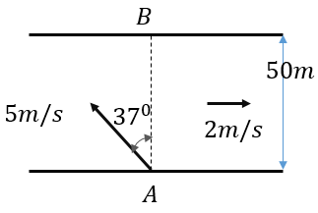
- A boat can row at a speed of 5 m/s in still water. It sets its course at $37°$ with the normal to river bank as shown. The velocity of the river is 2 m/s and its width is 50 m. The boat starts from A and B is directly opposite point. What will be the drift of the boat when it reaches the other side?
(A) 10 m upstream of B (B) 12.5 m upstream of B
(C) 10 m downstream of B (D) 12.5 m downstream of B

- [JEE Main 2021, 16 Mar, Shift 2] A swimmer can swim with velocity of 12 km/h in still water. Water flowing in the river has a velocity of 6 km/h. The direction with respect to the direction of flow of river water he should swim in order to reach the point on the other bank just opposite to his starting point is … (in degrees to the nearest integer)?
- A boat-man can row a boat to make it move with a speed of 10 km/h in still water. River flows steadily at the rate of 5 km/h. and the width of the river is 2 km. If the boat man cross the river along the shortest path then time elapsed in rowing the boat will be?
(A) $\frac{2}{5\sqrt{3}}$hrs (B) $\frac{4}{5\sqrt{3}}$hrs (C) $\frac{2\sqrt{3}}{5}$hrs (D) $\frac{3\sqrt{2}}{5}$hrs
- A boat can travel at 13m/min in still water. The width of the river is 78 m flowing with a velocity of 5 m/min. What is the ratio of time taken to cross by shortest route to minimum time to cross the river?
(A) 12/13 (B) 13/12 (C) 13/11 (D) 13/10
- A man wishes to cross a river in a boat. If he crosses the river in minimum time, then he takes 10 min with a drift of 120 m. If he crosses the river taking shortest route, he takes 12.5 min, find the velocity of the boat with respect to water (in m/min)?
(A) 12 (B) 15 (C) 16 (D) 20
- [JEE Main 2021, 18 Mar, Shift 1] A person is swimming with a speed of 10 m/s at an angle of $120°$ with the flow and reaches a point directly opposite on the other side of the river. The speed of the flow is x m/s. The value of x to the nearest integer is:
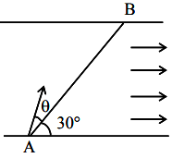
- [L2] [JEE Main 2021, 27 Jul, Shift 2] A swimmer wants to cross a river from point A to point B. Line AB makes an angle of $30°$ with the flow of river. The magnitude of the velocity of the swimmer is same as that of the river. The angle θ with the line AB should be ….. $.°$, so that the swimmer reaches point B?

- [L2] A river is flowing towards East with speed which varies as distance from the bank as $(5+0.05y)$ m/s, where $y$ is the distance from the bank. A boat having speed of 10 m/s in still water is rowed, always aiming towards North, starting from the bank. Find the drift it will have by the time it is 100 m from the bank?
(A) 25 m (B) 30 m (C) 50 m (D) 75 m
- [L2] The velocity of the river water is $v$. Width of the river is d. A swimmer swims, with reference to the water, perpendicular to the current with an acceleration of a = 2t, starting from rest. The equation of the trajectory of the path followed by the swimmer is?
(A) $y=x^{2}/2v$ (B) $y=x^{3}/2v$ (C) $y=x^{3}/3v$ (D) $y=x^{3}/3v^{3}$

Answer Key
2D/3D Motion in Vector & Calculus Form
Q1 | C | Q2 | B | Q3 | A
Q4 | B | Q5 | A | Q6 | A
Q7 | D | Q8 | A | Q9 | 48 m; 16$\sqrt{2}$ m/s
Q10 | 12 | Q11 | $y=\frac{x^{2}}{4}$ ; $2\hat{i}+2t\hat{j}$ | Q12 | (6ac²x + 2bc²) k̂
Q13 | A | Q14 | C | Q15 | D
Ground-to-Ground Projectile
Q16 | 2h | Q17 | C | Q18 | C
Q19 | B | Q20 | B | Q21 | D
Q22 | D | Q23 | B | Q24 | D
Q25 | D | Q26 | B | Q27 | B
Q28 | D | Q29 | D | Q30 | C
Q31 | C | Q32 | D | Q33 | B
Q34 | A | Q35 | 5 | Q36 | C
Q37 | C | Q38 | C | Q39 | B
Q40 | D | Q41 | C | Q42 | C
Q43 | $\frac{2u}{g\sqrt{3}}$
Horizontal Projection from a Height
Q44 | 45° | Q45 | C | Q46 | 1 s
Q47 | B | Q48 | C | Q49 | A
Q50 | B | Q51 | 9
Oblique Projection from a Height or to a Target
Q52 | 7.5 m | Q53 | D | Q54 | C
Q55 | 3 | Q56 | 5 m
Projectile on an Inclined Plane
Q57 | D | Q58 | D | Q59 | D
Q60 | C | Q61 | B | Q62 | D
Q63 | D | Q64 | C | Q65 | $$A$$
Relative Motion of Projectiles & Moving Frames
Q66 | A | Q67 | C | Q68 | D
Q69 | D | Q70 | 15 m | Q71 | 30° from the vertical; $100\sqrt{7}$ m/s
Q72 | C | Q73 | B | Q74 | D
Q75 | C | Q76 | v = 15 m/s; u = 3 m/s | Q77 | D
Q78 | C
Relative Velocity in 2D: Rain, Wind & Closest Approach
Q79 | C | Q80 | D | Q81 | D
Q82 | A | Q83 | D | Q84 | 3√2 km/h
Q85 | D | Q86 | 8 | Q87 | 20 s
Q88 | B | Q89 | B | Q90 | D
River–Boat Crossing
Q91 | (i) 100 s, 300 m; (ii) 250 s; (iii) 312.5 s; (iv) $127°$with river flow direction; (v) $\frac{200}{\sqrt{3}}s$ | Q92 | A | Q93 | C
Q94 | C | Q95 | B | Q96 | 120
Q97 | A | Q98 | B | Q99 | D
Q100 | 5 | Q101 | 30 | Q102 | D
Q103 | D

Hints & Solutions
2D/3D Motion in Vector & Calculus Form
Q1 Hint
Use $\vec{v}= \vec{u}+ \vec{a}t$
Q2 Hint
Let the initial velocity be $2\hat{i}$ then acceleration: $\hat{i}+\sqrt{3}\hat{j}$
Final velocity: $4\hat{i}+2\sqrt{3}\hat{j}$ Average velocity: 3$\hat{i}+\sqrt{3}\hat{j}$
Q4 Hint
$\vec{v}\left(2\right)=2\hat{i}+6\hat{j}+9\hat{k}$ $tanα\left(x-axis\right):\frac{\sqrt{v_{y}^{2}+v_{z}^{2}}}{v_{x}}$
Q6 Hint
Will reach maximum x co-ordinate when $v_{x}=0$ (at t = 3 s)
Q8 Hint
$\vec{v}=\left(2t-4\right)\hat{i}+(2t)\hat{j}$ $\vec{a}=2\hat{i}+2\hat{j}$
Mutually perpendicular when the dot product is zero
Q9 Hint
$t=4 s$
Q12 Hint
X and Y components of acceleration are zero.
$\frac{dz}{dt}=3ax^{2}\left(\frac{dx}{dt}\right)+2by\left(\frac{dy}{dt}\right)=3acx^{2}+2bcy$; then differentiate again
Q13 Hint
Velocity $\vec{v}=\frac{dx}{dt}\hat{i}+\frac{dy}{dt}\hat{j}+\frac{dz}{dt}\hat{k}$
Q15 Hint
For the given path $\frac{dy}{dx}=x=\frac{v_{y}}{v_{x}}$; At t = 1 s, x = 4 m
Ground-to-Ground Projectile
Q22 Hint
$$\frac{2u_{x}u_{y}}{g}=\frac{u_{y}^{2}}{2g}$$
Q25 Hint
Maximum range $R∝u^{2}$ and area $A∝R^{2}$ hence $A∝u^{4}$
Q27 Hint
For $θ=45°$: $R=4h$ (we can think of this as the case of $h_{1}=h_{2}=h)$
Q28 Hint
$t_{1}=\frac{2usinα}{g}$; $t_{2}=\frac{2usin(90-α)}{g}=\frac{2ucosα}{g}$ and $R=\frac{2usinαcosα}{g}$
Q30 Hint
Angle of elevation $tanα=\frac{H_{m}}{\frac{R}{2}}$
Q32 Solution
Average velocity in x-direction $u_{x}=20$m/s
Average velocity in y-direction: 25 m/s = $v_{y}(t=1)$
Hence $u_{y}=35$ m/s
Q34 Solution
The y-component of velocity 1 s before it reaches the top point = g = 10 m/s
As it makes an angle of $30°$ with the horizontal $u_{x}=10\sqrt{3}$
Two seconds prior to this, the y-component of velocity will be: 30 m/s
Q35 Hint
Difference of two vectors of equal magnitude at right angle to each other
Q36 Hint
For uniformly accelerated motion: $∆\vec{v}=\vec{a}(∆t)$
Q37 Hint
The projectile will be at the same height at 3 s and 4 s (as it reaches the highest point at time 3.5 s)
Hence the displacement = horizontal distance travelled = $u_{x}=\frac{105}{7}=15m$
Q38 Solution
The original time of flight is 6 s (as $H=45m)$; hence $u_{x}=15$ m/s
The horizontal acceleration will not change time of flight or the maximum height.
Horizontal displacement with $a_{x}=1$ : $s_{x}=u_{x}T+\frac{1}{2}a_{x}T^{2}=108$
Q39 Hint
Displacement = $\sqrt{{\left(H\right)}^{2}+{\left(\frac{R}{2}\right)}^{2}}$ and time = $T/2$
Q40 Solution
Let the angle with horizontal be $α$ and $(90-α)$ when the velocities are 3 m/s and 4 m/s respectively.
Equating horizontal components: $3cosα=4cos⁡(90-α)$; $tanα=\frac{3}{4};cosα=4/5$
Minimum speed = horizontal component = 3 cos α = 12/5 m/s, so minimum KE = ½ × 2 × (12/5)² = 5.76 J
Q41 Hint
$$u_{y}^{2}=v_{y}^{2}+2gh=12$$
Q43 Think further
Why is this answer the same as the answer to Q65?
Horizontal Projection from a Height
Q48 Hint
It should travel a minimum horizontal distance of 40 m by the time it falls by 10 m.
Q49 Solution
Time taken by the bullet to hit the target: 1 s
Vertical displacement during this time interval = 5 m
Hence bullet will hit a point 5 m below the point it is aimed at.
Q51 Solution
Time to fall n steps = $\sqrt{\frac{2\left(0.2n\right)}{10}}=0.2\sqrt{n}$; Horizontal distance travelled L = $4.5t=0.9\sqrt{n}$
It will not clear the nth step if $L<0.3n$ (the smallest integer value of n);
OR will hit the edge of nth step if $L=0.3n$
Oblique Projection from a Height or to a Target
Q52 Hint
The height will be the y-co-ordinate at $x=10$m on the trajectory of the projectile
Q53 Hint
The vertical component of velocity = 10 m/s; or T = 2 s; hence $u_{x}=30$
Q54 Hint
Time of flight T = 4 s; the time taken from top of second pole to ground = time taken from ground to top of first pole as both are at the same height
Q55 Hint
The projectile rises by height H in time T;
Hence the vertical distance it will fall from top point in time 2T: $4H$ which is equal to $H+h$
Q56 Hint
From the instant, the particle (A) projected up reaches its projection level, its motion will be identical to the other particles. Hence, the difference in range = range of particle (A) on horizontal ground.
Projectile on an Inclined Plane
Q57 Hint
Given $u_{x}=15$; $v_{y}$when velocity vector is at $30°$ with the horizontal = $5\sqrt{3}$
Q58 Hint
It is easy to find AC = $u_{x}t=ut/2$; then AB = AC$sec30$
Q59 Solution
It strikes the inclined plane at the instant it is at its maximum height;
The angle between the highest point and the point of projection is $45°$
Or $tan45°=1=\frac{H_{m}}{\frac{R}{2}}=\frac{u_{y}^{2}}{2g}/(\frac{u_{x}u_{y}}{g})$
Q60 Solution
Choose down-the-slope as x-axis and $⊥$ up as y-axis:
Then $u_{x}=0$ and $a_{x}=gsinθ=\frac{3}{5}g$; $u_{y}=u$ and $a_{y}=-gcosθ=-\frac{4}{5}g$
Time of flight T = $\frac{2u_{y}}{a_{y}}=\frac{5u}{2g}$
Range = Displacement along x-axis in time T = $\frac{1}{2}a_{x}T^{2}$
Q61 Solution
Using normal axes: $\vec{r_{t}}=u_{x}t\hat{i}+(u_{y}t-\frac{1}{2}gt^{2})\hat{j}$ = $\sqrt{2}t\hat{i}+(\sqrt{2}t-5t^{2})\hat{j}$
It will strike the plane at the instant the position vector makes an angle of $30°$
$tan30°=\frac{1}{\sqrt{3}}=\frac{(\sqrt{2}t-5t^{2})}{\sqrt{2}t}$
Q62 Hint
Effective $g_{e}=gsin30$
Q63 Hint
The acceleration $gsinθ=6$ will act along the slope ($⊥$ to initial velocity)
Q64 Hint
Similar to Q59, the angle of projection for it to strike the plane horizontally $tanα=2tan37°=\frac{3}{2}$
Hence $u_{y}=\frac{3u}{2}$; time to strike the plane = $\frac{u_{y}}{g}$
Q65 Hint
The final velocity is along AO, or when the component $⊥$ to AO is zero;
Hence $T=u/a_{y}$ where y is along OB ($⊥$ to AO) = $\frac{u}{gcos30°}$
Relative Motion of Projectiles & Moving Frames
Q66 Hint
Velocity of bullet: $40\hat{i}+30\hat{j}$; it will be at a height of 45 m at t = 3 s.
Q77 Hint
First gum ball will fall at $x=0$, vertically below the starting position of the boy
The second ball will be dropped when boy has travelled 1 m and moving with a speed of 2 m/s. The gum ball will fall at a further horizontal distance of $2\sqrt{\frac{2×0.8}{10}}$ = 0.8 m
Q78 Hint
Let x, y, and z axis be along East, North and Up direction;
Initial velocity of the bullet = $5\hat{i}+10\hat{j}$; Considering motion in vertical dir: $v_{z}=4$

