Take g = 10 m/s² unless stated otherwise.

Circular Motion Kinematics
- A car is moving in a circular path of radius R with a uniform speed v. Find magnitude of change in velocity and average acceleration when the car’s direction changes by θ.
- [JEE Main 2020, 8 Jan, Shift 2; NEET 2016] A particle moves so that its position vector is given by $\vec{r}=cosωt\hat{x}+sinωt\hat{y}$. Where ω is a constant. Which of the following is true?
(A) Velocity and acceleration both are perpendicular to $\vec{r}$.
(B) Velocity and acceleration both are parallel to $\vec{r}$
(C) Velocity is perpendicular to $\vec{r}$ and acceleration is directed towards the origin
(D) Velocity is perpendicular to $\vec{r}$ and acceleration is directed away from the origin
- [AIPMT 2015 (Re-exam)] The position vector of a particle $\vec{R}$as a function of time is given by $\vec{R}=4\sin\left(2πt\right)\hat{i}+4\cos\left(2πt\right)\hat{j}$; where R is in meters, t is in seconds and $\hat{i}$and $\hat{j}$ denote unit vectors along x and y-directions, respectively. Which one of the following statements is wrong for the motion of particle ?
(A) Path of the particle is a circle of radius 4 meter
(B) Acceleration vectors is along $-\vec{R}$
(C) Magnitude of acceleration vector is $\frac{v^{2}}{R}$where v is the velocity of particle.
(D) Magnitude of the velocity of particle is 8 meter/second
- [JEE Main 2019, 11 Jan, Shift 1] A particle is moving along a circular path with a constant speed of 10 m/s. What is the magnitude of change in velocity of the particle when it moves through an angle of $60°$ around the centre of the circle?
(A) $10\sqrt{2}$ m/s (B) $10\sqrt{3}$ m/s (C) 10 m/s (D) zero
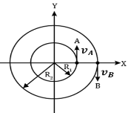
- [JEE Main 2019, 12 Jan, Shift 2] Two particles A and B are moving on concentric circles of radii $R_{1}$ and $R_{2}$ with equal angular speed ω. At t = 0, their positions and the directions of motion are as shown in the figure. The relative velocity $\vec{v_{A}}- \vec{v_{B}}$ at t = $π/2ω$ is given by:
(A) $ω(R_{1}+R_{2})\hat{i}$ (B) $-ω(R_{1}+R_{2})\hat{i}$
(C) $ω(R_{1}-R_{2})\hat{i}$ (D) $ω(R_{2}-R_{1})\hat{i}$

- [AIPMT 2011] A particle moves in a circle of radius 5 cm with constant speed and time period 0.2π sec. The acceleration of the particle is :-
(A) 15 m/$s^{2}$ (B) 25 m/$s^{2}$ (C) 36 m/$s^{2}$ (D) 5 m/$s^{2}$
- [JEE Main 2020, 6 Sep, Shift 1] A clock has a continuous moving second’s hand of 0.1 m length. The magnitude of the acceleration of the tip of the hand (in ms⁻²) is of the order of:
(A) ${10}^{-3}$ (B) ${10}^{-4}$ (C) ${10}^{-2}$ (D) ${10}^{-1}$
- [AIIMS 2016] A particle starts with angular acceleration 2 rad/sec². It turns through 100 rad in a certain interval of 5 s. Find the time at which this interval starts.
(A) 7.5 sec (B) 4.5 sec (C) 5 sec (D) 6 sec
- [NEET 2016] A particle of mass 10 g moves along a circle of radius 6.4 cm with a constant tangential acceleration. What is the magnitude of this acceleration if the kinetic energy of the particle becomes equal to 8 $×{10}^{-4}$ J by the end of the second revolution after the beginning of the motion?
(A) 0.1 m/$s^{2}$ (B) 0.15 m/$s^{2}$ (C) 0.18 m/$s^{2}$ (D) 0.2 m/$s^{2}$
- If the equation for the angular displacement of a particle moving on a circular path is given by (θ) =$2t^{3}+0.5$, where θ is in radians and t in seconds, then the angular velocity of the particle after 2 s from its start is?
(A) 8 rad/s (B) 12 rad/s (C) 24 rad/s (D) 36 rad/s
- If angular velocity of a particle depends on the angle rotated θ as ω = $θ^{2}+2θ$, then its angular acceleration α at θ = 1 rad is :
(A) 8 rad/$s^{2}$ (B) 10 rad/$s^{2}$ (C) 12 rad/$s^{2}$ (D) None of these
- Shown here are the velocity and acceleration vectors for an object in several different types of motion. In which case is the object slowing down and turning to the right?

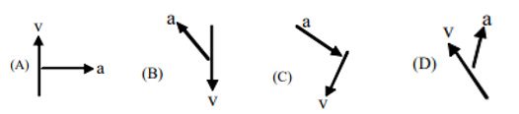

- If the magnitude of velocity of a particle moving in circle of fixed radius is $'kt'$, then choose INCORRECT statement:
(A) Its speed will keep on increasing
(B) The angle between centripetal and tangential acceleration will keep on decreasing
(C) The magnitude of centripetal force will keep on increasing
(D) The angle between velocity and acceleration will keep increasing
- A particle moves in a circle of radius 20 cm. Its linear speed is given by v = 2t m/s. Find its radial and tangential acceleration at t = 3 s.
(A) 180, 2 $m/s^{2}$ (B) 180, 4 $m/s^{2}$ (C) 90, 2 $m/s^{2}$ (D) 90, 4 $m/s^{2}$
- At a particular instant, a car moving with speed 30 m/s on a circular path of radius 500 m; and its speed is increasing at the rate of 2m/$s^{2}$ . The acceleration of the car is?
(A) 9.8 m/$s^{2}$ (B) 1.8 m/$s^{2}$ (C) 2 m/$s^{2}$ (D) 2.7 m/$s^{2}$
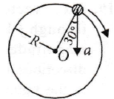
- [NEET 2016] In the given figure, a = 15 m/$s^{2}$ represents the total acceleration of a particle moving in the clockwise direction in a circle of radius R = 2.5 m at a given instant of time. The speed of the particle is:
(A) 5.7 m/s (B) 6.2 m/s
(C) 4.5 m/s (D) 5.0 m/s

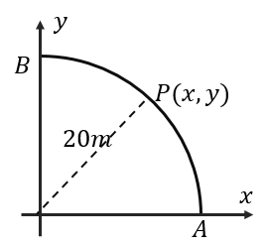
- [AIEEE 2010] A point P moves in counter-clockwise direction on a circular path as shown in the figure. The movement of P is such that it sweeps out a length $s=t^{3}+5$, where s is in metre and t is in second. The radius of the path is 20 m. The acceleration of P when t = 2 s is nearly:
(A) 7.2 $ms^{-2}$ (B) 12 $ms^{-2}$
(C) 13 $ms^{-2}$ (D) 14 $ms^{-2}$

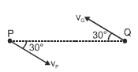
- Two moving particles P & Q are 10 m apart at any instant. Velocity of P is 8 m/s and that of Q is 6 m/s at 30° angle with the line joining P & Q. Calculate the angular velocity of P w.r.t. Q?
(A) 1 rad/s (B) 0.8 rad/s
(C) 0.7 rad/sec (D) 0.5 rad/sec

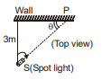
- A spot light S rotates in a horizontal plane with a constant angular velocity of 0.1 rad/s. The spot of light’ ‘p moves along the wall at a distance 3 m. What is the velocity of the spot P when θ = 45° ?
(A) 0.6 m/s (B) 0.5 m/s
(C) 0.4 m/s (D) 0.3 m/s

- A particle is projected at angle $θ(=53°)$ with the horizontal with a speed of $u(=$30 m/s). Find the instantaneous radius of circular motion soon after projection
(A) 60 m (B) 90 m (C) 120 m (D) 150 m
- [L2] Starting from rest, a particle rotates in a circle of radius R = $\sqrt{2}$m with an angular acceleration α=π/4 rad/s². The magnitude of average velocity of the particle over the time it rotates quarter circle is?
(A) $π$ m/s (B) $\frac{π}{2}$ m/s (C) 2 m/s (D) 1 m/s
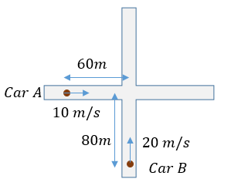
- [L2] Two cars A and B are moving on perpendicular roads as shown in the figure. Their respective speeds 10 m/s and 20 m/s. At an instant, they are at a distance of 60 m and 80 m from the intersection point. What will be the angular velocity of car B as seen from car A at the instant shown.
(A) 0.2 rad/s (B) 0.08 rad/s
(C) 0.12 rad/s (D) 0.04 rad/s

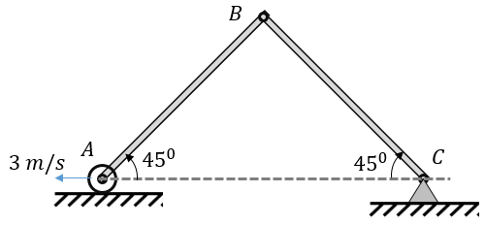
- [L2] The two rods AB, BC shown in the given system are of equal length of 3 m. The end A is placed on a roller at the same horizontal plane as end C. If end A is moved with a uniform horizontal velocity of 3 m/s and both rods are at $45°$ with the horizontal, then what will be the instantaneous angular velocity of rod BC?
(A) $\sqrt{2} rad/s$ (B) $\frac{1}{\sqrt{2}} rad/s$
(C) $\sqrt{3} rad/s$ (D) $3\sqrt{2} rad/s$

- [L2] A particle of 1 kg mass is moving in xy–plane whose position is described by position vector $\vec{r}= t^{2}\hat{i}+4t\hat{j}$. At t = 1 sec, find its instantaneous radius of circular motion.
(A) $10m$ (B) $5\sqrt{5}m$ (C) $5\sqrt{3}m$ (D) 5 m
- [L2] A particle is moving in x–y plane. At certain instant of time, the components of its velocity and acceleration are as follows $v_{x}$ = 3 m/s, $v_{y}$ = 4 m/s, $a_{x}$ = 2 m/s² and $a_{y}$ = 1 m/s². The rate of change of speed at this moment is?
(A) 2 $m/s^{2}$ (B) $\sqrt{2} m/s^{2}$ (C) 3 $m/s^{2}$ (D) 4 $m/s^{2}$
- [L2] A point moves in x-y plane according to relation x = 4 sin 6$π$t and y = 4(1 – cos 6$π$t). The distance traversed by the particle in 3 seconds is (x and y are in meters)

Horizontal Circle: Centripetal Force & Rotating Frames
- [AIPMT 2013 (Re-exam)] Two stones of masses ‘m’ and ‘2m’ are whirled in horizontal circles, the heavier one in a radius $\frac{r}{2}$ and the lighter one in a radius $r$. The tangential speed of lighter stone is n times that of the value of heavier stone when they experience same centripetal forces. The value of n is:
(A) 1 (B) 2 (C) 3 (D) 4
- A string of length 10 cm breaks if its tension exceeds 10 newton. A stone of mass 250 g tied to this string, is rotated in a horizontal circle. The maximum angular velocity of rotation can be?
(A) 20 rad/s (B) 40 rad/s (C) 100 rad/s (D) 200 rad/s
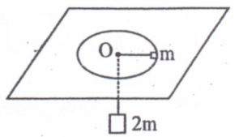
- A mass m rotating freely in a horizontal circle of radius 1 m on a frictionless smooth table supports a stationary mass 2 m, attached to the other end of the string passing through smooth hole O in table, hanging vertically. Find the angular velocity of rotation.
(A) $\sqrt{g}$ (B) $\sqrt{2g}$
(C) $\sqrt{g/2}$ (D) $\sqrt{3g}$

- A stone is rotated steadily in a horizontal circle with a time period T by means of a string of length $l$. If the tension in the string is kept constant and length $l$ increase by 1%, then percentage change in time period T is:
(A) Increase by 1% (B) Decrease by 1% (C) Increase by 0.5% (D) Decrease by 0.5%
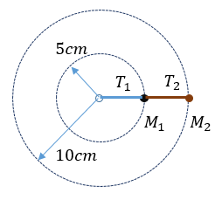
- Two different masses $M_{1}=0.25kg$ and $M_{2}=1kg$ are connected to two massless strings as shown in the figure. Both the masses rotate about a central fixed point with angular velocity 10 rad/s on a smooth horizontal plane. The ratio of tension $T_{1}$/$T_{2}$ in the string is?
(A) 1/8 (B) ¼
(C) 5/4 (D) 9/8

- One end of ideal spring of k= 100N/m and natural length of 0.5 m is fixed and other end is connected to a particle of mass 0.5 kg lying on a frictionless horizontal surface. If the mass is made to rotate in horizontal plane with angular velocity of 2 rad/sec, the elongation of the spring will be approximately be equal to?
(A) 1 cm (B) 4 cm (C) 10 cm (D) 20 cm
- A small object placed on a rotating horizontal turn table just slips when it is placed at a distance 4 cm from the axis of rotation. If the angular velocity of the turn-table is doubled, the object slips when its distance from the axis of rotation is
(A) 1 cm (B) 2 cm (C) 4 cm (D) 8 cm
- [AIPMT 2010 (Pre)] A gramophone record is revolving with an angular velocity ω. A coin is placed at a distance r from the centre of the record. The static coefficient of friction is µ. The coin will revolve with the record if:
(A) $r≥\frac{μg}{ω^{2}}$ (B) $r=μgω^{2}$ (C) $r<\frac{ω^{2}}{μg}$ (D) $r≤\frac{μg}{ω^{2}}$
- [JEE Main 2021, 16 Mar, Shift 1] A block of 200 g moves with a uniform speed in horizontal circular groove with vertical side walls of radius 20 cm. If the block takes 40 s to complete one round, the normal force by the side walls of the groove is:
(A) 0.0314 N (B) 9.859$×{10}^{-2}$N (C) 6.28$×{10}^{-3}$N (D) 9.859$×{10}^{-4}$N
- [JEE Main 2021, 26 Feb, Shift 1] A particle is moving with uniform speed along the circumference of a circle of radius R under the action of a central fictitious force F which is inversely proportional to $R^{3}$. Its time period of revolution will be given by:
(A) $T∝R^{2}$ (B) $T∝R^{3/2}$ (C) $T∝R^{5/2}$ (D) $T∝R^{4/3}$
- A metal ring of mass m and radius R is placed on a smooth horizontal plane and set in rotation about its own axis at an angular velocity of ω. Find the tension in the ring.
(A) $mRω^{2}$ (B) $\frac{mRω^{2}}{2π}$ (C) $\frac{mRω^{2}}{π}$ (D) $mπRω^{2}$
- [AIPMT 2006] A tube of length L is filled completely with an incompressible liquid of mass M and closed at both the ends. The tube is then rotated in a horizontal plane about one of its ends with a uniform angular velocity $ω$. The force exerted by the liquid at the other end is:
(A) $\frac{1}{2}MLω^{2}$ (B) $\frac{1}{2}ML^{2}ω$ (C) $MLω^{2}$ (D) $\frac{1}{2}ML^{2}ω^{2}$
- [JEE Main 2019, 12 Apr, Shift 1] A uniform rod of length L is being rotated in a horizontal plane with a constant angular speed about an axis passing through one of its ends. If the tension generated in the rod due to rotation is T(x) at a distance x from the axis, then which of the following graphs depict it most closely:
(A) 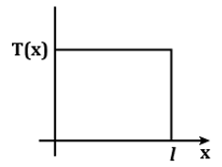 (B) 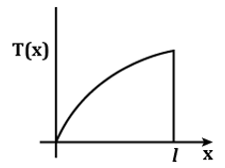 (C) 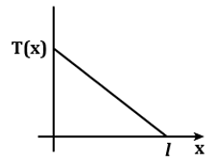 (D) 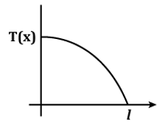
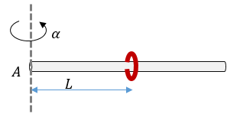
- [L2] A long horizontal rod has a bead which can slide along its length, and initially placed at a distance L from one end A of the rod. The rod is set into angular motion about A with constant angular acceleration α. If the coefficient of friction between the rod and bead is µ, and gravity is neglected, then the time after which the bead starts slipping is?
(A) $2\sqrt{μ/α}$ (B) $\sqrt{2μ/α}$
(C) $\sqrt{μ/2α}$ (D) $\sqrt{μ/α}$

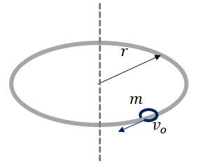
- [L2] A small bead of mass ‘m’ is given an initial velocity of $v_{o}$ on a horizontal circular ring of radius ‘r’. The coefficient of friction between the bead and the ring is μ. This arrangement is placed in a gravity free space. Find the initial acceleration of the bead?
(A) $\frac{{v_{o}}^{2}}{r}(1+μ)$ (B) $\frac{{v_{o}}^{2}}{r}(1+μ^{2})$
(C) $\frac{{v_{o}}^{2}}{r}\sqrt{1+μ^{2}}$ (D) $\frac{{{μv}_{o}}^{2}}{r}$

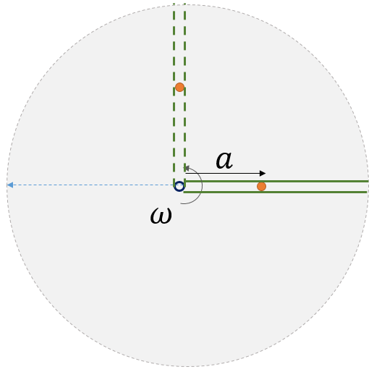
- [L2] A table with smooth horizontal surface is rotating with angular velocity of ω. A groove is made on the surface along the radius and a particle of mass m is placed in the groove at a distance ‘a’ from the center. Find the radial speed of the particle when its distance from the center becomes L.

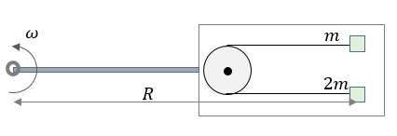
- [L2] On a smooth horizontal surface free to rotate in circle of large radius R. Two masses are connected through a string passing over a pulley on the horizontal surface as shown. The system of two masses is released from the position of rest with respect to the surface rotating as shown. Find the instantaneous tension in the string connecting two masses soon after the release.
(A) $\frac{2mR ω^{2}}{3}$ (B) $\frac{4mR ω^{2}}{3}$
(C) $\frac{mR ω^{2}}{3}$ (D) $mR ω^{2}$

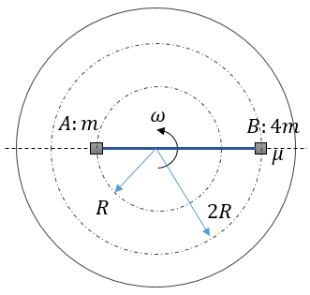
- [L3] Two blocks A and B of mass $m$ and 4$m$ respectively, connected by a string, are placed on a horizontal surface which is rotating with a constant angular velocity of $ω$ about a vertical axis. A and B are at distances R and 2R from the axis, on opposite sides of it. There is no friction between ‘A’ and the surface. What should be minimum coefficient of friction between the surface and block B if there is no slipping.

Conical Pendulum & Motion in Cones/Bowls
- [NEET 2019] A block of mass 10 kg is in contact against the inner wall of a hollow cylindrical drum of radius 1 m. The coefficient of friction between the block and the inner wall of the cylinder is 0.1. The minimum angular velocity needed for the cylinder to keep the block stationary when the cylinder is vertical and rotating about its axis, will be?
(A) $\sqrt{10}$ rad/sec (B) $\frac{10}{2π}$ rad/sec (C) 10 rad/sec (D) 10π rad/sec
- [JEE Main 2021, 26 Aug, Shift 2] A particle of mass m is suspended from a ceiling through a string of length L. The particle moves in a horizontal circle of radius r such that r = $\frac{L}{\sqrt{2}}$. The speed of the particle will be:
(A) $\sqrt{rg}$ (B) $\sqrt{2rg}$ (C) $2\sqrt{rg}$ (D) $\sqrt{rg/2}$
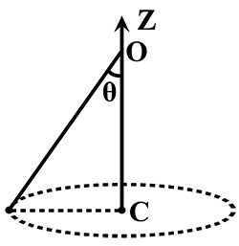
- [JEE Main 2017, 9 Apr (Online)] A conical pendulum makes an angle θ = 45° w.r.t. Z-axis and moves in a circle in the XY plane. The radius of the circle is 0.4 m and its centre is vertically below O. The speed of the pendulum, in its circular path, will be:
(A) 0.2 m/s (B) 0.4 m/s
(C) 2 m/s (D) 4 m/s

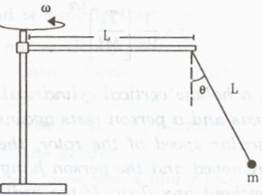
- Figure shows a rod of length 20 cm pivoted near an end and which is made to rotate in a horizontal plane with a constant angular speed. A ball of mass m is suspended by a string also of length 20 cm from the other end of the rod. If the angle θ made by the string with the vertical is 30°, find the angular speed of the rotation.
(A) $\frac{g}{\sqrt{3}}$ (B) $\frac{g}{3\sqrt{3}}$
(C) $\sqrt{\frac{10g}{3\sqrt{3}}}$ (D) $\frac{g}{\sqrt{2}}$

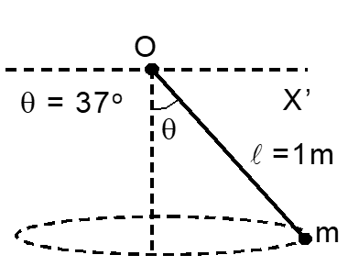
- A particle of mass 1 kg is tied with a string of length 1 m is made to undergo uniform circular motion in horizontal plane as shown in figure. Choose INCORRECT option(s):
(A) the speed of particle is 2.1 m/s (B) Time period will be about 1.8 s
(C) the tension in string is 10 N (D) angular velocity is $5/\sqrt{2}$ rad/s

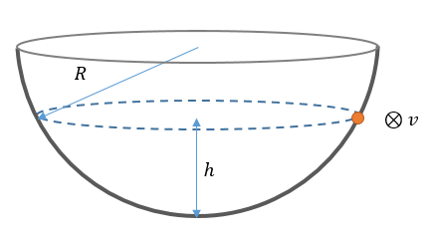
- A small mass ‘m’ is given a horizontal velocity of $v$ tangential to the surface of a smooth hemisphere of radius R such that the particles moves into horizontal circular path. If the height $h$=R/2, find the value of $v$?
(A) $\sqrt{3gR}$ (B) $\sqrt{2gR}$
(C) $\sqrt{\frac{3}{2}gR}$ (D) $\sqrt{gR}$

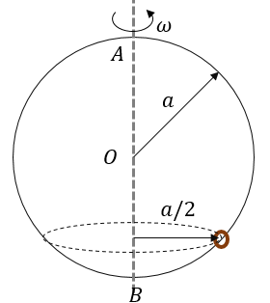
- [JEE Main 2019, 12 Apr, Shift 2] A smooth wire of length 2πa is bent into a circle and kept in a vertical plane. A bead can slide smoothly on the wire. When the circle is rotating with angular speed ω about a vertical diameter AB as shown in the figure, the bead is at rest with respect to the circular ring at position P. Then $ω^{2}$ is equal to:
(A) $\frac{2g}{a}$ (B) $\frac{2g}{a\sqrt{3}}$ (C) $\frac{g\sqrt{3}}{a}$ (D) $\frac{g\sqrt{3}}{2a}$

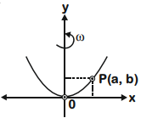
- [JEE Main 2020, 2 Sep, Shift 1] What should be angular velocity of a wire bent in form of parabola $y=4cx^{2}$lying in a vertical plane if a bead of mass m does not slip if placed at (a, b) ?
(A)$2\sqrt{2gc}$ (B)$\sqrt{2gc}$
(C) $2\sqrt{2gc/b}$ (D) $2\sqrt{gc/b}$

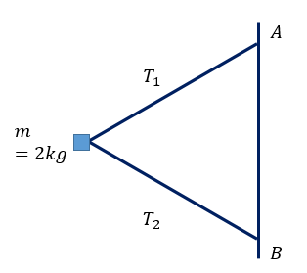
- [L2] Two strings of length $l=$ 0.5 m each are connected to a block of mass m = 2 kg at one end and their ends are attached to the point A and B 0.5 m apart on a vertical pole which rotates with a constant angular velocity ω = 7 rad/sec. Find the ratio $T_{1}$: $T_{2}$ of tension in the upper string ($T_{1}$) and the lower string ($T_{2}$). [g = 9.8 m/$s^{2}$]
(A) 9 (B) $4\sqrt{3}$
(C) $9\sqrt{3}$ (D) 6

Vehicles on Flat & Banked Curves
- A car turns a corner on a slippery road at a constant speed of 12 m/s. If the coefficient of friction is 0.4, the minimum radius of the arc in metres in which the car turns is:
(A) 72 (B) 36 (C) 18 (D) 9
- A truck is carrying a box of mass m = 50 kg on its flat horizontal rough surface with coefficient of friction μ = 0.3. It is crossing a circular track of radius 27 m. What is the maximum speed of the truck so that the box does not slide from the truck while moving on the circular path?
(A) 3 m/s (B) 9 m/s (C) 6 m/s (D) 12 m/s
- [JEE Main 2021, 17 Mar, Shift 1] A modern grand-prix racing car of mass m is travelling on a flat track in a circular arc of radius R with a speed v. If the coefficient of static friction between the tyres and the track is $μ_{s}$; then the magnitude of negative lift $f_{L}$ acting downwards on the car is:
(A) $m\left(\frac{v^{2}}{μ_{s}R}+g\right)$ (B) $m\left(\frac{v^{2}}{μ_{s}R}-g\right)$ (C) $m\left(g-\frac{v^{2}}{μ_{s}R}\right)$ (D) $-m\left(\frac{v^{2}}{μ_{s}R}+g\right)$
- [AIPMT 2012 (Pre)] A car of mass 1000 kg negotiates a banked curve of radius 90 m on a frictionless road. If the banking angle is 45°, the speed of the car is :-
(A) 5 m/s (B) 10 m/s (C) 20 m/s (D) 30 m/s
- A cyclist is moving on a circular track of radius 80 m with a velocity of 72 km/h. He has to lean from the vertical approximately through an angle:
(A) $\tan^{-1}\left(1/4\right)$ (B) $\tan^{-1}\left(1\right)$ (C) $\tan^{-1}\left(1/2\right)$ (D) $\tan^{-1}\left(2\right)$
- A car is moving in a circular horizontal track of radius 10 m with a constant speed of 10 m/s. A plumb bob is suspended from the roof of the car by string of length 1 m. The angle made by the string with the vertical?
(A) $15°$ (B) $30°$ (C) $37°$ (D) $45°$
- [NEET 2016] A car is negotiating a curved road of radius R. The road is banked at an angle θ. the coefficient of friction between the tyres of the car and the road is $μ_{s}$. The maximum safe velocity on this road is:
(A) $\sqrt{gR^{2}\frac{μ_{s}+tanθ}{1-μ_{s}tanθ}}$ (B) $\sqrt{gR\frac{μ_{s}+tanθ}{1-μ_{s}tanθ}}$ (C) $\sqrt{\frac{g}{R}\frac{μ_{s}+tanθ}{1-μ_{s}tanθ}}$ (D) $\sqrt{(g{/R}^{2})\frac{μ_{s}+tanθ}{1-μ_{s}tanθ}}$
- [JEE Main 2021, 20 Jul, Shift 1] The normal reaction N for a vehicle of 800 kg mass negotiating a turn on a $30°$ banked road at maximum possible speed without skidding is ……$×{10}^{3}$ N. (Take g = 9.8 m/s² and $μ_{s}=0.2)$
(A) 10.2 (B) 7.2 (C) 12.4 (D) 6.96

Answer Key
Circular Motion Kinematics
Q1 | $2vsin(\frac{θ}{2})$; $\frac{v^{2}}{R}\frac{sin(\frac{θ}{2})}{\frac{θ}{2}}$ | Q2 | C | Q3 | D
Q4 | C | Q5 | D | Q6 | D
Q7 | A | Q8 | A | Q9 | A
Q10 | C | Q11 | C | Q12 | B
Q13 | B | Q14 | A | Q15 | D
Q16 | A | Q17 | D | Q18 | C
Q19 | A | Q20 | D | Q21 | D
Q22 | D | Q23 | B | Q24 | B
Q25 | A | Q26 | $72π$
Horizontal Circle: Centripetal Force & Rotating Frames
Q27 | B | Q28 | A | Q29 | B
Q30 | C | Q31 | D | Q32 | A
Q33 | A | Q34 | D | Q35 | D
Q36 | A | Q37 | B | Q38 | A
Q39 | D | Q40 | D | Q41 | C
Q42 | $$v^{2}=ω^{2}(L^{2}-a^{2})$$ | Q43 | B | Q44 | $$μ=7Rω^{2}/4g$$
Conical Pendulum & Motion in Cones/Bowls
Q45 | C | Q46 | A | Q47 | C
Q48 | C | Q49 | C | Q50 | C
Q51 | B | Q52 | A | Q53 | A
Vehicles on Flat & Banked Curves
Q54 | B | Q55 | B | Q56 | B
Q57 | D | Q58 | C | Q59 | D
Q60 | B | Q61 | A

Hints & Solutions
Circular Motion Kinematics
Q22 Hint
What will be the minimum distance between the two cars? 18 m)
Think further
(What is the velocity of approach at the instant? Answer: 22 m/s
Q25 Hint
Component of acceleration along velocity: $\vec{a}.\hat{v}$
Q26 Hint
Moving in a circular path of radius 4 with angular velocity of $6π$ rad/s.

