Motion in a Straight Line
Solutions to Worksheet 03MSL
How to use these solutions. Each problem is in layers. Open them one at a time.
Hint: a nudge at the point where most students get stuck. Read it, close the page, and try again.
Think it through: the solution as a teacher would talk it through, with no writing. Each step follows from the one before for a stated reason. Aim to have the whole path in your head before you pick up the pen. Another way gives a different route, and No-pen route is one you can finish in your head.
Worked solution: the solution as you would write it in an exam, with figures, ending with the answer and the traps to watch out for.
The “Notes” line at the end of each problem points to the section of the Kinematics revision notes that the problem draws on.

Distance, Displacement, Speed & Velocity

Q1 · The tip of a clock’s second hand
ID 03MSL-0305-a974 · Code 0305 · Worksheet 03MSL_v2 Q1

Problem
A clock has its second hand 2 cm long. Find the distance travelled and displacement of the tip of the second hand in 15 seconds.

Hint
Distance is the length of the path the tip actually traces, which is the arc it sweeps in 15 s. For displacement, ask only where the tip starts and where it ends.

Think it through
- The tip moves on a circle of radius 2 cm about the centre of the clock. So “distance” means the length of arc it sweeps, and “displacement” means the straight arrow from where it starts to where it ends.
- A full turn takes 60 s, so 15 s is a quarter turn: say from the 12 to the 3.
- The full circle is 2π × 2 = 4π cm, so the quarter arc is π cm, about 3.14 cm.
- For the displacement, the start and the end are each 2 cm from the centre, and the two radii are at right angles. The arrow joining them is the hypotenuse of a right isosceles triangle with legs of 2 cm, so it is 2√2 ≈ 2.83 cm, pointing from the 12 mark to the 3 mark.
- Check: 2.83 cm is less than 3.14 cm, as it must be for a curved path.

Another way: the chord rule
On a circle, the chord joining two points that subtend angle θ at the centre is 2R sin(θ/2). Here that is 2 × 2 × sin 45° = 2√2 cm. The same rule gives any fraction of a turn at once: after 20 s (120°) the displacement is 2√3 cm, and after 30 s (180°) it is the diameter, 4 cm.

Worked solution
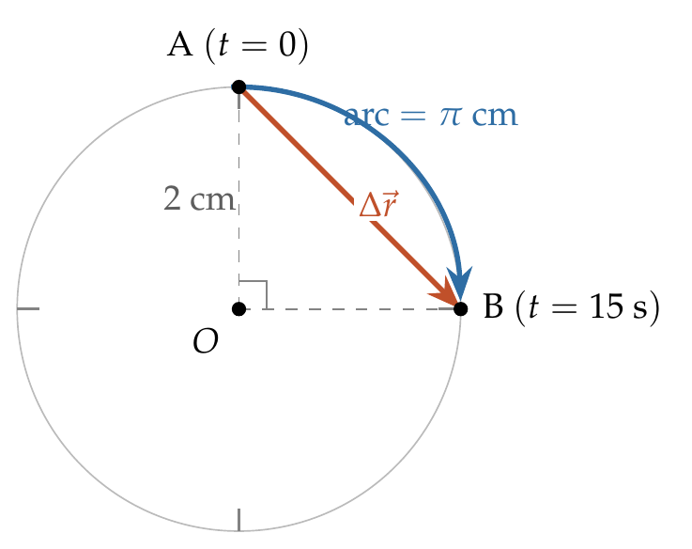
Take the centre $O$ as origin, with $x$ to the right and $y$ up. In 15 s the hand turns through
$$θ=\frac{15}{60}×{360}^{∘}={90}^{∘}=\frac{π}{2} rad.$$
Distance travelled = arc AB:
$$s=Rθ=2×\frac{π}{2}=π cm≈3.14 cm.$$
Position vectors: ${\vec{r}}_{A}=2\hat{ȷ}$ cm and ${\vec{r}}_{B}=2\hat{ı}$ cm. So
$$Δ\vec{r}={\vec{r}}_{B}−{\vec{r}}_{A}=\left(2\hat{ı}−2\hat{ȷ}\right) cm, \left|Δ\vec{r}\right|=\sqrt{2^{2}+2^{2}}=2\sqrt{2} cm≈2.83 cm,$$
directed at 45° below the horizontal, from the 12 mark towards the 3 mark.

Answer
Distance = π cm ≈ 3.14 cm; displacement = 2√2 cm ≈ 2.83 cm.

Watch out
• Displacement is the chord (2√2 cm), not the arc (π cm). It is a vector: say which way it points.
• 15 s is a quarter turn for the second hand; for a minute hand it would be a tiny fraction of a turn.
Notes: Sec. 1 (distance vs displacement; quarter-circle example).

Q2 · A point on a rolling wheel
ID 03MSL-0305-9828 · Code 0305 · Worksheet 03MSL_v2 Q2

Problem
A wheel of radius R metre rolls forward half a revolution on a horizontal ground. The magnitude of the displacement of the point of the wheel initially in contact with the ground is?

Hint
Picture the wheel at the start and after half a turn: where is that point now? Then think of its displacement as a horizontal part and a vertical part.

Think it through
- Displacement depends only on where the point P starts and where it ends, not on the curved path in between. So find the end position.
- After half a revolution the wheel has turned through 180°. The point that was at the bottom is now at the top.
- How far forward has the wheel gone? In rolling without slipping, each bit of rim that touches the ground lays down an equal length of ground. Half the rim, πR, has touched the ground, so the centre has moved forward πR.
- Now see P’s displacement as two parts. The centre carries P forward by πR. Relative to the centre, P has gone from directly below it to directly above it, 2R upward.
- These two parts are at right angles, so the displacement is √((πR)² + (2R)²) = R√(π² + 4) ≈ 3.72R, at tan⁻¹(2/π) ≈ 32.5° above the ground.
- Check: the distance P actually travels along its curved path (half an arch of a cycloid) is 4R. That is more than 3.72R, as it must be.

Another way: coordinates
Put the origin at P’s starting point. At the end P is at height 2R (top of the wheel) and directly above the new contact point, which is πR ahead. So P’s end coordinates are (πR, 2R), and the magnitude follows by Pythagoras.

Worked solution
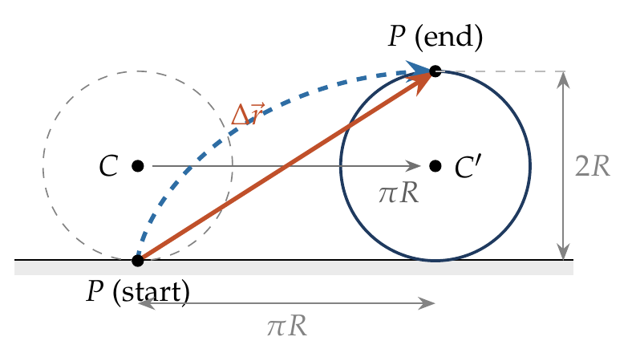
Take the origin at the initial point of contact $P$, with $x$ along the ground and $y$ upward.
For rolling without slipping, the centre moves forward by the arc length that has touched the ground:
$$x_{C}=Rθ=Rπ \left(θ=π for half a revolution\right).$$
After half a revolution, $P$ is at the top of the wheel, vertically above the new point of contact:
$${\vec{r}}_{P}\left(end\right)=πR \hat{ı}+2R \hat{ȷ}.$$
Since ${\vec{r}}_{P}\left(start\right)=0$,
$$\left|Δ\vec{r}\right|=\sqrt{{\left(πR\right)}^{2}+{\left(2R\right)}^{2}}=R\sqrt{π^{2}+4}≈3.72R.$$

Answer
$R\sqrt{π^{2}+4}$ m (≈ 3.72R), at tan⁻¹(2/π) ≈ 32.5° to the ground.

Watch out
• πR is only the horizontal part and 2R only the vertical part; the displacement is their vector sum.
• The distance travelled (4R, along the curved path) is not the displacement.
Notes: Sec. 1.1 (rolling-wheel example).

Q3 · Three sides of a square
ID 03MSL-0305-fb10 · Code 0305 · Worksheet 03MSL_v2 Q3

Problem
A particle moves along the sides AB, BC, CD of a square of side 25 m with a speed of 15 m/s. Its average velocity is?

Hint
Average velocity is displacement ÷ time. To find the displacement, identify the particle’s initial and final positions; the path in between does not matter.

Think it through
- Average velocity is displacement divided by time. The route matters only through the time it takes.
- Time: three sides, 75 m, at a steady 15 m/s take 5 s.
- Displacement: going round three sides of a square, A → B → C → D, brings the particle to D, the corner next to A. So the displacement is just the side AD: 25 m, pointing from A to D.
- Average velocity = 25 m in 5 s = 5 m/s, directed from A to D.
- Compare: average speed = 75/5 = 15 m/s, three times as large, because the path is three times the displacement.

No-pen route
For three sides of a square at a constant speed v, the path is three sides but the displacement is one side. So the average velocity is always v/3: 15/3 = 5 m/s.

Worked solution
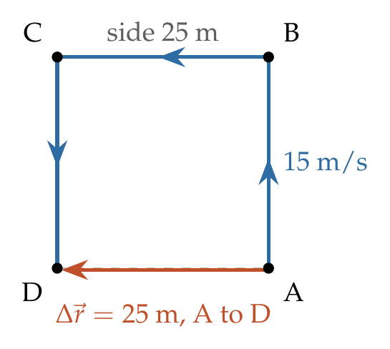
Total distance $=AB+BC+CD=3×25=75$ m.
Time taken:
$$t=\frac{75}{15}=5 s.$$
Displacement $=\vec{AD}$, of magnitude 25 m, directed from A to D. So
$$\left|{\vec{v}}_{av}\right|=\frac{\left|Δ\vec{r}\right|}{t}=\frac{25}{5}=5 m/s along AD.$$

Answer
5 m/s, directed from A to D.

Watch out
• Average velocity uses the displacement (25 m), not the path length (75 m). 15 m/s is the average speed.
• Give the direction (along AD): average velocity is a vector.
Notes: Sec. 2.1 (average velocity); Sec. 2.2 (average speed ≥ |average velocity|).

Q4 · A train crossing a bridge
ID 03MSL-0305-6a68 · Code 0305 · Worksheet 03MSL_v2 Q4

Problem
A 150 m long train is moving with a uniform velocity of 45 km/h. The time taken by the train to cross a bridge of length 850 metres is
(A) 56 s (B) 68 s (C) 80 s (D) 92 s

Hint
Follow one point, the front of the engine. Between the moment it enters the bridge and the moment the last coach leaves, it travels the bridge length plus the train length.

Think it through
- “Crossing” begins when the front of the engine reaches the bridge and ends when the last coach leaves it.
- A train in uniform motion is a rigid body in translation, so every point on it moves the same way. Follow just the front of the engine.
- The front must cover the bridge, 850 m. At that moment the rest of the train, 150 m, is still on the bridge, so the front must go another 150 m. Total: 1000 m.
- 1000 m is exactly 1 km. At 45 km/h, 1 km takes 1/45 of an hour, which is 3600/45 = 80 s. (C)

Another way: convert to m/s
Convert first: 45 × 5/18 = 12.5 m/s, and 1000/12.5 = 80 s.

Why the other options are there
Using only the bridge length gives 850/12.5 = 68 s (B). Subtracting the train length gives 700/12.5 = 56 s (A).

Worked solution
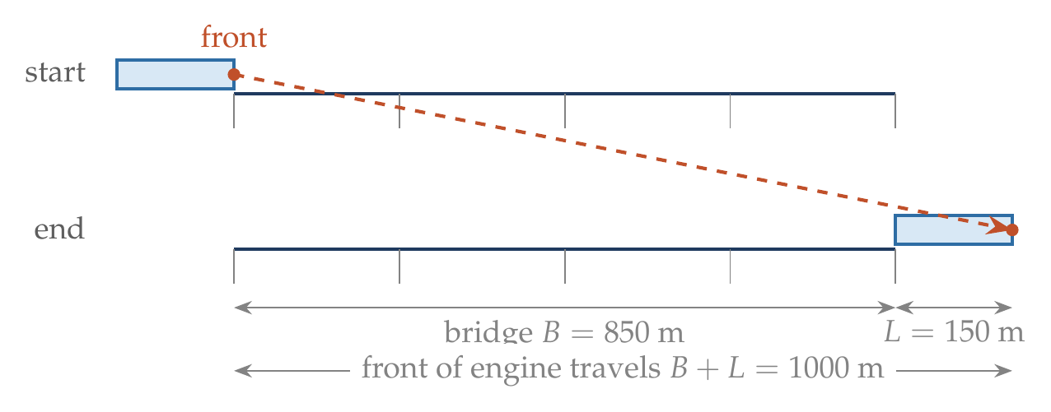
Distance to be covered by the front of the engine:
$$s=B+L=850+150=1000 m.$$
Speed:
$$v=45×\frac{5}{18}=12.5 m/s.$$
Time:
$$t=\frac{s}{v}=\frac{1000}{12.5}=80 s.$$

Answer
(C) 80 s.

Watch out
• Crossing ends when the last coach leaves the bridge: add the train’s length (850 m alone gives the distractor 68 s).
• Convert 45 km/h to m/s (× 5/18) before dividing metres by speed, or keep everything in km and hours.
Notes: Sec. 1 (Common traps: a train of length L crossing a bridge of length B covers L + B).

Q5 · One lap of a circular track [AIPMT 2006]
ID 03MSL-0305-cb0b · Code 0305 · Worksheet 03MSL_v2 Q5

Problem
A car runs at a constant speed on a circular track of radius 100 m, taking 62.8 seconds for every circular lap. The average velocity and average speed for each circular lap respectively is:
(A) 0, 0 (B) 0, 10 m/s (C) 10 m/s, 10 m/s (D) 10 m/s, 0

Hint
After a full lap the car is back where it started. Then notice that 62.8 = 20π.

Think it through
- After one complete lap the car is back at its starting point. Displacement is zero, so the average velocity is zero. That rules out (C) and (D).
- The car did move, so the distance is not zero and the average speed cannot be zero. That rules out (A).
- Average speed = circumference ÷ lap time = 2π × 100 / 62.8. Since 62.8 = 20π, this is 200π/20π = 10 m/s. (B)
- Note: the speed is 10 m/s at every instant, but the velocity keeps turning. It averages to zero over a lap because it points in every direction equally.

No-pen route
Steps 1 and 2 alone pick (B); the value 10 m/s only confirms it.

Worked solution
For one lap, initial and final positions coincide:
$$Δ\vec{r}=0 ⇒ {\vec{v}}_{av}=\frac{Δ\vec{r}}{T}=0.$$
Distance in one lap $=2πR=2π\left(100\right)=628$ m. So
$$average speed=\frac{628}{62.8}=10 m/s.$$

Answer
(B) 0, 10 m/s.

Watch out
• Average velocity over a closed loop is zero even though the car never stopped; average speed is not.
Notes: Sec. 1 (full lap: displacement = 0); Sec. 2.2 (average speed).

Q6 · Round trip at two speeds
ID 03MSL-0305-b0f5 · Code 0305 · Worksheet 03MSL_v2 Q6

Problem
A car moves from X to Y with a uniform speed $v_{u}$ and returns to X with a uniform speed $v_{d}$. The average speed for this round trip is:
(A) $\frac{v_{u}+v_{d}}{2}$ (B) $\frac{2v_{u}v_{d}}{v_{u}+v_{d}}$ (C) $\sqrt{v_{u}v_{d}}$ (D) $\frac{v_{u}v_{d}}{v_{u}+v_{d}}$

Hint
The two legs cover equal distances, not equal times, so the slower leg lasts longer and counts for more. Average speed is total distance ÷ total time.

Think it through
- Average speed is always total distance ÷ total time. It equals the simple mean of two speeds only when the two speeds last for equal times.
- Here the distances are equal, so the car spends longer at the slower speed. The answer must be pulled towards the slower speed, below the simple mean. So (A) is wrong.
- Let XY = d. The times are d/v_u and d/v_d, and the total distance is 2d. The d cancels, leaving 2v_u v_d/(v_u + v_d): the harmonic mean. (B)

No-pen route: limiting cases
Test each option on cases whose answer is obvious.
- If both speeds are equal to v, the average must be v. (A), (B) and (C) give v; (D) gives v/2. So (D) is out.
- If the return is almost instant ($v_{d}$ huge), the whole 2d is covered in the time d/v_u, so the average approaches 2v_u. (B) tends to 2v_u; (A) and (C) grow without limit. Only (B) survives.

Worked solution
Let $XY=d$. Then
$$t_{1}=\frac{d}{v_{u}}, t_{2}=\frac{d}{v_{d}}.$$
$$\overset{‾}{v}=\frac{2d}{t_{1}+t_{2}}=\frac{2d}{d\left(\frac{1}{v_{u}}+\frac{1}{v_{d}}\right)}=\frac{2v_{u}v_{d}}{v_{u}+v_{d}}.$$

Answer
(B) $\frac{2v_{u}v_{d}}{v_{u}+v_{d}}$, the harmonic mean of the two speeds.

Watch out
• “Average speed = mean of the speeds” is true only for equal times. For equal distances it is the harmonic mean.
Notes: Sec. 2.2 (equal distances: harmonic mean; example a: 30 and 60 km/h give 40 km/h).

Q7 · Half the distance, then two equal times
ID 03MSL-0305-2b48 · Code 0305 · Worksheet 03MSL_v2 Q7

Problem
A particle moving in a straight line covers half the distance with speed of 3 m/s. The other half of the distance is covered in two equal time intervals with speed of 4.5 m/s and 7.5 m/s respectively. The average speed of the particle during this motion is?

Hint
Average the second half first: equal times give the simple mean, 6 m/s. Now you have two equal distances at 3 m/s and 6 m/s.

Think it through
- There are two kinds of “equal” here: equal distances (the two halves) and, inside the second half, equal times. Work from the inside out.
- Inside: the second half is covered in two equal times at 4.5 and 7.5 m/s. For equal times the average is the simple mean, 6 m/s. In any time t the particle covers 4.5t + 7.5t = 12t in 2t.
- Outside: the motion is now one half at 3 m/s and one half at an effective 6 m/s. For equal distances the average is the harmonic mean: 2 × 3 × 6 / (3 + 6) = 4 m/s.
- Sense check: 4 lies between 3 and 6 and closer to 3, as it should, because the particle spends twice as long on the slow half.

No-pen route: choose a convenient distance
Let each half be 6 m, which divides neatly by 3 and by 6. The first half takes 2 s and the second half takes 1 s. That is 12 m in 3 s, so 4 m/s.

Worked solution
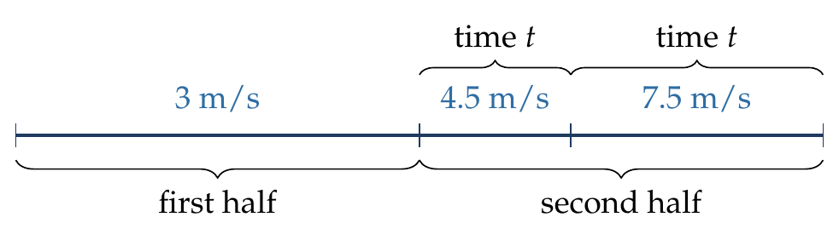
Let the total distance be $2s$.
First half:
$$t_{1}=\frac{s}{3}.$$
Second half, two intervals of $t$ each:
$$4.5t+7.5t=s ⇒ t=\frac{s}{12}, t_{2}=2t=\frac{s}{6}.$$
$$\overset{‾}{v}=\frac{2s}{t_{1}+t_{2}}=\frac{2s}{\frac{s}{3}+\frac{s}{6}}=\frac{2s}{s/2}=4 m/s.$$

Answer
4 m/s.

Watch out
• Don’t average 3, 4.5 and 7.5 (giving 5 m/s): the three stages are neither equal times nor equal distances.
• Combine the equal-time part first, then the two equal-distance halves.
Notes: Sec. 2.2 (unequal pieces; nested problems solved stage by stage).

Q8 · Three speeds round a circle
ID 03MSL-0305-5f2e · Code 0305 · Worksheet 03MSL_v2 Q8

Problem
A particle is moving along a circular path of radius R. For the first quarter of the circle it travels with a speed v, then it covers another third of the circle with a speed of 2v, and finally the remaining part with speed 3v. Find its average speed.

Hint
The remaining part is 1 − ¼ − ⅓ = 5/12 of the circle. Time for each part = (its share of the circumference) ÷ (its speed).

Think it through
- Only fractions of the circumference and the speeds enter. The radius will cancel, so call the circumference C.
- The parts are ¼, ⅓ and 1 − ¼ − ⅓ = 5/12 of C.
- Pick a convenient C, say 36 units (divisible by 4, 3 and 12, and the pieces divide neatly by the speeds). The pieces are 9, 12 and 15 units.
- Times: 9 units at v takes 9/v; 12 at 2v takes 6/v; 15 at 3v takes 5/v. Total time 20/v.
- Average speed = 36 ÷ (20/v) = 1.8v.
- Sense check: the answer lies between v and 3v and below 2v, because nearly half the time (9 of 20 parts) is spent on the slowest stretch.
- The particle completes the circle, so its average velocity is zero.

Worked solution
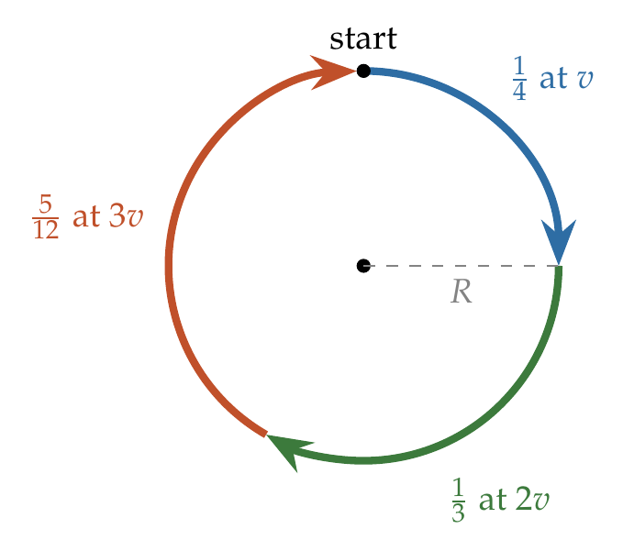
Let $L=2πR$.
$$t_{1}=\frac{L/4}{v}=\frac{L}{4v}, t_{2}=\frac{L/3}{2v}=\frac{L}{6v}, t_{3}=\frac{5L/12}{3v}=\frac{5L}{36v}.$$
$$t_{1}+t_{2}+t_{3}=\frac{L}{36v}\left(9+6+5\right)=\frac{5L}{9v}.$$
$$\overset{‾}{v}=\frac{L}{5L/9v}=\frac{9v}{5}=1.8 v.$$

Answer
1.8v (independent of R). The average velocity over the full circle is zero.

Watch out
• Averaging v, 2v and 3v (giving 2v) is wrong: each speed must be weighted by the time spent at it.
• The last part is 5/12 of the circle, not ⅓.
Notes: Sec. 2.2 (unequal pieces, distances given).

Q9 · Least time: road, then field [L2]
ID 03MSL-0305-f4f7 · Code 0305 · Worksheet 03MSL_v2 Q9

Problem
A man in a car at location Q on a straight highway is moving with speed v. He decides to reach a point P in a field at a distance d from the highway (point M). Speed of the car in the field is half of that on the highway. What should be the distance RM, so that the time taken to reach P is minimum?
(A) d (B) d/√2 (C) d/2 (D) d/√3

Hint
At the best turning point R, turning off a tiny distance later should neither save nor lose time. Compare the extra road time with the field time saved.

Think it through
- The car is fast on the road and slow in the field. Turning off early means a long, slow field leg. Turning off late shortens the field leg but adds road. The best point R balances the two.
- Balance test: suppose R is the best point, and imagine turning off a tiny distance δ later, at R′.
- The extra road costs δ at speed v, a time of δ/v.
- The field leg gets shorter by the part of δ that lies along the field path. If the field path makes angle θ with the perpendicular PM, it meets the road at 90° − θ. So the field leg shortens by δ cos(90° − θ) = δ sin θ, which saves δ sin θ at speed v/2, a time of 2δ sin θ/v.
- At the best point the loss and the saving must be equal (otherwise moving R would help). So δ/v = 2δ sin θ/v, giving sin θ = ½ and θ = 30°.
- In the right triangle PMR, RM = d tan 30° = d/√3. (D)
- This is Snell’s law in disguise: light, too, takes the path of least time, and sin θ = (slow speed)/(fast speed).
- Check: this works only if Q is more than d/√3 from M. Otherwise the car should head into the field straight from Q.

Another way: calculus
Write the total time as a function of x = RM and set its derivative to zero (worked solution below).

Worked solution
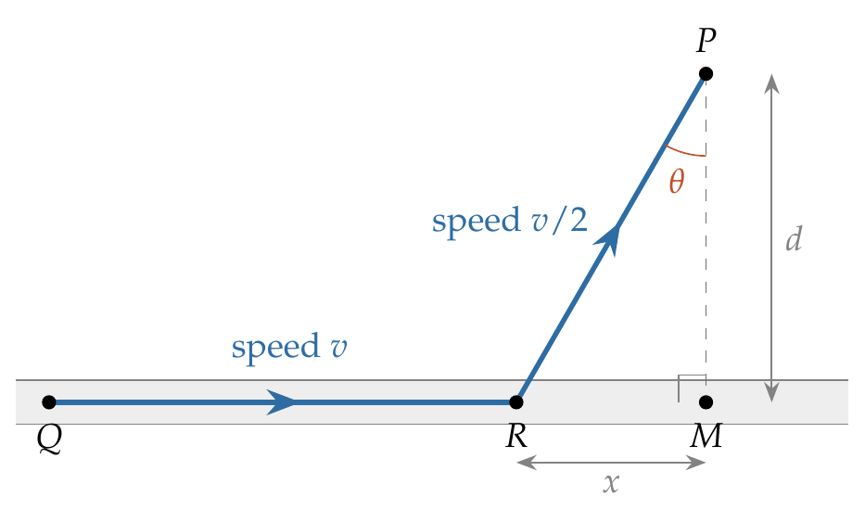
Let $QM=D$ (fixed) and $RM=x$ (variable). The car covers $QR=D−x$ at speed $v$ and $RP=\sqrt{d^{2}+x^{2}}$ at speed $v/2$:
$$T\left(x\right)=\frac{D−x}{v}+\frac{2\sqrt{d^{2}+x^{2}}}{v}.$$
For minimum time:
$$\frac{dT}{dx}=−\frac{1}{v}+\frac{2x}{v\sqrt{d^{2}+x^{2}}}=0 ⇒ \frac{x}{\sqrt{d^{2}+x^{2}}}=\frac{1}{2}.$$
Squaring: $4x^{2}=d^{2}+x^{2}$, so
$$x=\frac{d}{\sqrt{3}}.$$
$d^{2}T/dx^{2}=2d^{2}/\left[v{\left(d^{2}+x^{2}\right)}^{3/2}\right]>0$, so this is a minimum. Note that $x/\sqrt{d^{2}+x^{2}}=sinθ$, where $θ=∠RPM$, so the condition is $sinθ=1/2$ ($θ={30}^{∘}$).
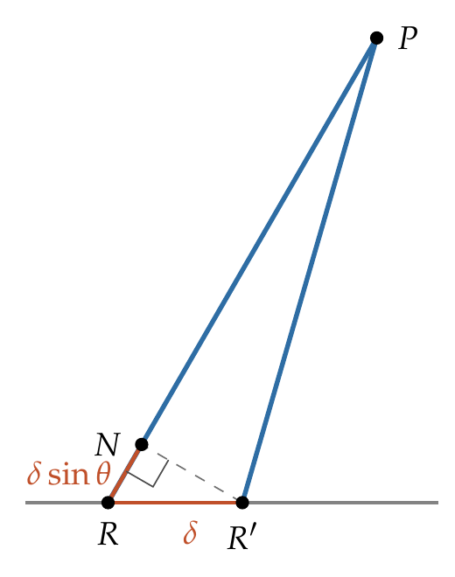
Check by small shift (figure above). Moving the turning point from R to R′ by δ adds road time δ/v. The field path shortens by RN = δ sin θ, saving 2δ sin θ/v. These are equal when sin θ = ½.
The minimum time is $T_{min}=\left(D+\sqrt{3} d\right)/v$.

Answer
(D) d/√3.

Watch out
• θ is measured from the perpendicular PM, not from the road.
• The question asks for RM (how far before M to leave the road), not QR.
Notes: Sec. 1.2 (least time with two speeds: sin θ = v₂/v₁).

Q10 · An ant crossing two walls [L2]
ID 03MSL-0305-d57d · Code 0305 · Worksheet 03MSL_v2 Q10

Problem
There is a room of size 2 m × 2 m and of height 3 m. An ant is at one corner of the room on the floor and it wants to reach the opposite corner on the roof. If the ant travels only along the vertical walls, find the minimum distance it has to travel to reach the diagonally opposite corner.

Hint
Unfold the two walls the ant crosses into one flat sheet, like opening a cardboard box. On a flat sheet the shortest path is a straight line.

Think it through
- The ant stays on the vertical walls and goes from a floor corner to the diagonally opposite ceiling corner. It must cross two adjacent walls, passing over the vertical edge where they meet.
- On one flat surface the shortest path is a straight line. Two walls meeting at an edge can be unfolded flat without changing any length drawn on them.
- Unfolded, the two walls form a rectangle 2 + 2 = 4 m wide and 3 m high. The ant goes from one bottom corner to the opposite top corner.
- The straight line is the hypotenuse of a 3–4–5 triangle: 5 m.
- The line crosses the shared edge halfway up, at 1.5 m. So the ant should aim for the middle of the corner edge.
- Check against other routes: up the corner edge and along two top edges is 3 + 2 + 2 = 7 m; across one wall diagonally and then along a top edge is √13 + 2 ≈ 5.6 m. Both are longer.

Worked solution
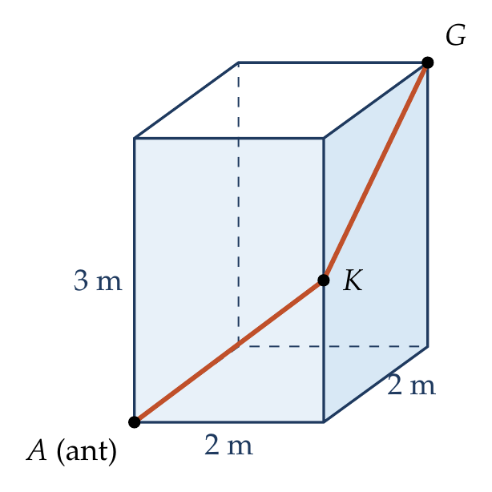
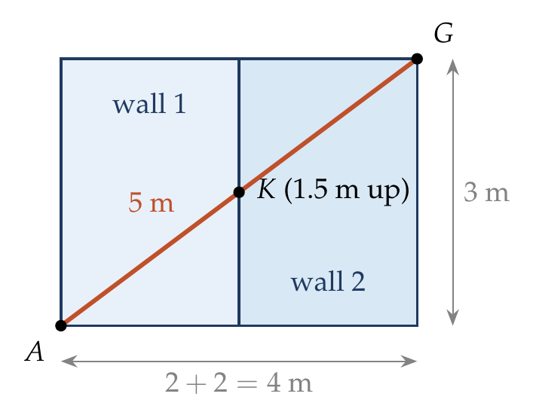
The ant goes from $A$ to $G$ over wall 1 (front) and wall 2 (side), crossing the common edge at $K$.
Unfold wall 2 about the common edge into the plane of wall 1. The two walls form a 4 m × 3 m rectangle, and the shortest path is its diagonal:
$$AG=\sqrt{{\left(2+2\right)}^{2}+3^{2}}=\sqrt{25}=5 m.$$
By similar triangles, $K$ is at height $3×2/4=1.5$ m on the common edge.

Answer
5 m.

Watch out
• The space diagonal of the room, √(2² + 2² + 3²) = √17 ≈ 4.1 m, is shorter than 5 m but passes through the air: the ant must stay on the walls.
• Adding the diagonals of the two walls separately (√13 + …) is not the shortest; unfold first, then draw one straight line.
Notes: Sec. 1.2 (unfold the surfaces).

Equations of Uniformly Accelerated Motion

Q11 · Average velocity from rest
ID 03MSL-0310-35d6 · Code 0310 · Worksheet 03MSL_v2 Q11

Problem
During a uniformly accelerated motion of a particle starting from state of rest, which of the following statement(s) are correct?
(A) average velocity of the particle is always less than its final velocity
(B) average velocity of the particle is always greater than its final velocity
(C) average velocity of the particle may be zero also
(D) average velocity of the particle is half its final velocity

Hint
With constant acceleration, average velocity = (u + v)/2. Put u = 0 and test each statement.

Think it through
- Acceleration is constant, so velocity changes at a steady rate. The average over the interval is then the mean of the first and last values, (u + v)/2.
- The particle starts from rest, so u = 0 and the average is v/2. (D) is true.
- Half of a positive number is less than the number, so the average is less than the final velocity at every instant after the start. (A) is true and (B) is false.
- Could the average velocity be zero? That needs zero displacement, which means coming back to the start. A body starting from rest with a constant acceleration speeds up in one direction and never turns back. (C) is false.

Another way: v–t graph
The v–t graph is a straight line from the origin. The displacement is the triangle’s area, ½vt. Dividing by t gives v/2, and the dashed line at v/2 cuts off equal areas above and below the graph.

Worked solution
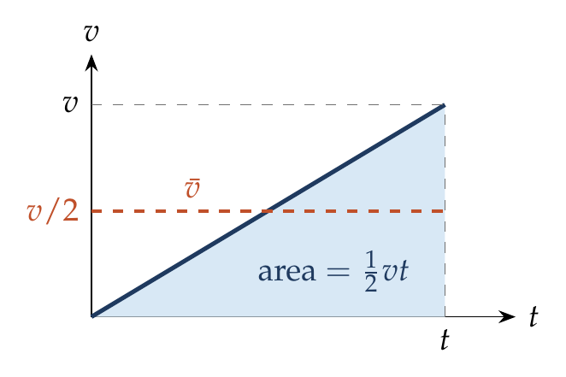
With $u=0$ and constant $a$:
$$v=at, s=1/2at^{2}.$$
$$\overset{‾}{v}=\frac{s}{t}=\frac{1/2at^{2}}{t}=\frac{1}{2}at=\frac{v}{2}.$$
For $t>0$, $v>0$, so $\overset{‾}{v}=v/2<v$. Since $s=1/2at^{2}>0$ for all $t>0$, $\overset{‾}{v}≠0$.

Answer
(A) and (D).

Watch out
• From rest with constant acceleration the body never reverses, so its average velocity can never be zero.
Notes: Sec. 3.1 (average velocity = mean of u and v for constant a); Sec. 3.2A (starting from rest).

Q12 · Distances in successive 5 s intervals
ID 03MSL-0310-74a6 · Code 0310 · Worksheet 03MSL_v2 Q12

Problem
A particle travels 10 m in first 5 s and 8 m in next 5 s. Assuming constant acceleration, what is the distance travelled in next 5 s?
(A) 9 m (B) 6 m (C) 3 m (D) None of above

Hint
With constant acceleration, how do the displacements in successive equal time intervals change from one interval to the next?

Think it through
- Under constant acceleration, each equal interval’s displacement differs from the previous one by the same amount (aτ²), because the velocity changes by the same amount in each interval.
- The first two intervals give 10 m and then 8 m, a drop of 2 m. So the next interval gives 8 − 2 = 6 m. (B)
- One check before trusting this: the progression is for displacement. If the particle stopped and turned back within the third interval, the distance would differ. Its average velocity falls from 2 m/s to 1.6 m/s over 5 s, so it loses 0.4 m/s every 5 s. It is still moving at about 1 m/s at the end of the third interval, so there is no reversal, and distance = displacement = 6 m.

Another way: mid-interval velocities
Average velocity over an interval = velocity at its middle instant. So v = 2 m/s at t = 2.5 s and v = 1.6 m/s at t = 7.5 s, giving a = −0.08 m/s². At t = 12.5 s, v = 1.2 m/s, so the third interval covers 1.2 × 5 = 6 m.

Worked solution
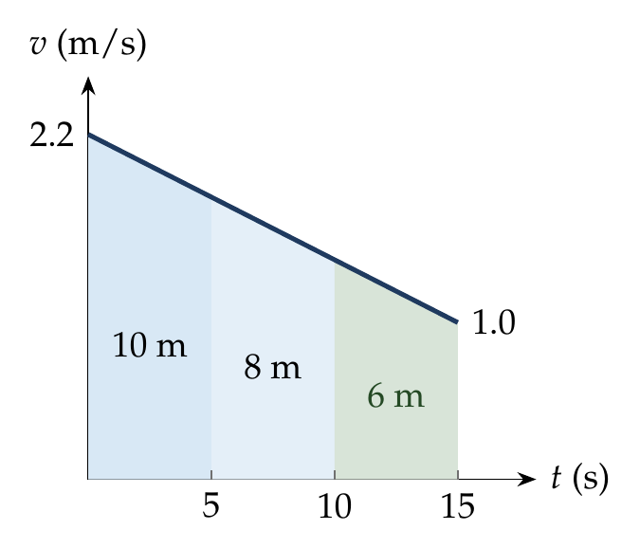
Let the initial velocity be $u$ and the acceleration $a$; take $τ=5$ s.
First 5 s:
$$10=5u+1/2a\left(25\right).$$
First 10 s:
$$10+8=10u+1/2a\left(100\right).$$
Solving: $a=−0.08$ m/s² and $u=2.2$ m/s.
Displacement in the first 15 s:
$$s_{15}=2.2\left(15\right)+1/2\left(−0.08\right)\left(225\right)=33−9=24 m.$$
So the third interval covers $24−18=6$ m. Velocity at 15 s: $2.2−0.08\left(15\right)=1.0$ m/s > 0, so the particle has not reversed and the distance is 6 m.
(Check by the progression rule: $s_{2}−s_{1}=aτ^{2}=−0.08×25=−2$ m.)

Answer
(B) 6 m.

Watch out
• The constant difference is $aτ^{2}$, not $aτ$.
• The progression holds for displacement. Check that the body has not stopped and reversed inside an interval before calling it distance.
Notes: Sec. 3.1 (equal successive intervals: displacements in AP, difference aτ²).

Q13 · Uniform retardation: how much farther?
ID 03MSL-0310-a3c0 · Code 0310 · Worksheet 03MSL_v2 Q13

Problem
A particle moving with uniform retardation covers a distance of 18 m, 14 m and 10 m in successive seconds. How much further will it travel before coming to a stop?
(A) 6 m (B) 2 m (C) 10 m (D) 8 m

Hint
Run the motion backwards: from rest, distances in successive seconds go as 1 : 3 : 5 : 7 : … Where do 18, 14 and 10 fit in that pattern?

Think it through
- Successive one-second distances drop by 4 m each time, so the retardation is 4 m/s² (difference = a × 1²).
- Run the film backwards. Uniform retardation to rest, reversed, is uniform acceleration from rest at the same 4 m/s². From rest, successive seconds cover a/2 × (1, 3, 5, 7, 9, …) = 2, 6, 10, 14, 18 m.
- So the forward sequence is 18, 14, 10, then 6, then 2, and the particle stops exactly at the end of that second.
- Still to go after the 10 m second: 6 + 2 = 8 m. (D)

Another way: velocity at the end of the third second
The 10 m second has average velocity 10 m/s, which is the velocity at its middle. Half a second later, at the end of that second, the velocity is 10 − 2 = 8 m/s. Stopping distance = v²/2a = 64/8 = 8 m.

Worked solution
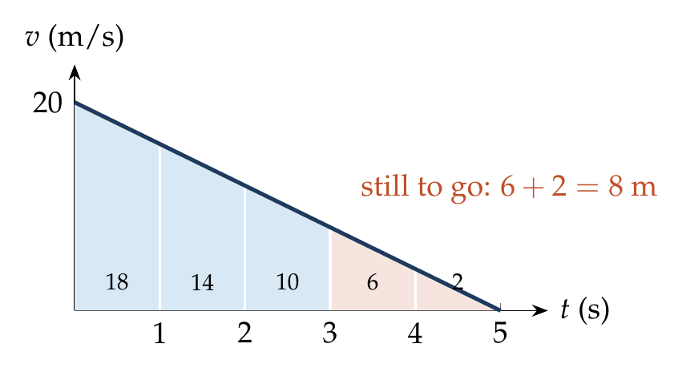
Distances in successive equal intervals of 1 s differ by $aτ^{2}$:
$$a{\left(1\right)}^{2}=14−18=−4 ⇒ a=−4 {m/s}^{2}.$$
Distance in the $n$th second: $s_{n}=u+\frac{a}{2}\left(2n−1\right)$. For $n=1$:
$$18=u−2 ⇒ u=20 m/s.$$
Velocity after 3 s:
$$v_{3}=20−4\left(3\right)=8 m/s.$$
Further distance to stop:
$$s=\frac{v_{3}^{2}}{2\left|a\right|}=\frac{64}{8}=8 m.$$

Answer
(D) 8 m.

Watch out
• The pattern 18, 14, 10, 6, 2 ends exactly at a whole second here. If the numbers did not fit a/2 × (odd numbers), the body would stop partway through a second; use v²/2a instead.
• The retardation is the difference divided by τ² (τ = 1 s here), not by τ.
Notes: Sec. 3.2B (time-reversal trick: … : 5 : 3 : 1); Sec. 3.1 (equation 6, nth-second displacement).

Q14 · Stopping distance at n times the speed
ID 03MSL-0310-e03f · Code 0310 · Worksheet 03MSL_v2 Q14

Problem
When the speed of a car is u, the minimum distance over which it can be stopped is s. If the speed becomes nu, what will be the minimum distance over which it can be stopped? (Assume the braking retardation is constant.)

Hint
Which equation of motion links speed and distance without time? With the same retardation, how does stopping distance change with speed?

Think it through
- The brakes give the same retardation a in both cases. Time is not involved, so think of v² = u² − 2as: to bring v² to zero, the distance must be u²/2a.
- So stopping distance goes as the square of the speed. n times the speed needs n² times the distance: n²s.
- Why it is a square: at n times the speed, the car takes n times as long to stop, and it also moves n times as fast on average. n × n = n².

No-pen route: v–t graph
Both stops are straight lines of the same slope (−a). The second triangle is the first enlarged n times in both height and base, so its area, the stopping distance, is n² times as large.

Worked solution
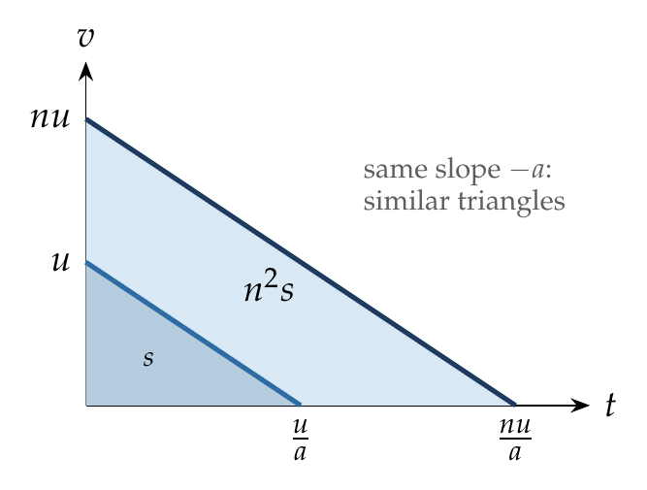
Using $v^{2}=u^{2}−2as$ with $v=0$:
$$s=\frac{u^{2}}{2a}.$$
With the same $a$ and initial speed $nu$:
$$s′=\frac{{\left(nu\right)}^{2}}{2a}=n^{2} \frac{u^{2}}{2a}=n^{2}s.$$

Answer
$n^{2}s$.

Watch out
• The answer is not ns: with constant retardation, stopping distance grows as the square of the speed.
Notes: Sec. 3.2B (stopping distance ∝ u²).

Q15 · Reaction time before braking
ID 03MSL-0310-d2a0 · Code 0310 · Worksheet 03MSL_v2 Q15

Problem
A car is moving with a speed of 40 m/s. The driver observes a stationary truck ahead at a distance of 120 m. After a reaction time of δt, the driver applies the brake, producing a retardation of 8 m/s². What is the maximum reaction time to avoid collision?
(A) 1 s (B) 0.8 s (C) 0.6 s (D) 0.5 s

Hint
The 120 m is shared by two phases: the reaction time, at a constant 40 m/s, and braking, which needs 40²/(2 × 8) m.

Think it through
- During the reaction time nothing changes: the car keeps going at 40 m/s.
- Once the brakes act, the car needs a fixed braking distance: speed squared over twice the retardation, 1600/16 = 100 m.
- The truck is 120 m away, so only 20 m can be spent reacting. At 40 m/s, 20 m takes 0.5 s. (D)
- Any longer reaction and the braking starts less than 100 m from the truck: collision.

Worked solution
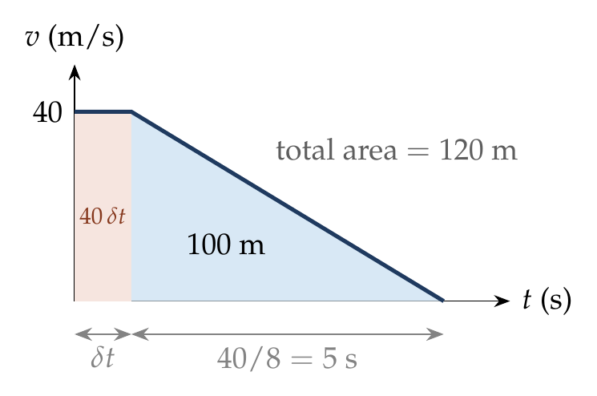
Distance during reaction: $40 δt$. Braking distance:
$$s_{b}=\frac{u^{2}}{2a}=\frac{{40}^{2}}{2\left(8\right)}=100 m.$$
To just avoid collision:
$$40 δt+100=120 ⇒ δt=0.5 s.$$
On the v–t graph, the total area (rectangle + triangle) must not exceed 120 m.

Answer
(D) 0.5 s.

Watch out
• There is no braking during the reaction time: the car covers 40δt at full speed first.
• The braking distance is u²/2a = 100 m, not u²/a.
Notes: Sec. 3.2B (stopping distance with a reaction time: ut_r + u²/2a).

Q16 · Bullet in a fixed target
ID 03MSL-0310-5a24 · Code 0310 · Worksheet 03MSL_v2 Q16

Problem
A bullet fired into a fixed target loses half of its velocity after penetrating 3 cm. How much further will it penetrate before coming to rest, assuming that it faces constant resistance to motion?

Hint
Under constant retardation, how does v² change with distance? Compare the share of v² lost in the first 3 cm with the share still left.

Think it through
- Constant resistance means constant retardation, and the question links speed with distance, not time. So think of v² = u² − 2as: v² drops by equal amounts over equal distances.
- The bullet starts with u² and must lose all of it to stop. Losing half the speed takes v² to u²/4, so ¾ of the total has gone in 3 cm.
- The remaining ¼ is one-third of what has already gone, so it needs one-third of the distance: 1 cm.

Another way: time reversal
Run the motion backwards: the bullet starts from rest at C and speeds up uniformly. Its speed goes 0 → u/2 → u in two equal times (equal changes of velocity at constant a). From rest, distances in successive equal times are in the ratio 1 : 3, so CB : BA = 1 : 3 and CB = 1 cm.

Another way: v–t graph
The speed falls linearly from u to u/2 and then to 0, in equal times τ. The areas (the penetrations) of the trapezium and the small triangle are in the ratio 3 : 1.

Worked solution
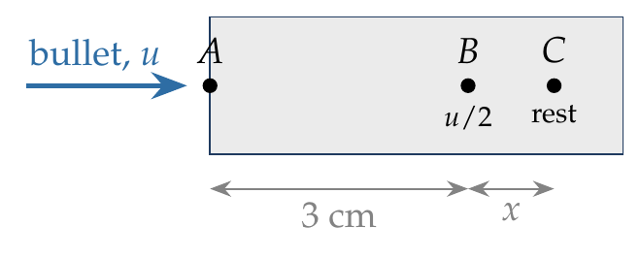
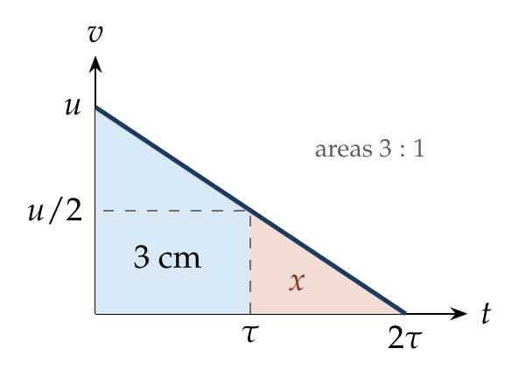
From A to B ($s=3$ cm), using $v^{2}=u^{2}−2as$ with distances in cm:
$${\left(\frac{u}{2}\right)}^{2}=u^{2}−2a\left(3\right) ⇒ a=\frac{u^{2}}{8}.$$
From B to C (comes to rest after a further $x$):
$$0={\left(\frac{u}{2}\right)}^{2}−2ax ⇒ x=\frac{u^{2}/4}{2\left(u^{2}/8\right)}=1 cm.$$

Answer
1 cm more (total penetration 4 cm).

Watch out
• Losing half the speed is not losing half of v²: v² falls to ¼, so ¾ of the stopping “budget” is used.
• The question asks for the further penetration (1 cm), not the total (4 cm).
Notes: Sec. 3.2B (v² ∝ distance still to go; example b; time-reversal trick).

Q17 · Velocity at the mid-point of AB
ID 03MSL-0310-d209 · Code 0310 · Worksheet 03MSL_v2 Q17

Problem
A body moving with a uniform acceleration has velocities of u and v when passing through points A and B in its path. The velocity of the body midway between A and B is?

Hint
“Midway” is about distance, not time. Which equation links velocity with distance, and how does v² change along the path?

Think it through
- “Midway” is about distance, not time, so the useful relation is the one without time: v² = u² + 2as.
- That relation says v² grows by equal amounts over equal distances. Half the distance gives half the rise in v².
- So at the mid-point v² is halfway between u² and v², that is (u² + v²)/2, and the speed is √((u² + v²)/2).
- Compare with the mid-time velocity (u + v)/2. The root-mean-square is always larger (unless u = v). If the body is speeding up, it spends more than half the time on the slower first half, so it passes the mid-point after the mid-time, when it is already faster.

Worked solution
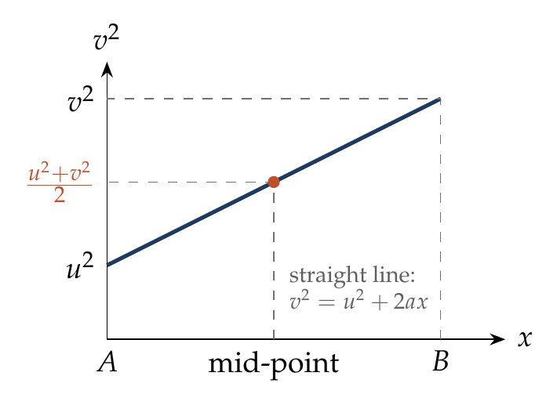
Let $AB=2s$ and let $v_{m}$ be the velocity at the mid-point M.
From A to B:
$$v^{2}=u^{2}+2a\left(2s\right).$$
From A to M:
$$v_{m}^{2}=u^{2}+2as.$$
Eliminating $2as=\left(v^{2}−u^{2}\right)/2$:
$$v_{m}^{2}=u^{2}+\frac{v^{2}−u^{2}}{2}=\frac{u^{2}+v^{2}}{2} ⇒ v_{m}=\sqrt{\frac{u^{2}+v^{2}}{2}}.$$

Answer
$\sqrt{\frac{u^{2}+v^{2}}{2}}$.

Watch out
• The mid-point (in distance) is not the mid-time: (u + v)/2 is the velocity at mid-time, and it is smaller.
Notes: Sec. 3.1 (velocity at the mid-point of the path).

Free Fall & Vertical Throw

Q18 · A falling object lands in a moving boat
ID 03MSL-0315-0c8e · Code 0315 · Worksheet 03MSL_v2 Q18

Problem
An object falls from a bridge that is 45 m above the water. It falls directly into a small row-boat moving with constant velocity that was 12 m from the point of impact when the object was released. What was the speed of the boat?

Hint
The two motions start together and end together. Which one tells you how long that is?

Think it through
- The object and the boat are independent: the object falls straight down, the boat moves horizontally. They are linked only by time, because both start at the release and end at the impact.
- The fall decides the time. Dropped from rest, a body falls 5 m in the first second, 20 m in two seconds and 45 m in three seconds. So the fall takes 3 s.
- In those same 3 s the boat must cover its 12 m to the impact point. That is 4 m every second.
- Check: a row-boat at 4 m/s (about 14 km/h) is brisk but believable.

Worked solution
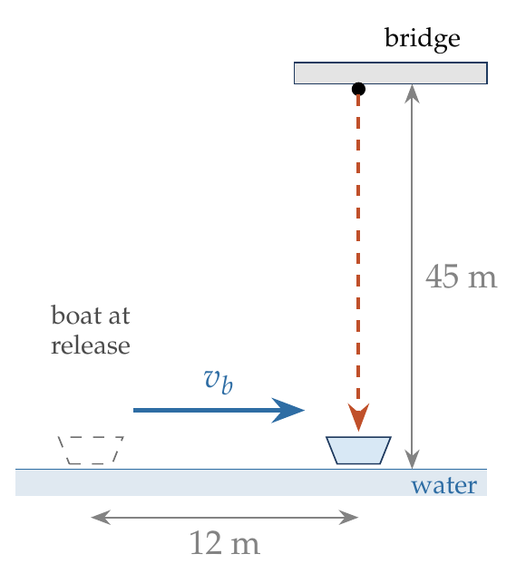
Time of fall from rest through $h=45$ m, using $h=1/2gt^{2}$:
$$t=\sqrt{\frac{2h}{g}}=\sqrt{\frac{2\left(45\right)}{10}}=3 s.$$
The boat covers 12 m in the same time at constant velocity:
$$v_{b}=\frac{12}{3}=4 m/s.$$

Answer
4 m/s.

Watch out
• The boat’s speed does not affect the fall; only the common time links the two motions.
• Use the fall from rest ($u=0$) to get the time, not 45/12 or any mix of the two distances.
Notes: Sec. 4 (motion under gravity: same constant acceleration g); Sec. 3.2A (starting from rest).

Q19 · Last second equals the first three
ID 03MSL-0315-4f03 · Code 0315 · Worksheet 03MSL_v2 Q19

Problem
A ball is dropped from the roof of a tower of height h. The total distance covered by it in the last second of its motion is equal to the distance covered by it in the first three seconds. The value of h in metres is

Hint
The first three seconds are easy: 45 m. In which second does a falling body cover 45 m?

Think it through
- Dropped from rest, the ball covers 5, 15, 25, 35, 45 m, … in successive seconds: each second 10 m more than the last, because its speed grows by 10 m/s every second.
- The first three seconds give 5 + 15 + 25 = 45 m.
- The last second must also be 45 m. In the list, 45 m is the 5th second. So the ball is in the air for 5 s.
- In 5 s from rest it falls ½ × 10 × 25 = 125 m. So h = 125 m.

Another way: velocity at the middle of the last second
The distance covered in any one second equals the velocity at the middle of that second (constant acceleration). If the fall lasts T seconds, the last second is centred at T − ½, where the velocity is 10(T − ½). Setting this equal to 45 gives T = 5 s, and h = 125 m.

Worked solution
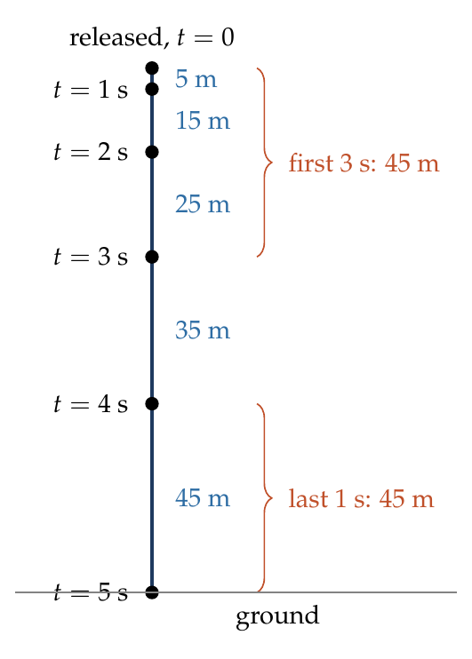
Distance in the first 3 s:
$$s_{3}=1/2g{\left(3\right)}^{2}=45 m.$$
Let the total time of fall be $T$. Distance in the last second:
$$h\left(T\right)−h\left(T−1\right)=1/2gT^{2}−1/2g{\left(T−1\right)}^{2}=g\left(T−1/2\right).$$
Setting the two equal:
$$10\left(T−1/2\right)=45 ⇒ T=5 s.$$
$$h=1/2gT^{2}=1/2\left(10\right)\left(25\right)=125 m.$$

Answer
h = 125 m.

Watch out
• The last second is the interval from T − 1 to T, not the 1st or the 3rd second.
• The distance in the last second is g(T − ½), not gT: the body is not moving at its final speed throughout that second.
Notes: Sec. 4.2 (last-second problems); Sec. 3.2A (successive intervals 1 : 3 : 5 : 7).

Q20 · Falling past a window
ID 03MSL-0315-03ab · Code 0315 · Worksheet 03MSL_v2 Q20

Problem
A ball is dropped from the top of a building. The ball takes 0.5 s to fall past the 3 m length of a window some distance from the top of the building. If the velocities of the ball at the top and at the bottom of the window are $v_{t}$ and $v_{b}$ respectively, then:
(A) $v_{t}$ = 6 m/s (B) $v_{t}$ = 2 m/s (C) $v_{b}$ = 12 m/s (D) $v_{b}$ = 8.5 m/s

Hint
Over the window you know the time and the distance. What do they tell you about the average of $v_{t}$ and $v_{b}$, and what does 0.5 s of free fall do to the speed?

Think it through
- Look only at the window stretch. The ball covers 3 m in 0.5 s, so its average speed there is 6 m/s.
- With constant acceleration the average is the mean of the speeds at the two ends. So $v_{t}$ and $v_{b}$ add up to 12 m/s.
- In 0.5 s gravity adds 10 × 0.5 = 5 m/s. So $v_{b}$ is 5 m/s more than $v_{t}$.
- Two numbers that add to 12 and differ by 5: 3.5 and 8.5. So $v_{t}$ = 3.5 m/s and $v_{b}$ = 8.5 m/s. (D)
- Option (A) is the trap: 6 m/s is the average speed over the window, not the speed at its top.

Another way: velocity at mid-time
The average speed over the 0.5 s, 6 m/s, is the speed at the middle of that interval. A quarter of a second later (at the bottom) gravity has added 2.5 m/s: 8.5 m/s. A quarter of a second earlier (at the top) it was 3.5 m/s.

Worked solution
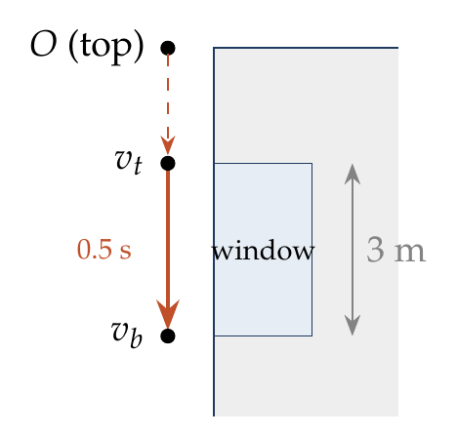
Take downward as positive. Across the window ($s=3$ m, $t=0.5$ s):
$$s=\frac{v_{t}+v_{b}}{2} t ⇒ v_{t}+v_{b}=\frac{2\left(3\right)}{0.5}=12 m/s.$$
$$v_{b}=v_{t}+gt ⇒ v_{b}−v_{t}=10\left(0.5\right)=5 m/s.$$
Solving: $v_{t}=3.5$ m/s and $v_{b}=8.5$ m/s.
(The top of the window is $v_{t}^{2}/2g=0.61$ m below the roof.)

Answer
(D) $v_{b}$ = 8.5 m/s ($v_{t}$ = 3.5 m/s).

Watch out
• 6 m/s is the average speed across the window, not the speed at its top (option A).
• The ball is already moving at the top of the window. Don’t use $s=1/2gt^{2}$ for the window stretch as if it started from rest.
Notes: Sec. 3.1 (average velocity = mean of u and v for constant a; velocity at mid-time); Sec. 4 (motion under gravity).

Q21 · Height at half the time of ascent
ID 03MSL-0315-919e · Code 0315 · Worksheet 03MSL_v2 Q21

Problem
A body is thrown vertically up from the ground with a speed u and it reaches its maximum height h at time $t=t_{0}$. The height to which it would have risen at $t=t_{0}/2$?

Hint
Run the motion backwards from the top: it becomes a body dropped from rest. How far does a dropped body fall in half the time it takes to fall all the way?

Think it through
- The climb from the ground to the top, run backwards, is exactly a drop from rest at the top: same g, same path, same times.
- Seen that way, the instant $t_{0}/2$ is half-way through a fall that takes $t_{0}$ to cover h.
- Falling from rest, distance grows as the square of time. In half the time a body falls a quarter of the distance: ¼h.
- So at $t_{0}/2$ the body is ¼h below the top, which is ¾h above the ground.
- Check: the body is fastest near the ground, so it covers more than half the height in the first half of the time. ¾h fits.

Worked solution
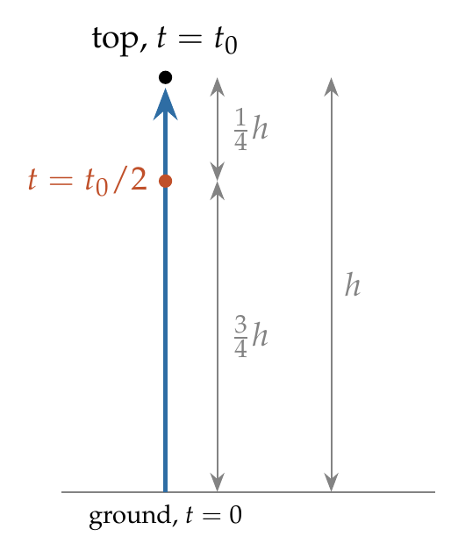
Take up as positive. At the top $v=0$:
$$t_{0}=\frac{u}{g}, h=\frac{u^{2}}{2g}.$$
At $t=t_{0}/2=u/2g$:
$$y=u\left(\frac{u}{2g}\right)−\frac{1}{2}g{\left(\frac{u}{2g}\right)}^{2}=\frac{u^{2}}{2g}−\frac{u^{2}}{8g}=\frac{3u^{2}}{8g}=\frac{3}{4}h.$$

Answer
$\frac{3}{4}h$.

Watch out
• Half the time is not half the height (h/2): the body is slowing down, so it covers more height in the first half of the time.
Notes: Sec. 4.1 (symmetry; last second of ascent = first second of descent); Sec. 3.2B (time-reversal trick).

Q22 · At 80 m twice, 6 s apart
ID 03MSL-0315-7bc1 · Code 0315 · Worksheet 03MSL_v2 Q22

Problem
A ball is thrown upwards from the ground with an initial speed of u. The ball is at a height of 80 m at two instants of time $t_{1}$ and $t_{2}$. If the time interval $t_{2}−t_{1}$ is 6 s, then find u.
(A) 60 m/s (B) 50 m/s (C) 40 m/s (D) 30 m/s

Hint
Between the two instants, the ball goes from 80 m to the top and back. By symmetry, how long does it take to rise from 80 m to the top, and what speed must it have at 80 m?

Think it through
- Between $t_{1}$ and $t_{2}$ the ball rises from the 80 m level to the top and falls back to 80 m.
- Up and down are mirror images, so it spends 3 s rising and 3 s falling.
- To come to rest in 3 s under g, it must be moving at 30 m/s as it passes 80 m going up.
- Below 80 m it was faster. Going down from 80 m to the ground (thinking in reverse) a body at 30 m/s gains speed: v² rises by 2 × 10 × 80 = 1600. So u² = 900 + 1600 = 2500 and u = 50 m/s. (B)
- Check: from the ground at 50 m/s the top is at 125 m; 80 m is 45 m below the top, and a 45 m fall takes 3 s. It fits.

Another way: total time and product of times
The two instants are the roots of 80 = ut − 5t². Their product is 80/5 = 16 and their difference is 6, so they are 2 s and 8 s. Their sum, 10 s, is the whole time of flight 2u/g, so u = 50 m/s.

Worked solution
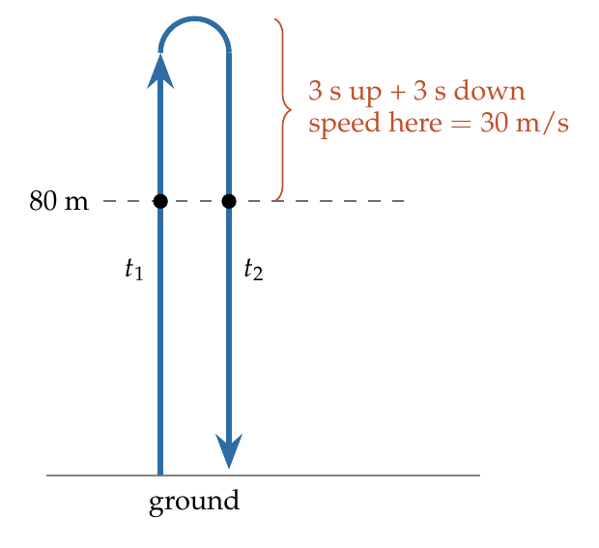
Take up as positive. By symmetry, the time from the 80 m level to the top is $1/2\left(t_{2}−t_{1}\right)=3$ s, so the speed at 80 m is
$$v=g\left(3\right)=30 m/s.$$
From the ground to 80 m, using $v^{2}=u^{2}−2gh$:
$${30}^{2}=u^{2}−2\left(10\right)\left(80\right) ⇒ u^{2}=2500 ⇒ u=50 m/s.$$

Answer
(B) 50 m/s.

Watch out
• The 6 s is the time above 80 m (up and back), so the time to the top from there is 3 s, not 6 s.
• 30 m/s is the speed at 80 m (option D), not the speed of projection.
Notes: Sec. 4.2 (two instants at the same height: speed there = ½g times the difference of the times).

Q23 · Catching the ball on its way down
ID 03MSL-0315-aa85 · Code 0315 · Worksheet 03MSL_v2 Q23

Problem
A ball is projected vertically upwards with a velocity of 25 m/s from the bottom of a tower. A boy standing at the top of the tower is unable to catch the ball as it passes him in the upward direction. He catches the ball when it passes him again 3 seconds later. Find the height of the tower.
(A) 15 m (B) 20 m (C) 22.5 m (D) 25 m

Hint
The ball spends 3 s above the boy, half going up and half coming down. How fast must it be moving as it passes him?

Think it through
- The ball passes the top of the tower going up and again coming down, 3 s apart. By symmetry it takes 1.5 s from the boy up to its highest point.
- To stop in 1.5 s under g, it must pass the boy at 15 m/s.
- So between the ground and the top of the tower the speed falls from 25 to 15 m/s. That takes 1 s, at an average speed of 20 m/s: 20 m. (B)
- Check: the top of the flight is 25²/20 = 31.25 m, and 15²/20 = 11.25 m above the tower top. 20 + 11.25 = 31.25. It fits.

Another way: product of the two times
The ball is at height h at two instants whose difference is 3 s and whose sum is the whole flight time 2 × 25/10 = 5 s. So the instants are 1 s and 4 s, and h = ½g × (1 × 4) = 20 m.

Worked solution
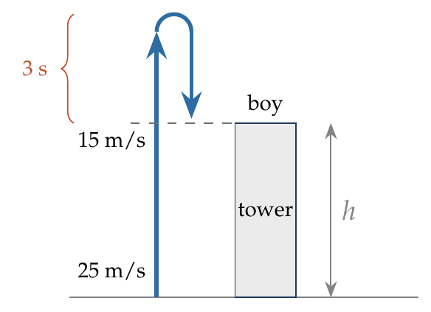
Take up as positive. The ball spends 3 s above the top of the tower, so by symmetry the speed there is
$$v=g\left(\frac{3}{2}\right)=15 m/s.$$
From the ground to the top of the tower, using $v^{2}=u^{2}−2gh$:
$${15}^{2}={25}^{2}−2\left(10\right)h ⇒ h=\frac{625−225}{20}=20 m.$$

Answer
(B) 20 m.

Watch out
• The 3 s is spent above the boy (up and back down), so use 1.5 s, not 3 s, for the time to the top.
• The tower height is not the maximum height (31.25 m); the ball goes 11.25 m above the boy.
Notes: Sec. 4.2 (two instants at the same height: speed there = ½g times the difference of the times; h = ½g t₁t₂).

Q24 · Height of a point passed on the way up
ID 03MSL-0315-5747 · Code 0315 · Worksheet 03MSL_v2 Q24

Problem
A particle is projected vertically upwards from a point A on the ground. It takes time $t_{1}$ to reach a point B, but it still continues to move up. If it takes a further time $t_{2}$ to reach the ground from B, then the height of point B from the ground is?

Hint
The particle is at B twice. At what two instants (measured from launch) is it there?

Think it through
- The whole flight lasts $t_{1}+t_{2}$.
- The particle passes B going up at $t_{1}$. By symmetry, the time from B down to the ground equals the time from the ground up to B, which is $t_{1}$. So it passes B going down at $\left(t_{1}+t_{2}\right)−t_{1}=t_{2}$ after launch.
- For any height, the two passing instants multiply to give 2h/g. Here they are $t_{1}$ and $t_{2}$, so the height of B is ½g$t_{1}t_{2}$.

Another way: use the launch speed
The flight time $t_{1}+t_{2}$ equals 2u/g, so u = ½g($t_{1}+t_{2}$). Then the height after time $t_{1}$ is u$t_{1}$ − ½g$t_{1}^{2}$ = ½g$t_{1}t_{2}$.

Worked solution
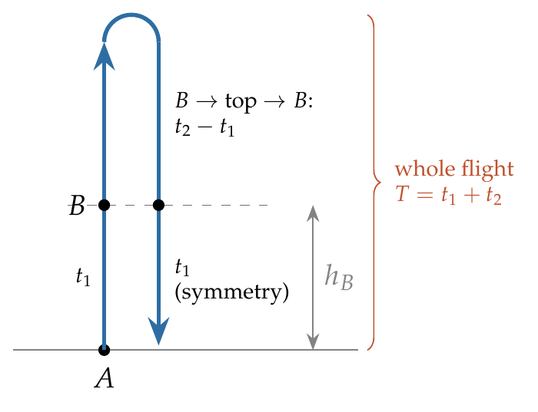
Take up as positive, with $u$ the speed of projection. Time of flight:
$$T=t_{1}+t_{2}=\frac{2u}{g} ⇒ u=\frac{g\left(t_{1}+t_{2}\right)}{2}.$$
Height at time $t_{1}$:
$$h_{B}=ut_{1}−\frac{1}{2}gt_{1}^{2}=\frac{g\left(t_{1}+t_{2}\right)t_{1}}{2}−\frac{gt_{1}^{2}}{2}=\frac{1}{2}g t_{1}t_{2}.$$

Answer
$h_{B}=\frac{1}{2}g t_{1}t_{2}$.

Watch out
• $t_{2}$ is the time from B to the ground (going over the top), not from the top to the ground.
• Don’t use $1/2gt_{1}^{2}$: the particle does not start from rest; it is slowing down on the way to B.
Notes: Sec. 4.2 (two instants at the same height: t₁ + t₂ = T, h = ½g t₁t₂).

Q25 · Two speeds at two points
ID 03MSL-0315-dfdf · Code 0315 · Worksheet 03MSL_v2 Q25

Problem
A stone projected upwards with a velocity u passes through points P and Q, separated by distance h, with velocities u/2 and u/3. Find the maximum height the stone will reach with respect to the point of projection.
(A) $9h$ (B) $18h/5$ (C) $6h/5$ (D) $36h/5$

Hint
Under gravity, v² falls by the same amount for every metre of rise. What fraction of the starting u² is lost between P and Q?

Think it through
- Speeds at two heights, and a height gap, with no time anywhere: think of v², which falls steadily with height (by 2g per metre).
- Going from the launch point to the top, v² falls from u² to 0. That whole drop corresponds to the maximum height H.
- Between P and Q, v² falls from u²/4 to u²/9, a drop of 5u²/36. That is 5/36 of the whole drop.
- So h is 5/36 of H, and H = 36h/5. (D)

Worked solution
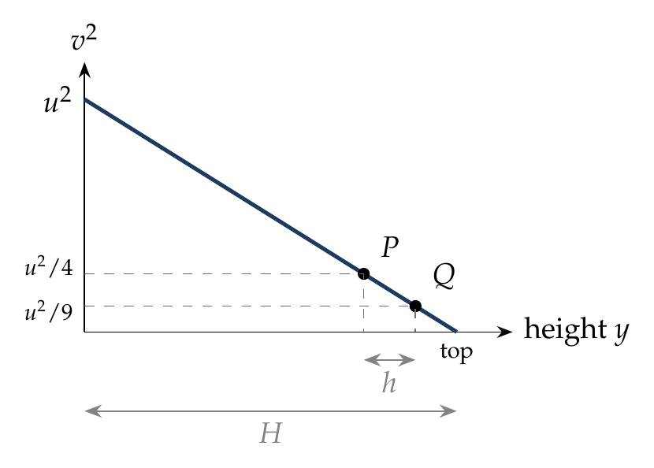
From P to Q, using $v^{2}=u^{2}−2gh$:
$${\left(\frac{u}{3}\right)}^{2}={\left(\frac{u}{2}\right)}^{2}−2gh ⇒ 2gh=u^{2}\left(\frac{1}{4}−\frac{1}{9}\right)=\frac{5u^{2}}{36}.$$
Maximum height:
$$H=\frac{u^{2}}{2g}=\frac{36}{5} h.$$

Answer
(D) $36h/5$.

Watch out
• Speeds don’t change linearly with height; v² does. Using u/2 − u/3 = u/6 leads nowhere.
• H is measured from the point of projection, not from P.
Notes: Sec. 4.2 (speed at height h); Sec. 3.2B (v² ∝ distance still to go).

Q26 · Distance after the turning point
ID 03MSL-0315-7e05 · Code 0315 · Worksheet 03MSL_v2 Q26

Problem
A stone is thrown vertically upward with an initial velocity $v_{0}$. The distance travelled in time $4v_{0}/3g$ is?
(A) $\frac{5v_{0}^{2}}{9g}$ (B) $\frac{4v_{0}^{2}}{9g}$ (C) $\frac{5v_{0}^{2}}{18g}$ (D) $\frac{11v_{0}^{2}}{18g}$

Hint
Distance, not displacement. When does the stone turn round, and is $4v_{0}/3g$ before or after that?

Think it through
- The question asks for distance, so first check whether the stone reverses within the time. It stops at the top after $v_{0}/g$, and $4v_{0}/3g$ is later than that. So split the motion at the top.
- Going up, it climbs the full maximum height, $v_{0}^{2}/2g$.
- It then falls for the remaining third of $v_{0}/g$. A body dropped from rest falls distances in proportion to the square of time, so in one-third of the ascent time it falls one-ninth of the maximum height: $v_{0}^{2}/18g$.
- Total distance: $v_{0}^{2}/2g+v_{0}^{2}/18g$ = 10/18 of $v_{0}^{2}/g$ = $5v_{0}^{2}/9g$. (A)
- Check: the displacement at that instant is only $v_{0}^{2}/2g−v_{0}^{2}/18g=4v_{0}^{2}/9g$, which is option (B), the trap.

Another way: v–t graph
The v–t graph is a straight line from $v_{0}$, crossing zero at $v_{0}/g$ and reaching $−v_{0}/3$ at $4v_{0}/3g$. The distance is the total unsigned area: a large triangle ($v_{0}^{2}/2g$) above the axis plus a small similar triangle, one-third the size in each direction, below it (one-ninth of the area).

Worked solution
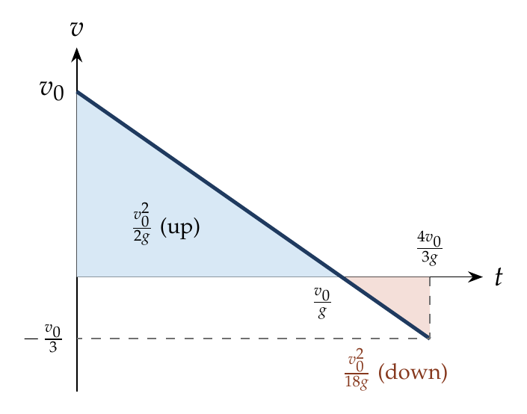
Take up as positive. The stone stops at
$$t_{a}=\frac{v_{0}}{g}<\frac{4v_{0}}{3g},$$
so it reverses within the interval. Distance going up:
$$h_{1}=\frac{v_{0}^{2}}{2g}.$$
It then falls from rest for $\frac{4v_{0}}{3g}−\frac{v_{0}}{g}=\frac{v_{0}}{3g}$:
$$h_{2}=\frac{1}{2}g{\left(\frac{v_{0}}{3g}\right)}^{2}=\frac{v_{0}^{2}}{18g}.$$
$$d=h_{1}+h_{2}=\frac{9v_{0}^{2}+v_{0}^{2}}{18g}=\frac{5v_{0}^{2}}{9g}.$$

Answer
(A) $\frac{5v_{0}^{2}}{9g}$.

Watch out
• Putting $t=4v_{0}/3g$ into $s=ut−½gt^{2}$ gives the displacement, $4v_{0}^{2}/9g$ (option B), not the distance.
• Always find the turning time first when distance is asked.
Notes: Sec. 3.2C (distance for t beyond the turning point: split at the top); Sec. 4.2 (example d: distance vs displacement).

Q27 · Up and down from a tower
ID 03MSL-0315-ade7 · Code 0315 · Worksheet 03MSL_v2 Q27

Problem
A ball is thrown vertically upwards with a speed of 10 m/s from the top of a 200 m high tower. Another ball is thrown vertically downwards at the same speed simultaneously. The time difference between the two balls reaching the ground?
(A) 4 s (B) 2 s (C) 6 s (D) $\sqrt{2}$ s

Hint
Follow the ball thrown up until it is back at the top of the tower. How is it moving then, compared with the other ball at the start?

Think it through
- The ball thrown up at 10 m/s rises, stops and falls back. By symmetry it passes the top of the tower again after 2 s, moving down at 10 m/s.
- From then on it is in exactly the situation the second ball was in at the start: at the top, moving down at 10 m/s.
- So it repeats the second ball’s journey, just 2 s late. The difference is 2 s, whatever the height of the tower. (B)

No-pen route
The answer is the time to go up and come back: 2u/g = 2 s. The 200 m is not needed.

Worked solution
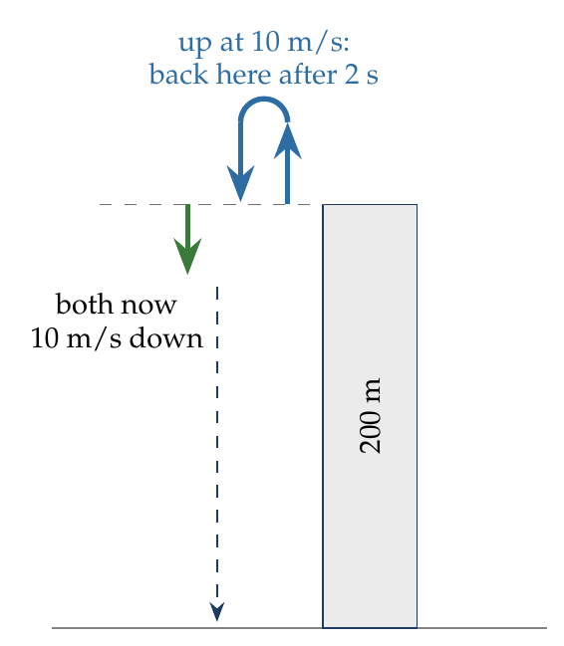
Take up as positive and the top of the tower as origin; the ground is at $y=−200$ m.
Ball thrown up: $−200=10t_{1}−5t_{1}^{2}$, so $t_{1}^{2}−2t_{1}−40=0$ and $t_{1}=1+\sqrt{41}$ s.
Ball thrown down: $−200=−10t_{2}−5t_{2}^{2}$, so $t_{2}^{2}+2t_{2}−40=0$ and $t_{2}=−1+\sqrt{41}$ s.
$$t_{1}−t_{2}=2 s=\frac{2u}{g}.$$

Answer
(B) 2 s.

Watch out
• No need to solve two quadratics: the difference is just the extra up-and-back time, 2u/g.
• Both balls hit the ground with the same speed; only their times differ.
Notes: Sec. 4.2 (projection from a tower: t₁ − t₂ = 2u/g).

Q28 · Thrown up, thrown down, dropped
ID 03MSL-0315-34ed · Code 0315 · Worksheet 03MSL_v2 Q28

Problem
From the top of a tower, a stone is thrown up and reaches the ground in time $t_{1}$. A second stone is thrown down with the same speed and reaches the ground in time $t_{2}$. A third stone is released from rest and reaches the ground in time $t_{3}$. What is the relation between the three times?

Hint
Write the equation for reaching the ground for the stone thrown up. What are its two roots, and how is the second one related to $t_{2}$?

Think it through
- The dropped stone is the simplest: H = ½g$t_{3}^{2}$.
- For the stone thrown up, reaching the ground is a quadratic in time. Its positive root is $t_{1}$.
- Its negative root has a meaning: running time backwards, a stone thrown up at u is the same as one thrown down at u. So the negative root is −$t_{2}$.
- The product of the roots of that quadratic is −2H/g. So $t_{1}t_{2}$ = 2H/g = $t_{3}^{2}$.
- Hence $t_{3}=\sqrt{t_{1}t_{2}}$: the dropped stone’s time is the geometric mean of the other two.

Another way: solve both and multiply
Solving gives $t_{1}=\left(u+\sqrt{u^{2}+2gH}\right)/g$ and $t_{2}=\left(−u+\sqrt{u^{2}+2gH}\right)/g$. Their product is $\left(u^{2}+2gH−u^{2}\right)/g^{2}=2H/g$, which is $t_{3}^{2}$.

Worked solution
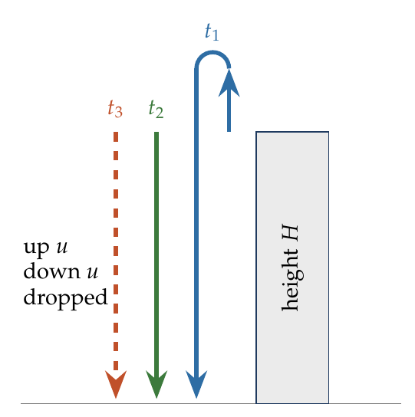
Take up as positive, origin at the top; the ground is at $y=−H$.
Stone thrown up: $−H=ut−\frac{1}{2}gt^{2}$, i.e.
$$\frac{1}{2}gt^{2}−ut−H=0.$$
Stone thrown down: $−H=−ut−\frac{1}{2}gt^{2}$, i.e. $\frac{1}{2}gt^{2}+ut−H=0$, which is the first equation with $t$ replaced by $−t$. So the roots of the first equation are $t_{1}$ and $−t_{2}$. Product of the roots:
$$t_{1}\left(−t_{2}\right)=−\frac{2H}{g} ⇒ t_{1}t_{2}=\frac{2H}{g}.$$
Dropped stone: $H=\frac{1}{2}gt_{3}^{2}$, so $t_{3}^{2}=2H/g$. Hence
$$t_{3}=\sqrt{t_{1}t_{2}}.$$

Answer
$t_{3}=\sqrt{t_{1}t_{2}}$ (and $t_{1}−t_{2}=2u/g$).

Watch out
• It is the geometric mean, not the arithmetic mean $\left(t_{1}+t_{2}\right)/2$.
Notes: Sec. 4.2 (projection from a tower: t₃ is the geometric mean of t₁ and t₂; example a).

Q29 · Time to ground n times the time to top
ID 03MSL-0315-15d5 · Code 0315 · Worksheet 03MSL_v2 Q29

Problem
From a tower of height H a particle is thrown vertically upwards with speed u. The time taken by the particle to hit the ground is n times the time taken to reach the highest point. Find the relation between H, u and n.
(A) $2gH=n^{2}u^{2}$ (B) $gH={\left(n−2\right)}^{2}u^{2}$ (C) $2gH=nu^{2}\left(n−2\right)$ (D) $gH=u^{2}\left(n−2\right)$

Hint
Time to the top is u/g, so the whole flight lasts nu/g. Use one equation for the whole flight from the top of the tower to the ground.

Think it through
- Time to the highest point is u/g, so the time to the ground is nu/g.
- Over the whole flight the displacement is H downward. One equation of motion, with the time nu/g, links H, u and n.
- Quick check on the options: if n = 2 the particle is back at the top of the tower exactly when it “hits the ground”, so H must be 0. (A) fails this; (B), (C) and (D) pass.
- Second check: for a very tall tower (large n) the short climb hardly matters, and the flight is almost a drop lasting nu/g. Then H ≈ ½g(nu/g)², i.e. 2gH ≈ n²u². (C) matches this; (B) gives twice as much and (D) grows only like n. So (C).

No-pen route: limiting cases
Steps 3 and 4 settle it without algebra: H = 0 at n = 2 rules out (A), and “almost a drop” for large n (2gH ≈ n²u²) rules out (B) and (D).

Worked solution
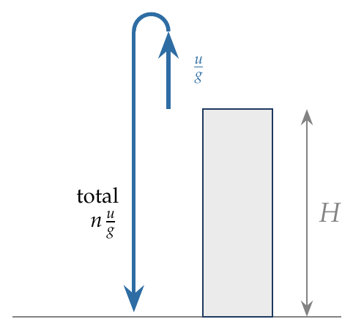
Take up as positive, origin at the top of the tower; the ground is at $y=−H$. Time to the ground $t=nu/g$:
$$−H=u\left(\frac{nu}{g}\right)−\frac{1}{2}g{\left(\frac{nu}{g}\right)}^{2}=\frac{nu^{2}}{g}−\frac{n^{2}u^{2}}{2g}.$$
$$2gH=n^{2}u^{2}−2nu^{2}=nu^{2}\left(n−2\right).$$

Answer
(C) $2gH=nu^{2}\left(n−2\right)$.

Watch out
• Take the displacement to the ground as −H (below the launch point), not +H.
• Use one equation for the whole flight; there is no need to split it at the top.
Notes: Sec. 4.2 (projection from a tower: one equation for the whole flight); Sec. 4 (Common traps: no need to split at the top).

Q30 · Half the speed 4.5 m above, 4.5 m below
ID 03MSL-0315-df2a · Code 0315 · Worksheet 03MSL_v2 Q30

Problem
A ball is thrown vertically up with a certain velocity from the top of a tower of height 40 m. At 4.5 m above the top of the tower its speed is exactly half of that it will have at 4.5 m below the top of the tower. Find the maximum height reached by the ball above the ground.
(A) 44.5 m (B) 47.5 m (C) 49 m (D) 54 m

Hint
Speeds at two heights and no times: work with v². How much does v² change between the two points, 9 m apart?

Think it through
- Speeds at two heights, no time involved: think in v², which changes by 2g = 20 per metre of height.
- The two points are 9 m apart, so v² at the lower point exceeds v² at the upper point by 180.
- The lower speed is twice the upper, so its v² is four times as large. “Four times, and 180 more” means the upper v² is 60 and the lower is 240.
- At the upper point (4.5 m above the tower) v² = 60, so the ball rises a further 60/20 = 3 m. The top of its flight is 4.5 + 3 = 7.5 m above the tower.
- Above the ground: 40 + 7.5 = 47.5 m. (B)

Worked solution
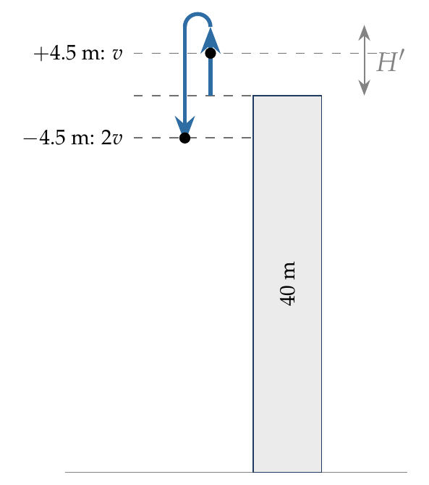
Let $u$ be the speed of projection at the top of the tower. Using $v^{2}=u^{2}−2gy$:
At $y=+4.5$ m: $v_{1}^{2}=u^{2}−90$. At $y=−4.5$ m: $v_{2}^{2}=u^{2}+90$.
Given $v_{2}=2v_{1}$:
$$u^{2}+90=4\left(u^{2}−90\right) ⇒ u^{2}=150.$$
Maximum height above the tower:
$$H′=\frac{u^{2}}{2g}=\frac{150}{20}=7.5 m.$$
Above the ground: $40+7.5=47.5$ m.

Answer
(B) 47.5 m.

Watch out
• The question asks for height above the ground: add the 40 m tower (7.5 m alone is the height above the top).
• Double the speed means four times v², not double.
Notes: Sec. 4.2 (speed at height h); Sec. 4.1 (symmetry: same speed at a height going up and coming down).

Q31 · Stone released from a rising lift
ID 03MSL-0315-3ff7 · Code 0315 · Worksheet 03MSL_v2 Q31

Problem
A stone is released from an elevator ascending with acceleration a. The acceleration of the stone immediately after the release is?

Hint
What acts on the stone once it is no longer in contact with the elevator?

Think it through
- While inside, the floor pushed the stone and gave it the lift’s acceleration a.
- Once released, nothing touches it. The only force is its weight, so its acceleration is g, downward, at once.
- Its velocity does not change suddenly: at the instant of release it is moving up with the lift’s velocity. So it first rises, slowing down, and then falls.
- Seen from inside the lift, the stone’s acceleration is g + a downward (the lift accelerates up away from it).

Worked solution
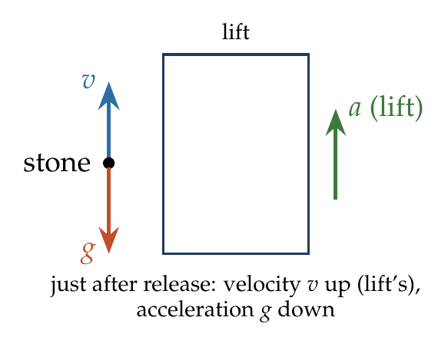
After release the only force on the stone is $mg$ (downward). By Newton’s second law,
$${\vec{a}}_{stone}=\vec{g} \left(magnitude g, downward\right),$$
independent of the lift’s acceleration $a$. Its initial velocity equals the lift’s velocity at that instant (upward).
Relative to the lift: ${\vec{a}}_{stone, lift}=\vec{g}−\vec{a}$, of magnitude $g+a$, downward.

Answer
g, downward (relative to the ground).

Watch out
• The stone does not keep the lift’s acceleration a: that came from the floor’s push, which stops at release.
• It does keep the lift’s velocity, so it moves up first.
Notes: Sec. 4.2 (released from a moving body); Sec. 10.3 (accelerating frames: lift).

Q32 · Vertical throw with air resistance
ID 03MSL-0315-3da9 · Code 0315 · Worksheet 03MSL_v2 Q32

Problem
A vertical projectile experiences a retarding acceleration of $a$ opposite to the direction of motion of the projectile. If the speed of projection is $u$, find:
(i) the time of ascent; (ii) the time of descent; (iii) the maximum height reached; (iv) the speed just before it hits the ground; (v) points D and E are at the same height during the upward and downward motion of the projectile. Which point has the greater speed?

Hint
Resistance always opposes motion. So which way does it point going up, and going down? That gives two different constant accelerations.

Think it through
- Resistance opposes the motion. Going up, it acts downward, with gravity: the deceleration is g + a. Going down, it acts upward, against gravity: the acceleration is g − a. Each phase has its own constant acceleration, so treat them separately.
- Ascent: the speed u falls to zero at the rate g + a, taking u/(g + a). The height is u²/2(g + a), lower than without air.
- Descent: the same height is covered from rest with the smaller acceleration g − a. Smaller acceleration over the same distance means more time: descent takes longer than ascent.
- The landing speed comes from v² = 2(g − a)H, which is less than u. Air has taken energy away on both legs.
- At the same height, D (going up) is faster than E (coming down). The body is on its way to stopping, and air resistance only ever removes speed.

Another way: v–t graph
The graph is two straight lines: steep (slope −(g + a)) up to the top, then gentler (slope −(g − a)) below the axis. The two triangles have equal areas (same height H). The gentler triangle must be longer and shallower: longer descent, smaller landing speed.

Worked solution
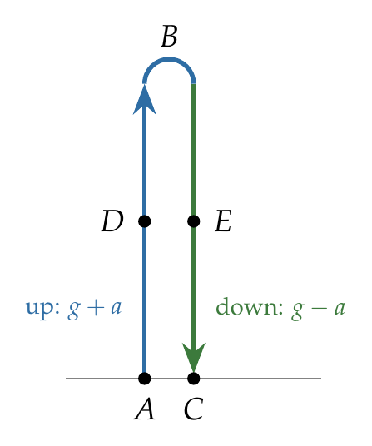
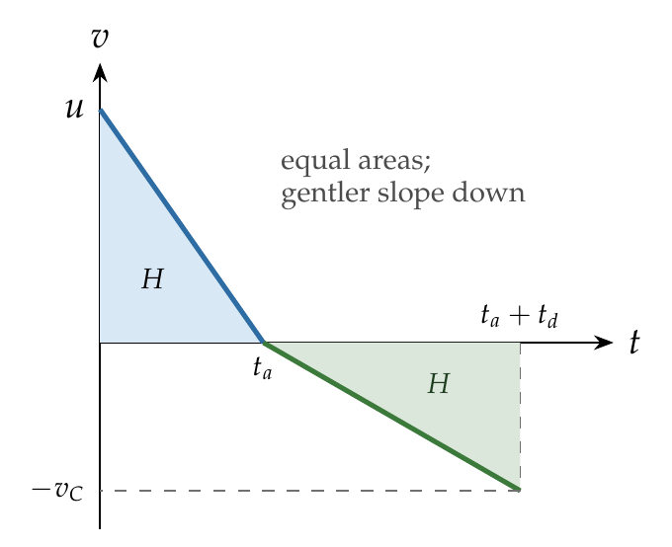
Take up as positive for the ascent and down as positive for the descent.
(i) Ascent, deceleration $g+a$:
$$t_{a}=\frac{u}{g+a}.$$
(iii) Maximum height:
$$H=\frac{u^{2}}{2\left(g+a\right)}.$$
(ii) Descent from rest through $H$ with acceleration $g−a$:
$$t_{d}=\sqrt{\frac{2H}{g−a}}=\frac{u}{\sqrt{\left(g+a\right)\left(g−a\right)}}=\frac{u}{\sqrt{g^{2}−a^{2}}}.$$
Note $t_{d}/t_{a}=\sqrt{\left(g+a\right)/\left(g−a\right)}>1$.
(iv) Speed at the ground:
$$v_{C}=\sqrt{2\left(g−a\right)H}=u\sqrt{\frac{g−a}{g+a}}<u.$$
(v) At height $y$: going up, $v_{D}^{2}=u^{2}−2\left(g+a\right)y=2\left(g+a\right)\left(H−y\right)$; coming down, $v_{E}^{2}=2\left(g−a\right)\left(H−y\right)$. Since $g+a>g−a$, $v_{D}>v_{E}$.

Answer
(i) $t_{a}=\frac{u}{g+a}$; (ii) $t_{d}=\frac{u}{\sqrt{g^{2}−a^{2}}}$; (iii) $H=\frac{u^{2}}{2\left(g+a\right)}$; (iv) $v_{C}=u\sqrt{\frac{g−a}{g+a}}$; (v) D (going up) is faster than E.

Watch out
• The resistance flips direction at the top, so the acceleration is g + a going up and g − a coming down; one SUVAT equation cannot cover the whole flight.
• The descent time is not u/(g − a): the body does not start the descent with speed u. Use the height: $t_{d}=\sqrt{2H/\left(g−a\right)}$.
Notes: Sec. 4.2 (constant air resistance: tₐ, H, t_d/tₐ, return speed).

Q33 · Ratio of descent to ascent time
ID 03MSL-0315-99ca · Code 0315 · Worksheet 03MSL_v2 Q33

Problem
A particle is thrown upwards from the ground. It experiences a constant resistive force which produces a retardation of 6 m/s². What will be the ratio of time of descent to time of ascent?
(A) 2 (B) 3 (C) 4 (D) 1

Hint
The particle covers the same height going up (acceleration 16 m/s²) and coming down (4 m/s²). For the same distance from or to rest, how does time depend on acceleration?

Think it through
- Going up, gravity and resistance both act downward: deceleration 10 + 6 = 16 m/s². Coming down, resistance acts upward: acceleration 10 − 6 = 4 m/s².
- Both legs cover the same height, each between rest and motion (ascent ends at rest; descent starts from rest).
- For a given distance from rest, time goes as one over the square root of acceleration. The descent acceleration is one-quarter of the ascent value, so the descent takes √4 = 2 times as long. (A)

Worked solution
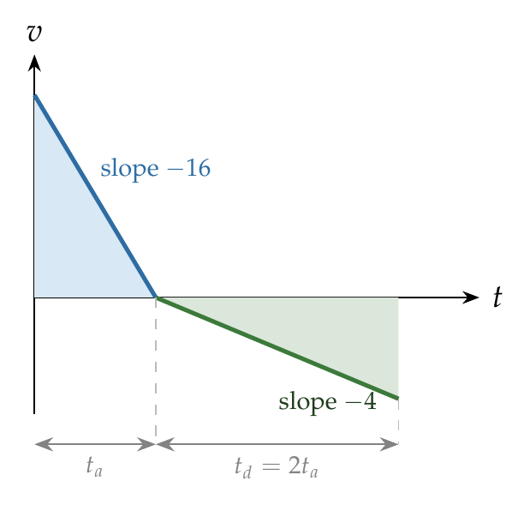
Ascent (run backwards from the top): $H=\frac{1}{2}\left(g+a\right)t_{a}^{2}$. Descent: $H=\frac{1}{2}\left(g−a\right)t_{d}^{2}$. So
$$\frac{t_{d}}{t_{a}}=\sqrt{\frac{g+a}{g−a}}=\sqrt{\frac{16}{4}}=2.$$

Answer
(A) 2.

Watch out
• The ratio of accelerations is 4, but times go as the square root: 2, not 4 (option C).
• Without resistance the ratio would be 1 (option D); resistance always makes the descent longer.
Notes: Sec. 4.2 (constant air resistance: ratio of descent to ascent times).

Two-Body & Multi-Phase Motion

Q34 · Accelerate for T, then decelerate at half the rate
ID 03MSL-0320-26c3 · Code 0320 · Worksheet 03MSL_v2 Q34

Problem
A train starts from station A with a constant acceleration of $a$ for time T immediately followed by deceleration of $a/2$ till it comes to stop at station B:
(i) What will be the time for deceleration
(ii) Ratio of distance travelled during acceleration and deceleration?
(iii) What will be the total distance travelled?
(iv) What will be the average speed for the entire journey from A to B?

Hint
Draw the v–t graph: a rise to aT, then a fall at half the slope. Everything (times, distances, average speed) can be read off that triangle.

Think it through
- The train gains speed aT in time T. It must lose the same speed aT at half the rate, which takes twice as long: 2T.
- Both phases go between rest and the same top speed aT, so each has average speed aT/2. Distances are then in the ratio of the times: 1 : 2.
- Acceleration phase: ½aT². Deceleration phase is twice that: aT². Total: 3/2 aT², that is 3 × (½aT²).
- Average speed = total distance ÷ total time = (3/2 aT²)/(3T) = aT/2. It is half the top speed, as for any rest-to-rest journey with a triangular v–t graph.

No-pen route
In any rest → v_max → rest trip with constant acceleration and deceleration, every phase has average speed v_max/2. So the whole trip averages aT/2, and distances go as the times (1 : 2).

Worked solution
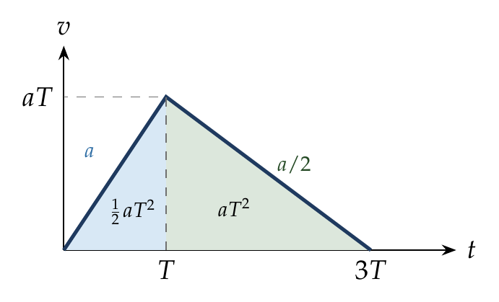
(i) The speed reached at time T is $v=aT$. During deceleration ($a/2$):
$$0=aT−\frac{a}{2}t_{2} ⇒ t_{2}=2T.$$
(ii) Areas under the v–t graph:
$$s_{1}=1/2\left(aT\right)\left(T\right)=1/2aT^{2}, s_{2}=1/2\left(aT\right)\left(2T\right)=aT^{2}, s_{1}:s_{2}=1:2.$$
(iii) Total distance:
$$s=s_{1}+s_{2}=3/2aT^{2}=3\left(1/2aT^{2}\right).$$
(iv) Average speed:
$$\overset{‾}{v}=\frac{3/2aT^{2}}{3T}=\frac{aT}{2}.$$

Answer
(i) 2T; (ii) 1 : 2; (iii) $3/2aT^{2}$; (iv) $1/2aT$.

Watch out
• Halving the deceleration doubles the time, not halves it.
• Average speed is total distance ÷ total time (3T), not the mean of the two accelerations.
Notes: Sec. 3.3 (two-phase motion: times inversely proportional to accelerations; average speed = v_max/2).

Q35 · Accelerate at α, decelerate at β, total time T
ID 03MSL-0320-72e0 · Code 0320 · Worksheet 03MSL_v2 Q35

Problem
A particle starts with an acceleration ‘α’ immediately followed with a deceleration ‘β’ and finally coming to stop. The total time duration of motion is ‘T’ then find:
(i) The time of acceleration (in terms of T)
(ii) The maximum speed reached:
(iii) The total distance travelled:
(iv) Average speed for the entire duration of motion:

Hint
Both phases share one number: the maximum speed. Each phase time is that speed divided by its own acceleration, and the two times add up to T.

Think it through
- The peak speed v links the two phases. Acceleration takes v/α and deceleration takes v/β.
- These add up to T. So v(1/α + 1/β) = T, giving v = αβT/(α + β).
- Time of acceleration = v/α = βT/(α + β). Each time is inversely proportional to its own acceleration: the gentler phase lasts longer.
- The v–t graph is a triangle of base T and height v, so the distance is ½vT = αβT²/2(α + β).
- Average speed = distance/T = v/2 = αβT/2(α + β).
- Check with α = β: each phase takes T/2 and v = αT/2. The formulas give exactly that.

Worked solution
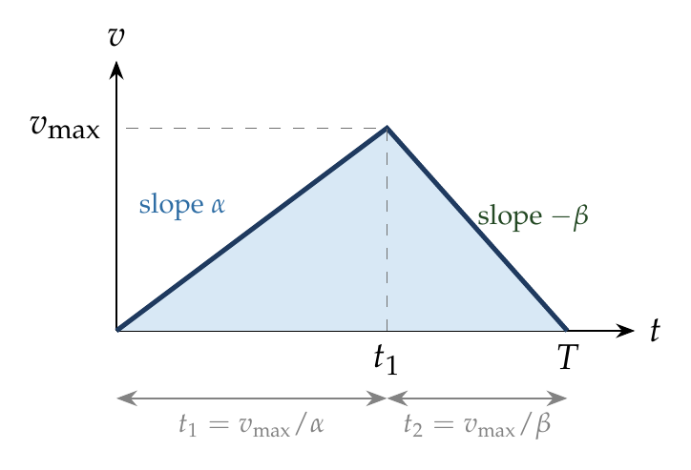
Let $t_{1}$, $t_{2}$ be the times of acceleration and deceleration and $v$ the maximum speed:
$$v=αt_{1}=βt_{2}, t_{1}+t_{2}=T.$$
$$\frac{v}{α}+\frac{v}{β}=T ⇒ v=\frac{αβ}{α+β}T, t_{1}=\frac{v}{α}=\frac{β}{α+β}T.$$
Distance = area of the triangle:
$$s=\frac{1}{2}vT=\frac{αβ}{2\left(α+β\right)}T^{2}, \overset{‾}{v}=\frac{s}{T}=\frac{αβ}{2\left(α+β\right)}T.$$

Answer
(i) $\frac{βT}{α+β}$; (ii) $\frac{αβT}{α+β}$; (iii) $\frac{αβT^{2}}{2\left(α+β\right)}$; (iv) $\frac{αβT}{2\left(α+β\right)}$.

Watch out
• The time of acceleration has β (not α) on top: the phase with the smaller rate lasts longer.
• Average speed is v_max/2, not v_max.
Notes: Sec. 3.3 (two-phase motion: t₁ = βT over the sum of the accelerations; v_max, distance, average speed).

Q36 · Minimum time between stations
ID 03MSL-0320-72cb · Code 0320 · Worksheet 03MSL_v2 Q36

Problem
The greatest acceleration or deceleration that a train may have is ‘a’. The minimum time in which the train may reach from one station to the other separated by a distance d is?

Hint
On the v–t graph the distance d is a fixed area and the slopes cannot exceed a. What shape covers that area in the shortest base?

Think it through
- The train starts and ends at rest. On the v–t graph, the distance d is the area, and the steepest allowed slopes are +a and −a.
- To cover a fixed area in the least time, the speed should be as high as possible at every instant. So accelerate as hard as allowed, then brake as hard as allowed, with no cruising.
- Equal rates up and down make the triangle symmetric: accelerate for half the time, brake for the other half.
- Each half covers ½a(t/2)² = at²/8, so d = at²/4 and t = 2√(d/a).

Worked solution
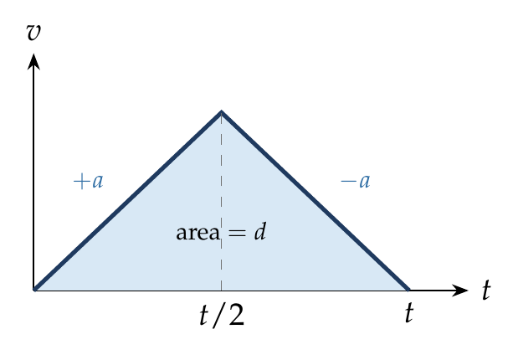
With maximum acceleration for $t/2$ and maximum deceleration for $t/2$, the peak speed is $a t/2$ and
$$d=\frac{1}{2}\left(a\frac{t}{2}\right)t=\frac{at^{2}}{4} ⇒ t_{min}=2\sqrt{\frac{d}{a}}.$$
Any other plan (smaller rates, or a cruising stretch) gives a lower v–t curve, which needs a longer base for the same area.

Answer
$t_{min}=2\sqrt{d/a}$.

Watch out
• Don’t use √(2d/a): that is the time to cover d from rest without stopping at the end.
Notes: Sec. 3.3 (minimum time from rest to rest).

Q37 · Same accelerations, different order
ID 03MSL-0320-8f95 · Code 0320 · Worksheet 03MSL_v2 Q37

Problem
Two particles A and B start from rest and move for equal time on a straight line. The particle A has an acceleration of ‘a’ for the first half of the time and ‘2a’ for the second half. The particle B has an acceleration of ‘2a’ for the first half and ‘a’ for the second half. What will be the ratio of the distances travelled by A and B?
(A) 7/5 (B) 1 (C) 5/7 (D) 3/8

Hint
Sketch both v–t graphs. They end at the same speed. Which one is higher in between?

Think it through
- Both gain the same total speed (a × T/2 + 2a × T/2), so they end at the same velocity. The difference is in the middle.
- B gets the big acceleration first, so it is faster throughout the second half. Its v–t graph lies above A’s, so B covers more distance. That rules out (A) and (B).
- Count in units of a(T/2)²: A covers ½ in the first half; then starts at speed 1 and adds 1 more: 1 + 1 = 2. Total 2.5.
- B covers 1 in the first half; then starts at speed 2 and adds ½: 2 + ½ = 2.5. Total 3.5.
- Ratio A : B = 2.5 : 3.5 = 5 : 7. (C)

Another way: graph areas
The two v–t graphs differ only by the shaded parallelogram between them. B’s total area is A’s plus that parallelogram, giving 7 : 5 in favour of B.

Worked solution
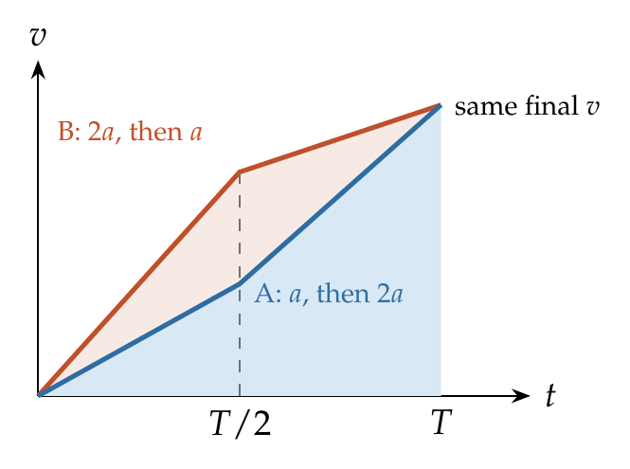
Let $τ=T/2$.
A: $s_{1}=\frac{1}{2}aτ^{2}$, $v_{1}=aτ$; $s_{2}=aτ⋅τ+\frac{1}{2}\left(2a\right)τ^{2}=2aτ^{2}$. So $s_{A}=\frac{5}{2}aτ^{2}$.
B: $s_{1}=\frac{1}{2}\left(2a\right)τ^{2}=aτ^{2}$, $v_{1}=2aτ$; $s_{2}=2aτ⋅τ+\frac{1}{2}aτ^{2}=\frac{5}{2}aτ^{2}$. So $s_{B}=\frac{7}{2}aτ^{2}$.
$$\frac{s_{A}}{s_{B}}=\frac{5}{7}.$$

Answer
(C) 5/7.

Watch out
• Equal final speeds do not mean equal distances: the order of the accelerations matters.
• The second phase does not start from rest: include the uτ term.
Notes: Sec. 6 (area under the v–t graph = displacement); Sec. 3.1 (equations of motion).

Q38 · Two cars finishing together
ID 03MSL-0320-a894 · Code 0320 · Worksheet 03MSL_v2 Q38

Problem
Two cars start the race with velocities $u_{1}$ and $u_{2}$ and travel in straight line with acceleration ‘α’ and ‘β’. If both reach the finish line at the same time, then the range of the race is?

Hint
Same distance, same time. Write each car’s distance in time T and set them equal; then T follows, and the range from either car.

Think it through
- Both cars cover the race length R in the same time T, starting together.
- Setting u₁T + ½αT² equal to u₂T + ½βT² and cancelling one T gives T = 2(u₁ − u₂)/(β − α). The car with the higher start speed must have the lower acceleration for this to be positive.
- Put this T back into either car’s distance to get R.

Another way: relative motion
In car 2’s frame, car 1 starts at relative speed u₁ − u₂ with relative acceleration −(β − α). It returns to “level” after 2(u₁ − u₂)/(β − α), the time to go out and come back, as for a vertical throw.

Worked solution
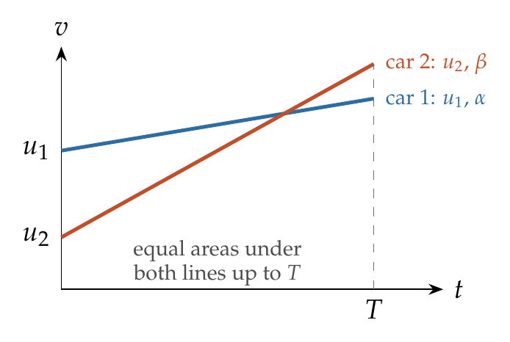
$$R=u_{1}T+1/2αT^{2}=u_{2}T+1/2βT^{2} ⇒ T=\frac{2\left(u_{1}−u_{2}\right)}{β−α}.$$
$$R=T\left(u_{1}+\frac{αT}{2}\right)=\frac{2\left(u_{1}−u_{2}\right)}{β−α}⋅\frac{u_{1}\left(β−α\right)+α\left(u_{1}−u_{2}\right)}{β−α}=\frac{2\left(u_{1}−u_{2}\right)\left(u_{1}β−u_{2}α\right)}{{\left(β−α\right)}^{2}}.$$

Answer
$R=\frac{2\left(u_{1}−u_{2}\right)\left(u_{1}β−u_{2}α\right)}{{\left(β−α\right)}^{2}}$.

Watch out
• Don’t cancel T = 0: that root is the start, not the finish.
Notes: Sec. 3.4 (chasing, overtaking and meeting: set the two positions equal).

Q39 · Cyclist chasing a bus: two meetings
ID 03MSL-0320-6ee5 · Code 0320 · Worksheet 03MSL_v2 Q39

Problem
A bus starts moving with acceleration 2 m/s². A cyclist 96 m behind the bus starts simultaneously towards the bus at a constant speed of 20 m/s. At what time(s) will he be adjacent to the bus?
(A) at 8 sec (B) at 10 sec (C) at 12 sec (D) at 8 and 12 sec

Hint
The cyclist starts faster but the bus keeps speeding up. Could they be side by side more than once?

Think it through
- They are side by side when the cyclist has covered 96 m more than the bus.
- The cyclist covers 20t; the bus covers t². So 20t − t² = 96, a quadratic with two positive roots: 8 s and 12 s.
- Meaning: at 8 s the cyclist (20 m/s) passes the bus (then at 16 m/s). The bus keeps accelerating, catches up and passes him back at 12 s (bus at 24 m/s). (D)
- Check by symmetry: the gap is smallest when the speeds are equal (10 s), and the two meetings are equally spaced about it.

Another way: bus frame
In the bus frame the cyclist starts at 20 m/s with a retardation of 2 m/s², like a ball thrown up. He reaches 96 m “up” going out at 8 s and coming back at 12 s; his peak is 100 m at 10 s.

Worked solution
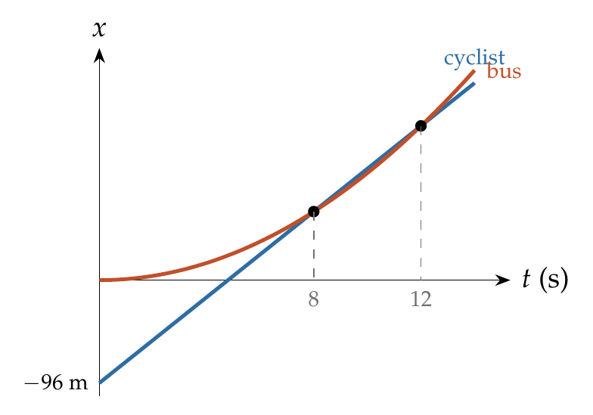
Origin at the cyclist’s start. Cyclist: $x_{c}=20t$. Bus: $x_{b}=96+t^{2}$.
$$20t=96+t^{2} ⇒ t^{2}−20t+96=0 ⇒ t=8 s or 12 s.$$

Answer
(D) at 8 s and at 12 s.

Watch out
• Don’t keep only the first root: the bus overtakes the cyclist again at 12 s.
• 10 s is when the gap is least (equal speeds), not a meeting time.
Notes: Sec. 3.4 (two positive roots: A overtakes B, then B overtakes A).

Q40 · Can the jeep catch the dacoit?
ID 03MSL-0320-b38b · Code 0320 · Worksheet 03MSL_v2 Q40

Problem
A police jeep moving at a constant speed v is chasing a dacoit on a motorcycle. When the jeep is a distance $x$ behind, the dacoit starts from rest with a constant acceleration α. Which of the following relations must hold if the police are to catch the dacoit?
(A) $v^{2}≤αx$ (B) $v^{2}≤2αx$ (C) $v^{2}≥2αx$ (D) $v^{2}≥αx$

Hint
Sit on the motorcycle. The jeep then approaches at v but is “decelerated” at α. How far can it get before its relative speed is used up?

Think it through
- The gap closes only while the jeep is faster than the bike. Once the bike’s speed exceeds v, the gap grows for ever.
- From the bike’s frame, the jeep starts at relative speed v with a relative retardation α. Like a ball thrown up, it can travel at most v²/2α before its relative speed falls to zero.
- To catch the bike, that reach must be at least the gap x: v²/2α ≥ x, i.e. v² ≥ 2αx. (C)

Another way: quadratic
vt = x + ½αt² must have a real root, so its discriminant v² − 2αx ≥ 0.

Worked solution
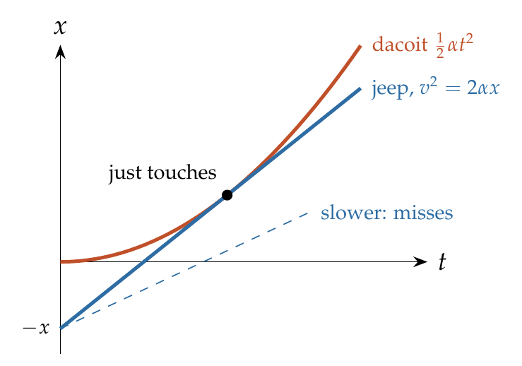
Positions from the jeep’s starting point: jeep $vt$, bike $x+\frac{1}{2}αt^{2}$. Catching requires
$$1/2αt^{2}−vt+x=0$$
to have a real root: discriminant $v^{2}−2αx≥0$, so
$$v^{2}≥2αx.$$

Answer
(C) $v^{2}≥2αx$.

Watch out
• Equality means the jeep just touches the bike at the instant their speeds are equal; any less and it never catches up.
• Relative distance under relative retardation is v²/2α, not v²/α.
Notes: Sec. 3.4 (relative-frame shortcut: catch only if the gap is at most u_rel² over 2a_rel).

Q41 · Maximum lead the man can close
ID 03MSL-0320-7fb3 · Code 0320 · Worksheet 03MSL_v2 Q41

Problem
A bus starts from rest with an acceleration of 2 m/s², and at the same instant a man starts running after the bus at a constant speed of 10 m/s. If he is $x$ m behind the bus, then what is the maximum value of $x$ so that the man may be able to catch the bus?

Hint
The man gains on the bus only while he is faster than it. How much ground can he gain before the bus matches his speed?

Think it through
- The man gains ground only while he is faster than the bus. The bus reaches 10 m/s after 5 s; after that it pulls away.
- In those 5 s the man runs 50 m and the bus covers 25 m. He gains 25 m.
- So he can catch the bus only if he started at most 25 m behind.

No-pen route: bus frame
Relative speed 10 m/s, relative retardation 2 m/s²: maximum gain = 10²/(2 × 2) = 25 m.

Worked solution
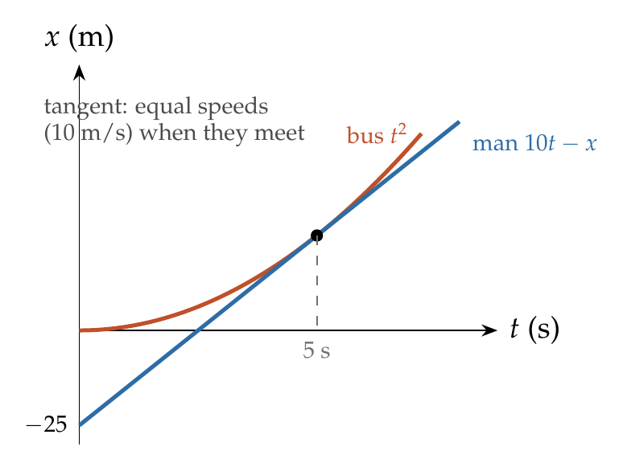
Catching requires $10t=x+t^{2}$ to have a real root: $100−4x≥0$, so $x≤25$ m. At the limit they meet at $t=5$ s, when both move at 10 m/s.

Answer
$x_{max}=25$ m.

Watch out
• Don’t use the bus’s distance at the meeting alone; it’s the gain (50 − 25) that matters.
Notes: Sec. 3.4 (relative-frame shortcut; example: largest gap the cyclist can close).

Q42 · Jeep catching a bike that passed 10 s earlier
ID 03MSL-0320-f300 · Code 0320 · Worksheet 03MSL_v2 Q42

Problem
A police jeep is chasing a culprit going on a motor bike. The motor bike crosses a turning at a speed of 72 km/h. The jeep follows it at a speed of 90 km/h crossing the turning ten seconds later than the bike. Assuming that they travel at constant speeds, how far from the turning will the jeep catch up with the bike? (in km)
(A) 3 km (B) 5 km (C) 1 km (D) 7 km

Hint
When the jeep reaches the turning, how far ahead is the bike, and how fast does the jeep close that gap?

Think it through
- Speeds: bike 20 m/s, jeep 25 m/s.
- When the jeep reaches the turning, the bike is 10 s × 20 m/s = 200 m ahead.
- The jeep closes the gap at 5 m/s, which takes 40 s.
- In 40 s the jeep goes 25 × 40 = 1000 m from the turning: 1 km. (C)

Worked solution
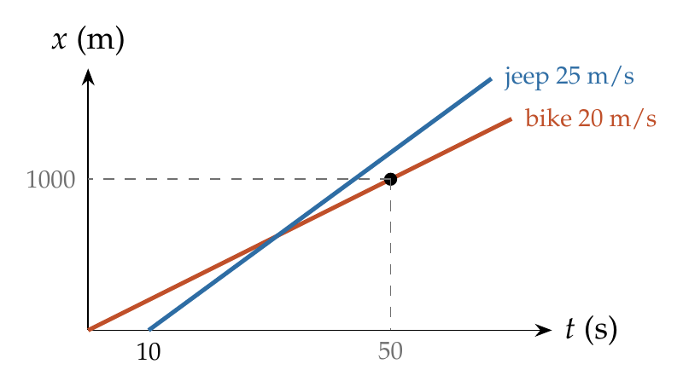
Take $t=0$ when the bike crosses the turning. Bike: $x=20t$. Jeep: $x=25\left(t−10\right)$.
$$20t=25t−250 ⇒ t=50 s, x=20\left(50\right)=1000 m=1 km.$$

Answer
(C) 1 km.

Watch out
• Convert km/h to m/s (× 5/18) before combining with seconds.
• The answer is measured from the turning, not from where the jeep was when the bike passed.
Notes: Sec. 3.4 (chasing: set the two positions equal).

Q43 · Equal displacements in the same second
ID 03MSL-0320-84ba · Code 0320 · Worksheet 03MSL_v2 Q43

Problem
A starts from rest with an acceleration of $a_{1}$. Two seconds later, B starts from rest with an acceleration of $a_{2}$. If the displacement of A in 5th second of its motion is same as that of B in the same time interval, then the ratio of accelerations?
(A) 5:7 (B) 5:9 (C) 9:5 (D) 5:3

Hint
Displacement in a one-second interval equals the velocity at its middle. Where is each body, on its own clock, at the middle of that interval?

Think it through
- The interval is A’s 5th second: A’s clock reads 4 to 5 s. B started 2 s later, so on B’s clock the same interval is 2 to 3 s.
- Over a one-second interval, displacement equals the velocity at the middle instant. That is A at 4.5 s and B at 2.5 s.
- Equal displacements mean 4.5 a₁ = 2.5 a₂, so a₁ : a₂ = 2.5 : 4.5 = 5 : 9. (B)

Worked solution
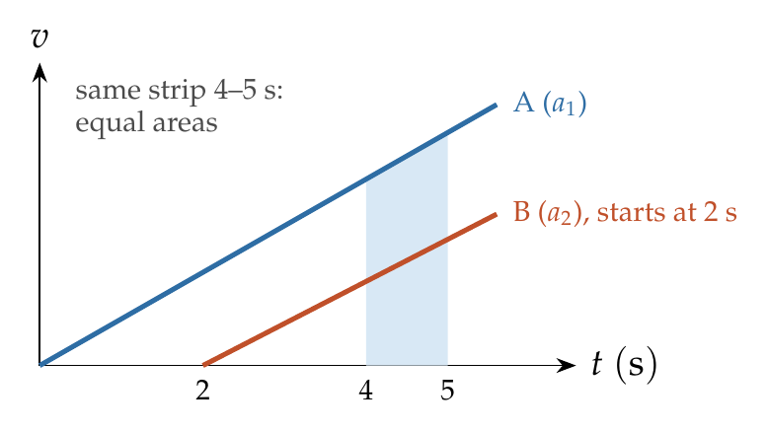
A from $t=4$ to 5 s: $s_{A}=\frac{1}{2}a_{1}\left(5^{2}−4^{2}\right)=4.5 a_{1}$.
B over the same interval (its own times 2 to 3 s): $s_{B}=\frac{1}{2}a_{2}\left(3^{2}−2^{2}\right)=2.5 a_{2}$.
$$4.5 a_{1}=2.5 a_{2} ⇒ \frac{a_{1}}{a_{2}}=\frac{5}{9}.$$

Answer
(B) 5 : 9.

Watch out
• “The same interval” is the same clock time, which is B’s 3rd second, not B’s 5th second.
Notes: Sec. 3.1 (average velocity over an interval = velocity at its middle; nth-second displacement).

Q44 · Two trains braking towards each other
ID 03MSL-0320-4545 · Code 0320 · Worksheet 03MSL_v2 Q44

Problem
Two trains A and B travelling on the same track are approaching each other with equal speeds of 40 m/s. The drivers of the trains begin to decelerate simultaneously when they are just 2.0 km apart. Assuming the decelerations of A is half that of B, what must be the minimum value of the deceleration of A to barely avoid collision?
(A) 3 m/s² (B) 0.6 m/s² (C) 1.2 m/s² (D) 2.4 m/s²

Hint
Collision is avoided if both trains stop within the 2 km between them. Add their stopping distances.

Think it through
- Each train brakes to rest independently. They avoid a collision if their two stopping distances together fit in 2000 m.
- Stopping distance = speed²/(2 × deceleration). A (deceleration a) needs 800/a; B (deceleration 2a) needs half of that, 400/a.
- Together 1200/a ≤ 2000, so a ≥ 0.6 m/s². (B)

Worked solution
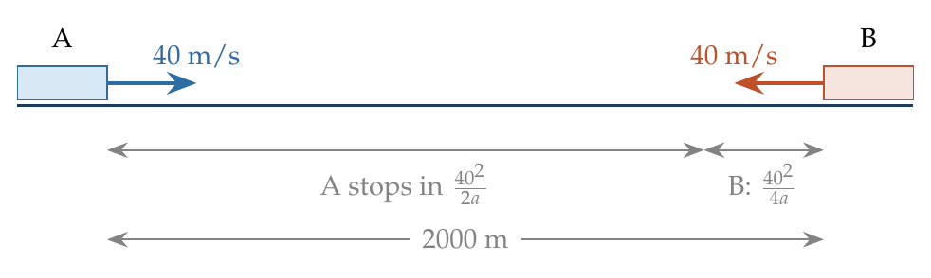
Let A’s deceleration be $a$ and B’s $2a$.
$$s_{A}=\frac{{40}^{2}}{2a}=\frac{800}{a}, s_{B}=\frac{{40}^{2}}{2\left(2a\right)}=\frac{400}{a}.$$
$$s_{A}+s_{B}≤2000 ⇒ \frac{1200}{a}≤2000 ⇒ a≥0.6 {m/s}^{2}.$$

Answer
(B) 0.6 m/s².

Watch out
• Don’t give B’s deceleration (1.2 m/s², option C); the question asks for A’s.
• A relative-motion shortcut with relative retardation 3a fails after B stops; adding stopping distances avoids that trap.
Notes: Sec. 3.2B (stopping distance); Sec. 3.4 (chasing, overtaking and meeting).

Q45 · Race: time gap and speed gap [JEE Main 2019, 9 Jan, Shift 2]
ID 03MSL-0320-d3d2 · Code 0320 · Worksheet 03MSL_v2 Q45

Problem
In a car race on straight road, car A takes a time ‘t’ less than car B at the finish and passes finishing point with a speed ‘v’ more than that of car B. Both the cars start from rest and travel with constant acceleration $a_{1}$ and $a_{2}$ respectively. Then ‘v’ is equal to:
(A) $\frac{a_{1}+a_{2}}{2}t$ (B) $\sqrt{2a_{1}a_{2}} t$ (C) $\frac{2a_{1}a_{2}}{a_{1}+a_{2}}t$ (D) $\sqrt{a_{1}a_{2}} t$

Hint
For the same distance d from rest, speed goes as √a and time as 1/√a. Write the speed gap and the time gap in terms of √a₁ and √a₂ and divide.

Think it through
- Same distance d from rest: final speed √(2a d) and time √(2d/a).
- Speed gap v = √(2d)(√a₁ − √a₂). Time gap t = √(2d)(1/√a₂ − 1/√a₁) = √(2d)(√a₁ − √a₂)/√(a₁a₂).
- Dividing, v/t = √(a₁a₂). (D)
- Sense check: if a₁ = a₂ both gaps vanish together, and v/t tends to the common acceleration, which the geometric mean gives.

Another way: v–t graph
Both graphs are lines from the origin enclosing equal areas. With v_A = a₁t_A and v_B = a₂t_B and equal areas, v_A t_A = v_B t_B. Then v_A − v_B and t_B − t_A combine to give √(a₁a₂).

Worked solution
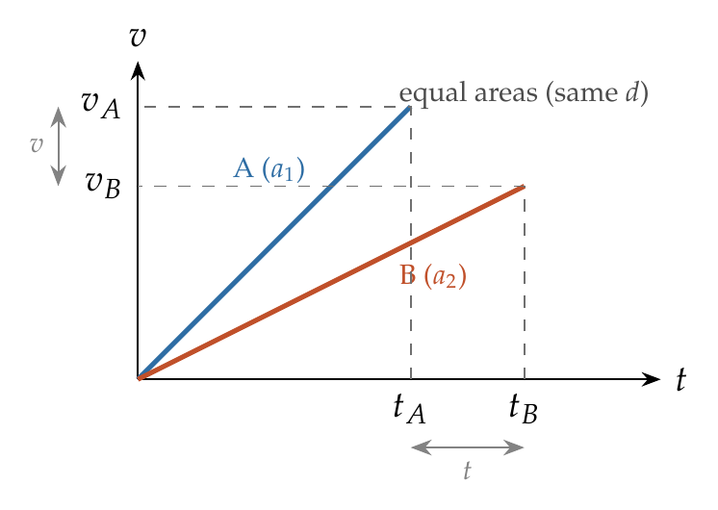
Let the race length be $d$:
$$v_{A}=\sqrt{2a_{1}d}, v_{B}=\sqrt{2a_{2}d}, t_{A}=\sqrt{\frac{2d}{a_{1}}}, t_{B}=\sqrt{\frac{2d}{a_{2}}}.$$
$$v=v_{A}−v_{B}=\sqrt{2d} \left(\sqrt{a_{1}}−\sqrt{a_{2}}\right), t=t_{B}−t_{A}=\sqrt{2d} \frac{\sqrt{a_{1}}−\sqrt{a_{2}}}{\sqrt{a_{1}a_{2}}}.$$
$$\frac{v}{t}=\sqrt{a_{1}a_{2}} ⇒ v=\sqrt{a_{1}a_{2}} t.$$

Answer
(D) $\sqrt{a_{1}a_{2}} t$.

Watch out
• t is the time difference, not the time of either car.
• Speed ∝ √a for a fixed distance, not ∝ a.
Notes: Sec. 3.2A (starting from rest); Sec. 3.1 (equations of motion).

Q46 · Stopped mid-fall, then released again
ID 03MSL-0320-43c4 · Code 0320 · Worksheet 03MSL_v2 Q46

Problem
A body is released from the top of a tower of height H metre. After 2 seconds it is stopped and then instantaneously released. What will be its height after next 2 seconds?

Hint
After being stopped, the body is released from rest again. So the next 2 s are just like the first 2 s.

Think it through
- In the first 2 s from rest it falls ½ × 10 × 4 = 20 m.
- It is then stopped: all its speed is removed. Released again, it starts from rest, exactly as at the top.
- So the next 2 s also give 20 m. Total fall 40 m; height above the ground H − 40 (provided H ≥ 40 m).

Worked solution
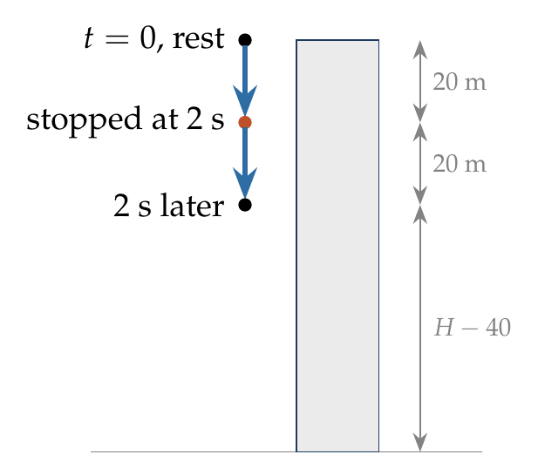
Each stage starts from rest: $s=\frac{1}{2}gt^{2}=\frac{1}{2}\left(10\right){\left(2\right)}^{2}=20$ m.
$$h=H−20−20=\left(H−40\right) m.$$

Answer
(H − 40) m.

Watch out
• Don’t treat it as a 4 s continuous fall (80 m): stopping resets the speed to zero.
• If H < 40 m the body reaches the ground before the 4 s are up.
Notes: Sec. 3.2A (starting from rest); Sec. 4 (motion under gravity).

Q47 · Juggler with four balls
ID 03MSL-0320-4822 · Code 0320 · Worksheet 03MSL_v2 Q47

Problem
A juggler maintains four balls in motion, making each in turn rise to a height of 5 m from his hand. What will be the time interval between two successive balls thrown up? Assume that balls do not collide in air and the time taken to receive and throw the ball again is negligible.

Hint
How long is each ball in the air? The juggler must throw four balls in that time before the first one comes back.

Think it through
- A ball rising 5 m takes 1 s up and 1 s down: 2 s in the air.
- In a steady pattern, the first ball lands just as the next throw is due, and in between the other three are thrown.
- So the 2 s of one flight are shared among four equal gaps: 0.5 s between throws.

Worked solution
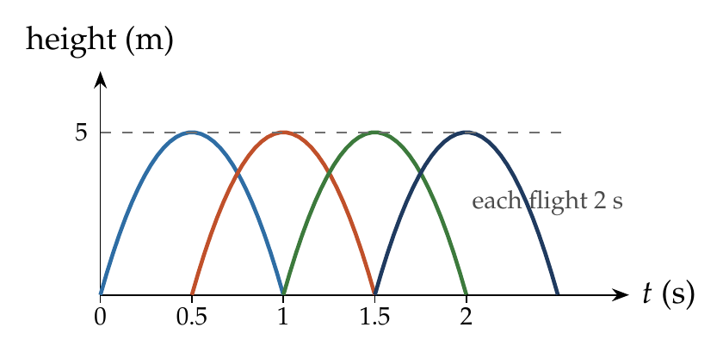
Speed of throw: $u=\sqrt{2gh}=\sqrt{2\left(10\right)\left(5\right)}=10$ m/s. Time of flight: $T=2u/g=2$ s.
With $n=4$ balls in a steady cycle, $n$ throws fill one flight time:
$$Δt=\frac{T}{n}=\frac{2}{4}=0.5 s.$$

Answer
0.5 s.

Watch out
• Divide the flight time by the number of balls (4), not by 3: the first ball is caught and rethrown as the fifth throw, so four equal gaps fill one flight.
Notes: Sec. 4.2 (time of flight); Sec. 4.1 (symmetry).

Q48 · Rocket: fuel burn, then free flight
ID 03MSL-0320-d773 · Code 0320 · Worksheet 03MSL_v2 Q48

Problem
A rocket is fired and it ascends with a constant acceleration of 10 m/s². Its fuel exhausts after one minute and it continues to move as a free object. Find the maximum height reached by the rocket?
(A) 18 km (B) 54 km (C) 9 km (D) 36 km

Hint
Two phases with different constant accelerations. The second phase starts with the speed reached at burn-out.

Think it through
- Phase 1 (fuel on): from rest at 10 m/s² for 60 s, so speed 600 m/s and height ½ × 10 × 3600 = 18 km.
- Phase 2 (fuel out): the rocket still moves up at 600 m/s but now decelerates at g = 10 m/s². It rises another 600²/20 = 18 km.
- Maximum height 18 + 18 = 36 km. (D)
- Symmetry check: the free phase has the same rate (10) as the powered phase, so it is a mirror image and covers the same height.

Worked solution
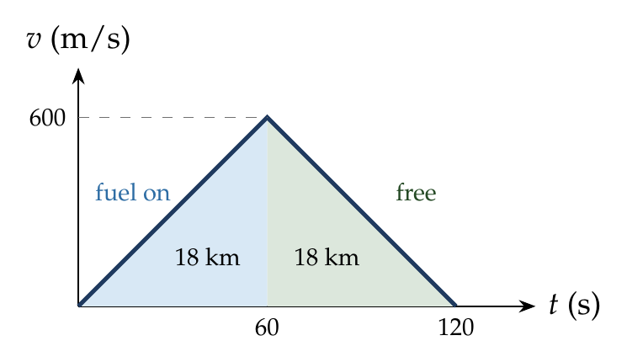
Phase 1: $v=at=10\left(60\right)=600$ m/s, $h_{1}=\frac{1}{2}at^{2}=\frac{1}{2}\left(10\right){\left(60\right)}^{2}=18 000$ m.
Phase 2: $h_{2}=\frac{v^{2}}{2g}=\frac{{600}^{2}}{20}=18 000$ m.
$$H=h_{1}+h_{2}=36 km.$$

Answer
(D) 36 km.

Watch out
• The rocket doesn’t stop when the fuel runs out; it keeps rising (18 km alone is option A).
• After burn-out the acceleration is g downward, not zero.
Notes: Sec. 3.3 (two-phase motion); Sec. 4.2 (released from a moving body).

Q49 · Particle released from a rising helicopter [JEE Main 2020, 5 Sep, Shift 1]
ID 03MSL-0320-76f3 · Code 0320 · Worksheet 03MSL_v2 Q49

Problem
A helicopter is rising from the ground with an acceleration of g m/s² starting from rest. After it has risen to a height h, a particle is released from it. Take t = 0 at the instant the particle is released, find time t when it reaches the ground (in terms of h and g).

Hint
At release the particle keeps the helicopter’s velocity (upward), not its acceleration. What is that velocity after rising h with acceleration g?

Think it through
- At release the particle shares the helicopter’s velocity: having risen h from rest at g, that is √(2gh), upward.
- From then on only gravity acts. It is like a ball thrown up at √(2gh) from height h.
- It first rises a further h (since √(2gh) is exactly the speed to rise h), reaching 2h above the ground, which takes √(2h/g).
- Then it falls 2h from rest, which takes √(4h/g) = √2 × √(2h/g).
- Total: (1 + √2)√(2h/g).

Worked solution
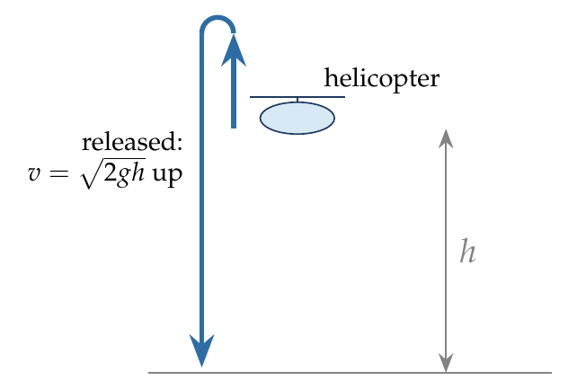
Velocity at release: $v^{2}=2gh$, so $u=\sqrt{2gh}$ upward. Take up as positive, origin at the release point; the ground is at $−h$:
$$−h=\sqrt{2gh} t−1/2gt^{2}.$$
$$t=\frac{\sqrt{2gh}+\sqrt{2gh+2gh}}{g}=\frac{\sqrt{2gh}\left(1+\sqrt{2}\right)}{g}=\left(1+\sqrt{2}\right)\sqrt{\frac{2h}{g}}.$$

Answer
$t=\left(1+\sqrt{2}\right)\sqrt{2h/g}$.

Watch out
• The particle is not released from rest: don’t use √(2h/g).
• After release its acceleration is g downward, not the helicopter’s g upward.
Notes: Sec. 4.2 (released from a moving body); Sec. 4.2 (projection from a tower).

Q50 · Two bodies released 2 s apart
ID 03MSL-0320-291a · Code 0320 · Worksheet 03MSL_v2 Q50

Problem
Two bodies are released from the same point. The second one is released 2 s after the first. Find the time, measured from the release of the first object, at which the distance between the two objects is L = 60 m?
(A) 6 s (B) 2 s (C) 4 s (D) $2\sqrt{2}$ s

Hint
Once both are falling, their relative acceleration is zero. What is the gap and the relative speed when the second one is released?

Think it through
- When the second body is released (t = 2 s), the first has fallen 20 m and is moving at 20 m/s.
- After that both accelerate equally, so the first stays 20 m/s faster: the gap grows steadily by 20 m every second.
- From 20 m to 60 m takes 2 more seconds: t = 4 s from the first release. (C)

Another way: v–t graph
The two v–t lines are parallel, 2 s apart. The gap is the area between them: 20 m for the first 2 s, then 20 m per second. 60 m at t = 4 s.

Worked solution
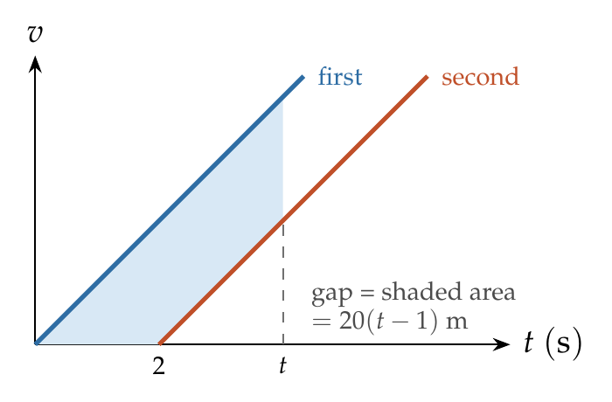
For $t≥2$ s:
$$Δy=1/2gt^{2}−1/2g{\left(t−2\right)}^{2}=g\left(2t−2\right)=20t−20.$$
$$20t−20=60 ⇒ t=4 s.$$

Answer
(C) 4 s.

Watch out
• Measure t from the first release, as asked; the second body has fallen for only 2 s at that moment.
Notes: Sec. 10.2 (two bodies under gravity: relative motion is uniform).

Q51 · Second ball thrown to hit the first
ID 03MSL-0320-160f · Code 0320 · Worksheet 03MSL_v2 Q51

Problem
A ball is thrown vertically down with velocity of 5 m/s. With what velocity should another ball be thrown down after 2 seconds so that it can hit the 1st ball in 2 seconds?
(A) 40 m/s (B) 55 m/s (C) 15 m/s (D) 25 m/s

Hint
Find where the first ball is 4 s after its throw. The second ball must cover that distance in its 2 s.

Think it through
- The first ball, thrown down at 5 m/s, is 5 × 4 + 5 × 16 = 100 m below the start after 4 s.
- The second ball must cover those 100 m in 2 s. Gravity gives it 20 m in 2 s on its own, so its throw must supply the other 80 m: 40 m/s. (A)
- Check: the second ball must be faster than the first at the meeting, or it could never catch up. The first is moving at 45 m/s at t = 4 s; the second at 40 + 20 = 60 m/s. It fits.

Another way: relative motion
At t = 2 s the first ball is 30 m down, moving at 25 m/s. Both then have the same acceleration, so the second ball must close the 30 m gap in 2 s with a relative speed of 15 m/s: 25 + 15 = 40 m/s.

Worked solution
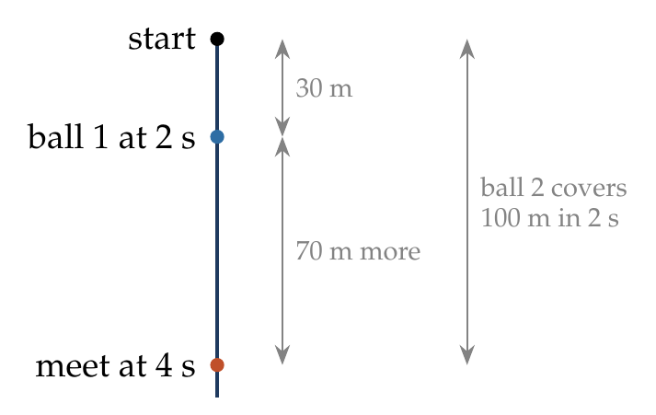
Ball 1 at $t=4$ s: $s_{1}=5\left(4\right)+\frac{1}{2}\left(10\right){\left(4\right)}^{2}=100$ m.
Ball 2 over 2 s: $u\left(2\right)+\frac{1}{2}\left(10\right){\left(2\right)}^{2}=100 ⇒ u=40$ m/s.

Answer
(A) 40 m/s.

Watch out
• Use the first ball’s total time (4 s), not 2 s, for its position.
Notes: Sec. 10.2 (two bodies under gravity: relative motion is uniform).

Q52 · Dropped from the top, thrown from the foot
ID 03MSL-0320-aa57 · Code 0320 · Worksheet 03MSL_v2 Q52

Problem
A body is dropped from the top of a given tower of height h. At the same time a body is projected from the foot of the tower, in the same vertical line, with a velocity which would be just sufficient to take it to top of the tower. They will meet at a height?
(A) h/2 (B) h/4 (C) h/3 (D) 3h/4

Hint
Both have the same acceleration, so they close the gap h at a constant relative speed. When do they meet, and how far has the dropped body fallen by then?

Think it through
- The lower body is thrown up at u = √(2gh), just enough to reach the top.
- Both fall equally under gravity, so relative to each other they move uniformly: the gap h closes at speed u. They meet after h/u.
- In that time the dropped body falls ½g(h/u)² = ½g h²/(2gh) = h/4.
- So they meet h/4 below the top, at height 3h/4. (D)

Worked solution
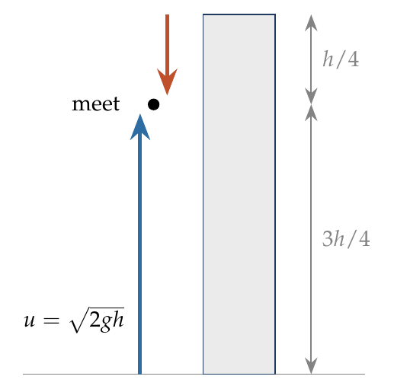
$u=\sqrt{2gh}$. Meeting time (relative motion uniform):
$$t=\frac{h}{u}=\frac{h}{\sqrt{2gh}}.$$
Fall of the dropped body: $\frac{1}{2}gt^{2}=\frac{1}{2}g\frac{h^{2}}{2gh}=\frac{h}{4}$. Height of meeting:
$$h−\frac{h}{4}=\frac{3h}{4}.$$

Answer
(D) 3h/4.

Watch out
• They do not meet half-way (option A): the upper body is slow and the lower body fast at the start.
• h/4 is the fall from the top (option B), not the height of the meeting point.
Notes: Sec. 10.2 (two bodies under gravity; dropped and thrown up meet at 3h/4).

Q53 · Two balls shot up 2 s apart
ID 03MSL-0320-4679 · Code 0320 · Worksheet 03MSL_v2 Q53

Problem
Two balls of same masses are shot upward one after another at an interval of 2 seconds along the same vertical line and with same initial velocity of 40 m/s. At what height from the ground will they collide?
(A) 75 m (B) 45 m (C) 15 m (D) 30 m

Hint
The two flights are identical, just shifted by 2 s. When they meet, one must be coming down while the other is going up. Where is that by symmetry?

Think it through
- Each ball spends 4 s going up and 4 s coming down. The second ball’s flight is the first one’s, shifted 2 s later.
- They meet at the same height at the same instant: the first on its way down, the second on its way up. By symmetry the first must be as far past its top as the second is short of its top: 1 s each.
- So the meeting is at t = 5 s (first ball 1 s after its top). In 1 s from the top a body falls 5 m: height 80 − 5 = 75 m. (A)

Another way: relative motion
When the second ball is thrown, the first is at 60 m moving up at 20 m/s. Their relative speed, 40 − 20 = 20 m/s, stays constant, so the 60 m gap closes in 3 s (t = 5 s). Height of the second ball then: 40 × 3 − 5 × 9 = 75 m.

Worked solution
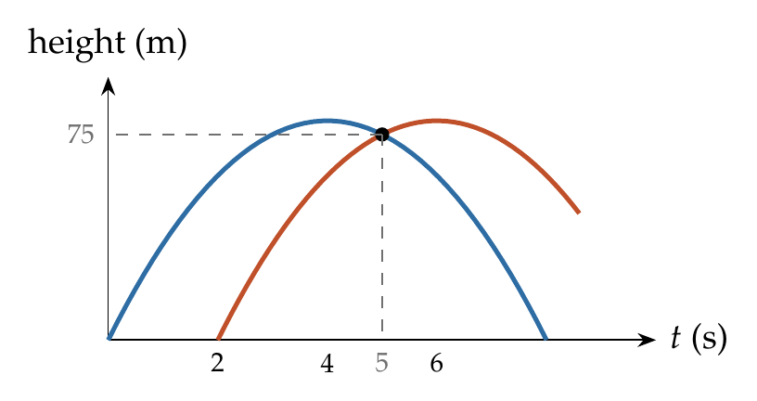
Let them meet at time $t$ after the first throw:
$$40t−5t^{2}=40\left(t−2\right)−5{\left(t−2\right)}^{2} ⇒ 0=−80+20t−20 ⇒ t=5 s.$$
$$h=40\left(5\right)−5\left(25\right)=75 m.$$

Answer
(A) 75 m.

Watch out
• The maximum height is 80 m; the collision is just below it, not at it.
Notes: Sec. 10.2 (two bodies under gravity; example: balls thrown up 2 s apart).

Q54 · Average speed of a rest-to-rest trip [L2]
ID 03MSL-0320-fec0 · Code 0320 · Worksheet 03MSL_v2 Q54

Problem
A car starts from rest and moves with uniform acceleration ‘a’ on a straight road from time t = 0 to t = T. After that, a constant deceleration of ‘b’ brings it to rest. In this process the average speed of the car is
(A) $\frac{aT}{4}$ (B) $\frac{3aT}{2}$ (C) $\frac{aT}{2}$ (D) Will depend on ‘b’

Hint
Rest → top speed → rest with constant rates: what is the average speed in each phase?

Think it through
- The top speed is aT.
- Each phase is uniformly accelerated between rest and aT, so each has average speed aT/2.
- If every phase averages aT/2, the whole trip does too, however long the braking takes. b changes the time and distance, not the average speed. (C)

Worked solution
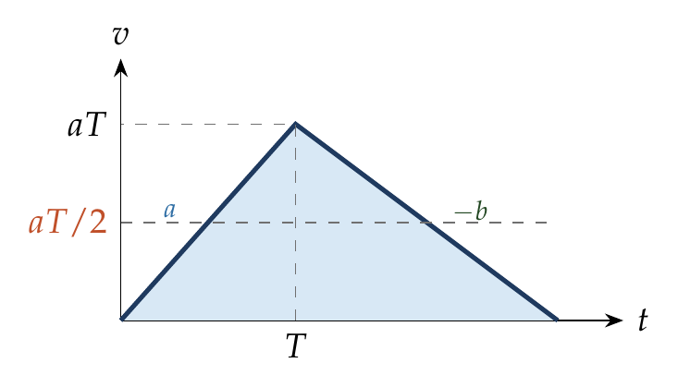
Peak speed $v=aT$; braking time $aT/b$. Distance = area of the triangle:
$$s=\frac{1}{2}aT\left(T+\frac{aT}{b}\right), \overset{‾}{v}=\frac{s}{T+aT/b}=\frac{aT}{2}.$$

Answer
(C) $\frac{aT}{2}$.

Watch out
• Option (D) is tempting, but b cancels: the average speed is half the peak speed for any triangular v–t graph.
Notes: Sec. 3.3 (average speed = v_max/2, independent of the accelerations).

Q55 · Collision where A is twice as fast as B [L2]
ID 03MSL-0320-bef2 · Code 0320 · Worksheet 03MSL_v2 Q55

Problem
A ball A is dropped from the top of a building of height 90 m and at the same time an identical ball B is thrown vertically upwards from the ground. When the balls collide, the speed of ball A is twice that of B. At what height did the collision happen?
(A) 30 m (B) 60 m (C) 50 m (D) 45 m

Hint
In the same time, A gains exactly the speed that B loses. If B has v left at the collision, what was B’s launch speed?

Think it through
- Both have the same acceleration g. In any time, A gains as much speed as B loses.
- At the collision A has 2v and B has v. A started at 0, so each has changed by 2v. B therefore started at 3v.
- Average speeds over the time to meet: A averages v (from 0 to 2v); B averages 2v (from 3v to v). So B covers twice as much as A.
- They share the 90 m in the ratio 1 : 2: A falls 30 m, B rises 60 m. Collision at 60 m. (B)

Worked solution
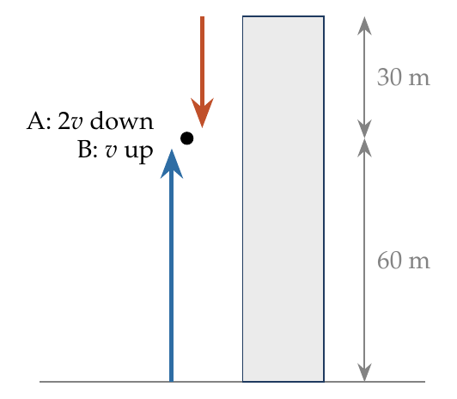
Let B’s launch speed be $u$ and the meeting time $t$: $v_{A}=gt$, $v_{B}=u−gt$, and $v_{A}=2v_{B}$ gives $u=\frac{3}{2}gt$.
Meeting: $\frac{1}{2}gt^{2}+\left(ut−\frac{1}{2}gt^{2}\right)=90 ⇒ ut=90 ⇒ \frac{3}{2}gt^{2}=90 ⇒ t^{2}=6$.
A’s fall: $\frac{1}{2}gt^{2}=30$ m, so the collision is at $90−30=60$ m.

Answer
(B) 60 m.

Watch out
• The answer is the height from the ground (60 m), not A’s fall (30 m, option A).
• This assumes B is still rising at the collision (it is: B has 12 m/s left).
Notes: Sec. 10.2 (two bodies under gravity); Sec. 3.1 (average velocity = mean of u and v for constant a).

Q56 · Two stones reaching the bottom together [L2] [JEE Main 2021, 25 Feb, Shift 2]
ID 03MSL-0320-aa1e · Code 0320 · Worksheet 03MSL_v2 Q56

Problem
A stone is dropped from the top of a building. When it crosses a point 5 m below the top, another stone starts to fall from a point 25 m below the top. Both stones reach the bottom of building simultaneously. The height of the building is:
(A) 35 m (B) 25 m (C) 50 m (D) 45 m

Hint
When the second stone starts, the first is 20 m above it and 10 m/s faster. With equal accelerations, how long does it take to close that gap?

Think it through
- After falling 5 m, the first stone moves at 10 m/s. The second starts from rest 20 m lower.
- Both accelerate equally, so the first stays 10 m/s faster and closes the 20 m gap in 2 s. They reach the bottom together, so that is the moment of meeting.
- In 2 s from rest the second stone falls 20 m. So the bottom is 25 + 20 = 45 m below the top. (D)

Worked solution
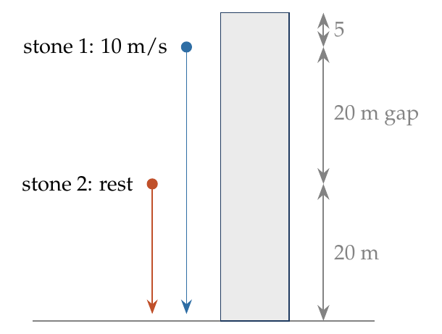
Speed of stone 1 after 5 m: $v=\sqrt{2\left(10\right)\left(5\right)}=10$ m/s. Let both take time $t$ more to reach the bottom:
$$5+10t+5t^{2}=25+5t^{2} ⇒ t=2 s.$$
$$H=25+1/2\left(10\right){\left(2\right)}^{2}=45 m.$$

Answer
(D) 45 m.

Watch out
• The second stone starts from rest; only the first stone has 10 m/s at that instant.
Notes: Sec. 10.2 (two bodies under gravity: relative motion is uniform).

Variable Acceleration (Calculus)

Q57 · Acceleration from a quadratic x(t)
ID 03MSL-0325-7c6a · Code 0325 · Worksheet 03MSL_v2 Q57

Problem
The displacement $x$ of a particle along a straight line at time $t$ is given by $x=a_{0}+a_{1}t+a_{2}t^{2}$. The acceleration of the particle is
(A) $a_{0}$ (B) $a_{1}$ (C) $2a_{2}$ (D) $a_{2}$

Hint
Compare with x = x₀ + ut + ½at². Which coefficient is “½a”?

Think it through
- Position quadratic in time means constant acceleration: the motion is ordinary SUVAT motion.
- Matching with x₀ + ut + ½at²: a₀ is the starting position, a₁ the initial velocity, and a₂ is half the acceleration.
- So the acceleration is 2a₂. (C)

Another way: differentiate
v = dx/dt = a₁ + 2a₂t, and a = dv/dt = 2a₂.

Worked solution
$$v=\frac{dx}{dt}=a_{1}+2a_{2}t, a=\frac{dv}{dt}=2a_{2}.$$

Answer
(C) $2a_{2}$.

Watch out
• a₂ is half the acceleration (option D is the trap): x = ut + ½at² has a ½ in front of a.
Notes: Sec. 5.1 (useful recognitions: x quadratic in t means uniform acceleration 2a₂).

Q58 · Displacement proportional to t³
ID 03MSL-0325-fca7 · Code 0325 · Worksheet 03MSL_v2 Q58

Problem
The displacement of a body is given to be proportional to the cube of time elapsed. The magnitude of the acceleration of the body is
(A) Increasing with time (B) Decreasing with time (C) Constant but not zero (D) Zero

Hint
Differentiate x ∝ t³ twice. What power of t is left?

Think it through
- Each differentiation lowers the power of t by one. From t³, velocity goes as t² and acceleration as t.
- Acceleration proportional to t grows steadily with time. (A)
- Contrast: constant acceleration would need x ∝ t² (option C belongs to that case).

Worked solution
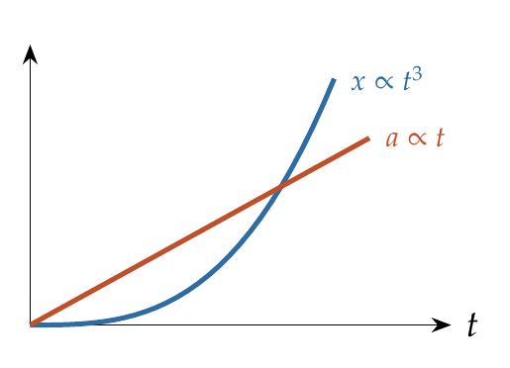
$x=kt^{3}⇒v=3kt^{2}⇒a=6kt$, which increases linearly with time.

Answer
(A) Increasing with time.

Watch out
• x ∝ t³ is not uniformly accelerated motion; don’t use SUVAT for it.
Notes: Sec. 5.1 (useful recognitions: x ∝ t³ gives a ∝ t).

Q59 · Velocity when a = αt
ID 03MSL-0325-7b0c · Code 0325 · Worksheet 03MSL_v2 Q59

Problem
The initial velocity of a particle is $u$ (at $t=0$) and the acceleration $a$ is given by $αt$. Which of the following relation is valid
(A) $v=u+αt^{2}$ (B) $v=u+\frac{1}{2}αt^{2}$ (C) $v=αt^{2}$ (D) $v=u$

Hint
The acceleration changes with time, so v = u + at does not apply. The change in velocity is the area under the a–t graph.

Think it through
- Acceleration grows with time, so the “v = u + at” shortcut is out: it assumes constant a.
- Change in velocity = area under the a–t graph. Here the graph is a straight line from 0 to αt: a triangle of area ½ × t × αt = ½αt².
- So v = u + ½αt². (B)
- Option (A) is what you get by wrongly putting a = αt into v = u + at.

Worked solution
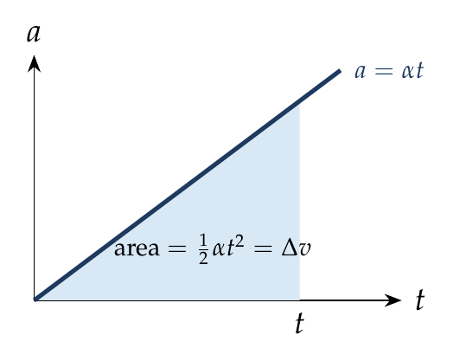
$$\frac{dv}{dt}=αt ⇒ \int_{u}^{v}{d}v=\int_{0}^{t}{α}t dt ⇒ v=u+\frac{1}{2}αt^{2}.$$

Answer
(B) $v=u+\frac{1}{2}αt^{2}$.

Watch out
• Putting a = αt into v = u + at gives option (A): wrong, because a is not constant.
Notes: Sec. 5.1 (a of t given: integrate; Common traps: a = αt gives u + ½αt²).

Q60 · Electron with v = kt
ID 03MSL-0325-aa6b · Code 0325 · Worksheet 03MSL_v2 Q60

Problem
An electron starting from rest has a velocity that increases linearly with the time that is $v=kt$ where $k=2$ m/s². The distance travelled in the first 3 seconds will be
(A) 9 m (B) 16 m (C) 27 m (D) 36 m

Hint
Velocity linear in time means constant acceleration k. Find the area under the v–t line.

Think it through
- v = kt is a straight line through the origin: uniform acceleration of 2 m/s² from rest.
- At 3 s the speed is 6 m/s. The distance is the triangle under the line: ½ × 3 × 6 = 9 m. (A)
- Check: the average speed over the 3 s is half the final speed, 3 m/s, and 3 m/s × 3 s = 9 m.

Another way: SUVAT
From rest with a = 2 m/s²: s = ½ × 2 × 3² = 9 m.

Worked solution
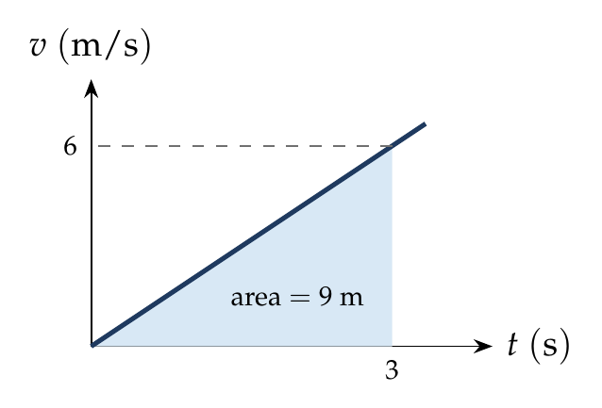
$$s=\int_{0}^{3}{2}t dt={\left[t^{2}\right]}_{0}^{3}=9 m.$$

Answer
(A) 9 m.

Watch out
• Don’t multiply the final speed by the time (6 × 3 = 18 m): the speed is not 6 m/s throughout.
Notes: Sec. 5.1 (v of t given: integrate for x); Sec. 3.2A (starting from rest).

Q61 · Distance between 1 s and 2 s for v = At + Bt²
ID 03MSL-0325-b982 · Code 0325 · Worksheet 03MSL_v2 Q61

Problem
If the velocity of a particle is $v=At+Bt^{2}$, where A and B are positive constants, then the distance travelled by it between 1 s and 2 s is
(A) $\frac{3}{2}A+4B$ (B) $3A+7B$ (C) $\frac{3}{2}A+\frac{7}{3}B$ (D) $\frac{A}{2}+\frac{B}{3}$

Hint
Is v ever negative between 1 s and 2 s? If not, distance is just the integral of v over that interval.

Think it through
- A, B and t are all positive, so v stays positive: no reversal, and distance equals displacement.
- Distance = area under v from 1 to 2. The At part gives A(4 − 1)/2 = 3A/2; the Bt² part gives B(8 − 1)/3 = 7B/3. (C)
- Sense check: (A) and (B) have no division by the powers, the sign of forgetting to integrate properly.

Worked solution
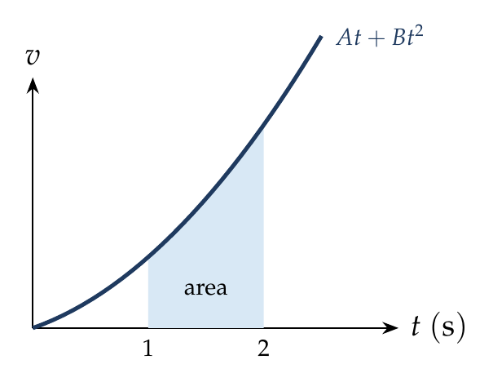
$$s=\int_{1}^{2}{\left(At+Bt^{2}\right)} dt={\left[\frac{At^{2}}{2}+\frac{Bt^{3}}{3}\right]}_{1}^{2}=\frac{3}{2}A+\frac{7}{3}B.$$

Answer
(C) $\frac{3}{2}A+\frac{7}{3}B$.

Watch out
• Check that v doesn’t change sign in the interval before equating distance with ∫v dt.
Notes: Sec. 5.1 (v of t given: distance = integral of |v|, split at the roots of v = 0).

Q62 · When do the two cars have equal velocity?
ID 03MSL-0325-3d66 · Code 0325 · Worksheet 03MSL_v2 Q62

Problem
Two cars P and Q start from a point at the same time in a straight line and their positions are represented by $x_{P}=at+bt^{2}$ and $x_{Q}=ft−t^{2}$. At what time do the cars have the same velocity?
(A) $\frac{a+f}{2\left(1+b\right)}$ (B) $\frac{f−a}{2\left(1+b\right)}$ (C) $\frac{a−f}{1+b}$ (D) $\frac{a+f}{2\left(b−1\right)}$

Hint
Differentiate each position to get each velocity, then set them equal.

Think it through
- Velocity is the slope of each position formula: v_P = a + 2bt and v_Q = f − 2t.
- P starts at a and speeds up; Q starts at f and slows down. If f > a they cross once.
- Equal when a + 2bt = f − 2t, i.e. t = (f − a)/2(1 + b). (B)

Worked solution
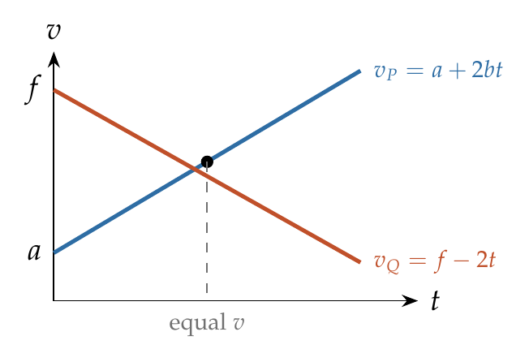
$$v_{P}=a+2bt, v_{Q}=f−2t.$$
$$a+2bt=f−2t ⇒ t=\frac{f−a}{2\left(1+b\right)}.$$

Answer
(B) $\frac{f−a}{2\left(1+b\right)}$.

Watch out
• Equal velocities is not the same as equal positions (meeting); don’t set x_P = x_Q.
Notes: Sec. 5.1 (x of t given: differentiate).

Q63 · Velocity when the acceleration falls to zero [AIPMT 2007]
ID 03MSL-0325-ed1c · Code 0325 · Worksheet 03MSL_v2 Q63

Problem
A particle moving along x-axis has acceleration f, at time t, given by $f=f_{0}\left(1−\frac{t}{T}\right)$, where $f_{0}$ and T are constants. The particle at t = 0 has zero velocity. At the instant when f = 0, the particle’s velocity is?
(A) ½$f_{0}T$ (B) $f_{0}T$ (C) $\frac{1}{2}f_{0}T^{2}$ (D) $f_{0}T^{2}$

Hint
Sketch f against t: a straight line from f₀ down to zero. The velocity gained is the area under it.

Think it through
- f becomes zero at t = T.
- Starting from rest, the velocity at T equals the area under the f–t graph from 0 to T.
- That graph is a triangle with height f₀ and base T: area ½f₀T. (A)
- Units check: (C) and (D) have units of distance, not velocity.

Worked solution
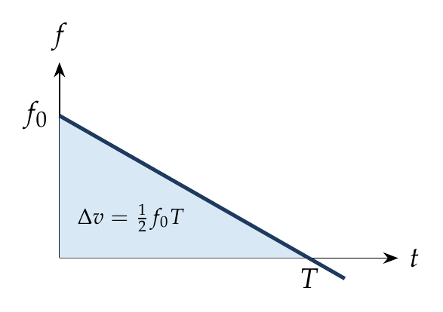
$f=0$ at $t=T$.
$$v=\int_{0}^{T}{f_{0}}\left(1−\frac{t}{T}\right)dt=f_{0}{\left[t−\frac{t^{2}}{2T}\right]}_{0}^{T}=\frac{1}{2}f_{0}T.$$

Answer
(A) ½$f_{0}T$.

Watch out
• v = f₀T (option B) wrongly assumes the acceleration stays f₀ throughout.
Notes: Sec. 5.1 (a of t given: v = u plus the integral of a); Sec. 6 (area under the a–t graph).

Q64 · When is the acceleration zero?
ID 03MSL-0325-de2f · Code 0325 · Worksheet 03MSL_v2 Q64

Problem
The position $x$ of a particle varies with time $t$ as $x=at^{2}−bt^{3}$. The acceleration of the particle will be zero at time $t$ equal to
(A) $\frac{a}{b}$ (B) $\frac{2a}{3b}$ (C) $\frac{a}{3b}$ (D) Zero

Hint
Differentiate twice and set the result to zero.

Think it through
- v = 2at − 3bt², and a(t) = 2a − 6bt.
- Acceleration starts positive (2a) and falls linearly; it is zero when 6bt = 2a, i.e. t = a/3b. (C)
- Option (B), 2a/3b, is where the velocity is zero, not the acceleration.

Worked solution
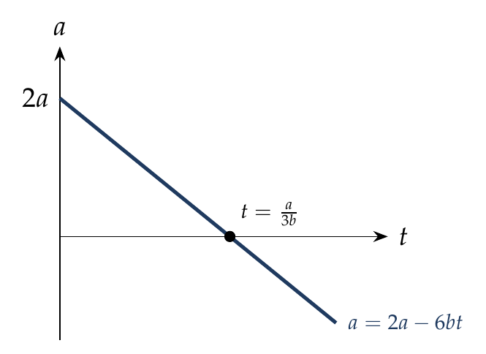
$$v=\frac{dx}{dt}=2at−3bt^{2}, \frac{dv}{dt}=2a−6bt=0 ⇒ t=\frac{a}{3b}.$$

Answer
(C) $\frac{a}{3b}$.

Watch out
• Setting v = 0 gives t = 2a/3b (option B): that’s when the particle turns round, not when a = 0.
Notes: Sec. 5.1 (useful recognitions: a = 0 where v is extremum).

Q65 · Retardation when t = αx² + βx
ID 03MSL-0325-59d4 · Code 0325 · Worksheet 03MSL_v2 Q65

Problem
The relation between time and position is $t=αx^{2}+βx$, where α and β are constants. The retardation is
(A) $2αv^{3}$ (B) $2βv^{3}$ (C) $2αβv^{3}$ (D) $αv^{3}$

Hint
Here t is given as a function of x. dt/dx is 1/v. Differentiate that with respect to time.

Think it through
- dt/dx = 2αx + β, and this equals 1/v.
- Differentiate 1/v = 2αx + β with respect to time: the left side gives −a/v², the right side gives 2α × dx/dt = 2αv.
- So a = −2αv³: a retardation of magnitude 2αv³. (A)
- β disappears because it is a constant term in 1/v; that rules out (B) and (C).

Worked solution
$$\frac{dt}{dx}=2αx+β=\frac{1}{v}.$$
Differentiating with respect to $t$:
$$−\frac{1}{v^{2}}\frac{dv}{dt}=2α\frac{dx}{dt}=2αv ⇒ a=−2αv^{3}.$$
Retardation $=2αv^{3}$.

Answer
(A) $2αv^{3}$.

Watch out
• Don’t differentiate 1/v with respect to x and stop there: the chain rule must bring in dx/dt = v.
Notes: Sec. 5.1 (t of x given: v is 1 over dt/dx; a = −v³ times d²t/dx²).

Q66 · Acceleration when v = βx^(−2n)
ID 03MSL-0325-f5b5 · Code 0325 · Worksheet 03MSL_v2 Q66

Problem
A particle of unit mass undergoes one-dimensional motion such that its velocity varies according to $v\left(x\right)=βx^{−2n}$ where β and n are constants and x is the position of the particle. The acceleration of the particle as a function of x, is given by?
(A) $−2nβ^{2}x^{−4n−1}$ (B) $−2β^{2}x^{−2n+1}$ (C) $−2nβ^{2}x^{−4n+1}$ (D) $−2nβ^{2}x^{−2n−1}$

Hint
Velocity is given as a function of position. Use a = v dv/dx.

Think it through
- With v given as a function of x, the acceleration is v × dv/dx.
- dv/dx = −2nβx^(−2n−1). Multiplying by v = βx^(−2n) adds the powers: −2nβ²x^(−4n−1). (A)
- Quick check: a must contain β² (one β from v, one from dv/dx). (D) has β² but the wrong power, because it forgets the extra factor x^(−2n) from v.

Worked solution
$$a=v\frac{dv}{dx}=\left(βx^{−2n}\right)\left(−2nβx^{−2n−1}\right)=−2nβ^{2}x^{−4n−1}.$$

Answer
(A) $−2nβ^{2}x^{−4n−1}$.

Watch out
• a is v dv/dx, not dv/dx alone (option D is close to dv/dx with β² attached).
Notes: Sec. 5.1 (v of x given: a = v dv/dx).

Q67 · Acceleration when x = (t + 5)⁻¹
ID 03MSL-0325-504a · Code 0325 · Worksheet 03MSL_v2 Q67

Problem
A particle moves a distance x in time t according to equation $x={\left(t+5\right)}^{−1}$. The acceleration of particle is proportional to:
(A) ${\left(velocity\right)}^{2/3}$ (B) ${\left(velocity\right)}^{3/2}$ (C) ${\left(distance\right)}^{2}$ (D) ${\left(distance\right)}^{−2}$

Hint
Write v and a in powers of (t + 5), then express a through the power of v.

Think it through
- Let s = t + 5. Then x = s⁻¹, v = −s⁻², a = 2s⁻³.
- v has power −2, a has power −3. So a goes as (s⁻²)^(3/2), that is |v|^(3/2). (B)
- In terms of distance, a = 2x³, which matches neither (C) nor (D).

Worked solution
$$v=\frac{dx}{dt}=−{\left(t+5\right)}^{−2}, a=\frac{dv}{dt}=2{\left(t+5\right)}^{−3}.$$
Since $\left|v\right|={\left(t+5\right)}^{−2}$, ${\left(t+5\right)}^{−3}={\left|v\right|}^{3/2}$:
$$a=2{\left|v\right|}^{3/2} ∝ v^{3/2}.$$

Answer
(B) ${\left(velocity\right)}^{3/2}$.

Watch out
• Match the powers carefully: a ∝ s⁻³ and v ∝ s⁻², so the exponent is 3/2, not 2/3.
Notes: Sec. 5.1 (x of t given: differentiate).

Q68 · When is the particle retarding?
ID 03MSL-0325-f0dd · Code 0325 · Worksheet 03MSL_v2 Q68

Problem
A particle starts moving rectilinearly at time t = 0 such that its velocity ‘v’ changes with time ‘t’ according to the equation $v=t^{2}−t$ where t is in seconds and v is in m/s. The time interval for which the particle retards is
(A) t < 1/2 (B) 1/2 < t < 1 (C) t > 1 (D) t < 1/2 and t > 1

Hint
Retarding means slowing down: v and a have opposite signs. Find where each changes sign.

Think it through
- A body slows down when its acceleration opposes its velocity, so look at the signs of both.
- v = t(t − 1) is negative for 0 < t < 1 and positive after 1 s. a = 2t − 1 is negative before ½ s and positive after.
- Before ½ s, both are negative: the particle speeds up in the negative direction. Between ½ and 1 s, v < 0 and a > 0: it slows down. After 1 s, both positive: speeding up.
- So it retards only for ½ < t < 1. (B)

Worked solution
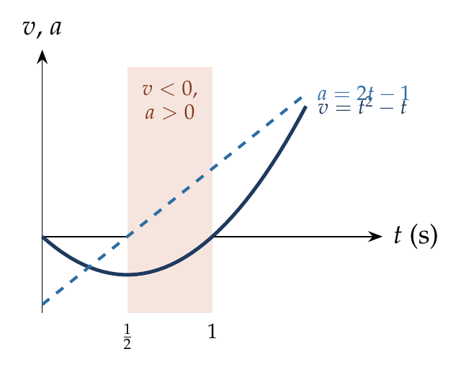
$v=t^{2}−t=t\left(t−1\right)$, $a=\frac{dv}{dt}=2t−1$.
- $0<t<1/2$: $v<0$, $a<0$, speeding up.
- $1/2<t<1$: $v<0$, $a>0$, retarding.
- $t>1$: $v>0$, $a>0$, speeding up.

Answer
(B) 1/2 < t < 1.

Watch out
• Retardation is not “a < 0” (option A): it is a opposite to v.
Notes: Sec. 5.1 (Common traps: retarding interval is where v and a have opposite signs).

Q69 · Average speed for v = ½kt²
ID 03MSL-0325-7daf · Code 0325 · Worksheet 03MSL_v2 Q69

Problem
A particle moves with a velocity of $v\left(t\right)=\frac{1}{2}kt^{2}$ along a straight line. Find its average speed in time T.
(A) $\frac{1}{2}kT^{2}$ (B) $\frac{1}{3}kT^{2}$ (C) $\frac{3}{4}kT^{2}$ (D) $\frac{1}{6}kT^{2}$

Hint
Average speed is total distance ÷ total time. Distance is the area under v from 0 to T.

Think it through
- v is never negative, so distance = area under ½kt² from 0 to T = kT³/6.
- Dividing by T gives kT²/6. (D)
- Sense check: the average of t² over 0 to T is T²/3 (not T²/2, because the curve is low for most of the time). Then ½k × T²/3 = kT²/6.

Worked solution
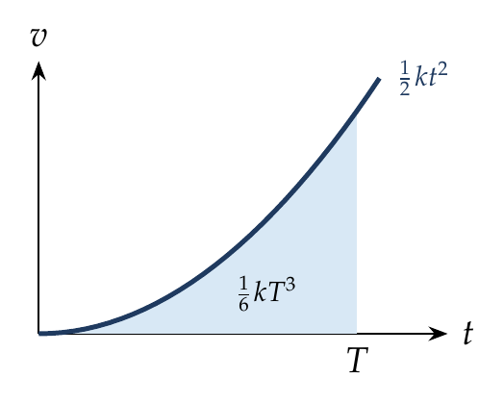
$$s=\int_{0}^{T}{\frac{1}{2}}kt^{2} dt=\frac{kT^{3}}{6}, \overset{‾}{v}=\frac{s}{T}=\frac{kT^{2}}{6}.$$

Answer
(D) $\frac{1}{6}kT^{2}$.

Watch out
• Averaging the first and last speeds (½ × ½kT² = ¼kT²) works only for constant acceleration; here a is not constant.
Notes: Sec. 5.1 (time-average of v = Δx over Δt).

Q70 · Average velocity and average speed with a turn
ID 03MSL-0325-73ec · Code 0325 · Worksheet 03MSL_v2 Q70

Problem
A particle moves along x-axis according to given position function $x\left(t\right)=10+t^{2}−10t$.
(i) The average velocity of particle in time interval from t = 0 to t = 10 seconds, is?
(ii) The average speed of particle in time interval from t = 0 to t = 10 seconds is?

Hint
Check positions at 0 and 10 s first. Then find where v = 0 inside the interval: the particle turns there.

Think it through
- x(0) = 10 m and x(10) = 10 m: the particle ends where it began. Average velocity = 0.
- v = 2t − 10 is zero at 5 s. The particle goes from 10 m back to −15 m (25 m), then returns to 10 m (another 25 m).
- Distance 50 m in 10 s: average speed 5 m/s.
- Note that this is uniformly accelerated (x quadratic in t), so the motion is symmetric about the turning time.

Worked solution
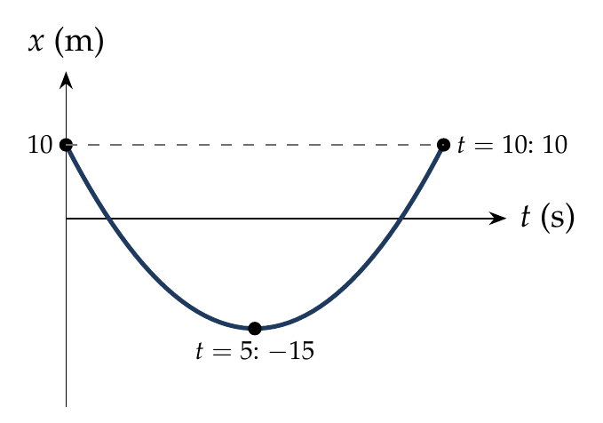
$v=\frac{dx}{dt}=2t−10$, zero at $t=5$ s.
$x\left(0\right)=10$ m, $x\left(5\right)=−15$ m, $x\left(10\right)=10$ m.
(i) $\overset{‾}{v}=\frac{x\left(10\right)−x\left(0\right)}{10}=0$.
(ii) Distance $=\left|−15−10\right|+\left|10−\left(−15\right)\right|=50$ m, so average speed $=50/10=5$ m/s.

Answer
(i) 0; (ii) 5 m/s.

Watch out
• Average speed is not |average velocity| when the particle reverses: split the interval at v = 0.
Notes: Sec. 5.1 (distance: split at the roots of v = 0); Sec. 2.2 (average speed).

Q71 · Distance in the first 6 s
ID 03MSL-0325-919b · Code 0325 · Worksheet 03MSL_v2 Q71

Problem
The position of a particle is given as $y\left(m\right)=−\frac{2}{3}t^{2}+4t+2$. Find the distance travelled in first 6 sec of its motion?
(A) zero (B) 4 m (C) 6 m (D) 12 m

Hint
Where does the particle turn round? Compare the positions at 0 s, at the turn, and at 6 s.

Think it through
- v = 4 − (4/3)t is zero at t = 3 s, inside the interval, so the particle turns round.
- Positions: 2 m at 0 s, 8 m at 3 s, 2 m at 6 s.
- It goes up 6 m and comes back 6 m: distance 12 m, although the displacement is zero. (D)
- Option (A) is the displacement, the trap.

Worked solution
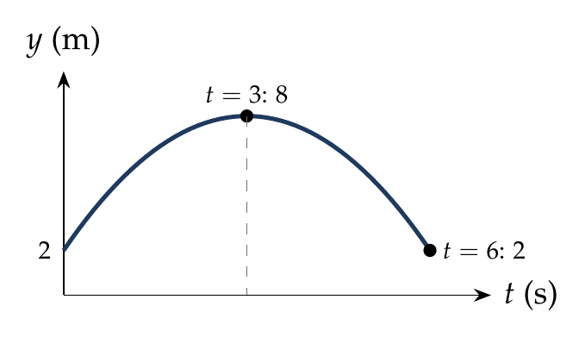
$v=\frac{dy}{dt}=4−\frac{4}{3}t=0$ at $t=3$ s.
$y\left(0\right)=2$ m, $y\left(3\right)=−6+12+2=8$ m, $y\left(6\right)=−24+24+2=2$ m.
$$d=\left|8−2\right|+\left|2−8\right|=12 m.$$

Answer
(D) 12 m.

Watch out
• y(6) − y(0) = 0 is the displacement (option A), not the distance.
Notes: Sec. 5.1 (distance: split at the roots of v = 0); Sec. 3.2C (reversal).

Q72 · Mean velocity when v = α√x
ID 03MSL-0325-c8e5 · Code 0325 · Worksheet 03MSL_v2 Q72

Problem
The velocity of a particle moving in the positive direction of x axis varies as $v=α\sqrt{x}$, where α is a positive constant. Assuming that at moment t = 0, the particle was located at the point x = 0. Find the mean velocity of the particle averaged over the time that particle takes to cover first ‘$S$’ meters of the path.
(A) $2αS$ (B) $α^{2}S$ (C) $\frac{1}{2}α^{2}S$ (D) $\frac{1}{2}α\sqrt{S}$

Hint
Square the velocity: v² = α²x. What kind of motion has v² growing linearly with distance?

Think it through
- v² = α²x is linear in x, exactly like v² = 2ax from rest. So the motion is uniformly accelerated from rest, with a = α²/2.
- For uniform acceleration from rest, the mean velocity is half the final velocity.
- Final velocity after S is α√S, so the mean is ½α√S. (D)
- Units check: α has units m^½/s, so α√S is a velocity; (B) and (C) are not.

Worked solution
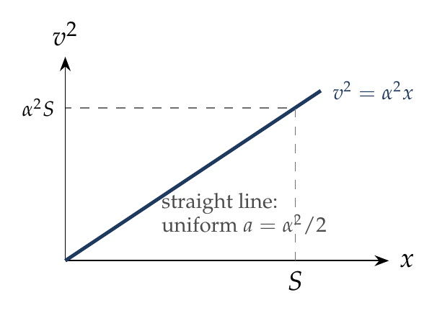
$v=α\sqrt{x}$ gives $a=v\frac{dv}{dx}=α\sqrt{x}⋅\frac{α}{2\sqrt{x}}=\frac{α^{2}}{2}$ (constant). Starting from rest:
$$t=\frac{v}{a}=\frac{α\sqrt{S}}{α^{2}/2}=\frac{2\sqrt{S}}{α}, \overset{‾}{v}=\frac{S}{t}=\frac{α\sqrt{S}}{2}.$$

Answer
(D) $\frac{1}{2}α\sqrt{S}$.

Watch out
• The mean over time is v/2 only because the acceleration turns out constant; check that before using it.
Notes: Sec. 5.1 (useful recognitions: v² linear in x means uniform acceleration).

Q73 · Average velocity with linearly falling acceleration
ID 03MSL-0325-39eb · Code 0325 · Worksheet 03MSL_v2 Q73

Problem
A particle starts from rest and moves along the x-axis with acceleration ‘a’ at time ‘t’ given by $a=a_{0}\left(1−\frac{t}{T}\right)$. Find average velocity during the time interval $t=0$ to $t=T$?
(A) $\frac{1}{3}a_{0}T$ (B) $\frac{1}{2}a_{0}T$ (C) $a_{0}T$ (D) $2a_{0}T$

Hint
Integrate a to get v(t), then integrate again for the displacement over 0 to T, and divide by T.

Think it through
- The acceleration is not constant, so average velocity must come from displacement ÷ time.
- v(t) = a₀(t − t²/2T), reaching ½a₀T at t = T.
- Displacement = area under v(t) = a₀(T²/2 − T²/6) = a₀T²/3. Average velocity = a₀T/3. (A)
- Sense check: the v–t curve is concave (rises quickly, then levels off), so the average lies above the simple ¼a₀T of a straight line through the origin to ½a₀T; ⅓a₀T fits.

Worked solution
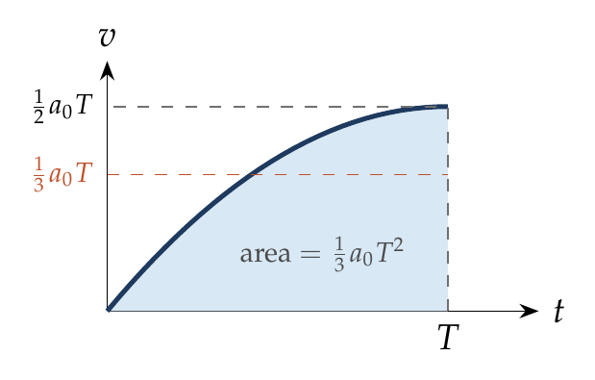
$$v=\int_{0}^{t}{a_{0}}\left(1−\frac{t}{T}\right)dt=a_{0}\left(t−\frac{t^{2}}{2T}\right).$$
$$Δx=\int_{0}^{T}{a_{0}}\left(t−\frac{t^{2}}{2T}\right)dt=a_{0}\left(\frac{T^{2}}{2}−\frac{T^{2}}{6}\right)=\frac{a_{0}T^{2}}{3}, \overset{‾}{v}=\frac{Δx}{T}=\frac{a_{0}T}{3}.$$

Answer
(A) $\frac{1}{3}a_{0}T$.

Watch out
• ½a₀T (option B) is the final velocity, not the average.
Notes: Sec. 5.1 (a of t given: integrate twice); Sec. 5.1 (time-average of v).

Q74 · Stopping distance when a = −k√v
ID 03MSL-0325-7b0d · Code 0325 · Worksheet 03MSL_v2 Q74

Problem
A particle initially moving with velocity u is subjected to a retarding force which decelerates it as $a=−k\sqrt{v}$. Find the distance travelled by the particle before it comes to rest?
(A) $\frac{1}{3k}u^{3/2}$ (B) $\frac{2}{3k}u^{3/2}$ (C) $\frac{1}{2}ku^{3/2}$ (D) $ku^{3/2}$

Hint
Distance and velocity, no time: write the acceleration as v dv/dx and separate the variables.

Think it through
- Acceleration depends on v, and the question links v with distance. So use a = v dv/dx.
- v dv/dx = −k√v gives √v dv = −k dx.
- Integrating √v from u down to 0 gives ⅔u^(3/2), which equals k times the distance. So the distance is 2u^(3/2)/3k. (B)
- Units check: k has units m^½ s^(−3/2), and u^(3/2)/k comes out in metres. Option (C) and (D) have k in the numerator and fail this check.

Worked solution
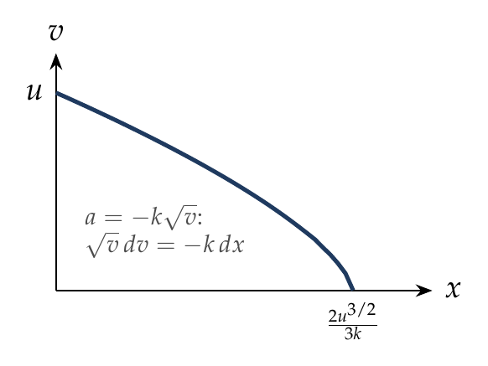
$$v\frac{dv}{dx}=−k\sqrt{v} ⇒ \sqrt{v} dv=−k dx.$$
$$\int_{u}^{0}{v^{1/2}} dv=−k\int_{0}^{s}{d}x ⇒ −\frac{2}{3}u^{3/2}=−ks ⇒ s=\frac{2u^{3/2}}{3k}.$$

Answer
(B) $\frac{2}{3k}u^{3/2}$.

Watch out
• Use a = v dv/dx (for distance), not a = dv/dt (which gives the stopping time, 2√u/k).
Notes: Sec. 5.1 (a of v given: for distance dx = v dv over a of v; example c).

Q75 · Acceleration falling linearly to zero in 6 s [L2]
ID 03MSL-0325-9fbd · Code 0325 · Worksheet 03MSL_v2 Q75

Problem
A particle starts from rest at x = 0. Its acceleration is 5 m/s² which decreases linearly with time to zero in 6 seconds. Find (i) the maximum speed of the particle and (ii) its displacement in time interval t = 0 to t = 2 sec.

Hint
The speed keeps rising as long as the acceleration is positive. When does it stop rising? The gain is the area under the a–t graph up to then.

Think it through
- a = 5 − (5/6)t, positive until 6 s. So the speed grows all the way to 6 s: that is the maximum.
- Velocity gained = area of the a–t triangle: ½ × 6 × 5 = 15 m/s.
- For (ii), integrate twice: v = 5t − (5/12)t², and x = (5/2)t² − (5/36)t³. At 2 s: 10 − 10/9 = 80/9 ≈ 8.9 m.
- Sense check: at a constant 5 m/s² it would cover 10 m in 2 s; the acceleration is falling, so a little less.

Worked solution
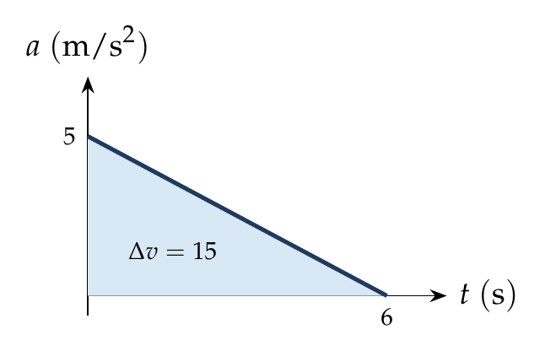
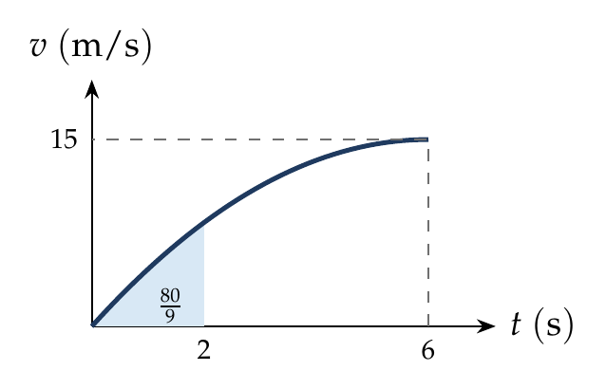
$$a=5−\frac{5}{6}t \left(0≤t≤6 s\right).$$
(i) $v=\int_{0}^{t}{a} dt=5t−\frac{5}{12}t^{2}$. Maximum when $a=0$, at $t=6$ s:
$$v_{max}=30−15=15 m/s.$$
(ii) $x=\int_{0}^{t}{v} dt=\frac{5}{2}t^{2}−\frac{5}{36}t^{3}$:
$$x\left(2\right)=10−\frac{10}{9}=\frac{80}{9} m≈8.9 m.$$

Answer
(i) 15 m/s; (ii) 80/9 m ≈ 8.9 m.

Watch out
• Maximum speed is where a = 0 (at 6 s), not where a is largest (at 0 s).
• Don’t use s = ½at² with a = 5: the acceleration is falling.
Notes: Sec. 5.1 (a of t given: integrate twice; a = 0 where v is extremum).

Motion Graphs: x–t & v–t

Q76 · Velocities from x–t slopes
ID 03MSL-0330-dd2e · Code 0330 · Worksheet 03MSL_v2 Q76

Problem
The displacement-time graph for two particles A and B are straight lines inclined at angles of 30° and 60° with the time axis. The ratio of velocities of $V_{A}:V_{B}$ is?
(A) 1 : 2 (B) 1 : √3 (C) √3 : 1 (D) 1 : 3

Hint
On an x–t graph, velocity is the slope. What is the slope of a line at 30°, and at 60°?

Think it through
- Straight x–t lines mean constant velocities, each equal to the slope of its line.
- Slope = tan of the angle with the time axis: tan 30° = 1/√3 and tan 60° = √3.
- Ratio = (1/√3) : √3 = 1 : 3. (D)
- Trap: the ratio of the angles (1 : 2, option A) means nothing; it’s the tangents that matter.

Worked solution
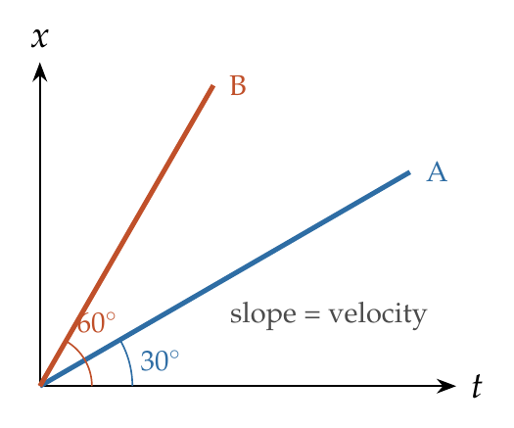
$$\frac{V_{A}}{V_{B}}=\frac{tan{30}^{∘}}{tan{60}^{∘}}=\frac{1/\sqrt{3}}{\sqrt{3}}=\frac{1}{3}.$$

Answer
(D) 1 : 3.

Watch out
• Velocity is tan θ, not θ; 30° : 60° is not 1 : 2 in velocity.
• Reading slopes as tan θ only works when both axes use the same scale; here the question intends that.
Notes: Sec. 6 (x–t graph: slope = velocity).

Q77 · Displacement and distance from a v–t graph
ID 03MSL-0330-ba0b · Code 0330 · Worksheet 03MSL_v2 Q77

Problem
The velocity-time graph of a body moving in a straight line is shown in the figure. The displacement and distance travelled by the body in 6 sec are respectively:
(A) 8 m, 16 m (B) 16 m, 8 m (C) 16 m, 16 m (D) 8 m, 8 m
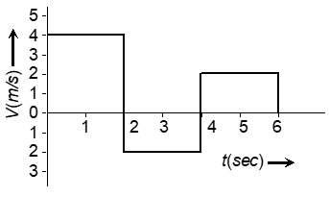

Hint
Area under a v–t graph is displacement. Areas below the time axis count as negative for displacement but positive for distance.

Think it through
- Three rectangles: 4 m/s for 2 s, −2 m/s for 2 s, +2 m/s for 2 s.
- Signed areas: +8, −4, +4. Displacement = 8 m.
- Distance adds the sizes: 8 + 4 + 4 = 16 m. (A)
- Check: distance is at least the displacement, and larger here because the body reverses for 2 s.

Worked solution
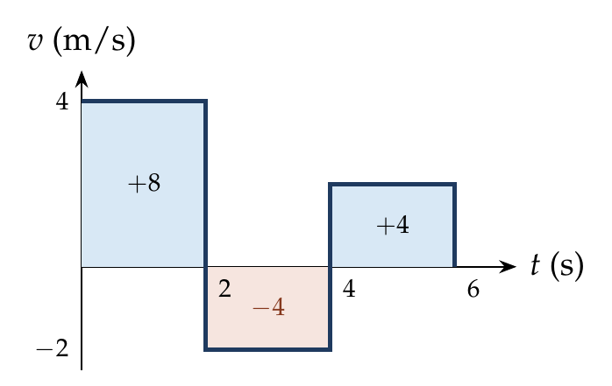
$$s=4\left(2\right)+\left(−2\right)\left(2\right)+2\left(2\right)=8 m, d=8+4+4=16 m.$$

Answer
(A) 8 m, 16 m.

Watch out
• Don’t add the area below the axis to the displacement: it is negative.
Notes: Sec. 6 (v–t graph: area = displacement; total unsigned area = distance).

Q78 · Maximum acceleration from a v–t graph
ID 03MSL-0330-a010 · Code 0330 · Worksheet 03MSL_v2 Q78

Problem
The $v$–$t$ graph of a moving object is given in figure. The maximum acceleration is?
(A) 1 cm/s² (B) 2 cm/s² (C) 3 cm/s² (D) 6 cm/s²
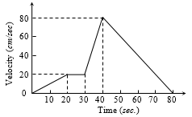

Hint
Acceleration is the slope of the v–t graph. Which segment is steepest?

Think it through
- Acceleration is the slope of each straight segment.
- 0–20 s: 20 cm/s in 20 s, slope 1. 20–30 s: flat, 0. 30–40 s: 60 cm/s in 10 s, slope 6. 40–80 s: −80 in 40 s, slope −2.
- Steepest rise: 6 cm/s². (D)

Worked solution
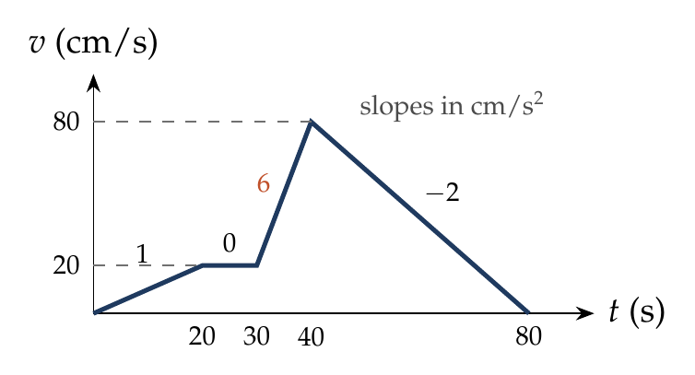
$$a_{30−40}=\frac{80−20}{40−30}=6 {cm/s}^{2},$$
the largest of the slopes 1, 0, 6 and −2 cm/s².

Answer
(D) 6 cm/s².

Watch out
• Read the steepness, not the height: the highest point (80 cm/s) is not where the acceleration is largest.
• Units are cm/s and s, so the answer is in cm/s².
Notes: Sec. 6 (v–t graph: slope = acceleration).

Q79 · Height reached by a lift
ID 03MSL-0330-6300 · Code 0330 · Worksheet 03MSL_v2 Q79

Problem
A lift is going up. The variation in the speed of the lift is as given in the graph. What is the height to which the lift takes the passengers:
(A) 3.6 m (B) 28.8 m (C) 36.0 m (D) Cannot be calculated from the above graph
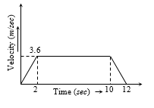

Hint
The height climbed is the area under the speed–time graph. What shape is it?

Think it through
- The lift moves only upward, so height = area under the graph.
- The graph is a trapezium: 0 to 3.6 m/s in 2 s, steady until 10 s, back to 0 at 12 s.
- Area = average of the parallel sides × height = ½(12 + 8) × 3.6 = 36 m. (C)
- Trap: 28.8 m (B) counts only the steady part; 3.6 m (A) is just the speed.

Worked solution
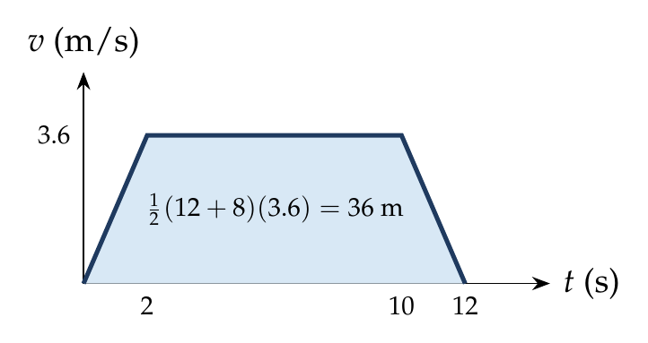
$$h=1/2\left(2\right)\left(3.6\right)+\left(8\right)\left(3.6\right)+1/2\left(2\right)\left(3.6\right)=3.6+28.8+3.6=36 m.$$

Answer
(C) 36.0 m.

Watch out
• Include the speeding-up and slowing-down triangles, not just the constant-speed rectangle.
Notes: Sec. 6 (v–t graph: area = displacement).

Q80 · Car and scooter: gap at 15 s and catching time [JEE Main]
ID 03MSL-0330-04ad · Code 0330 · Worksheet 03MSL_v2 Q80

Problem
The velocity-time graphs of a car and a scooter are shown in the figure. (i) The difference between the distance travelled by the car and the scooter in 15 s and (ii) the time at which the car will catch up with the scooter are, respectively?
(A) 112.5 m and 22.5 s (B) 337.5 m and 25 s (C) 112.5 m and 15 s (D) 225.5 m and 10 s
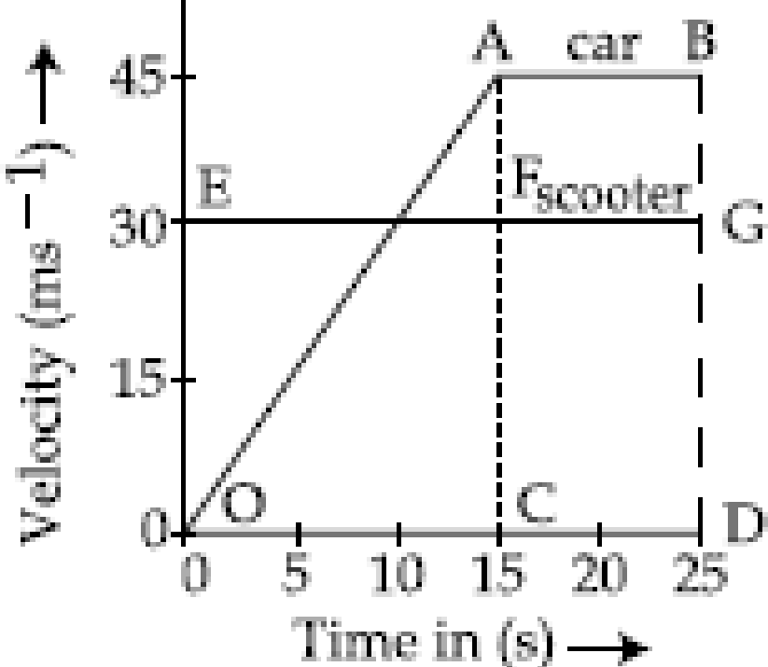

Hint
Compare areas under the two graphs. After 15 s the car is 15 m/s faster: how long to make up the deficit?

Think it through
- Both start together. In 15 s the scooter covers 30 × 15 = 450 m; the car’s triangle is ½ × 15 × 45 = 337.5 m. The car is 112.5 m behind.
- After 15 s the car moves at 45 m/s and the scooter at 30 m/s: the car gains 15 m every second.
- 112.5 ÷ 15 = 7.5 s more, so it catches up at 22.5 s. (A)
- Check with areas: up to 10 s the scooter pulls ahead by 150 m (pink triangle); from 10 to 15 s the car gains back 37.5 m; so 112.5 m remains at 15 s.

Worked solution
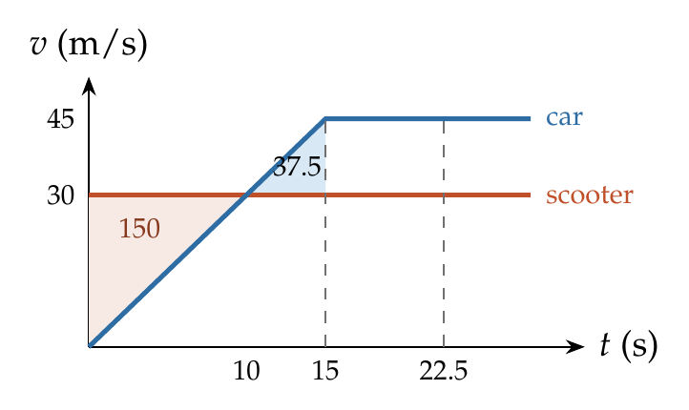
(i) At $t=15$ s: $s_{car}=\frac{1}{2}\left(15\right)\left(45\right)=337.5$ m, $s_{scooter}=30\left(15\right)=450$ m. Difference $=112.5$ m.
(ii) For $t>15$ s: $337.5+45\left(t−15\right)=30t ⇒ 15t=337.5 ⇒ t=22.5$ s.

Answer
(A) 112.5 m and 22.5 s.

Watch out
• Equal velocities at 10 s is when the gap is largest, not when the car catches up.
Notes: Sec. 6 (v–t graph: area = displacement); Sec. 3.4 (chasing, overtaking and meeting).

Motion Graphs: a–t, v–x, a–x & Conversion

Q81 · Velocity graph for a sine x–t curve
ID 03MSL-0335-5cd3 · Code 0335 · Worksheet 03MSL_v2 Q81

Problem
If position-time graph of a particle is a sine curve as shown, then which one will be the corresponding velocity-time graph:
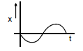
Option (A):
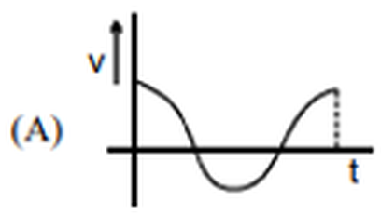
Option (B):
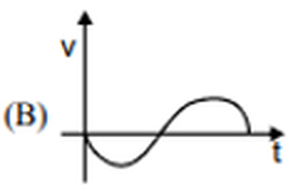
Option (C):
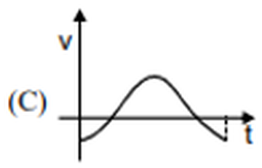
Option (D):
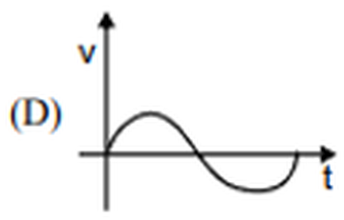

Hint
Velocity is the slope of the x–t curve. What is the slope at t = 0, and where is it zero?

Think it through
- Velocity is the slope of the x–t graph, so read slopes, not heights.
- At t = 0 the curve heads downward at its steepest: the velocity starts at its most negative value.
- At the lowest point of x the slope is zero, and after it the curve rises, so v becomes positive. At the top of x, v is zero again and then turns negative.
- So v starts at a negative maximum, rises through zero, peaks, and comes back: a negative cosine shape. (C)
- (B) and (D) start at v = 0, which would need a flat x–t curve at t = 0; (A) starts positive. All three are out.

Worked solution
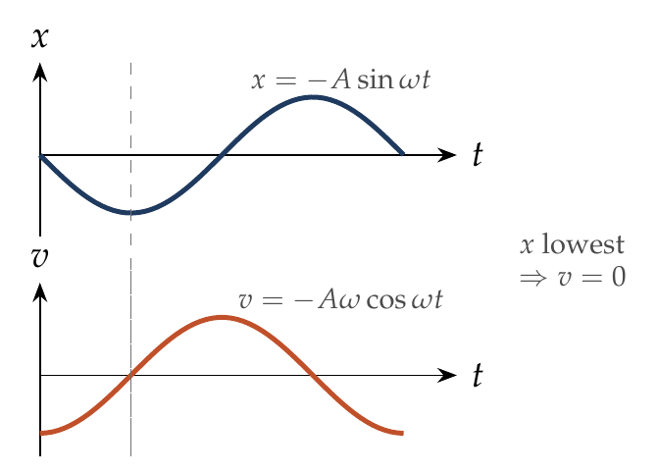
The curve is $x=−Asinωt$, so
$$v=\frac{dx}{dt}=−Aωcosωt,$$
which is $−Aω$ at $t=0$, zero when $x$ is lowest ($ωt=π/2$), and so on: graph (C).

Answer
(C).

Watch out
• Don’t copy the shape of the x–t graph: v is its slope, shifted by a quarter cycle.
Notes: Sec. 6.1 (reading shapes: v is the slope of x–t).

Q82 · Graphs for constant acceleration [JEE Main 2021, 18 Mar, Shift 1]
ID 03MSL-0335-1b8e · Code 0335 · Worksheet 03MSL_v2 Q82

Problem
The position, velocity and acceleration of a particle moving with a constant acceleration can be represented by:
Option (A):
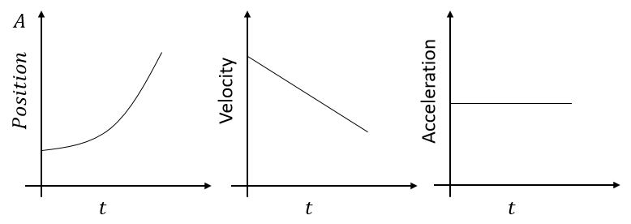
Option (B):
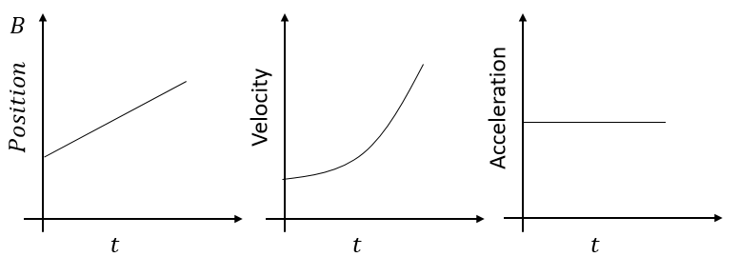
Option (C):
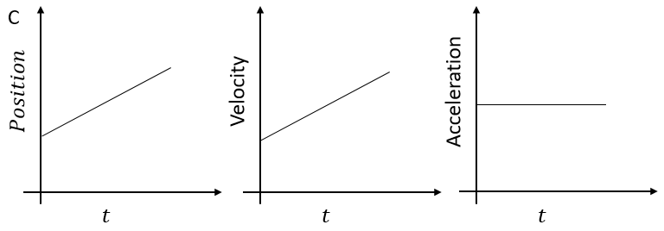
Option (D):
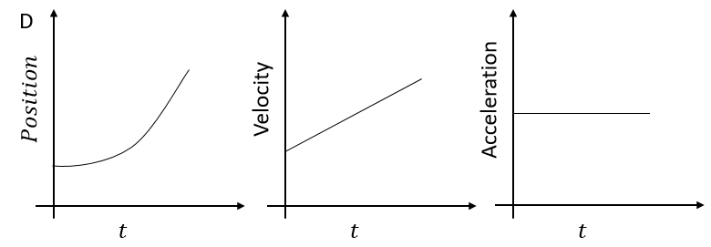

Hint
Constant acceleration means a horizontal a–t line, a straight v–t line, and a parabolic x–t curve. And the three must agree with each other.

Think it through
- Constant acceleration: the a–t graph is flat. All options have that, so look at the others.
- v changes at a constant rate, so the v–t graph must be a straight line. (B) has a curved v–t graph: out.
- x then changes at a steadily changing rate, so the x–t graph must be a parabola. (C) has a straight x–t line: out.
- The graphs must also be consistent. In (A) velocity decreases, but the x–t curve gets steeper (velocity increasing): out.
- (D): curved x–t getting steeper, straight rising v–t, positive constant a. All consistent. (D)

Worked solution
For constant $a$: $v=u+at$ (straight line, slope $a$), $x=x_{0}+ut+\frac{1}{2}at^{2}$ (parabola, getting steeper when $a>0$).
(A) slope of x–t increases but v–t falls: inconsistent. (B) v–t curved: a not constant. (C) x–t straight: v would be constant. (D) fits all three.

Answer
(D).

Watch out
• Each graph alone may look right; check that the slope of one matches the next.
Notes: Sec. 6.1 (reading shapes); Sec. 3.1 (equations of motion).

Q83 · Acceleration graph for a V-shaped v–t graph [JEE Main 2021, 24 Feb, Shift 1]
ID 03MSL-0335-fafd · Code 0335 · Worksheet 03MSL_v2 Q83

Problem
If the velocity–time graph has the shape AMB, what would be the shape of the corresponding acceleration–time graph?
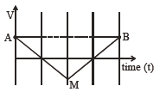
Option (A):
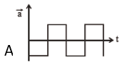
Option (B):
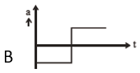
Option (C):
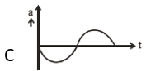
Option (D):
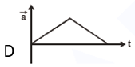

Hint
Acceleration is the slope of the v–t graph. What are the slopes of AM and MB?

Think it through
- AM is a straight line going down: constant negative slope, so a constant negative acceleration.
- MB is a straight line going up: constant positive acceleration.
- So a is a negative constant, then jumps to a positive constant at M, and stays there. (B)
- (A) keeps switching sign, (C) is smooth, and (D) is never negative: all out.

Worked solution
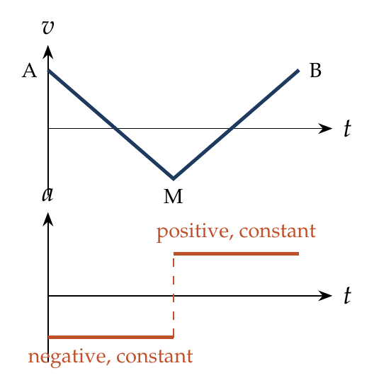
$$a_{AM}=slope of AM<0 \left(constant\right), a_{MB}=slope of MB>0 \left(constant\right).$$
The a–t graph is a step from a negative value to a positive value at the instant of M: graph (B).

Answer
(B).

Watch out
• The sign of a follows the slope of v, not the sign of v: velocity is negative near M but the acceleration there is positive on the MB side.
Notes: Sec. 6.1 (reading shapes: a is the slope of v–t).

Q84 · Which graph misrepresents the motion?
ID 03MSL-0335-9336 · Code 0335 · Worksheet 03MSL_v2 Q84

Problem
All the graphs below are intended to represent the same motion. One of them does it incorrectly. Pick it up:
Option (A):
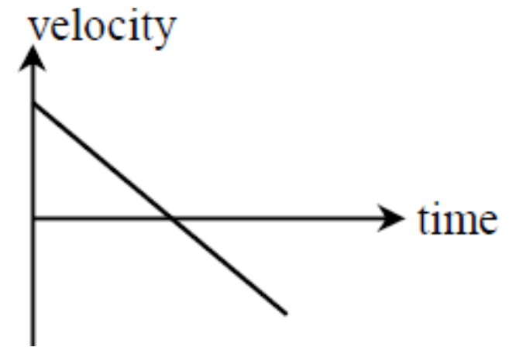
Option (B):
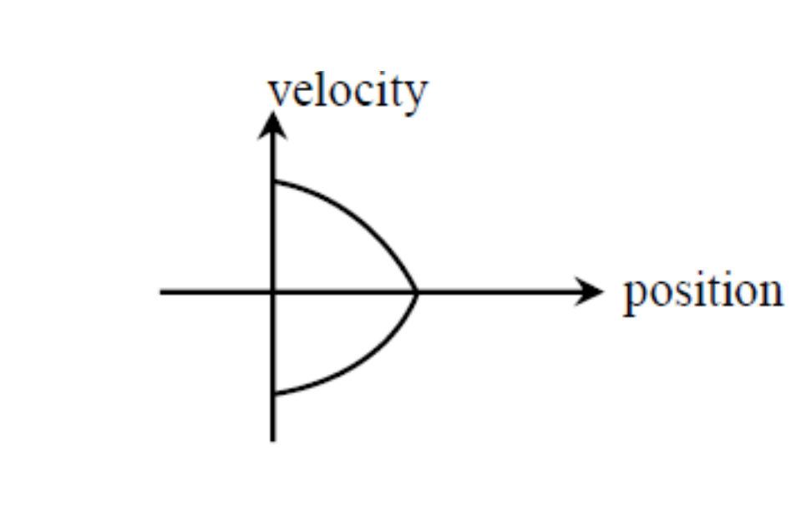
Option (C):
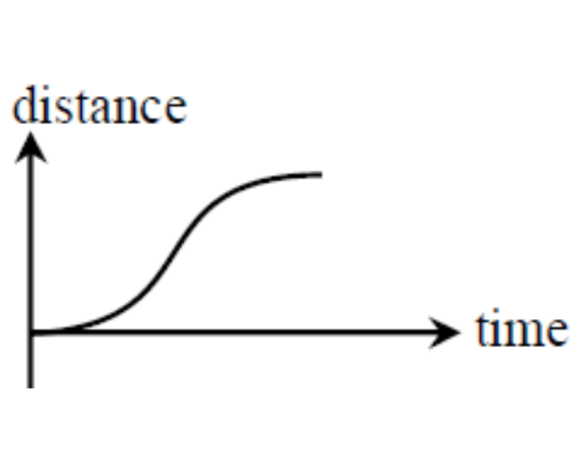
Option (D):
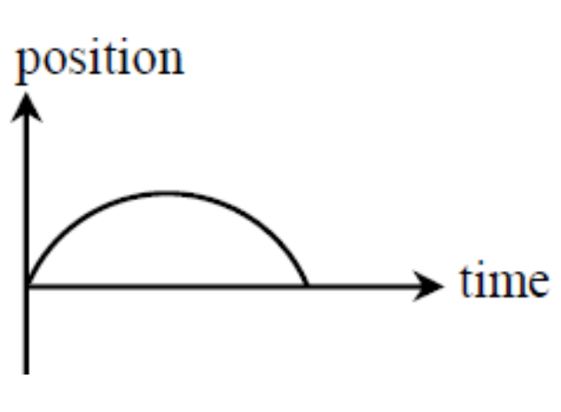

Hint
Three of the graphs describe a ball thrown straight up that comes back down. Name that motion from the clearest graph, then ask of each other graph: what should its slope be at the start, at the top, and at the end?

Think it through
- Graph (A): velocity starts positive, falls at a steady rate, passes through zero and becomes negative. That is constant downward acceleration: a body thrown up that stops at the top and comes back.
- Graph (D): position rises, flattens, and falls back to zero along a symmetric arch. That is the same throw: it returns to the starting point.
- Graph (B): velocity against position. Going up, v falls from u to zero as the position grows; coming down, v is negative and grows in size as the position shrinks back to zero. v² falls linearly with height, so each half is a sideways parabola. That fits too.
- Graph (C): distance only ever grows, at a rate equal to the speed. The speed is largest at the start, zero at the top, and largest again at the end. So the distance–time curve must start steep, go flat at the top, and end steep.
- Graph (C) does the opposite: it starts flat (zero speed at launch) and ends flat (zero speed at the end). It is the incorrect one. (C)

No-pen route
Speed at launch and at return is the largest in the whole flight, so any distance–time graph for this motion must be steepest at both ends. (C) is flattest at both ends.

Worked solution
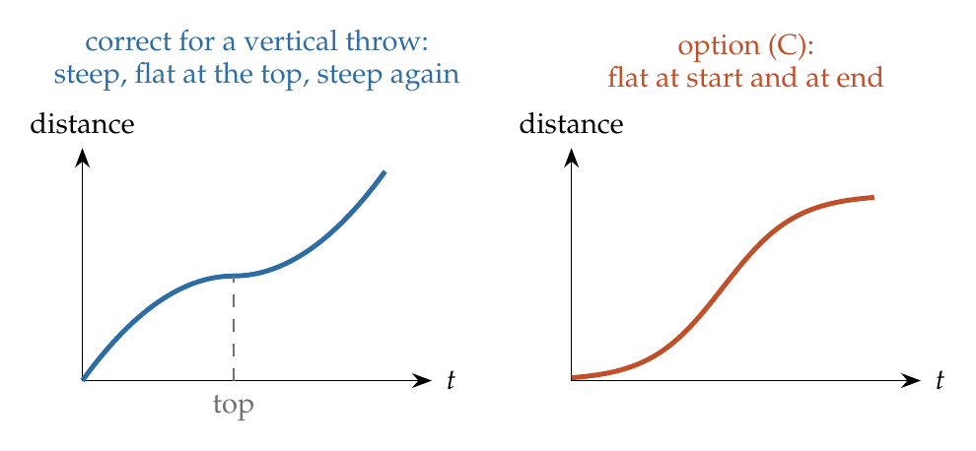
Take up as positive with launch speed $u$:
- Graph (A): $v=u−gt$: straight line, slope $−g$. Correct.
- Graph (D): $x=ut−\frac{1}{2}gt^{2}$: arch returning to zero at $t=2u/g$. Correct.
- Graph (B): $v^{2}=u^{2}−2gx$: $v=±\sqrt{u^{2}−2gx}$, a sideways parabola, upper half going out and lower half coming back. Correct.
- Graph (C): distance $d\left(t\right)$ has slope = speed $=\left|u−gt\right|$: largest ($u$) at $t=0$ and at $t=2u/g$, zero at the top. The graph shown has zero slope at both ends. Incorrect.

Answer
(C).

Watch out
• Distance–time and position–time differ: position comes back down, but distance never decreases; its slope is the speed, never negative.
• A flat start on a distance–time graph means the body starts from rest; a thrown body starts at its fastest.
Notes: Sec. 6.1 (reading shapes); Sec. 4.1 (symmetry); Sec. 3.2C (reversal).

Q85 · Acceleration–displacement graph of a bicycle [JEE Main 2021, 16 Mar, Shift 1]
ID 03MSL-0335-fbdb · Code 0335 · Worksheet 03MSL_v2 Q85

Problem
The velocity-displacement graph describing the motion of a bicycle is shown in the figure. The acceleration–displacement graph of the bicycle’s motion is best described by:
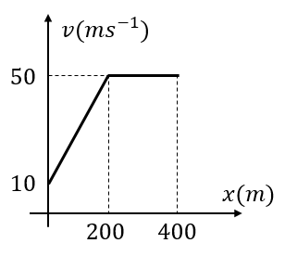
Option (A):
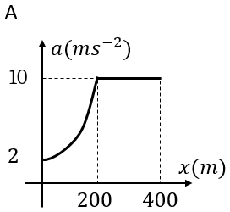
Option (B):
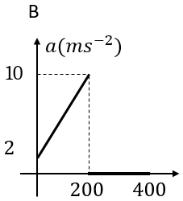
Option (C):
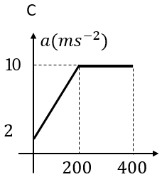
Option (D):
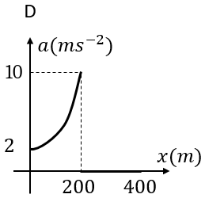

Hint
With v given against x, a = v dv/dx. On the first part, dv/dx is constant; what happens to a as v grows? On the flat part?

Think it through
- When v is given as a function of x, a = v × (slope of the v–x graph).
- Up to 200 m, the slope is (50 − 10)/200 = 0.2 per second, constant. So a = 0.2v, which grows with v: from 2 m/s² at x = 0 to 10 m/s² at x = 200 m.
- Since v itself grows linearly with x there, a = 0.2v also grows linearly with x: a straight line from 2 to 10.
- Beyond 200 m the velocity is constant, so a = 0.
- Straight line from 2 to 10, then zero: (B).

Worked solution
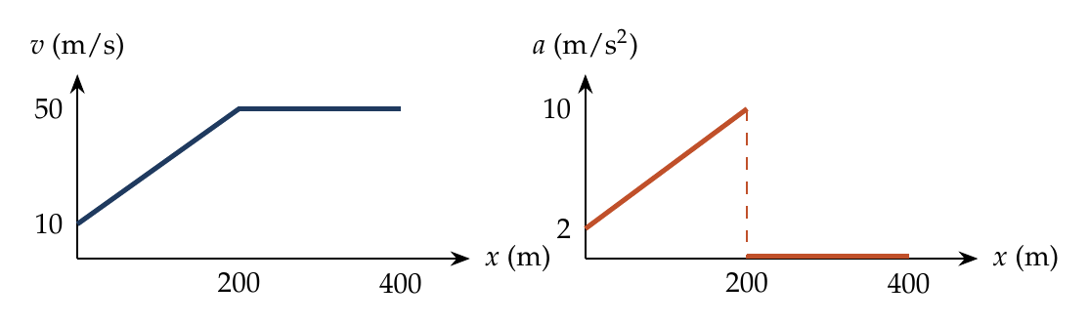
For $0≤x≤200$ m: $v=10+0.2x$, $\frac{dv}{dx}=0.2$ s⁻¹,
$$a=v\frac{dv}{dx}=0.2\left(10+0.2x\right)=2+0.04x,$$
linear from 2 m/s² to 10 m/s². For $x>200$ m: $v=50$ m/s (constant), $a=0$.

Answer
(B).

Watch out
• a is not the slope of the v–x graph (that would give a constant 0.2); it is v times that slope.
• Constant velocity beyond 200 m means a = 0, not a constant 10 m/s² (options A and C).
Notes: Sec. 5.1 (v of x given: a = v dv/dx); Sec. 6.1 (reading shapes).

Q86 · Velocity and acceleration as functions of position
ID 03MSL-0335-874e · Code 0335 · Worksheet 03MSL_v2 Q86

Problem
The velocity–displacement graph of a particle moving along x–axis is shown. The particle starts at t = 0 from the origin. The equation of velocity and acceleration as function of position is?
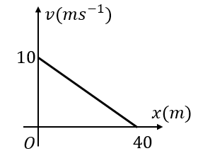

Hint
Write the straight line v = intercept + slope × x. Then a = v dv/dx.

Think it through
- The line runs from 10 m/s at x = 0 to 0 at x = 40 m: slope −¼ per second. So v = 10 − x/4.
- a = v × dv/dx = (10 − x/4)(−¼) = x/16 − 5/2.
- Check: at x = 0, a = −2.5 m/s² (slowing down from 10 m/s); at x = 40 m, where the particle stops, a = 0. The particle approaches x = 40 m ever more slowly, like the drag case a = −kv.

Worked solution
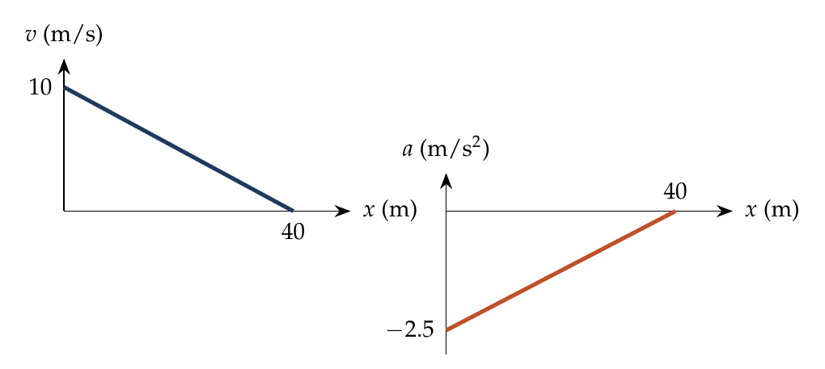
$$v=10−\frac{x}{4}, a=v\frac{dv}{dx}=\left(10−\frac{x}{4}\right)\left(−\frac{1}{4}\right)=\frac{x}{16}−\frac{5}{2}.$$

Answer
$v=10−\frac{x}{4}$ m/s; $a=\frac{x}{16}−\frac{5}{2}$ m/s².

Watch out
• The acceleration is not the constant slope (−¼); multiply by v.
• a here is proportional to −v (a = −v/4), so the particle never actually reaches 40 m in finite time.
Notes: Sec. 5.1 (v of x given: a = v dv/dx; example b: drag a = −kv).

Q87 · Velocity from an a–x graph
ID 03MSL-0335-2e28 · Code 0335 · Worksheet 03MSL_v2 Q87

Problem
The acceleration of a particle which moves along the positive x-axis varies with its position as shown. If the velocity of the particle is zero at x = 0, then find the velocity at x = 1 m?
(A) 3 m/s (B) 2 m/s (C) 1 m/s (D) √3 m/s
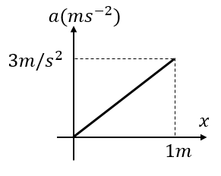

Hint
For an a–x graph, the area under it gives the change in ½v².

Think it through
- With acceleration given against position, use v dv = a dx: the area under the a–x graph equals the change in ½v².
- The area is a triangle: ½ × 1 × 3 = 1.5.
- So ½v² = 1.5, v² = 3 and v = √3 m/s. (D)
- Trap: reading the area as the velocity gives 1.5, and multiplying a × x gives 3 (option A).

Worked solution
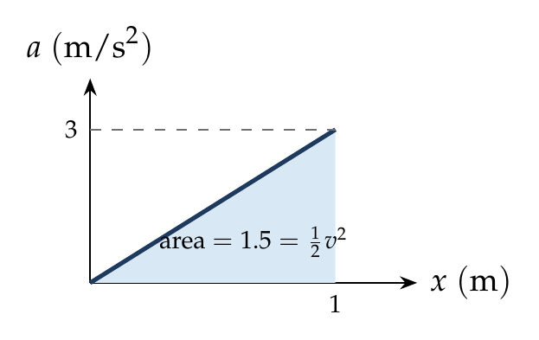
$a=3x$. Using $v dv=a dx$:
$$\int_{0}^{v}{v} dv=\int_{0}^{1}{3}x dx ⇒ \frac{v^{2}}{2}=\frac{3}{2} ⇒ v=\sqrt{3} m/s.$$

Answer
(D) √3 m/s.

Watch out
• Area under an a–x graph is ½(v² − u²), not the change in v.
Notes: Sec. 5.1 (a of x given: area under the a–x graph = ½ times the change in v²).

Q88 · Velocity from a triangular a–t graph
ID 03MSL-0335-30bb · Code 0335 · Worksheet 03MSL_v2 Q88

Problem
Acceleration–time graph of a particle moving in a straight line is shown in the figure. Velocity of a particle at time t = 0 is 2 m/s. Find velocity at the end of fourth second.
(A) 16 m/s (B) 8 m/s (C) 10 m/s (D) 4 m/s
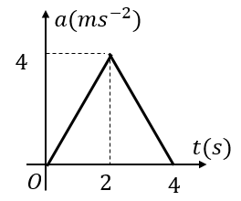

Hint
Area under the a–t graph = change in velocity. Don’t forget the starting 2 m/s.

Think it through
- The change in velocity is the area under the a–t graph: a triangle with base 4 s and height 4 m/s², area 8 m/s.
- The particle started at 2 m/s, so at 4 s it moves at 2 + 8 = 10 m/s. (C)
- Option (B) forgets the initial velocity.

Worked solution
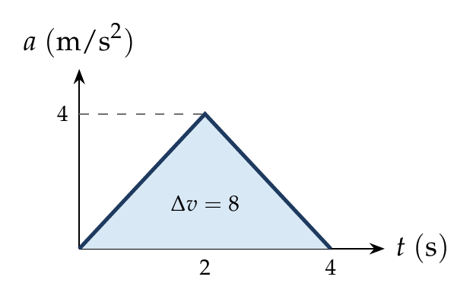
$$v\left(4\right)=v\left(0\right)+\int_{0}^{4}{a} dt=2+1/2\left(4\right)\left(4\right)=10 m/s.$$

Answer
(C) 10 m/s.

Watch out
• Add the initial velocity: the area gives only the change (8 m/s, option B).
Notes: Sec. 6 (a–t graph: area = change in velocity).

Q89 · Velocity from a sloping a–t graph
ID 03MSL-0335-fd99 · Code 0335 · Worksheet 03MSL_v2 Q89

Problem
The acceleration – time graph of a particle moving along a straight line is shown. The initial velocity is 8 m/s. What is the velocity at $t=4$ sec?
(A) 18 m/s (B) 10 m/s (C) 2 m/s (D) −2 m/s
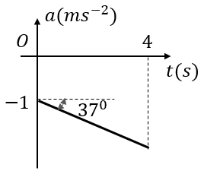

Hint
The line starts at −1 and falls at tan 37° = ¾ per second. Find a at 4 s, then the (negative) area.

Think it through
- The a–t line starts at −1 m/s² and goes down with slope tan 37° = ¾, so at 4 s it is −1 − 3 = −4 m/s².
- The area between 0 and 4 s is a trapezium below the axis: ½(1 + 4) × 4 = 10, counted as −10 m/s.
- v(4) = 8 − 10 = −2 m/s: the particle has reversed. (D)
- Option (A) adds the area; option (C) uses ½ × 4 × 3 only.

Worked solution
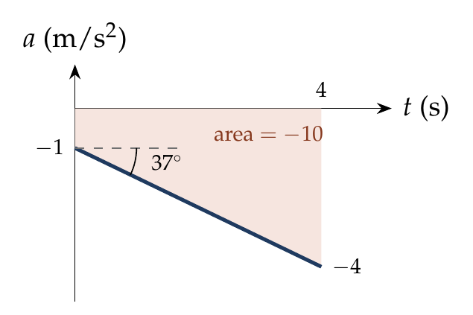
$a=−1−\frac{3}{4}t$, so $a\left(4\right)=−4$ m/s².
$$v\left(4\right)=8+\int_{0}^{4}{\left(−1−\frac{3}{4}t\right)}dt=8−4−6=−2 m/s.$$

Answer
(D) −2 m/s.

Watch out
• The area below the time axis is a negative change in velocity.
• The 37° is the angle with the horizontal, so the slope is tan 37° = ¾ (downward).
Notes: Sec. 6 (a–t graph: area = change in velocity).

Q90 · Velocity–height graph of a bouncing ball [L3] [JEE Main 2020, 4 Sep, Shift 1]
ID 03MSL-0335-33b1 · Code 0335 · Worksheet 03MSL_v2 Q90

Problem
A tennis ball is released from a height ‘h’ and it rebounds to a height ‘h/2’ after hitting the floor. Which of the following graphs best represent the velocity-height of the ball?
Option (A):
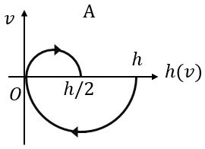
Option (B):
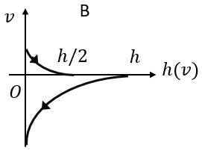
Option (C):
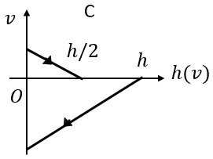
Option (D):
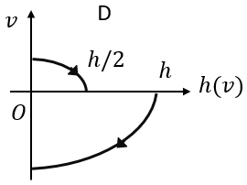

Hint
Take up as positive. Falling, v is negative and v² = 2g(h − y). After the bounce, v is positive and v² = 2g(h/2 − y). Where is each branch steepest?

Think it through
- Falling from h: v is downward (negative). Its size grows with the drop: v² = 2g(h − y), a sideways parabola. At y = h, v = 0 and the curve leaves the axis vertically (tangent along the v-axis direction).
- At y = 0 the speed is largest, √(2gh), and v jumps from negative to positive at the bounce (with smaller size, since it only reaches h/2).
- Rising: v is positive and v² = 2g(h/2 − y), falling to zero at y = h/2, again meeting the axis vertically.
- So: a lower curve from h down to a large negative value at y = 0, and an upper curve from a smaller positive value at y = 0 down to zero at h/2, both with vertical tangents where v = 0. That is (D).
- (C) uses straight lines (that would be v ∝ height, not v² ∝ height); (B) has the curvature the wrong way; (A) wrongly links the branches in loops.

Worked solution
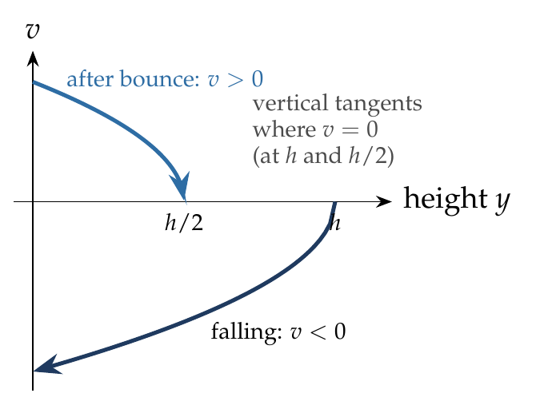
Taking up as positive:
Falling ($h→0$): $v=−\sqrt{2g\left(h−y\right)}$.
Rising ($0→h/2$): $v=+\sqrt{2g\left(h/2−y\right)}=+\sqrt{g\left(h−2y\right)}$.
Both are half-parabolas with $dv/dy→∞$ where $v=0$: graph (D).

Answer
(D).

Watch out
• v against height is not linear: v² is linear in height, so each branch is a parabola lying on its side.
• The rebound speed is smaller (it reaches only h/2), so the positive branch starts lower than the negative branch ends.
Notes: Sec. 4.2 (speed at height h); Sec. 6.1 (reading shapes).

Relative Motion in 1D

Q91 · Truck meeting two cars 3 min apart
ID 03MSL-0340-d356 · Code 0340 · Worksheet 03MSL_v2 Q91

Problem
Two cars are travelling in the same direction with a velocity of 60 km/h. They are separated by a distance of 5 km. A truck moving in opposite direction meets the two cars in a time interval of 3 minutes. The velocity of the truck is?
(A) 40 km/h (B) 36 km/h (C) 30 km/h (D) 24 km/h

Hint
In the cars’ frame, the two cars are fixed points 5 km apart. How fast must the truck move in that frame to cover 5 km in 3 minutes?

Think it through
- The cars move together, so in their frame they are two fixed markers 5 km apart.
- The truck goes from one to the other in 3 min = 1/20 h, so its speed relative to the cars is 5 × 20 = 100 km/h.
- Moving opposite to the cars, its relative speed is its own speed plus 60. So the truck moves at 100 − 60 = 40 km/h. (A)

Worked solution
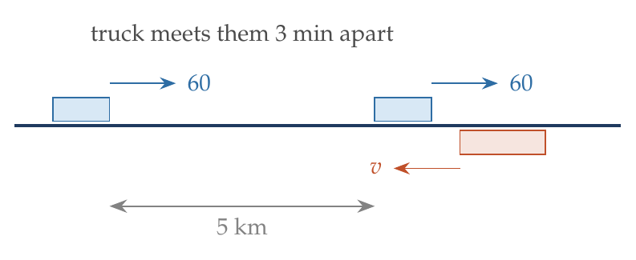
Relative speed of the truck with respect to the cars: $v+60$ km/h. Covering 5 km in $\frac{3}{60}$ h:
$$\left(v+60\right)\frac{3}{60}=5 ⇒ v+60=100 ⇒ v=40 km/h.$$

Answer
(A) 40 km/h.

Watch out
• Opposite directions: relative speed is the sum (v + 60), not the difference.
• Convert 3 min to hours (1/20 h) when speeds are in km/h.
Notes: Sec. 10 (relative motion: work in the frame of one body).

Q92 · Person walking in one train, seen from another [JEE Main 2020, 2 Sep, Shift 1]
ID 03MSL-0340-3a86 · Code 0340 · Worksheet 03MSL_v2 Q92

Problem
Trains A and B are running on parallel tracks in the opposite directions with speeds of 36 km/h and 72 km/h respectively. A person is walking in train A in the opposite direction to its motion with a speed of 1.8 km/h. Speed (in m/s) of this person as observed from train B will be close to? (the distance between tracks is negligible)
(A) 28.5 (B) 30.5 (C) 29.5 (D) 31.5

Hint
First find the person’s velocity relative to the ground, then subtract train B’s velocity (with signs).

Think it through
- Take A’s direction as positive. Speeds in m/s: A +10, B −20, person relative to A −0.5.
- Person relative to ground: 10 − 0.5 = +9.5 m/s.
- Relative to B: 9.5 − (−20) = 29.5 m/s. (C)

Worked solution
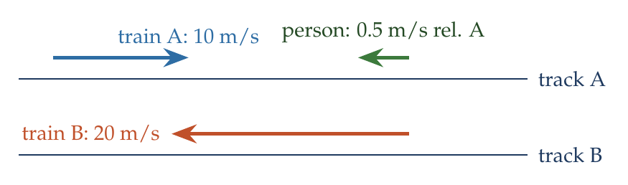
$$v_{P,g}=v_{A}+v_{P,A}=10−0.5=9.5 m/s, v_{P,B}=v_{P,g}−v_{B}=9.5−\left(−20\right)=29.5 m/s.$$

Answer
(C) 29.5 m/s.

Watch out
• Keep the signs: B moves opposite to A, so subtracting its velocity adds 20 m/s.
Notes: Sec. 10 (relative velocity = velocity of A minus velocity of B).

Q93 · Trains crossing: same vs opposite directions [JEE Main 2019, 12 Jan, Shift 1]
ID 03MSL-0340-1fe4 · Code 0340 · Worksheet 03MSL_v2 Q93

Problem
A passenger train of length 60 m travels at a speed of 80 km/h. Another freight train of length 120 m travels at a speed of 30 km/h. The ratio of time taken by the passenger train to completely cross the freight train when: (i) they are moving in the same direction and (ii) in the opposite direction is:
(A) 3/2 (B) 25/11 (C) 11/5 (D) 5/2

Hint
In either case the relative distance is the sum of the lengths. Only the relative speed changes.

Think it through
- To cross completely, the passenger train must move 60 + 120 = 180 m relative to the freight train, in both cases.
- Same direction: relative speed 80 − 30 = 50 km/h. Opposite: 80 + 30 = 110 km/h.
- Same distance, so time ∝ 1/speed: t₁/t₂ = 110/50 = 11/5. (C)

Worked solution
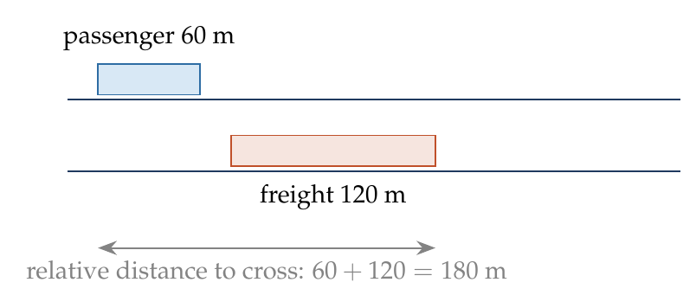
$$\frac{t_{1}}{t_{2}}=\frac{180/\left(80−30\right)}{180/\left(80+30\right)}=\frac{110}{50}=\frac{11}{5}.$$

Answer
(C) 11/5.

Watch out
• The ratio is inverse to the relative speeds; don’t invert it to 5/11.
Notes: Sec. 10 (relative motion); Sec. 1 (Common traps: crossing covers both lengths).

Q94 · Stone thrown down from an accelerating balloon
ID 03MSL-0340-55c1 · Code 0340 · Worksheet 03MSL_v2 Q94

Problem
A man in a balloon throws a stone downwards with a speed of 4 m/s with respect to balloon. The balloon is moving upwards with a constant acceleration of 5 m/s². What will the distance between the stone and the balloon after 2 seconds?
(A) 8 m (B) 18 m (C) 28 m (D) 38 m

Hint
Work in the balloon’s frame. What are the stone’s initial velocity and acceleration relative to the balloon?

Think it through
- In the balloon’s frame, the stone starts at 4 m/s downward.
- The stone accelerates down at g; the balloon accelerates up at 5. Relative to the balloon, the stone accelerates down at 10 + 5 = 15 m/s².
- In 2 s: 4 × 2 + ½ × 15 × 4 = 8 + 30 = 38 m. (D)
- The balloon’s own velocity cancels out: it is shared by both at the instant of the throw.

Worked solution
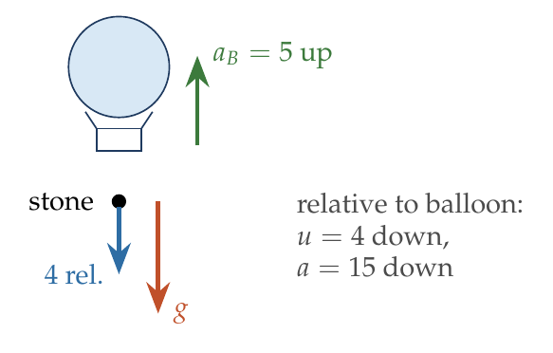
Relative to the balloon (down positive): $u_{rel}=4$ m/s, $a_{rel}=g+5=15$ m/s².
$$s_{rel}=4\left(2\right)+1/2\left(15\right){\left(2\right)}^{2}=38 m.$$

Answer
(D) 38 m.

Watch out
• Relative acceleration is g + 5 (they accelerate in opposite directions), not g − 5 or g.
• The balloon’s velocity at the instant of the throw is not given and is not needed.
Notes: Sec. 10.3 (accelerating frames: lift, train).

Q95 · Bolt falling inside an accelerating lift
ID 03MSL-0340-ccd1 · Code 0340 · Worksheet 03MSL_v2 Q95

Problem
A lift having floor to ceiling distance of 2.7 m, starts ascending with a constant acceleration of 2 m/s². Two seconds after it starts, a bolt begins to fall from the ceiling. Find the free fall time of the bolt (time to strike the floor of the lift).
(A) $\sqrt{9/10}$ sec (B) $\sqrt{9/20}$ sec (C) $\sqrt{3/5}$ sec (D) $\sqrt{3/8}$ sec

Hint
In the lift’s frame the bolt starts at rest. What is its acceleration relative to the floor?

Think it through
- At the instant it comes loose, the bolt shares the lift’s velocity, so relative to the lift it starts from rest. The “2 seconds” only sets that common velocity, which drops out.
- Relative to the lift, the bolt accelerates down at g + a = 12 m/s².
- 2.7 = ½ × 12 × t², so t² = 0.45 = 9/20. (B)

Worked solution
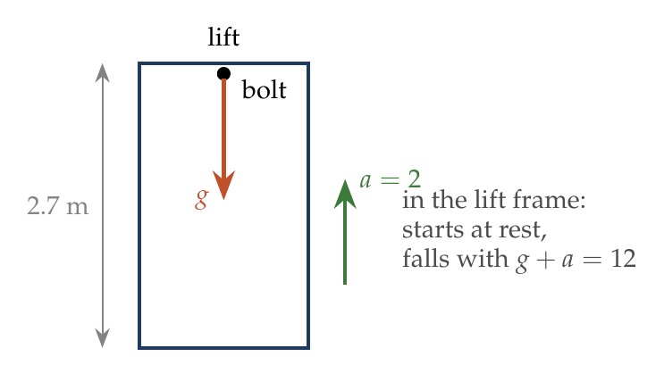
In the lift’s frame: $u_{rel}=0$, $a_{rel}=g+a=12$ m/s², $s_{rel}=2.7$ m.
$$2.7=1/2\left(12\right)t^{2} ⇒ t=\sqrt{\frac{9}{20}} s.$$

Answer
(B) $\sqrt{9/20}$ s.

Watch out
• The 2 s is a distractor: the time the lift has been moving does not affect the relative motion.
• Use g + a, not g: the floor rises to meet the bolt.
Notes: Sec. 10.3 (accelerating frames: lift).

Q96 · Relative speed of perpendicular movers [JEE Main 2020, 8 Jan, Shift 1]
ID 03MSL-0340-1c68 · Code 0340 · Worksheet 03MSL_v2 Q96

Problem
A particle is moving along x-axis with its coordinates given by $x\left(t\right)=10+8t−3t^{2}$. Another particle is moving along y-axis with its coordinates given by $y\left(t\right)=5−8t^{3}$. At t = 1 s, the speed of the second particle as measured in the frame of first particle is given as $\sqrt{v}$. Then v in m/s is:

Hint
Find each velocity at t = 1 s. They are at right angles, so the relative speed comes from Pythagoras.

Think it through
- Particle 1: v₁ = 8 − 6t, which is 2 m/s along x at t = 1 s.
- Particle 2: v₂ = −24t², which is 24 m/s along −y at t = 1 s.
- The relative velocity v₂ − v₁ has components −2 (x) and −24 (y). Its square is 4 + 576 = 580, so v = 580.

Worked solution
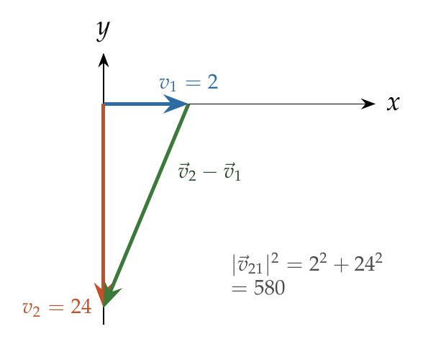
$${\vec{v}}_{1}=\left(8−6t\right)\hat{ı}=2\hat{ı}, {\vec{v}}_{2}=−24t^{2}\hat{ȷ}=−24\hat{ȷ} \left(t=1 s\right).$$
$${\vec{v}}_{21}={\vec{v}}_{2}−{\vec{v}}_{1}=−2\hat{ı}−24\hat{ȷ}, \left|{\vec{v}}_{21}\right|=\sqrt{4+576}=\sqrt{580}.$$

Answer
v = 580.

Watch out
• Use velocities at t = 1 s, not positions.
• The velocities are perpendicular: combine with Pythagoras, not by adding or subtracting magnitudes.
Notes: Sec. 10 (relative velocity = velocity of A minus velocity of B).

