Take g = 10 m/s² unless stated otherwise.

Distance, Displacement, Speed & Velocity
- A clock has its second hand 2 cm long. Find the distance travelled and displacement of the tip of the second hand in 15 seconds.
- A wheel of radius R meter rolls forward half a revolution on a horizontal ground. The magnitude of the displacement of the point of the wheel initially in contact with the ground is?
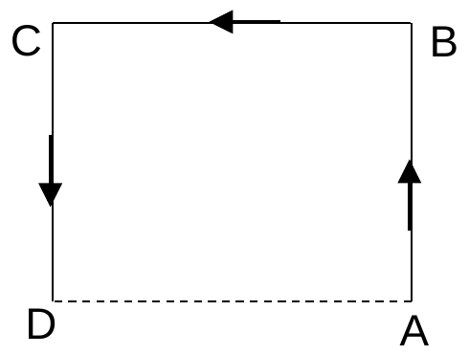
- A particle moves along the sides AB, BC, CD of a square of side 25 m with a speed of 15 m/s. Its average velocity is?

- A 150 m long train is moving with a uniform velocity of 45 km/h. The time taken by the train to cross a bridge of length 850 meters is
(A) 56 sec (B) 68 sec (C) 80 sec (D) 92 sec
- [AIPMT 2006] A car runs at a constant speed on a circular track of radius 100 m, taking 62.8 seconds for every circular lap. The average velocity and average speed for each circular lap respectively is:
(A) 0,0 (B) 0, 10 m/s (C) 10 m/s, 10 m/s (D) 10 m/s, 0
- A car moves from X to Y with a uniform speed $v_{u}$and returns to X with a uniform speed $v_{d}$. The average speed for this round trip is:
(A) $\frac{v_{u}+v_{d}}{2}$ (B) $\frac{2v_{u}v_{d}}{v_{u}+v_{d}}$ (C) $\sqrt{v_{u}v_{d}}$ (D) $\frac{v_{u}v_{d}}{v_{u}+v_{d}}$
- A particle moving in a straight line covers half the distance with speed of 3 m/s. The other half of the distance is covered in two equal time intervals with speed of 4.5 m/s and 7.5 m/s respectively. The average speed of the particle during this motion is?
- A particle is moving along a circular path of radius R. For the first quarter of the circle it travels with a speed ‘v’ and then it covers another third of the circle with a speed of ‘2v’ and finally the remaining part with speed ‘3v’. Find its average speed.
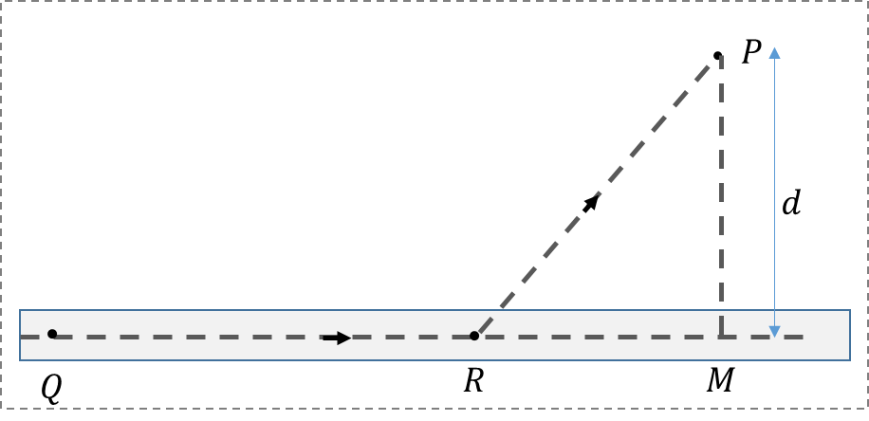
- [L2] A man in a car at location Q on a straight highway is moving with speed v. He decides to reach a point P in a field at a distance d from the highway (point M) as shown in the figure. Speed of the car in the field is half of that on the highway. What should be the distance RM, so that the time taken to reach P is minimum?
(A) d (B) d/$\sqrt{2}$ (C) d/2 (D) d/$\sqrt{3}$

- [L2] There is a room of size 2 m × 2 m and of height 3 m. An ant is at one corner of the room on the floor and it wants to reach the opposite corner on the roof. If the ant travels only along the vertical walls, find the minimum distance it has to travel to reach diagonally opposite corner?

Equations of Uniformly Accelerated Motion
- During a uniformly accelerated motion of a particle starting from state of rest, which of the following statement(s) are correct?
(A) average velocity of the particle is always less than its final velocity
(B) average velocity of the particle is always greater than its final velocity
(C) average velocity of the particle may be zero also
(D) average velocity of the particle is half its final velocity
- A particle travels 10 m in first 5 sec and 8 m in next 5 sec. Assuming constant acceleration what is the distance travelled in next 5 sec
(A) 9 m (B) 6 m (C) 3 m (D) None of above
- A particle moving with uniform retardation covers a distance of 18 m, 14 m, and 10 m in successive seconds. How much further it will travel before coming to a stop.
(A) 6 m (B) 2 m (C) 10 m (D) 8 m
- When the speed of a car is u, the minimum distance over which it can be stopped is s. If the speed becomes nu, what will be the minimum distance over which it can be stopped? (assuming the braking or retardation is constant)
- A car is moving with a speed of 40 m/s. The driver observes a stationary truck ahead at a distance of 120 m. After a reaction time of δt, the driver applies the brake producing a retardation of 8 m/s². What is the maximum reaction time to avoid collision?
(A) 1 sec (B) 0.8 sec (C) 0.6 sec (D) 0.5 sec
- A bullet fired into a fixed target loses half of its velocity after penetrating 3 cm. How much further it will penetrate before coming to rest assuming that it faces constant resistance to motion?
- A body moving with a uniform acceleration has velocities of u and v when passing through points A and B in its path. The velocity of the body midway between A and B is?

Free Fall & Vertical Throw
- An object falls from a bridge that is 45 m above the water. It falls directly into a small row-boat moving with constant velocity that was 12 m from the point of impact when the object was released. What was the speed of the boat?
- A ball is dropped from the roof of a tower of height h. The total distance covered by it in the last second of its motion is equal to the distance covered by it in first three seconds. The value of h in meters is
- A ball is dropped from the top of a building. The ball takes 0.5 s to fall past the 3 m length of a window some distance from the top of the building. If the velocities of the ball at the top and at the bottom of the window are $v_{t}$ and $v_{b}$ respectively, then:
(A) $v_{t}$ = 6 m/s (B) $v_{t}$ = 2 m/s
(C) $v_{b}$= 12 m/s (D) $v_{b}$= 8.5 m/s
- A body is thrown vertically up from the ground with a speed u and it reaches its maximum height ‘h’ at time $t=t_{0}$. The height to which it would have risen at t =$t_{0}$/2?
- A ball is thrown upwards from the ground with an initial speed of u. The ball is at a height of 80 m at two instances of time$t_{1}$and $t_{2}$. If the time interval $t_{2}-t_{1}$ is 6 s, then find u?
(A) 60 m/s (B) 50 m/s (C) 40 m/s (D) 30 m/s
- A ball is projected vertically upwards with a velocity of 25 m/s from the bottom of a tower. A boy standing at the top of the tower is unable to catch the ball as it passes him in the upward direction. He catches the ball when it passes him again 3 seconds later. Find the height of the tower?
(A) 15 m (B) 20 m (C) 22.5 m (D) 25 m
- A particle is projected vertically upwards from a point A on the ground. It takes time $t_{1}$ to reach a point B, but it still continues to move up. If it takes further $t_{2}$ time to reach the ground from point B. Then height of point B from the ground is?
- A stone projected upwards with a velocity ‘u’ passes through points P and Q, separated by distance ‘h’ with velocities u/2 and u/3. Find the maximum height the stone will reach with respect to point of projection?
(A) $9h$ (B) $18h/5$ (C) $6h/5$ (D) $36h/5$
- A stone is thrown vertically upward with an initial velocity v₀. The distance travelled in time 4$v_{0}/3g$ is?
(A) $\frac{5v_{0}^{2}}{9g}$ (B) $\frac{4v_{0}^{2}}{9g}$ (C) $\frac{5v_{0}^{2}}{18g}$ (D) $\frac{11v_{0}^{2}}{18g}$
- A ball is thrown vertically upwards with a speed of 10 m/s from the top of a 200 m high tower. Another ball is thrown vertically downwards at the same speed simultaneously. The time difference between two ball reaching the ground?
(A) 4 s (B) 2 s (C) 6 s (D) $\sqrt{2} s$
- From the top of a tower, a stone is thrown up and reaches the ground in time $t_{1}$. A second stone is thrown down with the same speed and reaches the ground in time $t_{2}$. A third stone is released from rest and reaches the ground in time $t_{3}$; then what is the relation between the three times?
- From a tower of height ‘H’ a particle is thrown vertically upwards with speed u. The time taken by the particle to hit the ground is ‘n’ times the time taken by the particle to reach the highest point. Find the relation between H, u, and n.
(A) 2gH = n²u² (B) gH = (n-2)²u² (C) 2gH = nu² (n-2) (D) gH = u² (n-2)
- A ball is thrown vertically up with a certain velocity from the top of a tower of height 40 m. At 4.5 m above the top of the tower its speed is exactly half of that it will have at 4.5 m below the top of the tower. Find the maximum height reached by the ball above the ground?
(A) 44.5 m (B) 47.5 m (C) 49 m (D) 54 m
- A stone is released from an elevator ascending with acceleration a. The acceleration of the stone immediately after the release is?
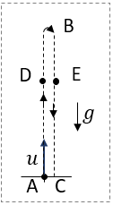
- A vertical projectile experiences a retarding acceleration of $a$ opposite to the direction of motion of the projectile. If the speed of projection is $u$, then:
(i) Time of ascent
(ii) Time of descent
(iii) Maximum height reached
(iv) Speed just before it hits the ground
(v) Point D and E are at same height during upward and downward motion of projectile. Which point will have greater speed?

- A particle is thrown upwards from ground. It experiences a constant resistive force which produces a retardation of 6 m$s^{-2}.$ What will be the ratio of time of descent to time of ascent?
(A) 2 (B) 3 (C) 4 (D) 1

Two-Body & Multi-Phase Motion
- A train starts from station A with a constant acceleration of $a$ for time T immediately followed by deceleration of $a/2$ till it comes to stop at station B:
(i) What will be the time for deceleration
(ii) Ratio of distance travelled during acceleration and deceleration?
(iii) What will be the total distance travelled?
(iv) What will be the average speed for the entire journey from A to B?
- A particle starts with an acceleration ‘α’ immediately followed with a deceleration ‘β’ and finally coming to stop. The total time duration of motion is ‘T’ then find:
(i) The time of acceleration (in terms of T)
(ii) The maximum speed reached:
(iii) The total distance travelled:
(iv) Average speed for the entire duration of motion:
- The greatest acceleration or deceleration that a train may have is ‘a’. The minimum time in which the train may reach from one station to the other separated by a distance d is?
- Two particles A and B start from rest and move for equal time on a straight line. The particle A has an acceleration of ‘a’ for the first half of the time and ‘2a’ for the second half. The particle B has an acceleration of ‘2a’ for the first half and ‘a’ for the second half. What will be the ratio of the distances travelled by A and B?
(A) 7/5 (B) 1 (C) 5/7 (D) 3/8
- Two cars start the race with velocities u₁ and u₂ and travel in straight line with acceleration ‘α’ and ‘β’. If both reach the finish line at the same time, then the range of the race is?
- A bus starts moving with acceleration 2 ms^{–2}. A cyclist 96 m behind the bus starts simultaneously towards the bus at a constant speed of 20 m/s. At what time(s) will he be adjacent to the bus?
(A) at 8 sec (B) at 10 sec (C) at 12 sec (D) at 8 and 12 sec
- A police jeep moving at a constant speed v is chasing a dacoit on a motorcycle. When the jeep is a distance $x$ behind, the dacoit starts from rest with a constant acceleration α. Which of the following relations must hold if the police are to catch the dacoit?
(A) $v^{2}≤αx$ (B) $v^{2}≤2αx$ (C) $v^{2}≥2αx$ (D) $v^{2}≥αx$
- A bus starts from rest with an acceleration of 2 m/$s^{2}$, and at the same instant a man starts running after the bus at a constant speed of 10 m/s. If he is $x$ m behind the bus, then what is the maximum value of $x$ so that the man may be able to catch the bus?
- A police jeep is chasing a culprit going on a motor bike. The motor bike crosses a turning at a speed of 72 km/h. The jeep follows it a speed of 90 km/h crossing the turning ten seconds later than the bike. Assuming that they travel at constant speeds, how far from the turning will the jeep catch up with the bike ? (in km)
(A) 3 km (B) 5 km (C) 1 km (D) 7 km
- A starts from rest with an acceleration of a₁. Two seconds later, B starts from rest with an acceleration of a₂. If the displacement of A in 5th second of its motion is same as that of B in the same time interval, then the ratio of accelerations?
(A) 5:7 (B) 5:9 (C) 9:5 (D) 5:3
- Two trains A and B travelling on the same track are approaching each other with equal speeds of 40 m/s. The drivers of the trains begin to decelerate simultaneously when they are just 2.0 km apart. Assuming the decelerations of A is half that of B, what must be the minimum value of the deceleration of A to barely avoid collision?
(A) 3 m/s² (B) 0.6 m/s² (C) 1.2 m/s² (D) 2.4 m/s²
- [JEE Main 2019, 9 Jan, Shift 2] In a car race on straight road, car A takes a time ‘t’ less than car B at the finish and passes finishing point with a speed 'v' more than that of car B. Both the cars start from rest and travel with constant acceleration a₁ and a₂ respectively. Then 'v' is equal to:
(A) $\frac{a_{1}+a_{2}}{2}t$ (B) $\sqrt{2a_{1}a_{2}}$ t (C) $\frac{2a_{1}a_{2}}{a_{1}+a_{2}}$ t (D) $\sqrt{a_{1}a_{2}}$ t
- A body is released from the top of a tower of height H metre (H > 40 m). After 2 seconds it is stopped and then instantaneously released. What will be its height after next 2 seconds?
- A juggler maintains four balls in motion, making each in turn rise to a height of 5 m from his hand. What will be the time interval between two successive balls thrown up? Assume that balls do not collide in air and the time taken to receive and throw the ball again is negligible.
- A rocket is fired and it ascends with a constant acceleration of 10 m/$s^{2}$. Its fuel exhausts after one minute and it continues to move as a free object. Find the maximum height reached by the rocket?
(A) 18 km (B) 54 km (C) 9 km (D) 36 km
- [JEE Main 2020, 5 Sep, Shift 1] A helicopter is rising from the ground with an acceleration of g m/$s^{2}$ starting from rest. After it has risen to a height h, a particle is released from it. Take t = 0 at the instant the particle is released, find time t when it reaches the ground (in terms of h and g).
- Two bodies are released from the same point. The second one is released 2 s after the first. Find the time, measured from the release of the first object, at which the distance between the two objects is L = 60 m?
(A) 6 s (B) 2 s (C) 4 s (D) $2\sqrt{2}$ s
- A ball is thrown vertically down with velocity of 5 m/s. With what velocity should another ball be thrown down after 2 seconds so that it can hit the 1st ball in 2 seconds?
(A) 40 m/s (B) 55 m/s (C) 15 m/s (D) 25 m/s
- A body is dropped from the top of a given tower of height h. At the same time a body is projected from the foot of the tower, in the same vertical line, with a velocity which would be just sufficient to take it to top of the tower. They will meet at a height?
(A) h/2 (B) h/4 (C) h/3 (D) 3h/4
- Two balls of same masses are shot upward one after another at an interval of 2 seconds along the same vertical line and with same initial velocity of 40 m/s. At what height from the ground will they collide?
(A) 75 m (B) 45 m (C) 15 m (D) 30 m
- [L2] A car starts from rest and moves with uniform acceleration ‘a’ on a straight road from time t = 0 to t = T. After that, a constant deceleration of ‘b’ brings it to rest. In this process the average speed of the car is
(A) $\frac{aT}{4}$ (B) $\frac{3aT}{2}$ (C) $\frac{aT}{2}$ (D) Will depend on ‘b’
- [L2] A ball A is dropped from the top of a building of height 90 m and at the same time an identical ball B is thrown vertically upwards from the ground. When the balls collide, the speed of ball A is twice that of B. At what height did the collision happen?
(A) 30 m (B) 60 m (C) 50 m (D) 45 m
- [L2] [JEE Main 2021, 25 Feb, Shift 2] A stone is dropped from the top of a building. When it crosses a point 5 m below the top, another stone starts to fall from a point 25 m below the top. Both stones reach the bottom of building simultaneously. The height of the building is:
(A) 35 m (B) 25 m (C) 50 m (D) 45 m

Variable Acceleration (Calculus)
- The displacement $x$ of a particle along a straight line at time $t$ is given by$x=a_{0}+a_{1}t+a_{2}t^{2}$. The acceleration of the particle is
(A) $a_{0}$ (B) $a_{1}$ (C) ${2a}_{2}$ (D) $a_{2}$
- The displacement of a body is given to be proportional to the cube of time elapsed. The magnitude of the acceleration of the body is
(A) Increasing with time (B) Decreasing with time
(C) Constant but not zero (D) Zero
- The initial velocity of a particle is $u$ (at $t=0$) and the acceleration $a$ is given by $αt$. Which of the following relation is valid
(A) $v=u+αt^{2}$ (B) $v=u+\frac{1}{2}αt^{2}$ (C) $v=αt^{2}$ (D) $v=u$
- An electron starting from rest has a velocity that increases linearly with the time that is $v=kt$ where $k=2 m/s^{2}$. The distance travelled in the first 3 seconds will be
(A) 9 m (B) 16 m (C) 27 m (D) 36 m
- If the velocity of a particle is $v=At+Bt^{2};$where A and B are positive constants, then the distance travelled by it between 1 s and 2 s is
(A) $\frac{3}{2}A+4B$ (B) $3A+7B$ (C) $\frac{3}{2}A+\frac{7}{3}B$ (D) $\frac{A}{2}+\frac{B}{3}$
- Two cars P and Q start from a point at the same time in a straight line and their positions are represented by $x_{P}=at+bt^{2}$ and $x_{Q}=ft-t^{2}$. At what time do the cars have the same velocity?
(A) $\frac{a+f}{2\left(1+b\right)}$ (B) $\frac{f-a}{2\left(1+b\right)}$ (C) $\frac{a-f}{\left(1+b\right)}$ (D) $\frac{a+f}{2\left(b-1\right)}$
- [AIPMT 2007] A particle moving along x-axis has acceleration f, at time t, given by $f=f_{o}(1-\frac{t}{T})$, where $f_{0}$ and T are constants. The particle at t = 0 has zero velocity. At the instant when f = 0, the particle's velocity is?
(A) ½ $f_{0}T$ (B) $f_{0}T$ (C) $\frac{1}{2}f_{0}T^{2}$ (D) $f_{0}T^{2}$
- The position $x$ of a particle varies with time $t$ as $x=at^{2}-bt^{3}$. The acceleration of the particle will be zero at time $t$ equal to
(A) $\frac{a}{b}$ (B) $\frac{2a}{3b}$ (C) $\frac{a}{3b}$ (D) Zero
- The relation between time and position is $t=αx^{2}+βx$, where α and β are constants. The retardation is
(A) $2αv^{3}$ (B) $2βv^{3}$ (C) $2αβv^{3}$ (D) $αv^{3}$
- A particle of unit mass undergoes one-dimensional motion such that its velocity varies according to $v\left(x\right)=βx^{-2n}$where β and n are constants and x is the position of the particle. The acceleration of the particle as a function of x, is given by?
(A) $-2nβ^{2}x^{-4n-1}$ (B) $-2β^{2}x^{-2n+1}$ (C) $-2nβ^{2}x^{-4n+1}$ (D) $-2nβ^{2}x^{-2n-1}$
- A particle moves a distance x in time t according to equation x = ${(t+5)}^{-1}$. The acceleration of particle is proportional to:
(A) ${(velocity)}^{2/3}$ (B) ${(velocity)}^{3/2}$ (C) ${(distance)}^{2}$ (D) ${(distance)}^{-2}$
- A particle starts moving rectilinearly at time t = 0 such that its velocity ‘v’ changes with time ‘t’ according to the equation $v=t^{2}-t$ where t is in seconds and v is in m/s. The time interval for which the particle retards is
(A) t < 1/2 (B) 1/2 < t < 1 (C) t > 1 (D) t < 1/2 and t > 1
- A particle moves with a velocity of v(t) = (1/2)k$t^{2}$ along a straight line. Find its average speed in time T.
(A) $\frac{1}{2}kT^{2}$ (B) $\frac{1}{3}kT^{2}$ (C) $\frac{3}{4}kT^{2}$ (D) $\frac{1}{6}kT^{2}$
- A particle moves along x–axis according to given position function x(t) = 10 + t² – 10t.
(i) The average velocity of particle in time interval from t = 0 to t = 10 seconds, is?
(ii) The average speed of particle in time interval from t = 0 to t = 10 seconds is?
- The position of a particle is given as y (m) =$-\frac{2}{3}t^{2}+$4t + 2. Find the distance travelled in first 6 sec of its motion?
(A) zero (B) 4 m (C) 6 m (D) 12 m
- The velocity of a particle moving in the positive direction of x axis varies as $v=α\sqrt{x}$, where α is a positive constant. Assuming that at moment t = 0, the particle was located at the point x = 0. Find the mean velocity of the particle averaged over the time that particle takes to cover first ‘$S$’ meters of the path.
(A) $2αS$ (B) $α^{2}S$ (C) $\frac{1}{2}α^{2}S$ (D) $\frac{1}{2}α\sqrt{S}$
- A particle starts from rest and moves along the x-axis with acceleration ‘a’ at time ‘t’ given by $a=a_{0}(1-\frac{t}{T})$. Find average velocity during the time interval $t=0$ to $t=T$?
(A) $\frac{1}{3}a_{0}T$ (B) $\frac{1}{2}a_{0}T$ (C) $a_{0}T$ (D) $2a_{0}T$
- A particle initially moving with velocity u is subjected to a retarding force which decelerates it as $a=-k\sqrt{v}$ . Find the distance travelled by the particle before it comes to rest?
(A) $\frac{1}{3k}u^{3/2}$ (B) $\frac{2}{3k}u^{3/2}$ (C) $\frac{1}{2}ku^{3/2}$ (D) $ku^{3/2}$
- [L2] A particle starts from rest at x = 0. Its acceleration is 5 m/s² which decreases linearly with time to zero in 6 seconds. Find (i) the maximum speed of the particle and (ii) its displacement in time interval t = 0 to t= 2 sec.

Motion Graphs: x–t & v–t
- The displacement-time graph for two particles A and B are straight lines inclined at angles of $30°$ and $60°$ with the time axis. The ratio of velocities of $V_{A}:V_{B}$ is ?
(A) $1:2$ (B) $1:\sqrt{3}$ (C) $\sqrt{3}:1$ (D) $1:3$
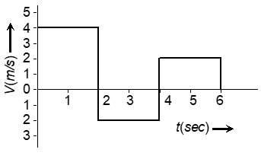
- The velocity-time graph of a body moving in a straight line is shown in the figure. The displacement and distance travelled by the body in 6 sec are respectively :
(A)8 m, 16 m (B)16 m, 8 m
(C)16 m, 16 m (D)8 m, 8 m

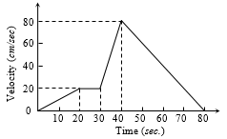
- The $v-t$ graph of a moving object is given in figure. The maximum acceleration is ?
(A) $1 cm/s^{2}$
(B) $2 cm/s^{2}$
(C) $3 cm/s^{2}$
(D) $6 cm/s^{2}$

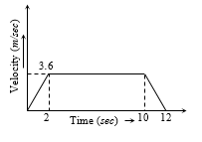
- A lift is going up. The variation in the speed of the lift is as given in the graph. What is the height to which the lift takes the passengers:
(A) 3.6 m
(B) 28.8 m
(C) 36.0 m
(D) Cannot be calculated from the above graph

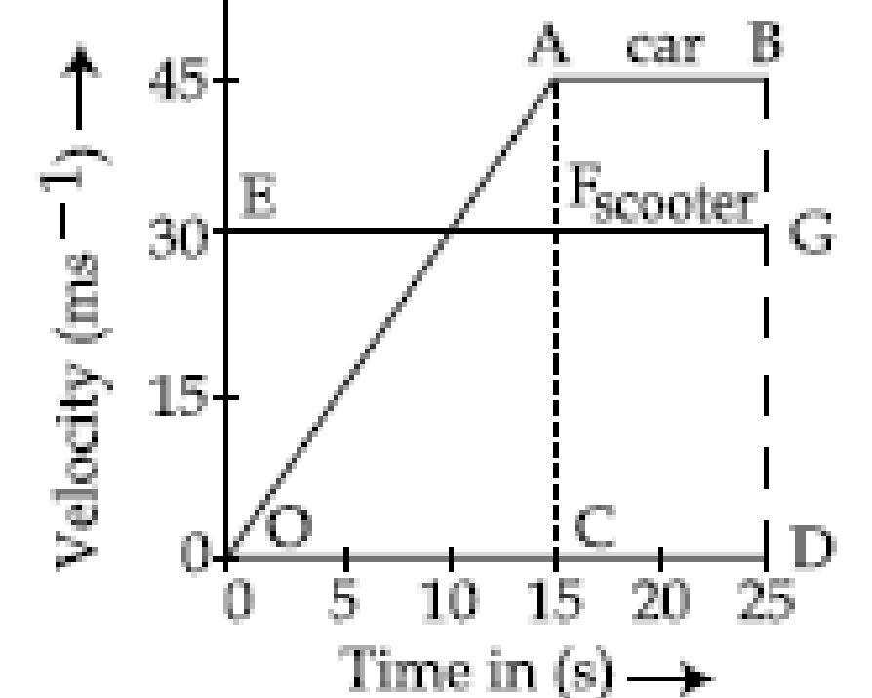
- [JEE Main] The velocity-time graphs of a car and a scooter are shown in the figure. (i) The difference between the distance travelled by the car and the scooter in 15 s and (ii) the time at which the car will catch up with the scooter are, respectively?
(A) 112.5 m and 22.5 s
(B) 337.5 m and 25 s
(C) 112.5 m and 15 s
(D) 225.5 m and 10 s

Motion Graphs: a–t, v–x, a–x & Conversion
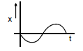
- If position-time graph of a particle is a sine curve as shown, then which one will be the corresponding velocity-time graph:

(A) 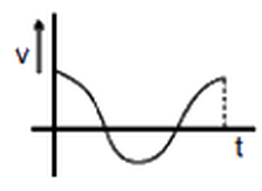 (B) 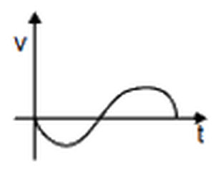
(C) 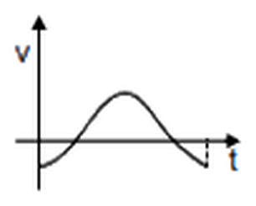 (D) 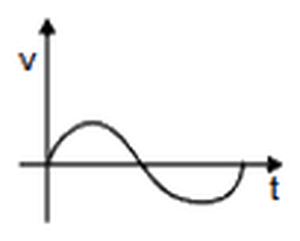

- [JEE Main 2021, 18 Mar, Shift 1] The position, velocity and acceleration of a particle moving with a constant acceleration can be represented by:
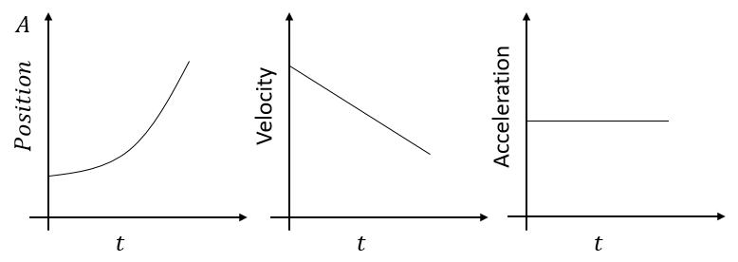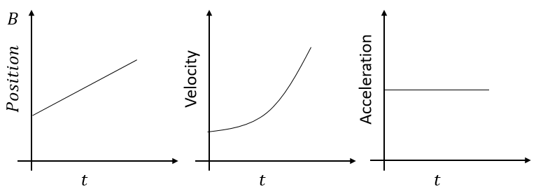
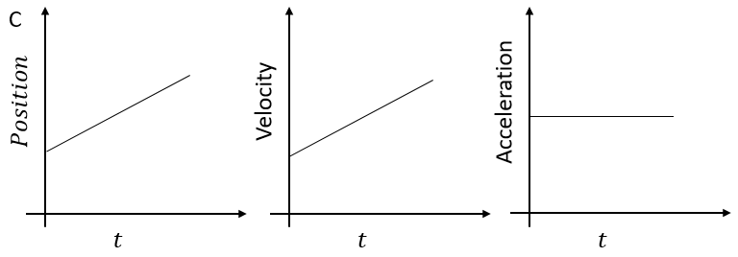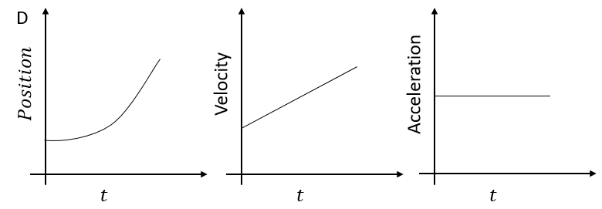
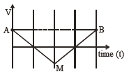
- [JEE Main 2021, 24 Feb, Shift 1] If the velocity–time graph has the shape AMB, what would be the shape of the corresponding acceleration–time graph?

(A) 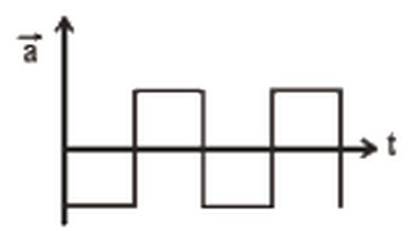 (B) 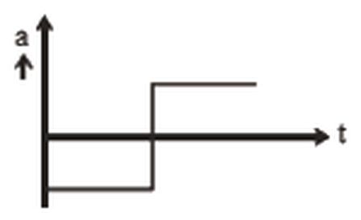
(C) 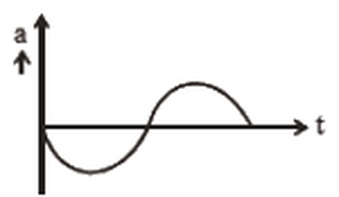 (D) 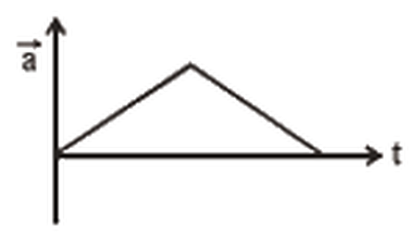

- All the graphs below are intended to represent the same motion. One of them does it incorrectly. Pick it up:
(A) 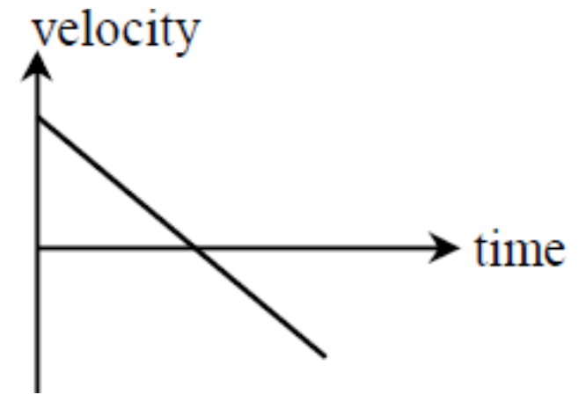 (B) 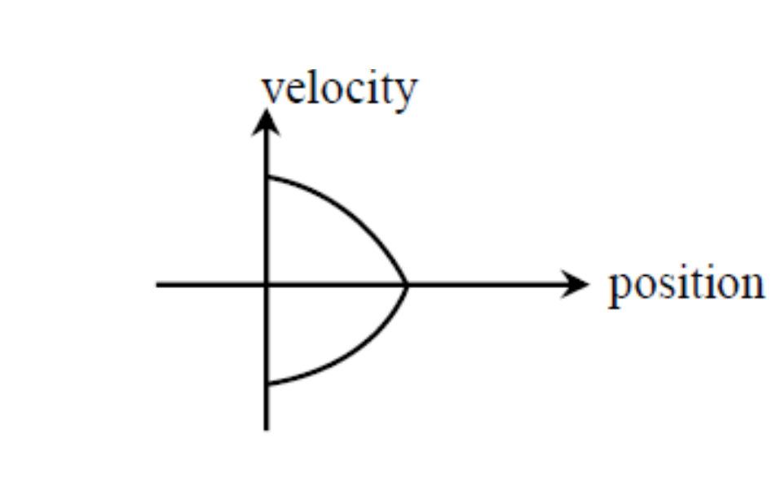
(C) 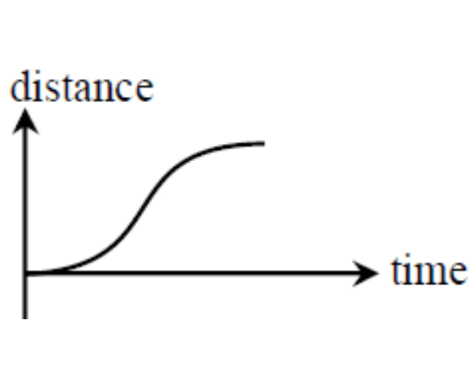 (D) 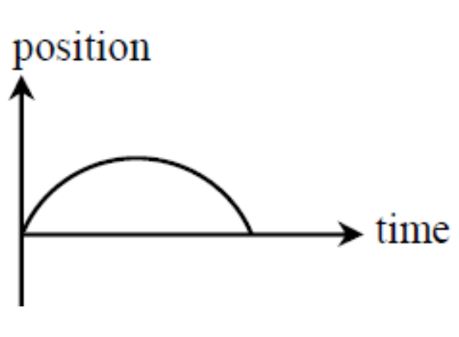

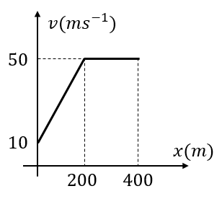
- [JEE Main 2021, 16 Mar, Shift 1] The velocity-displacement graph describing the motion of a bicycle is shown in the figure. The acceleration–displacement graph of the bicycle's motion is best described by:

(A) 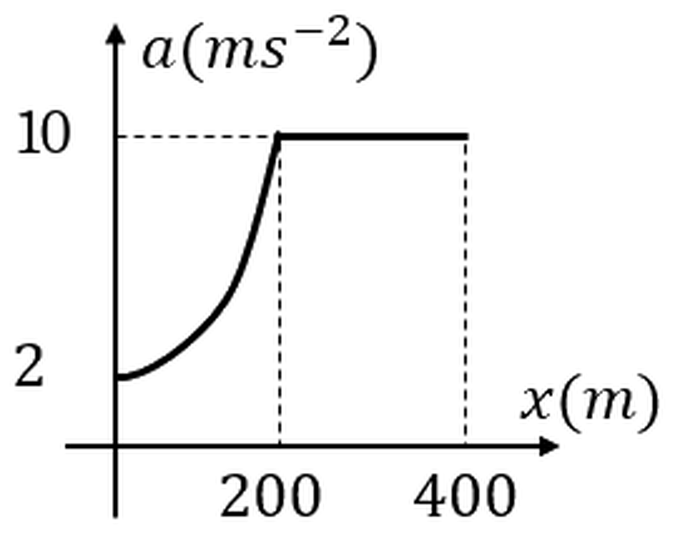 (B) 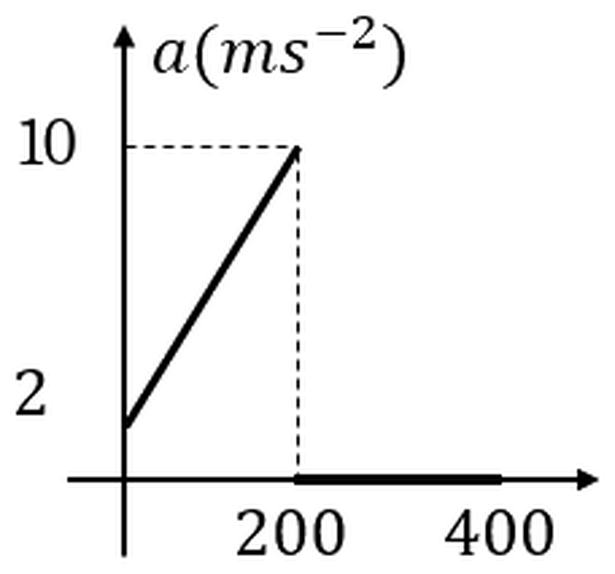
(C) 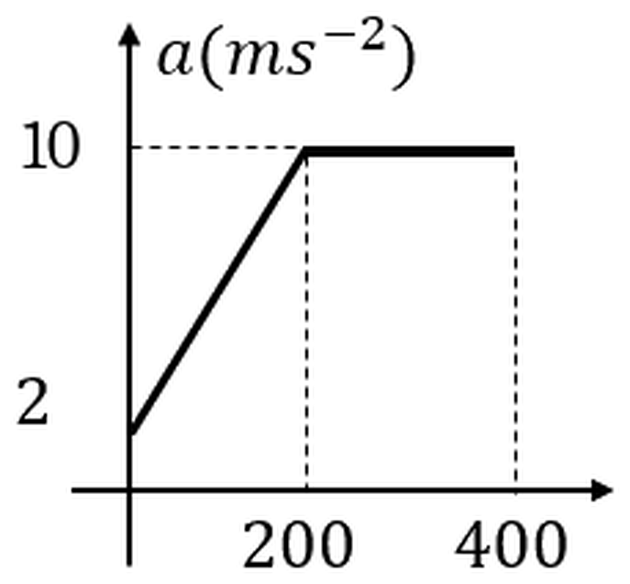 (D) 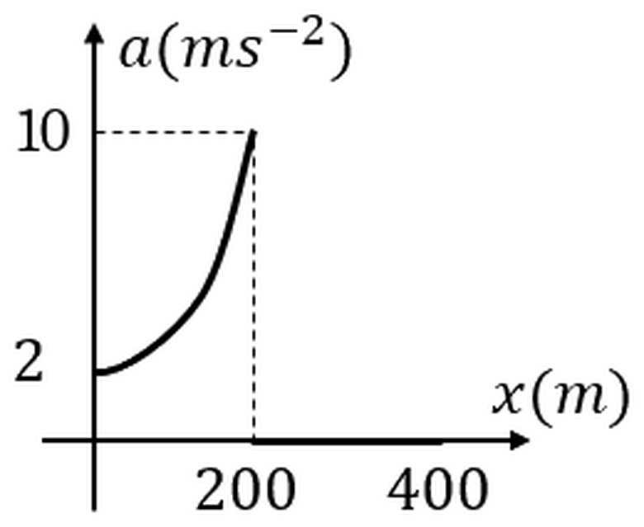

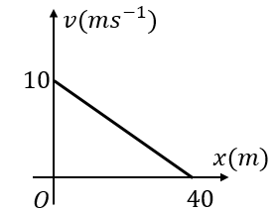
- The velocity – displacement graph of a particle moving along x–axis is shown. The particle starts at t = 0 from the origin.
The equation of velocity and acceleration as function of position is?

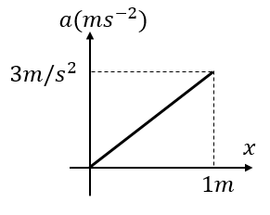
- The acceleration of a particle which moves along the positive x-axis varies with its position as shown. If the velocity of the particle is zero at x =0, then find the velocity at x = 1m?
(A) 3 m/s (B) 2 m/s
(C) 1 m/s (D) $\sqrt{3}$ m/s

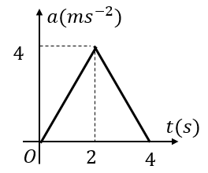
- Acceleration–time graph of a particle moving in a straight line is shown in the figure. Velocity of a particle at time t = 0 is 2 m/s. Find velocity at the end of fourth second.
(A) 16 m/s (B) 8 m/s
(C) 10 m/s (D) 4 m/s

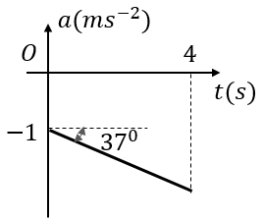
- The acceleration – time graph of a particle moving along a straight line is shown. The initial velocity is 8 m/s. What is the velocity at $t=4 sec?$
(A) 18 m/s (B)10 m/s
(C) 2 m/s (D) -2 m/s

- [L3] [JEE Main 2020, 4 Sep, Shift 1] A tennis ball is released from a height ‘h’ and it rebounds to a height ‘h/2’ after hitting the floor. Which of the following graphs best represent the velocity-height of the ball?
(A) 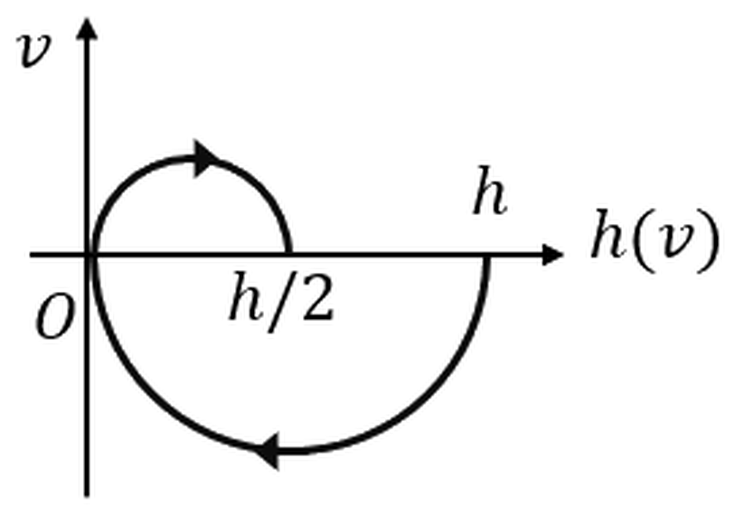 (B) 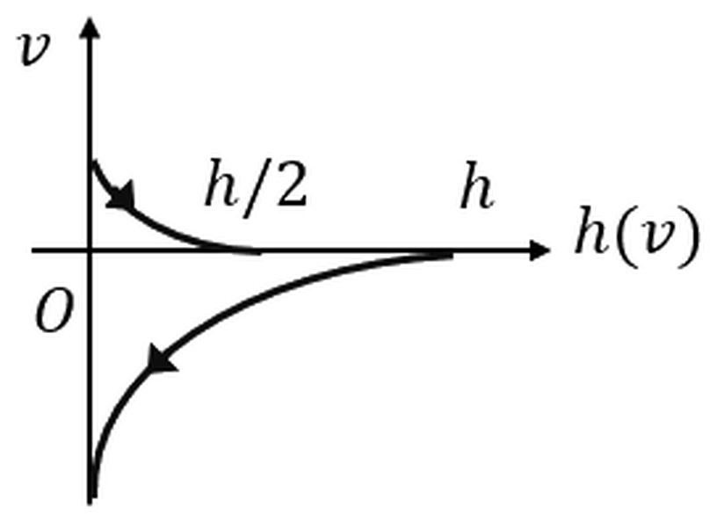
(C) 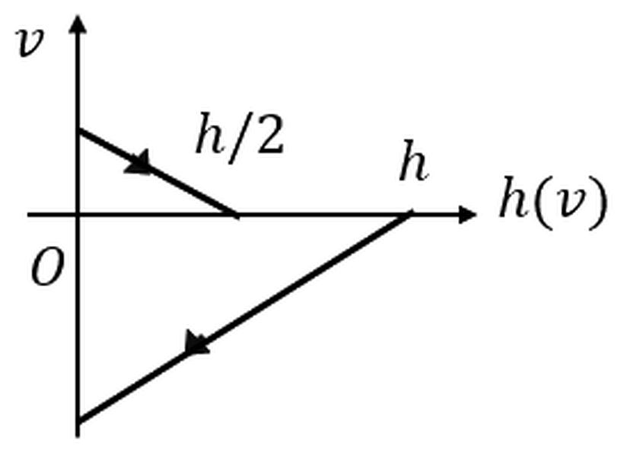 (D) 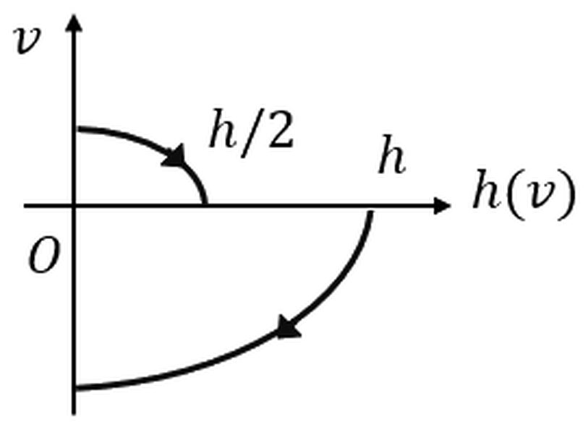

Relative Motion in 1D
- Two cars are travelling in the same direction with a velocity of 60 km/h. They are separated by a distance of 5 km. A truck moving in opposite direction meets the two cars in a time interval of 3 minutes. The velocity of the truck is?
(A) 40 km/h (B) 36 km/h (C) 30 km/h (D) 24 km/h
- [JEE Main 2020, 2 Sep, Shift 1] Trains A and B are running on parallel tracks in the opposite directions with speeds of 36 km/h and 72 km/h respectively. A person is walking in train A in the opposite direction to its motion with a speed of 1.8 km/h. Speed (in m/s) of this person as observed from train B will be close to? (the distance between tracks is negligible)
(A) 28.5 (B) 30.5 (C) 29.5 (D) 31.5
- [JEE Main 2019, 12 Jan, Shift 1] A passenger train of length 60 m travels at a speed of 80 km/h. Another freight train of length 120 m travels at a speed of 30 km/h. The ratio of time taken by the passenger train to completely cross the freight train when: (i) they are moving in the same direction and (ii) in the opposite direction is:
(A) 3/2 (B) 25/11 (C) 11/5 (D) 5/2
- A man in a balloon, throws a stone downwards with a speed of 4 m/s with respect to balloon. The balloon is moving upwards with a constant acceleration of 5 m/$s^{2}$ . What will the distance between the stone and the balloon after 2 seconds?
(A) 8 m (B) 18 m (C) 28 m (D) 38 m
- A lift having floor to ceiling distance of 2.7 m, starts ascending with a constant acceleration of 2 m/$s^{2}$. Two seconds after it starts, a bolt begins to fall from the ceiling. Find the free fall time of the bolt (time to strike the floor of the lift).
(A) $\sqrt{9/10}$ sec (B) $\sqrt{9/20}$ sec (C) $\sqrt{3/5}$ sec (D) $\sqrt{3/8}$ sec
- [JEE Main 2020, 8 Jan, Shift 1] A particle is moving along x-axis with its coordinates given by $x\left(t\right)=10+8t-3t^{2}$. Another particle is moving along y-axis with its coordinates given by $y\left(t\right)=5-8t^{3}$. At t = 1 s, the speed of the second particle as measured in the frame of first particle is given as $\sqrt{v}$. Then v in m/s is:

Answer Key
Distance, Displacement, Speed & Velocity
Q1 | π cm;$2\sqrt{2}$ cm (from the 12 mark to the 3 mark) | Q2 | $R\sqrt{π^{2}+4}$ | Q3 | 5 m/s, along AD
Q4 | C | Q5 | B | Q6 | B
Q7 | 4 m/s | Q8 | 1.8 v | Q9 | D
Q10 | 5 m
Equations of Uniformly Accelerated Motion
Q11 | AD | Q12 | B | Q13 | D
Q14 | n²s | Q15 | D | Q16 | 1 cm
Q17 | $\sqrt{\frac{u^{2}+v^{2}}{2}}$
Free Fall & Vertical Throw
Q18 | 4 m/s | Q19 | 125 m | Q20 | D
Q21 | 3h/4 | Q22 | B | Q23 | B
Q24 | $\frac{1}{2}g(t_{1}t_{2})$ | Q25 | D | Q26 | A
Q27 | B | Q28 | $t_{3}=\sqrt{t_{1}t_{2}}$ | Q29 | C
Q30 | B | Q31 | g downwards | Q32 | $t_{a}=\frac{u}{g+a}$; $t_{d}=\frac{u}{\sqrt{g^{2}−a^{2}}}$; Max height H: $\frac{u^{2}}{2\left(g+a\right)}$; Speed at C: $\sqrt{2\left(g-a\right)H}=u\sqrt{\frac{g-a}{g+a}}$; (v) Point D: the speed at D (going up) is greater than at E (coming down), because the retarding acceleration removes speed throughout the flight
Q33 | A
Two-Body & Multi-Phase Motion
Q34 | 2T; 1:2; $3\left(\frac{1}{2}aT^{2}\right);\frac{1}{2}aT$ | Q35 | $\frac{β}{α+β}$T; $\frac{αβ}{α+β}$T; $\frac{αβ}{2(α+β)}T^{2}$; $\frac{αβ}{2(α+β)}T$ | Q36 | 2$\sqrt{d/a}$
Q37 | C | Q38 | $\frac{2\left(u_{1}-u_{2}\right)}{{\left(β-α\right)}^{2}}(u_{1}β-u_{2}α)$ | Q39 | D
Q40 | C | Q41 | 25 m | Q42 | C
Q43 | B | Q44 | B | Q45 | D
Q46 | H-40 | Q47 | 0.5 s | Q48 | D
Q49 | $$(1+\sqrt{2})\sqrt{\frac{2h}{g}}$$ | Q50 | C | Q51 | A
Q52 | D | Q53 | A | Q54 | C
Q55 | B | Q56 | D
Variable Acceleration (Calculus)
Q57 | C | Q58 | A | Q59 | B
Q60 | A | Q61 | C | Q62 | B
Q63 | A | Q64 | C | Q65 | A
Q66 | A | Q67 | B | Q68 | B
Q69 | D | Q70 | 0, 5 | Q71 | D
Q72 | D | Q73 | A | Q74 | B
Q75 | 15 m/s, 80/9 m
Motion Graphs: x–t & v–t
Q76 | D | Q77 | A | Q78 | D
Q79 | C | Q80 | A
Motion Graphs: a–t, v–x, a–x & Conversion
Q81 | C | Q82 | D | Q83 | B
Q84 | C | Q85 | B | Q86 | $$v=-\frac{x}{4}+10;a=\frac{x}{16}-5/2$$
Q87 | D | Q88 | C | Q89 | D
Q90 | D
Relative Motion in 1D
Q91 | A | Q92 | C | Q93 | C
Q94 | D | Q95 | B | Q96 | 580

Hints & Solutions
Distance, Displacement, Speed & Velocity
Q1 Hint
Distance travelled is equal to length of the arc and displacement is along the chord
Q2 Hint
Horizontal component of displacement is equal to half the perimeter
Q7 Hint
Average speed for the second half of the journey (equal time): 6 m/s
Average speed for first and second half at 3 m/s and 6 m/s: 4 m/s
Q9 Solution
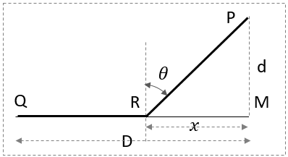
Here D and d are constant.
Let the path be QRP, where RM = $x$ is the variable
The time taken (T) to traverse QRP is a function of $x$
$$T=\frac{D-x}{v}+\frac{2\sqrt{d^{2}+x^{2}}}{v}$$
For time to be minimum $\frac{dT}{dx}=0$
Q10 Hint
Imagine flattening out two adjacent wall like a cardboard box, then minimum distance is along the diagonal
Equations of Uniformly Accelerated Motion
Q12 Hint
Note: Difference in displacements during equal successive time intervals $(∆t)$ is constant = $a{(∆t)}^{2}$
Q13 Solution
Similar to Q12: $a=-4m/s^{2}$ as $∆t=1 s$
Average velocity is AM of start and end velocity for $\frac{v_{0}+v_{1}}{2}=18 m/s$; and $v_{1}-v_{0}=a=-4$
Gives $v_{0}=20 m/s$
Time reversal: from rest, distances in successive seconds are 2, 6, 10, 14, 18 m (a/2 × 1, 3, 5, 7, 9). After 18, 14 and 10 m come 6 m and 2 m, so the particle travels 8 m more and stops exactly at t = 5 s. (Or: v₃ = 20 − 3 × 4 = 8 m/s, and 8²/(2 × 4) = 8 m.)
Q15 Hint
Stopping distance after braking + distance travelled during reaction time ($40δt)$ = 120 m
Q16 Solution
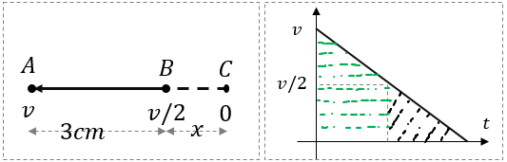
Method 1: Visualize motion in reverse order
Starting from C
Then time to travel C to B = time from B to A
(as change in velocities are equal)
Hence 3 cm = 3 times $x$
Method 2: $v-t$ graph:
Area of small triangle will be one fourth of area under triangle + trapezium
Free Fall & Vertical Throw
Q19 Hint
Let the total time of fall be T. Distance in the last second = average velocity over that second = velocity at (T − 0.5) s
Or $g\left(T-0.5\right)=\frac{1}{2}g{\left(3\right)}^{2}$
Q20 Hint
Average speed $\frac{1}{2}(v_{t}+v_{b})$ is 6 m/s and $v_{b}-v_{t}=5 m/s$
Q22 Hint
Speed at height of 80 m is 30 m/s as the times of ascent / descent is 3 s
Q24 Hint
The total time of flight is $T=(t_{1}+t_{2})$ or $u=gT/2$
Q26 Solution
The stone comes to a momentary rest and reverses its direction of motion at time $v_{0}/g$.
Hence distance travelled = distance travelled during upward motion ( t = 0 to t = $\frac{v_{0}}{g})$ =$\frac{v_{0}^{2}}{2g}$
+ distance fallen between time $v_{0}/g$ and $\frac{{4v}_{0}}{3g}=$( $\frac{1}{2}g{\left(\frac{v_{0}}{3g}\right)}^{2})$
Q32 Hint
Net downward acceleration during upward motion (A – B): $(g+a)$, and $(g-a)$ during downward motion.
Two-Body & Multi-Phase Motion
Q37 Hint
Use area under $v-t$graph
Q38 Hint
Let the time to finish the race be $T$: then $u_{1}T+\frac{1}{2}αT^{2}=u_{2}T+\frac{1}{2}βT^{2}=R$
Q39 Solution
Displacement of cyclist has to be 96 m compared to displacement of bus at time t
Or $20t-\frac{1}{2}×2×t^{2}=96$; has two positive real roots
First cyclist will overtake the bus at t = 8 sec when the speed of bus is 16 m/s (less than cyclist)
Then at t = 12 s the bus will overtake the cyclist with bus having speed of 24 m/s
Q43 Hint
Velocity of A at 4.5 s after its motion started = Velocity of B at 2.5 s after its motion has started
Q47 Hint
The fifth throw involves the first ball which is 2 sec after the first throw (equal to time of flight). First at 0 s, second 0.5 s, third 1 s, fourth 1.5 s, fifth 2 s (soon after it reaches the juggler)
Q48 Hint
Acceleration is 10 m/s² upward during first 60 s resulting in displacement of 18,000 m and final velocity of 600 m/s. Thereafter, the acceleration will be 10 m/s² downward (like a projectile) resulting in further rise of $\frac{{600}^{2}}{2×10}$
Q55 Solution
The speed gained by ball A will be equal to speed lost by B at any instant
If speed of B at the instant of collision is u, then speed of A will be 2u
Speed of projection of B = u + Speed lost (2u) = 3u
Average speed of A: u and average speed of B is 2u hence B will travel 2/3 of the distance
Variable Acceleration (Calculus)
Q63 Hint
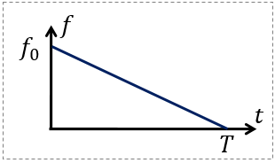
The acceleration is a linear function of time as shown
The area under the graph will give change in velocity
Q65 Hint
Differentiating wrt t: $1=2αx\frac{dx}{dt}+β\frac{dx}{dt}$ or $v=\frac{1}{2αx+β}$
Differentiating again and substituting v: $a=-2αv^{3}$ $-$ve for retardation
Q66 Hint
$\frac{dv}{dx}=-2nβx^{-2n-1}$; hence $a=v\frac{dv}{dx}=(βx^{-2n})(-2nβx^{-2n-1})$
Q70 Hint
$v\left(t\right)=2t-10$; the particle reverses its direction of motion at t = 5 s;
$x\left(0\right)=10, x\left(5\right)=-15 and x\left(10\right)=10$;
Q72 Hint
Comparing with a uniformly accelerated motion $v=\sqrt{u^{2}+2ax}$; $u=0 and v=α\sqrt{S}$
Average velocity = $\frac{\left(u+v\right)}{2}$
Q73 Solution
Average velocity during a time interval = (Displacement / time)
$\frac{dv}{dt}=a_{0}(1-\frac{t}{T})$; on integration $v=a_{0}(t-\frac{t^{2}}{2T})$
Further integration $∆x=a_{0}\frac{T^{2}}{3}$
Q74 Hint
As the problem requires relationship between $v and x$: use $a=v\frac{dv}{dx}=-k\sqrt{v}$
Q75 Hint
Here $a=5-\frac{5}{6}t$ Speed $v$ is maximum when $\frac{dv}{dt}=a=0$; i.e., at $t=6s$
On integrating twice $x=\frac{5t^{2}}{2}-\frac{5t^{3}}{36}$
Motion Graphs: x–t & v–t
Q77 Hint
Displacements: 0 – 2 sec: +$8m$; 2 – 4 sec: $-4m$ and 4 – 6 sec: $+4m$;
Distance travelled is sum of magnitude of displacements
Q80 Solution
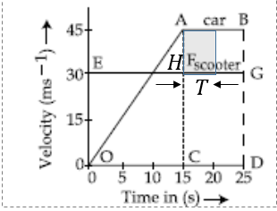
Use area under the $v-t$graph: respective displacement (unidirectional motion)
(i) Difference in area OHCO and OAC: 112.5 m (scooter ahead)
(ii) After 15 sec, the car starts to close the gap @ 15 m/s
Hence it will catch up after $\frac{112.5}{15} sec$ (shaded area)
Or after 22.5 sec after the start
Motion Graphs: a–t, v–x, a–x & Conversion
Q81 Hint
Note: $x-t$ graph is $-sin$ curve and $v-t$ graph will be its derivative
Q82 Think further
Draw the x–t and a–t graphs for the v–t graph in option A.
Q83 Hint
A-M: uniform deceleration and M-B: uniform acceleration
Q84 Hint
Other three represent a vertical projectile with instantaneous rest at highest point. Option C has max slope at mid-point (implying maximum speed) which doesn’t match with the rest
Q85 Hint
Key Concept: 0 – 200 m, straight line $→$ $\frac{dv}{dx}$ is constant; hence use $a=v\frac{dv}{dx}=v×constant$
Here v = 10 + 0.2x, so a = 0.2v = 2 + 0.04x: a straight line rising from 2 m/s² at x = 0 to 10 m/s² at x = 200 m; beyond 200 m, v is constant and a = 0.
Q88 Hint
Area under $a-t$ graph during a time interval $0$ to $t$ $≠$ $v$ but $=v_{t}-v_{0}$ (change in velocity)
Q90 Solution
Let us focus on downward motion (fall from h) with $x$ being the distance fallen
Option B: the speed increases at increasing rate as it falls (slope of tangent gets steeper as ‘h’ decreases)
Option C: speed increases linearly
Option D: it increases at decreasing rate
The key is to find the relationship between $v-x$ which is $v=\sqrt{2gx}$
$\frac{dv}{dx} ∝\frac{1}{\sqrt{x}}$ or the velocity will keep increasing at decreasing rate (increase in speed for a unit fall will keep decreasing as it falls)

