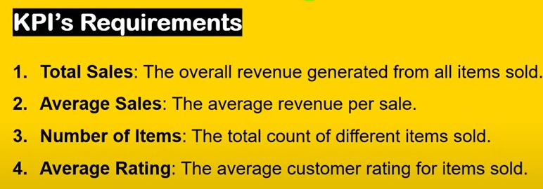**Instructions**

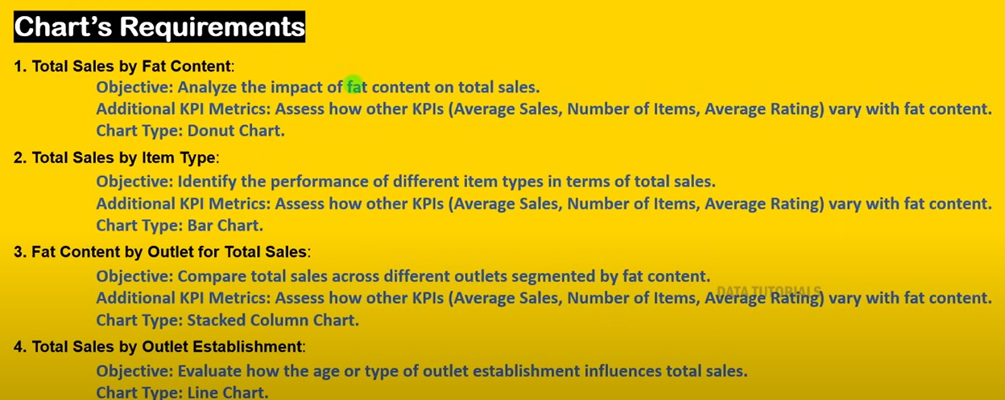

1. Import and load Grocery Data
2. See your data in table view and in data (numerical type of data)
3. Transform data
4. Quality check-**View column quality**
5. Home-Replace values
6. Home-Close and apply
7. Canvas Transparency-Keep 40% in canvas background
8. Insert>Shapes>**Rounded tab both top**
9. Click on shape

* Select shape>20 % rounded top corners
* select rotation >shape>90 degree
* Select Style-Colors>#FFD200
* Borders-off, shadow on
* Click on General >Properties> Height-750, width-205

1. Name a dashboard-Insert>Text box-Type blinkit-Font size36 and type-Segoe(Bold)
2. General >Effects>background off
3. Select”it” and colour as Green #008315
4. Insert>Text box-Type india’s last Minute App, Font size 10 and type-Segoe UI and then Bold
5. **Creation of Measures**

**Home >Enter Data>Column Name-Measures>Load**

1. Click on measures>New Measures-Total Sales- SUM('BlinkIT Grocery Data'[Sales])
2. Click on measures>New Measures -Average Sales=AVERAGE('BlinkIT Grocery Data'[Sales] )
3. Click on measures>New Measures- No of items = COUNTROWS('BlinkIT Grocery Data')
4. Click on measures>New Measures-Average Rating = AVERAGE('BlinkIT Grocery Data'[Rating])
5. Select visualization-Card New> add all measures
6. Double click the card

* Click on visual>Layout>Select Arrangement-Grid, Max rows and columns shown as 2 each, space between cards is 0,
* now go in general>Properties>size>ht 270, width 570
* Click on visual>call out values>values>font >seogoeUI Bold and font size 21, left alignment and in call out values >label>position below value, space between label and cards is 0

1. Double click the card >Build Visual>Data>Double click> Changes Names in Caps
2. Double click the card>Click on visual>Cards >shape>rounded rectangle, rounded corners 10, padding -wide, background-40% transparency, shadow on,border-off,Accent bar -on, colour Green, width 5 px
3. Click on visual>Cards>Series>Total Sales, Background>Background Image,image fit as fit and transparency-40
4. Click on visual>Images-Series-Total Sales>images-on, select images for each one by one, position-right of text, vertical alignment-Top, Space between image and lable-5 px, size-25
5. Click on visual>call out values>Series-Total Sales-Display units as millions, for average sales,no of items display units as none and value decimal places as 0, for average rating display units as none and value decimal places as 1
6. Click on measures-Measures tool- Total sales and average sales add symbol $ and decimal 2 places
7. **Charts**

* Insert rounded rectangle
* Double click , in shape, rounded corners as 3 and in style fill color is white and transparency 10 %, Border -color 30% darker, shadow on
* Donut Chart-Total Sales and fat content, but need more parameters
* Modelling-New parameter and field, add all measure values
* Double click on slicer and go into visual>slicer settings>style >tile, slicer header off,, then go in general>properties>size-ht-40, width 465
* Double click on slicer and go into visual>values>seogoe UI bold and 9 size, background colour-yellow FFD200

**Donut Chart-Parameters and fat content**

**Customization->Visual**

* Legend>Top Left, title-off, text-8, colour black
* Slices>colours>Low Fat-#CDA900, Regular 568949
* Slices>spacing-inner radius-75%
* Detail labels>Label contents>data value and value decimal places-1

**Customization->General**

Title-Text-Fat Content, font same=Segoe and size 10

* **Add New card-Total sales, customize and in call out values, label off and values font size 9**

**Clustered bar chart**

* Y axis—Outlet location type
* x-axis-Parameters
* legend-Item Fat content

**General-Title** Fat by outlet, same font and size 10, properties-Ht 230, width 220

* Effects -Background off

**Visuals**

* Legend-Title off,
* data labels -on
* X axis-Title and value off
* y axis-Title off and value on
* Bars-Low fat and regular fat color change

**Stacked bar chart**

* Y axis—item type
* x-axis-Parameters

**General-Title** Item Type, same font and size 10,

* Background off

**Visuals**

* Legend-off,
* Data labels-on>values>colour black
* Bars color change
* X axis-Title and value off
* y axis-Title off and value on

**Line chart**

* Y axis—Total Sales
* x-axis-Outlet establishment
* **General-Title** Outlet establishment, same font and size 10

**Visuals**

* X and y axis-Title off and value on
* Gridlines off
* Line-interpolation as smooth, smooth type-Monotone, line colour black
* Shade area on, match line -off, new colour, transparency 50%
* and markers on-size 4 pxs
* data labels on, back ground on

**Outlet size-Donut chart**

* Legend-Outlet size
* values total Sales
* **General-Title-Outlet size**
* Visual-Legend on top
* Visual Slices colours

Medium-#73B761

Small-#568949

High-#FFD200

**Sales by outlet location-Funnel chart**

* Category-Outlet location
* values total Sales
* **General-Title-Outlet location**
* Visuals-conversion rate off, colours-show all

Tier 3-#CDA900

Tier 2 -#F0D36B

Tier 1-#ABD4A0

**Matrix**

* Outlet Type
* Total Sales
* No of items
* Average sales
* Average rating
* Items visibility
* Visuals-Layout style as minimal, layout as tabular
* Grid on for horizontal and vertical with width as 10
* Columns and row subtotals -off
* Column and rows sub headers as 9
* Values
* Specific columns

Total Sales #FFD200, Display -Thousands

No of Items #26B103, Display -None

Avg Sales # E19490, Display -None

Avg Rating =# 5583AA, Display -None

Items visibility-F0D36B, Average

Filter-Outlet Location, Drodown,Outlet Size,Item type

Format-Edit interactions-Filter