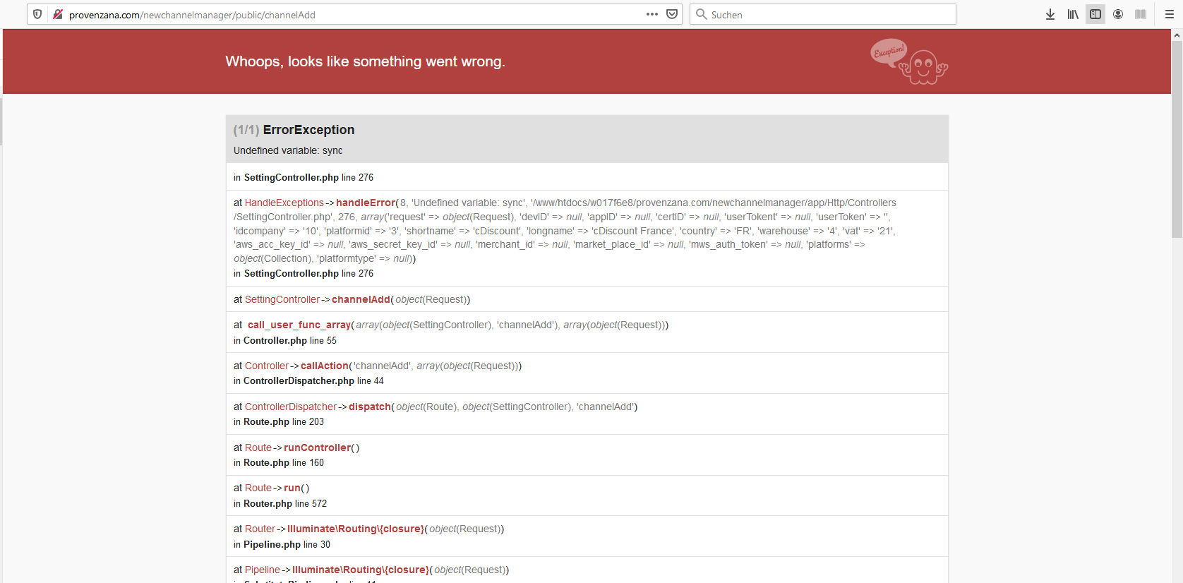[http://provenzana.com/newchannelmanager/public/channelAddView](http://provenzana.com/newchannelmanager/public/channelAddView)

If I try to add a new channel, I get this error

=====================================================================================

Manual order

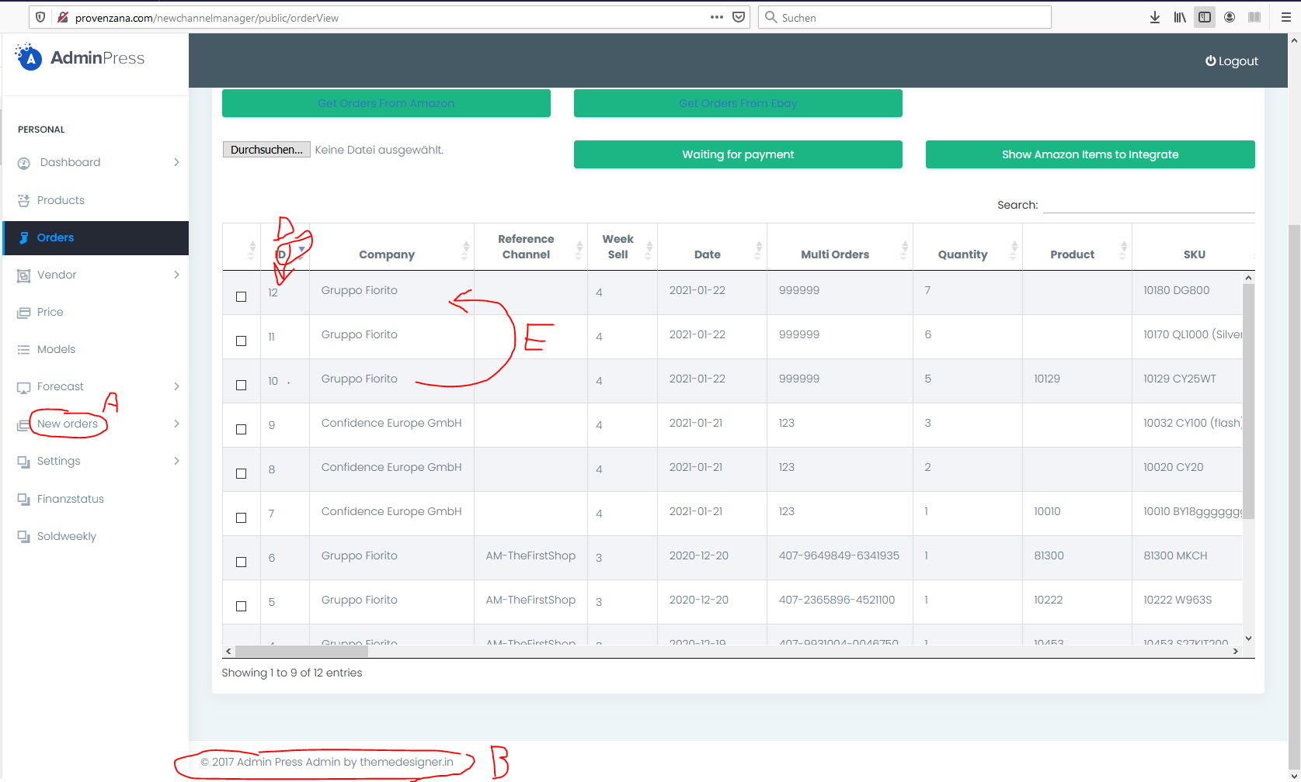

A rename: Manufacturer orders

B © 2021 Semplifat powered by Confidence Europe GmbH

D Sort descending by this column

E Is possible to show in the manual orders the first line with all the cell filled?

-------------------------------------------------

Unitedstore24 amazon

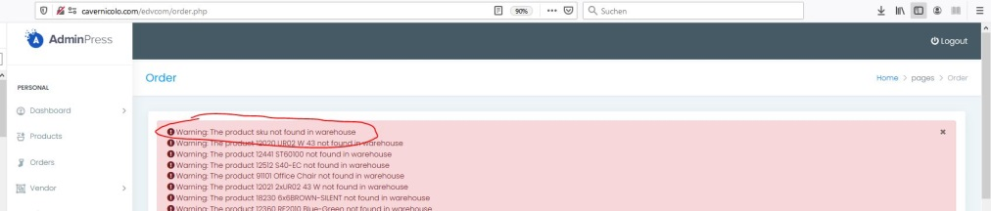

When the system doesn’t find a product, it generate a new line in the database product (this is ok), and let show a message as in the above screenshot about the missing of the product in the database. Now I don’t get more this message!

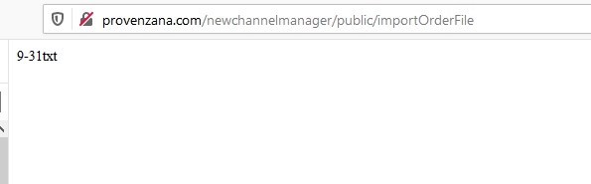

When I upload a file with I get this message

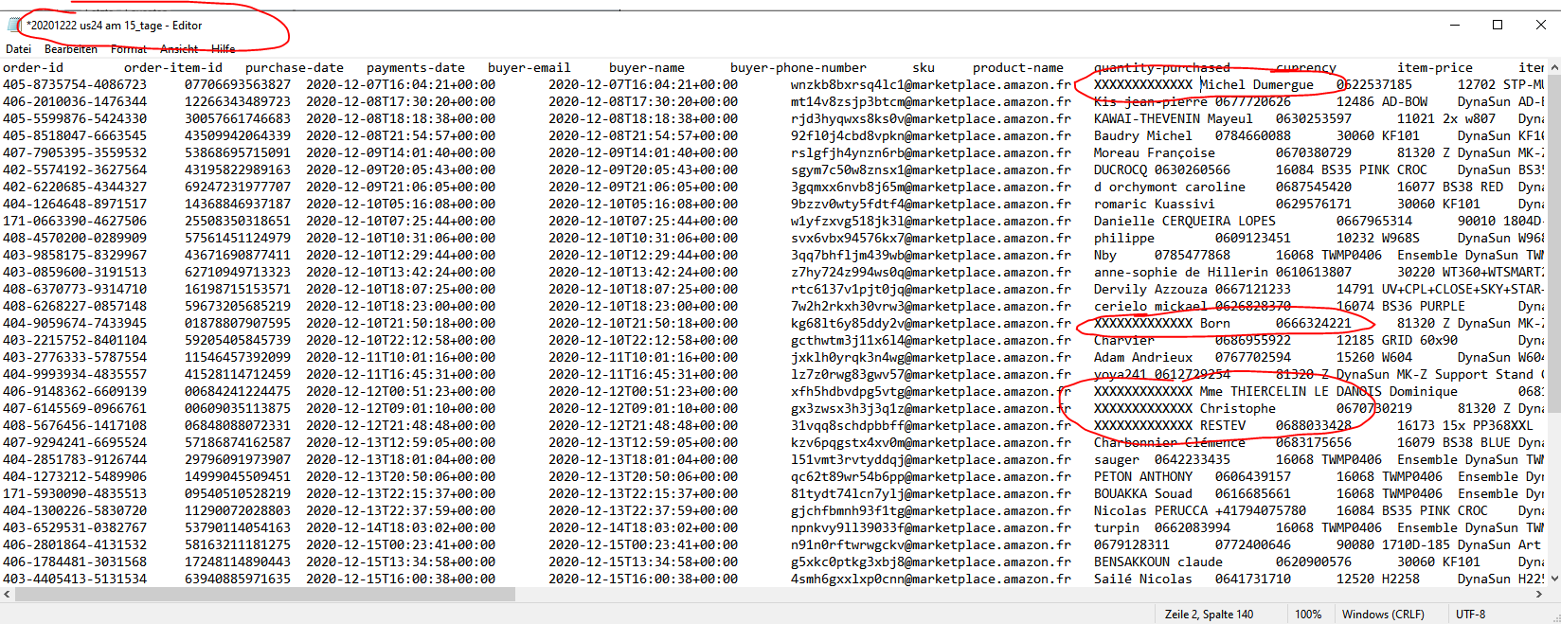

The system didn’t upload these orders! (an old problems that you fixed in the old project)

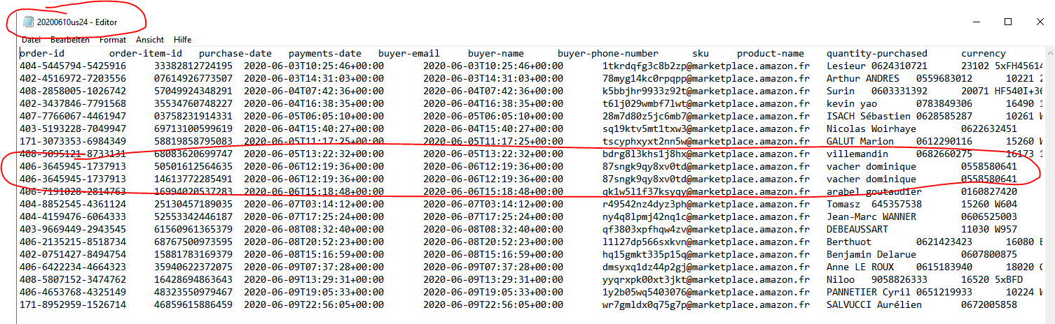

This multiorder is ignored

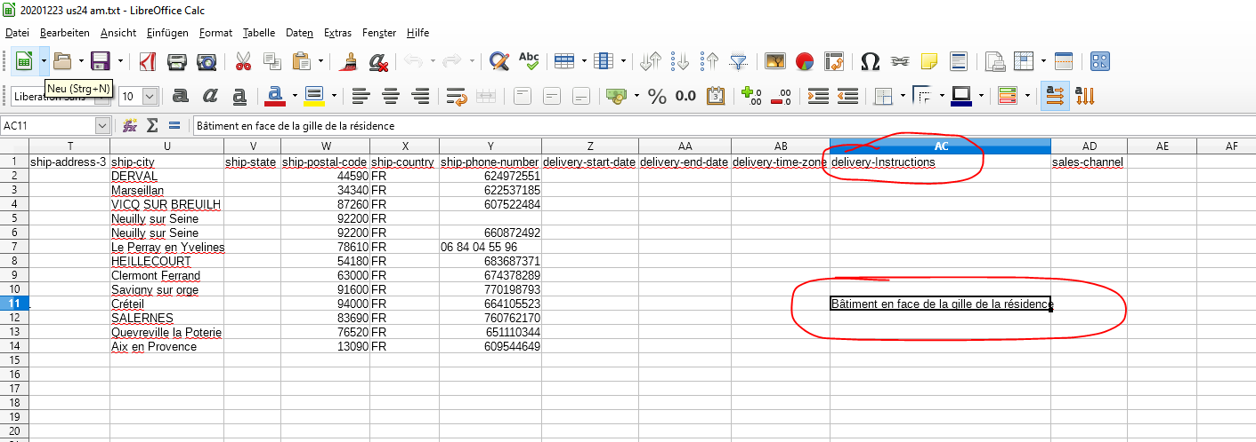

Also in the table of section “order” we have to add at the end this new column. In the page “order” the information is not showed

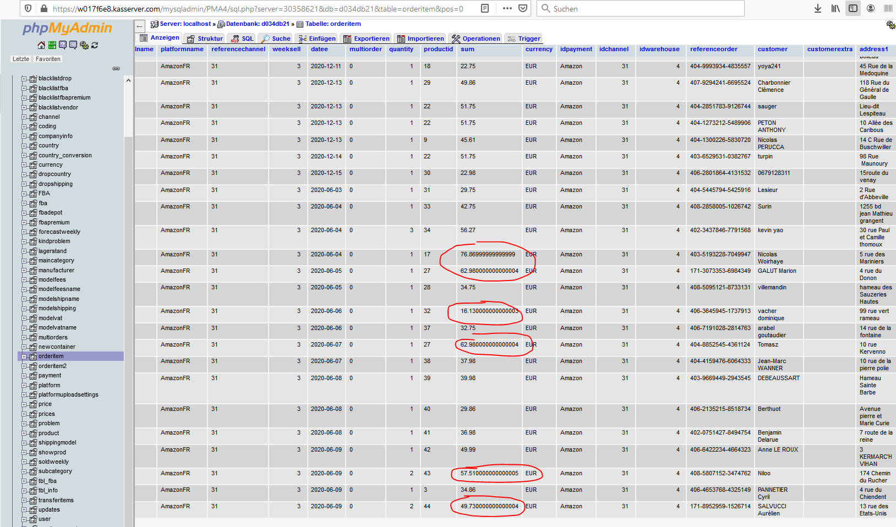

Fix this problem. Should be 76.87 or 62.98 …

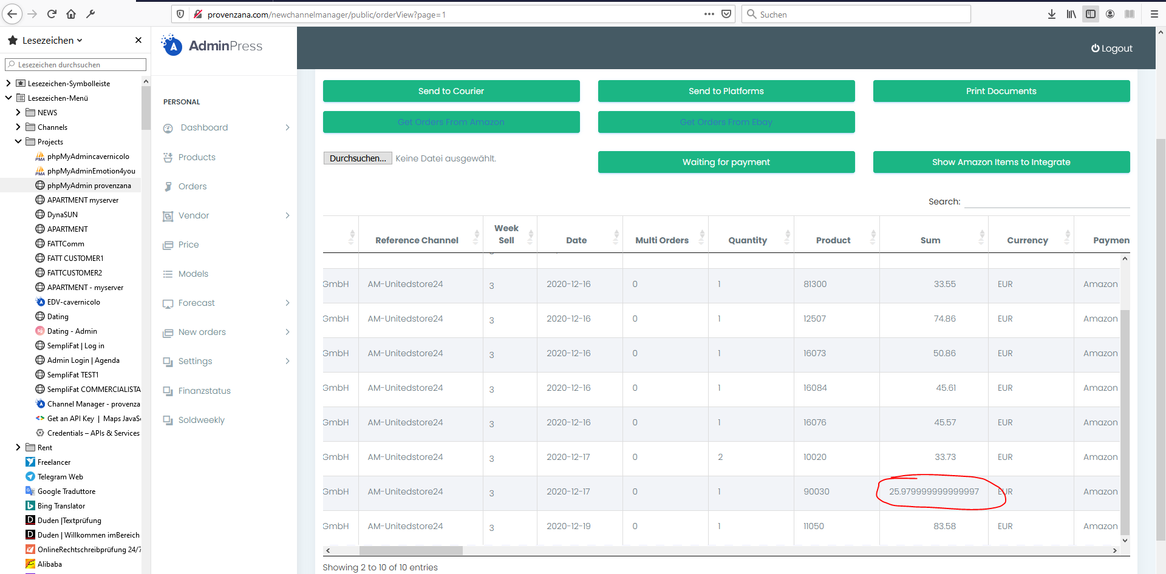

I don’t know why comes this value. Can you check the font? I expect be 25.98 (let put a round value xxxxx.xx format)

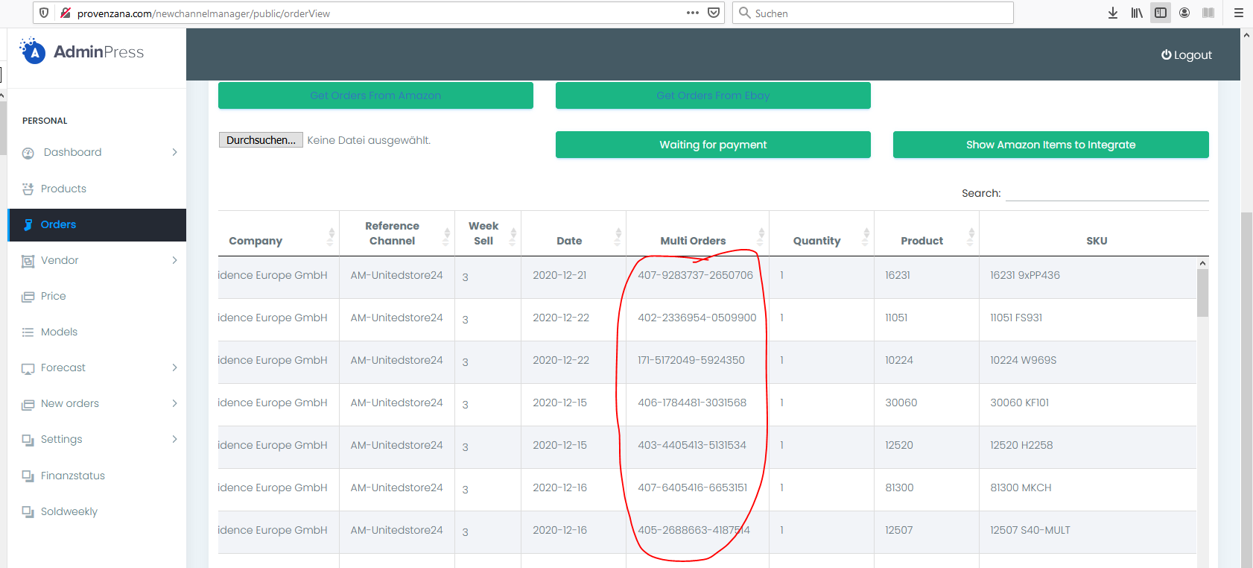

If single order these cells are empty. If is a multiorder, show the ordernumber. In this case are all empty because single orders

-------------------------------------------------

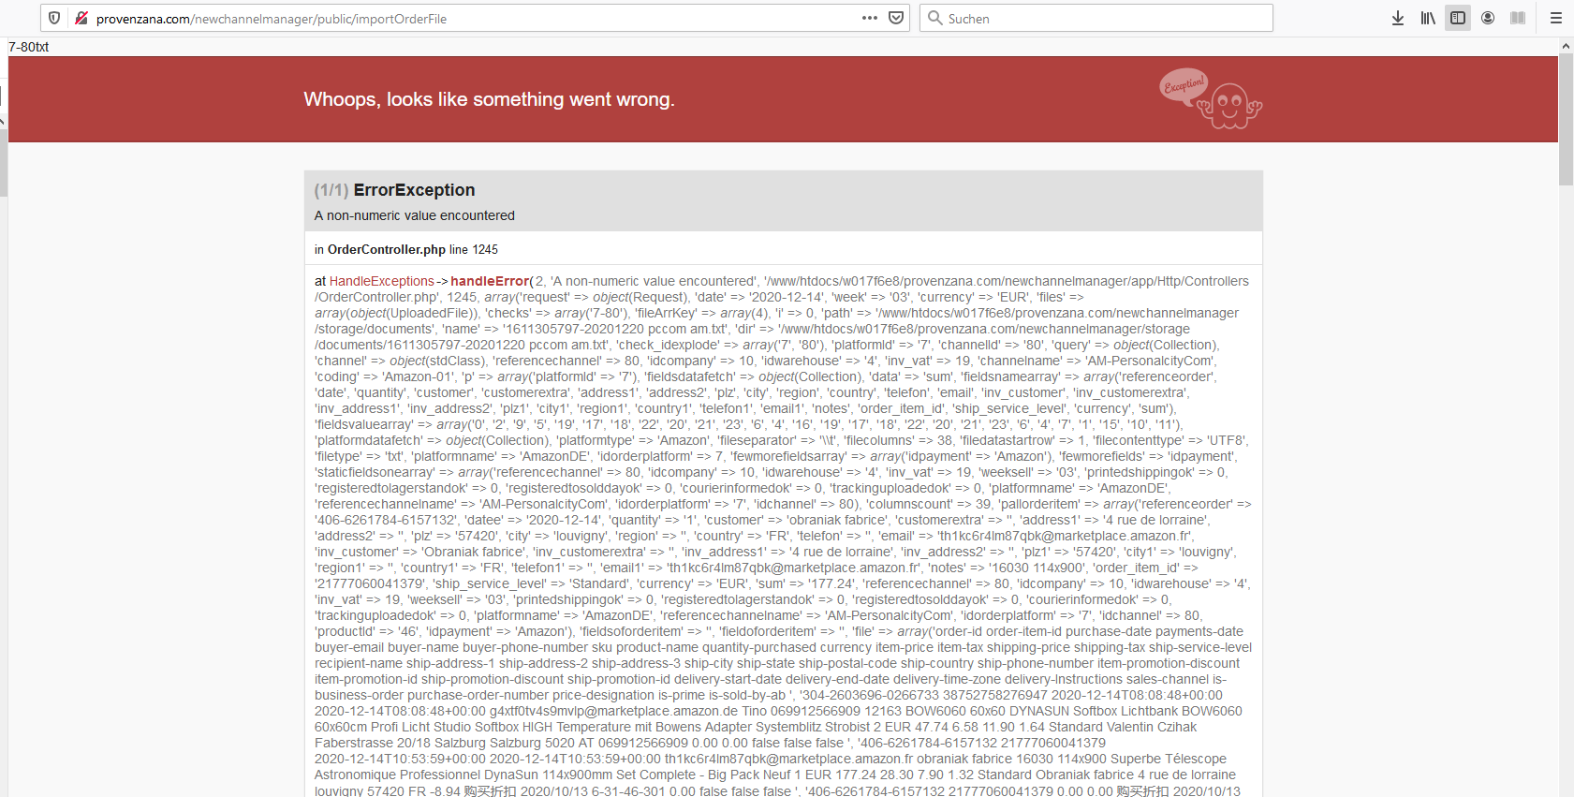

If I try to upload personalcitycom amazon file, I get error

=====================================================================================

EBAY ORDERS

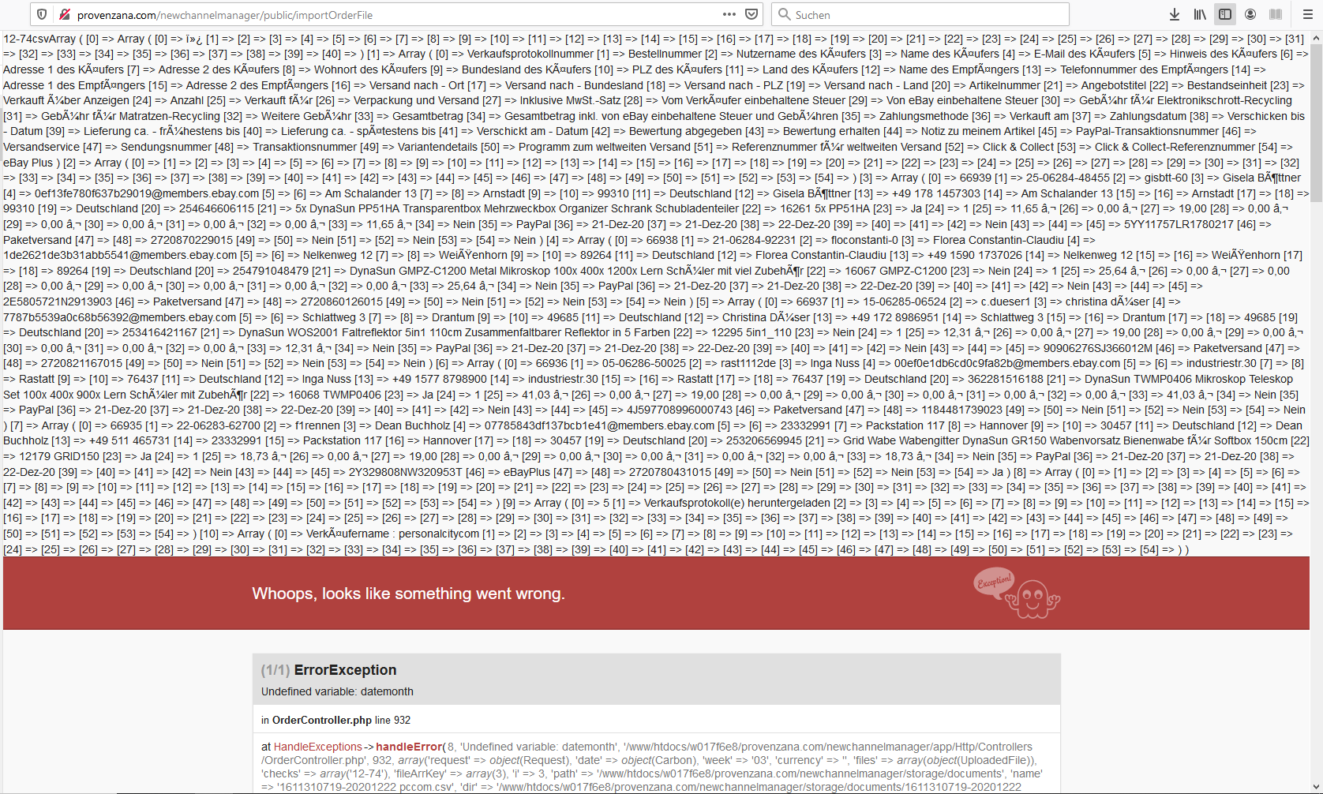

Personalcity ebay I get this errors

Problems with confidenceworld too

Problems with prostudio24 ebay

Cdiscount – I cannot add the channel

=====================================================================================

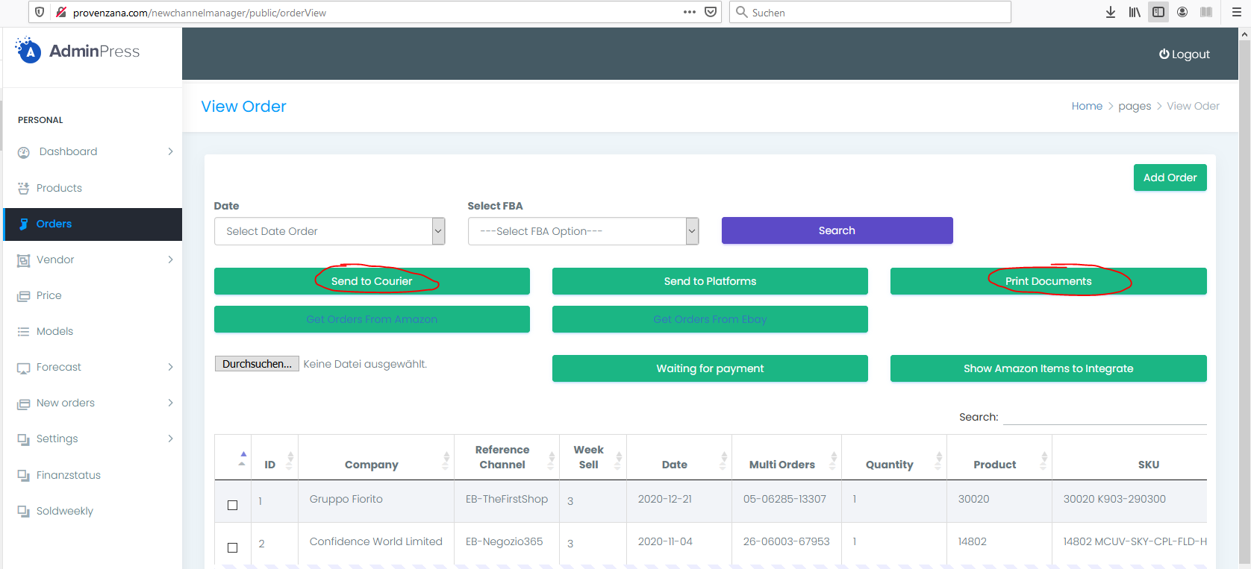

Reactive the 2 sections

=====================================================================================

To do “Finanzstatus” Section

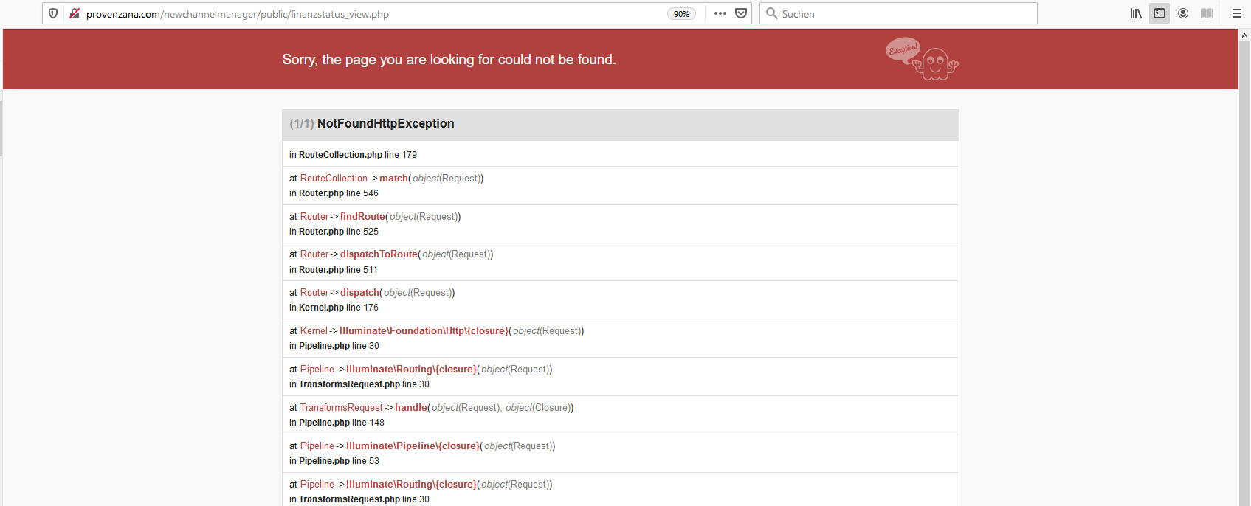

=====================================================================================

To do “Soldweekly” Section

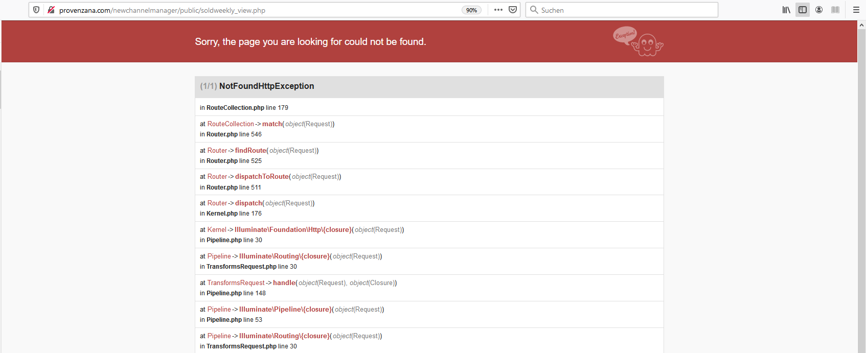

=====================================================================================

To do FBA Section

=====================================================================================

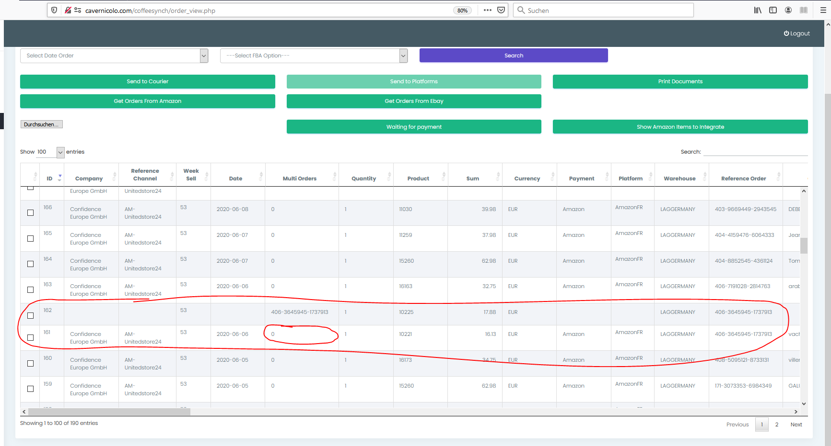

Unitedstore24 amazon, the multiorder is wrong

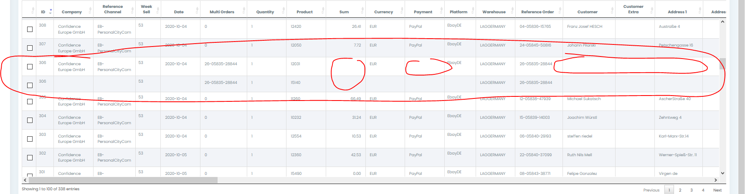

Personalcitycom ebay, are missing some cells

Problems with prostudio24 ebay

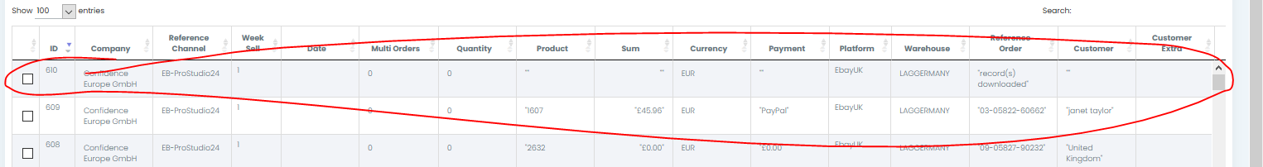

This line should not be here

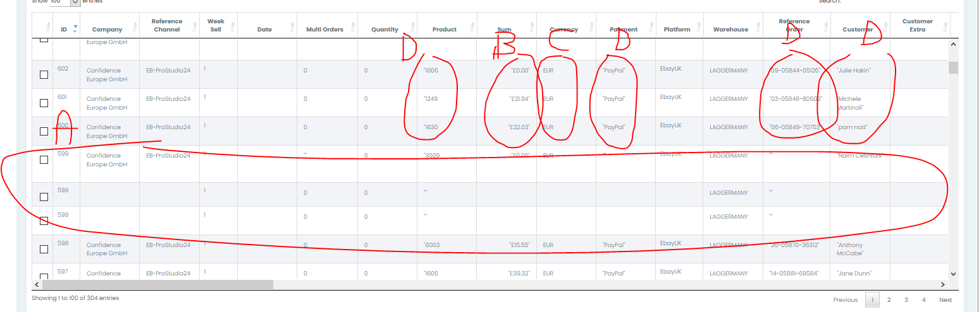

A

Thes 3 lines are effectively only one order (one line should be)

B

Here shouldn’t be the “Sterlin” symbol, only the value

C

Here should be Sterlin, and not Euro

D

Comes in many cells the symbol “ ‘ “. It should not be to see

=====================================================================================

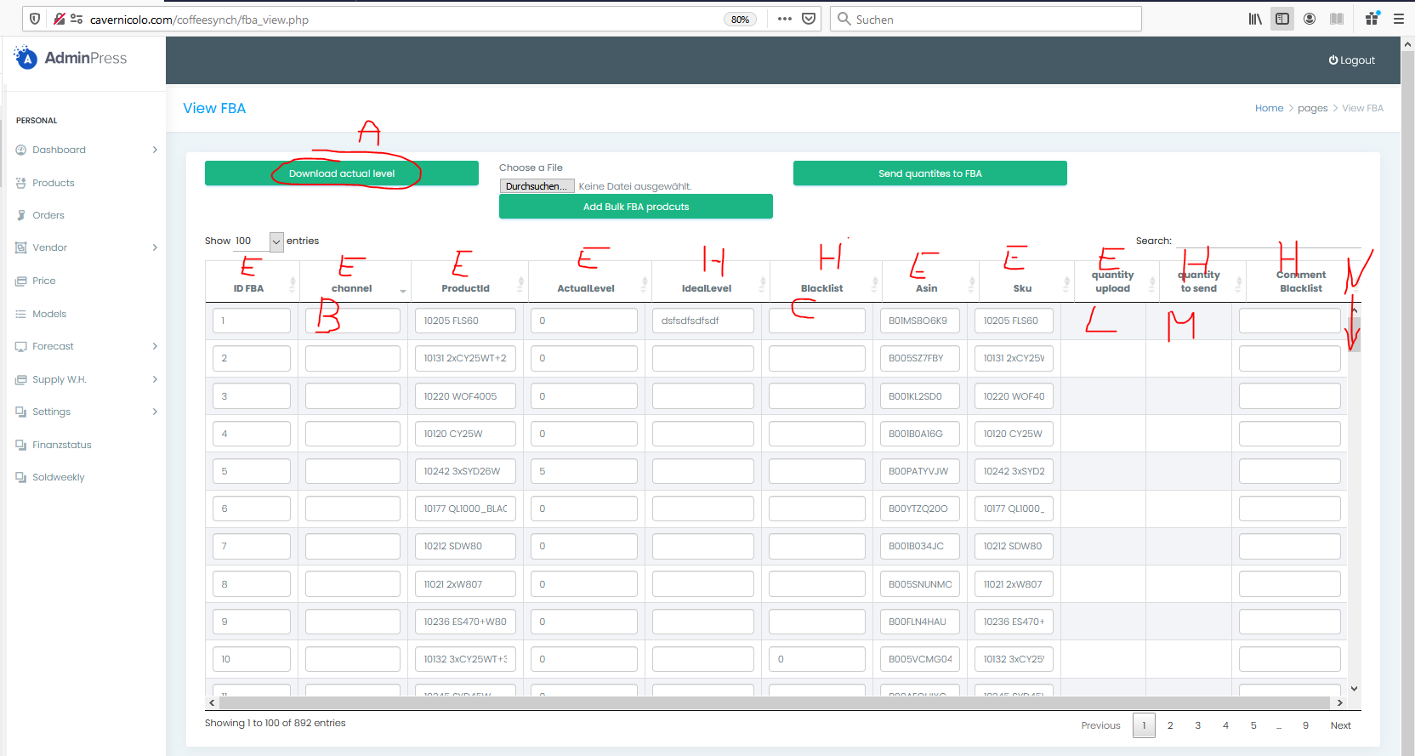

A

When I click on “A” the system should ask me which Channel I want to upload

Then all the products in the database “tbl_fba” related to the selected channel will be set the column “Active” to 0

As next step will be trasfered the information of the uploaded file to the database with these logic:

If the product (ASIN) to the related channel exist, then upload the value of actual level. Set also Active on 1

If the product (ASIN) to the related channel don’t exist, then create a new line, put the info and set also Active on 1

B

Here comes the channel selected

C

Here come a selector Yes/No (Yes=1, No=0)

L

Here put the formulas as discussed

M

Here put the same values as L, but the cell is editable

=====================================================================================