Optimal Traffic Light Signaling Based on Genetic Algorithm Approach

   Alok Yadav 58090001

**Introduction**

Traffic congestion is a globally occurring problem that results in a massive waste of resources. More than often, the congestion is repetitive and occurs as a result of the increase in inflow from certain sources. Current traffic management methods are far from efficient. As of right now, in Bangkok, the traffic signal timings are constant. They don’t change depending on the traffic conditions. Managing traffic signal timings based on traffic conditions is an efficient way of reducing traffic congestion. Genetic algorithms can be used to optimize traffic signaling based on changing traffic conditions and have been shown to be more efficient compared to other evolutionary strategies [6].

There have been many researches that attempt to use genetic algorithms to optimize traffic signal timings. However, they mostly focused on real time control based on existing traffic conditions. Due to the time constraints of real time control, the simulation time for most of the researches was only of the order of a few minutes. Actions on traffic signals can have long term consequences that are overlooked when using short time simulations. Furthermore, this approach fails to capitalize on the history of traffic, which can help in managing traffic more efficiently. The difficulty of optimizing traffic signaling over a long period of time arises due to the computational difficulty of running repeated simulations over long durations of time over a large area. It has been shown that expanding the area considered yields better optimization results [4], and increasing simulation time will allow the genetic algorithm to find better solutions. However, the potential of using genetic algorithms for traffic optimization hasn’t fully been realized due to the time complexity issues.

In this project, we attempt to overcome this obstacle by creating generic traffic light signal timings for an area during certain periods based on historic traffic data. Furthermore, we are going to be optimizing sequences of signal timings, this way, the timings respond to the way that traffic changes. We use these settings as a basis for future optimization, i.e. use these settings to evolve settings to fit future scenarios. This gives us the benefit of conducting longer simulations to optimize traffic, without having to conduct such long simulations during real-time control. During real-time control, we generate new timings based on the generic timings using much shorter simulations, hence improving computation time.

# Chapter 1: Objectives and Problem Description

## **1.1 Problem statement**

Genetic algorithms can be used to efficiently optimize traffic signals and reduce traffic congestion; however, the time complexity of the task is too high to be practical.

## **1.2 Problem Description**

One of the most cost-effective ways of managing traffic is optimizing traffic signal timings. Genetic algorithms can be used to find near optimal traffic signal timings. However, prior researches on the application of genetic algorithms to the traffic setting problem have had limited results due to the computational complexity of simulating traffic. As a result, optimizing traffic over long periods of time has proven to be problematic. This project aims to overcome this obstacle by performing the computations for long term traffic control prior to real time control and formulating a traffic control strategy. Then using a real time algorithm to adapt to the pre computed long term strategy. The application of this method is expected to reduce the total waiting time of cars by more than 20% for the area considered.

## **1.3 Objectives**

We have established the following major objectives for this project:

**Gather travel speed data for roads in the selected region:**

This data is going to be used to initialize and alter the simulations, as well as to understand the variability of traffic, which we will attempt to simulate.

We are going to acquire the travel speed data at roads near intersections using the TomTom traffic API. Then we will have to use that data to derive information about traffic flow at different time intervals. This information is meant to guide the traffic flow during simulations.

**Set up traffic simulation model:**

In order to use evolutionary algorithms, we need a mechanism to predict the fitness of a solution. We are going to need a traffic simulation model that can accurately predict traffic conditions based on changing traffic inflow and changing traffic light signaling.

Thus far, we have acquired permission to use the traffic simulation framework developed by Pawel Gora. Traffic simulation framework is an advanced tool for simulating and investigating real vehicular traffic in cities [8]. In the event that the time complexity of the task prevents the usage of traffic simulation framework, we will have to look into developing a mesoscopic traffic simulation model.

**Implement algorithms to optimize traffic flow in simulation:**

We need to implement algorithms capable of improving the fitness of the simulated traffic. In this project, we are going to use genetic algorithms to optimize traffic flow. The details about the function and implementation of the genetic algorithms are given in the following section.

**Experiment with different optimization algorithms:**

We are going to experiment with our proposed approach and other methods of optimizing traffic, to determine the merits of our proposed approach. The details about the experiments are given in the 5th chapter.

# Chapter 2: Literature Survey

The problem of optimizing traffic flow using traffic light signaling is a complex one and has been researched often. Many methods have been tested in their capability of optimizing traffic. These Methods include reinforcement learning, genetic algorithms, swarm algorithms, neural networks, organic computing and fuzzy logic [3]. For our project, we focused mostly on genetic algorithms. Most of the papers researched in this literature review focus on the application of genetic algorithms and different traffic simulation methods to the traffic optimization problem.

[3]: In this paper, Pawel Gora uses a genetic algorithm to optimize the flow of traffic using traffic simulation framework. The major shortcoming of the approach was the low simulation time of 600 seconds. This was due to the computational complexity of the simulations that were microscopic in nature. Microscopic models are models that continuously or discretely predict the state of individual vehicles [2]. As a result, the improvement in traffic conditions was only minor (3.1%).

[4]: This paper builds upon the work of Pawel Gora. It used a modified version of the traffic simulation framework and a high performance computing cluster to overcome the computational limitations. The results obtained were slightly better than in [3]. However, the results were still not satisfactory, in spite of running much more iterations of algorithms (50 populations). The results obtained after using a mesoscopic traffic simulation were much better. A significant result of this research was the impact of the area simulated and the area used for computing fitness. Performance is improved by expanding area optimized and reducing area for computing fitness.

[5]: This paper also focuses on real time control of traffic by using genetic algorithms to optimize traffic in a microsimulation. The scale of the simulation however, is smaller. The simulation model consisted of only six intersections with one way roads. The results from the prior paper show that optimization will not yield successful results when considering a small area; this is reflected by the fluctuations in the graph of performance and generation number in this paper.

[6]: A graph model is used to represent traffic in this research. They devise a branch and bound algorithm to obtain the optimal solution [6], this method takes a very long time in case of large graphs though. The paper also explores the effects of using other evolutionary algorithms such as genetic algorithms, particle swarm optimization and ant colony optimization. Amongst the tested evolutionary algorithms, genetic algorithms had the best performance.

[7]: In this paper, a genetic algorithm is used for real time optimization. But the algorithm also takes into account the importance of a road in the intersection. The parameter optimized is the total number of cars on a road. The results compared the efficiency of the genetic algorithm in comparison to a fixed timing system. The improvement was of almost 22%. That seems too good, in comparison to prior papers. We suspect that this improvement is due to the different models; similar to the improvement of performance in [4] when a mesoscopic model was used instead of a microscopic one.

[15]: Instead of optimizing traffic using just traffic light signal timings, this paper also examines the impact that optimizing individual car routes can have on overall traffic. Tests were performed to see how route optimization and signal timing optimization affected optimization in general. The results showed that optimizing traffic signaling in conjunction with traffic routes is a promising way to optimize traffic.

[16]: This research applies high performance computing and genetic algorithms to traffic optimization. It also presents an extensive analysis of the impact of different fitness functions on traffic optimization as well as the correlations that exist between the fitness functions. The paper was suggestive of using multi-objective fitness functions to optimize traffic.

The reviewed papers tend to mostly focus on short term control of traffic based on the current traffic conditions. There are two shortcomings of this approach. Firstly, traffic congestions have a tendency to repeat, optimizing based only on current traffic conditions fails to capitalize on this property of traffic. Secondly, actions on traffic have long term consequences that real time control will fail to consider. Real time control forces the use of short term simulations due to computational cost of long term simulations. Hence, we propose a new strategy for traffic optimization that formulates a long term strategy and focuses on short term adaptation to the strategy.

# Chapter 4: Approach

# In order to use genetic algorithms (GA) and traffic simulations to optimize traffic, we need to define a genotype for the GA.

**Definition 1:** *Let $A=\left\{A_{1}, A_{2}, A_{3}, …A_{k}\right\}$ be the set of traffic lights at a single crossroad.* ***Representant*** *of the set A is any element of the set A. It will be marked as $r\left(A\right)$.* ***Representant*** *of any element $A_{i}∈A$ is ${r\left(A\right): ∀A}_{i}∈A_{r}\left(A_{i}\right)=r\left(A\right)$. The choice of representant is important, because different representants will yield differing signal timings, however, the eventual result will be the same change in fitness, even though the genotype might look different.*

**Definition 2:** *Let $C=\{C_{1}, C_{2}, C_{3},…,C_{n}\}$ be the set of all crossroads in the road network. Let $G=\{r\left(C_{1}\right), r\left(C_{2}\right), r\left(C_{3}\right),…, r\left(C_{n}\right)\}$ be the set of* ***representants of all crossroads****.*

**Definition 3:** *Let $N=\{\left(\min_{g}, \min_{r}\right), \left(\min_{g}+1, \min_{r}\right), \left(\min_{g}, \min_{r}+1\right),…,\left(\max_{g}, \max_{r}\right)\}$ be the set of* ***possible phase durations*** *for the red and green traffic signals, where $\max_{g}, \max_{r}, \min_{g} and \min_{r}$ correspond to the maximum and minimum phase durations of red and green signals respectively.*

**Definition 4:** *Let $C=\{C_{1}, C_{2}, C_{3},…,C_{n}\}$ be the set of all crossroads in the road network. Let $G=\{r\left(C_{1}\right), r\left(C_{2}\right), r\left(C_{3}\right),…, r\left(C_{n}\right)\}$ be the set of representants of all crossroads. Let $N=\{\left(\min_{g}, \min_{r}\right), \left(\min_{g}+1, \min_{r}\right), \left(\min_{g}, \min_{r}+1\right),…,\left(\max_{g}, \max_{r}\right)\}$ be the set of possible phase durations for the traffic signals, where $\max_{g}, \max_{r}, \min_{g} and \min_{r}$ correspond to the maximum and minimum durations of red and green phases respectively.* ***Genotype*** *for the road network is any function $Genotype:G→N$ or.*

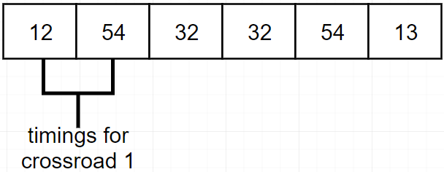

Fig 4.1: genotype for 3 crossroads in GA

# The traffic optimization process goes as follows:

# A traffic simulator is set up to test the genotypes generated by the GA

# GA generates a population of random genotypes, each genotype representing the timings at traffic signals across the road network for the considered time duration (optimization period)

# The fitness of these genotypes is calculated by using the traffic simulator, to measure how well each genotype is able to handle traffic

# The GA selects some of the genotypes based on some criteria and uses them to generate the next population of genotypes that are then again tested using the traffic simulator.

## **4.1 Setting up traffic simulation model:**

The traffic simulation model is meant to provide predictions of traffic conditions based on the changing traffic signal timings and changing traffic flow. We are going to use a series of simulations with similar traffic conditions, to test how our hypothesis about using past simulations (GA1) to better improve similar traffic conditions at a later stage (GA2).

In order to set up the model, we need to do the following:

* Select a region to model the traffic
* Setup a model that can accurately predict traffic based on the changing inflow and outflow of traffic from each road.
* Acquire data about the inflow and outflow of traffic for each road during the considered time period. To get information about traffic flow, we need to do the following:
  + Acquire Travel speed data at each road near the intersections.
  + Convert travel speed data into approximate density data.
  + Calculate the fraction of cars exiting into each road from an intersection using the density data
* Use the information gathered about traffic flow at a given time to initialize and direct the traffic simulation.

# 4.2 Genetic Algorithm Specifications:

**Initialization:**

Depends on approach used

**Fitness function:**

Depends on approach used

**Selection:**

We have opted to choose the best individuals in the population, due to the small population size imposed by long computation times. Hence, if there are N individuals in the population, we will select $\sqrt{N}/2$ of the individuals with the best fitness score.

**Crossover:**

The crossover operator will be selected based on the results of a parameter search. The parameter search is meant to select the suitable hyper parameters for traffic optimization. The results of the search are presented in chapter 6.2.

**Mutation:**

The mutation operator will be selected based on the results of a parameter search. The parameter search is meant to select the suitable hyper parameters for traffic optimization. The results of the search are presented in chapter 6.2.

**Termination:**

We will terminate computation, once a predefined generation limit has been reached.

**4.3 Approach 1:**

# In this approach, the genotypes represent the traffic signal timings for the entire optimization period. The approach is identical to the one explained previously

# GA Initialization:

# The genotypes will be initialized randomly.

# GA fitness function:

We are going to base the fitness of a genotype on either of the following attributes:

* Peak car density at any road in the road network.
* Total waiting time for cars.
* Average travel speed

## **4.4 Approach 2:**

# Let N represent the duration of the optimization period. In this approach, the optimization period is divided into *n* smaller intervals, each of which will be called a time step. Then we carry out *n* optimizations for each of the smaller intervals, each optimization identical to the optimization in approach 1.

# GA Initialization:

# The genotypes will be initialized randomly.

# GA fitness function:

We are going to base the fitness of a genotype on either of the following attributes:

* Peak car density at any road in the road network.
* Total waiting time for cars.
* Average travel speed

## **4.5 Approach 3:**

# Let N represent the duration of the optimization period. In this approach, the optimization period is divided into *n* smaller intervals, each of which will be called a time step. Then, one optimization is carried out, in which each genotype is also segmented into *n* sub-genotypes. Each sub-genotype represents the timings in one of the smaller intervals. The genotype representation in approach 3 is as follows:

**Definition 4:** *Let $T=\{t_{1}, t_{2}, t_{3},…, t_{num_steps}\}$ be the set of time steps. Let g: G → N be any function mapping the set of representants to the set of possible phase durations and let $GN=\{g_{1}, g_{2}, g,…, g_{num_steps}\}$ be a set of different possible mappings from the set of representants to the possible phases.* ***Genotype*** *for the road network is any one to one mapping $Genotype:GN→T$.*

# 

Fig 4.2: genotype with 3 crossroads and 2 time steps in approach 3

# Optimizing traffic by this approach can be very time consuming. Using this approach in real-time optimization is hence not practical. In order to circumvent this issue, we propose the following optimization procedure:

* Use above approach to optimize recurring traffic congestion over a long period of time based on historic traffic data.
* Use another genetic algorithm that uses the signal timings and traffic densities obtained from the prior optimization to optimize traffic conditions similar to the one optimized previously. This optimization can be done in real time, since it is similar to approach 2, the difference being the fitness function (density based) and the initialization (non-random, based on population from prior optimization)

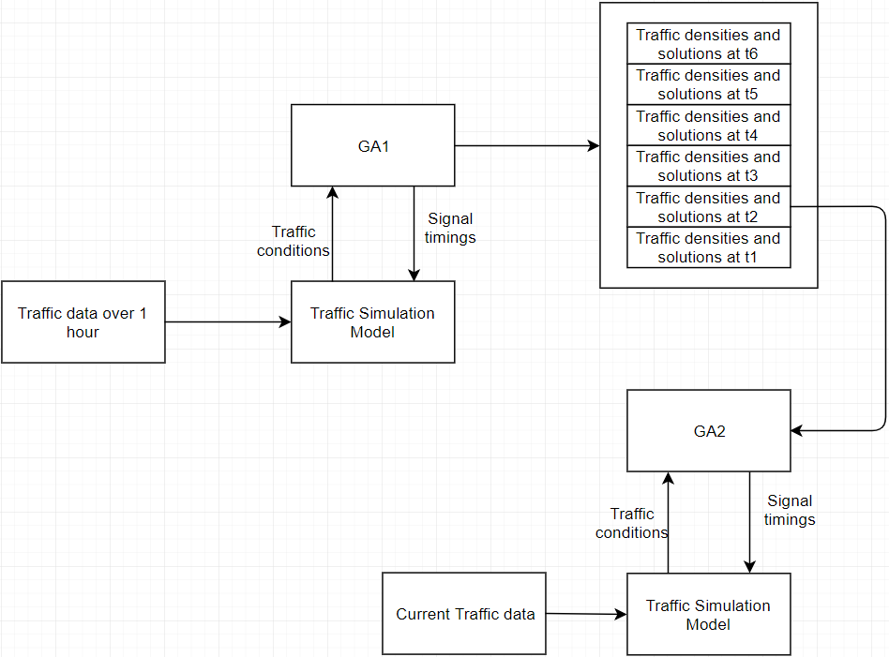

Fig 4.2: Diagram showing the operation of proposed method

## **4.5.1 Optimization 1 with GA1:**

Once we have the traffic data over a time period that relates to repeating traffic congestion, the long term genetic algorithm is meant to optimize a sequence of traffic signals over the entire period. The output of this process is going to be the optimal traffic signal timings at each time step. This task is computationally expensive and will have to be done prior to the real time control task.

**Initialization:**

# The genotypes will be initialized randomly.

**Fitness function**:

We are going to base the fitness of a genotype on either of the following attributes:

* Peak car density at any road in the road network.
* Total waiting time for cars.
* Average travel speed.

**Output of GA1:**

**Definition 5:** *Let D be the set of densities at each road in the network, $D=\{D_{1},D_{2}, D_{3},…, D_{n}\}$, where $D_{k}$ is the density at road k. Let $D^{t}$ denote the set of road densities at each road in the network at time step t for some genotype. Let* ***DTT*** *be the set of densities at each road in the network at each time step $DTT=\{D^{1}, D^{2}, D^{3},…, D^{num_steps}\}$.*

The output includes the genotypes with the highest finesses and their corresponding DTTs.

## **4.5.2 Optimization 2 with GA2:**

The second genetic algorithm will be used to achieve real time control of traffic. Instead of initializing the population randomly, GA2 derives its population from the signal settings obtained from GA1. GA2 then evolves these settings further to fit the current traffic conditions. Another modification is that GA2 can try to evolve the signal timings such that the traffic densities mimic the ones obtained from GA1. In that case, the fitness function for this genetic algorithm will be the difference between the simulated traffic densities produced by the individuals in the population and DTT.

**Initialization:**

Optimization 1 was done over time period N split into ***n*** smaller intervals. Optimization 2 will be done similar to approach 2, in that there will be ***n*** repeated optimizations. However, the initialization of the genotypes won’t be random. For optimization ***k*** out of the ***n*** optimizations, the population will be generated based on the ***k***th regions of the selected genotypes from optimization 1. The selected regions will be treated as individual genotypes and be crossed with each other to create the population.

**Fitness functions**:

In order to specify the fitness of a genotype, we need to define the attribute to be used to measure the fitness. We use the traffic density as the fitness measure. A genotype’s fitness can be defined as follows

**Definition 6:** *Consider a genotype G generated by GA2 corresponding to time step i from the long-term simulations conducted prior and its output densities D for each road, $D=\{D_{1},D_{2}, D_{3},…, D_{n}\}$, where $D_{k}$ is the density at road k. The* ***fitness of G*** *is given by the equation $f=||DTT\left[i\right]-D||$, where DTT is the optimal densities at each time step obtained from the long-term genetic algorithm, $DTT\left[i\right]$ are the optimal densities at each road at time step i.*

Apart from the above defined measure of fitness, we will also experiment with other fitness functions listed as follows:

* Peak car density at any road in the road network.
* Total waiting time for cars.
* Average travel speed.

**Output of GA2:**

The output for GA2 is going to be the traffic signal timings that provide the greatest simulated fitness.

# References:

[1] Ratrout, N. T., and Rahman, S. M. 2009. “A COMPARATIVE ANALYSIS OF CURRENTLY USED MICROSCOPIC AND MACROSCOPIC TRAFFIC SIMULATION SOFTWARE”, *The Arabian Journal for Science and Engineering*, vol. 34, no. 1, pp. 121-133.

[2] Boxill, S. A. and Yu, L. 2000. “An Evaluation of Traffic Simulation Models for Supporting ITS Development”, Center for Transportation Training and Research Texas Southern University, Houston, Texas.

[3] Gora, P. 2011 ) “A genetic algorithm approach to optimization of vehicular traffic in cities by means of configuring traffic signals”, *Emergent Intelligent Technologies in the Industry*, pp. 1-10, ISBN: 978-3-642-22731-8.

[4] Gora, P. and Pardel, P. W. 2015. "Application of Genetic Algorithms and High-Performance Computing to the Traffic Signal Setting Problem”.

[5] Kwasnicka, H. and Stanek, M. 2006. “Genetic Approach to Optimize Traffic Flow by Timing Plan Manipulation”. *ISDA 2006 Proceedings*, vol. II, pp. 1171–1176.

[6] Chen, S.W., Yang, C.B. and Peng, Y.H. 2007. “Algorithms for the Traffic Light Setting Problem on the Graph Model”. *the 12th Conference on Artificial Intelligence and Applications*, TAAI.

[7] Singh, L., Tripathi, S. and Arora, H. 2009. "Time Optimization for Traffic Signal Control Using Genetic Algorithm", *Int. J. of Recent Trends in Engineering and Technology*, vol. 2, no. 2.

[8] Gora, P. 2012. “Traffic Simulation Framework”. *14th International Conference on Modelling and Simulation*, pp. 345-349, ISBN: 978-0-7695-4682-7

[9] Gora, P. 2009. “Traffic Simulation Framework – a cellular automaton based tool for simulating and investigating real city traffic”. *Recent Advances in Intelligent Information Systems*, pp. 642-653.

[10] Nagel, K. and Schreckenberg, M. 1992. “A cellular automaton model for freeway traffic”. *Journal de Physique 2 (1992)*, pp. 2221-2229.

[11] J. D. Leonard II, 2001. "An Overview of Simulation Models in Transportation", [Online]. Available: https://web.archive.org/web/20081101205621/http://www.sisostds.org/webletter/siso/iss_79/art_429.htm. [Accessed: 08- Nov- 2018].

[12] Mathew, T. 2014. "Microscopic Traffic Simulation", IIT Bombay.

[13] Reiter, J. 2015. "Application of a Markov chain traffic model to the Greater Philadelphia Region", https://www.slideshare.net/JosephReiter1/traffic-model.

[14] Azlan N.N., and Rohani, M.M. 2018. "Overview Of Application Of Traffic Simulation Model". *MATEC Web of Conferences*, vol. 150, p. 03006.

[15] Dezain, H., Marranhghello, N. and Damian, F. 2014. “Genetic algorithm-based traffic lights timing optimization and routes definition using Petri net model of urban traffic flow”. *IFAC Proceedings Volumnes*, vol. 47, issue 3, pp 11326-11331

# [16] Javier, J., Sanchez-Medina, Manuel J. and Enrique, R. 2010. “Traffic Signal Optimization in “La Almozara” District in Saragossa Under Congestion Conditions, Using Genetic Algorithms, Traffic Microsimulation, and Cluster Computing”. *IEEE Transactions on Intelligent Transportation Systems,* vol. 11, issue 1, pp 132-141