|  |  |
| --- | --- |
| **USER INTERFACE DESIGN SPECIFICATION** | |
| **Cimbidia**  **Inventory Visibility**  **Version 1.0**  **June 20, 2014**  **UI Contacts:**  Barnali@cimbidia.com | Screen Shot 2014-04-03 at 4.16.15 PM.png |

# Table of Contents

1 Table of Contents 2

2 Introduction 3

3 Projected On Hand Inventory 4

3.1 Net Projected On Hand Inventory Data Definitions 4

3.2 Net Projected On Hand Calculation 6

3.3 Net Projected On Hand Data Sources (External or Internal Data) 7

4 Table/Lists Views of Inventory 8

4.1 On Hand Inventory Snapshot 9

4.1.1 Mockup - On Hand Inventory Snapshot 9

4.2 Time Phased Net Projected Inventory On Hand 10

4.2.1 Mockup – Time Phased Net Projected Inventory On Hand 11

5 Graph of Inventory – Forward Looking 13

5.1 Filters on Graph 14

5.2 Mockup of Inventory Graph 15

6 Map View of Inventory 16

6.1 Mockup of Map View of Inventory 17

7 Inventory Data Model 18

8 Revision History 19

9 Open Issues 20

# Introduction

This functional specification will focus on the inventory visibility functionality within the Cimbidia application.

Companies need to have a view of current and future projected on hand inventory levels for products across their supply chain network to ensure smooth operations and to minimize disruptions. Most companies have data only up to the current point in time to know what inventory is ‘on-hand’. However that data is not useful if you want to prevent issues from occurring ahead of time, and companies will have to react after problems/issues have already occurred.

Cimbidia will provide users a view of the projected on hand inventory for a given location and product for future upcoming weeks. This data can be compared to safety stock levels to guide users towards making the appropriate adjustments in inventory. Users will be able to view this data by:

* SKU
* Product Group
* Location
* Channel
* Any combination of items above

In this functional specification we will describe the information needed to arrive with the Projected On-Hand Inventory value which will be a baseline for the rest of the Inventory Visibility components, and also describe the different dashboard and graphical views of inventory we want users to be able to have access to in the Cimbidia application. Below will be the breakdown of this specification on Inventory Visibiility.

* Projected On Hand Inventory Calculation and Data Requirements and Definitions
* Table/List View of:
  + On Hand Inventory Snapshot
  + Time Phased View of Net Projected Inventory On Hand
* Graph of Projected on hand inventory
* Map of Inventory
* Inventory Data Model

Once users and the system have this data, it will be the baseline not only for making decisions in the supply chain to avoid inventory shortages or surpluses from occurring, but it will also factor into the automated sourcing and allocation functionality needed in order to commit to customer orders for a given company. Customer order sourcing and allocation will be discussed in a separate functional specification.

# Projected On Hand Inventory

Net Projected On Hand Inventory Data Definitions

With the Cimbidia product we would like to give users a view of what is projected to be on-hand. The net projected value of projected on hand will be derived from a number of inputs, which I will describe here. Below are the inputs needed for this calculation. In the view below I will describe the data inputs needed for Day 1, Day 2, and Day 3.

Day 1:

**On Hand** – physically located at a specific location at a given point in time (supply)

**Committed to Orders** – Total Quantity of a product committed to Customer orders still to go out from a specific location on this after after the given point in time above (demand)

**Available** – On hand minus committed to orders. This gives you the net supply.

**Ordered** – Supply for a product coming in from orders (Purchase orders, ASNs, Work orders, Planned Orders)

* in – transit,
* ordered not yet shipped,
* work orders, - MRP run from factory
* Planned orders – internal planned orders MRP run from factory

**Net Expected Demand** - from Demand Forecasts, usually comes in as time series by channel or customer or product

**Net Expected Receipts** – from Supply Forecasts to the supplier and to factories

**Net Projected On Hand** – Available + ordered – expected demand + expected receipts

Day 2:

**On Hand** – Net projected on Hand from **day 1**

**Committed to Orders** – Total Quantity of a product committed to Customer orders still to go out from a specific location on this day (demand)

**Available** – On hand minus committed to orders. This gives you the net supply.

**Ordered** – Supply for a product coming in from orders (Purchase orders, ASNs, Work orders, Planned Orders)

* in – transit,
* ordered not yet shipped,
* work orders, - MRP run from factory
* Planned orders – internal planned orders MRP run from factory

**Net Expected Demand** - from Demand Forecasts, usually comes in as time series by customer – already shipped by customer

**Net Expected Receipts** – from Supply Forecasts to the supplier and to factories

**Net Projected On Hand** – Available + ordered – expected demand + expected receipts

Day 3:

**On Hand** – Net Projected on Hand from **day 2**

**Committed to Orders** – Total Quantity of a product committed to Customer orders still to go out from a specific location on this day (demand)

**Available** – On hand minus committed to orders. This gives you the net supply.

**Ordered** – Supply for a product coming in from orders (Purchase orders, ASNs, Work orders, Planned Orders)

* in – transit,
* ordered not yet shipped,
* work orders, - MRP run from factory
* Planned orders – internal planned orders MRP run from factory

**Net Expected Demand** - from Demand Forecasts, usually comes in as time series by customer

**Net Expected Receipts** – from Supply Forecasts to the supplier and to factories

**Net Projected On Hand** – Available + ordered – expected demand + expected receipts

On hand inventory values will likely be imported as a batch process for locations/products on a daily basis, hence day 1 will be the current date and will start with the imported On hand inventory value. Day 2 onwards (for a period of two weeks) the on hand will all be projected on hand from previous day.

Order updates will be in the system real time for customer orders, purchase orders, ASNs etc which are in the Cimbidia application. All updates coming in externally will be a daily batch process for demand and supply forecasts etc.

## Net Projected On Hand Calculation

Day 1: **On Hand** minus **Committed to Orders** (actual Customer Orders within the application) plus **Ordered** (actual incoming orders into the given location or ASNs, work orders, planned orders) minus **Net Expected Demand** (demand forecasts imported into Cimbidia) plus **Net Expected Receipts** (Supply Forecasts imported into Cimbidia) = **Net Projected On Hand**

Day 2: **On Hand = Net Projected On Hand from Day 1** minus **Committed to Orders** (actual Customer Orders within the application) plus **Ordered** (actual incoming orders into the given location or ASNs, work orders, planned orders) minus **Net Expected Demand** (demand forecasts imported into Cimbidia) plus **Net Expected Receipts** (Supply Forecasts imported into Cimbidia) = **Net Projected On Hand**

Day 3: **On Hand = Net Projected On Hand from Day 2** minus **Committed to Orders** (actual Customer Orders within the application) plus **Ordered** (actual incoming orders into the given location or ASNs, work orders, planned orders) minus **Net Expected Demand** (demand forecasts imported into Cimbidia) plus **Net Expected Receipts** (Supply Forecasts imported into Cimbidia) = **Net Projected On Hand**

## Net Projected On Hand Data Sources (External or Internal Data)

**On Hand** – **EXTERNAL** Import from a ERP/WMS system on on-hand inventory for a given date/time

**Committed to Orders** – **INTERNAL** Sum of quantities in Customer Orders for a given product and origin location at stake set to go out after the given. The Cimbidia application will do the commits on the customer orders so will have this data in the system.

**Available** – **INTERNAL** On hand minus committed to orders. This gives you the net supply.

**Ordered** – **INTERNAL** and **EXTERNAL**) – Cimbidia will have the incoming quantities for a given product/destination from POs/ASNs for a particular day (in transit and ordered and not shipped). Work Orders and Planned orders from MRP runs will likely come from external sources.

**Net Expected Demand** – **EXTERNAL** from Aggregated Demand Forecasts for the product and locations specified, usually comes in as time series by customer – already shipped by customer

**Net Expected Receipts** – **EXTERNAL** from Aggregated Supply Forecasts

**Net Projected On Hand** –**INTERNAL** calculation: Available + ordered – expected demand + expected receipts

Day 2 onward the on hand would be internal as it is a projected value as the starting point for the on hand.

# Table/Lists Views of Inventory

Now that we have described the concept behind the projected on hand inventory, we would like to outline the various ways that inventory will be shown for a location (or group of locations) and/or products/ product groups. We will start with a table/list view of inventory. Which will feed into the other graphical and map views.

There are two views of inventory, which will be described in the following section:

* On Hand Inventory Snapshot
* Time Phased Net Projected Inventory On Hand

## On Hand Inventory Snapshot

Some users will want to see the on-hand inventory at a given moment in time for stores/DCs or other locations. This will allow users to see this view and also see the value of the quantity of hand as a result. A typical use case for this is if one store is out of a particular product, you can quickly check to see what other stores have this inventory on-hand, or whether the product is available at a DC to place an order against.

Users will be able to filter the slices of data that they wish to see by the following:

* **Product** (Selects All or a particular SKU)
* **Product Group** (Selects all or a particular product) - You cannot select a specific value in both SKU and product group, it must be one or the other)
* **Location Type** – All or specific location type (Store, DC, Supplier etc.)
* **Location** – All or a specific location (Need to check on the ability to select multiple locations or have a region view as well).
* **Channel** – All or a specific channel
* Any combination of items above

Based on the selections above the system will display the following fields for Inventory List:

* Product
* Product Description
* Location
* Quantity On Hand (total quantity for the filtered location(s), location type,
* Total Value of Inventory on Hand

### Mockup - On Hand Inventory Snapshot

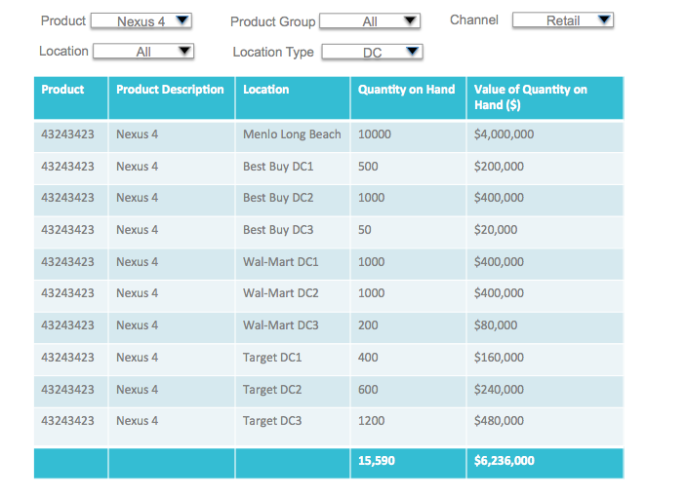

Time Phased Net Projected Inventory On Hand

Other users will have to monitor inventory of a particular product/ product group/ or channel closely to ensure that products are being ordered in the right quantities and/or make any adjustments accordingly ahead of time before there is a bigger issue. This view is a time – phased view of inventory from the current date to two weeks ahead to be able to monitor and sense.

Users will be able to view an aggregate view for example of a particular product/channel or a more specific view of a product/location combination.

Users will be able to filter the slices of data that they wish to see by the following:

* **Product** (Selects All or a particular SKU)
* **Product Group** (Selects all or a particular product) - You cannot select a specific value in both SKU and product group, it must be one or the other)
* **Location Type** – All or specific location type (Store, DC, Supplier etc.)
* **Location** – All or a specific location (Need to check on the ability to select multiple locations or have a region view as well).
* **Channel** – All or a specific channel
* Any combination of items above

After the user executes their filter they will be able to see a time phased view of net projected on hand inventory from ‘today’s date’ for the next two weeks. The calculation described earlier for net on hand-projected inventory will be applied for getting the values for Net Projected On Hand for two weeks.

Each Row will contain the following information:

* On Hand
* Committed to Orders
* Ordered
* Net Expected Demand
* Net Expected Receipts
* Net Projected On Hand
* Safety Stock
* %Delta from Net Projected On Hand (this will be filled by Red or Yellow)

Thresholds for the Safety Stock vs. Net Projected On Hand red/yellow alerting will be configurable as a business rule. However the norm for alerting would be around 5-10% delta or more.

On the last column the Average for the two week period would be displayed. The mockup shows the inventory of phones for the retail channel for the next two weeks.

### Mockup – Time Phased Net Projected Inventory On Hand (Avg. at the end, this will be the view of choice)

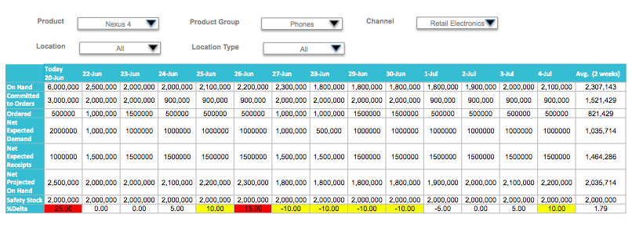

### Mockup – Time Phased Net Projected Inventory On Hand (Total. at the end)

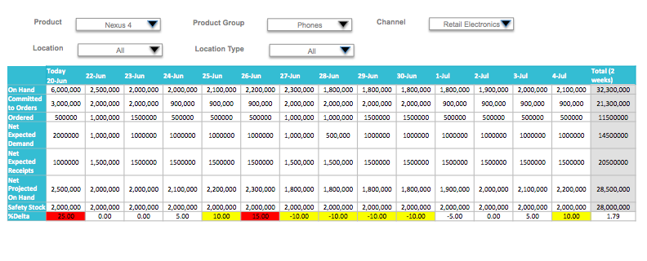

# Graph of Inventory – Forward Looking

In the Cimbidia Inventory Graph the inventory levels (actuals for the past) and the projected on hand inventory will be plotted in a bar graph. The sales forecast information will be plotted on the same graph in a line format. There will be a moving mark below the graph where the user can zoom in on a particular day. On that given day they will see the following:

* **On Hand**
* **Committed to Orders**
* **Available**
* **Ordered**
* **Net Expected Demand**
* **Net Expected Receipts**
* **Net Projected On Hand**

## Filters on Graph

**Content**

Users will be able to filter the data they see with the following selections available above the graph.

Users will be able to filter the slices of data that they wish to see by the following:

* SKU (Selects All or a particular SKU)
* Product Group (Selects all or a particular product) - You cannot select a specific value in both SKU and product group, it must be one or the other)
* Location Type – All or specific location type (Store, DC, Supplier etc.)
* Location – All or a specific location (Need to check on the ability to select multiple locations or have a region view as well).
* Channel – All or a specific channel
* Any combination of items above

**Date**

* Users will be able to select a Daily, Weekly, or Monthly View
* Users will be able to select a date range up to two weeks in the future. From Date and To Date, both calendar fields.
* The default will be a daily view of inventory from current date to two weeks looking ahead.

For dates in the past for which you are viewing data for, the users will see the actual on hand inventory at the designated point during the day (usually end of day) plotted on the graph and actual incoming and outgoing inventory values. We will however not displayed the forecasts for supply or demand or the projected on-hand inventory as that data is no longer of use.

## Mockup of Inventory Graph

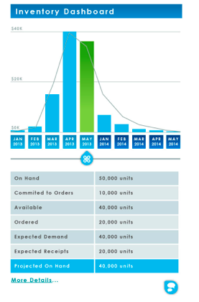

The inventory graph will appear as a dashboard type on the home page as a preference to select from. This graph will also appear to the right of the map view to be described in the next section.

Please note that the filters in the previous section will follow the UI style guide PSD for filtering that will be universal in the Cimbidia application.

# Map View of Inventory

Users will be able to view an inventory based map view of locations and the status of inventory at the selected locations. Users will be able to select views of data and the locations that fall into that category will be plotted on the map.

Users will be able to filter the slices of data that they wish to see by the following:

* **Product** (Selects All or a particular SKU)
* **Product Group** (Selects all or a particular product) - You cannot select a specific value in both SKU and product group, it must be one or the other)
* **Location Type** – All or specific location type (Store, DC, Supplier etc.)
* **Location** – All or a specific location (Need to check on the ability to select multiple locations or have a region view as well).
* **Channel** – All or a specific channel
* Any combination of items above

Each location will have an indicator of status -on the map itself (green, yellow and red) same concept as in the table/list view. If the user hovers over the location, the name, address of the location will be displayed as well as the type of location it is and the status of that location. If the user clicks on the location then the user will be able to see an inventory graph of that particular filter.

To the right of the map, the user will also see the graphical view of their selection. The function of the graph will be same as in section 5.

If the user clicks on a node, a pop-up window will appear with the inventory data of that particular location selected and the status of the inventory for each SKU (within the filter range).

Below the map, the list of the locations filtered and information related to it will be displayed. There will be a separate Node, view which will be discussed in a separate specification.

## Mockup of Map View of Inventory

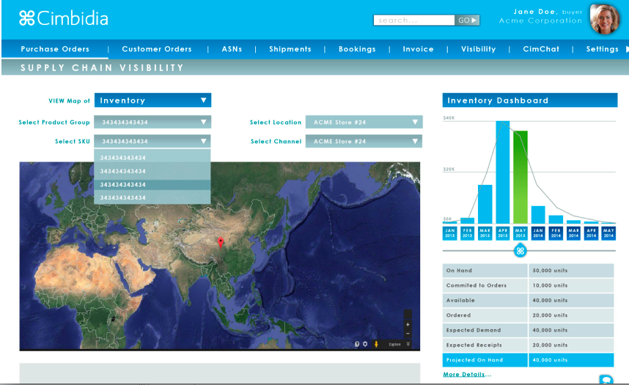

|  |  |  |  |  |  |
| --- | --- | --- | --- | --- | --- |
| Node | Node Type | Address | On Hand Inventory | Value of On Hand Inventory | Product(s) |
|  |  |  |  |  |  |
|  |  |  |  |  |  |

# Inventory Data Model

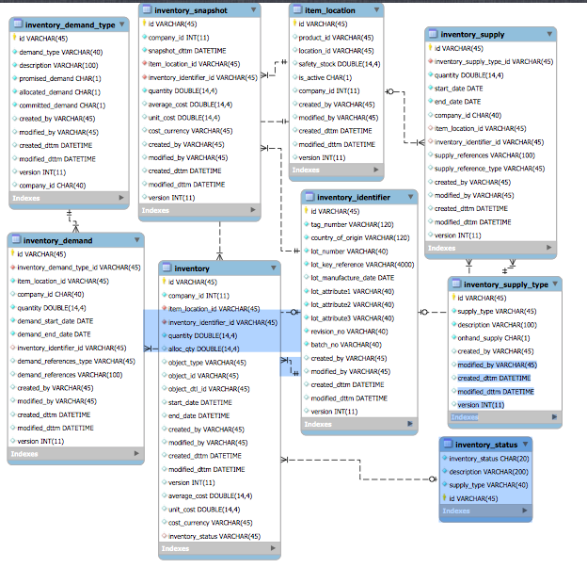

# Revision History

|  |  |  |  |  |
| --- | --- | --- | --- | --- |
| Version | Date | Author | Change | Bug(s) |
| 1.0 | 6/20/2014 | Barnali Mukherjee | Version 1.0 |  |
|  |  |  |  |  |

# Open Issues

|  |  |  |  |  |
| --- | --- | --- | --- | --- |
| Version | Date | Author | Issues | Bug(s) |
| 1.0 | July 30, 2013 | Barnali Mukherjee |  |  |
|  |  |  |  |  |