**Project Report**

**Title:** Design and Optimization of a Two-Stage Gearbox for a Small Electric Vehicle

**Group:** Group - 1

**Course:** Mechanical Engineering

**Institution:** MNIT Jaipur

# 1. Introduction

The increasing shift toward electric mobility has created demand for lightweight, efficient, and durable drivetrain components. This project focuses on the design and optimization of a **two-stage gearbox** specifically tailored for a small electric vehicle (EV) application. The goal is to develop a robust gearbox design that meets specified technical constraints while ensuring performance and manufacturability.

# 2. Objectives

* To design a two-stage gearbox compatible with a **2 kW** electric motor.
* To achieve a speed reduction ratio of **5:1**.
* To ensure the gearbox weighs no more than **10 kg**.
* To develop a weatherproof and vibration-resistant housing.
* To ensure a minimum lifespan of **50,000** operational hours.
* To create a CAD model and perform FEA simulations for strength and reliability assessment.

# 3. Design Requirements and Constraints

|  |  |
| --- | --- |
| Parameter | Specification |
| Power Input | 2 kW |
| Speed Reduction Ratio | 5:1 |
| Maximum Weight | 10 kg |
| Environmental Protection | Weatherproof, vibration-resistant |
| Operational Lifespan | 50,000 hours |

# 4. Design Methodology

1. **Preliminary Design:**

Selection of gear type (spur/helical) and materials. Basic calculations for torque, gear ratios, and shaft design.

1. **CAD Modeling:**

Developed using Fusion 360. Complete assembly of two-stage gear system and housing.

1. **Finite Element Analysis (FEA):**

Imported CAD model into **Abaqus** for structural analysis. Simulation under real-world loading conditions to check for maximum stress, factor of safety, displacement.

1. **Optimization:**

Weight minimization through topology optimization.

The two-stage gearbox functions on the **principle of gear reduction**, enabling high torque delivery at reduced speed.

In the first stage, the high-speed input shaft turns a larger driven gear, reducing speed and increasing torque.

The intermediate shaft transmits this torque to the second-stage gear pair, further reducing speed.

The output shaft then delivers the final torque to the EV wheels at a **5:1 reduction ratio**.

This multi-stage setup reduces stress on individual gears and improves durability.

# 5. Working Principle of the Gearbox

A **two-stage gearbox** is used to reduce the high rotational speed of an electric motor to a lower speed with a corresponding increase in torque. This is essential for applications like electric vehicles where motors operate at high speeds, but the wheels require lower speeds and higher torque.

**Stage 1: Initial Reduction**

* The **input shaft**, connected to a 2 kW electric motor, drives a **small pinion gear**.
* This pinion meshes with a **larger gear** mounted on the **intermediate shaft**.
* As the pinion rotates, it turns the larger gear more slowly, reducing speed and multiplying torque.

**Stage 2: Final Reduction**

* The **intermediate shaft** now acts as the input for the second stage.
* It drives a second pinion, which meshes with a **larger output** gear on the **final shaft**.
* This gear pair provides additional speed reduction and torque amplification, completing the 5:1 reduction ratio.

# 6. CAD Model Details

The CAD model of the two-stage gearbox was developed using Fusion 360, focusing on both functional and manufacturable aspects of the design. The model includes:

* Input shaft connected to the 2 kW electric motor.
* First-stage gear pair for initial speed reduction.
* Intermediate shaft transmitting torque to the second stage.
* Second-stage gear pair achieving final reduction to obtain 5:1 overall ratio.
* Output shaft aligned with the wheel axis of the EV.
* Compact housing that encapsulates the full assembly with necessary clearances and mounting provisions.
* Seals and bearing placements for minimizing friction and preventing contamination.
* Provision for lubrication access and thermal expansion tolerances.

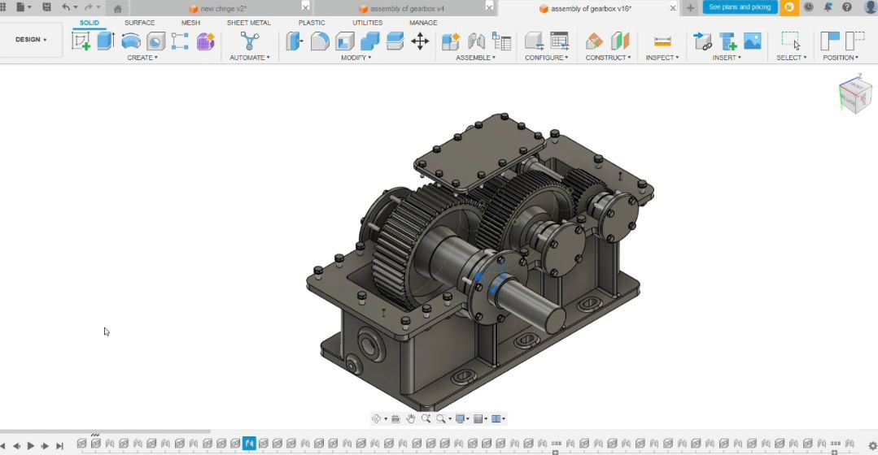

# 7. Results and Discussion

**Gearbox Configuration:**

Two-stage gear design with intermediate shaft.  
Gear material: Steel

**FEA Results:**

Maximum stress observed: 6.918 MPa

Maximum displacement: 0.001 mm

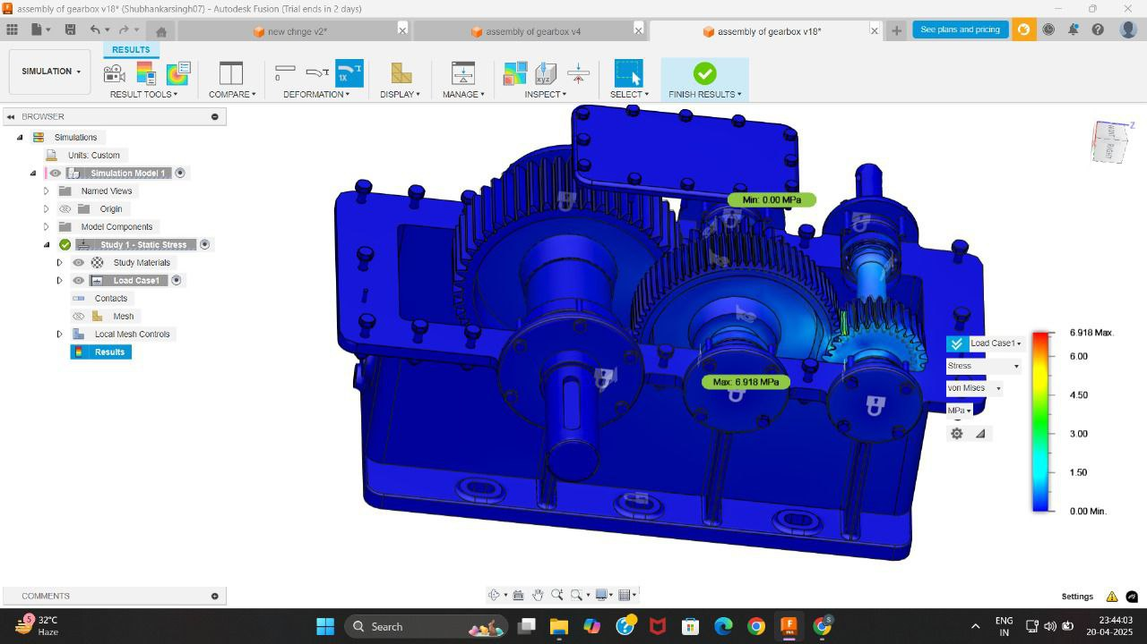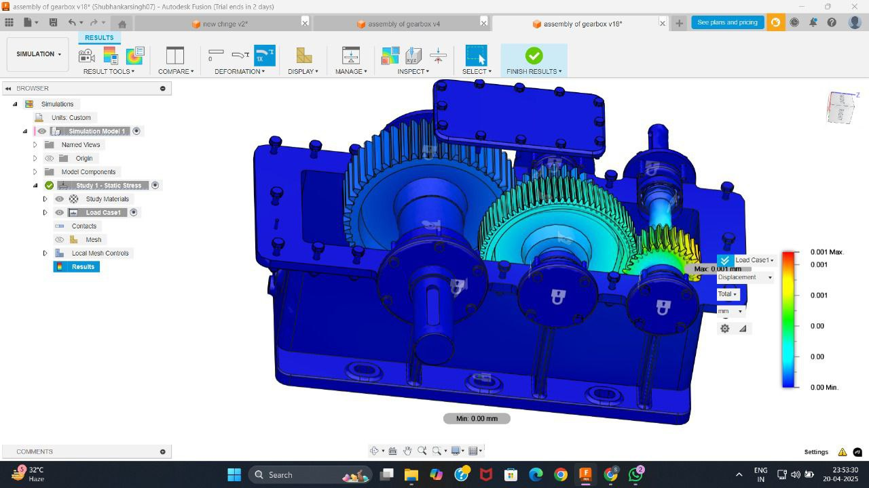

# 8. Conclusion

The project successfully delivers a CAD model and FEA simulation of a lightweight, efficient, and reliable two-stage gearbox for small electric vehicles. All design constraints were satisfied, including weight, performance, and environmental protection. The design demonstrates a strong foundation for further prototyping and testing.

# 9. References

* Norton, R. L., Machine Design
* AutoDesk Fusion 360 User Documentation
* ABAQUS User Documentation

# 10. Appendix

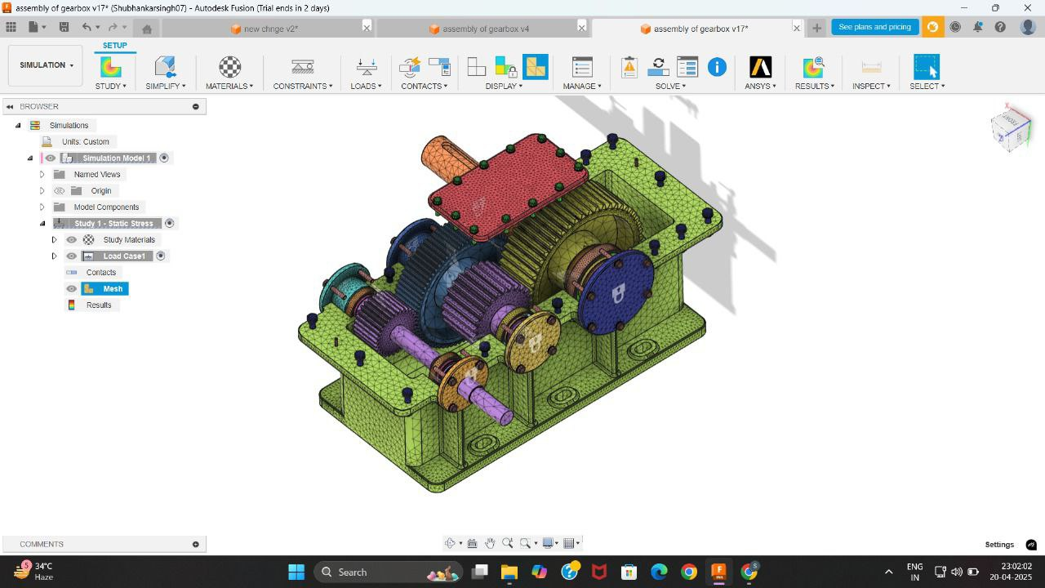

**Calculations:**

**(1)**

**Material – Steel**

**Speed ratio = 5:1** *(Speed reduction)*

**Stage 1**  
Np = 30, Ng = 75, dp = 90 mm, dg = 225 mm, m = 3

**Stage 2**  
Np = 25, Ng = 50, dp = 125, dg = 250, m = 5

**Given:**  
Power i/p = 2 kN, Speed reduction = 5:1 (overall), Max. wt = 10 kg, Min. lifespan = 50,000 hrs

**Assuming:**  
Gear Profile = Involute, Pressure angle = 20°, Profile type = Stub

**Design for 1st stage reduction**  
i₁ = Ng / Np = 75 / 30 = 2.5

Let o/p speed assume N = 3800 RPM

Center distance a₁ = m (dp + dg) / 2  
        = 3 (90 + 225) / 2  
        = 157.5 mm

**Stage 2**  
i₂ = Ng / Np = 50 / 25 = 2

Center distance a₂ = m (Np + Ng) / 2  
        = 5 (25 + 50) / 2  
        = 187.5 mm

**(2)**

Total Gear Ratio:  
i = i₁ × i₂ = 2 × 2.5 = 5

**Let assume,**  
i/p speed = 3000 RPM  
(N₁)₍ᵢₚ₎

N₀₍ₒₚ₎ = N₁ / i = 3000 / 5 = 600 RPM

**Stage 1 o/p speed**  
N₂ = N₁ / i₁ = 3000 / 2.5 = 1200 RPM

**Input Torque**

P = (2π × N × MT) / 60

2000 = (2π × 3000 × MT) / 60

(MT)₍ᵢₚ₎ = 6.37 N·m

**o/p torque** *(assuming 94% efficiency per stage)*

(MT)₍ₒₚ₎ = η × (MT)₍ᵢₚ₎ × i / η  
     = (6.37 × 5) / 0.94  
     = 33.88 N·m

**Intermediate shaft (after stage 1)**  
Speed = (3000 / 2.5) = 1200 RPM

Torque (MT)₂ = (6.37 × 5) / 0.97 = 16.42 N·m

**(3)**

**Gear strength:**

**Assume:** face width, b = 10 m

* Stage 1 → b₁ = 10 × 3 = 30 mm
* Stage 2 → b₂ = 10 × 5 = 50 mm

**Tangential force**

→ Stage 1 (rₚ = 45 mm)

 (Fₜ)₁ = (MT)₍ᵢₚ₎ / rₚ = 6.34 / 0.045 = 141.56 N

→ Stage 2 (rₚ = 62.5 mm)

 (Fₜ)₂ = (MT)₍ᵢₚ₎ / 0.0625 = 262.72 N

**Bending stress**  
 σ = Fₜ / (b × m × y)

**Stage 1**Lewis form factor, Y = π·y

  y = (0.154 - 0.912 / Nₚ)

  y = π(0.154 - 0.912 / 30)

  y = 0.3883

% σ₁ = (141.56) / (30 × 3 × 0.3883) × 1.5 = 6.0760 MPa

**Stage 2**  
  Y = π (0.154 - 0.912 / 25)  
  Y = 0.3691

  ∴ σ₂ = (262.72) / (50 × 5 × 0.3691) × 1.5 = 4.2707 MPa

  (% allowable bending strength for AISI 4340 steel = 400 MPa)  
  → Here both for both stages it is less, so safe

**Now, contact stress**

  σ_c = Cp √(Fₜ(i+1) / (b·dp·i·μ)) × 1 (for open gear)

  Cp = 1910 (elastic constant of steel)

  ∴ σ_c₁ = 1910 √(141.56(2.5+1) / (30×90×2.5×1)) = 16.35 MPa

  ∴ σ_c₂ = 1910 √(262.72(2+1) / (50×125×2×1)) = 15.16 MPa

(∴ allowable contact stress = 1000 MPa)  
  → Both stages are safe (as both are less)

**(4)**

**Lifespan calculation**

**Fatigue life**  
→ 50000 hrs at 3000 rpm = 50000 × 60 × 3000 = 9 × 10⁹ cycles

→ Stage 1 (Np = 30) each tooth =  
             = 9 × 10⁹ / 30 = 3 × 10⁸ cycles

→ Stage 2 (i = 2.5) each tooth =  
             = 3 × 10⁹ / 2.5 = 1.4 × 10⁸ cycles

**(5)**

**Weight**

**Gear Volume**

**Stage 1**

* Pinion V = π × (45)² × 30 = 190852 mm³
* Gear V = π × (112.5)² × 30 = 1192826 mm³

**Stage 2**

* Pinion V = π × (60.5)² × 50 ≈ 613592 mm³
* Gear V = π × (95)² × 50 ≈ 2454360 mm³

Gear weight (steel density = 7.85 × 10⁻⁶ kg/mm³)

* Stage 1: (190852 + 1192826) × 7.85 × 10⁻⁶ = 1.09 kg
* Stage 2: ≈ 2.41 kg

Total gear weight = 1.09 + 2.41 kg = 3.50 kg

**Let Assume:**

* Shaft & bearing set = 2 kg
* Housing (Aluminium) = 3.5 kg

∴ **Total WT** = 3.50 + 2.0 + 3.5 = **9.0 kg**  
                  which is less than 10 kg