**a**

**MINI PROJECT REPORT ON**

**“Text Editor for java”**

By

|  |  |  |
| --- | --- | --- |
| **Sr. No.** | **NAME** | **ROLL NO.** |
| **1)** | **Alok Agrawal** | **32403** |
| **2)** | **Krishna Chidrawar** | **32409** |
| **3)** | **Mohit Dulani** | **32420** |
| **4)** | **Chinmay Gate** | **32423** |

**GUIDE**

**Mrs. Bhakti Kadam**

**Course: Fundamentals of JAVA Programming**

**Department Of**

**Electronics and TELECommunication ENGINEERING**

**PUNE INSTITUTE OF COMPUTER TECHNOLOGY**

**PUNE – 43**

**A. Y. 2022-23**

**K**

**INDEX**

|  |  |  |
| --- | --- | --- |
| **Sr. No.** | **Contents** | **Page No.** |
| **1** | **Problem Statement** | **3** |
| **2** | **Objectives** | **3** |
| **3** | **Introduction** | **3** |
| **4** | **Source code with Flowchart** | **7** |
| **5** | **Result** | **14** |
| **6** | **Conclusion** | **17** |
| **7** | **Applications** | **17** |
| **8** | **Future scope** | **18** |
| **9** | **Copy Right Affirmation** | **18** |

**1. PROBLEM STATEMENT:**

In day-to-day life we come across the tasks where we are supposed to do lots of typing work in that case the user need to spend lots of time in typing. So, we thought to build a generalize text editor which will suggest the words according to the user input. The word text editor program is similar to a cell phone or email word suggester. User may enter a sub-word, press ENTER, and if the sub-word matches with already available words in dictionary the program will suggest the user to select his choice.

**2. OBJECTIVE:**

1. The objectives of the project were to build a text editor where user can note, type fluently. Basically the objective was to build a notepad where we will provide option to save, edit, cut, copy and paste the text . We will be using ActionListener for this purpose.
2. The second task is to get suggestions from the given dictionary and user will be able to select the desired word he wants. The Autocompletion algorithm will suggest used to suggest the words and complete the text by merging the two algorithms which will give us the final output.

**3. INTRODUCTION**:

* 1. **Background/context**

The text editor is a type of program used for editing pain text files. A plain text file is represented and edited by showing all the characters as they are present in the file . The most commonly used character set is ASCII , especially recently , as plain text files are more often being used for programming and configurations , and less frequently for documentation.

* 1. **Relevance**

This application is a text editor in JAVA This text editor is developed in a JAVA platform is a replica of the word editors we all are familiar with and which we use quite often daily. The only difference being that, this editor has been created using JAVA for the front-end interface and it is platform independent compile once and run everywhere with basic operations of the text editor cut copy paste file, edit operations and any new features can be easily coded. After opening text editor use can enter data using keyboard and edit existing document and open menu option to use save and save as options to save file. In order to save file we should select directory or it will show default directory To make editing simple, we have provided a set of pop down menus in the interface, as well as support for shortcut keys to give commands All the features are developed using java swings

* 1. **Project Details :**

This editor is a simple editor, very similar to that of a notepad editor that extends the basic features to the end-user like:

* File open - User can either open the files already existing n the system or open a new blank file
* Files save - one can save the file in any desired format like- txt, doc, java etc. The file is stored in the location specified by the user.
* Save As - One can save the file in any desired format like-txt, doc, java etc. The file is stored in any other location specified by the user.
* Cut-Copy-Paste - This editor also lets the user cut-copy-paste the edited text.
* Undo - The user is allowed to undo the text edited. This feature allows letter by letter undo.
* Redo The user is allowed to redo the text edited This feature allows letter by letter Redo.
* Print – It prints the content of the file or saves them in txt format.
  + 1. **OVERVIEW:**

This project "Text Editor" is software which can edit plain text. It is made using Java Swings and AWT. In this project all the frames are designed in Swing. Today most programmers use Swing. Swing is a set of classes that provides more powerful and flexible GUI components than does the AWT Swing provides the look and feel of the modern Java GUI .

Swing did not exist in the early days of Java. Rather, it was a response to deficiencies present in Java's original GUI subsystem, the Abstract Window Toolkit. The AWT defines a basic set of controls, windows, and dialog boxes that support a usable, but limited graphical interface

*SWING-OVERVIEW :*

Swing API is a set of extensible GUI Components to case the developer's life to create JAVA based Front End/GUI Applications. It is build on top of AWT API and acts as a replacement of AWT API, since it has almost every control corresponding to AWT controls.

Swing component follows a Model-View-Controller architecture to fulfill the following criteria’s.

* A single API is to be sufficient to support multiple look and feel .
* API is to be model driven so that the highest-level API is not required to have data .

The text editor supports many editing functions to the user . A user can edit a given text file. The different editing features are Open , Save , Print, Cut copy and paste and Exit.

The project is divided into three phases :

* Developing the graphical user interface .
* Writing the code for different functionality options.
* Code for user key functions.

Phase 1 : Developing the background window and menu bar :

The very first step in the development of the editor is to construct the background window. Then the background color is set for each menu options different sub windows we created and appropriate strings of different names are added into those sub windows.

Key Binding in each sub windows:

Each of the options in each of the menus are bound with or associated with keys on the keyboard which are shortcuts for the user to access these options. The other way to access them is using the movement of the cursor to navigate through them on the screen and even by moving left and right through menus.

Phase 2: Coding functionality options :

In this phase we have used several inbuilt functions in the for buffers within the editors. The various functions connect the back and front ends of the program and make it interactive as well as efficient Simple logic is used to code the same, for example the removal and insertion of nodes in the list work so cut or paste text.

Phase 3: Coding for user key function:

This phase maps each of the keys used by the user to a function wit the editor. The minimum moment of the user is using arrow-keys which is the first step after enabling the keypad. After this, since ALT is used in the terminal to access various menus, we have used CTRL with the first letter of each option to access menu -bars within the editor.

**4.SOURCE CODE:**

Paste working source code and illustrate the same

// Java Program to create a text editor for java using autocorrection of words

import javax.swing.*;

import java.io.*;

import java.awt.event.*;

import javax.swing.plaf.metal.*;

import java.util.ArrayList;

import java.util.HashMap;

import java.util.List;

import java.util.Map;

//This is action listner class which will implement all the menu items and its functiions

class editor extends JFrame implements ActionListener {

//For texting purpose

JTextArea t;

//Java frame

JFrame f;

// Constructor

editor()

{

// Create a frame

f = new JFrame("Notepad");

try {

// Set metal look and feel

UIManager.setLookAndFeel("javax.swing.plaf.metal.MetalLookAndFeel");

// Set theme to ocean

MetalLookAndFeel.setCurrentTheme(new OceanTheme());

}

catch (Exception e) {

}

t = new JTextArea();

// Create a menubar

JMenuBar mb = new JMenuBar();

// Create sub-menu for menu

JMenu m1 = new JMenu("File");

// Create menu items

JMenuItem mi1 = new JMenuItem("New");

JMenuItem mi2 = new JMenuItem("Open");

JMenuItem mi3 = new JMenuItem("Save");

JMenuItem mi9 = new JMenuItem("Print");

// Add action listener

mi1.addActionListener(this);

mi2.addActionListener(this);

mi3.addActionListener(this);

mi9.addActionListener(this);

m1.add(mi1);

m1.add(mi2);

m1.add(mi3);

m1.add(mi9);

// Create amenu for menu

JMenu m2 = new JMenu("Edit");

// Create menu items

JMenuItem mi4 = new JMenuItem("cut");

JMenuItem mi5 = new JMenuItem("copy");

JMenuItem mi6 = new JMenuItem("paste");

mi4.addActionListener(this);

mi5.addActionListener(this);

mi6.addActionListener(this);

m2.add(mi4);

m2.add(mi5);

m2.add(mi6);

JMenuItem mc = new JMenuItem("close");

mc.addActionListener(this);

mb.add(m1);

mb.add(m2);

mb.add(mc);

f.setJMenuBar(mb);

f.add(t);

f.setSize(500, 500);

f.show();

}

public void actionPerformed(ActionEvent e)

{

String s = e.getActionCommand();

if (s.equals("cut")) {

t.cut();

}

else if (s.equals("copy")) {

t.copy();

}

else if (s.equals("paste")) {

t.paste();

}

else if (s.equals("Save")) {

JFileChooser j = new JFileChooser("f:");

int r = j.showSaveDialog(null);

if (r == JFileChooser.APPROVE_OPTION) {

File fi = new File(j.getSelectedFile().getAbsolutePath());

try {

FileWriter wr = new FileWriter(fi, false);

BufferedWriter w = new BufferedWriter(wr);

w.write(t.getText());

w.flush();

w.close();

}

catch (Exception evt) {

JOptionPane.showMessageDialog(f, evt.getMessage());

}

}

else

JOptionPane.showMessageDialog(f, "the user cancelled the operation");

}

else if (s.equals("Print")) {

try

{

t.print();

}

catch (Exception evt) {

JOptionPane.showMessageDialog(f, evt.getMessage());

}

}

else if (s.equals("Open")) {

JFileChooser j = new JFileChooser("f:");

int r = j.showOpenDialog(null);

if (r == JFileChooser.APPROVE_OPTION) {

File fi = new File(j.getSelectedFile().getAbsolutePath());

try {

// String

String s1 = "", sl = "";

// File reader

FileReader fr = new FileReader(fi);

try (// Buffered reader

BufferedReader br = new BufferedReader(fr)) {

// Initialize sl

sl = br.readLine();

// Take the input from the file

while ((s1 = br.readLine()) != null) {

sl = sl + "\n" + s1;

}

}

// Set the text

t.setText(sl);

}

catch (Exception evt) {

JOptionPane.showMessageDialog(f, evt.getMessage());

}

}

// If the user cancelled the operation

else

JOptionPane.showMessageDialog(f, "the user cancelled the operation");

}

else if (s.equals("New")) {

t.setText("");

}

else if (s.equals("close")) {

f.setVisible(false);

}

}

// Main class

public static void main(String args[])

{

List<String> words = List.of("hello", "dog", "hell", "cat", "a", "hel","help","helps","helping");

Autocompletion trie = new Autocompletion(words);

System.out.println(trie.suggest("st"));

new editor();

}

}

//A autocompletion class to autoconplete the user given word and poke th

//user the suggestions of the word;

public class Autocompletion {

public class TrieNode {

Map<Character, TrieNode> children;

char c;

boolean isWord;

public TrieNode(char c) {

this.c = c;

children = new HashMap<>();

}

public TrieNode() {

children = new HashMap<>();

}

public void insert(String word) {

if (word == null || word.isEmpty())

return;

char firstChar = word.charAt(0);

TrieNode child = children.get(firstChar);

if (child == null) {

child = new TrieNode(firstChar);

children.put(firstChar, child);

}

if (word.length() > 1)

child.insert(word.substring(1));

else

child.isWord = true;

}

}

TrieNode root;

public Autocompletion(List<String> words) {

root = new TrieNode();

for (String word : words)

root.insert(word);

}

public boolean find(String prefix, boolean exact) {

TrieNode lastNode = root;

for (char c : prefix.toCharArray()) {

lastNode = lastNode.children.get(c);

if (lastNode == null)

return false;

}

return !exact || lastNode.isWord;

}

public boolean find(String prefix) {

return find(prefix, false);

}

public void suggestHelper(TrieNode root, List<String> list, StringBuffer curr) {

if (root.isWord) {

list.add(curr.toString());

}

if (root.children == null || root.children.isEmpty())

return;

for (TrieNode child : root.children.values()) {

suggestHelper(child, list, curr.append(child.c));

curr.setLength(curr.length() - 1);

}

}

public List<String> suggest(String prefix) {

List<String> list = new ArrayList<>();

TrieNode lastNode = root;

StringBuffer curr = new StringBuffer();

for (char c : prefix.toCharArray()) {

lastNode = lastNode.children.get(c);

if (lastNode == null)

return list;

curr.append(c);

}

suggestHelper(lastNode, list, curr);

return list;

}

}

**5.RESULTS:**

1. File Menu :

1. Open :

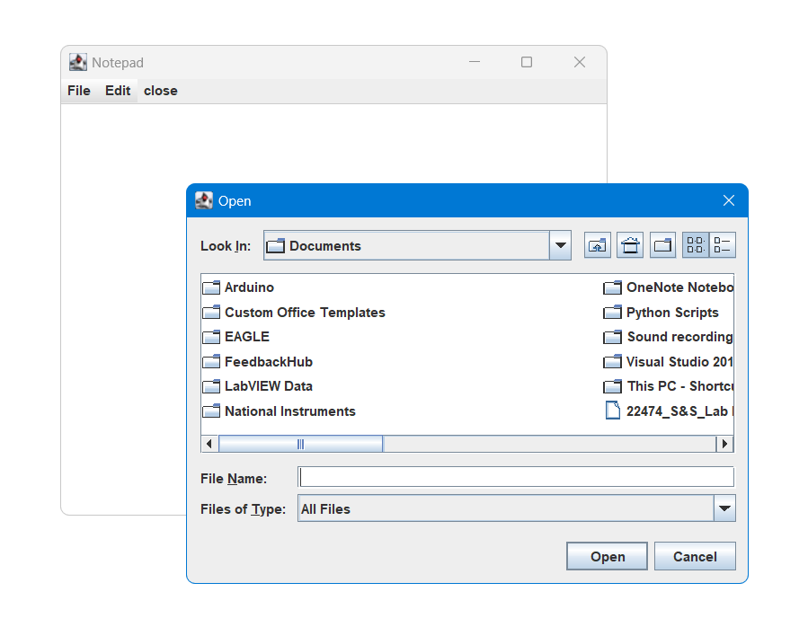

1. Save :

1. Print :

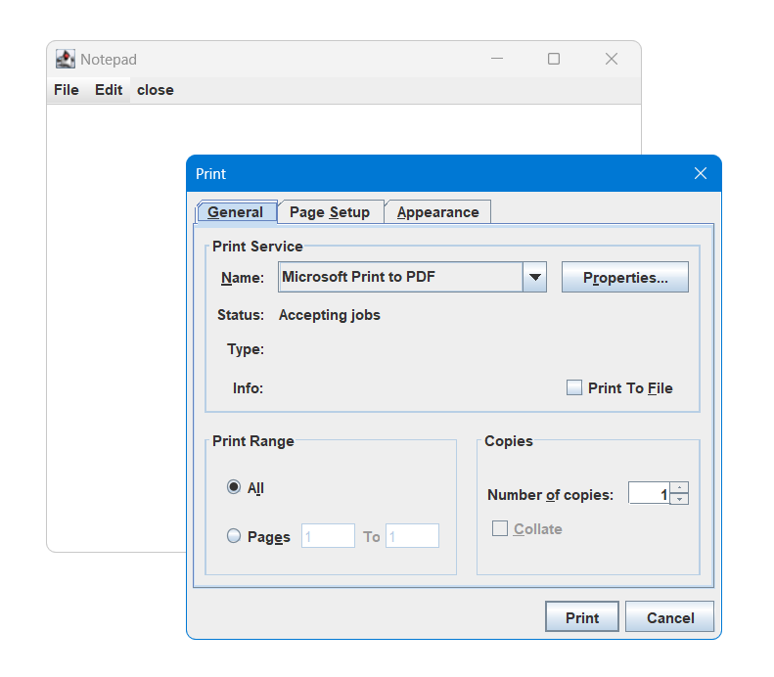

1. Edit :

**6. CONCLUSION:**

This project that I undertook was truly a very rewarding experience for me in more than one way It has given a big thrust to my technical knowledge a prospective Software professional. It has also helped me enhance my skills on the personal front.

1 feel extremely satisfied by the fact that I have managed to develop the project of

course with equal contribution from my team members. I think I have exploited the

opportunity that fully came my way to the fullest extend by increasing my technical know-how and also gaining the valuable work experience apart from studying the other subjects in our curriculum.

**7.APPLICATIONS:**

1. To note important texts that needs to be visited later.
2. To edit the predefined text files.
3. To save the file in pdf for documentation purpose.
4. To fluently write the content in text form with inbuild autocorrection functionality which in turn reduces work time.
5. To make use of available dictionary which will suggest the user words which increases the typing speed.

**8. FUTURE SCOPE:**

* To have templates.
* Help page that connects to internet.
* Automatic Dictionary.
* To insert image.
* To give color to the text.

**9. COPY RIGHT AFFIRMATION:**

We undersigned pledge and represent that the source code printed in this mini project report does not violate any proprietary or personal rights of others (including, without limitation, any copyrights or privacy rights); that the Work is factually accurate and contains no matter libelous or otherwise unlawful; that we have substantially participated in the creation of the Work and that it represents our original work sufficient for us to claim authorship.

**Name of students Sign**

**1. Alok Agrawal**

**2. Krishna Chidrawar**

**3. Mohit Dulani**

**4. Chinmay Gate**