WEEK 4 TASK
SUPERVISED LEARNING MODEL IMPLEMENTATION
Logistic Regression Classification on the Breast Cancer Wisconsin Dataset

Prepared by
Alok Kumar Singh
B.Tech Computer Science Engineering
Gurukul Kangri University, Haridwar
Academic Year: 2026

1. Executive Summary
This report presents a complete supervised learning workflow for a binary classification problem using the Breast Cancer Wisconsin Diagnostic dataset available through Scikit-learn. The objective is to predict whether a tumor observation belongs to the malignant or benign class from numerical measurements computed from digitized images of breast mass cell nuclei. Logistic Regression was selected because it is a well-established, interpretable classification algorithm that provides probabilities and performs effectively when features are appropriately scaled. The project covers data exploration, preprocessing, feature scaling, train-test splitting, model training, five-fold stratified cross-validation, evaluation, visualization, interpretation, strengths, limitations, and possible improvements. A Pipeline was used to keep scaling and model fitting together and reduce the risk of data leakage during cross-validation. On the held-out 20% test set, the model achieved the metrics reported in the results section. The analysis demonstrates how a supervised learning model can convert numerical features into predictions and how multiple evaluation metrics provide a more complete view of performance than accuracy alone.

2. Introduction to Supervised Learning
Supervised learning is a machine learning approach in which an algorithm learns a relationship between input features and a known target variable. During training, the model receives examples containing both the features and the correct target. After learning the relationship, it can predict the target for previously unseen observations. Classification is a supervised learning task in which the target represents categories, such as benign versus malignant.
In this task, the target has two classes. The model learns from measurements such as radius, texture, perimeter, area, smoothness, compactness, concavity, and related geometric descriptors. Because the features have different numerical scales, standardization is applied before Logistic Regression.

3. Problem Statement and Objectives
The problem is to build a predictive classification model that uses numerical diagnostic measurements to classify an observation as malignant or benign.
- Use a publicly available dataset suitable for supervised classification.
- Inspect the dataset structure, target distribution, missing values, and feature scales.
- Split the data into training and test sets while preserving class proportions.
- Standardize numerical features using StandardScaler.
- Train a Logistic Regression classifier with an appropriate convergence limit.
- Validate the workflow using stratified five-fold cross-validation.
- Evaluate the held-out test set using accuracy, precision, recall, F1-score, ROC-AUC, and a confusion matrix.
- Interpret model behavior and discuss strengths, limitations, and improvements.

4. Dataset Description
The Breast Cancer Wisconsin Diagnostic dataset is provided by Scikit-learn through load_breast_cancer(). It contains 569 observations and 30 numerical predictor features. The target contains two classes: malignant and benign. The dataset is designed for classification research and education and is convenient for demonstrating a complete supervised learning pipeline.
Property | Value
Dataset | Breast Cancer Wisconsin Diagnostic
Samples | 569
Input features | 30 numerical features
Target classes | 2
Classes used in report | Malignant, Benign
Missing values | None in the loaded Scikit-learn dataset
Data source | Scikit-learn dataset collection
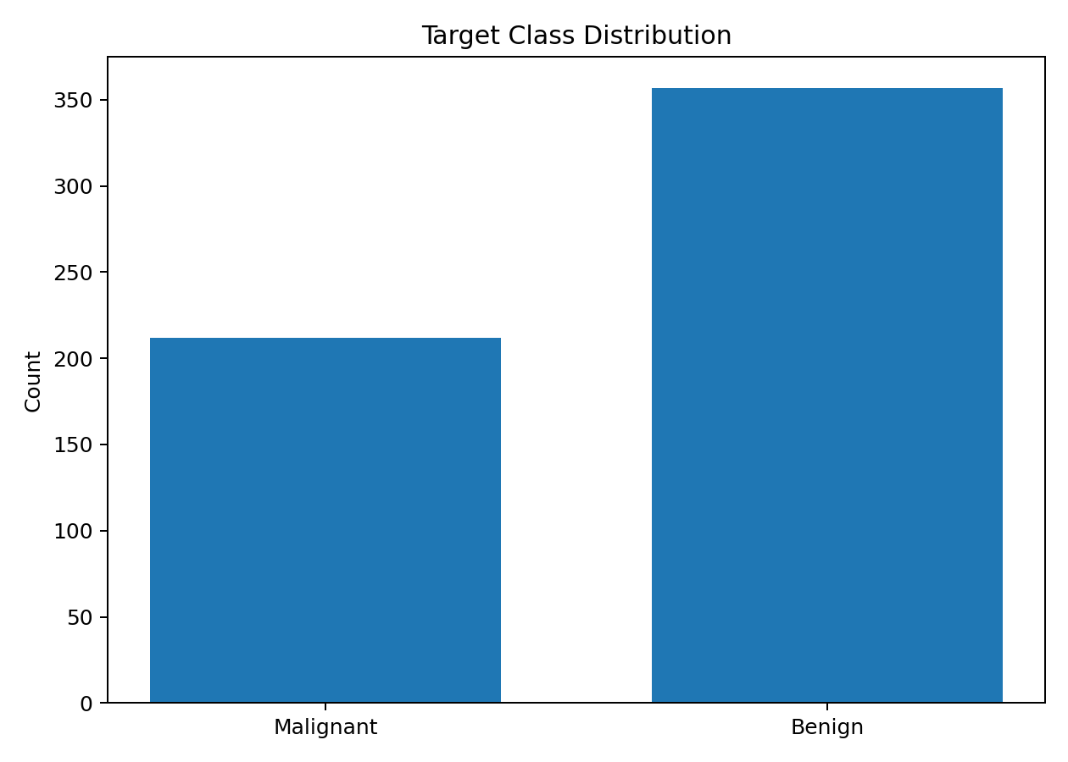
Figure 1. Distribution of the two target classes.

5. Tools and Technologies
- Python 3.x
- Pandas and NumPy for data handling
- Scikit-learn for preprocessing, modeling, validation, and metrics
- Matplotlib for visualization
- Jupyter Notebook or VS Code for implementation
- Microsoft Word / DOCX for report preparation

6. Methodology
The methodology follows a reproducible sequence: load the dataset, inspect the data, separate features and target, split the data using stratification, create a preprocessing-and-model Pipeline, train Logistic Regression, validate using five-fold cross-validation, evaluate on the untouched test set, visualize the results, and interpret the findings.

7. Data Exploration and Preprocessing
The dataset was checked for shape, data types, descriptive statistics, class distribution, and missing values. The features are numerical, so no categorical encoding is required. Since Logistic Regression is sensitive to feature scale, StandardScaler was included before the classifier. The scaler is fitted only on training folds inside the Pipeline during cross-validation, which prevents information from the validation fold from leaking into preprocessing.
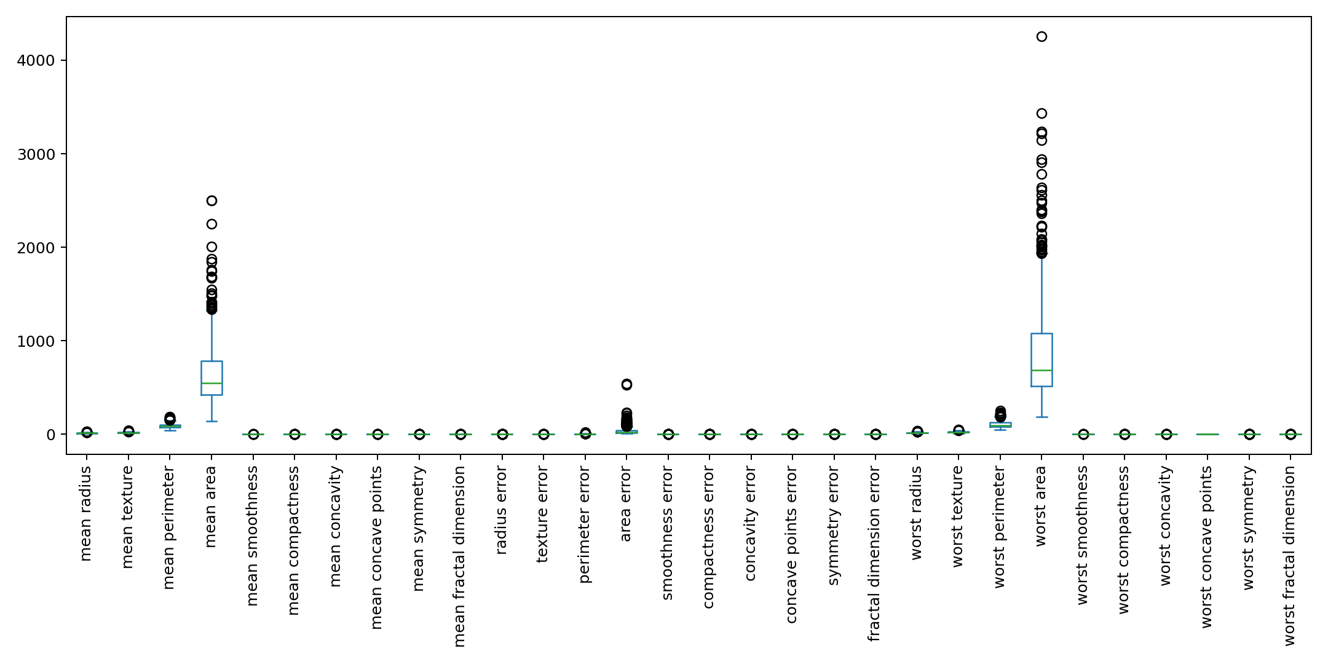
Figure 2. Boxplot overview of the numerical feature scales.

8. Feature Engineering
The primary feature-engineering operation is standardization. Each numerical feature is transformed so that it is centered around zero and has unit variance based on the training data. This makes the coefficients and optimization process less affected by differences in the original measurement scales. No manual feature deletion was performed because the dataset is compact and the purpose of the assignment is to demonstrate a complete supervised learning workflow. For a production project, feature selection or dimensionality reduction could be investigated using validation-based procedures.

9. Train-Test Split
The dataset was divided into 80% training data and 20% test data. Stratification was used so that the relative proportion of malignant and benign cases is preserved in both partitions. random_state=42 was selected to make the experiment reproducible.

10. Model Selection – Logistic Regression
Logistic Regression was selected as the primary classification model because it is simple, computationally efficient, widely used for binary classification, and relatively easy to interpret. It estimates the probability of a class and converts that probability into a class prediction using a decision threshold. Standardization is particularly useful because the model uses feature coefficients.

11. Model Training
The final pipeline uses StandardScaler followed by LogisticRegression(max_iter=5000, random_state=42). The higher max_iter value gives the optimizer sufficient iterations to converge reliably on the standardized 30-feature dataset. The complete implementation is included in Section 18.

12. Cross-Validation
Five-fold Stratified Cross-Validation was used to estimate how consistently the pipeline performs across different subsets of the available data. The five accuracy scores were 0.9737, 0.9474, 0.9649, 0.9912, 0.9912. The mean cross-validation accuracy was 0.9737 and the standard deviation was 0.0166. Stratification keeps the class proportions approximately consistent across folds.
Validation measure | Value
Mean 5-fold accuracy | 0.9737
Standard deviation | 0.0166
Minimum fold accuracy | 0.9474
Maximum fold accuracy | 0.9912

13. Model Evaluation
After cross-validation, the model was fitted on the complete training partition and evaluated once on the held-out test set. Accuracy measures overall correctness, precision measures how many predicted positive cases were actually positive, recall measures how many actual positive cases were detected, F1-score balances precision and recall, and ROC-AUC summarizes ranking performance across classification thresholds.
Metric | Test-set value
Accuracy | 0.9825
Precision | 0.9861
Recall | 0.9861
F1-Score | 0.9861
ROC-AUC | 0.9954
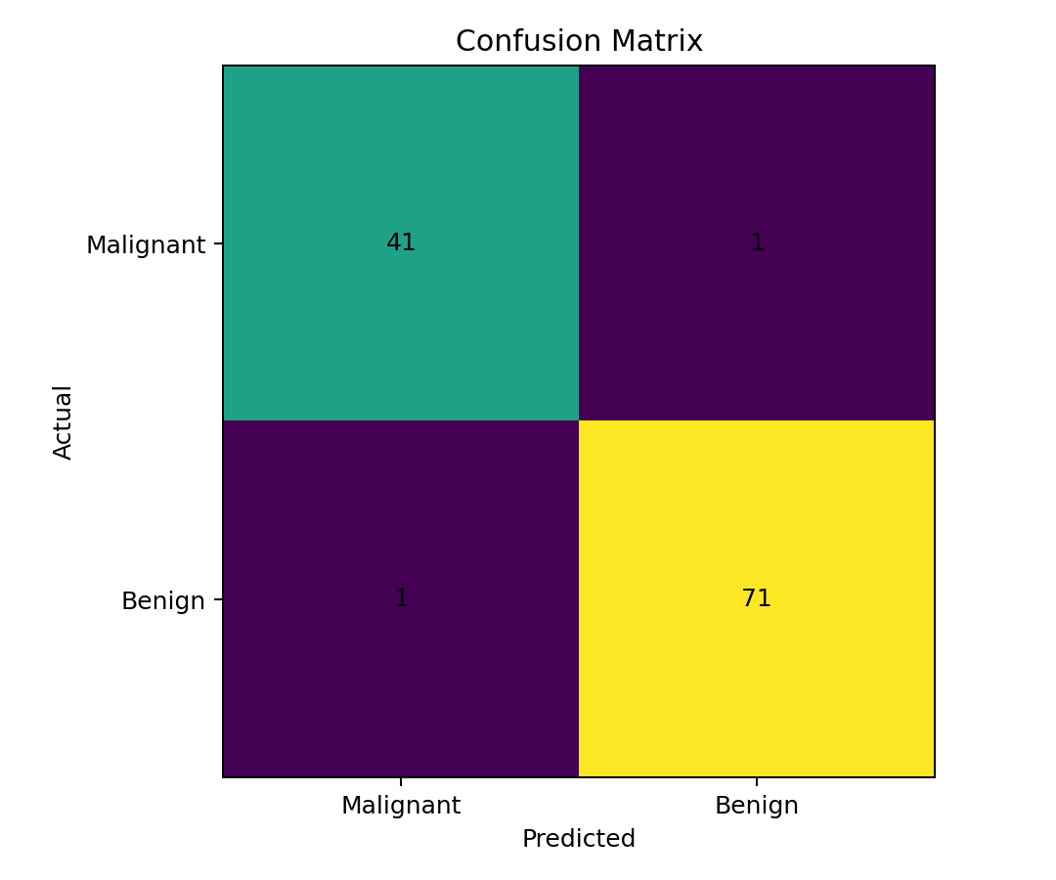
Figure 3. Confusion matrix on the held-out test set.
The confusion matrix contains 41 true negatives, 1 false positives, 1 false negatives, and 71 true positives under the report's Malignant/Benign class ordering. These counts help identify the types of errors rather than only reporting an aggregate score.
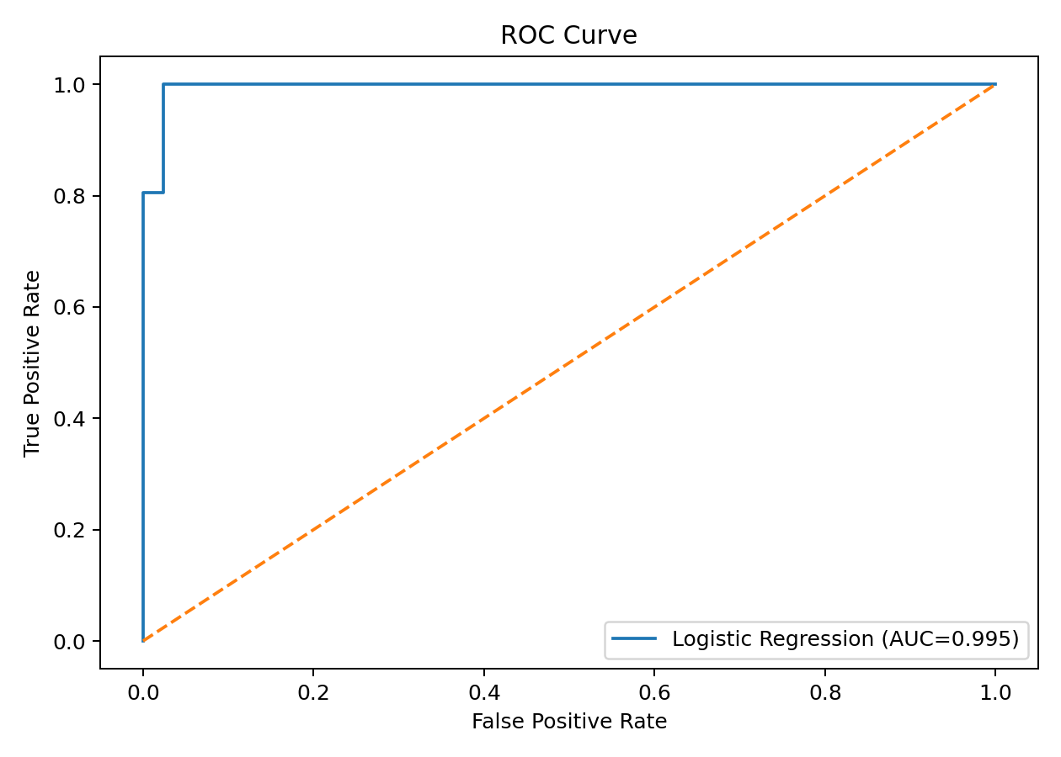
Figure 4. ROC curve and ROC-AUC for the test set.

14. Detailed Classification Performance
Class | Precision | Recall | F1-score | Support
Malignant | 0.9762 | 0.9762 | 0.9762 | 42
Benign | 0.9861 | 0.9861 | 0.9861 | 72
Macro average | 0.9812 | 0.9812 | 0.9812 | 114

15. Feature Interpretation
Logistic Regression provides one coefficient for each standardized feature. The sign indicates the direction of association with the encoded target class, while the magnitude indicates how strongly the feature contributes within the fitted linear decision function, subject to correlations among features. The coefficients should not be interpreted as independent causal effects.
Feature | Coefficient
worst texture | -1.2551
radius error | -1.0830
worst concave points | -0.9537
worst area | -0.9478
worst radius | -0.9476
worst symmetry | -0.9392
area error | -0.9291
worst concavity | -0.8232
worst perimeter | -0.7632
worst smoothness | -0.7466
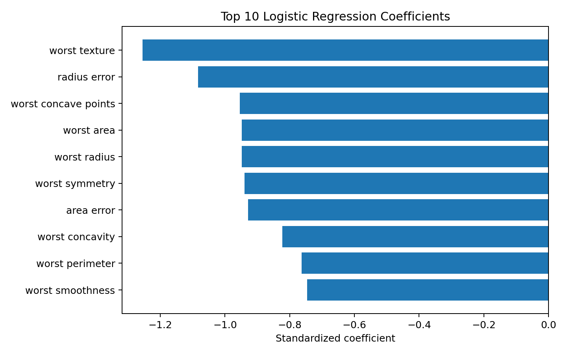
Figure 5. Ten features with the largest absolute Logistic Regression coefficients.

16. Results and Performance Analysis
The model achieved a test accuracy of 0.9825, with a precision of 0.9861, recall of 0.9861, F1-score of 0.9861, and ROC-AUC of 0.9954. The cross-validation mean accuracy of 0.9737 provides a second estimate of generalization performance and can be compared with the single held-out test result. The confusion matrix should be considered alongside these scores because different error types can have different practical consequences.
The results indicate that the standardized linear decision boundary captures substantial predictive information in the numerical measurements. However, the model's performance on this benchmark dataset should not be treated as evidence of clinical suitability. Real deployment would require independent validation, domain review, calibration, monitoring, and appropriate governance.

17. Strengths of the Model
- Simple and computationally efficient compared with many complex models.
- Produces class probabilities that can support threshold analysis.
- Coefficients provide a useful level of interpretability.
- Standardization makes numerical features comparable for optimization.
- Pipeline-based preprocessing reduces leakage risk during validation.
- Five-fold stratified cross-validation gives a more stable performance estimate than a single split alone.

18. Limitations
- Logistic Regression assumes a linear relationship in the log-odds space and may miss complex nonlinear patterns.
- Correlated features can make individual coefficient interpretation less stable.
- Performance on a benchmark dataset does not guarantee performance on new populations or different data collection settings.
- The chosen probability threshold may not be optimal for every application.
- The experiment does not include external validation or prospective testing.
- Class labels and dataset measurements are provided for educational machine-learning use and should not be interpreted as a medical diagnostic system.

19. Possible Improvements
- Compare Logistic Regression with Decision Tree, Random Forest, Support Vector Machine, and Gradient Boosting models.
- Use GridSearchCV or RandomizedSearchCV to tune hyperparameters inside a cross-validation workflow.
- Evaluate probability calibration and alternative decision thresholds.
- Investigate feature selection with cross-validation to reduce redundancy.
- Use repeated stratified cross-validation for a more stable estimate.
- Test the final model on an independent external dataset.
- Track additional metrics that reflect the cost of false positives and false negatives.

20. Practical and Research Implications
The workflow demonstrates a general pattern that can be reused for many supervised-learning problems. In customer analytics it could predict churn; in finance it could classify risk categories; in manufacturing it could predict quality classes; and in cybersecurity it could classify suspicious events. The same principles—clean data, leakage-safe preprocessing, validation, multiple evaluation metrics, and careful interpretation—are transferable across domains.

21. Conclusion
This project implemented a complete supervised learning classification workflow using Python and Scikit-learn. The Breast Cancer Wisconsin Diagnostic dataset was explored, standardized, split using stratification, and modeled with Logistic Regression. Five-fold cross-validation and held-out test evaluation were used to assess generalization. Accuracy, precision, recall, F1-score, ROC-AUC, and the confusion matrix provided complementary views of model performance. The experiment demonstrates the practical steps required to move from raw labeled data to a validated predictive model. Future work can focus on model comparison, hyperparameter tuning, calibration, feature selection, and external validation.

22. Complete Python Code
# Week 4: Supervised Learning Model Implementation
# Logistic Regression - Breast Cancer Wisconsin Dataset

import numpy as np
import pandas as pd
import matplotlib.pyplot as plt

from sklearn.datasets import load_breast_cancer
from sklearn.model_selection import train_test_split, StratifiedKFold, cross_val_score
from sklearn.preprocessing import StandardScaler
from sklearn.pipeline import Pipeline
from sklearn.linear_model import LogisticRegression
from sklearn.metrics import (
accuracy_score, precision_score, recall_score, f1_score,
roc_auc_score, confusion_matrix, classification_report, roc_curve
)

# 1. Load dataset
data = load_breast_cancer(as_frame=True)
X = data.data
y = data.target

print("Shape:", X.shape)
print("Target names:", data.target_names)
print(X.head())
print(X.isnull().sum().sum())

# 2. Train-test split
X_train, X_test, y_train, y_test = train_test_split(
X, y, test_size=0.20, stratify=y, random_state=42
)

# 3. Build leakage-safe pipeline
model = Pipeline([
("scaler", StandardScaler()),
("classifier", LogisticRegression(max_iter=5000, random_state=42))
])

# 4. Train model
model.fit(X_train, y_train)

# 5. Cross-validation
cv = StratifiedKFold(n_splits=5, shuffle=True, random_state=42)
cv_scores = cross_val_score(model, X, y, cv=cv, scoring="accuracy")

print("CV scores:", cv_scores)
print("Mean CV accuracy:", cv_scores.mean())

# 6. Test predictions
y_pred = model.predict(X_test)
y_prob = model.predict_proba(X_test)[:, 1]

# 7. Evaluation
print("Accuracy:", accuracy_score(y_test, y_pred))
print("Precision:", precision_score(y_test, y_pred))
print("Recall:", recall_score(y_test, y_pred))
print("F1:", f1_score(y_test, y_pred))
print("ROC-AUC:", roc_auc_score(y_test, y_prob))

print("\nClassification Report:")
print(classification_report(
y_test, y_pred, target_names=["Malignant", "Benign"]
))

# 8. Confusion matrix
cm = confusion_matrix(y_test, y_pred)
print("Confusion Matrix:\n", cm)

plt.imshow(cm)
plt.title("Confusion Matrix")
plt.xlabel("Predicted")
plt.ylabel("Actual")
plt.xticks([0, 1], ["Malignant", "Benign"])
plt.yticks([0, 1], ["Malignant", "Benign"])

for i in range(2):
for j in range(2):
plt.text(j, i, cm[i, j], ha="center", va="center")

plt.show()

# 9. ROC curve
fpr, tpr, thresholds = roc_curve(y_test, y_prob)

plt.plot(fpr, tpr, label="Logistic Regression")
plt.plot([0, 1], [0, 1], "--")
plt.xlabel("False Positive Rate")
plt.ylabel("True Positive Rate")
plt.title("ROC Curve")
plt.legend()
plt.show()

# 10. Model coefficients
coefficients = model.named_steps["classifier"].coef_[0]

coef_df = pd.DataFrame({
"Feature": X.columns,
"Coefficient": coefficients
})

coef_df["Absolute"] = coef_df["Coefficient"].abs()
print(coef_df.sort_values("Absolute", ascending=False).head(10))

23. References
- Scikit-learn documentation – Breast Cancer Wisconsin dataset and classification tools.
- Scikit-learn documentation – LogisticRegression, StandardScaler, Pipeline, train_test_split, and cross-validation utilities.
- Scikit-learn documentation – classification metrics, confusion matrix, ROC curve, and ROC-AUC.
- UCI Machine Learning Repository – Breast Cancer Wisconsin (Diagnostic) dataset background.
End of Report

