WEEK 3 TASK
UNSUPERVISED LEARNING AND
CLUSTERING ANALYSIS
K-Means Clustering on the Iris Dataset

Prepared by
Alok Kumar Singh
B.Tech Computer Science Engineering
Gurukul Kangri University, Haridwar
Academic Year: 2026

1. Executive Summary
This report applies unsupervised learning to the publicly available Iris dataset. K-Means clustering was used to segment 150 flower observations into three groups based only on four numerical measurements. StandardScaler was applied before clustering so that all features contributed on a comparable scale. The number of clusters was investigated with the Elbow Method and Silhouette Score. The final three-cluster model produced a silhouette score of 0.460. A PCA projection is used only for visualization, while an optional comparison with the original species labels gives an adjusted Rand index of 0.620.

2. Introduction to Unsupervised Learning
Unsupervised learning finds structure in data without using a target label during model training. Clustering is a major unsupervised technique in which observations are grouped so that members of the same group are relatively similar and members of different groups are relatively different. K-Means is suitable for this task because the Iris features are numerical and the goal is to create compact, interpretable segments.

3. Problem Statement and Objectives
The problem is to identify meaningful groups within a public dataset without using the known class labels during training. The objectives are to preprocess the data, determine a reasonable cluster count, train a clustering algorithm, visualize the resulting groups, describe their characteristics, and discuss practical implications.
- Select a public numerical dataset appropriate for clustering.
- Standardize the features before distance-based clustering.
- Compare candidate values of k using inertia and silhouette score.
- Train K-Means with a documented random state and initialization count.
- Visualize and interpret the resulting clusters.
- Compare against hierarchical clustering as a secondary analysis.

4. Dataset Description
The Iris dataset from scikit-learn contains 150 observations, four numerical features, and three known species. The species labels are deliberately excluded from K-Means training. They are used only after clustering for interpretation and an optional external validation metric.
Item | Value
150 | Observations
4 | Numerical features
3 | Known species (not used for training)
0 | Missing values in the standard Iris dataset
Feature | Unit | Type
sepal length (cm) | cm | Continuous numerical
sepal width (cm) | cm | Continuous numerical
petal length (cm) | cm | Continuous numerical
petal width (cm) | cm | Continuous numerical
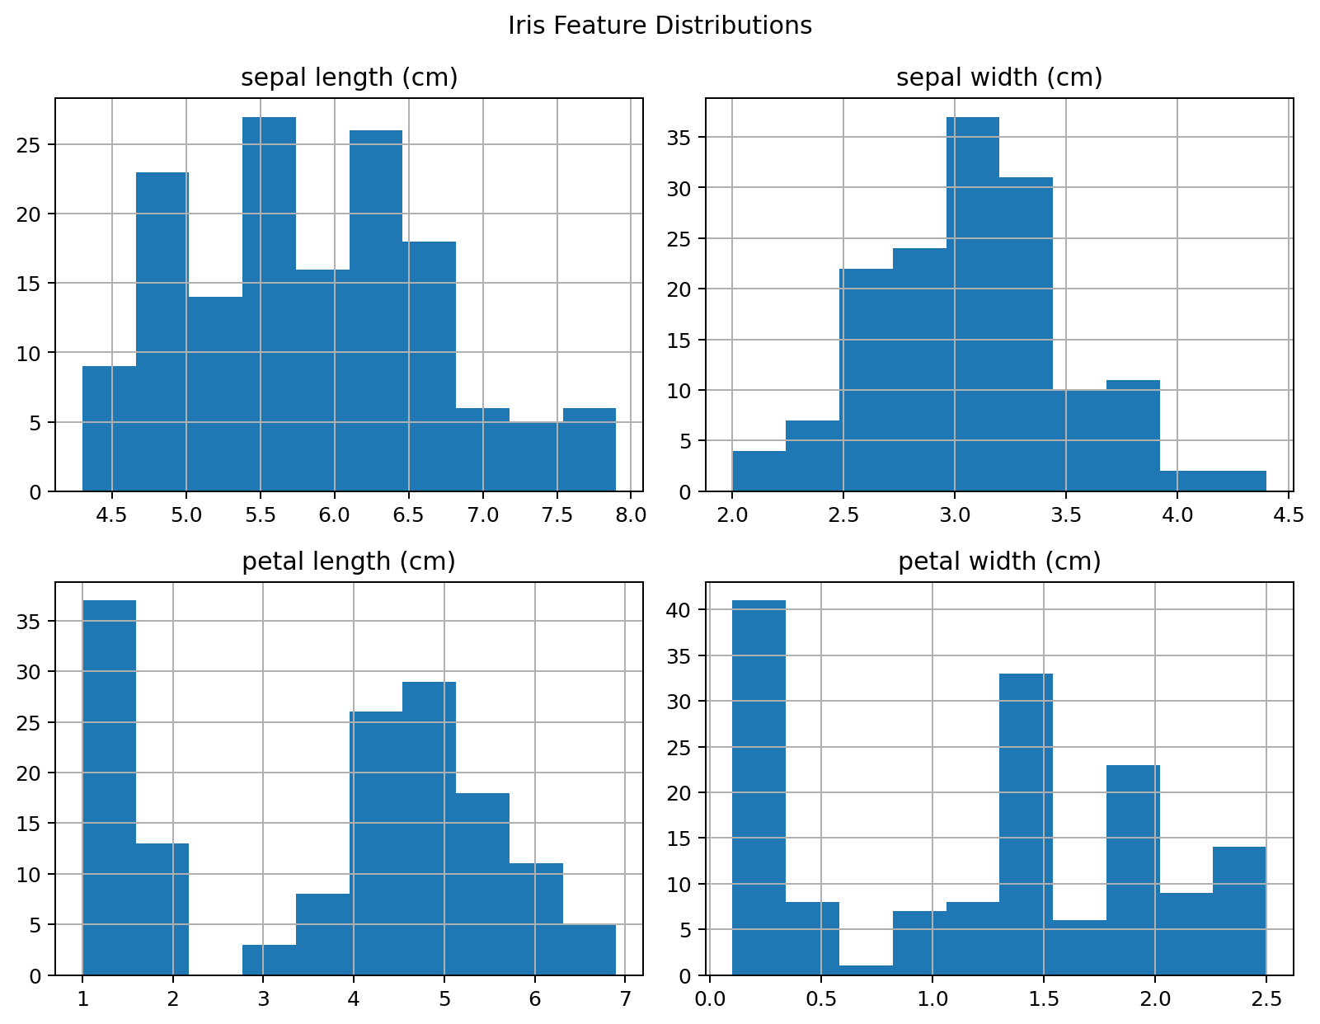
Figure 1. Distribution of the four Iris features.

5. Tools and Technologies
Tool | Purpose
Python | Programming language
Pandas / NumPy | Data handling and numerical operations
Scikit-learn | Scaling, clustering, PCA, metrics
Matplotlib | Graphs and visualizations
python-docx | Report generation

6. Methodology
The workflow consists of loading the data, checking its structure, standardizing the four features, evaluating candidate cluster counts, fitting K-Means, visualizing the clusters with PCA, profiling cluster means, and comparing the result with Agglomerative Clustering. PCA is not used to train K-Means; it is used only to display the four-dimensional data in two dimensions.

7. Data Preprocessing
K-Means uses Euclidean distance, so feature scale can influence the result. StandardScaler transforms each feature to approximately zero mean and unit variance. This prevents a feature with larger numerical variation from dominating the distance calculation.

8. Selecting the Number of Clusters
Candidate values k=2 through k=7 were evaluated. Inertia measures within-cluster squared distance and generally decreases as k increases. The Elbow Method looks for a point where additional clusters provide diminishing improvement. Silhouette Score measures how well each point fits its own cluster compared with neighboring clusters; higher values indicate better separation.
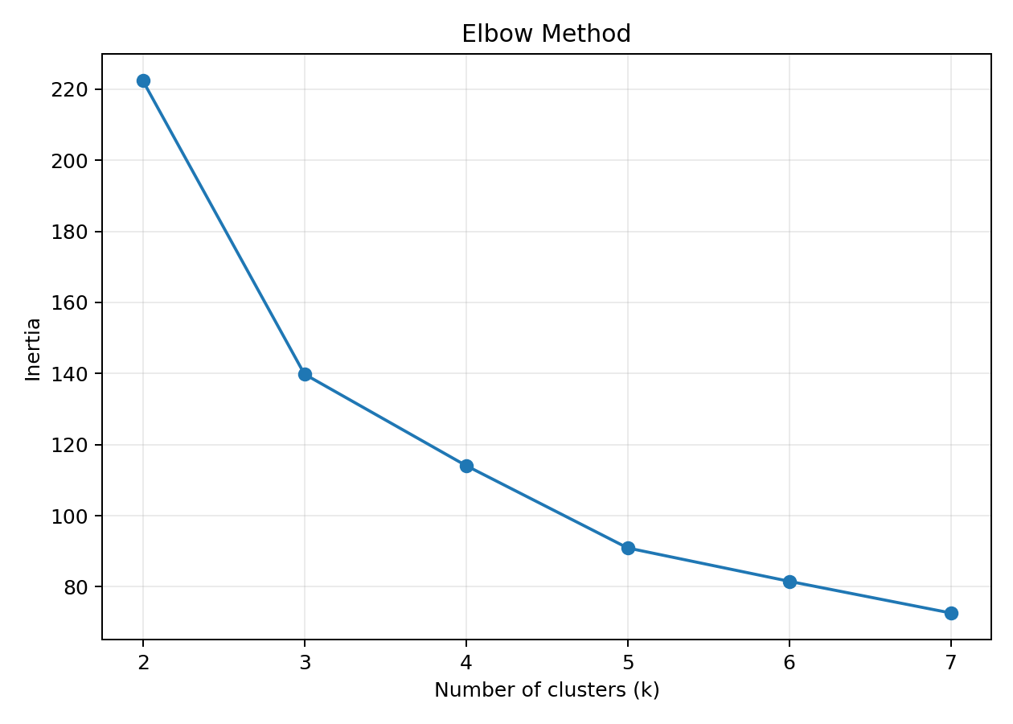
Figure 2. Elbow Method for candidate cluster counts.
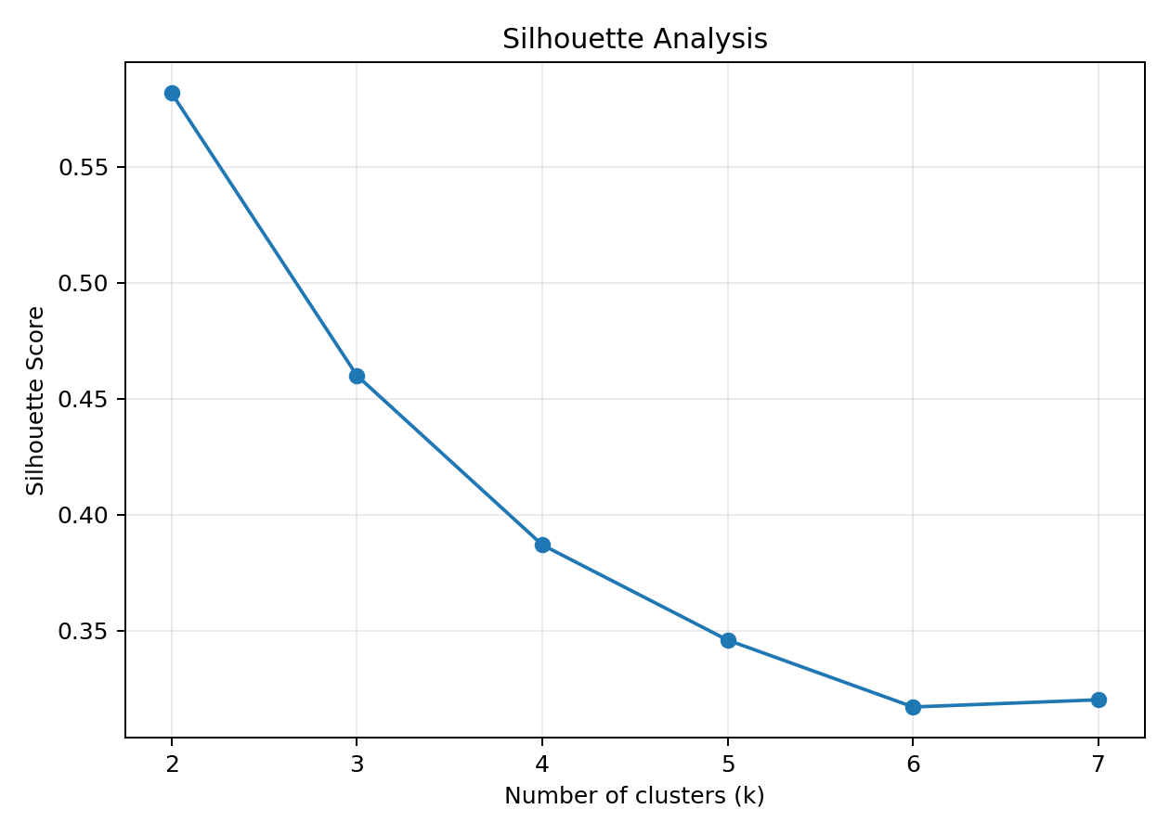
Figure 3. Silhouette scores for candidate cluster counts.
k | Inertia | Silhouette
2 | 222.36 | 0.582
3 | 139.82 | 0.46
4 | 114.09 | 0.387
5 | 90.93 | 0.346
6 | 81.54 | 0.317
7 | 72.63 | 0.32
Based on the overall elbow pattern and the strong silhouette result, k=3 was selected for the final K-Means model. This choice is also useful for interpretation because it produces three compact, distinct groups in this dataset.

9. K-Means Clustering
Final parameters: n_clusters=3, random_state=42, n_init=10. K-Means initializes three centroids, assigns each observation to the nearest centroid, updates centroid locations, and repeats until the solution stabilizes. random_state makes the experiment reproducible, while multiple initializations reduce sensitivity to an unlucky starting configuration.

10. Cluster Visualization
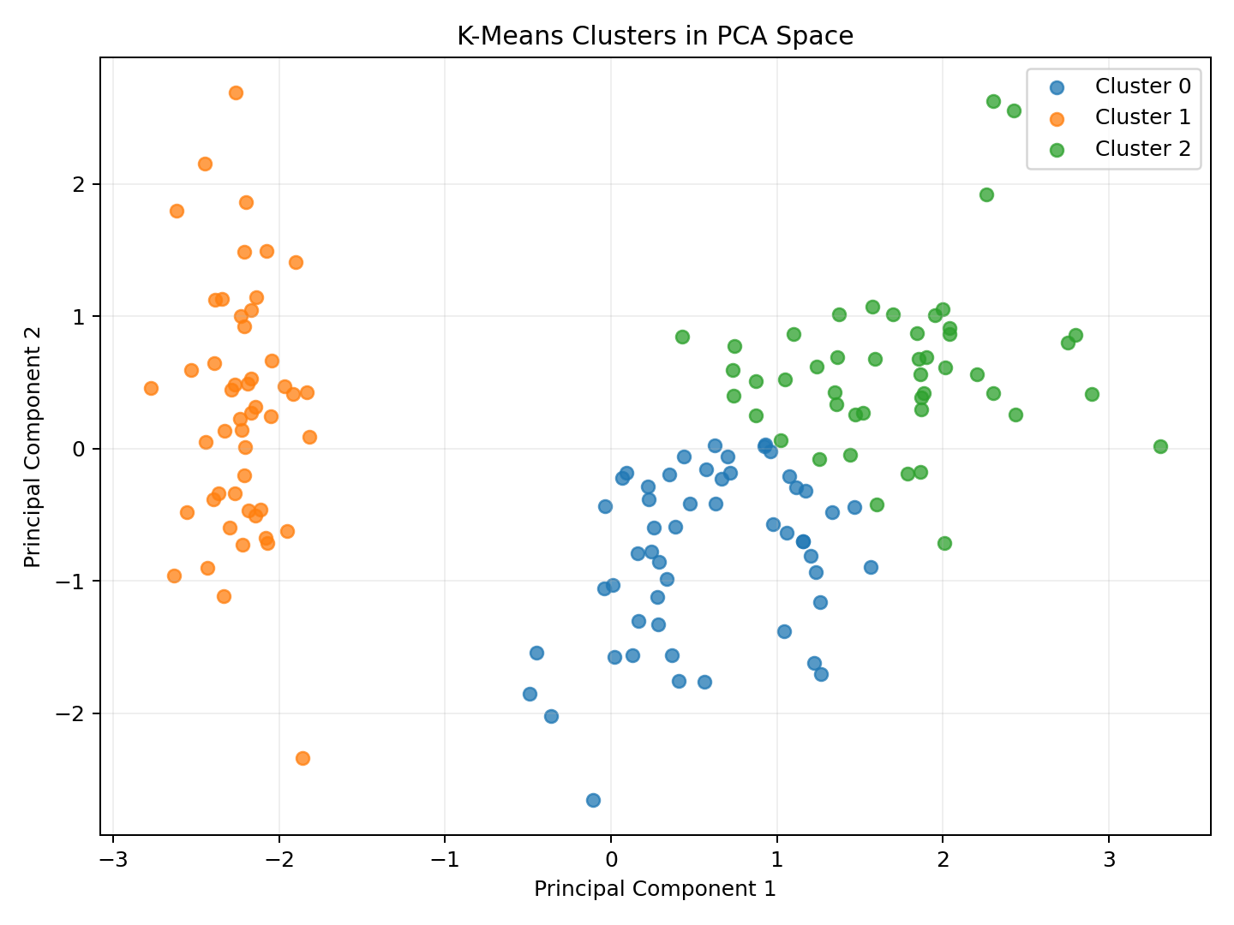
Figure 4. K-Means clusters shown in the first two PCA components.
The first two principal components explain 95.8% of the standardized variance. The plot is therefore a useful two-dimensional summary, but it should not be treated as a complete representation of the original four-dimensional feature space.

11. Cluster Characteristics
The table below shows the original-scale mean feature values for each cluster. These averages provide a direct way to describe the groups.
Cluster | sepal length (cm) | sepal width (cm) | petal length (cm) | petal width (cm)
Cluster 0 | 5.80 | 2.67 | 4.37 | 1.41
Cluster 1 | 5.01 | 3.43 | 1.46 | 0.25
Cluster 2 | 6.78 | 3.10 | 5.51 | 1.97
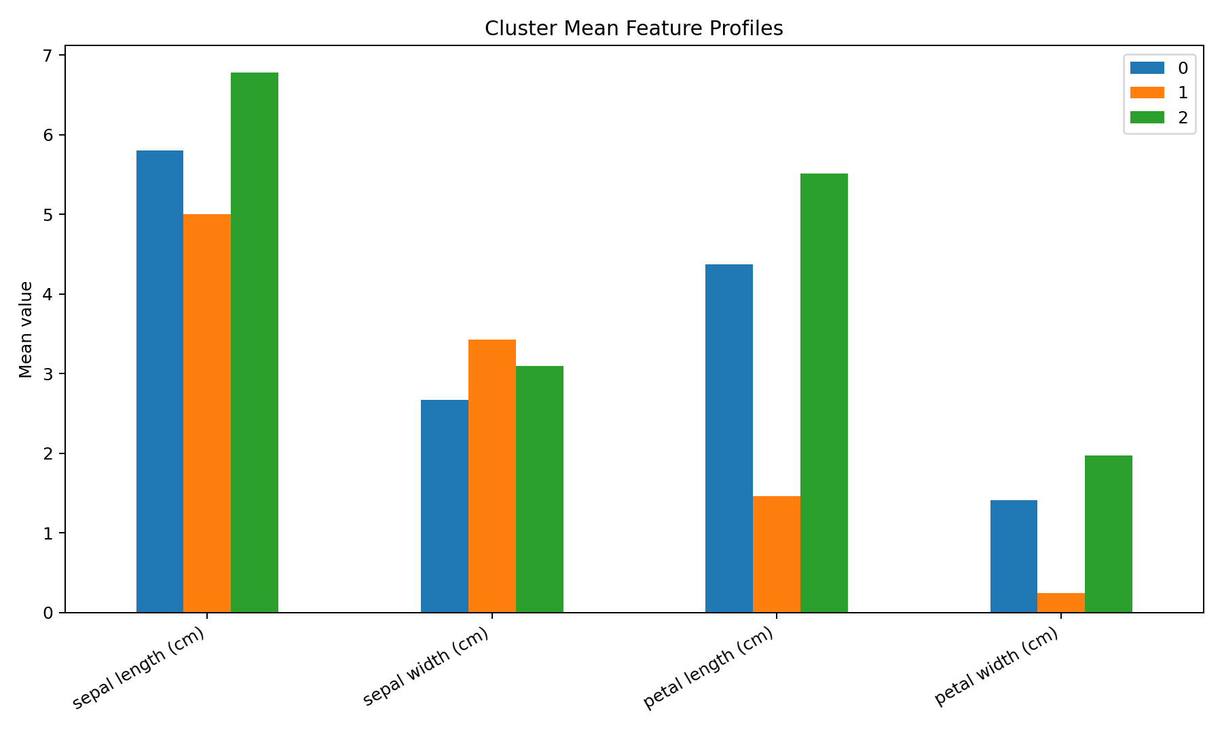
Figure 5. Mean feature profile for each K-Means cluster.
Cluster 0: mean sepal length 5.80, sepal width 2.67, petal length 4.37, and petal width 1.41. The strongest separation is generally visible in petal measurements, which helps explain the cluster structure.
Cluster 1: mean sepal length 5.01, sepal width 3.43, petal length 1.46, and petal width 0.25. The strongest separation is generally visible in petal measurements, which helps explain the cluster structure.
Cluster 2: mean sepal length 6.78, sepal width 3.10, petal length 5.51, and petal width 1.97. The strongest separation is generally visible in petal measurements, which helps explain the cluster structure.

12. Interpretation Against Original Species Labels
Although the species labels were not used to train the model, they can be inspected afterward to understand what the clusters correspond to. This is not part of the unsupervised training process.
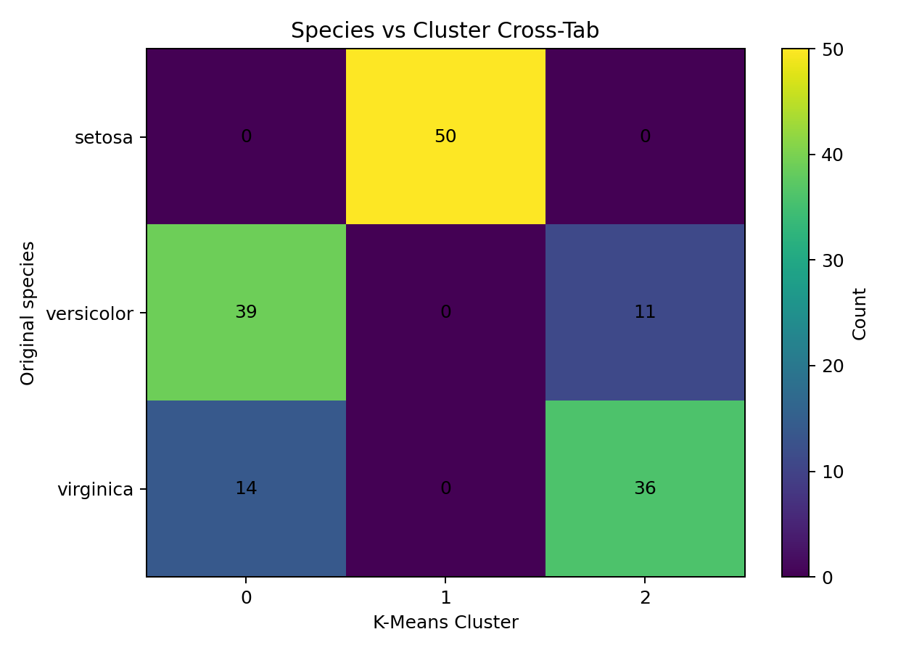
Figure 6. Cross-tabulation of original species and discovered clusters.
The adjusted Rand index is 0.620. ARI compares two partitions while correcting for agreement that could occur by chance. It is included as a post-hoc validation measure, not as a training objective.

13. Hierarchical Clustering Comparison
Agglomerative Hierarchical Clustering with Ward linkage and three clusters was also tested. Its silhouette score was 0.447. This comparison demonstrates that the cluster structure can be investigated with more than one method. K-Means remains the primary model for this report because it is simple, scalable, and easy to interpret for this numerical dataset.
Method | Clusters | Silhouette | Approach
K-Means | 3 | 0.460 | Centroid-based
Agglomerative | 3 | 0.447 | Ward hierarchical

14. Results Summary
The final analysis produced three clusters from 150 Iris observations. Standardization made the four measurements comparable for distance calculations. The final K-Means silhouette score was 0.460. PCA visualization shows clear grouping, while cluster mean profiles indicate that petal-related measurements contribute strongly to separation. The post-hoc ARI of 0.620 indicates substantial correspondence between the discovered groups and the known species partition, while still recognizing that clustering was performed without labels.

15. Potential Business and Research Implications
- Customer segmentation: the same workflow can group customers by purchasing or behavioral features.
- Product segmentation: numerical product attributes can be clustered to identify natural product families.
- Anomaly investigation: observations far from cluster centers may deserve additional review.
- Biological research: unsupervised grouping can reveal structure before known categories are considered.
- Exploratory analytics: clustering can help researchers form hypotheses when no target variable is available.

16. Limitations
- K-Means assumes cluster structure that can be represented reasonably by centroids and Euclidean distance.
- The chosen k can affect the result; no single metric should be treated as absolute proof.
- PCA plots can hide information from dimensions beyond the first two components.
- Iris is a small, clean teaching dataset, so real-world data may require missing-value handling, outlier treatment, feature engineering, and stronger validation.
- Post-hoc comparison with species labels is informative, but those labels were not available to the clustering algorithm.

17. Complete Python Code
# Week 3: Unsupervised Learning and Clustering Analysis
# K-Means + Hierarchical Clustering on Iris Dataset

import numpy as np
import pandas as pd
import matplotlib.pyplot as plt
from sklearn.datasets import load_iris
from sklearn.preprocessing import StandardScaler
from sklearn.cluster import KMeans, AgglomerativeClustering
from sklearn.decomposition import PCA
from sklearn.metrics import silhouette_score, adjusted_rand_score

# 1. Load public dataset
iris = load_iris()
X = iris.data
y = iris.target
features = iris.feature_names

# 2. Put data into a DataFrame
df = pd.DataFrame(X, columns=features)
print(df.head())
print(df.info())

# 3. Standardize features
scaler = StandardScaler()
X_scaled = scaler.fit_transform(X)

# 4. Test different values of k
k_values = range(2, 8)
inertias = []
silhouette_scores = []

for k in k_values:
model = KMeans(n_clusters=k, random_state=42, n_init=10)
labels = model.fit_predict(X_scaled)
inertias.append(model.inertia_)
silhouette_scores.append(silhouette_score(X_scaled, labels))

# 5. Elbow plot
plt.figure(figsize=(7, 5))
plt.plot(k_values, inertias, marker='o')
plt.xlabel('Number of clusters (k)')
plt.ylabel('Inertia')
plt.title('Elbow Method')
plt.grid(True, alpha=0.25)
plt.show()

# 6. Silhouette plot
plt.figure(figsize=(7, 5))
plt.plot(k_values, silhouette_scores, marker='o')
plt.xlabel('Number of clusters (k)')
plt.ylabel('Silhouette Score')
plt.title('Silhouette Analysis')
plt.grid(True, alpha=0.25)
plt.show()

# 7. Final K-Means model
kmeans = KMeans(n_clusters=3, random_state=42, n_init=10)
cluster_labels = kmeans.fit_predict(X_scaled)

print('Silhouette Score:', silhouette_score(X_scaled, cluster_labels))

# 8. PCA for 2D visualization only
pca = PCA(n_components=2, random_state=42)
X_pca = pca.fit_transform(X_scaled)

plt.figure(figsize=(8, 6))
for cluster in sorted(set(cluster_labels)):
plt.scatter(
X_pca[cluster_labels == cluster, 0],
X_pca[cluster_labels == cluster, 1],
label=f'Cluster {cluster}',
alpha=0.75
)
plt.xlabel('Principal Component 1')
plt.ylabel('Principal Component 2')
plt.title('K-Means Clusters')
plt.legend()
plt.grid(True, alpha=0.2)
plt.show()

# 9. Cluster characteristics
centers_original = scaler.inverse_transform(kmeans.cluster_centers_)
cluster_means = pd.DataFrame(centers_original, columns=features)
print('Cluster Mean Features:')
print(cluster_means)

# 10. Optional post-hoc comparison with original labels
ari = adjusted_rand_score(y, cluster_labels)
print('Adjusted Rand Index:', ari)

# 11. Hierarchical clustering comparison
hierarchical = AgglomerativeClustering(n_clusters=3, linkage='ward')
h_labels = hierarchical.fit_predict(X_scaled)
print('Hierarchical Silhouette Score:',
silhouette_score(X_scaled, h_labels))

18. Conclusion
This study demonstrates a complete unsupervised learning workflow using K-Means clustering. The Iris dataset was standardized, candidate cluster counts were evaluated, three clusters were selected, and the resulting groups were visualized and profiled. A hierarchical clustering comparison and post-hoc label analysis add depth to the investigation. The same methodology can be transferred to larger real-world datasets for customer, product, operational, or scientific segmentation.

19. References
- Scikit-learn documentation — Iris dataset and clustering utilities.
- Scikit-learn documentation — KMeans, StandardScaler, PCA, silhouette_score, and AgglomerativeClustering.
- Fisher, R. A. (1936). The use of multiple measurements in taxonomic problems. Annals of Eugenics, 7, 179–188.

