WEEK 2 PROJECT REPORT
Exploratory Data Analysis and Visualization
Dataset: Wine Recognition Dataset

Student Name: Alok Kumar Singh
Branch: Computer Science and Engineering
College: Gurukul Kangri University
Task: Week 2 – Exploratory Data Analysis and Visualization

1. Introduction
Exploratory Data Analysis (EDA) is the process of examining, summarizing, and visualizing data before advanced statistical analysis or machine learning. It helps identify patterns, distributions, relationships, missing values, and possible anomalies. This project analyzes the Wine Recognition Dataset using Python, Pandas, Matplotlib, and Seaborn.

2. Objectives
The objectives are to load a public dataset, inspect its structure and quality, calculate descriptive statistics, create meaningful visualizations, analyze correlations, compare wine classes, and interpret the findings.

3. Dataset Description
The Wine Recognition Dataset is a public dataset available through scikit-learn. It contains 178 wine samples, 13 numerical chemical features, and 3 target classes. The features include alcohol, malic acid, magnesium, flavanoids, color intensity, and proline.
- Records: 178
- Chemical features: 13
- Target classes: 3
- Missing values: 0

4. Importing Libraries and Loading Data
The dataset is loaded and converted into a Pandas DataFrame.
import pandas as pd
import matplotlib.pyplot as plt
import seaborn as sns
from sklearn.datasets import load_wine
wine = load_wine(as_frame=True)
df = wine.frame
df["target_name"] = df["target"].map(dict(enumerate(wine.target_names)))

5. Initial Data Exploration
The head(), shape, info(), isnull(), and describe() functions were used to inspect the dataset.
print(df.head())
print(df.shape)
print(df.info())
print(df.isnull().sum())
print(df.describe())
The dataset contains 178 records. The total number of missing values is 0, so missing-value treatment was not required.

6. Descriptive Statistics
Descriptive statistics summarize the mean, standard deviation, minimum, maximum, and quartiles of numerical features.
numeric_summary = df.describe().T
print(numeric_summary)
Feature | Mean | Std. Dev. | Minimum | Maximum
alcohol | 13.0 | 0.81 | 11.03 | 14.83
malic_acid | 2.34 | 1.12 | 0.74 | 5.8
ash | 2.37 | 0.27 | 1.36 | 3.23
alcalinity_of_ash | 19.49 | 3.34 | 10.6 | 30.0
magnesium | 99.74 | 14.28 | 70.0 | 162.0
total_phenols | 2.3 | 0.63 | 0.98 | 3.88
flavanoids | 2.03 | 1.0 | 0.34 | 5.08
nonflavanoid_phenols | 0.36 | 0.12 | 0.13 | 0.66

7. Visualization 1: Distribution of Wine Classes
The visualization was created to identify patterns and differences in the dataset.
class_counts = df["target_name"].value_counts()
class_counts.plot(kind="bar")
plt.title("Distribution of Wine Classes")
plt.xlabel("Wine Class")
plt.ylabel("Number of Samples")
plt.show()
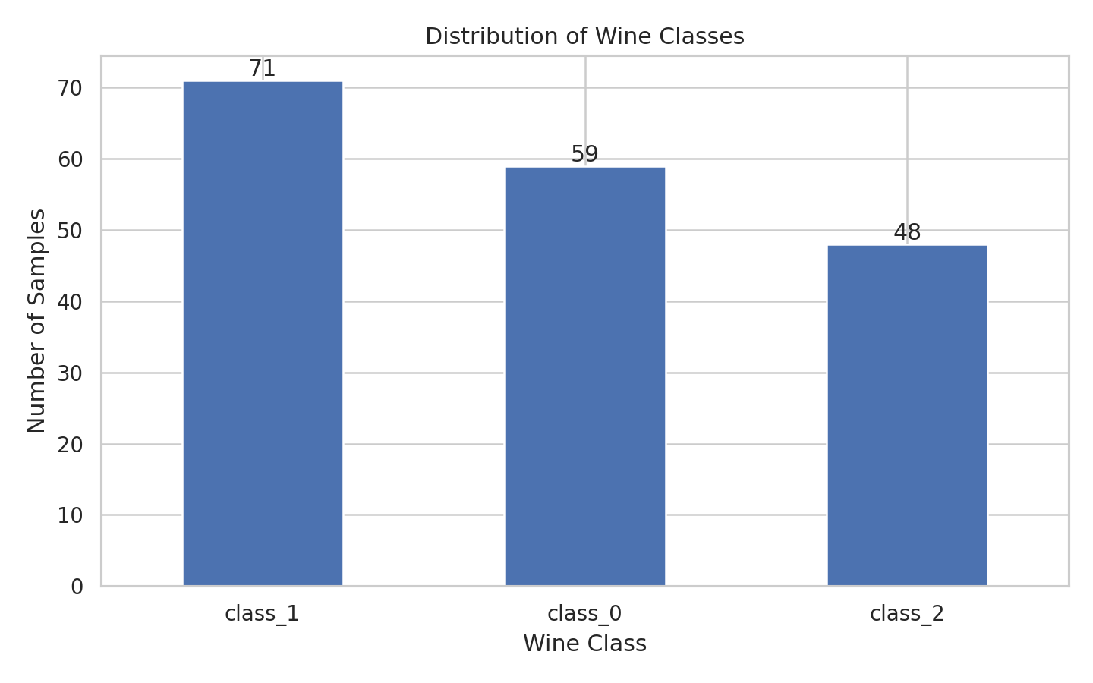
Figure 1: Distribution of samples across wine classes.
Interpretation: The class counts are not exactly equal. This should be considered in future classification tasks because class imbalance can influence model evaluation.

8. Visualization 2: Alcohol Content by Class
The visualization was created to identify patterns and differences in the dataset.
sns.boxplot(data=df, x="target_name", y="alcohol")
plt.title("Alcohol Content by Wine Class")
plt.xlabel("Wine Class")
plt.ylabel("Alcohol")
plt.show()
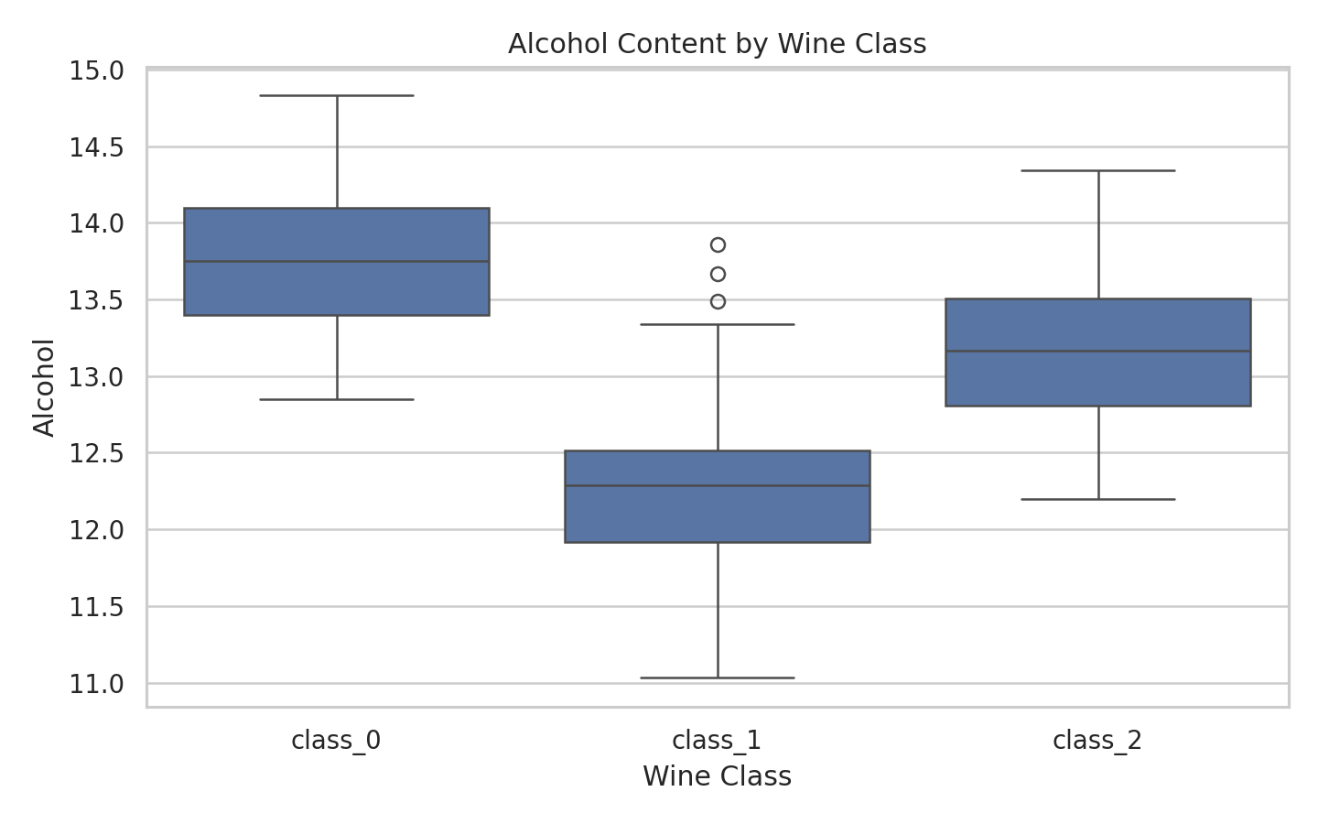
Figure 2: Alcohol content comparison among wine classes.
Interpretation: The average alcohol values differ among classes. class_0 has the highest average alcohol value. The box plot also shows spread and overlap.

9. Visualization 3: Flavanoids and Color Intensity
The visualization was created to identify patterns and differences in the dataset.
sns.scatterplot(data=df, x="flavanoids", y="color_intensity", hue="target_name")
plt.title("Flavanoids vs Color Intensity")
plt.xlabel("Flavanoids")
plt.ylabel("Color Intensity")
plt.legend(title="Wine Class")
plt.show()
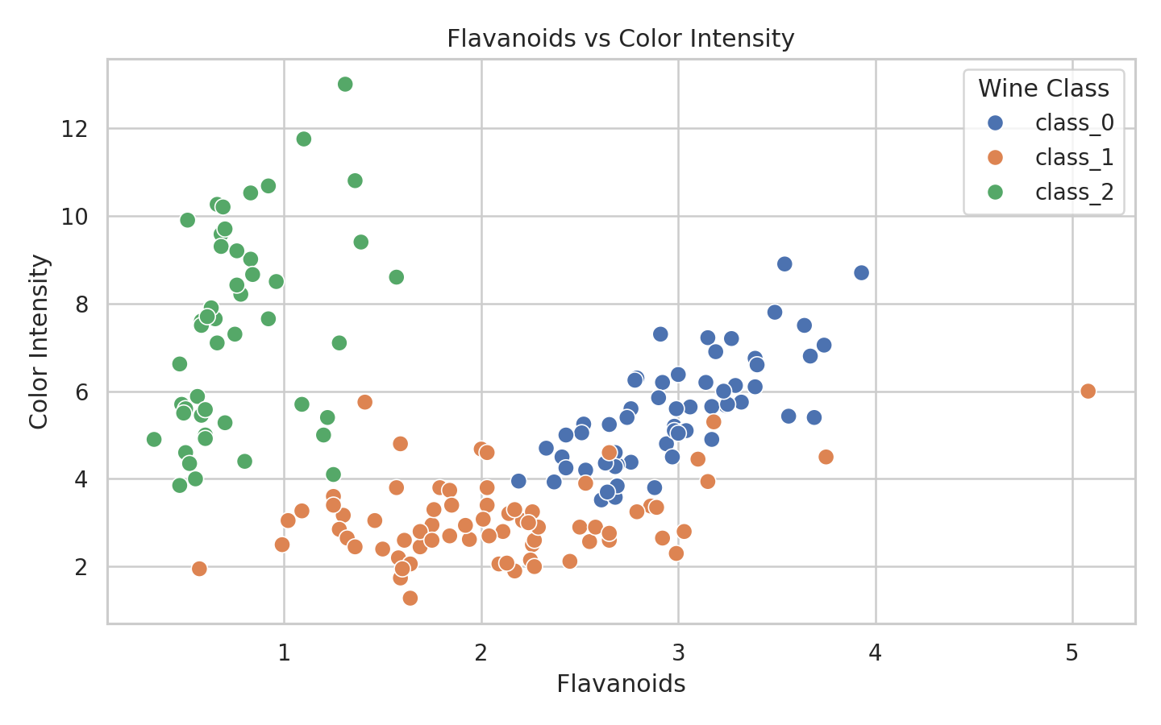
Figure 3: Flavanoids versus color intensity.
Interpretation: The scatter plot shows that some wine classes occupy different areas of the feature space, although some overlap exists. This suggests that chemical features may help distinguish classes.

10. Visualization 4: Correlation Heatmap
The visualization was created to identify patterns and differences in the dataset.
corr = df[feature_names].corr()
sns.heatmap(corr, cmap="coolwarm", center=0)
plt.title("Correlation Heatmap of Wine Features")
plt.show()
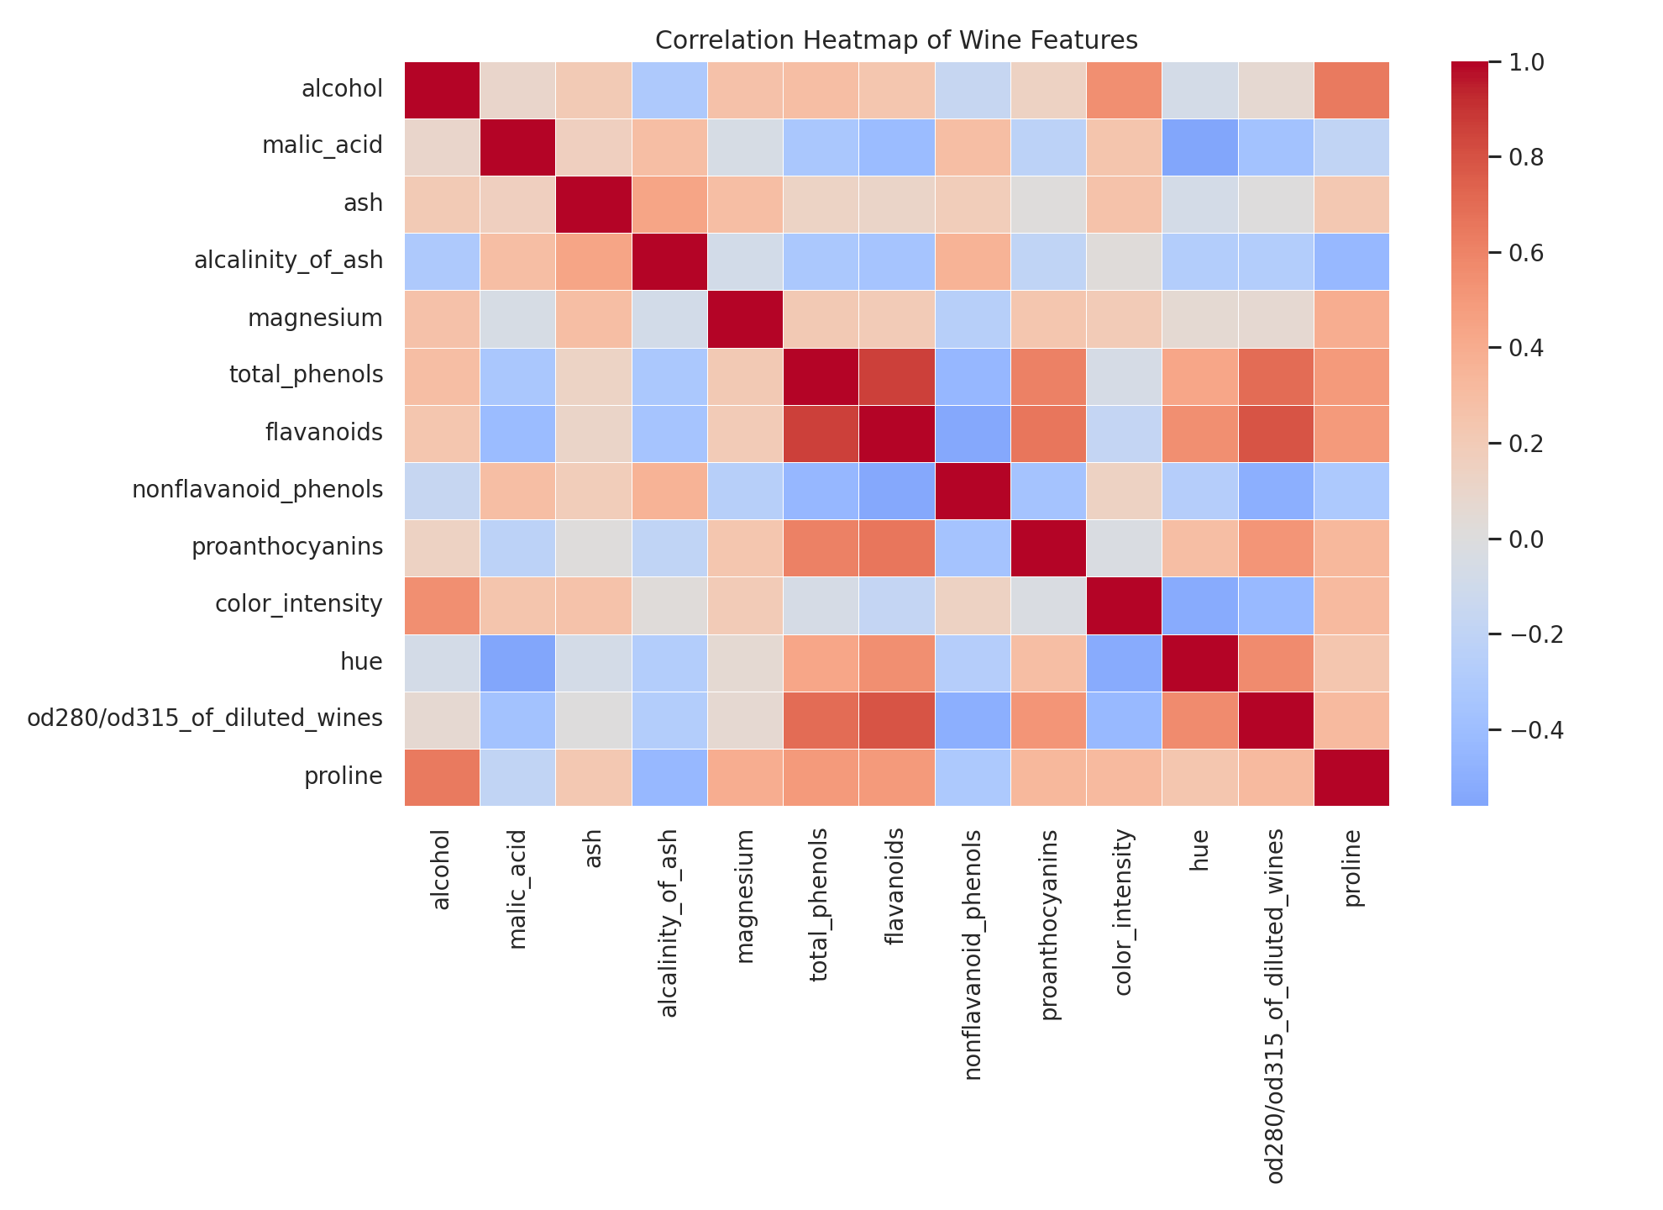
Figure 4: Correlation matrix of chemical features.
Interpretation: The strongest absolute correlation was observed between total_phenols and flavanoids, with an approximate correlation of 0.86. Correlation shows association, not causation.

11. Visualization 5: Average Features by Class
The visualization was created to identify patterns and differences in the dataset.
selected_features = ["alcohol", "malic_acid", "flavanoids", "color_intensity"]
mean_selected = df.groupby("target_name")[selected_features].mean()
mean_selected.plot(kind="bar")
plt.title("Average Selected Chemical Features by Wine Class")
plt.show()
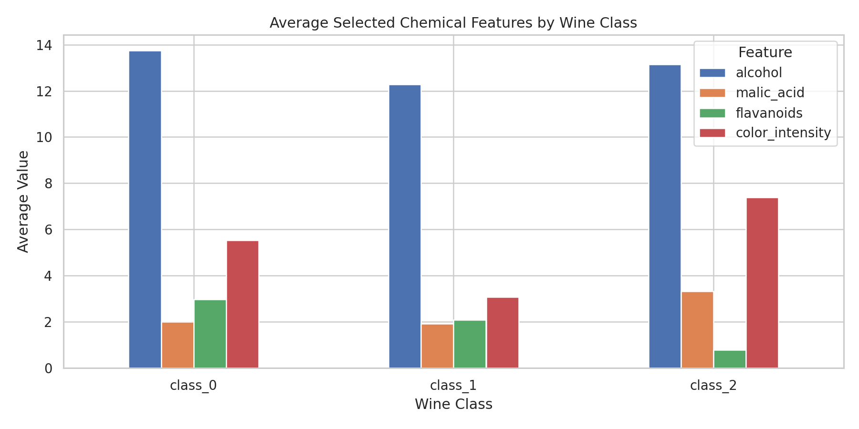
Figure 5: Mean selected chemical features by class.
Interpretation: The grouped chart compares average chemical measurements. class_0 has the highest average flavanoids value, while class_2 has the highest average color intensity.

12. Data Transformations and Aggregations
The target numbers were mapped to readable class names. Group-wise averages were calculated using groupby() and mean(). Correlations were calculated using corr(). No major cleaning operation was required because the dataset had no missing values.
df["target_name"] = df["target"].map(dict(enumerate(wine.target_names)))
class_means = df.groupby("target_name")[["alcohol", "flavanoids", "color_intensity"]].mean()
print(class_means)

13. Key Findings
- The dataset contains 178 samples and 13 chemical features.
- There are 3 wine classes.
- No missing values were detected.
- The class distribution is not perfectly balanced.
- class_0 has the highest average alcohol value.
- class_0 has the highest average flavanoids value.
- class_2 has the highest average color intensity.
- Several chemical features show relationships that can be examined through correlation analysis.

14. Critical Discussion
EDA helps identify patterns, but visual relationships must be interpreted carefully. Correlation does not prove causation, and separation in a scatter plot does not guarantee perfect classification. Since features have different scales, standardization may be useful before applying some machine learning algorithms.
Future work may include outlier detection, feature scaling, Principal Component Analysis (PCA), and classification models such as Logistic Regression, Decision Trees, or K-Nearest Neighbors.

15. Conclusion
This project performed EDA and visualization on the Wine Recognition Dataset. It included data inspection, descriptive statistics, class distribution, box plots, scatter plots, a correlation heatmap, and grouped averages. The analysis helped identify differences between wine classes and relationships among chemical features. EDA is an important foundation for further statistical analysis and machine learning.

16. References
- Scikit-learn documentation: Wine Recognition Dataset.
- Pandas documentation.
- Matplotlib documentation.
- Seaborn documentation.

