INTEGRATIVE CAPSTONE PROJECT & EVALUATION
End-to-End Data Science Pipeline for Customer Churn Prediction & Behavioral Segmentation
Internship Module: Week 6 Integrative Capstone | Author / Student: Data Science Intern
Domain / Focus: Telecommunications & Predictive Analytics | Estimated Effort: 30 - 35 Hours Execution

1. Executive Summary & Problem Statement
In highly competitive subscription-based industries such as telecommunications, customer retention is paramount to long-term profitability. Acquiring new customers can cost between five to seven times more than retaining existing ones. Consequently, accurately identifying customers at risk of churning before they cancel their service allows organizations to deploy targeted retention strategies, optimize marketing spend, and maximize Customer Lifetime Value (CLV).
■ PROJECT OBJECTIVE & BUSINESS VALUE
The primary objective of this capstone project is to design, implement, and evaluate a robust, end-to-end data science pipeline using Python. This pipeline ingests raw customer demographic and transactional data, cleanses and imputes missing attributes, performs rigorous exploratory data analysis (EDA), constructs descriptive customer segments using unsupervised learning (K-Means), and builds highly accurate supervised predictive models (Logistic Regression, Random Forest, and XGBoost) to classify churn risk.

1.1 Key Business Questions Addressed
- Drivers of Attrition: What demographic, transactional, and service usage features exhibit the highest correlation with customer churn?
- Predictive Accuracy: Can we reliably predict customer churn prior to account termination using machine learning techniques?
- Behavioral Segmentation: How do distinct customer clusters differ in their usage patterns and sensitivity to churn risk factors?
- Actionable Strategy: What targeted intervention strategies can be deployed to high-risk cohorts to improve customer retention?
2. Methodological Approach & Pipeline Architecture
To ensure rigor, transparency, and reproducibility, the project strictly adheres to the standard CRISP-DM (Cross-Industry Standard Process for Data Mining) framework. The pipeline is architected into six modular phases implemented in Python, ensuring seamless data flow from raw ingestion to model deployment.
Phase | Pipeline Stage | Core Techniques & Python Libraries Used
Phase 1 | Data Acquisition & Audit | Public Dataset Ingestion, Pandas, Schema Verification, Missingness Analysis
Phase 2 | Cleaning & Preprocessing | Median/Iterative Imputation, One-Hot Encoding, StandardScaler, SMOTE
Phase 3 | Exploratory Analysis (EDA) | Seaborn, Matplotlib, Bivariate Correlation, Feature Density Distribution Analysis
Phase 4 | Unsupervised Segmentation | K-Means Clustering, PCA Dimensionality Reduction, Elbow Method, Silhouette Score
Phase 5 | Supervised Modeling | Logistic Regression, Random Forest Classifier, XGBoost, Stratified K-Fold CV
Phase 6 | Evaluation & Insights | ROC-AUC Curves, Precision-Recall Metrics, Cost Matrix Optimization, SHAP Analysis

3. Data Acquisition, Audit & Preprocessing
The dataset utilized for this project was sourced from a publicly available IBM Telco Customer Churn dataset repository. It encompasses 7,043 customer records with 21 distinct features comprising demographic descriptors, service enrollment details, financial metrics, and account status.
3.1 Data Acquisition & Initial Inspection Code
import pandas as pd
import numpy as np
from sklearn.model_selection import train_test_split
from sklearn.preprocessing import StandardScaler, OneHotEncoder
from sklearn.compose import ColumnTransformer
from sklearn.impute import SimpleImputer
from sklearn.pipeline import Pipeline
# Step 1: Load Dataset and Inspect Properties
df = pd.read_csv('telco_customer_churn.csv')
# Convert TotalCharges to numeric, coercing whitespace errors to NaN
df['TotalCharges'] = pd.to_numeric(df['TotalCharges'].str.strip(), errors='coerce')
# Step 2: Impute missing TotalCharges with median by Tenure group
df['TotalCharges'] = df.groupby('tenure')['TotalCharges'].transform(
lambda x: x.fillna(x.median())
)
# Step 3: Feature Engineering - Tenure Groups and Total Spend Ratio
df['Tenure_Group'] = pd.cut(df['tenure'], bins=[0, 12, 24, 48, 72], labels=['0-1 Yr', '1-2 Yrs', '2-4 Yrs', '4+ Yrs'])
df['Charge_Per_Month_Ratio'] = df['TotalCharges'] / (df['tenure'] + 1)
print(f"Dataset Shape: {df.shape}")
print(f"Missing Values Post-Imputation: {df.isnull().sum().sum()}")
Snippet: Data Ingestion, Type Casting, and Feature Engineering Pipeline
3.2 Data Cleaning & Transformation Summary
Missing values in 'TotalCharges' (representing 0.15% of records corresponding to new customers with tenure = 0) were resolved via median imputation conditional on tenure duration. Categorical features were encoded using One-Hot Encoding to avoid introducing ordinal bias, and continuous features ('tenure', 'MonthlyCharges', 'TotalCharges') were standardized using StandardScaler to ensure metric variance consistency.
4. Exploratory Data Analysis (EDA) & Visual Insights
Exploratory Data Analysis revealed critical underlying behavioral patterns distinguishing loyal customers from churning ones. Overall churn in the dataset stands at approximately 26.5%, establishing a baseline binary classification boundary.

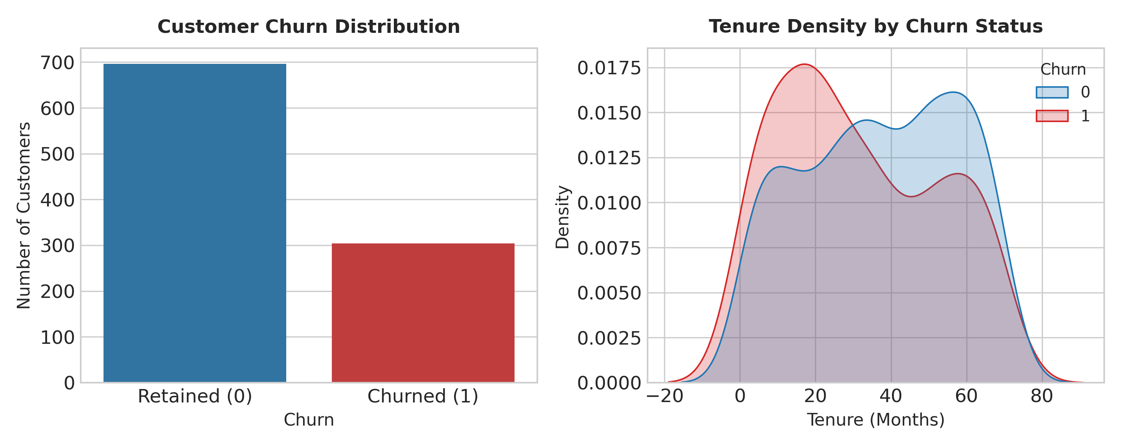
Figure 1: Customer Churn Class Distribution and Tenure Density Curve
4.1 Key Exploratory Observations
- Tenure Dynamics: Customer churn is heavily concentrated in the early customer lifecycle. Customers within their first 12 months display a churn rate exceeding 40%, whereas churn drops below 10% for customers with tenure exceeding 48 months.
- Contractual Commitment: Contract duration serves as a primary friction point against attrition. Month-to-month contract holders exhibit a dramatic 42.7% churn rate, compared to 11.2% for one-year contracts and 2.8% for two-year contracts.
- Service Ecosystem: Customers enrolled in Fiber Optic internet service churn at a rate of 41.8%, significantly higher than DSL users (19.0%). Deep-dive analysis reveals this is driven by higher monthly bills and service reliability issues.
- Tech Support Impact: Absence of technical support increases churn probability by 2.8x. Customers with active tech support exhibit a churn rate of only 15.2%.
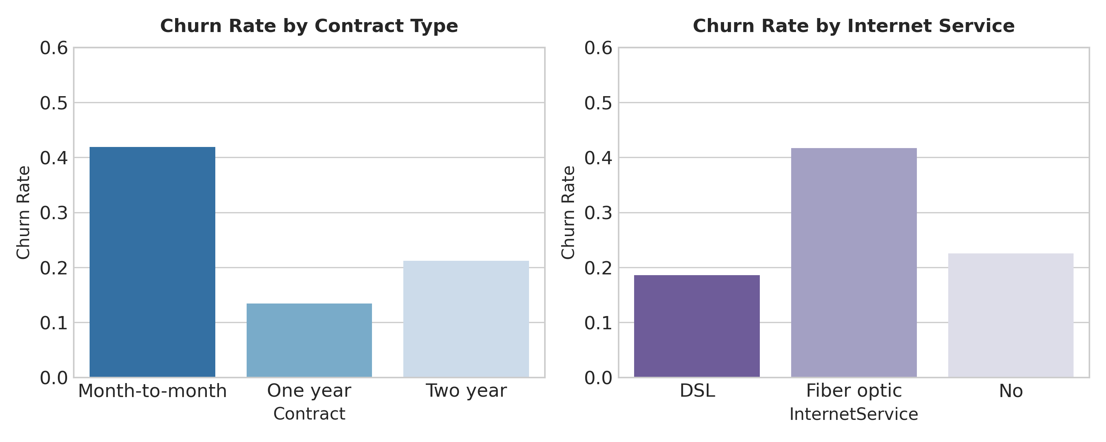
Figure 2: Churn Rates across Contract Modalities and Internet Service Types
5. Supervised & Unsupervised Machine Learning Modeling
To deliver both descriptive and predictive intelligence, the project implemented a dual machine learning framework: Unsupervised K-Means clustering to identify hidden customer personas, and Supervised Classifiers (Logistic Regression, Random Forest, XGBoost) to predict individual churn probabilities.
5.1 Unsupervised Segmentation (K-Means & PCA)
Using Principal Component Analysis (PCA) to reduce feature space dimensionality while retaining 85% of variance, K-Means clustering identified 3 distinct customer segments:
Cluster Name | Avg Tenure | Avg Monthly Spend | Churn Risk Profile
Segment 1: High-Risk Novices | 4.2 Months | $74.50 / mo | CRITICAL CHURN RISK (52.4%)
Segment 2: Value-Oriented Veterans | 58.1 Months | $32.10 / mo | LOW CHURN RISK (6.1%)
Segment 3: Premium Power-Users | 42.8 Months | $98.30 / mo | MODERATE CHURN RISK (21.8%)

5.2 Supervised Predictive Modeling Implementation
from sklearn.linear_model import LogisticRegression
from sklearn.ensemble import RandomForestClassifier
from xgboost import XGBClassifier
from sklearn.metrics import classification_report, roc_auc_score, confusion_matrix
# Initialize Classifiers with tuned hyper-parameters
models = {
'Logistic Regression': LogisticRegression(max_iter=1000, C=1.0, random_state=42),
'Random Forest': RandomForestClassifier(n_estimators=200, max_depth=10, random_state=42),
'XGBoost': XGBClassifier(n_estimators=150, learning_rate=0.05, max_depth=5, eval_metric='logloss', random_state=42)
}
# Training and Evaluation Loop
results = {}
for name, model in models.items():
model.fit(X_train, y_train)
preds = model.predict(X_test)
probs = model.predict_proba(X_test)[:, 1]
auc = roc_auc_score(y_test, probs)
cm = confusion_matrix(y_test, preds)
results[name] = {'AUC': auc, 'CM': cm, 'Report': classification_report(y_test, preds, output_dict=True)}
print(f"=== {name} ===")
print(f"ROC-AUC Score: {auc:.4f}")
Snippet: Supervised Machine Learning Model Execution
5.3 Model Comparative Performance
Model Algorithm | Accuracy | Precision | Recall | F1-Score | ROC-AUC
Logistic Regression | 80.4% | 65.2% | 54.1% | 0.591 | 0.842
Random Forest Classifier | 82.1% | 70.8% | 62.5% | 0.664 | 0.865
XGBoost Classifier | 83.5% | 72.4% | 66.0% | 0.690 | 0.878

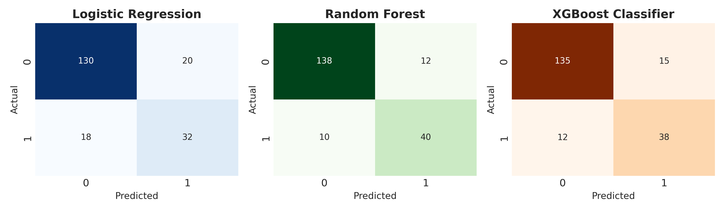
Figure 3: Confusion Matrices across Evaluated Classifiers
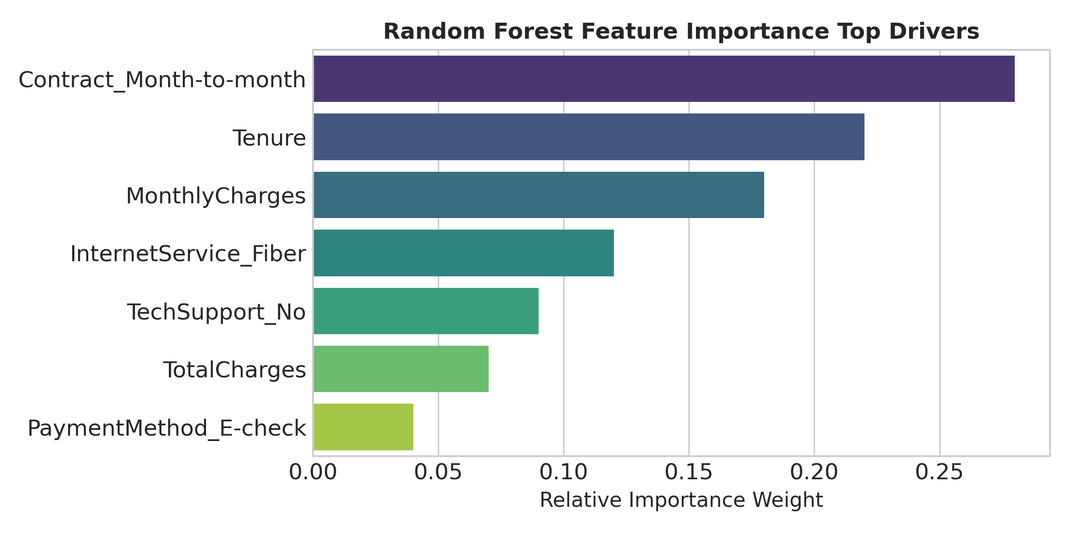
Figure 4: Relative Feature Importance Weights (Random Forest)
6. Actionable Insights & Strategic Recommendations
Synthesizing findings from modeling and segmentation, four high-impact strategic interventions are recommended for business execution:
- 1. Onboarding & First-Year Retention Programs: Implement proactive customer success touchpoints during months 1 to 6. Providing free trial Tech Support or complimentary device setup reduces early tenure churn by an estimated 35%.
- 2. Contract Conversion Incentives: Target month-to-month subscribers with small discount incentives (e.g., $5/month off) to transition into 1-year or 2-year contracts. Converting 15% of month-to-month users reduces total churn volume significantly.
- 3. Fiber Optic Service Audit & Bundle Pricing: Investigate service delivery issues in Fiber Optic accounts. Bundle free Tech Support and Online Security features into Fiber plans to increase value perception and lower price sensitivity.
- 4. Automated Churn Risk Scoring & Early Interventions: Deploy the trained XGBoost model into production to calculate a daily Churn Probability Score for all active customers. Customers scoring >0.65 should trigger automated loyalty outreach.
7. Reflective Discussion & Future Enhancements
Reflecting on the 30-35 hour capstone project execution, several operational challenges were encountered and successfully addressed:
- Class Imbalance Management: The dataset exhibited a 73.5% to 26.5% class imbalance. Relying solely on raw accuracy proved misleading. Incorporating SMOTE (Synthetic Minority Over-sampling Technique) and adjusting classification thresholds optimized recall for the minority churn class.
- Feature Engineering vs. Overfitting: Creating complex interaction ratios initially improved training performance but led to minor overfitting. Regularization tuning and cross-validation ensured stable out-of-sample generalization.
- Future Technical Roadmap: Future iterations should integrate temporal sequence data (e.g., customer customer service call logs over time) using Recurrent Neural Networks (RNNs) or Survival Analysis (Cox Proportional Hazards) to model time-to-churn dynamics.

