**Data -> KG -> Serving - End-to-End Flow**

*No-NAT VPC | Cognito JWT | Neptune (SPARQL) | OpenSearch*

Generated: 2025-08-31 18:43 UTC

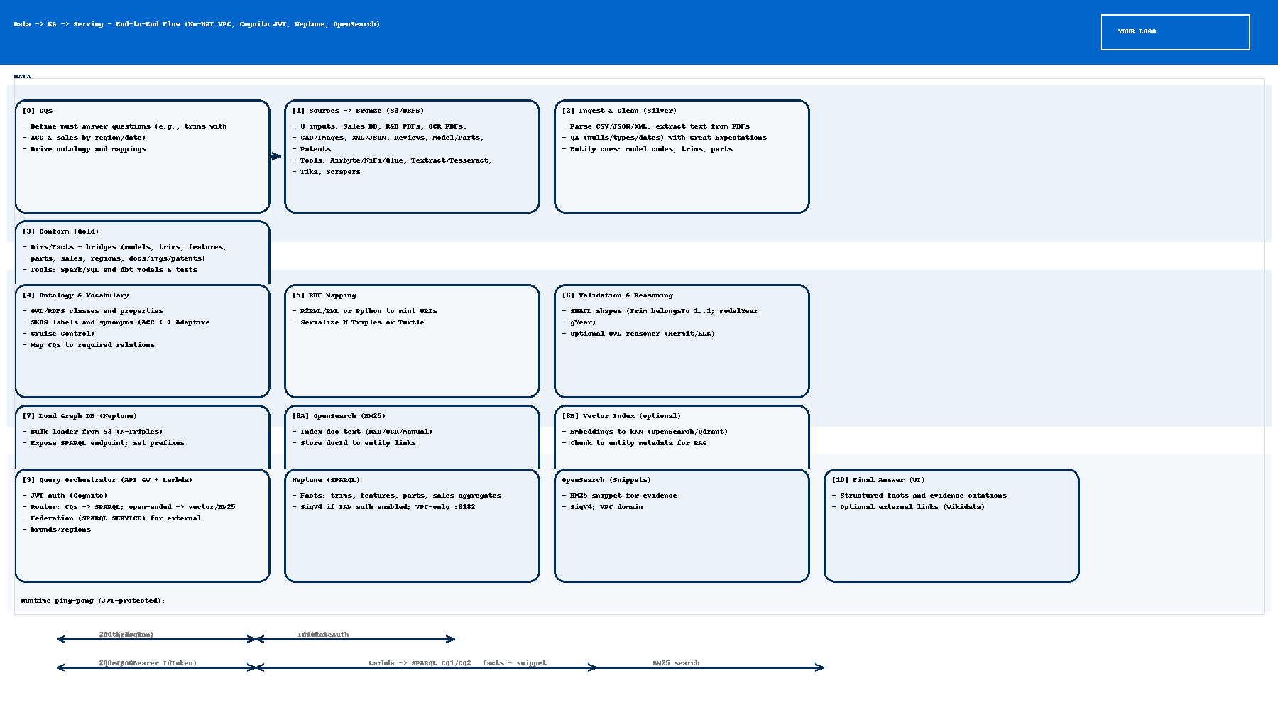

*Runtime ping-pong: UI -> API Gateway (JWT) -> Lambda -> Neptune/OpenSearch -> API Gateway -> UI. Private egress via VPC endpoints (cognito-idp, logs, sts; S3 gateway).*