UMANG Journeys
Product & Engineering Specification
Version 0.1 | 25 August 2026
Product thesis
Government is organised by departments. Citizens experience life events. UMANG Journeys reorganises services around the citizen's outcome, then guides them through one dependency-aware journey.

Round 1 reference journey
Having a Baby
Natural-language intake -> personalised service graph -> pre-filled birth registration -> simulated registration -> downstream services unlock.
Document use | Source of truth
Product concept | Sections 1-4
UI workflow | Sections 5-7 + screen specifications
Engineering implementation | Sections 8-16
Verification / QA | Sections 17-19
Future life-event extension | Section 20

Contents
1. Executive summary
2. Problem and opportunity
3. Fundamental product model
4. Product principles and scope
5. Core user journey
6. Screen specifications
7. Interaction and visual system
8. Technical architecture
9. Journey orchestration engine
10. AI and natural-language understanding
11. Data model and Prisma design
12. Backend contracts
13. Integration adapter model and synthetic services
14. State machine and navigation
15. Security, privacy and trust
16. Performance, accessibility and resilience
17. Analytics and observability
18. Acceptance criteria and feature matrix
19. End-to-end verification scripts
20. Extension framework for future journeys
21. Future roadmap
22. Screen reference appendix
23. Hackathon constraints and source notes

1. Executive summary
UMANG Journeys is a citizen-first redesign of government service discovery. Instead of asking people to find departments, schemes, portals or forms, it starts from a life event or desired outcome and composes the relevant services into a single guided journey.
The Round 1 implementation uses one complete example: a parent says, "We had a baby yesterday at Apollo Hospital in Hyderabad." The product extracts the known context, asks only for missing information, generates a dependency-aware journey, pre-fills a synthetic birth-registration workflow, simulates registration, then unlocks the next relevant services such as a child health record, vaccination timeline, identity documents and benefits.
The magic moment
The journey graph appears after one natural-language statement and one clarifying answer. The user sees government reorganise itself around their life, rather than being asked to understand government structure.

1.1 What engineers are implementing
- One reusable journey engine, not a hard-coded newborn microsite.
- One production-quality demo journey, Having a Baby.
- Five core screens, each fully functional and connected.
- Synthetic integration adapters, for hospital/profile/government responses.
- A deterministic dependency graph, with optional AI for intent and field extraction.
- A resettable demo mode, so judges can reproduce the exact journey reliably.

1.2 Definition of success
Success dimension | Required outcome
Comprehension | A new user understands the product concept within 10 seconds.
Magic moment | A life-event statement becomes a personalised dependency graph with minimal questions.
Completion | The user can complete the synthetic birth-registration path end-to-end.
Trust | Every synthetic or simulated government action is clearly identified.
Reusability | A second journey can be added by configuration + small adapter code, without cloning the app.
Demo reliability | A deterministic demo fixture completes even if an external AI call fails.

2. Problem and opportunity

2.1 Current mental model
A service aggregator can put thousands of government services in one place and still require the citizen to know which service they need. The citizen thinks in life events: a baby was born, a vehicle was bought, a parent retired, a family moved, or a business started. Government systems are usually organised around agencies, forms and service boundaries.
Mental-model inversion
CURRENT
Citizen -> search/browse -> service -> department -> form -> discover next service -> repeat
PROPOSED
Citizen -> life event -> contextual questions -> personalised journey graph -> guided completion

2.2 Core user problem
Problem statement
Citizens should not need to know government structure, service names or dependency order to complete the administrative work triggered by a life event.

2.3 Product opportunity
- Replace service discovery with outcome discovery.
- Use context and existing records to minimise repeated data entry.
- Expose dependencies visually so the citizen understands what unlocks what.
- Carry verified data forward across steps instead of asking for the same facts repeatedly.
- Suggest downstream services and benefits at the moment they become relevant.
- Preserve agency: users review inferred or imported data before consequential actions.

3. Fundamental product model
The product must be implemented as a reusable orchestration layer. "Having a Baby" is only the first JourneyTemplate. The same primitives must support Moving Home, Buying a Vehicle, Getting Married, Starting a Business, Retirement and future public-service journeys.

3.1 Domain primitives
Primitive | Meaning | Example
LifeEvent | Human-language event or desired outcome. | Having a Baby
JourneyTemplate | Versioned blueprint for one event. | new-baby.india.v1
JourneyInstance | One citizen's runtime journey. | journey_demo_aisha_001
ServiceNode | A government-facing task in the journey. | Birth registration
DependencyEdge | Prerequisite relationship between nodes. | Birth certificate unlocks child identity
Requirement | Fact, document or condition needed by a node. | Place of birth
DataField | Canonical citizen/event fact stored once and reused. | child.dateOfBirth
Evidence | Source that supports a fact. | Synthetic hospital record
IntegrationAdapter | Provider-specific read/write boundary. | Mock Hospital Adapter
EligibilityRule | Rule that decides whether a node/benefit appears. | State == Telangana
Action | User or system operation against a node. | Review registration

3.2 Journey graph semantics
Reference dependency graph
LifeEvent
-> ServiceNode A: Birth registration
-> ServiceNode B: Birth certificate
-> ServiceNode C: Child health record
-> ServiceNode D: Vaccination timeline
-> ServiceNode E: Child identity
-> ServiceNode F: Eligible benefits
Node states: locked | available | in_progress | waiting_external | completed | blocked | skipped

3.3 Design contract for future journeys
- Do not embed life-event-specific branching directly inside page components.
- Represent service order and unlock rules as versioned journey configuration.
- Store canonical facts once, then map them into individual service payloads.
- Every inferred fact must retain provenance and confidence metadata.
- Every external action must go through an adapter, even if the Round 1 adapter is synthetic.
- A JourneyTemplate must be testable without rendering the UI.

4. Product principles and scope

4.1 Product principles
Principle | Engineering implication
Life first | Start from user intent, never from department taxonomy.
Ask less | Extract what can be known; ask only unresolved, decision-changing questions.
One fact, once | Canonical data is reused across nodes.
Show causality | The journey graph must explain why a node is locked/unlocked.
Human confirmation | AI may propose; the citizen confirms consequential facts.
Honest simulation | Prototype-only approvals and integrations are visibly labelled.
Progressive disclosure | Show the current decision first, details on demand.
Resumable | A journey can be left and resumed without losing state.

4.2 Round 1 must-have scope
- Landscape web experience optimised for approximately 1024-1440 px wide viewports.
- Responsive fallback for mobile, but the hackathon demo is recorded in landscape.
- Home/life-event discovery screen.
- Natural-language intake + structured extraction + one clarifying question.
- Personalised journey graph with dependency states.
- Birth-registration review form with pre-filled synthetic data.
- Synthetic registration success and downstream unlock transition.
- Demo reset and deterministic demo fixture.
- Prototype disclaimer and simulation labels.

4.3 Explicit non-goals for Round 1
- Real government login, Aadhaar authentication, DigiLocker access or production data.
- Real municipal birth-registration submission.
- A complete implementation of child identity, benefits or health services.
- A universal scheme recommendation engine.
- Production-grade multi-tenant administration or case-management dashboards.
- A generic chatbot as the primary product surface.

5. Core user journey

5.1 Golden path
Step | User action | System behavior | Result
1. Discover | Choose Having a Baby or type/speak the life event. | Select JourneyTemplate and begin intake. | New draft JourneyInstance.
2. Explain | Say: "We had a baby yesterday at Apollo Hospital in Hyderabad." | Extract event, hospital context, place, state and date. | Known facts appear as chips.
3. Clarify | Answer one unresolved question. | Resolve branch condition and validate facts. | Journey can be compiled.
4. Reveal | Click Build My Journey. | Compile eligible nodes, dependencies, imported facts and statuses. | Personalised graph appears.
5. Review | Open Birth registration. | Hydrate form from profile + synthetic hospital record. | Only missing fields require input.
6. Complete | Fill missing fields and submit demo registration. | Mock adapter validates and returns synthetic success record. | Birth registration completed.
7. Unlock | Continue journey. | Recompute graph based on completed node/output document. | Health, vaccination, identity and benefits become available.

5.2 Magic-moment requirements
Critical product moment
After the final clarifying answer, the system must transition from a vague life event to a visible, personalised dependency graph. This transition is the core proof of the concept.

- The graph must feel generated for the citizen, not like a static service menu.
- At least one fact must visibly come from the user statement and one from a synthetic linked record.
- Locked downstream nodes must explain their prerequisite on focus/click.
- The active first node must have one obvious CTA: Review Birth Registration.
- The user should not see internal department acronyms unless required for the task.

6. Screen specifications
The five screens below form the implementation source-of-truth workflow. Additional pages such as Documents or Updates are optional extension surfaces and must not interrupt the Round 1 golden path.

6.1 Screen S1 - Life Event Home
ID | Requirement | Acceptance
S1-01 | Headline communicates outcome-first concept. | "Life happens. We guide you." or equivalent appears above the fold.
S1-02 | Natural-language entry accepts typed input. | Submitting non-empty text starts intake.
S1-03 | Having a Baby card starts same journey as typed equivalent. | Both paths create the same JourneyTemplate id.
S1-04 | Other event cards remain visible as concept breadth. | They may be preview-only, but must be labelled if not implemented.
S1-05 | No government department selection is required. | No department selector in the primary path.
S1-06 | Demo fixture shortcut is available in non-production demo mode. | Can load exact golden-path data in one action.

6.2 Screen S2 - Natural-Language Intake
ID | Requirement | Acceptance
S2-01 | Show the user statement verbatim. | Original text remains editable.
S2-02 | Show extracted facts as compact chips/cards. | Event, hospital birth, city/state and date are visible.
S2-03 | Ask only unresolved questions that change journey compilation. | Golden path asks no more than one clarifying question.
S2-04 | Do not mix chatbot transcript, wizard and permanent listening state. | One interaction model per state.
S2-05 | Voice is optional input, not required for completion. | Typed path fully works.
S2-06 | Build My Journey validates required intake facts. | Invalid/missing facts show actionable inline error.

6.3 Screen S3 - Journey Reveal
ID | Requirement | Acceptance
S3-01 | Display personalised context summary. | Hospital/place/date/state/profile facts visible.
S3-02 | Render nodes and dependency edges from config, not JSX constants. | Graph generated from JourneyTemplate.
S3-03 | Birth registration is first actionable node. | Status = in_progress or available.
S3-04 | Birth certificate depends on registration. | Graph edge and lock/recommended state are correct.
S3-05 | Downstream nodes depend on certificate/output where configured. | Health/vaccination/identity/benefits state derives from graph.
S3-06 | CTA opens the active node. | Review Birth Registration navigates to S4.
S3-07 | Dependency explanation is inspectable. | Click/focus on locked node shows why it is locked.

6.4 Screen S4 - Birth Registration Review
ID | Requirement | Acceptance
S4-01 | Hydrate form from canonical facts. | Known fields appear read-only or editable with provenance.
S4-02 | Imported hospital record is visually identified. | Source card displays synthetic hospital provider.
S4-03 | Missing fields are visually obvious. | Golden path has exactly two missing fields in demo fixture.
S4-04 | User can edit any imported non-locked field. | Edit updates canonical fact + source = user_confirmed.
S4-05 | Submission validates required fields. | No synthetic API call on invalid form.
S4-06 | Submission uses IntegrationAdapter. | UI does not directly fabricate success object.
S4-07 | Demo action is labelled. | CTA or nearby copy clearly states prototype/demo registration.

6.5 Screen S5 - Registration Success + Unlocks
ID | Requirement | Acceptance
S5-01 | Show completed birth-registration status. | Completed node is visible with date/id.
S5-02 | Show synthetic output document/record. | Birth certificate/record card is labelled synthetic or demo.
S5-03 | Recompute downstream nodes after success. | Previously locked nodes become available/recommended as configured.
S5-04 | Explain what unlocked. | At least four downstream cards show new status.
S5-05 | Continue Journey leads to next available node or journey overview. | No dead CTA.
S5-06 | Reset Demo available from menu/settings in demo mode. | Returns to pristine fixture.

6.6 Optional post-MVP surfaces
Surface | Purpose | Round 1
My Journeys | Resume active/completed life-event journeys. | Optional
Documents | View outputs/evidence across journeys. | Optional
Updates | Notifications and external-status updates. | Optional / mock only
Benefits | Eligibility suggestions from journey context. | Preview only
Family | Shared household profile and dependent data. | Future

7. Interaction and visual system

7.1 Target surface
- Responsive browser application. Do not require installation.
- Primary design target: landscape tablet / laptop viewport.
- Comfortable maximum content width around 1280-1360 px.
- Mobile layout must reflow to a single column without horizontal scrolling.

7.2 Design language
Use a premium consumer-service visual language: calm white space, soft illustration, restrained gradients, large readable type, clear hierarchy and friendly transitions. The interface must not visually resemble a traditional government portal or an enterprise admin dashboard.
- shadcn/ui primitives as the base component layer.
- Butterfly UI-style softness may inform cards/illustrations, but normalize all components to local design tokens.
- Avoid dense navigation, government seals, fake official branding, tricolour decoration or institutional chrome.
- One dominant action per screen.
- Use colour semantically: blue/indigo for action, green for completed/verified, amber for attention, neutral for locked.

7.3 Motion guidelines
Moment | Motion
Intent extraction | Facts appear progressively or fade into a summary row.
Journey reveal | Service nodes appear in dependency order; edges draw in after nodes.
Node unlock | Locked state transitions to available with subtle scale/fade and status label change.
Form completion | No confetti before success is returned by adapter.
Reduced motion | Respect prefers-reduced-motion and render final states without animation.

8. Technical architecture

8.1 Recommended stack
Layer | Recommendation | Reason
Web | Next.js App Router, current supported release | One deployment, server/client boundaries, fast iteration.
UI | React + Tailwind + shadcn/ui | Accessible primitives and agent-friendly component ownership.
Styling | Local design tokens + selected copied registry blocks | Avoid runtime dependency on external UI registries.
Validation | Zod | Shared schema validation for UI, server and AI outputs.
Forms | React Hook Form | Clear field-state and validation ergonomics.
ORM | Prisma | Declarative schema, generated types, migration clarity and strong agentic coding ergonomics.
Database | PostgreSQL | Reliable relational model for graph/config/runtime data.
AI | OpenAI structured output; optional Realtime/voice later | Intent/fact extraction, not authoritative workflow logic.
Deployment | Single web deployment + managed Postgres | Minimise operational surface for hackathon.

8.2 Logical architecture
Component view
Browser UI
|
|-- Journey pages / forms / graph
|-- Local optimistic state
|
Next.js server boundary
|-- Journey service
|-- Intake parser
|-- Validation / rules
|-- Integration adapter registry
|-- Demo fixture service
|
Prisma -> PostgreSQL
|
External providers (Round 1: synthetic adapters)

8.3 Dependency rule
Hard rule
AI must never decide whether a government service is completed, unlocked, officially approved or submitted. Those states are owned by deterministic application logic and adapter responses.

9. Journey orchestration engine

9.1 Responsibilities
- Select a JourneyTemplate from the resolved LifeEvent.
- Evaluate eligibility and branching rules.
- Instantiate ServiceNodes and DependencyEdges.
- Calculate node status from prerequisites and external results.
- Determine the next recommended action.
- Map canonical facts into service-specific inputs.
- Recompute the journey after any material state change.

9.2 Template format
Illustrative configuration shape
{
"id": "new-baby.india.v1",
"lifeEvent": "having_a_baby",
"nodes": [
{"id":"birth_registration","adapter":"mock_birth_registry","requires":["child.dateOfBirth","birth.place","parent.primary"]},
{"id":"birth_certificate","dependsOn":["birth_registration"]},
{"id":"child_health_record","dependsOn":["birth_certificate"]},
{"id":"vaccination_timeline","dependsOn":["birth_certificate"]},
{"id":"child_identity","dependsOn":["birth_certificate"]},
{"id":"eligible_benefits","dependsOn":["birth_certificate"]}
]
}

9.3 Node status algorithm
1. If node is explicitly completed, return completed.
2. If an external action is pending, return waiting_external.
3. If any hard prerequisite is incomplete, return locked.
4. If eligibility rule is false, return skipped or hidden according to template policy.
5. If required facts are missing, return blocked with missing requirements.
6. If this is the first available node, return in_progress or available + recommended.
7. Otherwise return available.

10. AI and natural-language understanding

10.1 AI responsibilities
- Map free text into a supported LifeEvent candidate.
- Extract non-authoritative contextual facts from the user statement.
- Normalize place/date/hospital strings into application-friendly values.
- Return confidence and provenance for every extracted field.
- Suggest which clarifying question will most reduce ambiguity.

10.2 AI non-responsibilities
- Do not invent government eligibility, fees, official timelines or completion status.
- Do not fabricate an external record or registration number.
- Do not silently overwrite user-confirmed facts.
- Do not decide whether an external integration succeeded.

10.3 Intake output contract
Validated structured output
{
"lifeEvent": {"value":"having_a_baby","confidence":0.98},
"facts": [
{"key":"birth.setting","value":"hospital","confidence":0.96,"source":"user_statement"},
{"key":"birth.city","value":"Hyderabad","confidence":0.99,"source":"user_statement"},
{"key":"birth.state","value":"Telangana","confidence":0.93,"source":"derived_from_city"},
{"key":"child.dateOfBirth","value":"2026-08-24","confidence":0.90,"source":"relative_date_parse"}
],
"clarification": {
"key":"birth.registeredByHospital",
"question":"Has the hospital already registered the birth?",
"choices":["yes","not_sure","no"]
}
}

10.4 Failure behavior
Failure | Required UX
AI unavailable | Fallback to deterministic event cards + 2-3 structured questions.
Low confidence event | Ask user to choose between top supported events.
Ambiguous date | Show interpreted date and ask for confirmation.
Unsupported life event | Explain prototype supports one journey; offer supported choices.
Malformed model response | Reject server-side via Zod and retry once; then fallback.

11. Data model and Prisma design
The schema below is the recommended conceptual model. Engineers may rename fields, but the separation between template/configuration, runtime journey state, canonical facts and integration events should be preserved.

11.1 Core entities
Model | Key fields
UserProfile | id, displayName, locale, stateCode, demoProfile
HouseholdMember | id, profileId, relationship, displayName
JourneyTemplate | id, version, lifeEventType, status, configJson
JourneyInstance | id, profileId, templateId, status, startedAt, updatedAt
JourneyNode | id, journeyId, nodeKey, status, recommended, completedAt
JourneyEdge | journeyId, fromNodeKey, toNodeKey, edgeType
Fact | id, journeyId, key, valueJson, confidence, sourceType, sourceRef, confirmed
Evidence | id, journeyId, type, provider, metadataJson
ExternalAction | id, nodeId, adapterKey, actionType, status, requestJson, responseJson
OutputDocument | id, journeyId, nodeId, type, synthetic, metadataJson
AuditEvent | id, journeyId, actorType, eventType, payloadJson, createdAt

11.2 Recommended Prisma conventions
- Use enums for LifeEventType, JourneyStatus, NodeStatus, SourceType and ExternalActionStatus.
- Use JSON only for deliberately variable configuration/provider payloads; keep query-critical fields relational.
- Store template version on each JourneyInstance to preserve reproducibility.
- Never mutate historical adapter response payloads; append a new ExternalAction for retries.
- Use createdAt/updatedAt across runtime entities.
- Use synthetic boolean on provider/output records so prototype data can never be mistaken for official data.

11.3 Canonical fact rules
Rule | Example
Namespaced keys | child.dateOfBirth, birth.place.city, parent.primary.name
Provenance required | user_statement, demo_profile, mock_hospital, user_confirmed
Confidence only for inferred facts | Imported deterministic fixture can use null or 1.0.
Confirmation wins | user_confirmed value supersedes AI inference.
Service payloads are projections | Birth registration payload is generated from canonical facts.

12. Backend contracts

12.1 Suggested application services
Service | Primary operations
IntakeService | resolveIntent(), parseFacts(), getClarification()
JourneyService | startJourney(), compileJourney(), getJourney(), recommendNext()
FactService | upsertFact(), confirmFact(), resolveFactSet()
NodeService | getNode(), validateNode(), completeNode()
AdapterRegistry | getAdapter(key), execute(action)
DemoFixtureService | resetDemo(), seedGoldenPath(), loadScenario(id)

12.2 Route / action suggestions
Contract | Method | Purpose
/api/intake/resolve | POST | Natural-language intent/fact extraction.
/api/journeys | POST | Create JourneyInstance.
/api/journeys/:id | GET | Return graph + facts + recommended action.
/api/journeys/:id/facts | PATCH | Confirm/edit canonical facts.
/api/journeys/:id/nodes/:key/submit | POST | Validate and execute adapter action.
/api/demo/reset | POST | Reset golden-path fixture.

12.3 Response discipline
- All mutating endpoints return the updated journey projection needed by the current screen.
- Errors use stable machine codes plus human-readable copy.
- Do not leak provider-specific raw payloads directly into React components.
- Use idempotency key for external-action submission, including synthetic adapters.

13. Integration adapter model and synthetic services

13.1 Adapter contract
TypeScript concept
interface ServiceAdapter {
key: string
capabilities(): Capability[]
prefill(ctx: JourneyContext): Promise<PrefillResult>
validate(input: unknown): Promise<ValidationResult>
submit(input: unknown, options: { idempotencyKey: string }): Promise<SubmitResult>
status?(externalRef: string): Promise<StatusResult>
}

13.2 Round 1 synthetic adapters
Adapter | What it simulates | Fixture output
mock_profile | Existing citizen profile | Parent names, address, state, phone
mock_hospital | Birth-event record | Hospital, DOB/time, birth weight, place
mock_birth_registry | Birth registration submission | Synthetic registration id + completion timestamp
mock_document_service | Output document generation | Synthetic birth record/certificate metadata

13.3 Simulation labelling
- Every mock adapter response includes synthetic: true.
- Screens that imply official completion include "Prototype / simulated" copy.
- Do not use official government logos or imply Ministry/department endorsement.
- Any downloadable synthetic document must contain a visible "DEMO / NOT OFFICIAL" marker if implemented.

14. State machine and navigation

14.1 Journey states
State | Meaning | Allowed next
draft | Journey exists but intake incomplete. | intake_ready / abandoned
intake_ready | Enough context exists to compile graph. | active
active | At least one service node available/in progress. | waiting / completed
waiting | Waiting on external provider in future real integration. | active / blocked
completed | All required journey nodes complete/skipped. | read-only / reopen if policy allows
abandoned | User exited or reset. | new journey

14.2 Navigation rules
- Back from S2 returns to S1 without losing typed statement unless user chooses Change Journey.
- Back from S4 returns to S3 with form draft preserved.
- Refreshing any core screen restores from persisted JourneyInstance.
- Direct URLs validate journey ownership/demo scope and redirect safely if invalid.
- A user cannot navigate to a locked node by guessing its URL.

15. Security, privacy and trust

15.1 Prototype rules
- Use synthetic identities only. Never request real Aadhaar numbers, OTPs, passwords or financial credentials.
- Mask any identity-like fixture values.
- Do not call live government systems.
- Keep OpenAI/API secrets server-side.
- Do not send more fixture/user text to AI than required for intake parsing.
- Provide Reset Demo that deletes/reseeds the demo journey state.

15.2 Trust language
Do | Do not
"Prototype - this registration is simulated." | "Registered with Government of India."
"Imported from synthetic hospital record." | "Verified by Apollo Hospital" unless it is a clearly fake provider.
"This would unlock these services in a connected implementation." | "Your Aadhaar application is ready" if no such integration exists.

16. Performance, accessibility and resilience

16.1 Performance targets
Metric | Prototype target
Initial usable UI | < 2.5 s on a typical broadband laptop after cold load.
Journey reveal after deterministic compilation | < 500 ms excluding optional AI call.
Form navigation | No full-page reload.
Image/illustration payload | Optimised; lazy-load below fold.
AI timeout | Fallback path after configured timeout; never strand user.

16.2 Accessibility
- Keyboard-operable primary journey.
- Visible focus state on all interactive controls.
- Native buttons/inputs or equivalent accessible semantics.
- Labels never depend on colour alone.
- Journey graph has a linear textual equivalent for screen readers.
- Minimum comfortable touch target around 44 px on touch layouts.
- Respect reduced-motion preferences.

16.3 Resilience
- Persist form draft before adapter submission.
- Retry transient server errors once where safe.
- Use idempotency to avoid duplicate synthetic registrations.
- Show a deterministic demo path when AI is unavailable.

17. Analytics and observability

17.1 Product events
Event | Key properties
life_event_selected | source=card|text|voice, lifeEventType
intake_resolved | confidence, factsExtracted, clarificationRequired
journey_compiled | templateId, nodeCount, compileMs
journey_node_opened | nodeKey, previousStatus
fact_confirmed | factKey, priorSource
node_submitted | nodeKey, adapterKey, synthetic
node_completed | nodeKey, durationMs
journey_unlocked | fromNode, newlyAvailableNodes[]
demo_reset | scenarioId

17.2 Engineering logs
- Request id / journey id on all server logs.
- AI parse duration and schema-validation result, but avoid logging sensitive free text in future real deployments.
- Adapter call status and idempotency key.
- Journey compilation reason trace in non-production mode.

18. Acceptance criteria and feature matrix
Feature ID | Feature | Priority | Requirement ref | Verification
F-001 | Life-event card starts journey | P0 | S1-03 | E2E-01
F-002 | Typed natural-language statement supported | P0 | S1-02/S2-01 | E2E-02
F-003 | Structured facts extracted/displayed | P0 | S2-02 | AI-01
F-004 | Clarifying question rendered | P0 | S2-03 | E2E-02
F-005 | Journey compiled from template | P0 | S3-02 | JRN-01
F-006 | Dependency lock/reveal works | P0 | S3-04/S3-05 | JRN-02
F-007 | Locked-node reason inspectable | P0 | S3-07 | UI-03
F-008 | Form hydrated from facts/adapters | P0 | S4-01/S4-02 | FORM-01
F-009 | Missing fields validated | P0 | S4-03/S4-05 | FORM-02
F-010 | Demo submission uses adapter | P0 | S4-06 | ADP-01
F-011 | Idempotent submit | P0 | Backend | ADP-02
F-012 | Success recomputes graph | P0 | S5-03 | E2E-01
F-013 | Downstream unlock cards visible | P0 | S5-04 | E2E-01
F-014 | Simulation labels shown | P0 | Trust | TRUST-01
F-015 | Demo reset works | P0 | S5-06 | DEMO-01
F-016 | Refresh preserves journey state | P1 | Navigation | STATE-01
F-017 | Responsive mobile fallback | P1 | Visual | RESP-01
F-018 | Keyboard journey | P1 | A11y | A11Y-01
F-019 | AI fallback path | P1 | AI-04 | FAIL-01
F-020 | Second JourneyTemplate can compile in tests | P1 | Extensibility | EXT-01

18.1 Priority meaning
- P0: Must pass before hackathon submission.
- P1: Should pass; may be deferred only with explicit owner and workaround.
- P2: Post-Round-1 extension.

19. End-to-end verification scripts

19.1 E2E-01 - Golden demo path
1. Reset demo scenario NEW_BABY_01.
2. Open the public web URL in a fresh browser session.
3. Select Having a Baby.
4. Enter or load: "We had a baby yesterday at Apollo Hospital in Hyderabad."
5. Verify extracted facts appear and no more than one clarifying question is required.
6. Answer the clarifying question and build the journey.
7. Verify the graph contains Birth registration -> Birth certificate -> four downstream nodes.
8. Open Birth registration.
9. Verify imported facts match the fixture and exactly two required fields remain empty.
10. Attempt submit without missing fields; verify validation blocks submission.
11. Fill the two missing fields and submit demo registration.
12. Verify a synthetic registration id is returned once.
13. Verify Birth registration becomes completed and downstream nodes change status.
14. Refresh the browser; verify completed state persists.

19.2 AI-01 - Intake parser
Input | Expected
We had a baby yesterday at Apollo Hospital in Hyderabad. | LifeEvent=having_a_baby; city=Hyderabad; state=Telangana; hospital birth; relative date resolved.
Our daughter was born at home in Vizag this morning. | LifeEvent=having_a_baby; setting=home; city=Visakhapatnam; date=current date; clarification as needed.
I bought a car. | Unsupported/preview life event in Round 1; graceful explanation.
asdfgh | No confident event; ask user to choose a supported event.

19.3 JRN-01 - Journey compiler unit test
- Given template new-baby.india.v1 and required intake facts, compiler returns six expected nodes.
- Graph is acyclic.
- All referenced dependencies exist.
- Exactly one initial recommended node exists.
- Completing birth_registration changes birth_certificate status according to config.

19.4 DEMO-01 - Demo reliability
- Reset produces identical fixture ids/values except timestamps explicitly allowed to vary.
- Demo works when AI provider is disabled via feature flag.
- No outbound government network calls are made.
- Every synthetic external result contains synthetic=true.

19.5 Visual verification checklist
- No dead CTA or placeholder control in the golden path.
- No clipped content at 1024x768, 1280x800 and 1440x900.
- No desktop-only horizontal overflow on mobile width.
- The journey graph remains understandable at browser zoom 125%.
- Focus order follows the visual flow.
- Prototype/simulation labelling remains visible at success state.

20. Extension framework for future journeys
A new life event should be introduced primarily through a new JourneyTemplate, rule set and adapters. The goal is to make feature growth proportional to the number of genuinely new service interactions, not the number of screens.

20.1 Adding a new journey
1. Define the human outcome and supported intent phrases.
2. Create a versioned JourneyTemplate.
3. Define canonical facts and required clarifications.
4. Add ServiceNodes with dependencies and eligibility rules.
5. Reuse existing adapters where possible; implement new adapter only for genuinely new service behavior.
6. Add demo fixture(s).
7. Add compiler/unit tests for graph structure and statuses.
8. Add one golden-path E2E test.
9. Add event card/preview only after the journey can compile in tests.

20.2 Example future templates
Life event | Possible nodes | Potential magic moment
Moving Home | Address change, utilities, voter record, vehicle address, local services | One address change fans out into all affected services.
Buying a Vehicle | Registration, insurance, tax, NOC, hypothecation, ownership transfer | RC scan becomes the exact dependency plan for the user's scenario.
Getting Married | Registration, name/address updates, benefits, document changes | One event identifies which records must change and which do not.
Starting a Business | Entity registration, tax, licences, bank, local permits | Business description compiles into the required compliance journey.
Retirement | Pension, EPF, health, senior benefits, documents | Retirement date becomes a coordinated pre/post-retirement checklist.

20.3 Extension invariants
- Every journey has one human-readable outcome.
- Every node has an owner/provider and a clear success state.
- Every dependency is explicit.
- Every externally sourced fact has provenance.
- Every mock external result is labelled synthetic.
- Every journey has at least one deterministic test fixture.

21. Future roadmap
Phase | Scope
Round 1 | One complete Having a Baby journey; synthetic integrations; landscape web demo.
Round 2 | Polish, richer dependency explanations, documents/updates surfaces, second journey preview.
Pilot architecture | Real authentication, consent, provider adapters, audit controls, state-specific template variants.
Multi-journey platform | Household graph, shared canonical profile, cross-journey documents, benefits and reminders.
Long-term | Government-service orchestration layer where new services are exposed as composable capabilities.

22. Screen reference appendix
These images are visual references from the latest coherent workflow. They communicate layout, hierarchy and flow. The written requirements in Sections 5-7 remain the source of truth when a visual detail conflicts with behavior, trust language or simulation rules.

22.1 S1 - Life Event Home
Entry point for outcome-first service discovery.
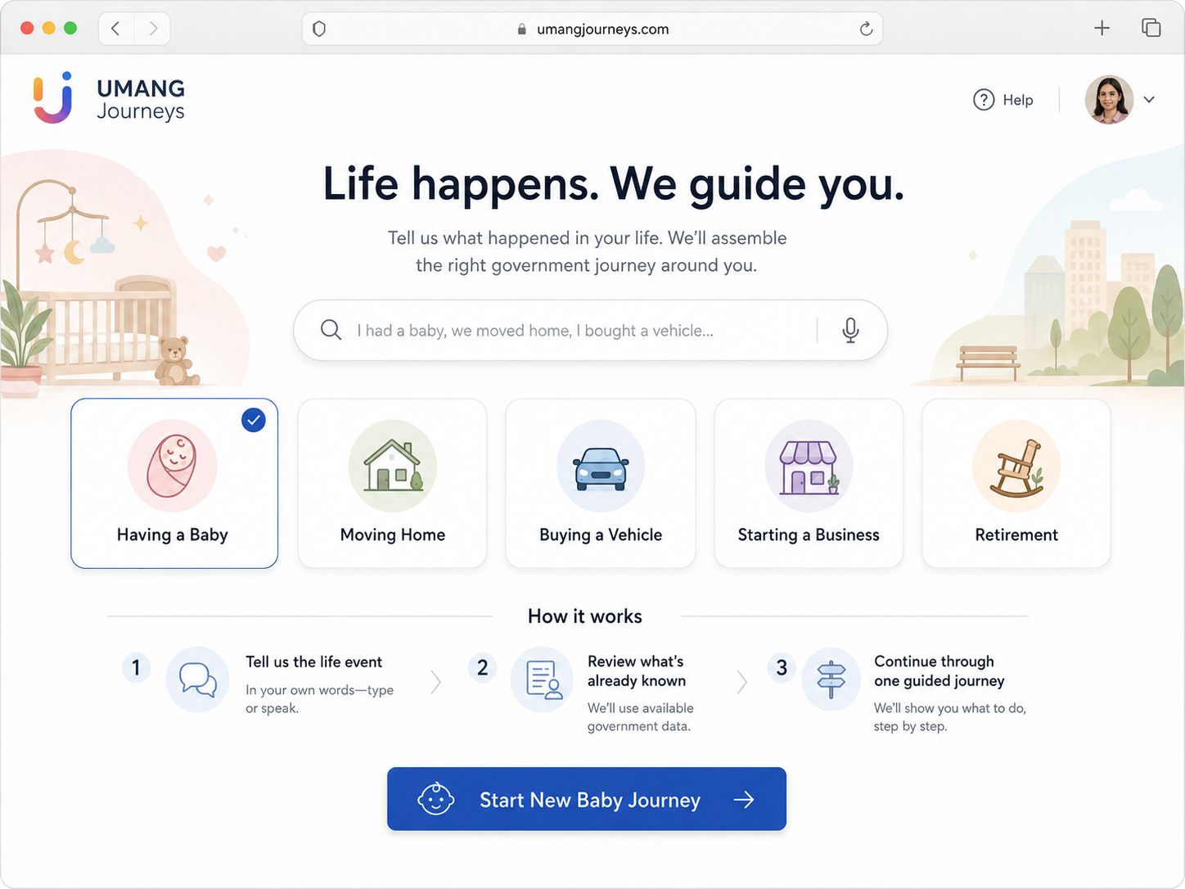
Implementation notes
Keep the page general enough to communicate that UMANG Journeys supports many life events. Having a Baby is selected for the Round 1 path. Do not add departmental navigation to the primary area.

22.2 S2 - Natural-Language Intake
The user describes the event naturally; the system extracts context and asks only the unresolved question.
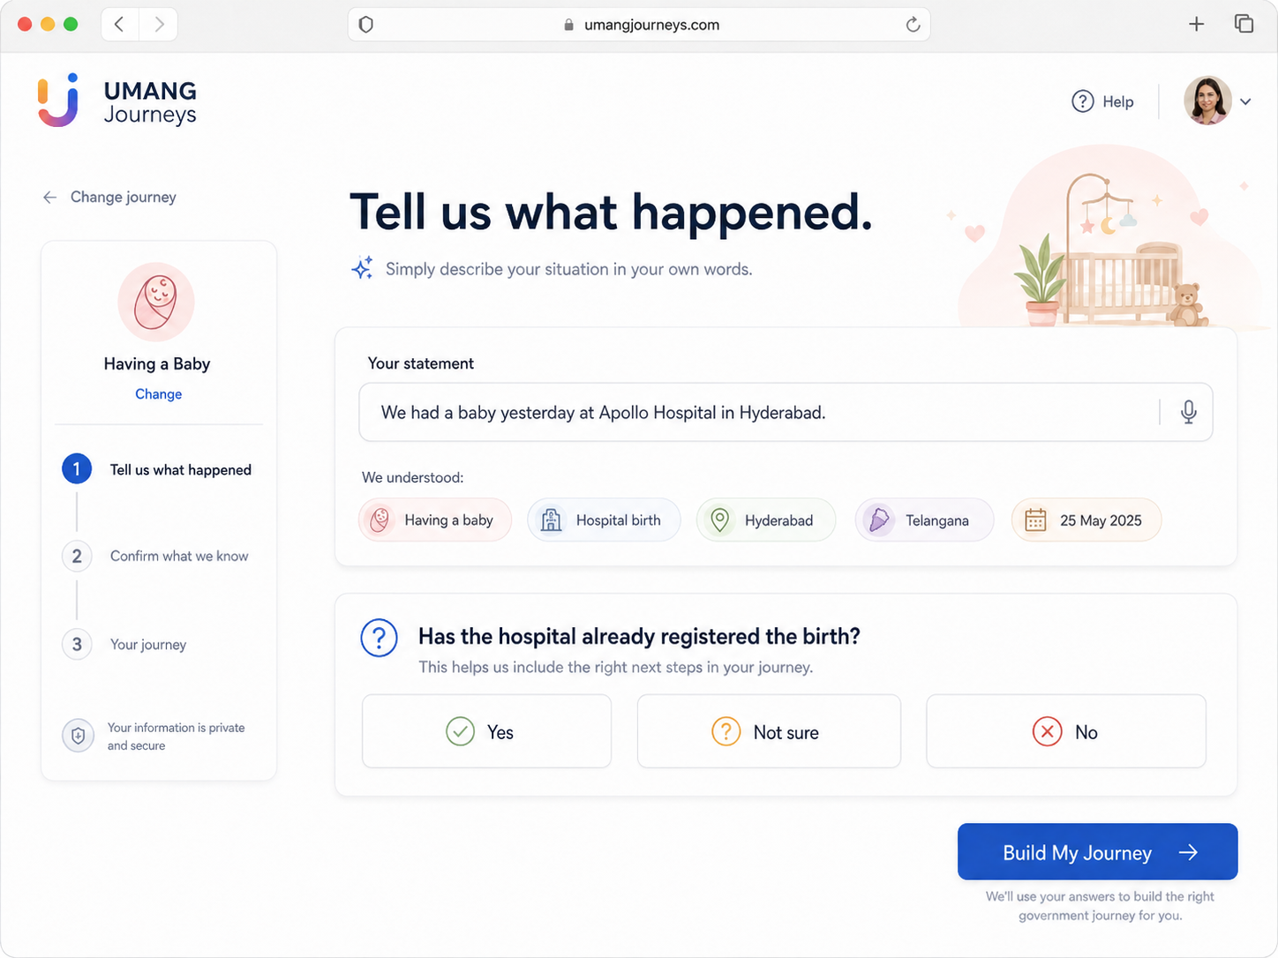
Implementation notes
This corrected screen intentionally avoids the earlier mixed chatbot/wizard/listening interaction. Voice may populate the same statement field, but the persistent state is a structured intake screen.

22.3 S3 - Journey Reveal
The core magic moment: a personalised dependency graph appears around the citizen's life event.
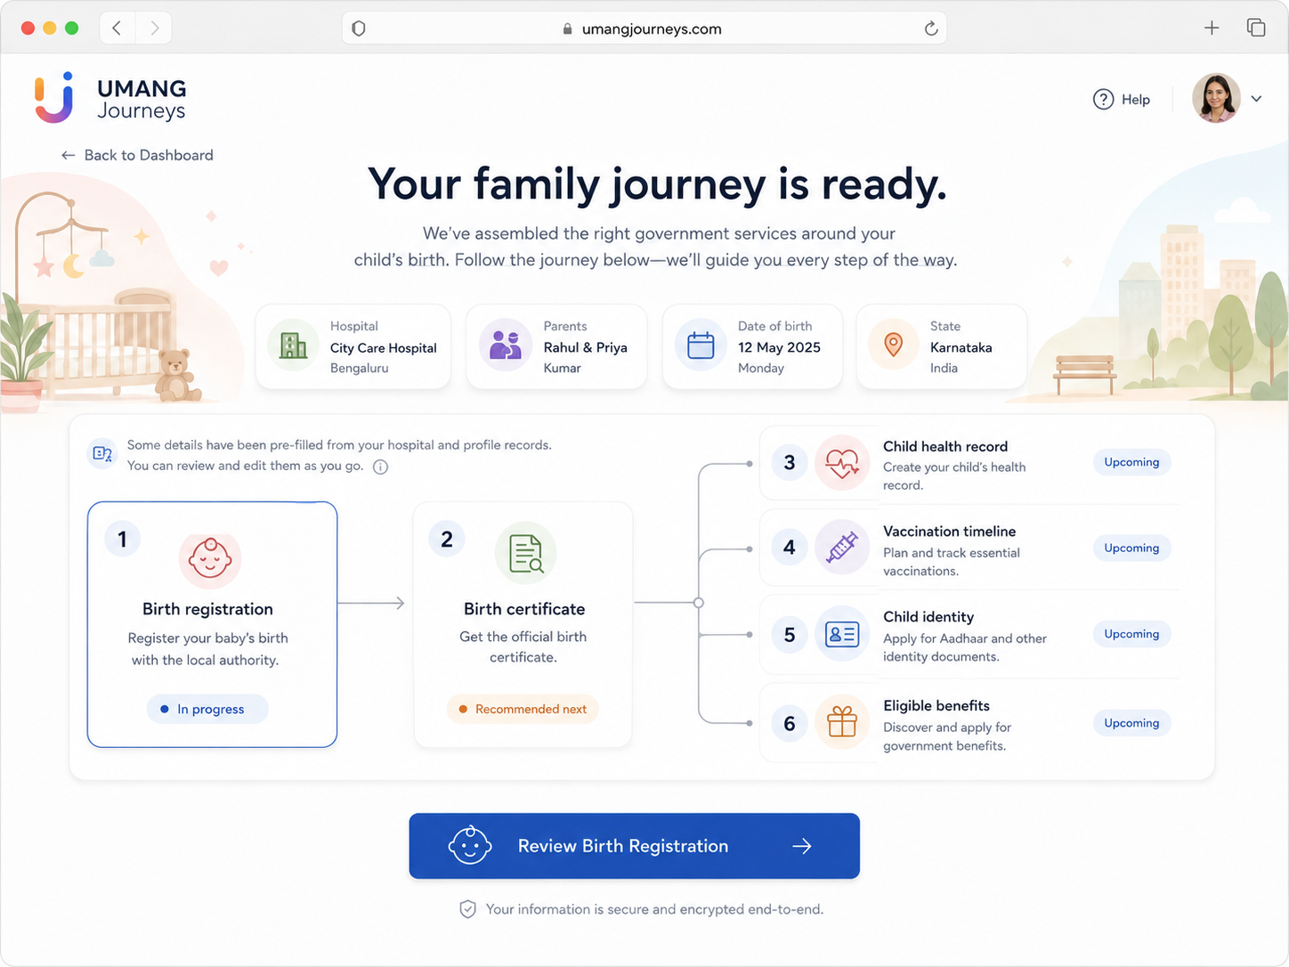
Implementation notes
Build the graph from JourneyTemplate data. The visual need not match pixel-for-pixel, but node status, dependencies, recommended action and contextual facts must be faithful to runtime state.

22.4 S4 - Birth Registration Review
Most fields are pre-filled from canonical profile and synthetic hospital facts; the user fills only what is missing.
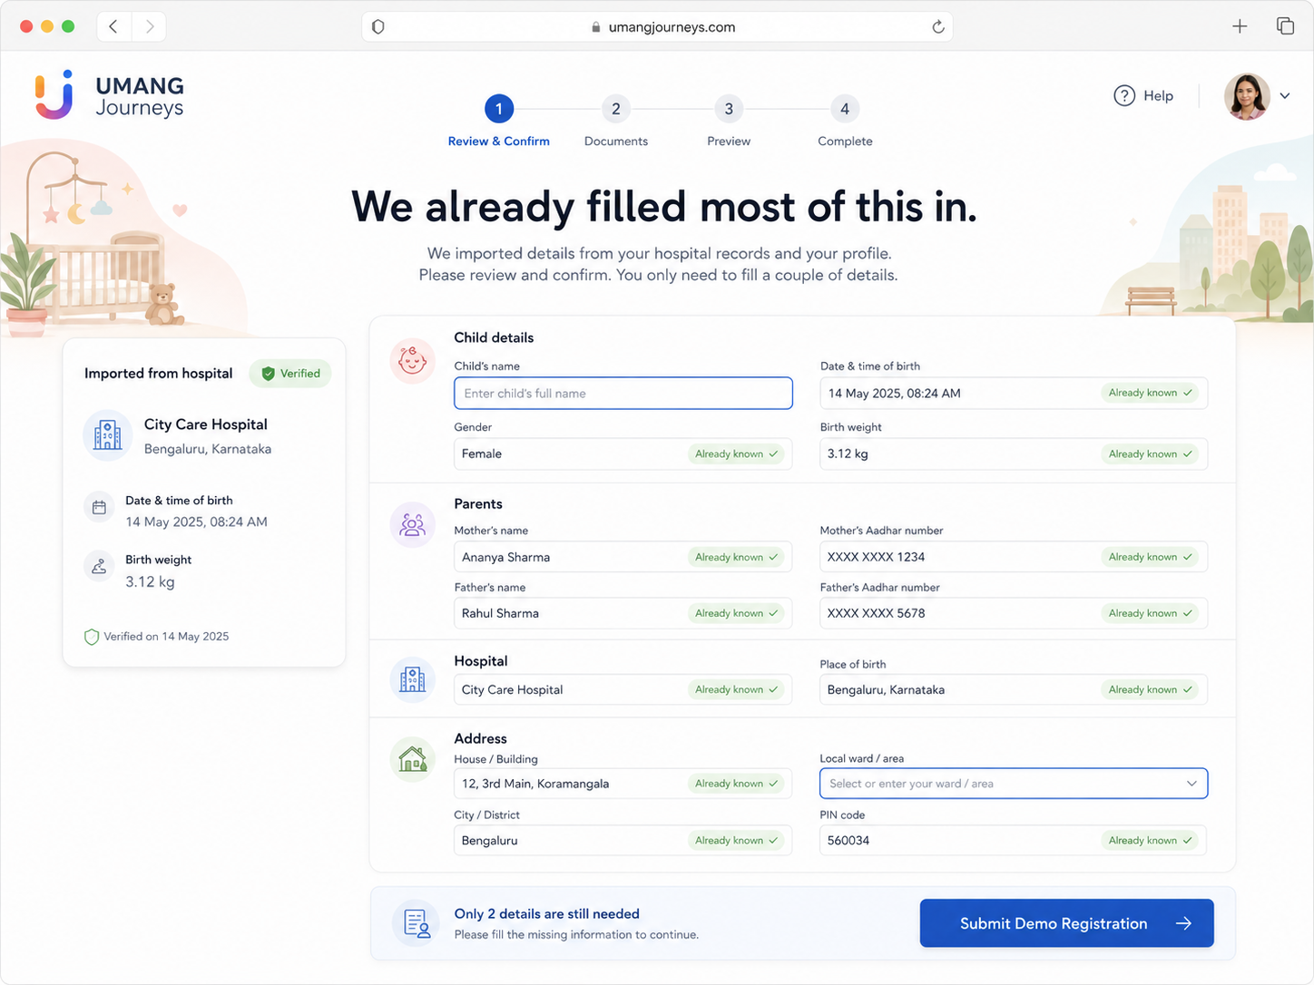
Implementation notes
All displayed imported data must have provenance. Any identity numbers must be synthetic and masked. The submit action must be explicitly presented as a demo/prototype action.

22.5 S5 - Success + Unlocks
Completing one node visibly unlocks downstream services and proves the dependency-aware concept.
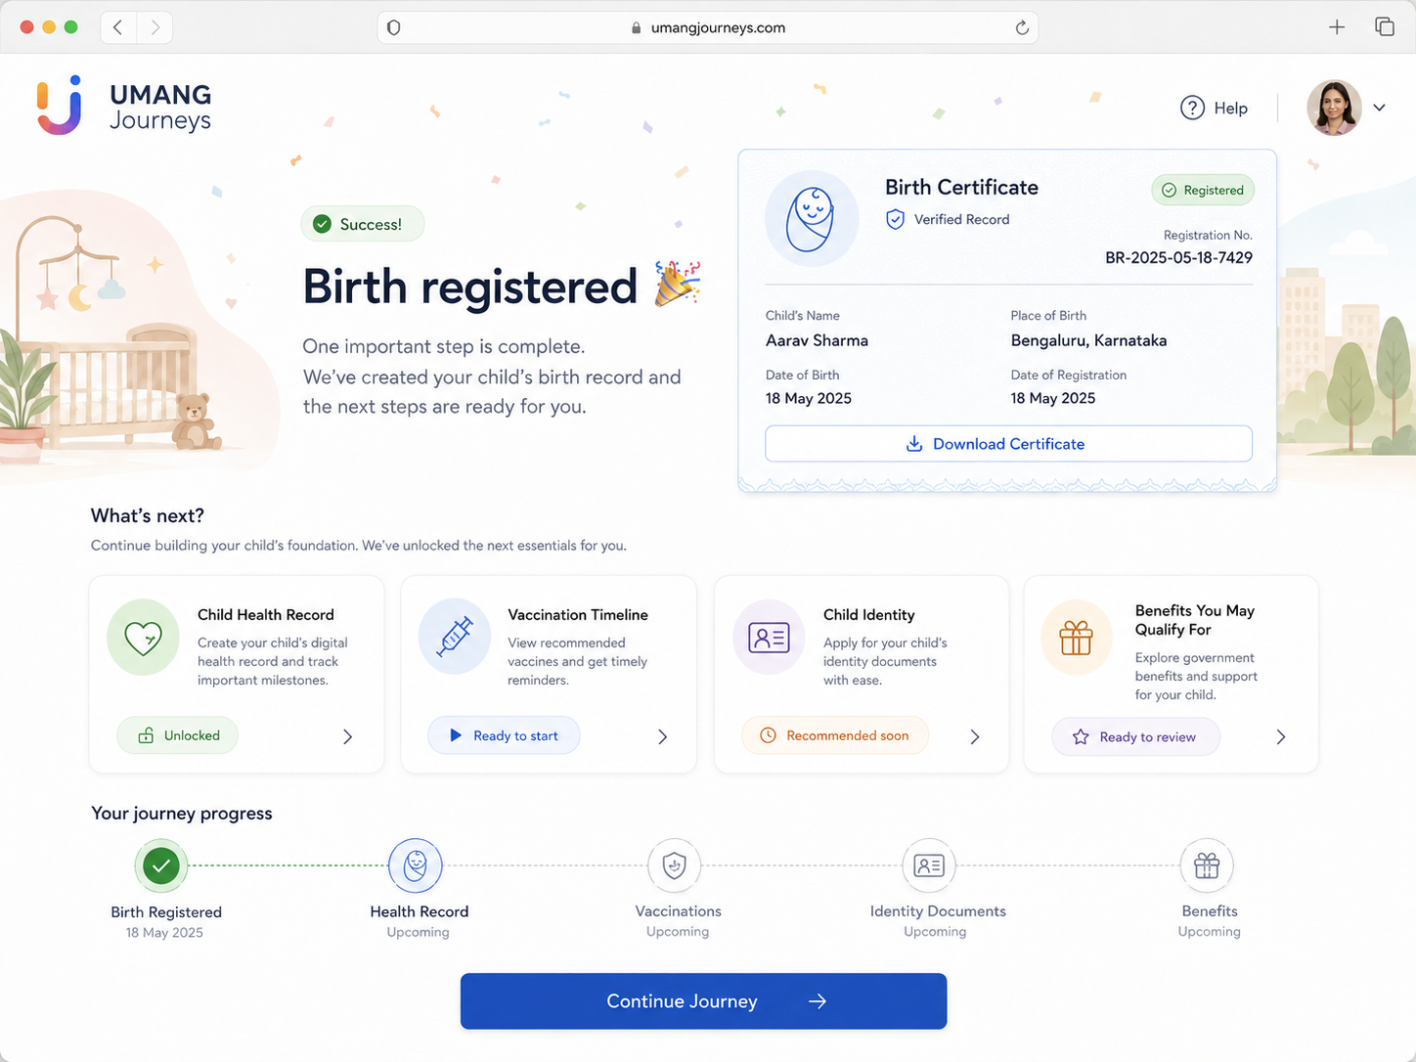
Implementation notes
Do not imply a real government registration. The synthetic output record and downstream availability are part of the prototype journey. The important visual transition is the graph/state change, not celebratory decoration.

23. Hackathon constraints and source notes
The user-provided Build What Moves India video transcript permits a browser-based citizen-facing proof of concept with mocked backend/data/accounts where needed. It also specifies a two-minute demo: minute one shows citizen use; minute two explains implementation and product decisions.
Engineering implication
Prioritise a complete, reliable citizen journey and a visually legible magic moment. Do not spend Round 1 time reproducing production government integrations that the prototype is explicitly allowed to simulate.

23.1 Round 1 delivery checklist
Deliverable | Ready when
Public web URL | Opens in a fresh browser with no local setup.
Demo mode | Golden path reproducible after reset.
Core journey | S1-S5 pass E2E-01.
Trust/compliance | All synthetic actions clearly labelled; no real PII.
2-minute video | Minute 1 = citizen journey; minute 2 = build/product decisions.
Text summary | Explains problem, inversion and why the journey model is better.

23.2 Final definition of done
Ship gate
The build is done when a reviewer can open the public URL, understand the concept without explanation, complete the synthetic newborn journey, see the downstream unlock moment, and repeat the demo after reset without developer intervention.

