**Introduction**

**Motivation:**

We chose this dataset so as to answer the question of how the transaction history of customers/consumers can give insight into consumers’ purchasing habits and also predict the products consumers might be interested in buying in the future. This kind of information can be used to align business decisions and also to understand which consumers are most valuable to the retail store, along with other essential insights.

The data set contains transactions occurring for a UK-based non-store online retail between 01/12/2009 and 09/12/2011.The company mainly sells unique all-occasion gift-ware, having many customers that are wholesalers.

**Modelling:**

1. Predicting what a customer might buy next (or recommendation)
2. Clustering customers into groups to apply different marketing strategies on them

**Exploratory Data Analysis:**

During the Exploratory Data Analysis of our dataset, we tried to analyze consumer trends and patterns of buying and also the countries that reported having most sales and revenues for the retail brand. We also did RFM analysis, which is a common technique to determine the best customers quantitatively by computing how recently a consumer has purchased (Recency), how often they purchase (Frequency) and how much the customer spends (Monetary). This is a popular way to analyze retail datasets better.

We tried to answer the following questions in our EDA:

* What are the top 10 Product categories based on sales?
* In each country , which product is sold the most?
* When were sales highest and lowest?
* Top 10 countries with maximum revenue
* Sale trends in countries with most purchases
* Who are the most valuable customers?
* Country with most valuable customers?
* Who is the most frequent and least frequent customer?
* Which customers spent the most and least?

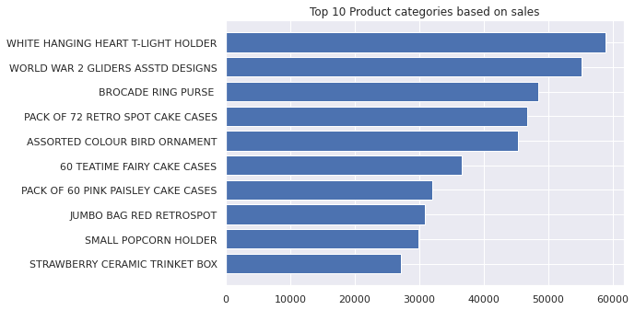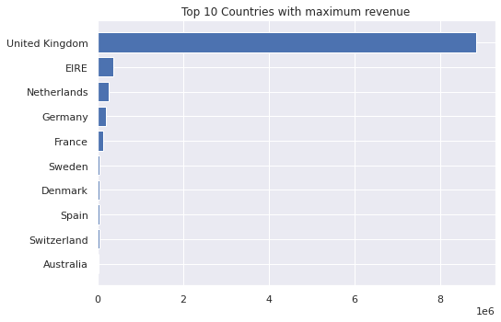

**Market Basket Analysis:**

Market Basket Analysis is a technique used to uncover strength of association between pairs of products purchased together and also helps to identify patterns of co-occurrence of those products in customer transactions, i.e., give more insight into purchase behavior of buyers. It works by finding combinations of items that frequently occur together in transactions.

Rule generation is the first step in mining of frequent patterns in transactional data. An association rule is simply an implication expression of the form x -> y, where x and y are disjoint itemsets. To evaluate the “interest” of an association rule (also suggests the significance of an association rule), different metrics such as Support, Confidence and Lift are used.

We will be using the Apriori Algorithm to generate association rules. Apriori Algorithm is a classic algorithm used for mining frequent itemsets and devising association rules from transactional data. It takes into consideration that, that a subset of a “frequent itemset” must also be a “frequent itemset”. The value of “frequent itemset” > than a threshold value(i.e. support).

Support used here is an indication of how frequently the itemset appears in the dataset. Confidence is an indication of how often the rule has been found to be true.

We used Market Basket Analysis using Association Mining for the Online Retail dataset as well as the CES Hybrid dataset and the following were our observations:

The most interesting association rules for Online Retail dataset with highest confidence are:

The most interesting association rules for CES Hybrid dataset with highest confidence for 2 cities:

For association mining, we took our metric as Confidence and minimum threshold as 0.7, i.e, association rules having confidence 70% or more only, will be considered. This will make sure that any associations that occurred by chance or at random will not be taken into consideration.

For City Belem:

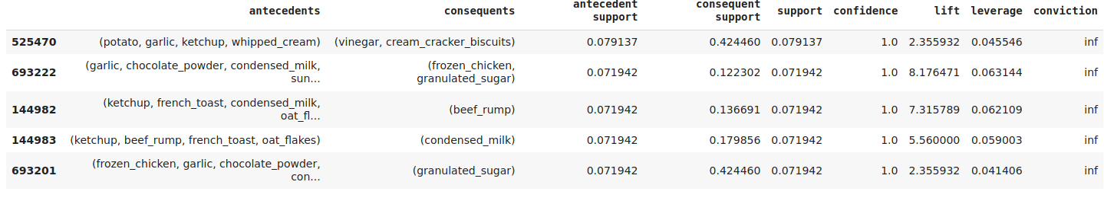

For City Belo Horizonte:

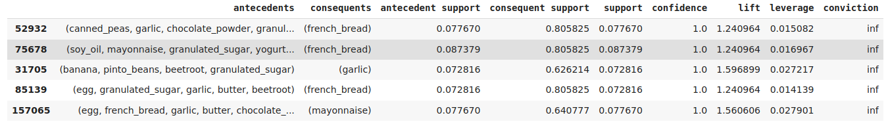

The association rules generated suggest the high correlation and co-occurrence of items or itemsets in transactional data.