Public-Facing Chatbot
Technical Architecture
How the public chatbot works, explained

AICC-IntelliDoc • AI Catalogue Platform

1. What Is the Public Chatbot?
The public chatbot is a question-and-answer assistant that anyone can use on a public website — no login, no account, no password. A visitor types a question in plain language, and the chatbot replies with a helpful answer drawn from an approved, curated knowledge base.
Think of it as a knowledgeable receptionist who has read an approved set of documents and is happy to answer questions about them 24 hours a day. It only talks about what it has been given, it answers in English, and it has a security guard standing next to it to keep things safe.

The single most important idea: isolation
The public chatbot is deliberately walled off from the main, private AI Catalogue platform. This is the central design principle. Because members of the public can reach it, it is built as a separate, self-contained system so that public traffic can never touch private documents, customer projects, or internal data.
Aspect | How isolation is achieved
Separate knowledge store | The public chatbot uses its own search database (ChromaDB), entirely separate from the main platform's private document database (Milvus).
Separate data tables | Its records live in their own database tables with no links to private user or project data.
Separate front door | It has its own web address and its own security gate, distinct from the logged-in application.

2. The Building Blocks
The chatbot is made of a few cooperating parts. Here is each one in everyday terms.
The Front Door (API endpoint)
The public web address where questions arrive. It accepts a question and returns an answer. There is also a 'live typing' version that streams the answer word-by-word as it is written, and a 'health check' address that monitoring tools use to confirm the service is alive.
The Security Guard
Before any question is processed, it is inspected for tricks and abuse — for example, attempts to make the chatbot ignore its instructions, overly long messages, or junk input. Suspicious messages are turned away politely.
The Traffic Warden (rate limiting)
Keeps any single visitor from overwhelming the service — limits such as a handful of questions per minute and a capped number per day, tracked by the visitor's network address.
The Librarian (knowledge search)
Searches the approved knowledge base to find the most relevant passages for the question, using 'meaning-based' search rather than simple keyword matching.
The Writer (the AI language model)
Takes the question plus the passages the Librarian found and composes a natural, readable answer. It can use OpenAI, Anthropic (Claude), or Google (Gemini) behind the scenes.
The Logbook (tracking & analytics)
Records each request — how long it took, whether it succeeded, how many sources were used — so administrators can monitor usage and quality. It stores no private platform data.
The Control Panel (configuration)
A single settings record administrators use to turn the chatbot on or off, set limits, choose the AI provider, edit the chatbot's personality, and switch features on or off — without touching code.

3. How a Question Becomes an Answer
When a visitor asks a question, it passes through a series of safety gates before any answer is produced. The flowchart below reads top to bottom: the diamonds are the three safety checks, and if any one of them fails, the chatbot stops and returns a polite message instead — the visitor never reaches the AI model in those cases.
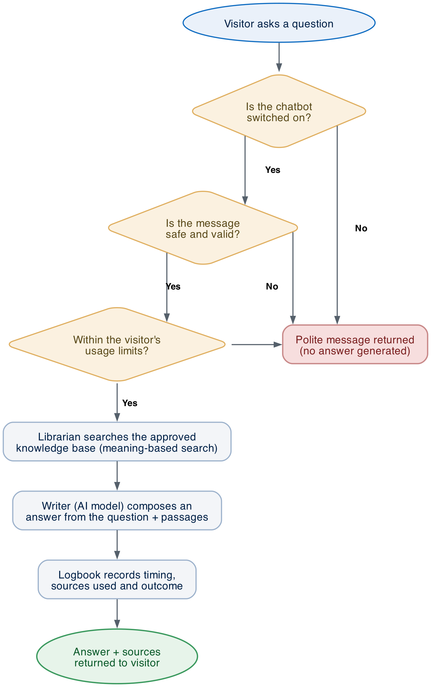
Figure 1 — The journey of a single question, from arrival to answer.

Start / End | Safety check | Processing step | Successful answer

In words: the chatbot first confirms it is switched on, then the Security Guard screens the message, then the Traffic Warden checks the visitor's usage is within limits. Only after all three pass does the Librarian search the approved knowledge base, the Writer compose an answer from what it finds, and the Logbook record what happened — before the answer and its sources are returned to the visitor.

4. How the Chatbot 'Knows' Things
The chatbot does not make answers up from thin air. It uses a well-established technique often called 'retrieval-augmented generation'. In plain terms: find the right reference material first, then write the answer from it. This keeps answers grounded in approved content.

Meaning-based search
Approved documents are converted into a mathematical 'fingerprint' that captures their meaning. When a question arrives, it is turned into the same kind of fingerprint, and the system finds the passages whose meaning is closest. This means a visitor can phrase a question in their own words and still find the right information, even if they don't use the exact words in the document.

Remembering the conversation
If a visitor asks a follow-up question (for example, just 'and the cost?'), the chatbot is smart enough to understand it in the context of the earlier conversation. It can rewrite a short or vague follow-up into a complete question behind the scenes, so the search still finds the right material.

Only confident matches are used
Each passage the Librarian finds is scored for how well it matches the question. Only passages above a confidence threshold are passed to the Writer. If nothing is confident enough, the chatbot answers without that material rather than forcing a poor match. Administrators can adjust this threshold.

Where the knowledge comes from
Knowledge is added only by administrators, through an approval workflow. Each document is reviewed and marked as approved and security-checked before it ever becomes searchable. Large documents are automatically broken into sensible chunks so they can be searched precisely. The public can never add or change the knowledge base — they can only ask questions of it.

5. Safety, Privacy and Control
- Walled off from private data — The public chatbot uses its own search database and its own data tables, with no connections to the private platform. Public visitors cannot reach private documents or projects.
- Protection against manipulation — Every message is screened for known tricks that try to hijack an AI assistant's instructions, as well as for spam-like or malformed input.
- Fair-use limits — Per-visitor limits (per minute, per hour and per day) prevent any individual from monopolising or abusing the service, and repeat offenders can be blocked automatically.
- English-only, on-topic answers — The Writer is instructed to always answer in English and to stay grounded in the approved knowledge base, giving consistent, predictable responses.
- Controlled website access — Only approved websites are allowed to embed and call the chatbot, managed by a dedicated access policy that sits in front of the service.
- Privacy-aware logging — The logbook keeps operational details for monitoring and quality, and full-conversation logging is an explicit administrator choice rather than the default.
- Instant on/off switch — Administrators can disable the chatbot or put it into maintenance mode at any moment from the control panel, with a custom message shown to visitors — no technical deployment required.

6. Why It Is Built This Way
Three goals shaped the design, and each maps to a concrete choice in the system:
Goal | How the design delivers it
Safety | A separate system, its own database, a security guard, and per-visitor limits keep public traffic contained and the main platform protected.
Trustworthy answers | Answers are grounded in an approved, curated knowledge base with confidence scoring — reducing the chance of confident-but-wrong replies.
Easy operation | A single control panel lets non-developers turn the service on/off, set limits, pick the AI provider and edit the chatbot's tone, all without code changes.

7. Glossary
A few technical terms, translated:
Term | Plain-English meaning
API endpoint | The web address where the chatbot receives questions and sends back answers.
Knowledge base | The curated, approved collection of documents the chatbot is allowed to draw on.
Vector / meaning-based search | Finding text by its meaning rather than exact keywords, by comparing mathematical 'fingerprints' of the text.
ChromaDB | The chatbot's own search database — kept separate from the main platform.
Language model (LLM) | The AI that writes the natural-language answer (e.g. OpenAI, Claude, Gemini).
Rate limiting | Caps on how many questions one visitor can ask in a given time window.
Prompt injection | A trick where a user tries to make the AI ignore its rules; actively screened for.
Streaming | Sending the answer progressively, word by word, so it appears to be 'typed' live.

AICC-IntelliDoc — Public Chatbot Architecture Overview

