Public Chatbot
Technical Architecture & Replication Guide
How the isolated public chatbot works — and how to rebuild it from scratch

Module: backend/public_chatbot/
Audience: a technical team replicating the system
Platform: AICC-IntelliDoc

0. How to Read This Document
This document has two jobs. Sections 1–10 explain how the chatbot works and, crucially, why each decision was made — the reasoning, the trade-offs, and the alternatives. Section 11 is a phased build roadmap: follow it in order and you can reconstruct the system from an empty Django app. Appendix A is the external API contract.
Three kinds of highlighted box appear throughout:
CONCEPT explains a pattern or term so you don't need outside references to follow along.

DESIGN DECISION records a deliberate design choice and the trade-off behind it — these are the parts you must understand to replicate intelligently rather than copy blindly.

CAVEAT flags a sharp edge, limitation, or thing to get right in your own build.

Mental model in one sentence: this is a retrieval-augmented Q&A pipeline wrapped in safety gates and deliberately isolated from the private platform, so anonymous internet traffic can be served without ever touching private data.

1. System Concept & Mental Model
CONCEPT Retrieval-Augmented Generation (RAG). Rather than trusting an LLM's trained-in memory, you (1) embed approved knowledge into a vector store, (2) embed the incoming question, (3) retrieve the nearest passages by similarity, and (4) inject them into the prompt as grounding context. The answer is then constrained to curated, auditable content — and you can update knowledge without retraining anything.

The chatbot answers public visitors' questions from an admin-curated knowledge base. Everything else in the system exists to make that safe, observable, and operable. The component view:
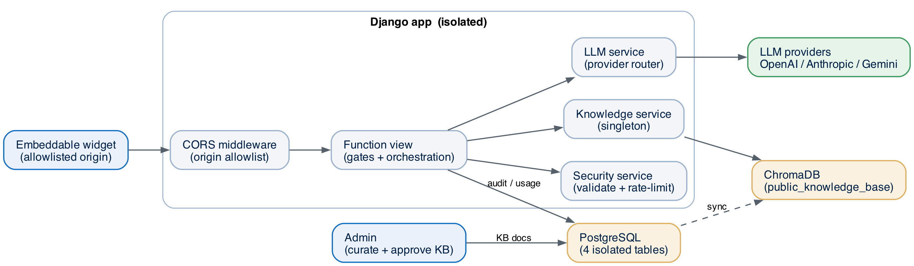
Figure 1 — Component architecture. The Django app is isolated; ChromaDB and Postgres are public-only stores; the LLM providers are external.

DESIGN DECISION Why isolation is the organising principle. A public, unauthenticated endpoint is the highest-risk surface in the platform. By giving the chatbot its own vector store, its own tables (no foreign keys to platform data), its own credentials, and its own ingress, a compromise or bug in the public path cannot read or corrupt private documents, user records, or project keys. You are trading a little duplication for a hard security boundary.

Layer | Private platform | Public chatbot | Why separate
Vector store | Milvus | ChromaDB | No shared index → public queries can't reach private docs
Tables | FKs to users.User | 4 tables, no FKs | No join path from public rows into private data
LLM keys | per-project, encrypted | system-level env key | Public traffic never unlocks project keys
Ingress | JWT / DRF | unauthenticated view | Different threat model → different stack

2. Technology Choices & Rationale
Each major choice below is one you will re-make when replicating. The reasoning matters more than the specific product.

2.1 ChromaDB for the public store (not the platform's Milvus)
DESIGN DECISION Milvus is the heavyweight, horizontally-scalable index for the private corpus. The public KB is small and curated, so it doesn't need that scale — it needs isolation and operational simplicity. ChromaDB runs as a single lightweight container, speaks a simple HTTP API, and can fall back to a local persistent file if the service is down. Trade-off: less raw scale and fewer index tuning knobs — perfectly acceptable for a hand-approved knowledge base.

2.2 SentenceTransformers all-MiniLM-L6-v2 (384-dim)
CONCEPT An embedding model maps text to a fixed-length vector so that semantically similar text sits close together in vector space. 384 dimensions is small and fast; similarity is computed as 1 − distance.

DESIGN DECISION We reuse the same model the platform already runs, so the weights are already cached on disk and no extra download/storage is incurred. It is fast on CPU and good enough for short FAQ-style passages. Trade-off: a 256-token input window — handled in §5 by chunking + sliding-window embedding.

2.3 Plain Django function views, csrf_exempt (not DRF)
DESIGN DECISION The endpoint is public, unauthenticated, and JSON-in/JSON-out, and one path must stream. DRF's auth/session/CSRF machinery would be dead weight and a foot-gun on a public route. Function views give explicit control over CORS, status codes, and the streaming response. We disable CSRF (no cookies/sessions are used) and restrict methods explicitly.

python
@csrf_exempt # no session/cookie auth → no CSRF
@require_http_methods(["POST", "OPTIONS"]) # OPTIONS for CORS preflight
@never_cache # answers must never be cached
@_rate_limit_decorator() # per-minute burst guard (see §6.2)
def public_chat_api(request):
...

2.4 A process-wide singleton for the knowledge service
DESIGN DECISION Loading the embedding model and opening the ChromaDB client are expensive (hundreds of ms to seconds). Doing that per request would be ruinous. A thread-safe singleton initialises once at process start (warmed in AppConfig.ready()) and is shared across all requests/threads.

python
class PublicKnowledgeService:
_instance = None
_lock = threading.Lock()
def __new__(cls):
if cls._instance is None: # double-checked locking
with cls._lock:
if cls._instance is None:
cls._instance = super().__new__(cls)
return cls._instance

3. Data Model
DESIGN DECISION Audit-first design. We persist a request row before doing any work and update it as the request progresses. If the process crashes or an LLM call times out, you still have a record of what happened. Tracking writes are best-effort and never block the user's answer.

Model | Table | Role
PublicChatRequest | public_chatbot_requests | Per-request audit + analytics
IPUsageLimit | public_chatbot_ip_limits | Per-IP counters, blocking, violations
PublicKnowledgeDocument | public_chatbot_knowledge | KB source-of-truth + sync state + approval
ChatbotConfiguration | public_chatbot_config | Singleton runtime config (pk=1)

DESIGN DECISION Why a singleton config row. Operators must change behaviour — limits, model, the system prompt, kill switch — without a code deploy. A single editable row (guarded so a second can't be created) gives you a live control panel via Django admin. get_config() reads it on each request.

CAVEAT Set db_table explicitly and add no ForeignKey to platform models. The moment a public table joins to private data, the isolation boundary is gone.

4. Request Lifecycle — and Why the Order Matters
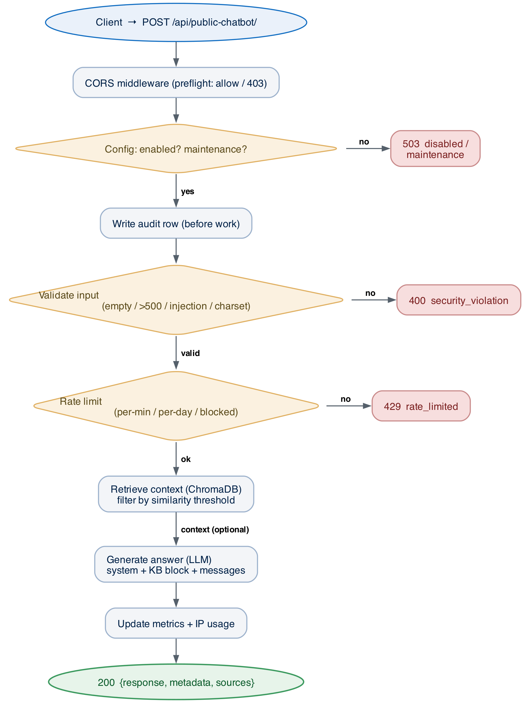
Figure 2 — Standard request lifecycle. Gates are ordered cheapest-first; each rejection is a fast-fail HTTP response.

DESIGN DECISION Order gates by ascending cost and descending blast-radius. Check the in-memory/DB config first, then cheap regex validation, then a DB rate-limit read, and only then the expensive, billable operations (vector search, then the LLM call). You never spend money or compute on a request you were always going to reject.

The pipeline, step by step:
- CORS preflight — the middleware answers OPTIONS and decides if this origin may call us at all (§6.3).
- Config check — is the bot enabled and not in maintenance? If not, 503 immediately.
- Write the audit row — so the request is traceable even if later steps fail.
- Validate input — empty, over-length, prompt-injection, or junk → 400 (§6.1).
- Rate limit — per-minute and per-day caps, plus block state → 429 (§6.2).
- Retrieve context — optional; degrade gracefully if the store is down (§5).
- Generate the answer — assemble the prompt and call the LLM (§7).
- Record metrics + usage, then return 200 with the answer and its sources.

4.1 Streaming variant (Server-Sent Events)
CONCEPT Server-Sent Events (SSE) is a one-way stream over plain HTTP: the server emits lines prefixed with 'data: ' and the browser reads them via EventSource. It is simpler than WebSockets and ideal for pushing answer tokens as they are generated.

DESIGN DECISION Streaming is OpenAI-only here because only the OpenAI client path implements incremental deltas; other providers fall back to a single response. We also set X-Accel-Buffering: no so nginx doesn't buffer the stream and defeat the point. If you replicate streaming for another provider, you add a provider-specific generator that yields the same event shapes.

4.2 Health endpoint
DESIGN DECISION A dedicated health route lets your orchestrator decide liveness/readiness. It reports healthy only if the bot is enabled and (vector search is off OR ChromaDB is actually reachable) — i.e. it reflects the real ability to serve, not just 'the process is up'.

5. Retrieval Subsystem — Building the 'Knowing'

5.1 Ingestion: chunk → embed → store
CONCEPT Chunking splits a long document into passages small enough to embed and retrieve precisely. Overlap (repeating some text between adjacent chunks) prevents an answer-bearing sentence from being split across a boundary and lost. Here: ~2048-token chunks with 750-token overlap (LARGE_SEMANTIC), with smaller/larger strategies available.

CONCEPT The embedding model has a 256-token window, smaller than a chunk. The sliding-window strategy embeds overlapping sub-windows and combines them, so large chunks are represented without truncation.

Pipeline (admin-driven, never public):
python
for doc in approved_documents: # admin-curated + approved only
chunks = chunker.chunk_document(doc.content, doc.id) # strategy: LARGE_SEMANTIC
vectors = embedder.embed(chunks) # sliding-window
chroma.smart_sync(chunks, vectors, document_id=doc.id) # idempotent upsert

5.2 Retrieval at query time
CONCEPT Similarity threshold. Each hit gets a score in [0,1] (1 − distance). Only hits above the threshold (default 0.7) are kept. Higher = stricter (fewer, more-relevant passages); lower = more recall but more noise. Expose it in config so operators can tune precision vs recall live.

Query construction adapts to conversation state — a subtle but important detail:
DESIGN DECISION Why follow-ups need special handling. A naive RAG system embeds only the latest message. But 'and the cost?' has no standalone meaning — embedding it retrieves nothing useful. Two strategies fix this: (a) LLM rephrasing rewrites the follow-up into a self-contained question using the conversation; (b) the cheaper fallback simply appends prior user turns to the query text. Rephrasing is a short, low-temperature LLM call; it is toggleable because it adds latency and cost.

Situation | Strategy | Resulting query
First turn | raw message | "What is the platform?"
Follow-up, rephrasing on | LLM rewrite | "What is the cost of AICC-IntelliDoc?"
Follow-up, rephrasing off | append prior user turns | "and the cost?. [What is the platform?]"

DESIGN DECISION Degrade gracefully. If retrieval errors or returns nothing above threshold, the request continues to the LLM with no context rather than failing. A public widget answering 'I don't have that' beats a 500 error.

5.3 Keeping the two stores consistent
DESIGN DECISION The relational row is the source of truth; ChromaDB is a derived index. When an admin deletes a knowledge document, a Django pre_delete signal purges its chunks from ChromaDB first — so you can never end up answering from content that was supposedly removed.

6. Security Model
CONCEPT Threat model. Anonymous users can send arbitrary text from arbitrary origins at arbitrary volume. The risks are: prompt injection (hijacking the assistant), abuse/DoS and cost blow-up (flooding the LLM), and unwanted embedding (other sites using your bot). Each control below targets one of these.

6.1 Input validation
CONCEPT Prompt injection is user text that tries to override the system instructions, e.g. 'ignore previous instructions and …'. Because user and system text share one prompt, you defend by (a) screening inputs for known patterns and (b) keeping system instructions authoritative and last.

- Reject empty / over-length (500-char cap) input before anything else.
- Screen against ~13 injection regexes; a match is logged and counts toward an auto-block.
- Charset heuristic: >30% non-alphanumeric characters → reject as junk/obfuscation.
DESIGN DECISION We also append a hard-coded English-only language rule after the operator's system prompt. Placing it last makes it authoritative, suppressing the script-mixing that multilingual base models sometimes produce — a cheap way to keep output predictable.

6.2 Rate limiting (defence in depth)
DESIGN DECISION Different time horizons catch different abuse. A per-minute cap stops bursts; a per-day cap stops sustained draining of your LLM budget; violation-based auto-blocking stops deliberate attackers. One limit alone leaves a gap, so we layer them.

Control | Limit | Catches
Per-minute (decorator) | 10/min per IP | Bursts / scripts
Per-day (DB counter) | 100/day → block to 23:59 | Sustained abuse / cost
Violation auto-block | 5 violations → 24h block | Deliberate attackers

CAVEAT IP is read from the proxy header chain (X-Forwarded-For → … → REMOTE_ADDR). These headers are client-settable, so your edge/reverse-proxy MUST overwrite X-Forwarded-For. If it doesn't, an attacker rotates fake IPs and every per-IP limit is bypassed.

6.3 CORS
CONCEPT A browser making a cross-origin request first sends an OPTIONS 'preflight' asking 'may site X call you?'. The server answers with Access-Control-Allow-* headers. An origin allowlist is how you control which sites may embed your widget.

DESIGN DECISION We run a dedicated CORS middleware first in the chain (before the platform's generic CORS handler) so the public path's rules are applied deterministically. Allowlisted origins get echoed; unknown origins are refused at preflight.

CAVEAT The per-view fallback still returns Allow-Origin: * for non-allowlisted origins on the actual response. That is acceptable ONLY because the endpoint honours no credentials/cookies (Allow-Credentials: false) — there is no session to steal. If you add auth, you must tighten this.

7. LLM Integration
DESIGN DECISION Provider abstraction. A single generate_response() routes to OpenAI, Anthropic, or Gemini behind one interface, so operators can switch providers from config and you can add a provider without touching the view. An unknown provider falls back to OpenAI rather than erroring.

CONCEPT Messages vs prompt. Modern chat APIs take a structured messages[] array with roles (system / user / assistant). We build that array — system instruction + KB block, then the prior turns, then the new question — so the model sees the conversation and its grounding cleanly. Anthropic takes the system text as a separate parameter; Gemini is flattened to one prompt string.

- Token-param differences — OpenAI GPT models use max_completion_tokens (GPT-5 needs a larger budget and a fixed temperature); legacy models use max_tokens. Encapsulate this so callers don't care.
- Credentials — a dedicated key for the bot's OpenAI usage; platform keys for the others. Never read project keys here.
- Resilience — a 30s timeout and a structured fallback payload on any error, so the view always has something to record and return.
Prompt assembly (conceptual):
python
system = operator_system_prompt + ENGLISH_ONLY_RULE
if kb_chunks:
system += "\n=== KNOWLEDGE BASE ===\n" + top_10_chunks + "\n=== END ==="
messages = [{"role": "system", "content": system}]
messages += prior_turns # user/assistant history
messages += [{"role": "user", "content": question}]

8. Configuration & Operations
- Runtime control — the config singleton is the operator console: kill switch, maintenance message, limits, similarity threshold, provider/model, system prompt, feature toggles. No deploy needed.
- Infra — ChromaDB as its own container (in-network host/port); a dedicated OpenAI key plus shared platform keys; two extra Python deps (a vector DB client and a rate-limit lib with a graceful fallback).
- Operational tasks — a management command syncs approved docs into the vector store (with dry-run and force-resync); another seeds sample knowledge.

9. Observability
DESIGN DECISION Because you wrote the audit row first and updated it throughout, every request yields latency, retrieval metrics, provider/model/tokens, and outcome — queryable for dashboards and incident triage. Return the request_id to the client so user-reported issues map straight to a row.

- Logging — a dedicated logger namespace with stage markers. Turn the CORS preflight log level down in production (it ships at ERROR for debugging visibility).

10. Failure Modes & the Degrade-Gracefully Philosophy
DESIGN DECISION Only the LLM call is load-bearing. Every other dependency has a fallback, because a public widget should keep answering through partial outages.

Failure | Designed behaviour
ChromaDB unreachable | HTTP client → local persistent fallback; if still down, answer without context
Embedding model missing | Fall back to the vector DB's default embedder
Audit write fails | Log and continue — never block the answer
LLM error / timeout | Structured fallback; mark request 'error'; safe user message
Rephrasing fails | Use the original / context-appended query
Unknown provider | Fall back to OpenAI

11. Replication Roadmap
Build in this order. Each phase is independently testable and leaves you with something that runs, so you are never debugging ten unknowns at once.
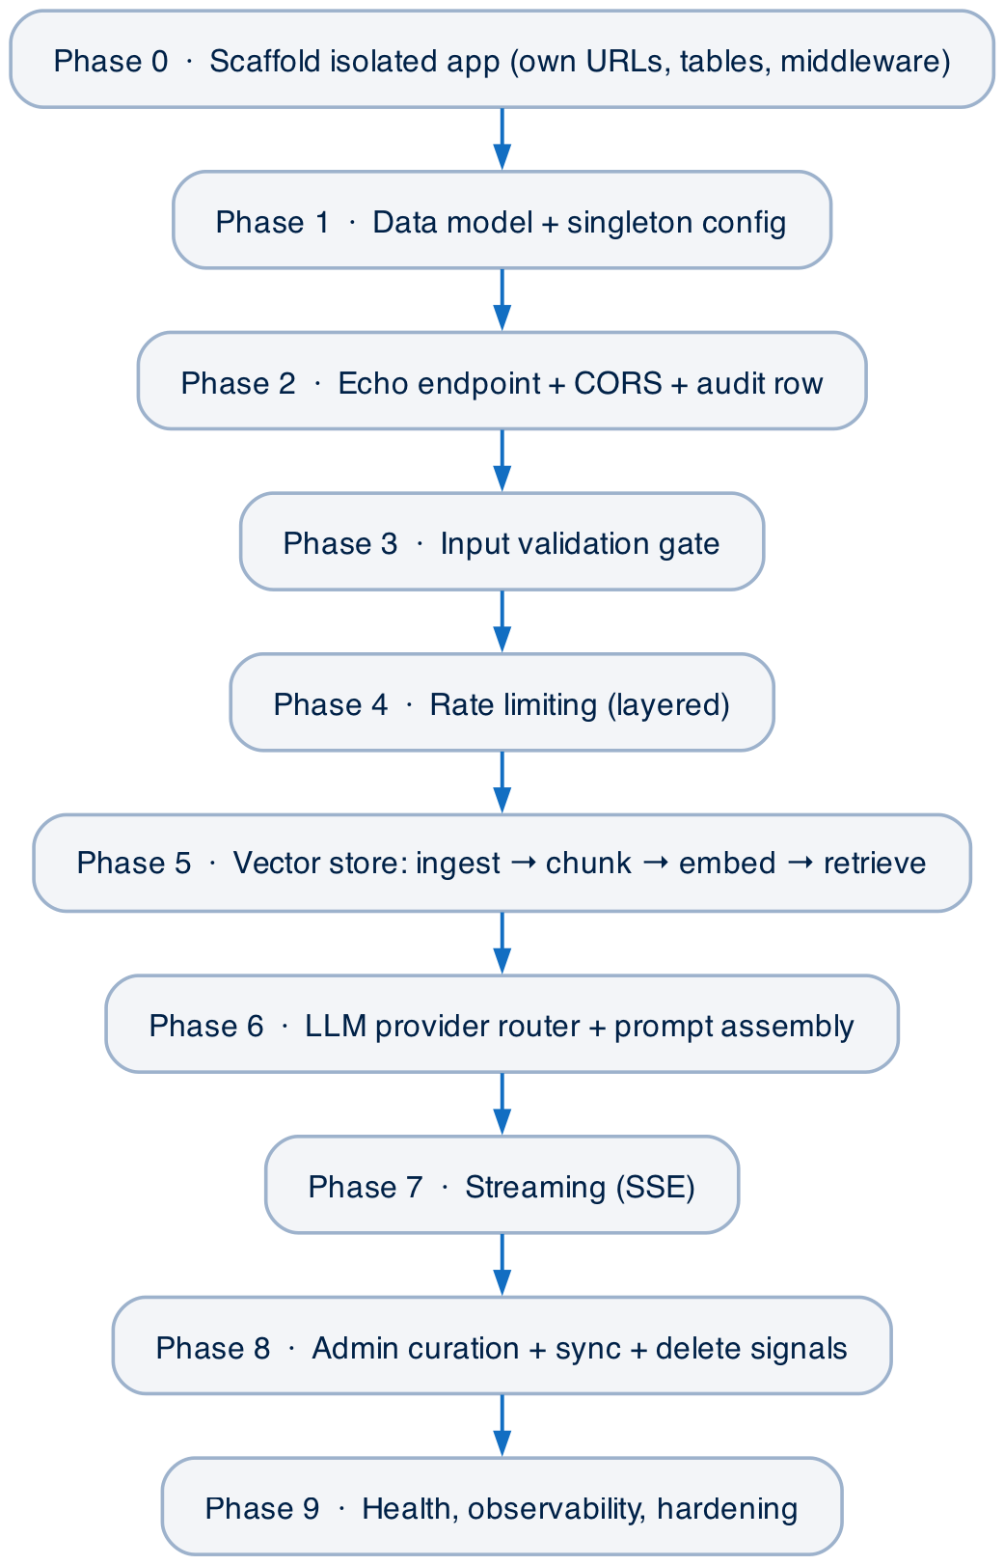
Figure 3 — Recommended build order. Each phase depends only on the ones above it.

Phase 0 — Scaffold the isolated app
Build: Create a new Django app with its own urls.py included under a public prefix, its own CORS middleware registered first, and its own logger. Goal: a 200 from a stub route.
Verify: Verify: curl the stub route from an allowlisted Origin and see CORS headers come back.
Phase 1 — Data model + config singleton
Build: Add the four models with explicit table names and no platform FKs. Implement get_config() returning a guarded pk=1 row with sensible defaults.
Verify: Verify: migrate; create the config row in admin; confirm a second one is refused.
Phase 2 — Echo endpoint + audit row
Build: Implement the function view: parse JSON, write the audit row FIRST, echo the message back. Wire csrf_exempt + method/cache decorators. Handle the OPTIONS preflight.
Verify: Verify: POST a message; see the echo and a persisted request row with a generated request_id.
Phase 3 — Input validation gate
Build: Add empty/length checks, the injection regex list, and the charset heuristic. On failure: mark the row security_violation and return 400.
Verify: Verify: 'ignore previous instructions' → 400; a normal question still passes.
Phase 4 — Rate limiting
Build: Add the per-minute decorator (with a cache fallback if the lib is absent), the per-day DB counter, and violation-based auto-blocking. Resolve client IP from the proxy header chain.
Verify: Verify: exceed the per-minute cap → 429 with retry_after.
Phase 5 — Vector store + retrieval
Build: Stand up the vector DB container. Build the singleton service (client + embedder, warmed in ready()). Implement chunk → embed → store ingestion and threshold-filtered search. Add query rephrasing / context-append for follow-ups.
Verify: Verify: ingest a doc; ask a question; see above-threshold chunks retrieved and returned as sources.
Phase 6 — LLM provider router
Build: Implement generate_response() with per-provider methods, the messages-first contract, token-param handling, timeout, and fallback. Assemble system + KB + history into the prompt.
Verify: Verify: a grounded answer that cites retrieved context; provider switchable via config.
Phase 7 — Streaming (SSE)
Build: Add the /stream/ route returning text/event-stream with content → completion → [DONE] events and X-Accel-Buffering: no. Gate to the streaming-capable provider.
Verify: Verify: curl -N shows incremental deltas then a completion event.
Phase 8 — Admin curation + sync
Build: Expose the KB model in admin with an approval workflow; add the sync management command and the pre_delete signal that purges ChromaDB.
Verify: Verify: approve + sync a doc → searchable; delete it → gone from both stores.
Phase 9 — Health, observability, hardening
Build: Add the health route, finalise metrics on the audit row, tune log levels, and confirm every fallback path from §10.
Verify: Verify: kill the vector DB → health reports unhealthy, but the bot still answers without context.
DESIGN DECISION Why this order. Safety and observability (audit, validation, limits) come before the expensive, externally-billed pieces (retrieval, LLM, streaming). At every phase the public surface is already protected, so you can test against real traffic without exposure or runaway cost.

12. Known Limitations / Extension Points
- Streaming is single-provider — add provider-specific SSE generators to extend it.
- max_message_length config is not wired into validation (500 is hard-coded) — unify if exposed.
- Hourly cap is tracked but not enforced in the main path — consolidate the limit logic if you want one source of truth.
- Gemini token usage is estimated — account for it in cost reporting.
- IP limits depend on a trustworthy proxy — see §6.2 caveat.

AICC-IntelliDoc — Public Chatbot · Technical Architecture & Replication Guide

Appendix A — API Reference
Base URL (production): https://aicc.uksouth.cloudapp.azure.com · All routes under /api/public-chatbot/. No authentication — access is governed by the CORS allowlist (§6.3) and the rate limits (§6.2). JSON in/out, except the streaming route (Server-Sent Events).

A.1 Error envelope & status codes
json
{
"status": "error",
"error": "<human-readable message>",
"request_id": "pub_20260604_a1b2c3d4",
["retry_after": 3600,] // 429 only
["metadata": { "timestamp": "...", "response_time_ms": 42 }]
}

Status | Meaning | When
200 | OK | Answer generated (or healthy, for /health/)
400 | Bad request | Missing message, invalid JSON, security_violation, or streaming on a non-OpenAI provider
429 | Rate limited | Per-minute or per-day cap exceeded / IP blocked (includes retry_after)
503 | Unavailable | Chatbot disabled or in maintenance mode
500 | Server error | LLM failure or unexpected exception

A.2 Chat (synchronous)
POST | /api/public-chatbot/

Request body
Field | Type | Req? | Notes
message | string | yes | User question. Max 500 chars; rejected if empty or failing security checks.
session_id | string | no | Opaque conversation id; stored truncated to 100 chars.
conversation | array | no | Prior turns [{role:"user"|"assistant", content}]. Drives follow-up rephrasing / context-aware search.
context_limit | int | no | Max KB results. Clamped to max_search_results (default 5).

Example request
bash
curl -X POST https://aicc.uksouth.cloudapp.azure.com/api/public-chatbot/ \
-H "Content-Type: application/json" \
-H "Origin: https://oxfordcompetencycenters.github.io" \
-d '{
"message": "What is AICC-IntelliDoc?",
"session_id": "sess-abc123",
"conversation": [
{"role": "user", "content": "Tell me about the platform"},
{"role": "assistant", "content": "It is an AI document platform..."}
],
"context_limit": 5
}'

Success response (200)
json
{
"status": "success",
"response": "AICC-IntelliDoc is a full-stack AI document analysis platform ...",
"metadata": {
"request_id": "pub_20260604_093045_1271_8842",
"timestamp": "2026-06-04T09:30:45.512Z",
"response_time_ms": 1840,
"provider_used": "openai",
"model_used": "gpt-3.5-turbo",
"context_sources": 4,
"vector_search_enabled": true,
"vector_search_used": true,
"chromadb_search_time_ms": 96,
"tokens_used": 312
},
"sources": [
{ "title": "Platform Overview", "source": "Public Knowledge Base",
"category": "General", "relevance_score": 0.8123,
"excerpt": "AICC-IntelliDoc lets users upload documents to projects..." }
]
}

sources is present only when retrieval returned ≥1 above-threshold chunk (top 3 surfaced). metadata is always present.
Response field reference
Field | Type | Notes
status | string | "success" | "error"
response | string | Generated answer text
metadata.request_id | string | Audit id (also on errors)
metadata.response_time_ms | int | End-to-end server time
metadata.provider_used / model_used | string | Resolved LLM provider / model
metadata.context_sources | int | Chunks passed to the LLM (≤10)
metadata.vector_search_enabled / used | bool | Config toggle / whether context applied
metadata.chromadb_search_time_ms | int | Retrieval latency (0 if disabled)
metadata.tokens_used | int | LLM tokens (estimated for Gemini)
sources[].relevance_score | float | Similarity 0–1 (1 − distance)
sources[].excerpt | string | First 150 chars of the chunk

A.3 Chat (streaming, SSE)
POST | /api/public-chatbot/stream/

Identical request body and gating to A.2. Requires default_llm_provider = openai (else 400). Content-Type: text/event-stream; X-Accel-Buffering: no.
Example request
bash
curl -N -X POST https://aicc.uksouth.cloudapp.azure.com/api/public-chatbot/stream/ \
-H "Content-Type: application/json" \
-H "Accept: text/event-stream" \
-H "Origin: https://oxfordcompetencycenters.github.io" \
-d '{"message": "Summarise the platform in one line."}'

Event stream (SSE)
text/event-stream
data: {"type": "content", "content": "AICC", "request_id": "stream_..."}
data: {"type": "content", "content": "-IntelliDoc", "request_id": "stream_..."}
data: {"type": "completion", "request_id": "stream_...",
"response_time_ms": 1620, "total_content": "AICC-IntelliDoc is ...",
"model": "gpt-3.5-turbo", "provider": "openai", "tokens_used": 0}
data: [DONE]

type | Payload | Meaning
content | content, request_id | One incremental delta — append in order
completion | total_content, response_time_ms, model, provider, tokens_used | Final summary after the last delta
error | error, request_id | Mid-stream failure

Stream terminates with a literal data: [DONE] line. tokens_used is reported as 0 in the completion event (streaming does not aggregate usage).

A.4 Health
GET | /api/public-chatbot/health/

No body. 200 healthy / 503 unhealthy. For liveness/readiness probes.
bash
curl https://aicc.uksouth.cloudapp.azure.com/api/public-chatbot/health/

Response (200)
json
{
"status": "healthy",
"timestamp": "2026-06-04T09:30:45.512Z",
"components": {
"chromadb": { "status": "healthy", "chromadb_available": true,
"sentence_transformers_available": true,
"collection_stats": { "status": "ready", "document_count": 128,
"collection_name": "public_knowledge_base" },
"search_test": "passed" },
"configuration": { "enabled": true, "maintenance_mode": false,
"vector_search_enabled": true,
"daily_limit": 100, "hourly_limit": 20 },
"performance": { "requests_last_5min": 12 }
}
}

overall_healthy = is_enabled AND (NOT vector_search_enabled OR ChromaDB healthy). When unhealthy, the same envelope returns with status "unhealthy" and HTTP 503.

A.5 Client integration notes
• Send an Origin header from an allowlisted domain (§6.3). Browsers do this automatically; server-side callers must set it to receive permissive CORS headers.
• Maintain conversation client-side and replay it each call — the server is stateless between requests apart from audit/usage rows; replay is what enables follow-up rephrasing.
• Back off on 429 using retry_after (seconds). Treat 503 as temporary maintenance.
• Log request_id (returned on success and error) to correlate with server-side records.

