To-do app — solution architecture

To-do app — solution architecture
The repository’s one solution-architecture document. First version written by CHG-0005 (node N05-solution-arch). It describes the whole app as CHG-0001 built it (React SPA, Spring Boot API, SQLite) and the two ways of running it: the native run (merged) and the Docker Compose stack (what CHG-0005 adds, not yet built). Claims about existing code cite path:Lstart-Lend; assumptions are marked Assumption:. This change’s additions are marked [new] and [changed]; nothing is [removed]. The CHG-0001 design (docs/specs/CHG-0001/design/architecture/) holds the component, sequence, data-model and screen-flow views; this document links to them and does not copy them.
This app is local-only. CHG-0001 NFR-002 AC-2 forbids a cloud or hosted deployment, so no AWS or cloud deployment is drawn. Where the Well-Architected method expects a distributed treatment, each pillar below says what applies to a one-machine app, and every non-distributed choice is marked in section 8.

1. Context and scope
The app lets people sign up, log in and manage only their own to-dos through a web UI backed by an HTTP API, stored in a SQLite file (docs/specs/CHG-0001/sdd.md:L16-L31). It runs on one machine. No external system exists at run time: no cloud service, hosted database or email service (docs/specs/CHG-0001/sdd.md:L41, L611). Image builds (Compose) and the native tool chain fetch base images and packages from public registries (Docker Hub, Maven Central, npm registry; Assumption: Docker Hub for the official base images); the context view draws them as build-time externals. Out of scope: any cloud or hosted deployment, dev/test environments, release automation, CI, registry publishing, HTTPS, Playwright against the Compose stack (docs/specs/CHG-0005/requirements.md:L303-L316).
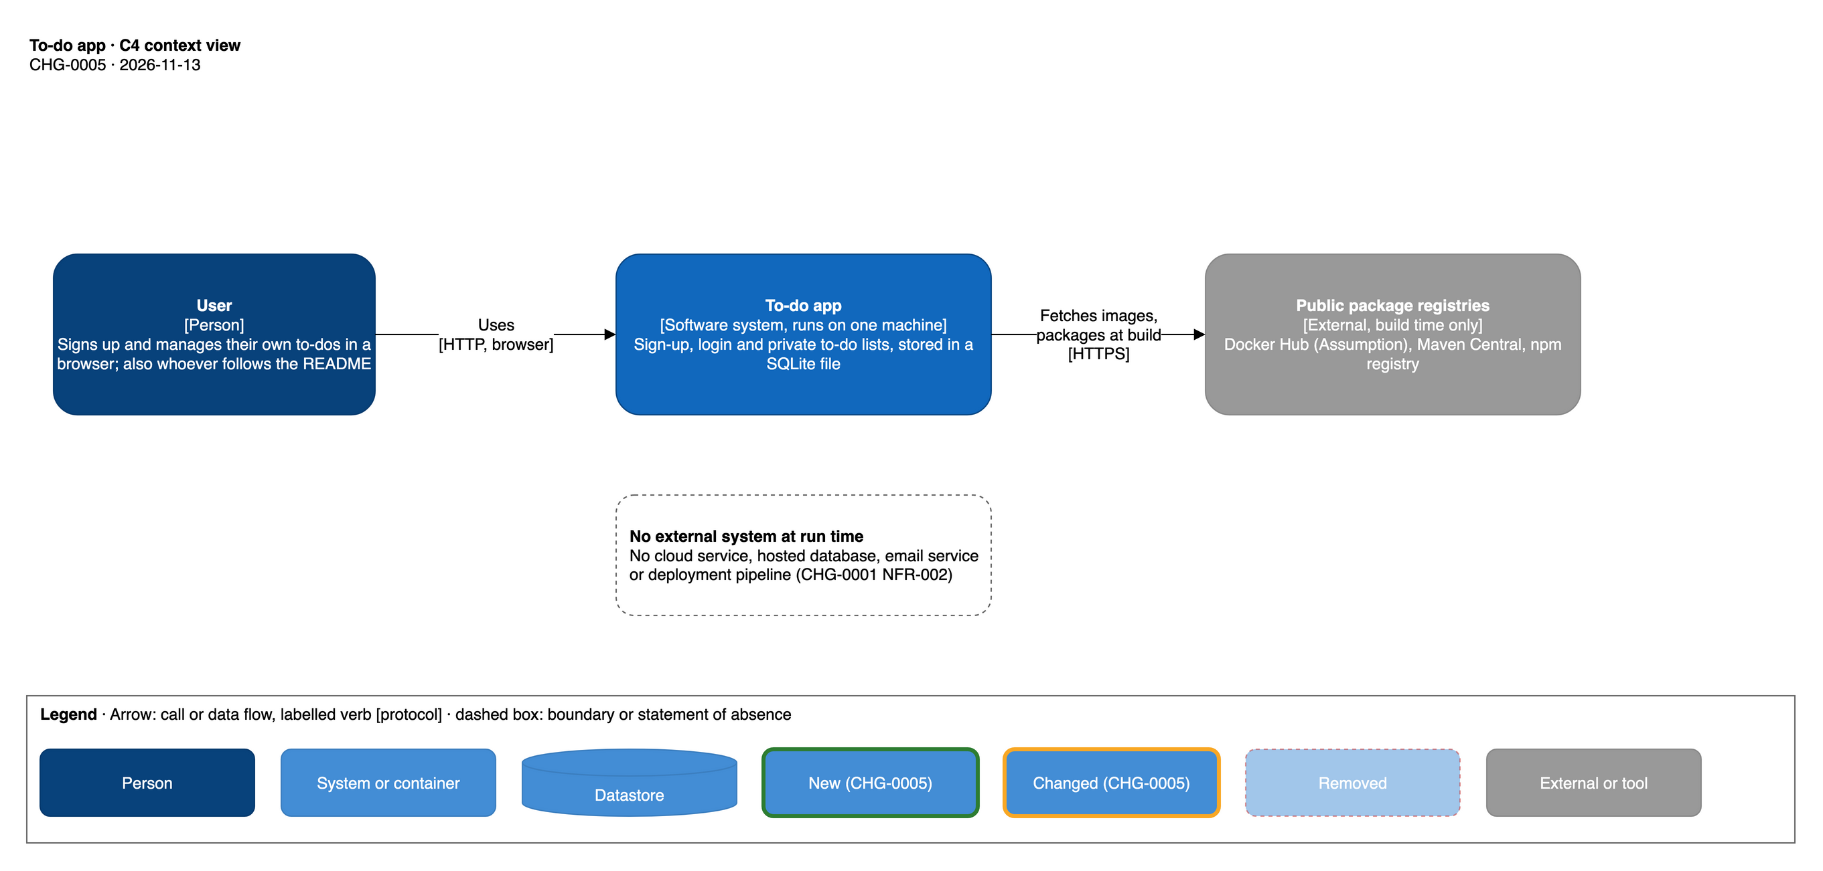
To-do app — C4 context view

2. Quality goals, principles and non-functional requirements
Quality goals, most important first: (1) a person on a fresh checkout can run the app and use it (CHG-0001 NFR-002 AC-1, completed by CHG-0005 REQ-DOC-001); (2) each user sees only their own data (REQ-ISO-001); (3) data survives restarts (REQ-DATA-001, CHG-0005 NFR-105); (4) accessible UI (NFR-001); (5) local-only exposure (NFR-002, CHG-0005 NFR-101).
Principles. The method’s “distributed first” principle is not met by this app on purpose: it is one machine, one API process, one SQLite file (see section 8 for each choice and its ADR). What it keeps from the principle: stateless HTTP handling (the Spring Security chain is stateless, api/src/main/java/app/todo/config/SecurityConfig.java:L52; the session lives in the database), module boundaries enforced by ArchUnit inside the one deployable (ADR-0018), and request-correlated structured logs.
NFR | Requirement | Measured by
CHG-0001 NFR-002 | local run, no cloud | e2e network spec; inspection (docs/specs/CHG-0001/conformance.md:L153-L155)
CHG-0001 NFR-003 | list and write results within 1 s at p95 with 500 to-dos | web/e2e/performance.spec.ts
CHG-0001 NFR-004, NFR-006 | input refused server-side; no internals shown | docs/specs/CHG-0001/sdd.md:L796-L823
CHG-0001 NFR-007 | modular monolith, one process, one pool | ArchUnit, endpoint-inventory test
CHG-0005 NFR-101 | published ports bound to 127.0.0.1 only | docker compose ps / port
CHG-0005 NFR-102 | no secrets in files | inspection
CHG-0005 NFR-103 | containers run as non-root | id -u in each container
CHG-0005 NFR-104 | images build for linux/amd64 and linux/arm64, nothing pushed | README buildx proof command
CHG-0005 NFR-105 | no to-do lost on docker compose down | person’s UAT
CHG-0005 NFR-106 | API healthy within 120 s on a warm machine (proposed) | smoke-check run, compose status times
CHG-0005 NFR-107 | README commands and paths exist | inspection

3. Containers and components
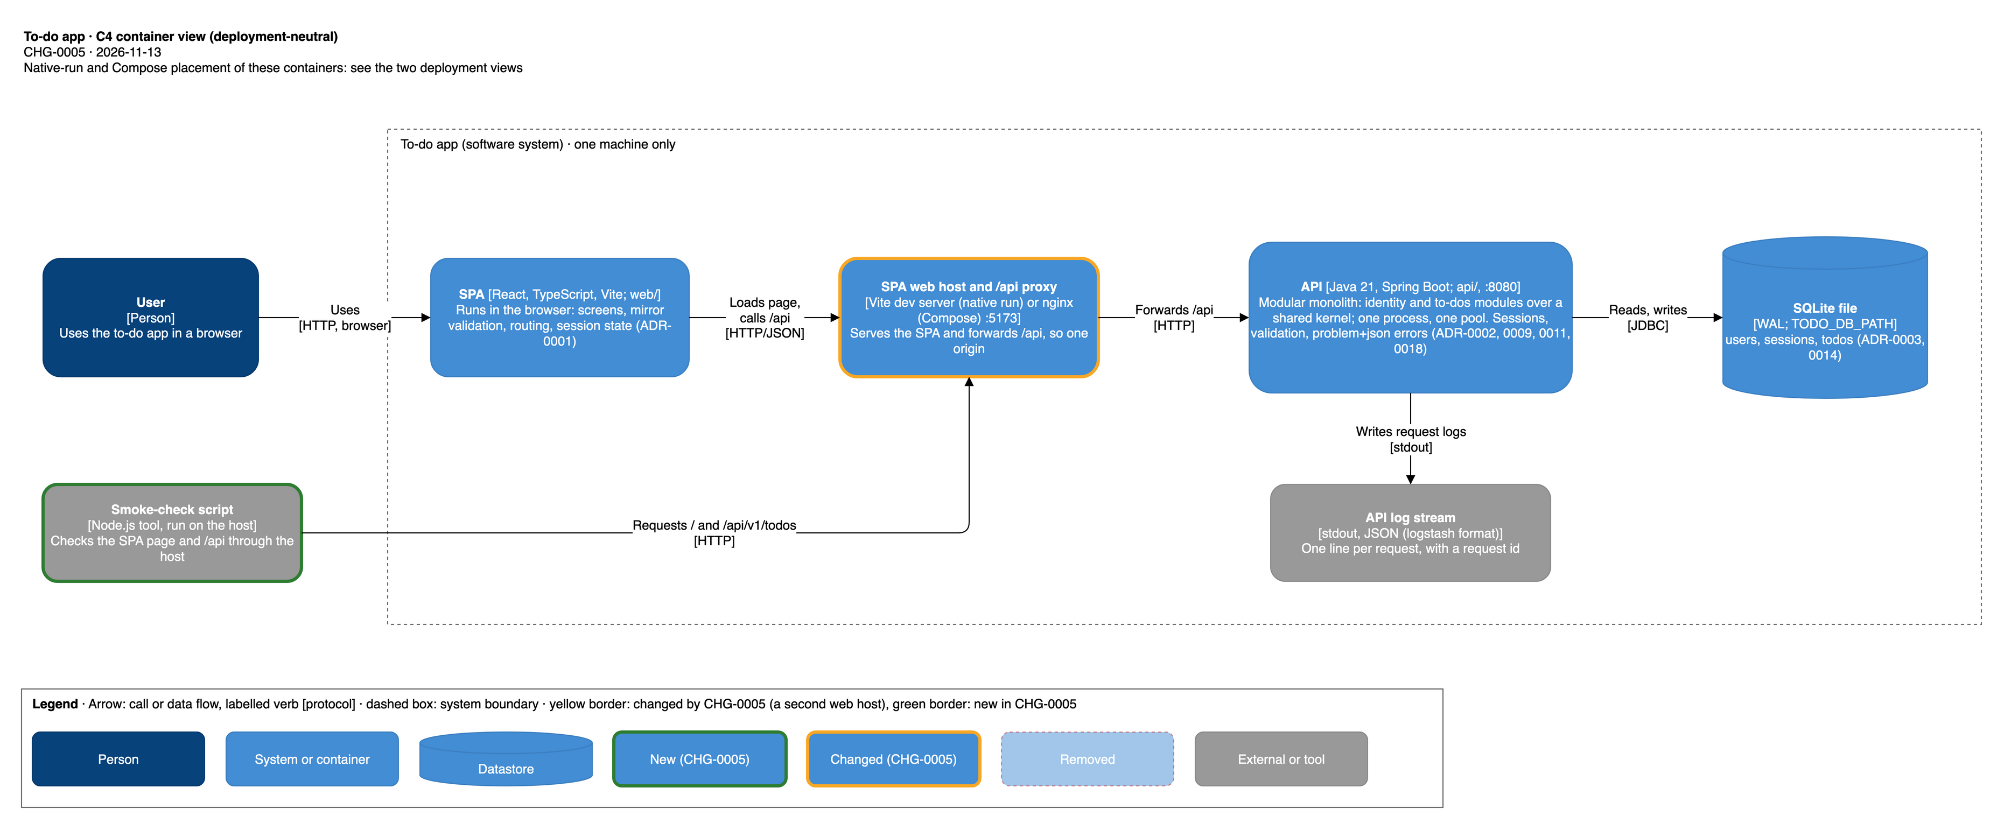
To-do app — C4 container view
Container | Technology | Responsibility | Owns | Calls
SPA | React, TypeScript, Vite; web/ (web/package.json:L21-L25, L42-L44) | screens, mirror validation, routing, session state; the one fetch wrapper web/src/api/client.ts sends X-Todo-Client: web on unsafe methods (ADR-0007) | no data | /api/v1/** on its own origin
SPA web host and /api proxy [changed] | native run: Vite dev server on 5173 proxying /api to http://localhost:8080 (web/vite.config.ts:L5-L10); Compose [new]: nginx serving the production build and proxying /api to the API container | one origin for page and API, so no CORS (ADR-0007) | nothing | API
API | Java 21, Spring Boot 4.1.2 (api/pom.xml:L11-L16, L24), one process, one pool | sign-up, login, sessions, validation (authoritative), to-do operations, problem+json errors, request logging | the SQLite file | SQLite (JDBC)
SQLite file | sqlite-jdbc 3.50.3.0 (api/pom.xml:L52-L57), WAL, one connection (api/src/main/java/app/todo/config/DatabaseConfig.java:L22-L39) | users, sessions, todos, flyway_schema_history | one owner: the API | —
API log stream | JSON (logstash format) to stdout (api/src/main/resources/application.properties:L12) | one line per request with request id; never bodies, cookies, hashes (docs/specs/CHG-0001/sdd.md:L573-L577) | — | —
Web host log stream [new] | Compose only: nginx access and error logs to stdout | host request log; must not record query strings (section 7.1, section 9) | — | —
Smoke-check script [new] | Node.js tool run on the host, outside the app’s boundary (its path is the SDD’s) | checks the SPA page and an unauthenticated /api call through the host | no data | web host
Components. The API is a modular monolith: identity module app.todo.auth, to-dos module app.todo.todo, shared kernel app.todo.common, composition root app.todo.config (docs/specs/CHG-0001/sdd.md:L43-L73; ADR-0018). Its component views are docs/specs/CHG-0001/design/architecture/c4-component-api.drawio and c4-component-errors.drawio. CHG-0005 changes none of them (it changes no code in api/, docs/specs/CHG-0005/requirements.md:L311). The SPA’s modules are listed in docs/specs/CHG-0001/sdd.md:L98-L105.

4. Integrations, contracts and key flows
No external integration exists. Internal interfaces, all synchronous:
Interface | Protocol | Contract | On failure
browser to web host to API | HTTP/JSON on one origin, /api/v1/** | docs/specs/CHG-0001/contracts/identity-api-v1.yaml, todo-api-v1.yaml, common-problem-v1.yaml | every error is application/problem+json (docs/specs/CHG-0001/sdd.md:L285-L303); the SPA maps failures to friendly messages (sdd §6.1)
API to SQLite | JDBC, one pooled connection | V1__init.sql (api/src/main/resources/db/migration/V1__init.sql) | unexpected errors give a generic 500 and a logged stack trace
smoke-check [new] to web host | HTTP, unauthenticated GET of / and /api/v1/todos | 401 problem+json is the contract answer (docs/specs/CHG-0001/contracts/common-problem-v1.yaml, as cited at docs/specs/CHG-0005/requirements.md:L226-L228) | exits non-zero and says which request failed
compose healthcheck [new] to API | HTTP probe inside the API container on an existing endpoint; 401 counts as up | none (no new endpoint) | container reported unhealthy; web container waits
Key flows (sequence views already exist: seq-signup-login.drawio, seq-todo-crud-list.drawio, seq-clear-completed.drawio in the CHG-0001 design folder).
- Login. The SPA posts credentials with X-Todo-Client: web; the API verifies the Argon2id hash, inserts a sessions row holding the SHA-256 of a random token and sets cookie todo_session (HttpOnly, SameSite=Strict, Path=/, Max-Age 8 h, Secure only when TODO_COOKIE_SECURE=true) (api/src/main/java/app/todo/auth/AuthController.java:L40-L47, L61-L69; api/src/main/java/app/todo/auth/SessionService.java:L23, L35-L43).
- Authenticated request. SessionCookieAuthenticationFilter resolves the cookie to a CurrentUser; the to-dos module takes the owner only from it. Order of checks: session (401), client header (403), route, content type, body, validation, ownership (docs/specs/CHG-0001/sdd.md:L174-L176; api/src/main/java/app/todo/config/SecurityConfig.java:L54-L60; api/src/main/java/app/todo/common/ClientHeaderFilter.java:L31-L41).
- Compose start-up [new]. Compose builds both images; the API starts, creates the database file on the volume and runs its Flyway migration (ADR-0014); the healthcheck reports healthy; only then the web container starts and publishes 5173.
- Smoke check [new]. The script requests the SPA page (expects 200 HTML) and GET /api/v1/todos without a cookie through the proxy (expects 401 problem+json); a 200 HTML answer on /api fails it (docs/specs/CHG-0005/requirements.md:L224-L231).

5. Data and storage
One store: the SQLite file at TODO_DB_PATH (default ./data/todo.db, api/src/main/java/app/todo/config/DatabaseConfig.java:L23), owned by the API alone. Tables: users and sessions (identity module), todos (to-dos module), flyway_schema_history (composition root); schema in docs/specs/CHG-0001/sdd.md:L107-L149, view docs/specs/CHG-0001/design/architecture/data-model.drawio.
- Consistency. One pooled connection serialises access; WAL journal, foreign keys on, 5 s busy timeout (DatabaseConfig.java:L33-L37; ADR-0016). Last write wins on edits (ADR-0006).
- Personal data. Identifiers (user names or email addresses) and to-do text; passwords are stored only as Argon2id hashes, session tokens only as SHA-256 (ADR-0005, ADR-0004).
- Native run. The file is api/data/todo.db when the API is started from api/; api/data/ is git-ignored (api/.gitignore:L1-L2). To wipe it, delete the file.
- Compose [new]. The file lives on a named volume declared in docker-compose.yml, so it survives docker compose down and is removed by docker compose down -v.
- Retention and backup. Sessions are absolute 8 h (ADR-0008); expired rows are deleted when met (SessionService.java:L52-L55). No automatic backup or restore; a person may copy the file (native) or the volume (Assumption: copying a volume is outside this change).

6. Deployment and infrastructure
Environments: CHG-0001 NFR-002 AC-2 allows no dev or test deployment; the only environment is the person’s own machine, in one of two modes. A change moves to no other environment. No network zones beyond the machine: no ingress from other hosts, no egress needed at run time. Build time is a trust boundary: image builds and the native tool chain fetch base images and dependencies from public registries (see section 1; drawn in the context view).

6.1 Native run (as built by CHG-0001; documentation added by CHG-0005)
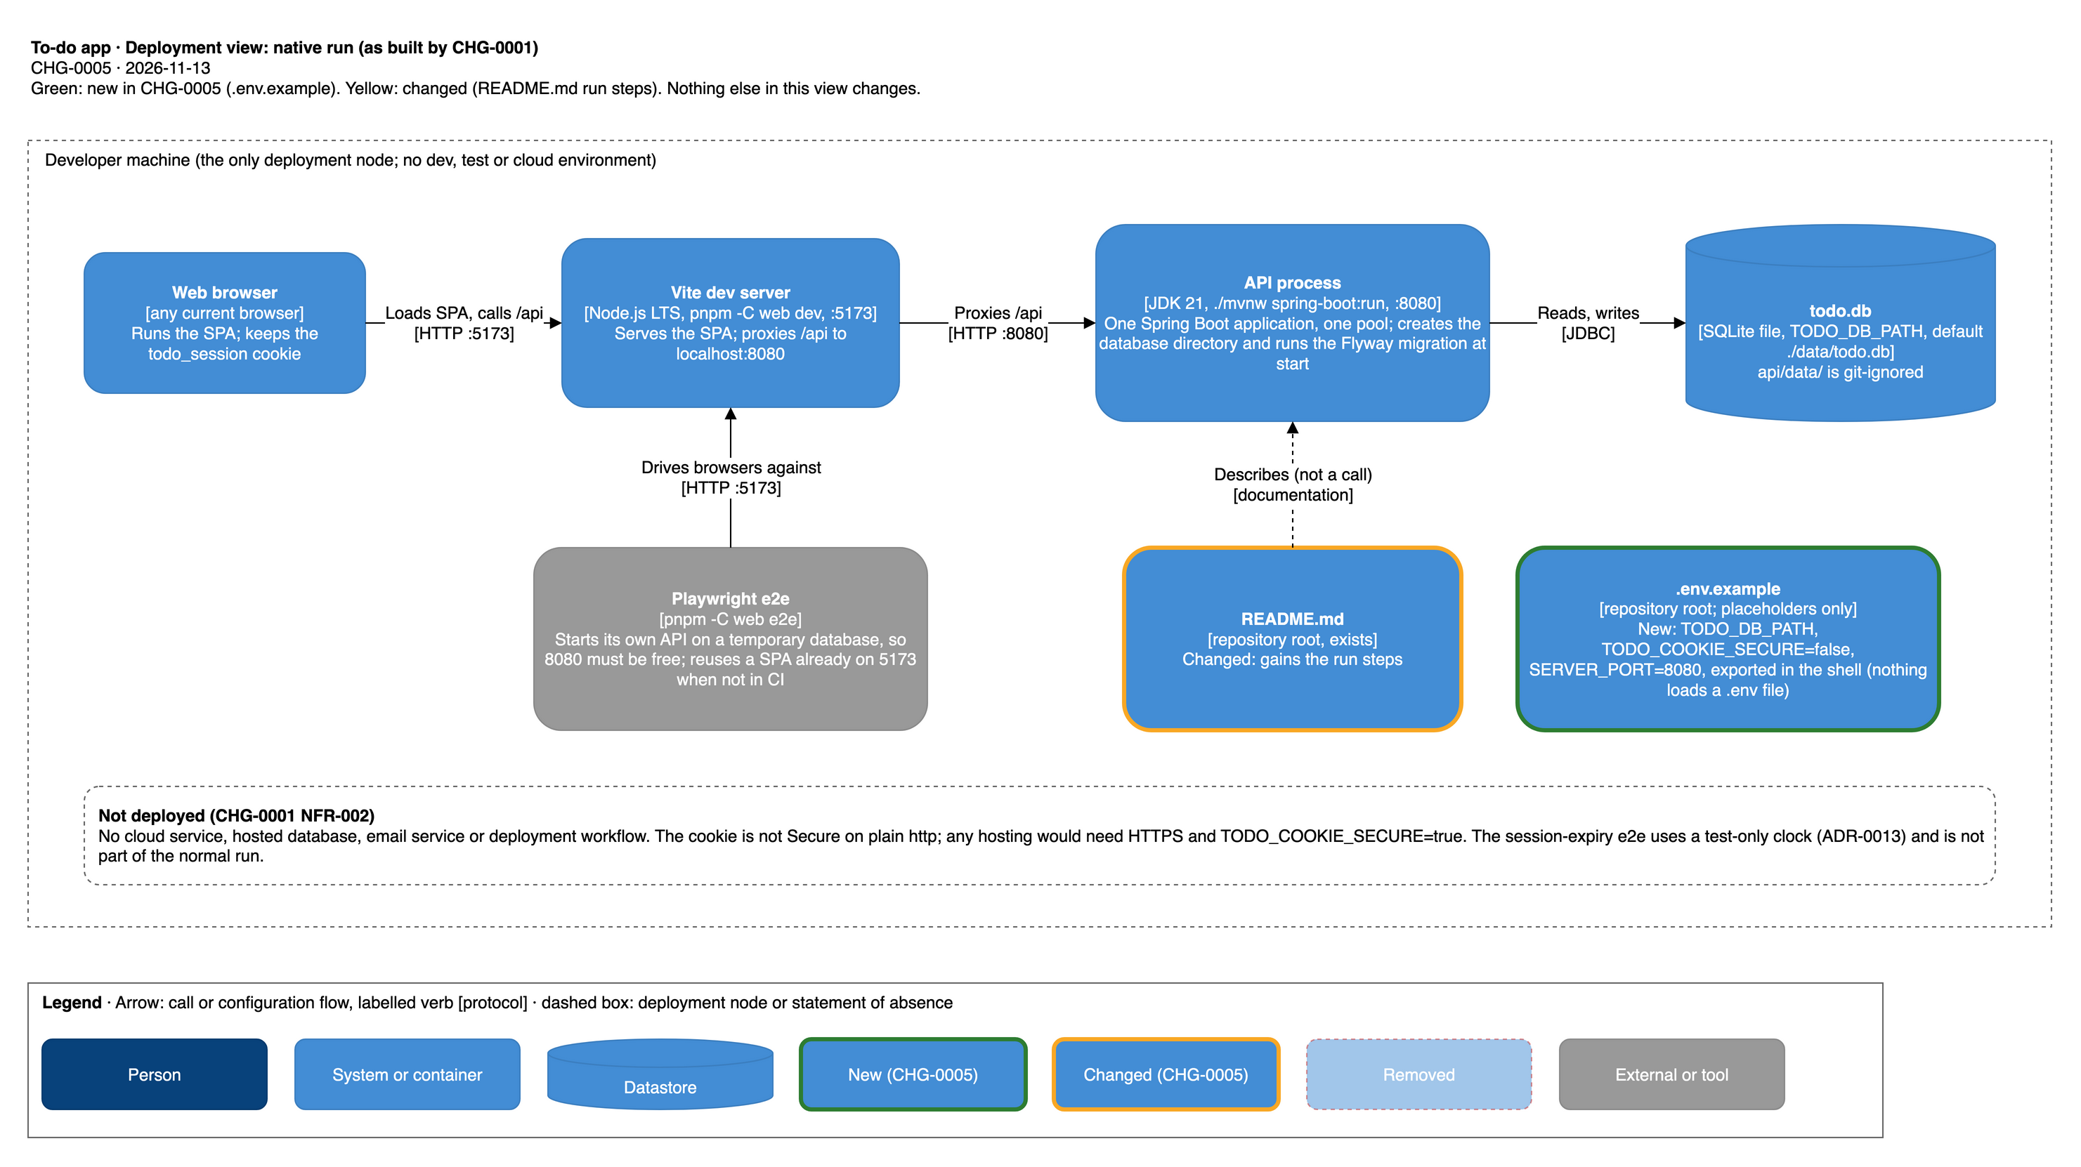
To-do app — deployment view, native run
API: cd api && ./mvnw spring-boot:run, port 8080; SPA: pnpm -C web install then pnpm -C web dev, port 5173 (docs/specs/CHG-0001/sdd.md:L603-L611; web/vite.config.ts:L5-L10). Prerequisites: JDK 21, Node.js LTS (web/.nvmrc:L1 is lts/*), pnpm. Settings are TODO_DB_PATH, TODO_COOKIE_SECURE, SERVER_PORT (api/src/main/resources/application.properties:L3-L6); nothing loads a .env file, the person exports them in the shell (docs/specs/CHG-0005/requirements.md:L77-L78). [changed] README.md gains the run steps (it exists today as a title only: README.md:L1; docs/specs/CHG-0001/conformance.md:L153-L154); [new] .env.example. The Playwright e2e (pnpm -C web e2e) starts its own API on a temporary database and checks that port 8080 is free (web/e2e/support/api-process.ts:L33; web/e2e/support/launch.ts:L7-L8, L33-L42); it starts the SPA on 5173 unless one already runs there, which it reuses outside CI (web/playwright.config.ts:L35-L42).

6.2 Docker Compose stack (target of CHG-0005, [new], not yet built)
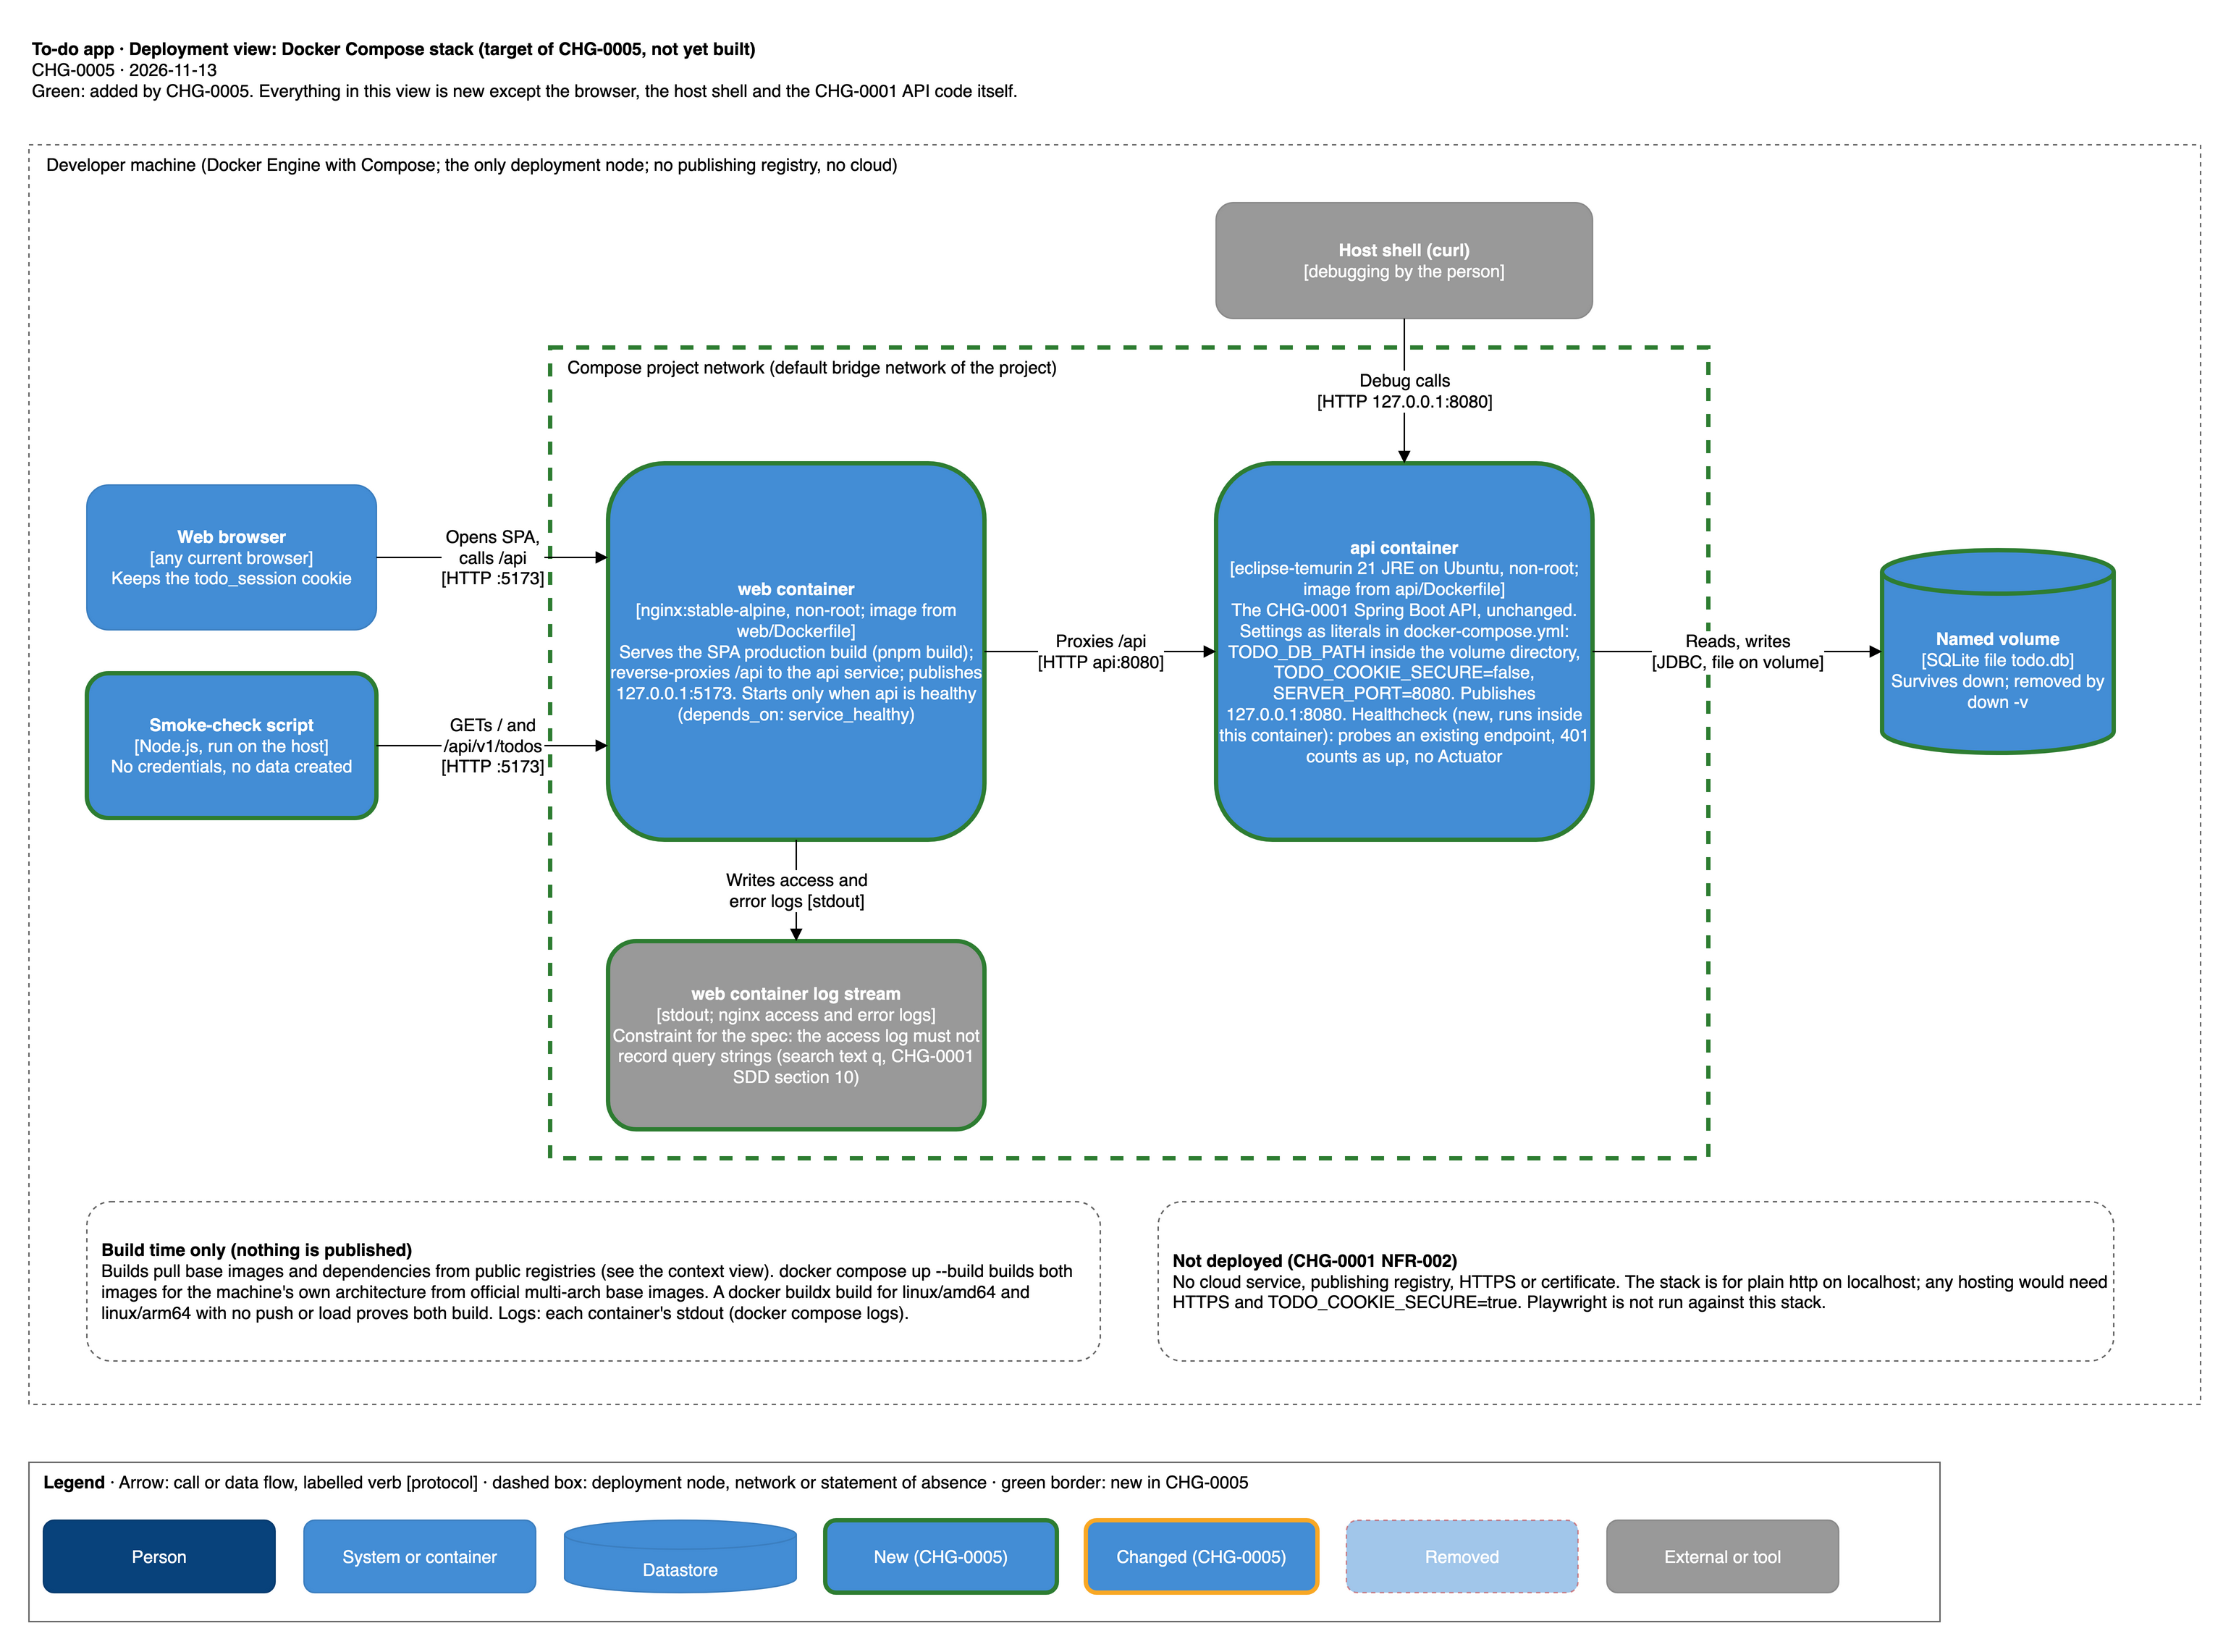
To-do app — deployment view, Docker Compose stack
- web container [new]: nginx:stable-alpine, non-root, image from web/Dockerfile (multi-stage: Node LTS and pnpm through corepack build the SPA with pnpm build). Serves the build and reverse-proxies /api to the api service, so the browser sees one origin and the todo_session cookie and X-Todo-Client header pass as in the native run. Client routes (for example the to-do list and login screens, docs/specs/CHG-0001/adr/0001-react-typescript-spa.md:L16-L20) must work on reload and direct entry, as they do under the Vite dev server, so every non-/api path that is not a file must answer index.html and /api must never do so (REQ-CMP-003 AC-3, REQ-CMP-002 AC-2; the nginx configuration is the spec author’s, section 9). Writes access and error logs to stdout, which must not record query strings (section 7.1). Publishes 127.0.0.1:5173. Starts after the API is healthy.
- api container [new]: image from api/Dockerfile (multi-stage: eclipse-temurin JDK 21 builds with ./mvnw; eclipse-temurin JRE 21 on the Ubuntu variant runs it, not Alpine, because the SQLite driver ships native code), non-root. Publishes 127.0.0.1:8080 (for debugging). Settings as literal values in docker-compose.yml: TODO_DB_PATH inside the volume’s directory, TODO_COOKIE_SECURE=false, SERVER_PORT=8080.
- named volume [new] holding the SQLite file; compose project network [new] between the two containers; healthcheck [new] on an existing endpoint (401 = up), no Actuator, no API change.
- Builds. docker compose up --build (or docker compose build) builds for the machine’s own architecture from official multi-architecture base images, pulled with dependencies from public registries; a documented docker buildx build --platform linux/amd64,linux/arm64 with no push or load proves both build. No publishing registry and no credentials.
- Scaling. None: one replica of each container.
- Cost drivers. None beyond the person’s machine: no cloud resources, no publishing registry.

7. Well-Architected
This is a one-machine, one-user-at-a-time app, so each pillar is treated at that scale. No cloud services are used.

7.1 Operational excellence
- Observability. The API writes one structured JSON log line per request (request id, method, route template, status, duration, internal user id) and logs unexpected exceptions with a stack trace and the request id; bodies, identifiers, passwords, cookies, titles and search text are never logged by the API; no metrics or tracing (docs/specs/CHG-0001/sdd.md:L571-L601). Native run: the console of the API process. Compose [new]: each container’s stdout through docker compose logs, including nginx access and error logs from the web container. [new] Design constraint for the spec author: that rule is CHG-0001’s for the whole app (docs/specs/CHG-0001/sdd.md:L575-L576), and the SPA keeps the search text q in the URL query string (docs/specs/CHG-0001/adr/0001-react-typescript-spa.md:L19-L20), so a default nginx access log, which records the request line with its query string, would write search text into docker compose logs. The Compose web host must not log query strings (for example access_log off, or a log format without $request, $args and $query_string); the spec author decides the form (section 9). Request ids are not returned to the client, so a line is matched by time.
- Deployment and rollback. No deployment pipeline. Native: restart the process. Compose: after a code change the images must be rebuilt (docker compose up --build or docker compose build), because Compose reuses an existing image otherwise; the exact README command is the SDD’s. docker compose down stops without losing data; down -v wipes it (the README warns it deletes the person’s own to-dos).
- Runbooks. The README troubleshooting (port in use, Docker not running). Smoke check and the person’s UAT are the checks of the Compose stack.

7.2 Security
- Identity and access. Server-side session in an opaque HttpOnly cookie, stateless Spring Security chain (ADR-0004; SecurityConfig.java:L47-L60), Argon2id passwords (ADR-0005; api/pom.xml:L58-L63), no login throttling (accepted, docs/specs/CHG-0001/sdd.md:L762).
- Trust boundaries. The browser is untrusted; the API validates everything. The only boundary exposed to the host network is 127.0.0.1:5173 and, for debugging, 127.0.0.1:8080 in Compose. Binding to loopback keeps the app off the local network (CHG-0005 NFR-101). The API-to-web-host hop in Compose stays inside the project network.
- Cross-site defence. No CORS; every POST, PUT, PATCH and DELETE under /api/ needs X-Todo-Client: web (ClientHeaderFilter.java:L22, L31-L33, L38; ADR-0007). Same origin is why the nginx proxy must pass this header and the cookie unchanged (Assumption: nginx’s default proxying passes both; the SDD verifies).
- Secrets. None: .env.example and docker-compose.yml hold placeholders or non-secret defaults (CHG-0005 NFR-102). .env is to be git-ignored (REQ-DOC-002 AC-4).
- Data protection. Hashes only for passwords and tokens. The cookie is not Secure over plain http on localhost (TODO_COOKIE_SECURE=false, AuthController.java:L29, L64); any hosting would need HTTPS and true (docs/specs/CHG-0001/sdd.md:L761; CHG-0005 REQ-CMP-006).
- Containers [new]. Non-root users, official base images with explicit non-latest tags (CHG-0005 REQ-CMP-001, NFR-103). Digest pinning is out of scope (requirements.md:L314). Build-time fetches from public registries are a supply-chain trust boundary; versions come from api/pom.xml and the web/ lockfile (Assumption: a lockfile is committed; the SDD verifies).
- Test-only clock. Exists only in the test source set and the e2e profile; it is not part of either run (ADR-0013; docs/specs/CHG-0001/sdd.md:L613-L620).

7.3 Reliability
One API process and one connection: a crash stops the app until restart; sessions and data survive a restart because both are in SQLite (ADR-0004; ADR-0016). No retries between components. [new] Compose healthcheck and start order make docker compose up report ready only when the API answers; a web container that cannot reach the API returns a proxy error (502 or 504), which the smoke check reports. Recovery objectives: none stated; restart is the recovery. No redundancy (section 8).

7.4 Performance efficiency
Load is one local user with up to 500 to-dos; p95 at most 1 s per action (CHG-0001 NFR-003, ADR-0015, ADR-0016 risk row docs/specs/CHG-0001/sdd.md:L765). No caching. Scaling out is not a goal. [new] nginx serves a static production build, lighter than the Vite dev server; the API still serialises all database access. Risks: first image builds (Maven and pnpm downloads) and the multi-arch proof under emulation are slow on a person’s machine, and image size grows with the JDK build stage; the 120 s warm-machine target (NFR-106) bounds only start-up. Met by multi-stage builds, so the run images carry only the JRE and nginx, and by the warm-machine scope of the target.

7.5 Cost optimisation
No running cost: no cloud, no publishing registry. Costs are build time and disk for images and the volume. Risk: disk use from build layers and old images accumulates on the person’s machine; none at any other scale. Met by the README’s cleanup note (down -v, image removal), which the SDD words.

7.6 Sustainability
No idle cloud capacity. Data is kept only on the person’s machine and is deletable by one command (native: delete the file; Compose: docker compose down -v). Sessions expire at 8 h. Risk: the volume and images keep using disk and the emulated multi-arch build uses CPU until the person removes them; negligible at one local user, so no further measure.

8. Decisions
Status lines of the CHG-0001 ADRs read “proposed (CHG-0001, N03-spec)”; the CHG-0001 spec was frozen and built. There is no docs/adr/ yet.
Decision | ADR | Status
React + TypeScript SPA, Vite, same origin through a proxy | docs/specs/CHG-0001/adr/0001-react-typescript-spa.md | proposed (frozen with CHG-0001)
Spring Boot REST API on Java 21, servlet stack, API serves no static files | .../0002-spring-boot-rest-api.md | proposed (frozen)
SQLite file through sqlite-jdbc | .../0003-sqlite-persistence.md | proposed (frozen)
Server-side sessions in the database, opaque HttpOnly cookie, stateless chain | .../0004-server-side-session-cookie.md | proposed (frozen)
Argon2id; client header instead of CORS; 8 h absolute session | .../0005-..., 0007-client-header-cross-site-request-defence.md, 0008-absolute-session-lifetime.md | proposed (frozen)
Whole-content update, last write wins; JDBC without JPA; validators; problem+json; contract tests | .../0006, 0009, 0010, 0011, 0012 | proposed (frozen)
Injected clock and test-only e2e clock; Flyway; derived lower-case columns; one connection; UTC text timestamps | .../0013, 0014, 0015, 0016, 0017 | proposed (frozen)
Modular monolith with ArchUnit-enforced boundaries | .../0018-modular-monolith-module-boundaries.md | proposed (frozen)
Non-distributed choices, and whether an existing ADR already covers them:
Choice | Covered by | Marking
One deployable (modular monolith), one process | ADR-0018 (decided for the app: one deployable, one process and one SQLite file, adr/0018-modular-monolith-module-boundaries.md:L9-L11) | covered
One shared SQLite file for all modules, todos.user_id foreign key into users | ADR-0003, ADR-0018, ADR-0014 | covered
One connection serialising all access | ADR-0016 | covered
Session state in the same single SQLite file, not in a separate session store (note: sessions are database rows, not in-process memory) | ADR-0004, ADR-0008 | covered (sessions are rows in the one SQLite file in either run); the Compose volume part is the ADR needed on the next row
Single API replica writing one SQLite file on one named volume in Compose (never more than one writer; no bind mount of the checkout) | none: ADR-0003, ADR-0016 name the file and the pool, not a container or volume | ADR needed: single API container with SQLite on a named volume (single writer, no scale-out) — why: one local user, cost, no shared database server
Same-origin delivery through an nginx reverse proxy serving the production build, instead of the Vite proxy | ADR-0001 decides same origin through the Vite dev proxy only | ADR needed: nginx serves the SPA build and proxies /api in Compose — why: keeps the same-origin and cookie design (ADR-0001, ADR-0004, ADR-0007), no CORS, no API change (Q1)
Compose healthcheck on an existing endpoint (401 = up), no Actuator | none | not a non-distributed choice: fixed by requirement (REQ-CMP-005), no ADR required
Container images: official multi-arch bases, Ubuntu JRE not Alpine, non-root, built locally, buildx proof, no publishing registry | none | not a non-distributed choice: fixed by requirements (REQ-CMP-001, REQ-CMP-007), no ADR required
No cloud, no HA, no horizontal scale | CHG-0001 NFR-002 and docs/specs/CHG-0001/sdd.md:L41; not an ADR | requirement, not a design choice
The spec author writes any ADR above in docs/specs/CHG-0005/adr/.

9. Risks and open questions
Risk or question | Impact | Who decides | Status
Can nginx:stable-alpine run non-root and bind its listen port, write its pid file and cache directories? The listen port inside the container is not set here | NFR-103 and REQ-CMP-003 | spec author | open
Does eclipse-temurin JRE 21 (Ubuntu) ship a tool the healthcheck can use (for example curl or wget)? The probe tool and the endpoint (an existing unauthenticated-401 path) are not set here | REQ-CMP-005 | spec author | open
The database path inside the container, the volume’s mount path, and making the volume writable by the non-root API user | REQ-CMP-004 AC-3 | spec author | open
The smoke-check script’s exact path, base-URL override name and command | REQ-SMK-001 | spec author (P3) | open
nginx must pass Cookie, Set-Cookie and X-Todo-Client through /api unchanged and not rewrite /api paths; the API has no /api prefix removal (SecurityConfig.java:L56) | one origin, login works | spec author | Assumption
The API binds all interfaces by default inside the container (no server.address is set: application.properties:L1-L14) so the web container can reach it | Compose | spec author | Assumption
One connection, one writer: a second API replica or a bind-mounted file on another filesystem could corrupt or lock SQLite | data integrity | covered by the ADR needed in section 8 | open
Session cookie not Secure on plain http; no login throttling; sign-up discloses that an identifier exists | security if ever exposed beyond localhost | accepted (docs/specs/CHG-0001/sdd.md:L761-L763) | accepted
[new] The Compose web host’s nginx access log, by default, records the request line with its query string, so search text q (kept in the URL, docs/specs/CHG-0001/adr/0001-react-typescript-spa.md:L19-L20) would reach docker compose logs, against docs/specs/CHG-0001/sdd.md:L575-L576 (search text never logged) | privacy; CHG-0001 observability rule | spec author: the nginx configuration must not log query strings (no access log, or a format without $request, $args, $query_string) | open (constraint)
[new] SPA history fallback in nginx: non-/api paths that are not files must answer index.html; /api must never do so | REQ-CMP-003 AC-3, REQ-CMP-002 AC-2, smoke check (a 200 HTML answer on /api fails it) | spec author | open (constraint)
Warm-machine 120 s target (proposed, requirements P1) | NFR-106 | requester at freeze (P1) | open
Who runs the smoke check where Docker is absent: settled by REQ-SMK-001 AC-6 (P5 covers only the record form) | REQ-SMK-001 AC-6 | settled in the requirements | closed
Multi-arch proof needs a buildx builder and emulation on the person’s machine | NFR-104 | documented in the README | accepted

10. Improvement opportunities
None yet: this is the first version.

11. Changes

CHG-0005 — Local run docs and Docker Compose for the to-do app
- Added: this document, the first solution architecture, with four views (docs/architecture/drawio/: todo-context, todo-containers, todo-deployment-native, todo-deployment-compose) covering the app as CHG-0001 built it, because the repository had no docs/architecture/ (requester decision D4, Q10 (a)).
- Added [new]: the Compose stack (web container and its nginx log stream, api container, project network, named volume, healthcheck, both published loopback ports), the smoke-check script and .env.example, because the request asks for one-command local runs and CHG-0001 NFR-002 AC-1 was deferred (docs/specs/CHG-0005/requirements.md:L14-L26).
- Changed [changed]: README.md (exists, gains the run steps), because the same requirement asks for documented runs.
- Changed [changed]: the SPA web host and /api proxy is now either the Vite dev server (native run) or nginx (Compose), because the dev proxy target is localhost:8080 and does not reach another container (web/vite.config.ts:L9). The native run itself is unchanged.
- Removed: nothing.
- ADRs the spec needs (section 8): single API container with SQLite on a named volume; nginx same-origin delivery of the production build. The healthcheck and image choices are requirement-fixed and need no ADR.
- Constraints for the spec author (section 9): the Compose web host must not log query strings; nginx falls back to index.html for client routes.

