Kathmandu Emergency Bed and Ambulance Finder System

Alok Padal
Westcliff University
PRG 100: System Analysis & Design
Professor Vaidhya
July 4, 2026

Kathmandu Emergency Bed and Ambulance Finder System
Kathmandu Emergency Hospital Bed and Ambulance Finder System is an online application designed for the citizens to find them hospitals with available beds, ICU facilities and ambulances for emergency situations. During emergencies, people waste their precious time calling several hospitals to ask if they have services are available or not. The idea behind this system is to bring that delay down to zero and to know the real time info of hospitals through a single platform. Medical staff will update the availability of beds, the number of beds in ICUs, hospital ambulances, etc., and users will make quick and better decisions in emergencies.
Requirements gathering is one of the most important stages in the development of the system as it is used to determine what needs are expected to met in the system prior to development. The clear requirements gathering will help in no-misunderstandings, ensure effective communication and increase the chances of developing a successful system (Chitchyan & Bird, 2022).
Stakeholders
The main stakeholders that will be involved in this project are:
- Citizens (patients and their family members)
- Hospital staff
- Hospital management
- System administrator
- Health authority (Future enhancement)
All the stakeholders have their own responsibilities and expectations and their involvement is needed throughout the development process.
Requirements
I have divided requirements into three parts: Functional, Non-Functional and Data
Functional Requirements
The system will have these functions:
Citizen Module
- Securely register and log in
- Use a location search to find hospitals
- View bed availability
- Check ICU availability
- View ambulance availability
- Call ambulance directly online
- Track ambulance requests
- Control personal information of their profile
Hospital Staff Module
- Secure login
- Update bed availability
- Update ICU availability
- Update ambulance availability
- Check incoming Ambulance requests
- Accept or reject the requests for an ambulance
- Update request status
Administrator Module
- Secure login
- Add, edit and remove hospitals
- Coordinate hospital staff accounts
- Manage citizen accounts
- Check for update in hospital resources
- Create reports and system stats
Non-Functional Requirements
The application also needs to meet several quality requirements along with system functions.
Performance
Returning the hospital search results should be done very quickly so that user will receive the necessary information in emergency cases without wasting any time.
Reliability
Resource information in hospital should be correct and up-to-date to provide reliable information to their users.
Security
Secure user authentication and encrypted passwords should be used for user accounts. Hospital information should only be updated by hospital authorizations and authorities.
Availability
It needs to be accessible all the times as medical emergencies can happen anytime.
Usability
The website must be simple, responsive and user-friendly and accessible to all the people so that people with less technical knowledge can also run.
Maintainability
The system should be designed in a modular way by allowing for the future updates, maintenance and feature enhancements.
Well-defined software requirements have been proved to be significant in software quality and lower risks in software development (Medeiros et al., 2018).
Data Requirements
The information that should be kept in the database:
- User accounts
- Hospital information
- Bed availability
ICU availability
- Ambulance status
- Ambulance requests
- Hospital staff records
- System activity logs
Assumptions
- The project is based on these assumptions:
Hospitals will keep updating availability of beds, ICUs bed and ambulances on a regular basis
- Users have access to an internet connection
- Only hospital staffs are allowed to update hospital info
- Data input into the system will be correct and trustworthy
Constraints
- Manual updating of resources for hospital staff.
- The system requires internet connection to be used
- The initial version of the system will only be applicable in hospitals in Kathmandu Valley
- A project will be done under one academic session
Feasibility Study
A feasibility study determines that if a proposed system is feasible (can be built and out into use) with the available resources, time ana budget. The feasibility study helps to recognize potential threats and determine project feasibility from technical operations, economic, legal and scheduling considerations (Kassab et al., 2020).
Technical Feasibility
The proposed system is technically feasible as it will be developed using widely used technologies which are suitable for web application development.
Development Tools
- HTML5
- CSS3
- Bootstrap 5
- JavaScript
- Python
- Django REST Framework
- Django Channels
- Daphne
- SQLite
- MySQL (optional here)
- Visual Studio Code
GitHub
Django offers pre-installed authentication, database integration and security capabilities that make it a suitable framework for this project.
Economic Feasibility
It is also economic feasibility because all the tools that will be used are free and open-source software.
Tools | Estimated Cost
HTML, CSS and JS | Free
Bootstrap | Free
Python | Free
Django | Free
SQLite | Free
VS Code | Free
GitHub | Free
Daphne | Free
Domain and Hosting (Future) | Low Cost

Operational Feasibility
The proposed system is feasible for daily use. Users can use a simple web interface to look up hospitals and requests ambulances. Hospital staff can update availability of bed, ICU, and ambulances, users and system report through a centralized dashboard. This will help the communication between hospitals and pubic as well as minimize delays during emergencies.
Schedule Feasibility
The project will take place in one session of our course. The development time is estimates to take approximately 7 weeks for the requirements analysis, system design, implementation, testing, documentation and presentation.
Legal Feasibility
The system will ensure privacy and security protocols, safeguarding user info and limiting access to authorized users only. Personal information will not be open and public for any other use and only hospital staff and admin are allowed to change hospital resource information.
Gantt Chart
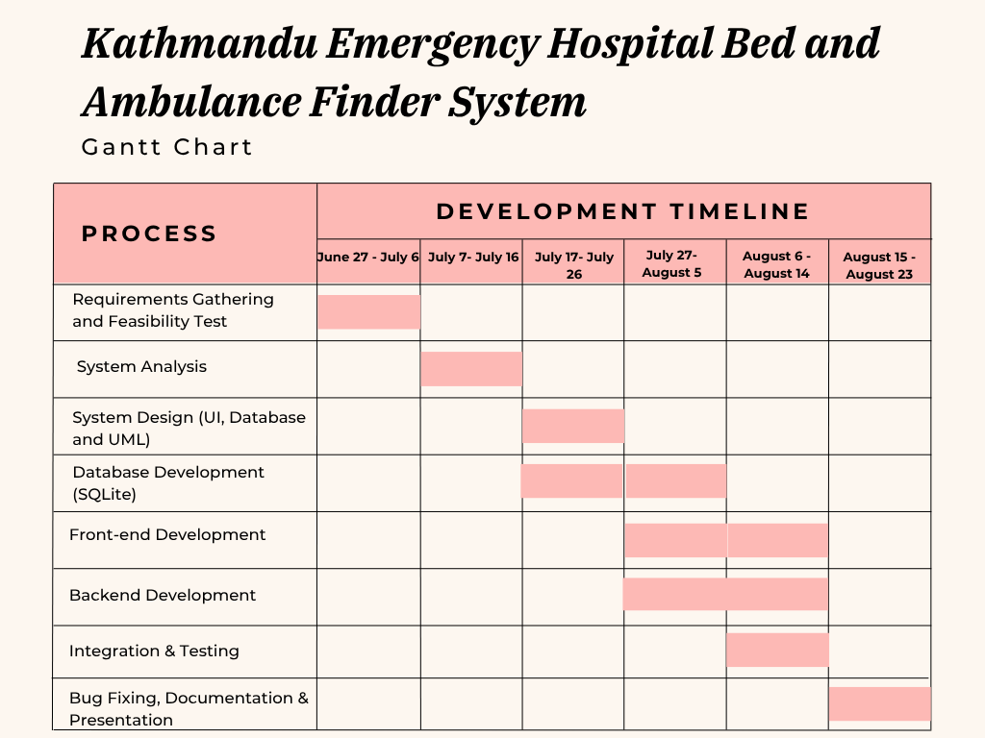
UML Diagram
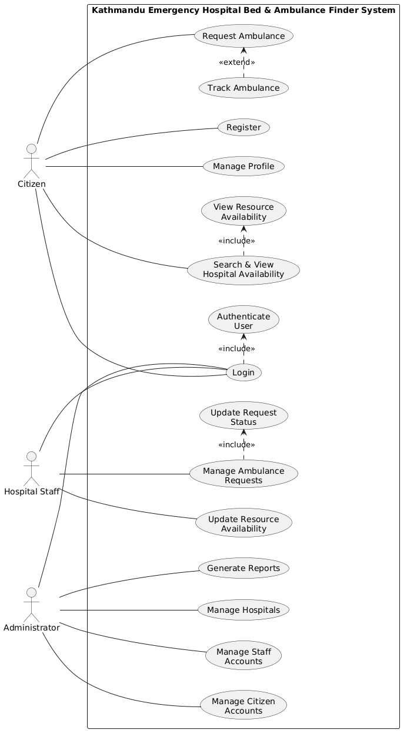
Conclusion
The Kathmandu Emergency Hospital Bed and Ambulance Finder System is technically, economically, operationally, legally and schedule feasible on the basis of feasibility analysis. The proposed system solves a real-life healthcare problem that is feasible for the time, budget and technical resources available.

References
Chitchyan, R., & Bird, C. M. (2022). Theory as a source of software and system requirements. Requirements Engineering, 27(3), 375–398. https://doi.org/10.1007/s00766-022-00380-w
Kassab, M., Neill, C., & Laplante, P. A. (2020). State of practice in requirements engineering: Contemporary data. Innovations in Systems and Software Engineering, 16(1), 29–40. https://doi.org/10.1007/s11334-019-00349-1
Medeiros, J., Vasconcelos, A., Silva, C., & Goulão, M. (2018). Quality of software requirements specification in agile projects: A cross-case analysis of six companies. Journal of Systems and Software, 142, 171–194. https://doi.org/10.1016/j.jss.2018.04.064

