Networking concepts
- FTP – Active mode, passive mode, TFTP
- Wake-on-LAN
- Loopback Address
- DMZ
- NAT and NAPT – static NAT, dynamic NAT, overlapping NAT, overloading NAT, DNAT
- MAC cloning
- ARP, ARP table (or) caching – static ARP, dynamic ARP, Gratuitous ARP
- How ping works
- Public IP, Private IP and Global IP
- Hop count, time-to-live, packet types (unicast, multicast, broadcast)
- Promiscuous mode, Power over Ethernet
- NPU – network process unit and EZ-chip, fast and slow paths
- Hub, switch, routers – how router works, routing tables in Windows and Linux
- Gateway, Subnet, DHCP, DNS
- Firewall, IP filtering, IP tables, Netfilter
- ICMP and IGMP
- IPv6
- SNMP and MIB
- TCP flags
- VLANs and types of VLAN
- TCP/IP functioning

1) FTP and TFTP
File Transfer Protocol (FTP)
The FTP is a standard network protocol used to transfer computer files from one host to another host over a TCP-based network, such as the Internet.
FTP is built on client-server architecture and uses separate control and data connections between the client and the server. The command channel and the data channel, which are actually separate TCP connections. The command channel is for commands and responses; the data channel is for actually transferring files
FTP users may authenticate themselves using a clear-text sign-in protocol, normally in the form of a username and password, but can connect anonymously if the server is configured to allow it.
FTP was not designed to be a secure protocol, and has many security weaknesses. The problems with the FTP could be Brute force attacks, Bounce attacks, Packet capture, Port stealing, Spoof attacks, Username protection.
FTP does not encrypt its traffic; all transmissions are in clear text, and usernames, passwords, commands and data can be read by anyone able to perform packet capture (like wireshark) on the network.
For secure transmission that protects the username and password, and encrypts the content, FTP is often secured with SSL/TLS (FTPS). SSH File Transfer Protocol (SFTP) is sometimes also used instead, but is technologically different.

Two types of FTP exists
Active mode:
- Client opens up command channel from client port 2000(a) to server port 21(b).
- Client sends PORT 2001(a) to server and server acknowledges on command channel.
- Server opens up data channel from server port 20(b) to client port 2001(a).
- Client acknowledges on data channel.

Passive mode:
- Client opens up command channel from client port 2000(a) to server port 21(b).
- Client sends PASV to server on command channel.
- Server sends back (on command channel) PORT 1234(a) after starting to listen on that port.
- Client opens up data channel from client 2001(a) to server port 1234(a).
- Server acknowledges on data channel.
Active mode:
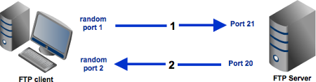

Passive mode:
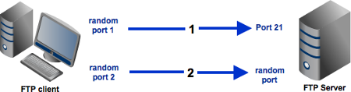
In an active mode configuration, the server will attempt to connect to a random client-side port. So chances are, that port wouldn't be one of those predefined ports. As a result, an attempt to connect to it will be blocked by the firewall and no connection will be established.
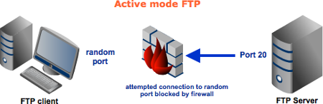
A passive configuration will not have this problem since the client will be the one initiating the connection. Of course, it's possible for the server side to have a firewall too. However, since the server is expected to receive many connection requests compared to a client, then it would be but logical for the server admin to adapt to the situation and open up ports to satisfy passive mode configurations.
So it would be best for you to configure server to support passive mode FTP. However, passive mode would make your system vulnerable to attacks because clients are supposed to connect to random server ports. Thus, to support this mode, not only should your server have to have multiple ports available, your firewall should also allow connections to all those ports to pass through!

Trivial File Transfer Protocol (TFTP)
TFTP is a simple file transfer protocol. Generally used for automated transfer of configuration or boot files between machines in a local environment.
Due to its simple design, TFTP can be implemented using a very small amount of memory.
- It is therefore useful for booting devices such as routers which may not have any data storage devices.
- It is also used in Pre-boot Execution Environment (PXE) network boot protocol, where it is implemented in the firmware ROM / NVRAM of the host's network card.
- It is also used to transfer small amount of data between hosts on a network, such as IP phone firmware or operating system images.
TFTP is a simple protocol for transferring files, implemented on top of the User Datagram Protocol using port 69.TFTP only reads and writes files from or to a remote server. It cannot list directories, and has no provisions for user authentication. The data transfer ports are chosen independently by the sender and receiver during initialization of the connection. The ports are chosen at random according to the parameters of the networking stack, typically from the range of ephemeral ports.

In TFTP, communication is initiated by the client issuing a request to read or write a file on the server. If the server grants the request, the connection is opened and the file is sent in fixed length blocks of 512 bytes. Each data packet contains one block of data, and must be acknowledged by an acknowledgment packet before the next packet can be sent. A data packet of less than 512 bytes signals termination of a transfer. And source sends 0 byte packet if the last sent packet is of 512 bytes. If a packet gets lost in the network, the intended recipient will timeout and may retransmit their last packet (which may be data or an acknowledgment), thus causing the sender of the lost packet to retransmit that lost packet. The sender has to keep just one packet on hand for retransmission, since the lock step acknowledgment guarantees that all older packets have been received. Notice that both machines involved in a transfer are considered senders and receivers. One sends data and receives acknowledgments; the other sends acknowledgments and receives data.

2) Wake-on-LAN
Wake-on-LAN, also known as 'wol', is the ability to switch on a computer that is connected to a network. It is important to note that Wake-on-LAN applies to the computers being physically connected (ie, not wireless systems).

**** Does my motherboard support Wake-on-LAN?
For Wake-on-LAN to work the target computer motherboard must support this feature and most of latest motherboards have this support.
Generally speaking, the Wake-on-LAN (non) ability of the target motherboard will be specified by the hardware manufacturer.
Sometimes, this ability is evident by browsing through said motherboard's BIOS and looking for something like 'PCI Power up'.

**** Ensure that Wake-on-LAN is enabled and survives a reboot
A common problem with the Wake-on-LAN in computers running Linux is that the network drivers have Wake-on-LAN switched off by default. To manually switch on the Wake-on-LAN feature on your driver, you will need to install ethtool.

- First query the driver to see if it's defaulted to 'on' by using ethtool:
# ethtool net0 | grep Wake-on
Supports Wake-on: pg
Wake-on: d

- We need a 'Wake-on' value of 'g' for WOL to work.
To enable the wol feature in the driver, simply run the following
# ethtool -s net0 wol g

- This command does not last beyond the next reboot. If using netctl, one can make this setting persistent by adding the following to your netctl profile:
/etc/netctl/PROFILE
ExecUpPost='/usr/bin/ethtool -s net0 wol g'

- For some network cards, you may also need the following command:
# echo enabled > /sys/class/net/net0/device/power/wakeup

***** With udev
udev is capable of running any command you desire as soon as a device is visible.
We want udev to turn on wake on LAN for our device. Put the following in /etc/udev/rules.d/50-wol.rules, replacing N with the number for your interface:
ACTION=="add", SUBSYSTEM=="net", KERNEL=="netN", RUN+="/usr/bin/ethtool -s %k wol g"

This tells udev to run "/usr/bin/ethtool -s netN wol g" as soon as the device netN exists. To turn on wake on lan for all new devices, replace the N with a '*':
ACTION=="add", SUBSYSTEM=="net", KERNEL=="net*", RUN+="/usr/bin/ethtool -s %k wol g"

***** With cron
A command can be run each time the computer is (re)booted using "@reboot" in a crontab.
First, make sure cron is enabled, and then edit a crontab for the root user that contains the following line:
@reboot /usr/bin/ethtool -s [net-device] wol g

Loopback address (virtual loopback interface)
Loopback address is that sends outgoing signals (packets) back to the same computer for testing. This is implemented entirely within the OS network stack and passes no packets to NIC. In a TCP/IP network, the loopback IP address is 127.0.0.1, and pinging this address will always return a reply unless the firewall prevents it. A loopback interface is put into no shutdown state when created.

Any IP datagram with a source or destination address set to a loopback address must not appear outside of a computing system, or be routed by any routing device. Packets received on an interface with a loopback destination address must be dropped. Such packets are sometimes referred to as Martian packet.

The range of addresses for loopback functionality is the range of 127.0.0.0 to 127.255.255.255. Similar to ping, loopback enables a user to test one’s own network to ensure the IP stack is functioning properly or not.

Loopback address for IPv6 is ::1 or sometimes written as [::1] or ::1/128

$ ifconfig lo
lo Link encap Local Loopback
inet addr 127.0.0.1 Bcast [NONE SET] Mask 255.0.0.0
UP BROADCAST LOOPBACK RUNNING MTU 2000 Metric 1
RX packets 0 errors 0 dropped 0 overrun 0
TX packets 0 errors 0 dropped 0 overrun 0

The loopback interface has been assigned a netmask of 255.0.0.0, since 127.0.0.1 is a class-A address. The interface doesn't have a broadcast address set, which isn't normally very useful for the loopback anyway. However, if you run the rwhod daemon on your host, you may have to set the loopback device's broadcast address in order for rwho to function properly.

DMZ - Demilitarized Zone
A DMZ (demilitarized Zone) is a network design where publicly accessible servers are placed on a separate, isolated network segment. The intention of a DMZ is to ensure that publicly accessible servers cannot contact other internal network segments, in the event that a server is compromised.
A Firewall is particularly relevant in DMZ implementation, since it is responsible for ensuring that proper policies are in place to protect local networks from the DMZ, while maintaining accessibility to the DMZ.
Due to the non-trivial nature of DMZ implementation, it is not recommended to attempt a DMZ unless you have a strong familiarity with networking. A DMZ is usually not a requirement, but is generally encouraged by security conscientious network administrators.

Broadband routers often implement a DMZ simply through additional firewall rules, meaning that incoming requests reach the firewall directly. In a true DMZ, incoming requests must first pass through a DMZ computer before reaching the firewall.
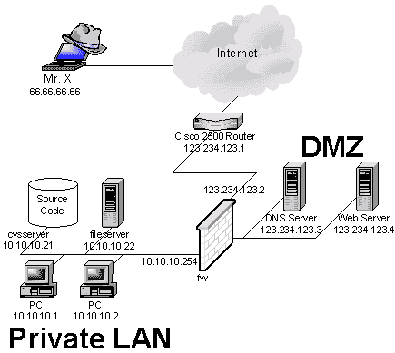

NAT – Network Address Translation
A computer to communicate with the other computers on the internet, it must have an IP address of the destination computer. IP address is just a 32-bit number and theoretically (2 power 32) unique addresses are available. Among these few addresses are segregated into classes, and some are set for multicasting, testing etc and can’t be used. So the IP addresses are very limitedly available. Hence to redesign the IP address format to allow more number of addresses, IPv6 is coming up which may take some more years. But the shortage of IP addresses is only one reason to use NAT. NAT acts as a router, between the internet (public network) and a local (private network). This means that only a single, unique IP address is required to represent an entire group of computers.

NAT enables a LAN to use one set of IP addresses for internal traffic and a second set of addresses for external traffic. NAT box is located where the LAN meets the Internet and makes all the necessary IP address translations. NAT serves the following purposes,
1) Provides a type of firewall by hiding internal IP addresses
2) Enables a company to use more internal IP addresses, as these are used internally. And there is no conflict with IP addresses used externally.
3) Allows a company to combine multiple ISDN connections into a single internet connection.

Static NAT – A type of NAT in which a private IP address is mapped to a public IP address, where the public address is always the same IP address (static address).
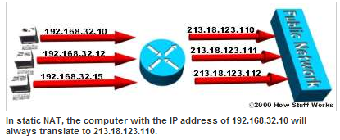

Dynamic NAT – A type of NAT in which a private IP address is mapped to a public address drawing from a pool of registered IP addresses. Typically, the NAT router in a network will keep a table of registered IP addresses, and when a private IP address requests access to the internet, the router chooses an IP address from the table that is not being used by another private IP address.
Dynamic NAT helps to secure a network as it masks the internal configuration of a private network and makes it difficult for someone outside the network to monitor individual usage patterns. Another advantage of dynamic NAT is that it allows a private network to use private IP addresses that are invalid on the Internet but useful as internal addresses.
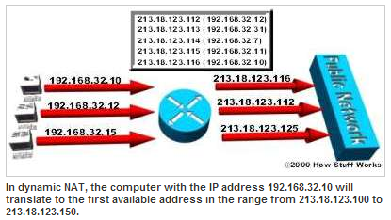
Overloading NAT – A type of NAT, which maps multiple private IP addresses to a single registered IP address by using different ports. This is also known as PAT (Port Address Translation), single address NAT or port-level multiplexed NAT.
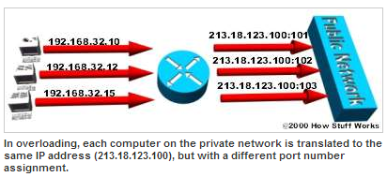
Overlapping NAT – When the IP addresses used on your internal network are registered IP addresses in use on another network, the router must maintain a lookup table of these addresses so that it can intercept them and replace them with registered unique IP addresses. It is important to note that the NAT router must translate the "internal" addresses to registered unique addresses as well as translate the "external" registered addresses to addresses that are unique to the private network. This can be done either through static NAT or by using DNS and implementing dynamic NAT.
DNAT - Destination network address translation (DNAT) is a technique for transparently changing the destination IP address of an end route packet and performing the inverse function for any replies. Any router situated between two endpoints can perform this transformation of the packet. DNAT is commonly used to publish a service located in a private network on a publicly accessible IP address. This use of DNAT is also called port forwarding.
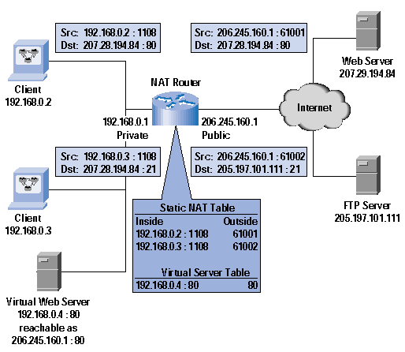

The web server IP should be 207.28.194.84 instead 207.29.194.84 in the above figure
NAPT
NAPT (Port NAT) NAPT maps a single public address to one or many internal addresses and all IP addresses on the private network are local and cannot be seen by the outside world. This would cause an ambiguity when routing the returned packets. To avoid this problem NAPT makes use of the TCP/ UDP port information in the outgoing traffic and maintains a translation table. This would allow routing the returned packets correctly to the requester.
NAT with Port Address Translation (PAT or NAPT), IP masquerading, NAT Overload and many-to-one NAT are the other names of NAPT.

NAT modifies IP address in a header of an IP packet, while it is travelling through a routing device and allows to use a different set of IP addresses to be used for traffic within a LAN than the set of IP addresses used for outside traffic, while NAPT is a special kind of NAT where multiple private IP addresses are mapped in to as single IP or a small group of public IP addresses. Therefore NAPT involves a many-to-one translation of IP addresses. NAPT is the most widely used NAT, therefore most of the time NAPT is referred as NAT.

Network address translation is not commonly used in IPv6 as one of its aims is to restore true host-to-host connectivity. NAT loopback is not commonly needed. Although still possible, the large addressing space of IPv6 obviates the need to conserve addresses and every device can be given a unique globally routable address.
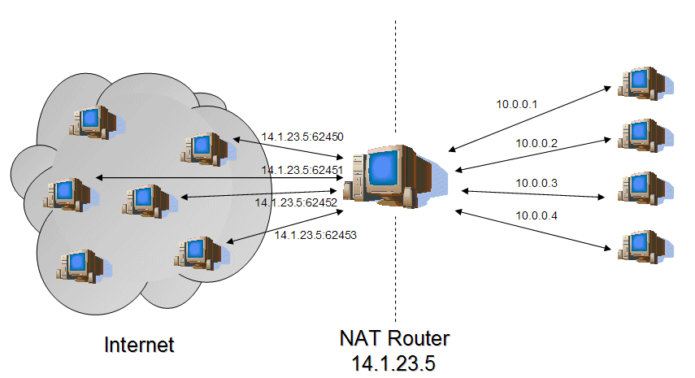

MAC Cloning
MAC cloning can only be done at your router providing it has those capabilities. Most ISPs assign their IPs based on the MAC address in your equipment. If the MAC address of your router is 00-11-22-33-44-55 and you connect to your ISP, the DHCP server records your MAC and assigns an IP. If you disconnect from the ISP, you lose your IP address. The next time you connect, the DHCP server sees your MAC, looks to see if it has assigned an IP address to you before. If it has and the lease time has not expired, it will most likely give you the same IP address you had before disconnecting. Why clone a MAC address? New MAC address most likely equals new IP. How to clone your MAC is dependent on the router itself. You’ll need to find the instructions on the manufacturer’s website.

Some ISP may register the MAC address of your computer when you dialing up to Internet for the first time via modem. If you add a router into your network to share your Internet connection, the ISP will not accept it. So you need to do MAC address clone on the router. Therefore the MAC of your computer is cloned to router.
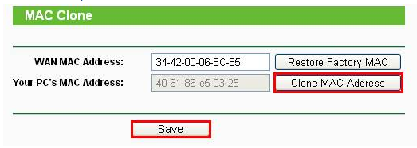
In many cases, it is absolutely unnecessary to use the MAC address clone. If you have a working internet connection through your router then there is no need to use the MAC address clone function.
Only when you find that you have a working internet connection on one computer directly on your modem but not when you connect through the router (or a different computer directly on the modem) then it is necessary to use the MAC address clone function.

MAC address is a 12-digit hexadecimal number (48 bits in length)

ARP (Type – 0x0806)
ARP is a function of the IP layer. It is necessary to translate the host IP address to its MAC address and ARP is used to determine the MAC address (hardware address). Another protocol RARP – Reverse ARP which translates a MAC address into IP address.

ARP table or ARP caching
IP networks maintain a mapping between the IP address of a device and its MAC address. This mapping is known as the ARP cache or ARP table.
Ethernet network adapters have the MAC address. Manufacturers ensure these 6-byte (48-bit) MAC addresses are unique, and Ethernet relies on these unique identifiers for message delivery. When any device wishes to send data to another target device over Ethernet, it must first determine the MAC address of that target given its IP address. These IP-to-MAC address mappings are derived from an ARP cache maintained on each device. If the given IP address does not appear in a device's cache, that device cannot directly message to that target until it obtains a new mapping. To do this, the initiating device first sends an ARP request broadcast message (with the dest MAC as ff:ff:ff:ff:ff:ff ) on the local subnet. The host with the given IP address sends an ARP reply in response to the broadcast, allowing the initiating device to update its cache and proceed to deliver messages directly to the target. The PC will put that entry into its local ARP cache and it will stay there until the entry has not been used and the ARP cache timeout has expired. Here is an ARP cache looks like,
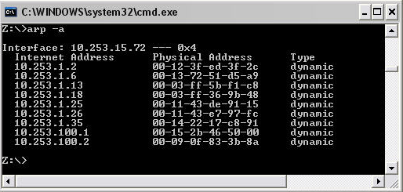
ARP is used to connect OSI Layer 3 (Network) to OSI Layer 2 (Data-Link). For most of us, that means that ARP is used to link our IP addressing to our Ethernet MAC Addressing.
Four types of ARP messages that can be sent by ARP protocol – ARP request, ARP reply, RARP request and RARP reply.
Static ARP – Manually enter the link between the Ethernet MAC address and the IP address
Dynamic ARP – ARP entry, which is the Ethernet MAC to IP address link, is kept on a device for some period of time, as long as it is being used. The dynamic ARP is created using the ARP protocol.

Gratuitous ARP – The network stack will issue gratuitous ARP if the IP or MAC address of a network interface changes, to inform other machines on LAN so that the others can report IP conflicts and update their ARP tables. A gratuitous ARP reply is a reply to which no request has been made. Gratuitous ARP is special ARP request packets with characteristics as,
** Both source and destination IP in the packet are the IP of the host issuing the Gratuitous ARP
** The dest MAC address is the broadcast MAC address (FF:FF:FF:FF:FF:FF) which means the packet is flooded to all hosts and switches.
** No reply is expected for this packet.

How ping works
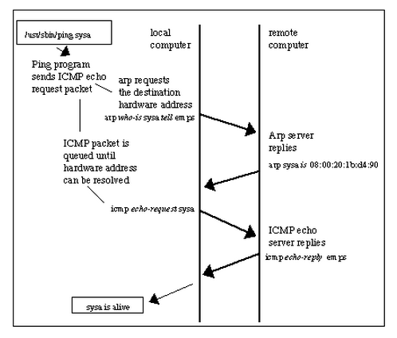
Ping sends ICMP echo request to destination host and expects the echo reply from it. If the destination host is unknown, then an ARP request to the destination host is made querying for the MAC address. Once the ARP reply is obtained from the destination host, ARP table on the source is updated with the destination MAC and IP details. Now the ICMP request from the source can be sent and reply is got from the destination host.

Public IP
A public IP address is any valid address that can be accessed over the Internet including web-sites, network servers and DNS servers or any computer connected to Internet. Internet standards groups, such as the Network Information Center (NIC) or the Internet Assigned Numbers Authority (IANA), are the organizations responsible for registering IP ranges and assigning them to organizations, such as Internet Service Providers (ISPs).
In the Cloud(n) system, a public IP address is an identifier assigned to a virtual router on the network. Any resources that will be available over the Internet will require a public IP address. Public IP addresses can be fixed or static IP addresses if they never change but most ISPs provide an IP address that can change from time to time which are dynamic addresses.
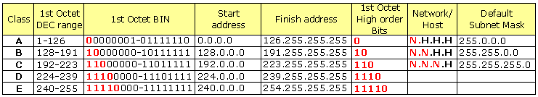

Private IP
A private IP address is any number or address assigned to a device on a private Local Area Network that is accessible only within the Local Area Network. For a resource inside the Local Area Network to be accessible over the Internet, a device within the Local Area Network must be connected to the Internet with a public IP address, and the networking must be appropriately configured. The same Internet standards organizations have reserved the following three IP address ranges that will never be registered publicly: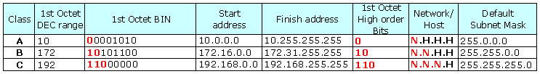
In Class A, the first number denotes the network Id and the other 3 numbers denotes the host ID
In class B, the first 2 numbers denotes network Id and the other 2 numbers denotes the host ID
In class C, the first 3 numbers denotes network ID and the last number denotes the host ID

Global IP
Global IP address is assigned to a computer or modem by an ISP and can be communicated from anywhere on the internet. Global IP addresses can be provisioned in any data center on the SoftLayer network and moved to another facility if necessary. You can point it to a server in Dallas, and if you need to perform maintenance on the server in Dallas, you can move the IP address to a server in Amsterdam to seamlessly (and almost immediately) transition your traffic.
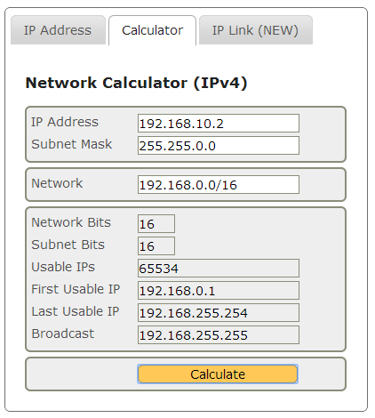

Hop count
In networking, the hop count represents the total number of devices a data packet passes through. The more hops data must traverse to reach their destination, the greater the transmission delay incurred.
Ping can be used to determine the hop count to a specific destination. Ping generates packets that include a field reserved for the hop count. Each time a capable device receives these packets, that device modifies the packet, incrementing the hop count by one. In addition, the device compares the hop count against a predetermined limit and discards the packet if its hop count is too high. This prevents packets from endlessly bouncing around the network due to routing errors. Both routers and bridges are capable of managing hop counts, but hubs cannot this.
Traceroute is a command used for displaying the route (hops) and measuring transit delays of packets across an IP network.
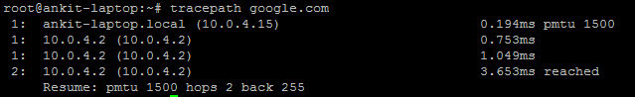
The above output shows the tracepath command executed on Ubuntu. This first column shows the TTL of the probe, followed by colon. The second column is the network hop, which replied to the probe. It is either address of the router or [LOCALHOST] if the probe was not sent to the network.
The rest of information about path to the corresponding network hop. The last line summarizes information about the entire path to the destination; it shows detected MTU, number of hops to the destination and hops from the destination to us.

Time-to-live (TTL) is a value in a packet that tells a network router whether or not the packet has been in the network too long and should be discarded.
Discard the packet after a certain time and send a message to the originator, who can decide whether to resend the packet. The initial TTL value is set default, in an 8-binary digit field of the packet header. The original idea of TTL was that it would specify a certain time span in seconds that, when exhausted, would cause the packet to be discarded. Since each router is required to subtract at least one count from the TTL field, the count is usually used to mean the number of router hops the packet is allowed before it must be discarded. Each router that receives a packet subtracts one from the count in the TTL field. When the count reaches zero, the router detecting it discards the packet and sends an Internet Control Message Protocol (ICMP) message back to the originating host.

Packet Types
The 802.11 hardware on the network adapter filters all packets received, and delivers to the host
- Unicast packets that are being sent to one of the addresses for that adapter, i.e. packets sent to that host on that network;
- Multicast packets that are being sent to a Multicast address for that adapter, or all Multicast packets regardless of the address to which they're being sent (some network adapters can be configured to accept packets for specific Multicast addresses, others deliver all multicast packets to the host for it to filter);
- Broadcast packets.
In order to capture the traffic other than unicast traffic, like multicast and broadcast traffic, the adapter has to put itself to monitor mode or promiscuous mode. If the host is connected to a switch, broadcast traffic and multicast traffic will go to al the ports, but unicast traffic won’t go this way.

Promiscuous mode
Promiscuous mode is a mode for wired or wireless NICs that cause the controller to pass all traffic it receives to the CPU rather than passing only the frames that the controller is intended to receive. This mode is normally used for packet sniffing that takes place on a router or on a computer connected to a hub (instead of a switch) or one being part of a WLAN.
In non-promiscuous mode, when a data packet is transmitted, all the LAN devices "listen to" the data to determine if the network address included in the data packet is theirs. If it isn't, the data packet is passed onto the next LAN device until the device with the correct network address is reached. That device then receives and reads the data.

The default flags for the NIC interface would be as below,
vnic1 Link encap:Ethernet HWaddr 00:13:97:57:C0:01
UP BROADCAST MULTICAST MTU:1500 Metric:1
RX packets:2190904 errors:0 dropped:1115813 overruns:0 frame:0
TX packets:214733 errors:0 dropped:0 overruns:0 carrier:0
collisions:0 txqueuelen:1000
RX bytes:175937029 (167.7 MiB) TX bytes:12883980 (12.2 MiB)

A NIC can be set to promiscuous mode as, ifconfig vnic1 promisc
vnic1 Link encap:Ethernet HWaddr 00:13:97:57:C0:01
UP BROADCAST PROMISC MULTICAST MTU:1500 Metric:1
RX packets:2190904 errors:0 dropped:1115813 overruns:0 frame:0
TX packets:214733 errors:0 dropped:0 overruns:0 carrier:0
collisions:0 txqueuelen:1000
RX bytes:175937029 (167.7 MiB) TX bytes:12883980 (12.2 MiB)

In promiscuous mode, some software might send responses to frames even though they were addressed to another machine. An example is sending a ping (ICMP echo request) with the wrong MAC address but the right IP address. If an adapter is operating in normal mode, it will drop this frame, and the IP stack never sees or responds to it. If the adapter is in promiscuous mode, the frame will be passed on, and the IP stack on the machine (to which a MAC address has no meaning) will respond as it would to any other ping. The sniffer can prevent this by configuring his or her firewall to block ICMP traffic.
Monitor mode applies to wireless devices, which acts like promiscuous mode.

Power over Ethernet (PoE)
Ethernet cables supply the power for network devices, at the same time as transmitting data in the normal way. Typical PoE users are VoIP phones in buildings for which power lines could be avoided.
- A device can send or receive power, but not both.
- The PSE supplies 15.4 watts of DC power (minimum 44 V DC and 350 mA) on 802.3af ports and 30Watts on 802.3at ports.
- The sender is a Power Sourcing device (PSE), while device that is powered is a Powered Device (PD)
- The electrical current must go into the data cable at the power-supply end, in such a way that the current is kept separate from the data signal so that neither interferes with the other.
- The current entering component is injector. If the device on the other end is PoE compatible, then that device will function properly without any modification. If the device is not PoE compatible, then a component called picker or tap must be installed to remove the current from the cable. This picked-off current is routed to the powered jack.
- Power sourcing equipment (PSE) is a device such as a switch that provides ("sources") power on the Ethernet cable.
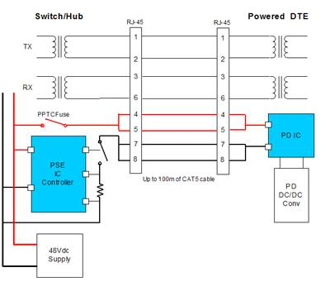

Network Process Unit (NPU)
Demand for higher bandwidth networks has driven the evolution of network equipment design. The general purpose CPUs is not ideal for network programming. While their programmability is important, their floating-point units go unused, they have too much data cache, and too little memory bandwidth. Further, demand for bandwidth is increasing faster than CPU speeds. Network equipment designers cannot afford to wait for the next generation of CPUs to increase the speed of their devices.
The conventional answer is to design an ASIC which can be much faster than CPUs, but are expensive to develop. Moreover, ASICs usually have limited programmability and must be redesigned as protocols and interfaces change. Network processor companies hope to bridge the gap between ASICs and CPUs by providing a device that is as programmable as a CPU but as fast as an ASIC.

Fast path and slow path
As packets enter the networking device, their destination address and port are examined, and based on that examination, they are sent on either the "slow path" or the "fast path" internally. Packets that need minimal or normal processing take the fast path, and packets that need unusual or complex processing take the slow path. Fast path packets correspond to data plane tasks, while slow path packets correspond to control plane tasks. Once they have been processed, packets from both the slow and fast path may leave via the same network interface. While the slow path processing will almost certainly be implemented with a CPU, fast path processing can be implemented with an FPGA, ASIC, co-processor, or maybe just another CPU.
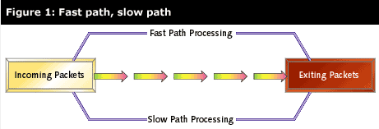

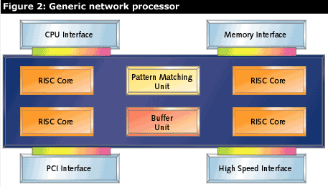
Block diagram of a NPU
A generic network processor includes traits like, multiple RISC cores, dedicated hardware for common networking operations, high speed memory and IO interfaces and interface to general CPU.
A network processor is a programmable microprocessor optimized for processing network data packets. Specifically, designed to handle the tasks associated with the upper layers of the seven-layer OSI networking model - header parsing, pattern matching, bit-field manipulation, table look-ups, packet modification, and data movement. Many independent packets will be available, providing opportunities for parallel processing. Data rates for network processors range from 1.2Gbps (dual OC-12 data rate) to 40Gbps.
Software programmability is an important characteristic of network processors, because it provides flexibility across a range of applications. Even though all network processors are programmable, by definition, not all of them can be programmed by the user. Some vendors restrict access to the underlying instruction set and architecture of their network processing unit (NPU), preferring instead to do all the programming inhouse.
Characteristics: NPU vendors have slimmed down their processors still further. Processing packets is a fairly simple task, consisting mainly of extracting data from a bit stream and doing some pattern matching or table lookups, so a packet processor doesn't need complex arithmetic, fancy addressing modes, or memory-translation units. Bulky circuits such as floating-point units (FPU) and memory-management units (MMU) are generally unnecessary. Instruction caches can be smaller, and data caches are generally eliminated completely, since most network data doesn't recur and is not reused. Network processors are called packet engines, although NPU vendors themselves use a variety of terms such as microengines and channel processors. By eliminating general-purpose CPU features and focusing on just the basics, NPU designers can fit a single packet engine into a small silicon chip.
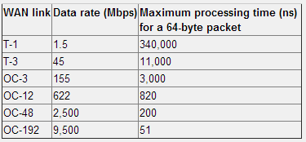
Some of the NPU manufacturers are Alcatel Lucent, Altera, AMD, Infineon, LSI, Broadcom, Freescale, EZchip.
Network Processor devices are categorized under 4 groups,
2.5-Gbit/s NPUs: Fast-path network processors capable of handling packet processing of 2 Gbit/s to 4 Gbit/s.
10-Gbit/s NPUs: Fast-path network processors capable of handling packet processing of at least 10 Gbit/s.
Control-plane processors: General-purpose processors networking I/O.
Communications processors: Programmable devices with fast-path acceleration to handle packet processing up to 1 Gbit/s. Most communications processors have integrated control-plane processors.

Reference: http://www.embedded.com/design/prototyping-and-development/4025000/The-basics-of-network-processors

EZchip semiconductor is a publicly traded fabless semiconductor company that develops and markets Ethernet network processors. EZchip has developed network processors that integrate multiple TOPs (Task Optimized Processors) to provide the performance required for next-generation networking products.

EZchip's breakthrough Task Optimized Processing technology (TOPcore) employs fast, efficient and flexible processors designed and optimized for layer 2-3 packet processing. This technology enables highly integrated chips that provide very high throughput rates. For the new NPS family of network processors, EZchip is developing innovative CTOPs (C-programmable Task Optimized Processors) that enable processing at all 7-layers and are C-programmable. These processing engines build on EZchip’s extensive NPU experience, are designed specifically for data-plane processing and are 10-fold smaller and faster compared to the general C-programmable RISC processors.
Notes: Just to know
Web switches:
Web switches are a new type of network device. They address the problem of trying to increase the responsiveness of a popular Web site by using more than one web server. A web switch can direct incoming HTTP requests to different servers based on a variety of networking parameters, including the URL itself. For instance, all secure HTTP requests could be forwarded to a special web server with cryptographic hardware to accelerate those requests.

OSPF and BGP – routers work on these protocols (control plane)
OSPF is an IGP (internal gateway protocol), while BGP is the only real EGP (exterior gateway protocol). If you are doing internal routing, i.e. routing within a site, company, or campus, you will want to use OSPF. Typically BGP is needed at a site edge, where you route out to the public internet. In small and medium size networks, static routes to the outside will usually be preferable to setting up BGP. If you have a complicated multi-homed site, regardless of size, you might consider BGP.

A fabless manufacturing is the design and sale of hardware devices and semiconductor chips while outsourcing the fabrication of fab to specialized manufacturer called semiconductor foundry. Foundries can be typically china, where the low cost labor is available.

Wireless 802.11 standards evolution
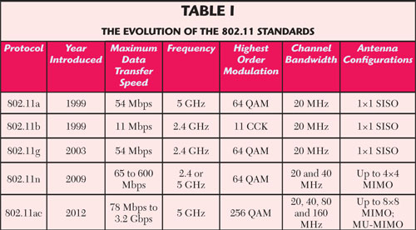

Crossover Cable – Two computers can be connected directly together in an Ethernet using crossover cable. It doesn’t have collision problem.
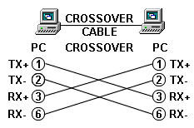

Management and control packets – The packets other than the data packets which intend to configure router, switch and other network devices can be termed as management and control packets.

NetBIOS - (Network Basic Input/Output System)
NetBIOS is a program that allows applications on different computers to communicate within a local area network (LAN). NetBIOS is used in Ethernet and Token Ring networks and, included as part of NetBIOS Extended User Interface (NetBEUI), in recent Windows OS. It does not support a routing mechanism so applications communicating on a WAN must use another "transport mechanism" (such as TCP) in addition to NetBIOS.

NetBIOS frees the application from having to understand the details of the network, including error recovery. A NetBIOS request is provided in the form of a Network Control Block (NCB) which specifies a message location and the name of a destination.
NetBIOS provides the session and transport services described in the Open Systems Interconnection (OSI) model. However, it does not provide a standard frame or data format for transmission. A standard frame format is provided by NetBUI.

NetBIOS provides two communication modes: session or datagram. Session mode lets two computers establish a connection for a "conversation," allows larger messages to be handled, and provides error detection and recovery. Datagram mode is "connectionless" (each message is sent independently), messages must be smaller, and the application is responsible for error detection and recovery. Datagram mode also supports the broadcast of a message to every computer on the LAN.
Hub, Switch and Router
In a hub, a frame is "broadcasted" to every one of its ports. The hub has no idea which port a frame should be sent to. Passing to every port ensures that it will reach its destination. This creates a lot of traffic on the network and leads to poor network response times. Hubs are used to connect the segments of a LAN. Hubs operate at half duplex. So collision detection (CSMA/CD) protocol used to sense the carrier before sending the data.

A switch, keeps a record of the MAC addresses of all the devices connected to it. With this information, a switch can identify which system is sitting on which port. So when a frame is received, it knows exactly which port to send to, without increasing network response times. Switch operates at the data link and sometimes network layer. Switches operate at full duplex.
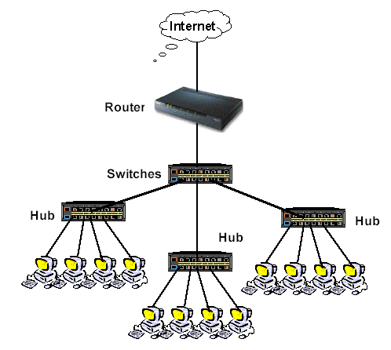
Router’s job is to route packets to other networks until that packet ultimately reaches its destination. One of the key features of a packet is that having the destination address of where it's going.
Router functionalities:
- A router is connected to at least two networks.
- Routers restrict broadcasts to the LAN; act as a default gateway, the place where two or more networks connect.
- Routers use headers and forwarding tables to determine the best path (loop free paths) for forwarding the packets.
- Routers use ICMP protocol to communicate with each other and configure the best route between any two hosts.
- The router acts as a “proxy” for home cables and wireless routers. The router changes the source IP address in the IP packet to its own address.
Today, many services are integrated into a router. A router typically includes 4-8 port Ethernet switch (a hub), a NAT, DHCP server, DNS proxy server, VPNs and a hardware firewall. Some routers also have wireless access points built to them. All routers have a WAN port that connects to a DSL or cable modem for broadband internet service and an integrated switch to create a LAN.

How a router works?
A router is just like a computer having CPU, Flash memory, NVRAM, RAM, network interfaces and console. The first system that worked as a router is ARPANET’s gateway. Taking the cable or DSL information through a WAN connection, the router directs the information data to the devices connected to the internet. The router is able to this by assigning local ISPs to every computer and handling each system as a separate avenue to the internet.
- The router powers on and loads it's OS from flash
- The router loads the configuration file last saved to NVRAM and sets up the network interfaces and routing protocols it will run.
- The router adds the network address and subnet for each interface to its routing table along with the name of the interface itself.
- The router has a simple static default route to send all non-local data out the network port connected to the cable.
- When the router receives a web page request from your computer, it checks the destination IP address against its routing table.
- The bits forming the destination IP address in the IP packet are used as a hash key to point to the correct route, which in turn points to the correct network interface that the packet should be forwarded out of.
- The router transmits the packet out the correct interface, to the next router, which repeats the process until the packet reaches the destination.

Routing is the process of forwarding IP packets from one network to another. A router is a device that joins networks together and routes traffic between them. A router will have at least two network cards (NICs), one physically connected to one network and the other physically connected to another network. A router can connect any number of networks together providing it has a dedicated NIC for each network.
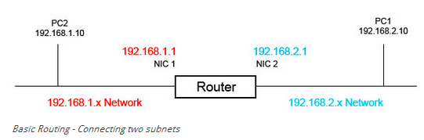
Learn and advertise loop-free paths
Routers can only learn and advertise routes dynamically if they are using a routing protocol such as RIP, OSPF, EIGRP, IS-IS or BGP. Otherwise, a human has to configure the routes by hand, which is called static routing.
Routing moves data on a hop-by-hop basis called as 'hot potato' routing. If a set of routers ends up passing the data around in a circle, without reaching the destination, it's called a 'routing loop'. Packets get handed off around the loop until they die of old age: their 'Time To Live' expires. Time To Live is a counter that is part of the IP datagram header. The Time To Live value is decremented as it passes through each router and eventually it reaches zero and is discarded.

Routing tables in Linux – example 1
All network devices use routing table to determine where to send packets. Without routing table the PC is unable to communicate with computers even within the same subnet. This is an electronic table that is stored in the router which has the routes to the particular network destination. This information contains the topology of the network immediately around it. The routing tables are constructed by routing protocols and static routes. The output of route –n or netstat –r –n is below.
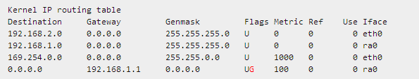
- Destination: The destination network or destination host.
- Gateway: The gateway address or ’*’ if none set.
- Genmask: The netmask for the destination net; 255.255.255.255 for a host destination and 0.0.0.0 for the default route.
- Flags: Possible flags include
U (route is up), H (target is a host), G (use gateway), R (reinstate route for dynamic routing), D (dynamically installed by daemon or redirect), M (modified from routing
daemon or redirect), A (installed by addrconf), C (cache entry), ! (reject route)
- Metric: The distance to the target (usually counted in hops). It is not used by recent kernels, but may be needed by routing daemons.
- Ref: Number of references to this route. (Not used in the Linux kernel.)
- Use: Count of lookups for the route. Depending on the use of -F and -C this will be either route cache misses (-F) or hits (-C).
- Iface: Interface to which packets for this route will be sent.
- MSS: Default maximum segment size for TCP connections over this route.
- Window: Default window size for TCP connections over this route.
- irtt: Initial RTT (Round Trip Time). The kernel uses this to guess about the best TCP protocol parameters without waiting on (possibly slow) answers.
- HH (cached only): The number of ARP entries and cached routes that refer to the hardware header cache for the cached route. This will be -1 if a hardware address is not needed for the interface of the cached route (e.g. lo).
- Arp (cached only): Whether or not the hardware address for the cached route is up to date.

Routing tables are created automatically based on the configuration of computer. You can manually add/modify/edit routing tables using route and ip commands. Types of entries in the routing table,
- Network Route: A route (path) to a specific Network ID in the internetwork.
- Host Route: A route to a specific internetwork address (Network ID and Host ID). Host routes are used to create custom routes to control or optimize network traffic.
- Default Route: A route that is used when no other routes for the destination are found in the routing table. If a router or end system cannot find a route for a destination, the default route is used. The default route is used if no other host or network route matches the destination address.

Routing table in Windows – example 2
The output of the “route print” in as below,
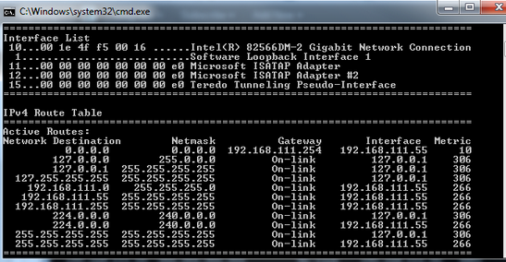
TCP/IP settings:
IP Address: 192.168.111.55
Subnet mask: 255.255.255.0
Default gateway: 192.168.111.254
Each line is a route to a specific network or device. The routes you can see in the picture are the default routes Windows creates for a PC. Let’s examine my routing table and take a look at each line:
0.0.0.0 – The 0.0.0.0 network combined with the netmask (subnet mask) of 0.0.0.0 means ALL IP addresses. Note how this is the only line where the gateway is 192.168.111.254. This line tells the computer that for ALL traffic no matter what the destination IP address is send it to 192.168.111.254. This is my default gateway. This is a default route created by Windows when configuring TCP/IP settings. It is the last route it evaluates if it can’t find a more specific match in the routing table.
127.0.0.0 – The next 3 lines are entries for the loopback address and can be ignored. These are default entries and the gateway says “On-link”. This means these addresses are directly accessible on the local LAN and do not need to be routed through another network. Although 127.0.0.1 is assigned to the local NIC, if this entry isn’t present in the routing table your PC would try to send these to the default gateway as the next entry it would closely match would be the 0.0.0.0 one.

192.168.111.0 – These next 3 lines are for your local network. The first one is the entire 192.168.111.x range as defined by the netmask of 255.255.255.0. This network is local it says “on-link” in the gateway. These are created automatically when you configuring TCP/IP settings.
224.0.0.0 – These are also default entries for multicasting and can be ignored.
255.255.255.255 – This is also a default entry and can be ignored.

How routing table is processed
Before sending a packet PC looks up the destination IP address in the routing table to determine the best route possible. A more specific match will take priority. For example if PC from above wants to send data to 192.168.111.9 it first looks in its routing table and finds the entry 192.168.111.0. It also finds the 0.0.0.0 entry but as 192.168.111.0 is a closer match it takes priority. If we add a static entry of 192.168.111.9 with a netmask of 255.255.255.255 this is an EXACT match so this would take priority over the 0.0.0.0 AND 192.168.111.0 entries. Once it finds a match it then checks the gateway column where in the case of our 192.168.111.0 entry it finds the “on-link” status. The on-link status tells the machine that this network is directly attached so it sends the packets directly to 192.168.111.9 using the NIC with interface 192.168.111.55.

If a PC can’t find a matching entry in the routing table it will fail. It will also fail if the routing table is wrongly configured. For example, if we remove all the entries starting with 192.168.111 and try to connect to any IP address starting with 192.168.111 there won’t be a specific entry for this anymore, so the next best route is 0.0.0.0. This route tells my PC to forward the packets to the gateway 192.168.111.254 which would consequently fail of course. The same would happen if I left those entries in but changed the gateway from “on-link” to 192.168.111.87 (a random IP). What I am telling my PC to do now is forward all traffic for the 192.168.111.0 network to 192.168.111.87 instead of going directly to the PC’s. As you can see this would also fail.

You may be wondering what the interface column is for? Well if you remember, routers have two NIC’s. When a router forwards packets it doesn’t know which NIC to use without this value. In the case where there is only one NIC in a device (like a PC) this value would be pointless, but when there are two or more NICs you must tell the router which one to use for a given route.

Reference: http://think-like-a-computer.com/2011/08/24/the-routing-table/
Gateway
The default gateway is where computer sends traffic to when it doesn’t know the destination address. The default gateway is always a router. Hence we put the router IP address as the default gateway. When 2 computers want to talk to each others in 2 different networks, the data is sent over the default gateway (router). Because a router will be attached to multiple networks it knows where these other networks are so it can route traffic to them. Routers also have default gateways so that if they don’t know where the destination is it also sends the data onto its own default gateway. This continues up the IP network hierarchy until it finds a router of the destination network.

Subnet (Netmask)
With the subnet there is no longer a need for different classes (class A, B and C) of IP address. This means you can use class C IP address 192.168.0.1 and make it class A or class B by altering the subnet mask
An IP (IPv4) address is composed of numbers separated by dots, for example, 201.10.70.67. Each of the numbers can be between 0 and 255.
Each local network is assigned a block of IP addresses. The IP address is split onto a network ID and a host ID part. The network ID identifies the network, for example, an IP address of 200.21.84.XXX, signifies that that 200.21.84 is the network ID and the XXX specifies the particular host connected to the network.
An IP address can be split in different ways to give a network ID and a host ID and this is usually indicated by a subnet mask. This is a pattern of ones and zeros that indicates which bit in the IP address is to be regarded as part of the network ID. For example a subnet mask of 11111111.0.0.0 or 255.0.0.0 in decimal means that the first eight bits of the IP address are the network ID and the rest identify particular machines on that network.
So now we know how the router can decide if the data packet is destined for a local machine or needs to be routed to some other network. When the router is set up it is told its IP address and a subnet mask. Using the subnet mask it can look to see if any data packet has an address that belongs on the same local network or to some other network and hence needs to be routed into the wider world.

DHCP – Dynamic Host Configuration Protocol
Any server or some routers can be configured to act as a DHCP server. Basically all it does it assign TCP/IP configuration parameters (IP address, Subnet mask, Default gateway, DNS server) to computers automatically. DHCP uses the concept of “lease” or amount of time that a given IP address will be valid for a computer. DHCP is an extension of BOOTP (Bootstrap Protocol). DHCP is a client-server model, and the DHCP server assigns the IP addresses to its clients. The process of leasing TCP/IP configuration from DHCP server involves,
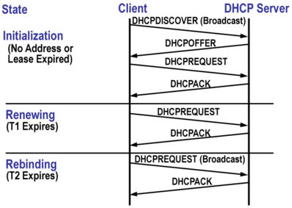
DHCPDISCOVER (client message) – DHCP client is not able to send and receive network traffic during device boot up, but it is able to broadcast a DHCP discovery message on the network containing its MAC address and NetBIOS destined for UDP port number 68. It’s a broadcast message that uses 255.255.255.255 as destination IP address while the source IP address is 0.0.0.0. This is a request to any DHCP server that receives the datagram for configuration info.

DHCPOFFER (server message) – DHCP server that receives the request responds with a DHCP offer message including the IP address and subnet mask of DHCP server as broadcast (UDP port number 67) to the computer that issued the DHCPDISCOVER. The DHCP client may receive multiple DHCPOFFER, but accepts the first DHCP offer that arrives.

DHCPREQUEST (client message) – DHCP client accepts an offer and broadcasts a DHCPREQUEST datagram. The DHCPREQUEST datagram contains the IP address of the server that issued the offer and the physical address (MAC Address) of the DHCP client. DHCPREQUEST message requests the selected DHCP server to assign the DHCP client an IP address and other TCP/IP configuration settings. DHCPREQUEST message also notifies all other DHCP servers that their offers were not accepted by the DHCP client.

DHCPACK (server message) – The DHCP server from which the offer was selected receives the DHCPREQUEST datagram, it constructs a DHCPACK datagram. This datagram is known as a DHCP ACKNOWLEDGEMENT. The DHCPACK includes an IP address and subnet mask for the DHCP client. It may include other TCP/IP configuration information like IP address for the default gateway, IP addresses for DNS servers, IP addresses for WINS servers etc.

DHCPNACK (server message) – This message opposite to DHCPACK sent by DHCP server when it is not able to satisfy the DHCPREQUEST from the client.

DHCPDECLINE (client message) – This message is sent from client in case the client finds that the IP address assigned by DHCP server is already in use.

DHCPINFORM (client message) – This message is sent from client in case the IP address is statically configured on the client and only the other network settings or configurations are desired to be dynamically acquired from DHCP server.

DHCPRELEASE (client message) – This message is sent by client in case it wants to terminate the lease of network address it has provided by DHCP server.
DHCP header format is as below,
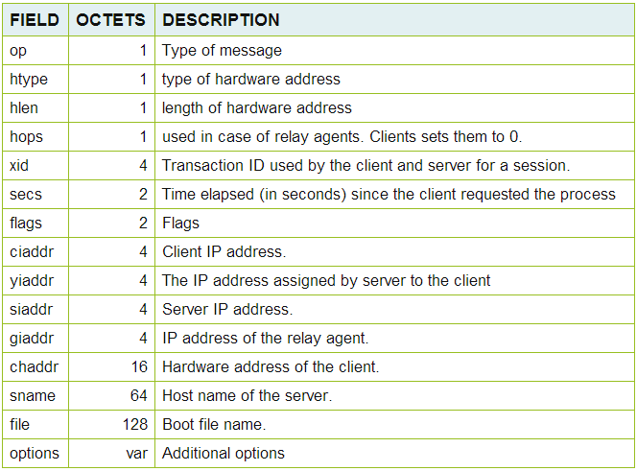
DNS
Remembering IP address of the servers is difficult for humans so each server also has a name (like google.com). So the users just need to remember the name and type it in their web browser. The first thing required is to convert the domain name to the corresponding IP. To accomplish this, a request is sent to the default gateway (most cases is the router) to contact the DNS server. The router has a configured DNS server IP to which this request is sent.

DNS servers are used to convert the domain name to IP address which is known as DNS name resolution. When a request is received by the DNS server, it checks whether it has the required information. If the information is not present then the DNS server forwards this request to the other DNS server. In this way, the domain name to IP address conversion is done and is sent back. Once the IP is known then a normal HTTP GET request to that particular IP is made and things move on.
DNS servers will be primary and secondary for redundancy, if one goes down, the backup DNS works as a replacement for the primary.

ISP automatically assigns a primary and secondary DNS server when router or computer requests TCP/IP configurations via DHCP. Public DNS servers are the servers available on internet that provide DNS resolution to anyone who requests it to them.
Google also offers IPv6 public DNS servers: 2001:4860:4860::8888 and 2001:4860:4860::8844
Most DNS servers are private and provide services to a company who owns and configures them. Some DNS servers are available on the net that provides DNS resolution to anyone who requests them. These are public DNS servers.

Firewall
Network firewalls guard an internal computer network against malicious or unauthorized access from outside. Network firewall may also be configured to limit access to the outside network. Firewall can be either hardware devices, software programs but the ideal firewall configuration will consist both.
Router has in-built firewall support which is a hardware firewall. The router includes configuration options for the firewall. Router firewalls can be turned off or they can be set to filter certain types of network traffic though firewall rules.
Another common form of network firewall is a proxy server. Proxy servers act as an intermediary between internal computers and external networks by receiving and selectively blocking data packets at the network boundary. In a proxy server firewall environment, network requests from multiple clients appear to the outsider as all coming from the same proxy server address.
Several firewall techniques can be used, many firewalls use two or more in concert.

Packet Filter - Looks at each packet entering or leaving the network and accepts or rejects it based on user-defined rules. Packet filtering is fairly effective and transparent to users, but it is difficult to configure. In addition, it is susceptible to IP spoofing.

Application Gateway - Applies security mechanisms to specific applications, such as FTP and Telnet servers. This is very effective, but can impose performance degradation.

Circuit-level Gateway - Applies security mechanisms when a TCP or UDP connection is established. Once the connection has been made, packets can flow between the hosts without further checking.

Proxy Server - Intercepts all messages entering and leaving the network. The proxy server effectively hides the true network addresses.
Next Generation Firewall – Newer class of firewalls filters network and internet traffic based upon the applications or traffic types using specific ports. Next generation firewall blend the features of a standard firewall with QOS functionalities.

IP filtering (set in kernel)
IP filter is an open source software package that provides firewall services and NAT. IP filtering is a mechanism that decides which types of IP packets should be processed and which will be discarded. Discarding mean the datagram is deleted and completely ignored, as if it never been received. Many sorts of criteria can be applied to determine which packets you wish to filter,
Protocol type: TCP, UDP, ICMP etc
Socket number for TCP/UDP
Datagram type: SYN/ACK, data, ICMP echo request
Datagram source/destination address
IP filtering is a network layer facility. This means, it doesn’t understand application using network connections.
The Linux kernel must be configured to support IP firewalling by selecting appropriate options is “make menuconfig” of kernel.

Netfilter (OS specific)
Netfilter is a host-based firewall for Linux operating systems. It is included as part of the Linux distribution and it is activated by default. This firewall is controlled by the program called iptables. The process of Netfilter takes place at the kernel level, before a program can even process the data from the network packet.
service iptables start/stop/restart :– Turn on/off/restart the firewall
iptables –line-numbers –n –L :- Display the default rules.
Understanding Firewall – There are 4 chains
PREROUTING – Packets will enter this chain before a routing decision is made.
INPUT – The default chain is used for packets addressed to the system. Use this to open or close incoming ports (such as 80, 25, and 110 etc) and ip addresses / subnet (such as 202.54.1.20/29).
OUTPUT – The default chain is used when packets are generating from the system. Use this open or close outgoing ports and IP addresses / subnets.
FORWARD – The default chains is used when packets send through another interface. Usually used when you setup Linux as router. For example, eth0 connected to ADSL/Cable modem and eth1 is connected to local LAN. Use FORWARD chain to send and receive traffic from LAN to the Internet.
POSTROUTING – Routing decision has been made and packets enter this chain just before handing them off to the hardware.
RH-firewall-1-INPUT – This is a user-defined custom chain. It is used by the INPUT, OUTPUT and FORWARD chains.

IP tables
IP tables are used to set up, maintain, and inspect the tables of IP packet filter rules in the Linux kernel. Each IP table contains a number of built-in chains and may contain user-defined chains.
Each chain is a list of rules which can match a set of packets. Each rule specifies what to do with a packet that matches. This is called a “target”, which may be a jump to a user-defined chain in the same table.
Target Meanings
- The target ACCEPT means allow packet.
- The target REJECT means to drop the packet and send an error message to remote host
- The target DROP means drop the packet and do not send an error message to remote PC

References:
http://www.cyberciti.biz/faq/rhel-fedorta-linux-iptables-firewall-configuration-tutorial/
http://www.cyberciti.biz/tips/linux-iptables-examples.html

The IPtables config file is located at /etc/sysconfig/iptables and the default rules are as, 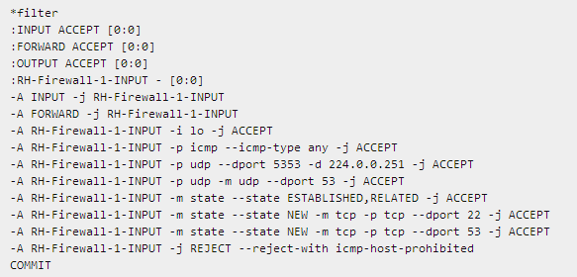

Display status of firewall – (iptables -L -n -v)
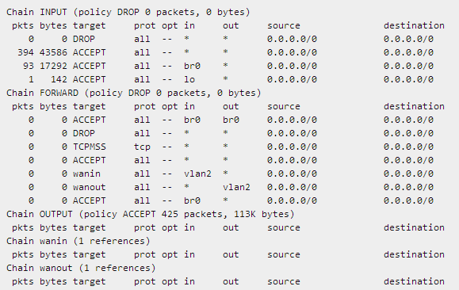

Commands available from the above reference for,
- Delete firewall rules, Insert firewall rules, save firewall rules, restore firewall rules
- Set the firewall policies, drop private network address
- Blocking an incoming IP address, blocking an outgoing IP address, log and drop packets
ICMP and IGMP
The Internet Control Message Protocol (ICMP) is a message control and error-reporting protocol, meaning that it does not carry application data, but rather information about the status of the network itself. ICMP can be used to report,
- Errors in the underlying communications of network applications
- Availability of remote hosts
- Network congestion
Each ICMP message contains three fields that define its purpose and provide a checksum. They are TYPE, CODE, and CHECKSUM fields. The TYPE field identifies the ICMP message, the CODE field provides further information about the associated TYPE field, and the CHECKSUM provides a method for determining the integrity of the message.
Ping uses ICMP for its communication.

The Internet Group Management Protocol (IGMP) provides a mechanism for sending data to a number of different hosts on a network. The hosts are configured as members of the IGMP address group, and receive all packets sent to the group. IGMP is used in one-to-many networking applications such as online streaming video, gaming etc.

IPv6 – IP version 6
IPv6 is the next generation Internet Protocol which replaces the current IPv4. IPv6 uses 128 bit addresses as compared to 32 bit addresses which create more available IP addresses.
In IPv4 there are 4,294,967,296 IP addresses and with IPv6, there are a total of 18,446,744,073,709,551,616 IP addresses
In IPv6, double-colon (::) is used to represent the series of zeroes and this can be used only once.
"2001:0DB8:0000:0003:0000:01FF:0000:002E", it can be written like "2001:DB8::3:0:1FF:0:2E" or "2001:DB8:0:3:0:1FF::2E", and can’t write it like "2001:DB8::3::1ff::2E".

Features
Larger address space – Ipv6 uses 4 times more bits to address a device on the internet.
Simplified Header – Ipv6 has simplified header by moving all unnecessary information to end of IPv6 header.Ipv6 header is twice long as IPv4, even though IPv6 address is 4 times longer.
End-to-End connectivity – can traverse through internet without NAT, so every host can directly communicate with other host on internet.
Auto configuration – supports both stateless and stateful auto configuration mode of host devices. So absences of DHCP servers does not put halt inter segment communication.
Faster forwarding/Routing – Simplified header puts all unnecessary information at the end of the header. All information in first part of the header are adequate for a Router to take routing decision thus making routing decision as quickly as looking at the mandatory header.
IPSec – Initially it was decided for IPv6 to must have IPSec security, making it more secure than IPv4. This feature has now been made optional.
No Broadcast – IPv6 does not have any Broadcast support anymore. It uses multicast to communicate with multiple hosts.
Anycast support – In this mode, multiple interfaces over the Internet are assigned same Anycast IP address. Routers, while routing, sends the packet to the nearest destination.
Unique IP address – Large IP address scheme in IPv6 enables to allocate devices with globally unique IP addresses. This assures that mechanism to save IP addresses such as NAT is not required. So devices can send/receive data between each other.
Fragmentation and checksum – IPv6 routers do not perform fragmentation. IPv6 hosts are required to either perform path MTU discovery, perform end-to-end fragmentation, or to send packets no larger than the IPv6 default MTU size of 1280octets.
The IPv6 header is not protected by a checksum;
Fixed Header
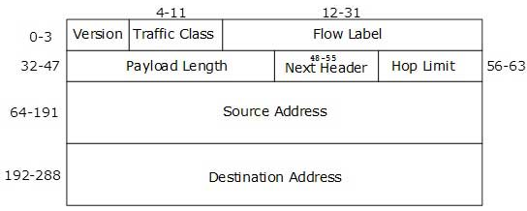
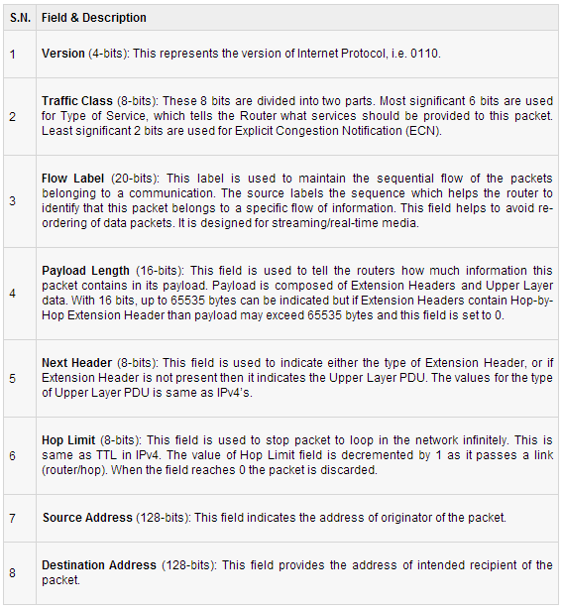

Anycast addressing mode
IPv6 has introduced a new type of addressing, which is called Anycast addressing. In this addressing mode, multiple interfaces (hosts) are assigned same Anycast IP address. When a host wishes to communicate with a host equipped with an Anycast IP address, sends a Unicast message. With the help of complex routing mechanism, that Unicast message is delivered to the host closest to the Sender, in terms of Routing cost.
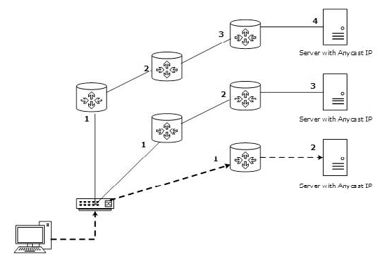

Address Structure
An IPv6 address is made of 128 bits divided into 8 blocks with 16 bits each. Each block is then converted into 4-digit Hexadecimal numbers.
0010000000000001 0000000000000000 0011001000110100 1101111111100001 0000000001100011 0000000000000000 0000000000000000 1111111011111011
Each block is then converted into Hexadecimal and separated by ‘:’ symbol:
2001:0000:3238:DFE1:0063:0000:0000:FEFB
Even after converting into Hexadecimal format, IPv6 address remains long. IPv6 provides some rules to shorten the address. These rules are:
Rule: 1 Discard leading Zero(es):
In Block 5, 0063, the leading two 0s can be omitted, such as (5th block):
2001:0000:3238:DFE1:63:0000:0000:FEFB
Rule: 2 If two of more blocks contains consecutive zeroes, omit them all and replace with double colon sign::, such as (6th and 7th block):
2001:0000:3238:DFE1:63::FEFB
Consecutive blocks of zeroes can be replaced only once by :: so if there are still blocks of zeroes in the address they can be shrink down to single zero, such as (2nd block):
2001:0:3238:DFE1:63::FEFB

Unicast addressing Scope in IPv6
The scope of Link-local address is limited to the segment. Unique Local Address is though locally global but is not routed over the Internet, limiting their scope to an organization’s boundary. Global Unicast addresses are globally unique and recognizable.

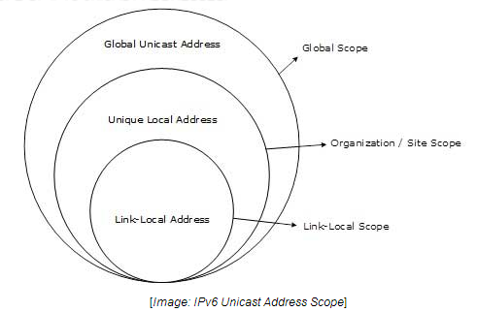
Interface ID (MAC)
IPv6 has three different type of Unicast Address scheme. The last 64 bits are always used for Interface ID. MAC address of a system is composed of 48-bits which is unique and represented in Hexadecimal. Interface ID takes advantage of this uniqueness of MAC addresses. A host can auto-configure its Interface ID by using IEEE’s Extended Unique Identifier (EUI-64) format. First, a Host divides its own MAC address into two 24-bits halves. Then 16-bit Hex value 0xFFFE is sandwiched into those two halves of MAC address, resulting in 64-bit Interface ID.
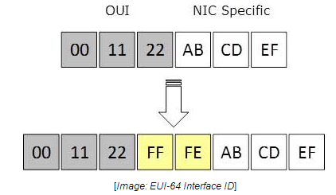

Link – local address
Auto-configured IPv6 address is known as Link-Local address. This address always starts with FE80. First 16 bits of Link-Local address is always set to 1111 1110 1000 0000 (FE80). Next 48-bits are set to 0. Link-Local addresses are used for communication among IPv6 hosts on a link (broadcast segment) only. These addresses are not routable so a Router never forwards these addresses outside the link.
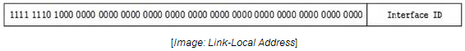
Unique – local address
This type of IPv6 address is though globally unique, but it should be used in local communication. This address has second half of Interface ID and first half is divided among Prefix, Local Bit, Global ID and Subnet ID. Prefix is always set to 1111 110. L bit, which is set to 1 if the address is locally assigned. So far the meaning of L bit to 0 is not defined. Therefore, Unique Local IPv6 address always starts with ‘FD’.

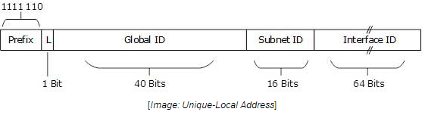
Global Unicast Address
This address type is equivalent to IPv4’s public address. Global Unicast addresses in IPv6 are globally identifiable and uniquely addressable. Global Routing Prefix: The most significant 48-bits are designated as Global Routing Prefix which is assigned to specific Autonomous System. Three most significant bits of Global Routing Prefix is always set to 001.
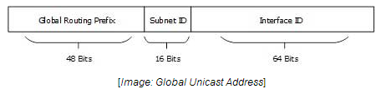
Special Addresses
::/128 –Unspecified address :- 0:0:0:0:0:0:0:0/128 address does not specify to anything and is unspecified address
::/0 – Default route :- 0.0.0.0 with netmask 0.0.0.0 represents default route in IPv4. Same concept applies here 0:0:0:0:0:0:0:0 with netmask all 0s represents default route.
::1/128 – Loopback address :- In IPv4 127.0.0.1 to 127.255.255.255 series represents loopback address. In IPv6 0:0:0:0:0:0:0:1/128 is the loopback address

Extension headers
In IPv6, the Fixed Header contains only information which is necessary and avoiding information which is either not required or is rarely used. All such information, are put between the Fixed Header and Upper layer header in the form of Extension Headers. Each Extension Header is identified by a distinct value.
When Extension Headers are used, IPv6 Fixed Header’s Next Header field points to the first Extension Header. If there is one more Extension Header, then first Extension Header’s ‘Next-Header’ field point to the second one, and so on. The last Extension Header’s ‘Next-Header’ field point to Upper Layer Header. Thus all headers from point to the next one in a linked list manner.
If the Next Header field contains value 59, it indicates that there’s no header after this header, not even Upper Layer Header.
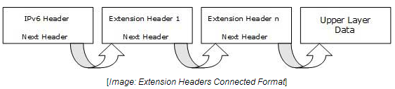

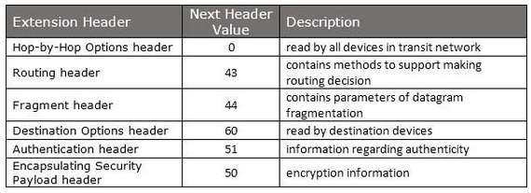

Protocols in IPv6
ICMPv6: Internet Control Message Protocol version 6 is an upgraded implementation of ICMP to accommodate IPv6 requirements. This protocol is used for diagnostic functions, error and information message, statistical purposes. ICMPv6’s Neighbor Discovery Protocol replaces ARP and helps discover neighbor and routers on the link. (No ARP in IPv6)

DHCPv6: Dynamic Host Configuration Protocol version 6 is an implementation of DHCP. Though IPv6 enabled hosts do not require any DHCPv6 Server to acquire IP address as they can be auto-configured. Neither do they need DHCPv6 to locate DNS server because DNS can be discovered and configured via ICMPv6 Neighbor Discovery Protocol. Yet DHCPv6 Server can be used to provide this information.

DNS: There has been no new version of DNS but it is now equipped with extensions to provide support for querying IPv6 addresses. A new AAAA (quad-A) record has been added to reply IPv6 query messages. Now DNS can reply with both IP versions (4 & 6) without any change in query format.
The IPv6 header is not protected by a checksum; integrity protection is assumed to be assured by both link-layer and higher-layer (TCP, UDP, etc.) error detection. UDP/IPv4 may actually have a checksum of 0, indicating no checksum; IPv6 requires UDP to have its own checksum. Therefore, IPv6 routers do not need to recompute a checksum when header fields (such as the time to live (TTL) or hop count) change. This improvement may have been made less necessary by the development of routers that perform checksum computation at link speed using dedicated hardware, but it is still relevant for software-based routers.

SNMP
Simple Network Management protocol (SNMP) is a standard TCP/IP protocol in network management. Network administrators use SNMP to monitor and map network availability, performance, and error rates. Two crucial SNMP concepts are OID (object identifier) and MIB (Management Information Base).
SNMP works by querying “Objects”. An object is simply something that we can gather information about on a network device. For instance, an object might be something like Interface Status.
A MIB is like a translator that helps a Management Station to understand SNMP responses obtained from your network devices. All SNMP compliant devices contain a MIB which supplies the standard set of objects (attributes) of a device. Some attributes are fixed (hard-coded) in the MIB while others are dynamic values calculated by agent software running on the device.

SNMP requires two basic components for its working, a management station and an agent. The management station is simply software that collects information from your network. Most management stations will poll your network for information regularly.
Second, the hardware or software that you want to monitor must have an agent running. The agent collects information, and then sends it to the monitoring station when polled. Agents can also send notification to the management station without being polled.

SNMP provides,
- Provide Read/Write abilities – for example you could use it to reset passwords remotely, or re-configure IP addresses.
- Collect information on how much bandwidth is being used.
- Collect error reports into a log, useful for troubleshooting and identifying trends.
- Email an alert when your server is low on disk space.
- Monitor your servers’ CPU and Memory use, alert when thresholds are exceeded.
- Page or send an SMS text-message when a device fails.
- Can perform active polling, i.e. Monitoring station asks devices for status every few minutes.
- Passive SNMP – devices can send alerts to a monitoring station on error conditions.
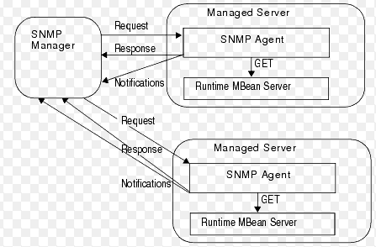

Bridge
A bridge is a device that separates two or more network segments within one logical network (e.g. a single IP-subnet).The job of the bridge is to examine the destination of the data packets one at a time and decide whether or not to pass the packets to the other side of the Ethernet segment. The result is a faster, quieter network with fewer collisions. The bridging code decides whether to bridge data or to drop it not by looking at the protocol type (IP, IPX, NetBEUI), but by looking at the MAC-address unique to each NIC.
19) TCP flags
Some TCP segments carry data while others are simple acknowledgements for previously received data. The popular 3-way handshake utilises the SYNs and ACKs available in the TCP to help complete the connection before data is transferred. As with all flags, a value of '1' means that a particular flag is 'set'. In addition to this, each flag is one bit long, and since there are 6 flags, this makes the Flags section 6 bits in total.

1ST FLAG - URGENT POINTER
The first flag is the Urgent Pointer flag. This flag is used to identify incoming data as 'urgent'. Such incoming segments do not have to wait until the previous segments are consumed by the receiving end but are sent directly and processed immediately.
An Urgent Pointer could be used during a stream of data transfer where a host is sending data to an application running on a remote machine. If a problem appears, the host machine needs to abort the data transfer and stop the data processing on the other end. Under normal circumstances, the abort signal will be sent and queued at the remote machine until all previously sent data is processed, however, in this case, we need the abort signal to be processed immediately.
By setting the abort signal's segment Urgent Pointer flag to '1', the remote machine will not wait till all queued data is processed and then execute the abort. Instead, it will give that specific segment priority, processing it immediately and stopping all further data processing.

2ND FLAG - ACKNOWLEDGEMENT
The ACKnowledgement flag is used to acknowledge the successful receipt of packets.
If you run a packet sniffer while transferring data using the TCP, you will notice that for every packet you send or receive, an ACKnowledgement follows. So if you received a packet from a remote host, then your workstation will most probably send one back with the ACK field set to "1".
In some cases where the sender requires one ACKnowledgement for every 3 packets sent, the receiving end will send the ACK expected once (the 3rd sequential packet is received). This is also called Windowing.

3RD FLAG - PUSH
The Push flag, like the Urgent flag, exists to ensure that the data is given the priority (that it deserves) and is processed at the sending or receiving end. This particular flag is used quite frequently at the beginning and end of a data transfer, affecting the way the data is handled at both ends. Push flag is usually set on the last segment of a file to prevent buffer deadlocks. It is also seen when used to send HTTP or other types of requests through a proxy - ensuring the request is handled appropriately and effectively.

4TH FLAG - RESET (RST) FLAG
The reset flag is used when a segment arrives that is not intended for the current connection. In other words, if you were to send a packet to a host in order to establish a connection, and there was no such service waiting to answer at the remote host, then the host would automatically reject your request and then send you a reply with the RST flag set. This indicates that the remote host has reset the connection.

5TH FLAG - SYNCHRONISATION FLAG
The SYN flag is initially sent when establishing the classical 3-way handshake between two hosts:
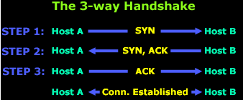
In the above diagram, Host A needs to download data from Host B using TCP as its transport protocol. The protocol requires the 3-way handshake to take place so a virtual connection can be established by both ends in order to exchange data.
During the 3-way handshake we are able to count a total of 2 SYN flags transmitted, one by each host. As files are exchanged and new connections created

6TH FLAG - FIN FLAG
The final flag available is the FIN flag, standing for the word FINished. This flag is used to tear down the virtual connections created using the previous flag (SYN), so because of this reason, the FIN flag always appears when the last packets are exchanged between a connections.
It is important to note that when a host sends a FIN flag to close a connection, it may continue to receive data until the remote host has also closed the connection, although this occurs only under certain circumstances. Once the connection is teared down by both sides, the buffers set aside on each end for the connection are released.
20) VLAN
VLAN's allow a network manager to logically segment a LAN into different broadcast domains.
This is a logical segmentation and not physical, workstations do not have to be physically located together.
VLAN's also allow broadcast domains to be defined without using routers. Bridging software is used instead to define which workstations are to be included in the broadcast domain. Routers would only have to be used to communicate between two VLAN's.

How it works
When a LAN bridge receives data from a workstation, it tags the data with a VLAN identifier indicating the VLAN from which the data came. This is called explicit tagging.
It is also possible to determine to which VLAN the data received belongs using implicit tagging. In implicit tagging the data is not tagged, but the VLAN from which the data came is determined based on other information like the port on which the data arrived.

Types of VLAN
VLAN membership by port
VLAN membership by MAC address
VLAN membership by Protocol type
VLAN membership by subnet address
Tagging can be based on the port from which it came, the source Media Access Control (MAC) field, the source network address, or some other field or combination of fields. VLAN's are classified based on the method used. To be able to do the tagging of data using any of the methods, the bridge would have to keep an updated database containing a mapping between VLAN's and whichever field is used for tagging.
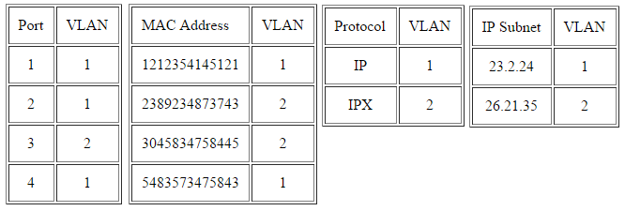

Types of connections
Trunk Link
All the devices connected to a trunk link, including workstations, must be VLAN-aware. All frames on a trunk link must have a special header attached. These special frames are called tagged frames.
Access Link
An access link connects a VLAN-unaware device to the port of a VLAN-aware bridge. All frames on access links must be implicitly tagged (untagged). The VLAN-unaware device can be a LAN segment with VLAN-unaware workstations or it can be a number of LAN segments containing VLAN-unaware devices.
Hybrid Link
This is a combination of the previous two links. This is a link where both VLAN-aware and VLAN-unaware devices are attached. A hybrid link can have both tagged and untagged frames, but all the frames for a specific VLAN must be either tagged or untagged.

Advantages of VLAN
Performance
VLAN's can reduce the broadcasts and multicasts traffic to unnecessary destinations.
Formation of virtual groups
Simplified Administration
Reduced cost
Eliminates the need for routers
Security
Sensitive data which is broadcasted can be restricted to only intended users.

Line rate and bit rate
The line rate is a physical layer term that has nothing to do with the line cards or switching fabrics. It indicates the actual speed with which the bits are sent onto the wire. The data transfer rate or bit rate is the transfer rate offered by the physical layer to the data link layer. To be precise, you should call it physical layer net bit rate.

22) TCP/IP model functioning
- Connection oriented - A connection is made between two endpoints (local and remote) and then data is transferred. The "TCP connection identifier" is a combination of addresses of the two endpoints,
<local IP address, local port number, remote IP address, remote port number>
- Bidirectional Byte stream – data communication is made by using byte stream
- In-order delivery – A receiver receives data in the order of sending data from a sender. To mark this order 32-type integer data type is used.
- Reliability through ACK – When the sender didn’t receive ACK from a receiver, the sender re-sends the data.
- Flow control – A sender sends as much data as a receiver can afford. A receiver sends maximum of bytes that receiver can receiver to the sender (buffer size, receive window).
- Congestion control – This is separate from receive window to prevent congestion. Like the receive window, the sender sends as much data as the size of bytes that the receiver's congestion window using algorithms – TCP vegas, CUBIC, RENO

Data transmission
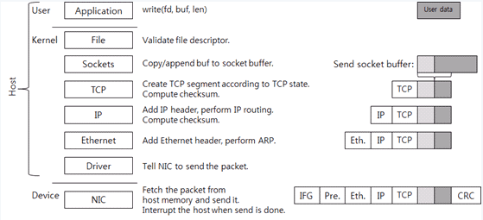
- The user area and kernel area called host which is separate from device area.
- The application creates data to send and then calls write() system call to send the data
- Socket is created and when the system call executed, switched to kernel area
- The kernel socket has 2 buffers – send & receive socket buffer
- In write system call, data in user area is copied to kernel memory and added to end of send socket buffer.
- The TCP control block (TCB) is connected to socket. TCB is required for TCP processing. Data in TCB are connection state (listen, establish, time wait), receive window, congestion window, sequence number, resending timer.
- If TCP state allows for data transmission, a new TCP segment (packet) is created. If data transmission is not possible, the system call ends and returns back to user mode.

The 2 segments in TCP are TCP header and payload
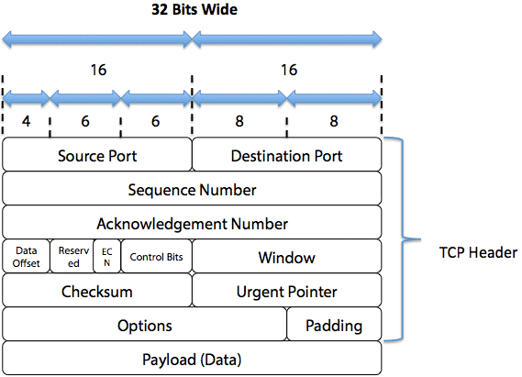
The maximum length of the payload is the maximum value among the receive window, congestion window, and maximum segment size (MSS).
TCP checksum is computed. In this checksum computation, pseudo header information (IP addresses, segment length, and protocol number) is included. The current network stack uses the checksum offload, the TCP checksum is computed by NIC, not by the kernel. However, we assume that the kernel computes the TCP checksum.
The created TCP segment goes down to the IP layer. The IP layer adds an IP header to the TCP segment and performs IP routing. IP routing is a procedure of searching the next hop IP in order to go to the destination IP.
After the IP layer has computed and added the IP header checksum, it sends the data to the Ethernet layer. The Ethernet layer searches for the MAC address of the next hop IP by using the Address Resolution Protocol (ARP). It then adds the Ethernet header to the packet. The host packet is completed by adding the Ethernet header.
After receiving the packet transmission request, the NIC copies the packets from the main memory to its memory and then sends it to the network line. At this time, by complying with the Ethernet standard, it adds the IFG (Inter-Frame Gap), preamble, and CRC to the packet. The IFG and preamble are used to distinguish the start of the packet and the CRC is used to protect the data. Packet transmission is started based on the physical speed of the Ethernet and the condition of Ethernet flow control.
When an NIC sends a packet, the NIC generates interrupts on the host CPU. Every interrupt has its own interrupt number. The driver registers a function to handle the interrupt. The OS calls the interrupt handler and then the interrupt handler returns the transmitted packet to the OS.

Data receiving

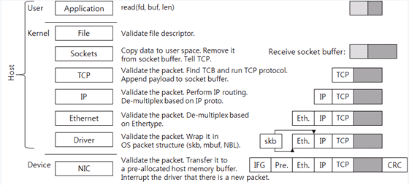
First, the NIC writes the packet onto its memory. It checks whether the packet is valid by performing the CRC check and then sends the packet to the memory buffer of the host. After the buffer has been allocated, the driver tells the memory address and size to the NIC. When there is no memory buffer allocated by the driver even though the NIC receives a packet, the NIC may drop the packet.
After sending the packet to the host memory buffer, the NIC sends an interrupt to the host OS. Then, the driver checks whether it can handle the new packet or not.
When the driver should send a packet to the upper layer, the packet must be wrapped in a packet structure that the OS uses for the OS to understand the packet. For example, sk_buff of Linux, The driver sends the wrapped packets to the upper layer.
The Ethernet layer checks whether the packet is valid and then de-multiplexes the upper protocol (network protocol). At this time, it uses the ethertype value of the Ethernet header. The IPv4 ethertype value is 0x0800. It removes the Ethernet header and then sends the packet to the IP layer.
The IP layer also checks whether the packet is valid. In other words, it checks the IP header checksum. It logically determines whether it should perform IP routing and make the local system handle the packet, or send the packet to the other system. If the packet must be handled by the local system, the IP layer de-multiplexes the upper protocol (transport protocol) by referring to the proto value of the IP header. The TCP proto value is 6. It removes the IP header and then sends the packet to the TCP layer.
Like the lower layer, the TCP layer checks whether the packet is valid. It also checks the TCP checksum. As mentioned before, since the current network stack uses the checksum offload, the TCP checksum is computed by NIC, not by the kernel.
Then it searches the TCP control block where the packet is connected. At this time, <source IP, source port, target IP, target port> of the packet is used as an identifier. After searching the connection, it performs the protocol to handle the packet. If it has received new data, it adds the data to the receive socket buffer. According to the TCP state, it can send a new TCP packet (for example, an ACK packet). Now TCP/IP receiving packet handling has completed.
The size of the receive socket buffer is the TCP receive window. To a certain point, the TCP throughput increases when the receive window is large. In the past, the socket buffer size had been adjusted on the application or the OS configuration. The latest network stack has a function to adjust the receive socket buffer size, i.e., the receive window, automatically.
When the application calls the read system call, the area is changed to the kernel area and the data in the socket buffer is copied to the memory in the user area. The copied data is removed from the socket buffer. And then the TCP is called. The TCP increases the receive window because there is new space in the socket buffer. And it sends a packet according to the protocol status. If no packet is transferred, the system call is terminated.
Control flow in stack
Flow (1) an application calls a system call to execute the TCP. For example, calls the read system call and the write system call and then executes TCP. However, there is no packet transmission.

Flow (2) is same as Flow (1) if it requires packet transmission after executing TCP. It creates a packet and sends down the packet to the driver. A queue is in front of the driver. The packet comes into the queue first, and then the queue implementation structure decides the time to send the packet to the driver. This is queue discipline (qdisc) of Linux. The function of Linux traffic control is to manipulate the qdisc. The default qdisc is a simple First-In-First-Out (FIFO) queue.
Flow (3) shows the case in which the timer used by the TCP has expired. For example, when the TIME_WAIT timer has expired, the TCP is called to delete the connection.

Like Flow (3), Flow (4) is the case in which the timer used by the TCP has expired and the TCP execution result packet should be transmitted. For example, when the retransmit timer has expired, the packet of which ACK has not been received is transmitted.

When the NIC driver receives an interrupt, it frees the transmitted packet. In most cases, execution of the driver is terminated here. Flow (5) is the case of packet accumulation in the transmit queue. The driver requests softirq and the softirq handler executes the transmit queue to send the accumulated packet to the driver.
When the NIC driver receives an interrupt and finds a newly received packet, it requests softirq. The softirq that processes the received packet calls the driver and transmits the received packet to the upper layer. In Linux, processing the received packet as shown above is called New API (NAPI). It is similar to polling because the driver does not directly transmit the packet to the upper layer, but the upper layer directly gets the packet.
Flow (6) shows the case that completes execution of TCP, and Flow (7) shows the case that requires additional packet transmission. All of Flow (5), (6), and (7) are executed by the softirq which has processed the NIC interrupt.
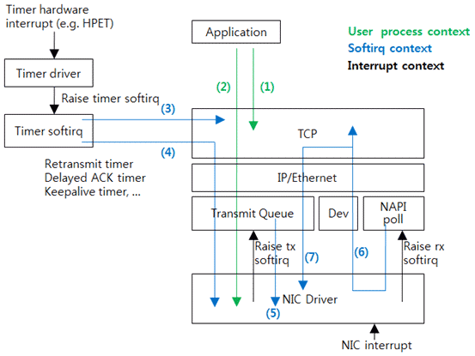
Process Interrupt and received packet
Assume that the CPU 0 is executing an application program. At this time, the NIC receives a packet and generates an interrupt for the CPU 0. Then the CPU executes the kernel interrupt (called irq) handler. This handler refers to the interrupt number and then calls the driver interrupt handler. The driver frees the packet transmitted and then calls the napi_schedule() function to process the received packet. This function requests the softirq (software interrupt).

After the interrupt context has been executed, the softirq context will be executed. The interrupt context and the softirq context are executed by an identical thread. However, they use different stacks. And, the interrupt context blocks hardware interrupts; however, the softirq context allows for hardware interrupts.
The softirq handler that processes the received packet is the net_rx_action() function. This function calls the poll() function of the driver. The poll() function calls the netif_receive_skb() function and then sends the received packets one by one to the upper layer. After processing the softirq, the application restarts execution from the stopped point in order to request a system call.
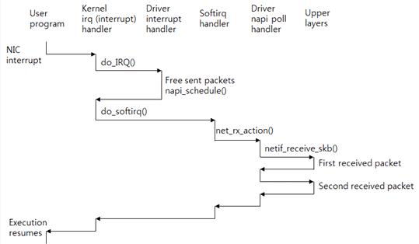
Data structure
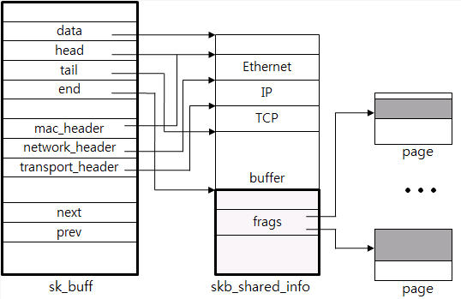

The sk_buff structure means a packet shown in the figure above.
The structure includes the packet data using a pointer. Some of the packets (from Ethernet to buffer) refer to using the data pointer and the additional data (frags) refer to the actual page.
The necessary information such as header and payload length is saved in the meta data area. The mac_header, the network_header, and the transport_header have the corresponding pointer data that points the starting position of the Ethernet header, IP header and TCP header, respectively. This way makes TCP protocol processing easy.
The header is added or deleted as up and down each layer of the network stack. Pointers are used for more efficient processing. For example, to remove the Ethernet header, just increase the head pointer.
The linked list is used for execution of tasks such as adding or deleting packet payload data to the socket buffer, or packet chain. The next pointer and the prev pointer are used for this purpose.
As a structure is allocated whenever creating a packet, the quick allocator is used. For example, if data is transmitted at the speed of 10-Gigabit Ethernet, more than one million packets per second must be created and deleted.
TCB control block
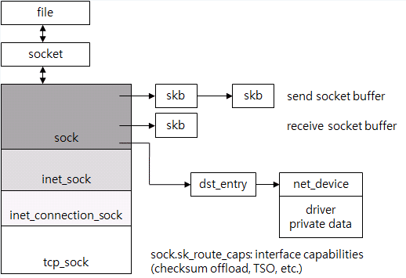
This TCB control block represents the TCP connection, also known as TCP control block.
When a system call has occurred, it searches the file in the file descriptor used by the application that has called the system call. In Linux, the socket, the file and the device for general file system for storage are abstracted to a file. For a socket, a separate socket structure saves the socket-related information and the file refers to the socket as a pointer. The socket refers to the tcp_sock again. The tcp_sock is classified into sock, inet_sock, etc to support various protocols except TCP. It may be considered as a kind of polymorphism.
All status information used by the TCP protocol is saved in the tcp_sock. The sequence number, receive window, congestion control, and retransmit timer are saved in the tcp_sock.
The send socket buffer and the receive socket buffer are the sk_buff lists and they include the tcp_sock. The dst_entry, the IP routing result, is referred to in order to avoid too frequent routing. The dst_entry allows for easy search of the ARP result, i.e., the destination MAC address. The dst_entry is part of the routing table. The NIC to be used for packet transmission is searched by using the dst_entry. The NIC is expressed as the net_device structure.
Therefore, by searching just the file, it is very easy to find all structures (from the file to the driver) required to process the TCP connection with the pointer. The size of the structures is the memory size used by one TCP connection. The memory size is a few KBs (excluding the packet data). As more functions have been added, the memory usage has been gradually increased.
Finally, let's see the TCP connection lookup table. It is a hash table used to search the TCP connection where the received packet belongs. The hash value is calculated by using the input data of <source IP, target IP, source port, target port> of the packet and the Jenkins hash algorithm. It is told that the hash function has been selected by considering defense against attacks to the hash table.

