Ethernet packet and frame structure
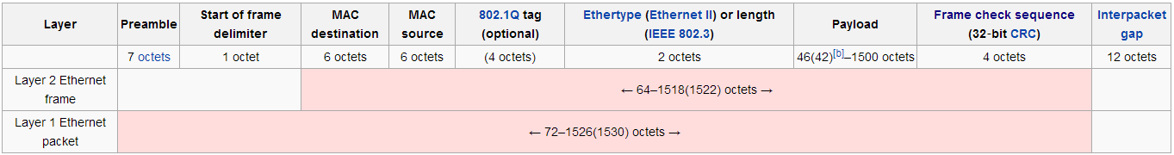

A data packet on an Ethernet link is called an Ethernet packet which transports an Ethernet frame as payload.
Note: Transport layer -> segment
Network layer -> packet
Data Link layer -> frame
Physical layer -> bits and in the top layers, it will be just data.

Data on Ethernet is transmitted most-significant octet (byte) first. Within each octet, however, the least-significant bit is transmitted first.

Preamble and start frame delimiter
An Ethernet frame starts with a 7-octet preamble and 1-octet start frame delimiter (SFD), both of which are part of the Ethernet packet enveloping the frame. On-the-wire bit pattern for this portion of the frame is 10101010 10101010 10101010 10101010 10101010 10101010 10101010 10101011. Since octets are transmitted least-significant bit first, the corresponding hexadecimal representation is 0x55 0x55 0x55 0x55 0x55 0x55 0x55 0xD5 (preamble and SFD)

The SFD is 1-byte value marking the end of the preamble, which is the first field of an Ethernet packet, and indicating the beginning of the Ethernet frame. SFD has the value of 171 (10101011 in binary notation), which is transmitted with least-significant bit first as 213 (11010101) (0xD5)

The preamble of an Ethernet packet consists of a 56-bit (7-byte) pattern of alternating 1 and 0 bits, which allows devices on the network to easily detect a new incoming frame. The SFD is designed to break this pattern and signal the start of the actual frame.

Physical layer transceiver chips (PHYs for short) are necessary to connect the Ethernet MAC to the physical medium. The connection between a PHY and MAC is independent of the physical medium and uses a bus from the media independent interface family.
Fast Ethernet transceiver chips utilize the MII bus, which is a 4-bit (one nibble) wide bus, therefore the preamble is represented as 14 instances of 0x5, and the start frame delimiter is 0x5 0xD (as nibbles). Gigabit Ethernet transceiver chips use the GMII bus, which is an 8-bit wide interface, thus the sequence would be 0x55 0x55 0x55 0x55 0x55 0x55 0x55 0xD5 (as bytes).

Header – MAC header (not IP or TCP header), ether type field, VLAN tag
The header features destination and source MAC addresses (each six octets in length).
The EtherType field is two octets long and it can be used for two different purposes. The values of 1500 and below mean that it is used to indicate the size of the payload in octets, while values of 1536 and above indicate which protocol is encapsulated in the payload of the frame. When used as EtherType, the length of the frame is determined by the location of the interpacket gap and validframe check sequence (FCS).
The IEEE 802.1Q tag, is a four-octet field that indicates Virtual LAN (VLAN) membership.

MAC Address (also known as hardware address or physical address) is a 6 byte address assigned by the IEEE Standards Association and is unique for every Ethernet device ever manufactured.
The first three bytes are the OUI (Organizationally Unique Identifier) the second three bytes is a unique identifier assigned by the vendor
Manufacturer burns MAC inside the NIC.
Ethernet makes frames, writes MAC into each as source.
MAC is read-only and frame is read-write.
Broadcast: A MAC with all bits set FF FF FF FF FF FF is a BROADCAST. It is received by all devices on the Ethernet segment
Multicast: A MAC address with the least significant bit of the most significant byte set is a MULTICAST address. 01 00 00 00 00 00 00
Change in MAC: The second least significant bit of the first byte is the "Locally Administrated" bit. This bit is always set to 0 for all assigned OIDs.
01 00 00 00 00 00 00 and when MAC changes it becomes 01 00 00 00 00 00 02
The purpose of this bit is that if you change your MAC address you should also set this bit to 1 in the new MAC address so that it is clear it is not a factory default MAC address.
Note:
- Ethernet frames are always displayed from most significant to least significant.
- In actual transmission, each byte is transmitted from least significant bit to most significant bit.
- host byte order - MSB to LSB - little endian
- network byte order - LSB to MSB - big endian
- All higher level protocols sent over Ethernet are encapsulated in an Ethernet frame
- To address a particular network node you must have the hardware MAC address

Payload
The minimum payload is 42 octets when VLAN tag is present and 46 octets when absent. The maximum payload is 1500 octets. Jumbo frames allow for larger maximum payload size. MTU more than 1500 are jumbo frames.

Frame check sequence

The frame check sequence (FCS) is a 4-octet cyclic redundancy check which allows detection of corrupted data within the entire frame. Running the FCS algorithm over the received frame data including the FCS will always result in the magic number or CRC32 residue 0xC704DD7B when data has been transmitted correctly. This allows for receiving a frame and validating the FCS without knowing where the FCS field actually starts.

FCS refers to error-detecting code added to a frame in the communication protocol. Error-detection does not also mean error recovery.
Ethernet defines that the error frame should be discarded, but Ethernet takes no action to cause the frame to be retransmitted. Other protocols, notably TCP, can notice the lost data and cause error recovery to occur.

Interpacket Gap (Not the part of Ethernet frame)

Interpacket gap is idle time between packets. After a packet has been sent, transmitters are required to transmit a minimum of 96 bits (12 octets) of idle line state before transmitting the next packet.

Ethernet II framing
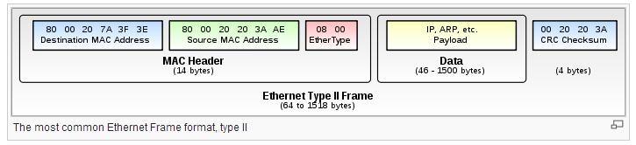
Ethernet II framing defines the two-octet EtherType field in an Ethernet frame, preceded by destination and source MAC addresses, that identifies an upper layer protocol encapsulating the frame data.
EtherType value: 0x0800 -> IPv4 datagram.
EtherType value: 0x0806 -> ARP frame
EtherType value: 0x8100 -> IEEE 802.1Q frame (VLAN)
EtherType value: 0x86DD -> IPv6 frame
EtherType value: 0x8137 -> Novell IPX

Ethernet packet frame for the TCP
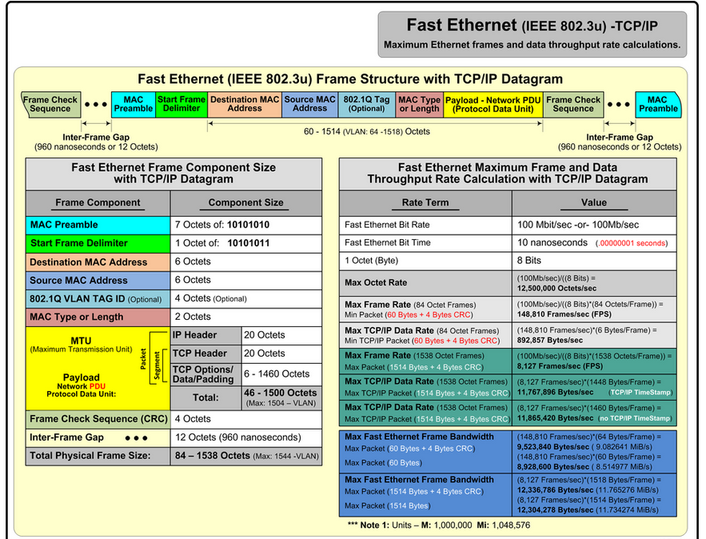

Ethernet packet frame for the UDP
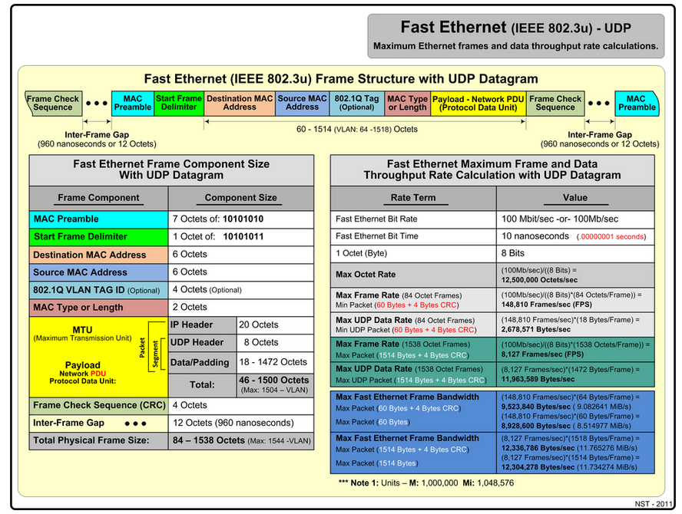

TCP header
TCP Header
Offsets | Octet | 0 |  |  |  |  |  |  |  | 1 |  |  |  |  |  |  |  | 2 |  |  |  |  |  |  |  | 3
Octet | Bit | 0 | 1 | 2 | 3 | 4 | 5 | 6 | 7 | 8 | 9 | 10 | 11 | 12 | 13 | 14 | 15 | 16 | 17 | 18 | 19 | 20 | 21 | 22 | 23 | 24 | 25 | 26 | 27 | 28 | 29 | 30 | 31
0 | 0 | Source port |  |  |  |  |  |  |  |  |  |  |  |  |  |  |  | Destination port
4 | 32 | Sequence number
8 | 64 | Acknowledgment number (if ACK set)
12 | 96 | Data offset |  |  |  | Reserved  0 0 0 |  |  | N  S | C  W  R | E  C  E | U  R  G | A  C  K | P  S  H | R  S  T | S  Y  N | F  I  N | Window Size
16 | 128 | Checksum |  |  |  |  |  |  |  |  |  |  |  |  |  |  |  | Urgent pointer (if URG set)
20  ... | 160  ... | Options (if data offset > 5. Padded at the end with "0" bytes if necessary.)  ...

IPv4 Header
IPv4 Header Format
Offsets | Octet | 0 |  |  |  |  |  |  |  | 1 |  |  |  |  |  |  |  | 2 |  |  |  |  |  |  |  | 3
Octet | Bit | 0 | 1 | 2 | 3 | 4 | 5 | 6 | 7 | 8 | 9 | 10 | 11 | 12 | 13 | 14 | 15 | 16 | 17 | 18 | 19 | 20 | 21 | 22 | 23 | 24 | 25 | 26 | 27 | 28 | 29 | 30 | 31
0 | 0 | Version |  |  |  | IHL |  |  |  | DSCP |  |  |  |  |  | ECN |  | Total Length
4 | 32 | Identification |  |  |  |  |  |  |  |  |  |  |  |  |  |  |  | Flags |  |  | Fragment Offset
8 | 64 | Time To Live |  |  |  |  |  |  |  | Protocol |  |  |  |  |  |  |  | Header Checksum
12 | 96 | Source IP Address
16 | 128 | Destination IP Address
20 | 160 | Options (if IHL > 5)

IPv4 addresses
The 32 bits of the IPv4 address are broken into 4 octets, or 8 bit fields.
For networks of different size, the first one (for large network) to three (for small networks) octets can be used to identify the network, while the rest of the octets can be used to identify the node of the network.

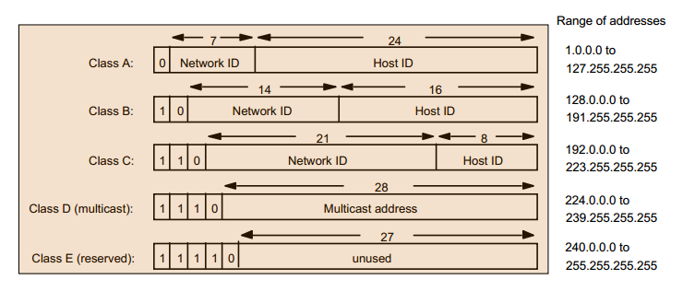

Wireshark
Small portion of the capture from opening wireshark.org in a web browser
- No. Time Source Destination Protocol Info
- 1 0.000000 192.168.2.3 mail.packet0.com TCP 1061 > http [SYN] Seq=0 Ack=0 Win=16384 Len=0 MSS=1460
- 2 0.063590 mail.packet0.com 192.168.2.3 TCP http > 1061 [SYN, ACK] Seq=0 Ack=1 Win=5840 Len=0 MSS=1380
- 3 0.063665 192.168.2.3 mail.packet0.com TCP 1061 > http [ACK] Seq=1 Ack=1 Win=16560 Len=0
- 4 0.064056 192.168.2.3 mail.packet0.com HTTP GET / HTTP/1.1
- 5 0.163470 mail.packet0.com 192.168.2.3 TCP http > 1061 [ACK] Seq=1 Ack=399 Win=6432 Len=0
- 6 0.193849 mail.packet0.com 192.168.2.3 HTTP HTTP/1.1 200 OK (text/html)
- 7 0.201317 mail.packet0.com 192.168.2.3 HTTP Continuation
- 8 0.201408 192.168.2.3 mail.packet0.com TCP 1061 > http [ACK] Seq=399 Ack=2761 Win=16560 Len=0
- 9 0.208895 192.168.2.3 mail.packet0.com TCP 1062 > http [SYN] Seq=0 Ack=0 Win=16384 Len=0 MSS=1460
- 10 0.280617 mail.packet0.com 192.168.2.3 HTTP Continuation
- 11 0.287876 mail.packet0.com 192.168.2.3 HTTP Continuation

Display Filter
Some useful filters:
Filter |  | Traffic Description
 | eth |  | all Ethernet based
 | eth.addr==08.00.08.15.ca.fe |  | to and from Ethernet MAC address 08:00:08:15:ca:fe
 | !(eth.addr==08.00.08.15.ca.fe) |  | all except to and from Ethernet MAC address 08:00:08:15:ca:fe
 | eth.dst==ff:ff:ff:ff:ff:ff |  | Ethernet Broadcast only
 | eth.dst!=ff:ff:ff:ff:ff:ff |  | all except Ethernet Broadcast
 | (eth.dst[0] & 1) |  | Ethernet Multicast only (least significant bit of first address byte set)
 | !(eth.dst[0] & 1) |  | all except Ethernet Multicast (least significant bit of first address byte not set)
 | Ether multicast |  | Ethernet multicast traffic only
 | Ether broadcast |  | Ethernet broadcast only
 | (ether[0:4]>=0x00804400 and ether[0:4]<=0x008044ff) or (ether[6:4]>=0x00804400 and ether[6:4]<=0x008044ff) |  | Ethernet traffic to/from a range of addresses

