Virtual File System (VFS)
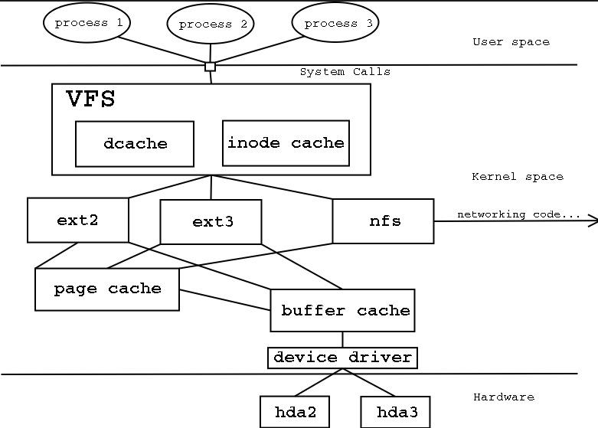

Virtual file system is an abstraction layer on top of concrete file system. The purpose of VFS is to allow applications to access different types of file systems (ext2, ext3, nfs) in a uniform way. It can be used to bridge the differences in Windows, Mac OS and Unix filesystems, so that applications can access files on local file systems of those types without having to know what type of file system they are accessing.

Single-file virtual file system
Sometimes Virtual File System refers to a file or a group of files that acts as a manageable container which should provide the functionality of a concrete file system through the usage of software.
The primary benefit for this type of file system is that it is centralized and easy to remove. A single-file virtual file system may include all the basic features of any file system (virtual or otherwise), but access to the internal structure of these file systems is often limited to programs specifically written to make use of the single-file virtual file system.
Virtual Memory
Linux supports virtual memory which is a disk as an extension of RAM so that the effective size of usable memory grows.
The kernel will write the currently unused block of memory to the hard disk so that the memory can be used for another purpose. When the original contents are needed again, they are read back into memory. Reading and writing always from the hard disk is slower than using real memory, so the programs don't run as fast. The part of the hard disk that is used as virtual memory is called the swap space.
Difference between swapping (writing the whole process out to swap space) and paging (writing only fixed size parts, usually kbs at a time). Paging is usually more efficient, and that's what Linux does.

Shared Virtual memory
Although virtual memory allows processes to have separate (virtual) address spaces, there are times when you need processes to share memory.
For example, there could be many processes in the system running in the bash shell. Rather than have several copies of bash, one in each processes virtual address space, it is better to have only one copy in physical memory and all of the processes running on bash share it.
Dynamic libraries are another common example of executing code shared between several processes.
Abstract model of virtual memory
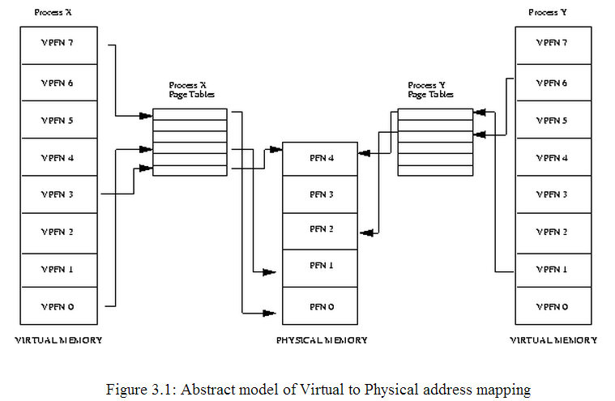
- As processor executes program, it reads an instruction from memory and decodes it. In decoding the instruction it may need to fetch or store the contents of a location in memory. This way processor is always fetching and storing data.
- In virtual memory system all the addresses are virtual addresses and not physical addresses. These virtual addresses are then converted into physical addresses by the processor
- To make this translation easier, virtual and physical memory are divided into fixed chunks called pages. These pages are all the same size of 4 Kbyte pages. Each of these pages is given a unique number; the page frame number (PFN).
- In this paged model, a virtual address is composed of two parts; an offset and a virtual page frame number. If the page size is 4 Kbytes, bits 11:0 of the virtual address contain the offset and bits 12 and above are the virtual page frame number. Each time the processor encounters a virtual address it must extract the offset and the virtual page frame number. The processor must translate the virtual page frame number into a physical one and then access the location at the correct offset into that physical page. To do this the processor uses page tables.
Above figure shows the virtual address spaces of two processes, process X and process Y, each with their own page tables.
- The processor uses the virtual page frame number as an index into the processes page table to retrieve its page table entry. If the page table entry at that offset is valid, the processor takes the physical page frame number from this entry. If the entry is invalid, the processor cannot resolve the address and must pass control to the operating system so that it can fix things up. This is known as a page fault and the operating system is notified of the faulting virtual address and the reason for the page fault.

Demand Paging
The physical memory is less than virtual memory, the operating system must be careful, not uses the physical memory inefficiently. One way to save physical memory is to only load virtual pages that are currently being used by the executing program. This technique is known as demand paging.
When a process attempts to access a virtual address that is not currently in memory the processor cannot find a page table entry for the virtual page referenced. At this point the processor notifies the operating system that a page fault has occurred.
If the faulting virtual address is invalid this means that the process has attempted to access a virtual address that it should not have. If the faulting virtual address was valid but the page that it refers to is not currently in memory, the operating system must bring the appropriate page into memory from the image on disk.
Linux uses demand paging to load executable images into a processes virtual memory. Whenever a command is executed, the file containing it is opened and its contents are mapped into the processes virtual memory. This is done by modifying the data structures describing this processes memory map and is known as memory mapping. However, only the first part of the image is actually brought into physical memory. The rest of the image is left on disk. As the image executes, it generates page faults and Linux uses the processes memory map in order to determine which parts of the image to bring into memory for execution.

Swapping
If a process needs to bring a virtual page into physical memory and there are no free physical pages available, the operating system must make room for this page by discarding another page from physical memory.

If the page to be discarded from physical memory came from an image or data file and has not been written to then the page does not need to be saved. Instead it can be discarded and if the process needs that page again it can be brought back into memory from the image or data file.
However, if the page has been modified, the operating system must preserve the contents of that page so that it can be accessed at a later time. This type of page is known as a dirty page and when it is removed from memory it is saved in a special sort of file called the swap file.

If the algorithm used to decide which pages to discard or swap, the swap algorithm is not efficient then a condition known as thrashing occurs. In this case, pages are constantly being written to disk and then being read back and the operating system is too busy to allow much real work to be performed.

Linux uses a Least Recently Used (LRU) page aging technique to fairly choose pages which might be removed from the system. This scheme involves every page in the system having an age which changes as the page is accessed. The more that a page is accessed, the younger it is; the less that it is accessed the older and more stale it becomes. Old pages are good candidates for swapping.

IRQ balancing
Reference : https://we.riseup.net/riseup+tech/balancing-hardware-interrupts
Irqbalance is the Linux utility with making sure that interrupts from your hardware devices are handled in as efficient a manner (meaning every cpu handles the interrupt work), at the same time no single cpu is tasked with a inappropriately large amount of work.

Problem with IRQ balancing
In order to achieve the best performance, it is recommended that all the interruptions generated by a device queue are handled by the same CPU, instead of IRQ balancing. Round robin IRQ distribution is not good for performance because when the interruption goes to another CPU, the new CPU probably will not have the interrupt handler function in the cache, and a long time will be required to get the properly interrupt handler from the main memory and run it.

BUT interrupt processing doesn’t use much data, so spreading interrupts across CPUs doesn’t result in much cache misses, so it might be a win to spread them out across CPUs. BUT there is problem for a network controller processing packets; state about the connection (like tcp objects, etc) is already loaded in the cache of one CPU. So if interrupts for the NIC move between CPUs that can be inefficient for the same reasons listed above.

1. Solution
MSI-X and modern NICs have the ability to have multiple queues per NIC, with each queue getting its own interrupt. Packets are assigned to queues according to a hash based on the pair of IP addresses/ports communicating. So then all packets for a particular connection will always go to the same queue/interrupt. Which allows us to map interrupts to particular CPUs and spread out the load without cache misses?

2. Solution
If the same CPU handles the same IRQ almost all the time, the IRQ handler function stays in the CPU cache, boosting the kernel performance. In order to disable the irqbalance tool, the following command should stop it.
# service irqbalance stop

If disabling this daemon is a very drastic change, then it is possible to disable irqbalance only for those CPUs that have an IRQ bound, and leave the IRQ balance enabled on all other CPUs. This can be done by editing the file /etc/sysconfig/irqbalance, and changing the IRQBALANCE_BANNED_CPUS option.
3. Solution -- SMP IRQ Affinity

By default, all hardware interrupts end up getting serviced by CPU 0. This can result in bottlenecks and reduced performance. In order to bind an interrupt line to a CPU, kernel provides scheme on the /proc interface which was created to allow the user to choose which group of processors will handle a specific interrupt line. The /proc/<IRQ number>/smp_affinity can be changed to set a bitmask to control which CPU interrupts go it any time on the-fly.
The default is all bits set (some number of "f"’s depending on how many cpus you have) which should spread interrupts across all CPUs.
Assuming there are 4 CPUs. And we would like to bind CPU 0 and 2 for IRQ 24,
Binary Hex
CPU 0 0001 1
CPU 1 0010 2
CPU 2 0100 4
CPU 3 1000 8

Binary Hex
CPU 0 0001 1
+ CPU 2 0100 4
-----------------------
both 0101 5

[root@archimedes /proc]# echo 5 > /proc/irq/24/smp_affinity
[root@archimedes /proc]# cat /proc/irq/24/smp_affinity
00000101
----------------------------------------------------------------------------------------------------------------
Here we are assigning 0f, which means interrupt is assigned to CPU0-3

[root@moon 44]# echo 0f > smp_affinity
[root@moon 44]# cat smp_affinity
0000000f
[root@moon 44]# ping -f h
PING hell (195.4.7.3): 56 data bytes
...
--- hell ping statistics ---
6029 packets transmitted, 6027 packets received, 0% packet loss
round-trip min/avg/max = 0.1/0.1/0.4 ms
[root@moon 44]# cat /proc/interrupts | grep 'CPU\|44:'
CPU0 CPU1 CPU2 CPU3 CPU4 CPU5 CPU6 CPU7
44: 1068 1785 1785 1783 0 0 0 0 IO-APIC-level eth1

----------------------------------------------------------------------------------------------------------------

Linux has gained the ability to assign certain IRQs to specific processors (or groups of processors). This is known as SMP IRQ affinity, and it allows you control how your system will respond to various hardware events. It allows you to restrict or repartition the work load that your server must do so that it can more efficient. SMP affinity will only work for IO-APIC enabled device drivers.

Intel-MP compliant SMP boards have the so-called 'IO-APIC', which is an enhanced interrupt controller. It enables us to route hardware interrupts to multiple CPUs, or to CPU groups. Without an
IO-APIC, interrupts from hardware will be delivered only to the CPU which boots the operating system (usually CPU#0).

DMA Bounce buffer
The DMA memory is at the top and the DMA memory can be marked as ZONE_DMA in usual case.
Special dma_{map/unmap/dma_sync}_* routines for systems that have limited DMA windows. These functions utilize bounce buffers to copy data to/from buffers located outside the DMA region.
This only works for systems in which DMA memory is at the bottom of RAM.
A bounce buffer resides in memory low enough for a device to copy from and write data to. It is then copied to the desired user page in high memory. This additional copy is undesirable, but unavoidable. Pages are allocated in low memory which is used as buffer pages for DMA to and from the device. This is then copied by the kernel to the buffer page in high memory when IO completes so the bounce buffer acts as a type of bridge.
Bounce buffer is required for devices that cannot access the full range of memory available in CPU (32-bits and 64-bits range).

Kworker Threads (Kernel threads)
"kworker" is a placeholder process for kernel worker threads, which perform most of the asynchronous execution for the kernel, especially in cases where there are interrupts, timers, I/O, etc. When an asynchronous execution context is needed, a work item describing which function to execute is put on a queue. An independent thread serves as the asynchronous execution context. The queue is called workqueue and the thread is called worker.
A single multithreaded wq needed to keep around the same number of workers as the number of CPUs.
Worker threads show up in the process list as (ps -ef)

root 5671 0.0 0.0 0 0 ? S 12:07 0:00 [kworker/0:1]
root 5672 0.0 0.0 0 0 ? S 12:07 0:00 [kworker/1:2]
root 5673 0.0 0.0 0 0 ? S 12:12 0:00 [kworker/0:0]
root 5674 0.0 0.0 0 0 ? S 12:13 0:00 [kworker/1:0]

andarsi 31495 31176 0 19:40 pts/0 00:00:00 grep ksoftirqd

The sytax is kworker/%u:%d%s (cpu, id, priority). The u designates a special CPU, the unbound cpu, meaning that the kthread is currently unbound.

-bash-4.1$ ps -ef | grep kworker
root 5 2 0 Jul18 ? 00:00:00 [kworker/u:0]
root 11 2 0 Jul18 ? 00:01:19 [kworker/0:1]
root 26 2 0 Jul18 ? 00:00:00 [kworker/5:0]
root 42 2 0 Jul18 ? 00:01:15 [kworker/6:1]
root 43 2 0 Jul18 ? 00:01:15 [kworker/5:1]
root 44 2 0 Jul18 ? 00:01:27 [kworker/4:1]
root 45 2 0 Jul18 ? 00:01:16 [kworker/3:1]
root 46 2 0 Jul18 ? 00:01:17 [kworker/2:1]
root 47 2 0 Jul18 ? 00:01:18 [kworker/1:1]
root 62 2 0 Jul18 ? 00:00:00 [kworker/u:1]
root 64 2 0 Jul18 ? 00:00:00 [kworker/3:2]
root 260 2 0 Jul18 ? 00:00:00 [kworker/4:2]
root 262 2 0 Jul18 ? 00:00:00 [kworker/6:2]
root 266 2 0 Jul18 ? 00:00:00 [kworker/2:2]
root 705 2 0 Jul18 ? 00:00:00 [kworker/1:2]
root 9578 2 0 Jul25 ? 00:02:22 [kworker/0:2]
andarsi 31502 31176 0 19:40 pts/0 00:00:00 grep kworker

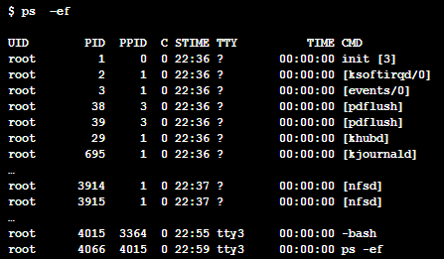

Output of ps –ef is a list of user and kernel processes running on your system. Kernel process names are surrounded by square brackets ([]).
The events/n threads (where n is the processor no.) help implement work queues, which are another way of deferring work in the kernel. If a part of the kernel wants to defer execution of work, it can either create its own work queue or make use of the default events/ n worker thread.
It is possible to run your work queues in your own kernel thread. Whenever your bottom half is activated, your unique kernel thread, instead of one of the default threads, wakes up and handles it. Having a unique work queue thread is useful only in certain performance-critical situations. For most bottom halves, using the default thread is the preferred solution.

Ksoftirqd
ksoftirqd is a per-cpu kernel thread that runs when the machine is under heavy soft-interrupt load. Soft interrupts are normally serviced on return from a hard interrupt, but it's possible for soft interrupts to be triggered more quickly than they can be serviced. The ksoftirq daemon is triggered to handle the soft interrupts in process context. If ksoftirqd is taking more than a tiny percentage of CPU time, this indicates the machine is under heavy soft interrupt load.

The [ksoftirqd/0] kernel thread is an aid to implement soft IRQs. Soft IRQs are raised by interrupt handlers to request “bottom half” processing of portions of the interrupt handler whose execution can be deferred. The idea is to minimize the code inside interrupt handlers. ksoftirqd ensures that a high load of soft IRQs neither starves the soft IRQs nor overwhelms the system. (On Symmetric Multi-Processing (SMP) machines, one instance of ksoftirqd is created per processor to improve throughput. On SMP machines, the kernel processes are named ksoftirqd/ n, where n is the processor number.)

-bash-4.1$ ps -ef | grep ksoftirqd
root 3 2 0 Jul18 ? 00:00:01 [ksoftirqd/0]
root 10 2 0 Jul18 ? 00:00:00 [ksoftirqd/1]
root 15 2 0 Jul18 ? 00:00:00 [ksoftirqd/2]
root 19 2 0 Jul18 ? 00:00:00 [ksoftirqd/3]
root 23 2 0 Jul18 ? 00:00:00 [ksoftirqd/4]
root 27 2 0 Jul18 ? 00:00:00 [ksoftirqd/5]
root 31 2 0 Jul18 ? 00:00:00 [ksoftirqd/6]

How to create Softirq
Tasklets are built on top of softirqs. Softirqs are statically allocated at compile-time, where as tasklets can be dynamically registered and destroyed.

Softirqs are represented by softirq_action structure.
/* structure representing a single softirq entry */
struct softirq_action{
void (*action) (struct softirq_action *); /* function to run */
void *data; /* data to pass to function */
};
There are 32 entries of array of this stucture is declared in kernel/softirq.c;
static struct softirq_action softirq_vec[32];

The Softirq Handler

The prototype of a softirq handler, action: void softirq_handler(struct softirq_action *)

For example, if my_softirq pointed to an entry in the softirq_vec array, the kernel would invoke the softirq handler function as
my_softirq->action(my_softirq)

The kernel does pass the entire structure, not just the data value to allow future additions to the structure without requiring a change in every softirq handler. Also, a softirq never preempts another softirq. The only thing that can preempt is an interrupt handler.

Tasklet | Priority | Softirq Description
HI_SOFTIRQ | 0 | High priority tasklets
TIMER_SOFTIRQ | 1 | Timer bottom half
NET_TX_SOFTIRQ | 2 | Send network packets
NET_RX_SOFTIRQ | 3 | Receive network packets
SCSI_SOFTIRQ | 4 | SCSI bottom half
TASKLET_SOFTIRQ | 5 | Tasklets

Registering Your Handler

After assigning an index, the softirq handler must be registered at run-time via open_softirq(), which takes three parameters: the softirq's index, its handler function, and a value for the data field. So you would register your softirq like this:
open_softirq(MY_SOFTIRQ, my_action, NULL);
The softirq handlers run with interrupts enabled and cannot sleep. When a handler runs, softirqs on the current processor are disabled; however another processor can run it simultaneously. So, shared data needs proper locking and because of this tasklets are preferred.
394 void open_softirq(int nr, void (*action)(struct softirq_action *))
395 {
396 softirq_vec[nr].action = action;
397 }

Raising Your Softirq
Finally, the softirq is ready to run. To mark it pending so it is run at the next invocation of do_softirq(), call raise_softirq().
Softirqs are most often raised from within interrupt handlers. First the interrupt handler performs the basic hardware-related work, raises the softirq, and then exits. After the kernel is done processing interrupts, the kernel invokes do_softirq().

void raise_softirq(unsigned int nr)
380 {
381 unsigned long flags;
382
383 local_irq_save(flags);
384 raise_softirq_irqoff(nr);
385 local_irq_restore(flags);
386 }

Difference between SoftIRQ and tasklets
SoftIRQs are re-entarant while a Tasklet is NOT. That same SoftIRQ can run on different CPUs while this is NOT the case with Tasklets.
Two different tasklets can run concurrently on different processors, but two same type of tasklet cannot run simultaneously.
Interrupt locking is needed in SoftIRQ and not needed for tasklets

iostat - reports CPU, disk I/O, and NFS statistics.
mstat - reports virtual memory statistics.
mpstat - reports processors statictics.

Frequency scaling
Dynamic frequency scaling (also known as CPU throttling) is a technique whereby the frequency of a microprocessor can be automatically adjusted "on the fly," either to conserve power or to reduce the amount of heat generated by the chip.
Dynamic frequency scaling is commonly used in laptops and other mobile devices, where energy comes from a battery and is limited. Less heat output, in turn, allows the system cooling fans to be throttled down or turned off, reducing noise levels and further decreasing power consumption. It is also used for reducing heat in insufficiently cooled systems.

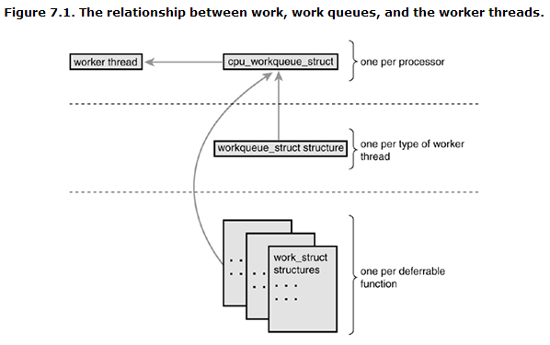
Strace
strace runs the specified command until it exits. It intercepts and records the system calls which are called by a process and the signals which are received by a process. The name of each system call, its arguments and its return value are printed on standard error or to the file specified with the -o option

Completely Fair Scheduler (CFS)
A process (or task) scheduler is a specific kernel subsystem that is responsible for assigning the order in which processes are sent to the CPU. The CFS implements the fair queuing scheduling algorithm.

O(1) scheduler
An O(1) scheduler is a kernel scheduling design that can schedule processes within a constant amount of time, regardless of how many processes are running on the operating system. In Linux, it has replaced the previously used O(n) scheduler.

CPU Scheduler can be tuned using sysctl. Scheduling policies are divided as
Realtime policies
- SCHED_FIFO – FIFO queue manner
- SCHED_RR – Round robin based
Normal policies
- SCHED_OTHER
- SCHED_BATCH
- SCHED_IDLE

Old style of registering
ret_val = register_chrdev(MAJOR_NUM, DEVICE_NAME, &Fops);

New style of registering
int alloc_chrdev_region(dev_t *dev, unsigned int firstminor, unsigned int count, char *name);
unregister_chrdev_region(dev_no, 1);
int char_dev_init (void)
{
int ret;
kernel_cdev = cdev_alloc();
kernel_cdev->ops = &fops;
kernel_cdev->owner = THIS_MODULE;
printk (" Inside init module\n");
ret = alloc_chrdev_region( &dev_no , 0, 1,"chr_arr_dev");
if (ret < 0) {
printk("Major number allocation is failed\n");
return ret;
}
Major = MAJOR(dev_no);
dev = MKDEV(Major,0);
sema_init(&char_dev.sem,1);
printk (" The major number for your device is %d\n", Major);
ret = cdev_add( kernel_cdev,dev,1);
return0;
}

