O(1) -Scheduler?
Big kernel Lock?
UML?
Zero Copu Networking?Zero Copy NFS?
System Call
Old mechanism:(2.4)
– use int 0x80 instruction to generate exception
New mechanism:(2.6)
– use sysenter, is much faster
Linus implemented an alternative system call mechanism to take advantage of SYSENTER/SYSEXIT instruction in X86

Types of Virtualization
• Full virtualization using binary translation
• OS assisted virtualization or paravirtualization
• Hardware assisted virtualization (first generation)

Xen Server
==========
Bare Metal
Para virtualization - modification to each OS to run. Gives near native performance.
unmodified OS - Intel VT and AMD-V

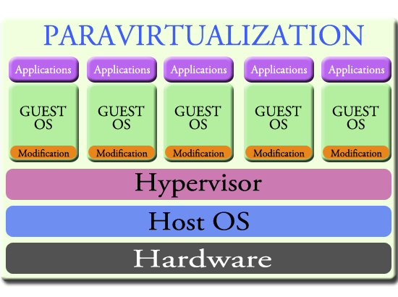

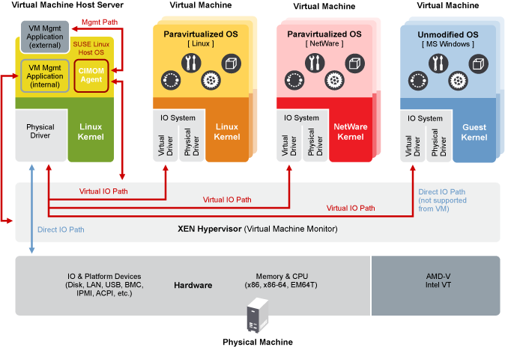

Dom 0 - Control Domain.
Paravirtualized OS :
In paravirtualized mode, the guest OS is explicitly ported for the para application programming interface (API) to facilitate communication with the host virtualization platform. This modification is basically for the communication Dom 0 AND Hypervisor.

E.g Linux-Xen mode is modified kernel that runs in Xen Hypervisor.

OpenStack - Management Software similar to OVMM but supports all hypervisor ( KVM, HyperV, ESX) through differencet Plugins

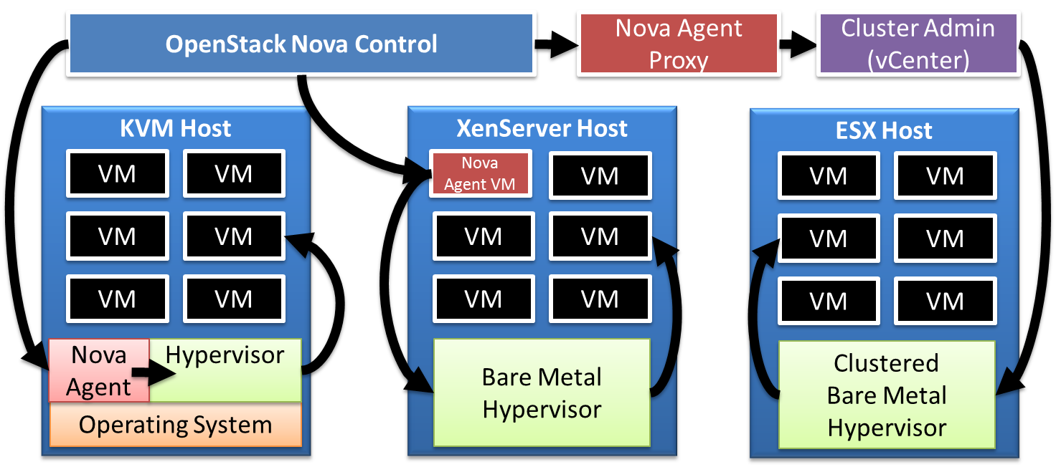

OpenSTACK Module - Eg Compute resource is NOVA

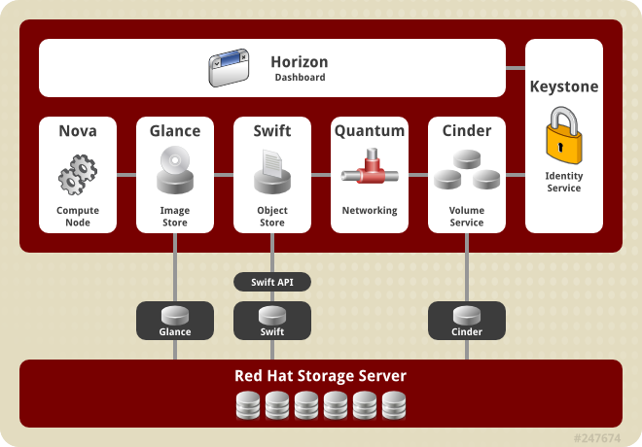

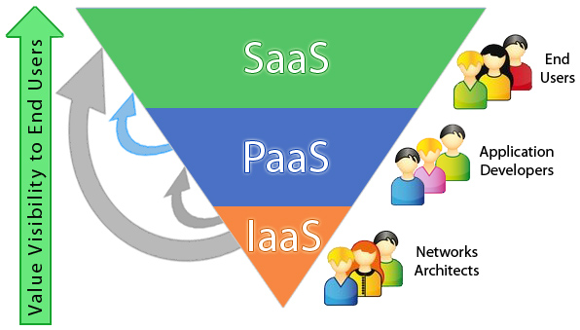
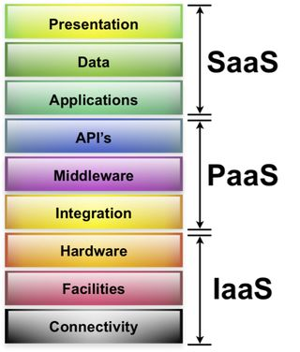

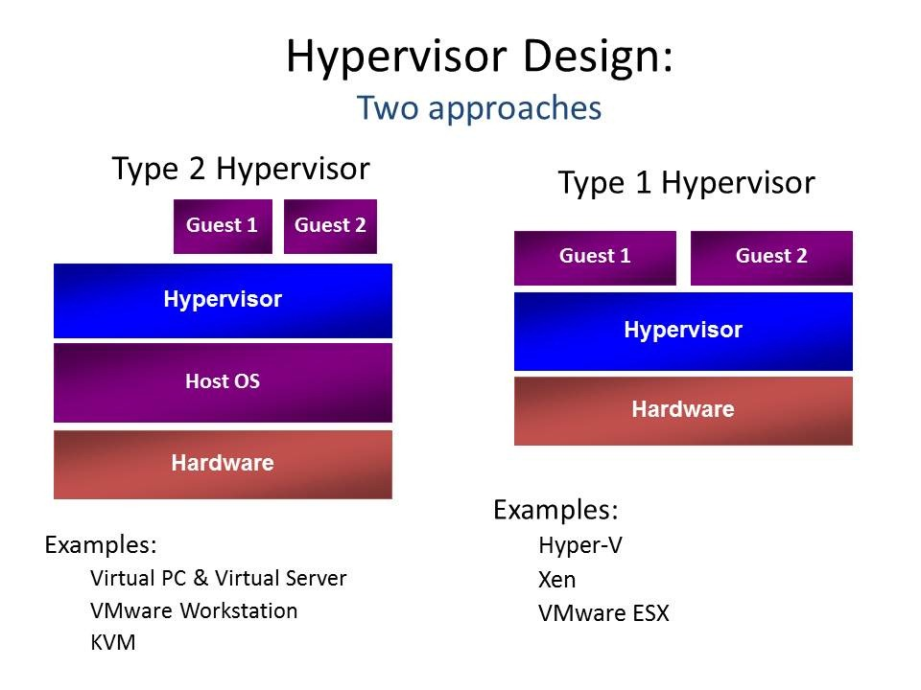

Now for Xen and KVM (simplified!):
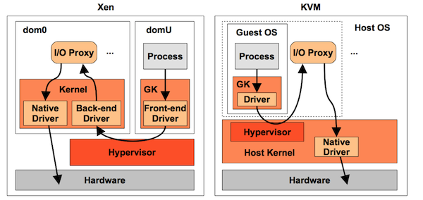
GK is Guest Kernel, and domU on Xen runs the guest OS. Some of these arrows are indicating thecontrol-path, where components inform each other, either synchronously or asynchronously, that more data is ready to transfer. The data-path may be implemented in some cases by shared memory and ring buffers. There are also different ways this can be configured. For example, Xen can use Isolated Driver Domains (IDD), or stub-domains, to run the I/O proxies in isolation.
With Xen, the hypervisor performs CPU scheduling for the domains, and then each domain has its own OS kernel for thread scheduling. The hypervisor supports different CPU scheduling classes, including Borrowed Virtual Time (BVT), Simple Earliest Deadline First (SEDF), and Credit-Based. The domains use the OS kernel scheduler, and whatever regular scheduler classes and policies they provide.
The extra overhead of multiple schedulers costs performance. Having multiple schedulers can also create complex issues with how they interact, adding CPU latency in the wrong situations. Debugging this can be very difficult, especially since the Xen hypervisor is running out of reach of the usual OS performance tools (try xentrace instead).
Sending I/O via the I/O proxy processes (which are usually qemu) involves context-switching and more overhead. There has been lots of work to minimize this, including shared memory transports, buffering, I/O coalescing, and paravirtualization drivers.
With KVM, the hypervisor is a kernel module (kvm) which is scheduled by the OS scheduler. It can be tuned using the usual OS kernel scheduler classes, policies and priorities. The I/O path takes fewer steps than Xen. (The original Qumranet KVM paper described it as five steps vs ten, although this description isn’t including paravirtualization.)

Oracle VM Server includes an updated version of the underlying Xen™ hypervisor technology, and the Oracle VM Agent. It also includes a Linux kernel with support for a broad array of devices, file systems, and software RAID volume management. The Linux kernel is run as dom0 to manage one or more domU virtual machines, each of which could be Linux or Microsoft Windows

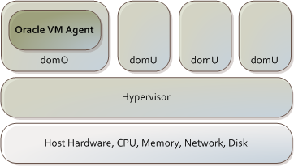

Types of OS
1.Paravirtualized OS
2.Hardware Virtualized OS ( uses Vt-d, Amd-d) /Fully Virtualized.

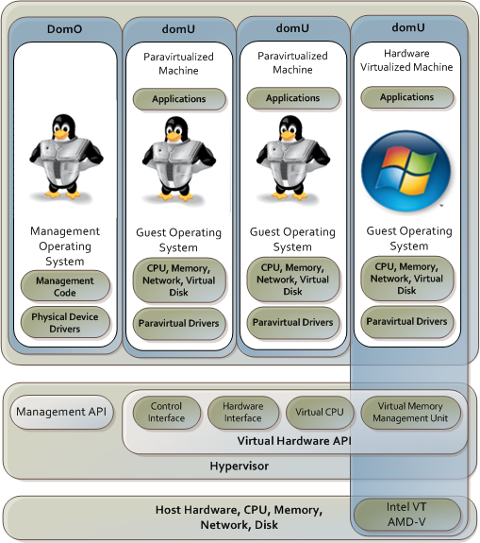

Xen supports 2 virtualization types, ( Meaning Amazon supports 2 types as it runs on Xen )
- Xen Para-virtulaization ( PV )
- Xen Full virtualization ( HVM )
HVM stands for Hardware-assited Virtual Machine.

Para-virtulaization ( PV )
- An OS or Kernel called Hypervisor is installed on the hardware.
- Dom0 is called the “privilged domain” which can issue commands to the hypervisor.

PRO
- Stability/Performance is close to the real servers and hardware virtualization.
- Overhead is very low

CONS
- Implementation is tough.
- Both the host & guest kernels has to be patched.
- Supports Linux only
- can’t change the OS options during install.
- Can’t compile and install a custom kernel

HVM
Stands for Hardware-assisted virtual machine. It provides complete hardware isolation. The hardware provides support to run independently for each OS

PROS
- Can run Linux and Windows
- Complete secure hardware isolation
- Resembles close to a physical server.
- Greater stability

CONS
- Low performance, because of the overheads at the hardware level

Xen Paravirtualization (PV)
Paravirtualization is an efficient and lightweight virtualization technique introduced by Xen, later adopted also by other virtualization solutions. Paravirtualization doesn't require virtualization extensions from the host CPU. However paravirtualized guests require special kernel that is ported to run natively on Xen, so the guests are aware of the hypervisor and can run efficiently without emulation or virtual emulated hardware. Xen PV guest kernels exist for Linux, NetBSD, FreeBSD, OpenSolaris and Novell Netware operating systems.
PV guests don't have any kind of virtual emulated hardware, but graphical console is still possible using guest pvfb (paravirtual framebuffer). PV guest graphical console can be viewed using VNC client, or Redhat's virt-viewer. There's a separate VNC server in dom0 for each guest's PVFB.
Upstream kernel.org Linux kernels since Linux 2.6.24 include Xen PV guest (domU) support based on the Linux pvops framework, so every upstream Linux kernel can be automatically used as Xen PV guest kernel without any additional patches or modifications.
See XenParavirtOps wiki page for more information about Linux pvops Xen support.
Xen Full virtualization (HVM)
Fully virtualized aka HVM (Hardware Virtual Machine) guests require CPU virtualization extensions from the host CPU (Intel VT, AMD-V). Xen uses modified version of Qemu to emulate full PC hardware, including BIOS, IDE disk controller, VGA graphic adapter, USB controller, network adapter etc for HVM guests. CPU virtualization extensions are used to boost performance of the emulation. Fully virtualized guests don't require special kernel, so for example Windows operating systems can be used as Xen HVM guest. Fully virtualized guests are usually slower than paravirtualized guests, because of the required emulation.
To boost performance fully virtualized HVM guests can use special paravirtual device drivers to bypass the emulation for disk and network IO. Xen Windows HVM guests can use the opensource GPLPV drivers. See XenLinuxPVonHVMdrivers wiki page for more information about Xen PV-on-HVM drivers for Linux HVM guests.
KVM
KVM is not Xen, it is another virtualization platform built inside the Linux kernel. From a guest point of view it resembles Xen HVM: the guest runs fully virtualized and there are specific driver to run some parts paravirtualized (again, disk and network).
Both Xen HVM and Linux KVM need hardware assisted virtualization support (Intel VT-x, AMD AMD-V), whereas Xen PV does not but can't run operating systems without PV support (you can't run Windows on Xen PV).
Both Xen HVM and Linux KVM will use parts of the qemu virtualization software to emulate actual hardware for devices not using PV drivers in the guest system

Paravirtualization (XEN-PV), Hardware Virtualization (ESX,QEMU-KVM), and Binary Translation (QEMU,VMPLAYER,VIRTUALBOX)
Oracle VM Server uses paravirtualization, not binary translation. That is, the source code of the operating system is modified to support virtualization.
Binary translation is neither faster, nor slower, than hardware virtualization. Whether binary translation or hardware virtualization is more efficient than paravirtualization depends on the implementation of the binary translation and hardware virtualization, and the applications and operating system running as a guest on the system.
Binary translation and hardware virtualization, is required if you are using an operating system where it is impractical to do paravirtualization, for example, if the source code is not available such as for Microsoft Windows™, or the user base is not large enough to sustain a paravirtualization effort such as for the Linux 2.4.x kernel. In many situations, paravirtualization may perform better than binary translation as operations that cause a hypervisor interaction can be grouped and reused, rather than each event requiring its own hypervisor interaction.
On 32-bit x86, the Xen host kernel code runs in Ring 0, while the hosted domains run in Ring 1 (kernel) and Ring 3 (applications)

Linux Containers/OpenVZ ( Similar to Solaris Zones)
Running the same OS, Linux, on both the host and the guest VMs, I suggest that you choose from User Mode Linux, or OpenVZ.
UML began life as a modified Linux kernel that could be booted up as a user mode process. It has been widely used in hosting companies, and by people who need to emulate large numbers of VMs on a single server. OpenVZ comes from a more enterprise background and is more modeled on Solaris containerisation. The idea is that you can partition your system and install software in a container that does not effect the rest of the system. To remove the software, simply delete the container.
Have a look at the two websites before you decide. I think that OpenVZ seems to be a better fit for you, but a lot depends on your future plans, i.e. it is best to choose the one that you might be able to use for work in the future.
Both UML and OpenVZ are quite different from XEN and KVM. In a nutshell, XEN and KVM are full-blown virtualisation hypervisors that allow running any operating system supported on x86 hardware, but UML and OpenVZ are an extension of the concept of a chroot jail, that allows the isolation of different Linux processes. If you plan to stick with Linux only, then it's best to avoid the complexities of XEN and KVM.
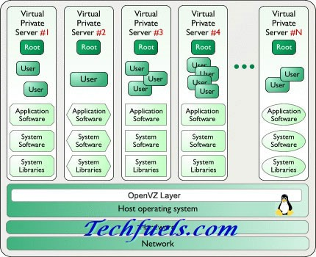

QEmu is a complete and standalone software of its own. You use it to emulate machines, it is very flexible and portable. Mainly it works by a special 'recompiler' that transforms binary code written for a given processor into another one (say, to run MIPS code on a PPC mac, or ARM in an x86 PC).
To emulate more than just the processor, Qemu includes a long list of peripheral emulators: disk, network, VGA, PCI, USB, serial/parallel ports, etc.

CloudStack is open source cloud computing software for creating, managing, and deploying infrastructure cloud services. It uses existing hypervisors such as KVM,vSphere, and XenServer/XCP for virtualization. In addition to its own API, CloudStack also supports the Amazon Web Services (AWS) API

Xen is only the Xen kernel, XenServer is Xen + marvelous tools for all of your virtualization needs, and Xen Cloud Platform (XCP) is the open source version of XenServer that really kicks it up a notch

The work of the I/O scheduler, a key component of every operating system, is precisely to extract as much juice as possible from these aging HDDs. Linux has not only one or two, but no less then four I/O schedulers at your disposition. Here is a brief explanation of these schedulers (taken from this Red Hat article):
- the Anticipatory scheduler introduces a controlled delay before dispatching the I/O to attempt to aggregate and/or re-order requests improving locality and reducing disk seek operations. This algorithm is intended to optimize systems with small or slow disk subsystems;
- the Completely Fair Queuing (CFQ) scheduler maintains a scalable per-process I/O queue and attempts to distribute the available I/O bandwidth equally among all I/O requests;
- the Deadline scheduler uses a deadline algorithm to minimize I/O latency for a given I/O request;
- the Noop scheduler is a simple FIFO queue, and it assumes performance of the I/O has been or will be optimized at the block device.
CFQ: best for desktop use with spinning hard-disks.
NOOP: best with solid state disks.
Deadline: best for database systems with high performance disks.

10Base2, 10Base5 and 10BaseT Ethernet LANs

10Base2 is Ethernet run over RG58 coax. The 10 = 10Mbps. The 2 = 200 meters maximum segment length between repeaters. This stuff died out long ago.
10Base5 is Ethernet run over a large diameter coax (RG6 I think), we used to call this stuff a garden hose because that is what diameter the cable was. Again 10 = 10Mbps and 5 = 500 meters maximum segment length between repeaters. This died out before 10Base2 died.
10BaseT is Ethernet over twisted pair, which is the current medium used.

Dynamic Kernel Module Support (DKMS) is a software framework used to generate Linux kernel modules whose sources do not generally reside in the Linux kernelsource tree. DKMS enables kernel device drivers to be automatically rebuilt when a new kernel is installed.
An essential feature of DKMS is that it automatically recompiles all DKMS modules if a new kernel version is installed. This allows drivers and devices outside of the mainline kernel to continue working after a Linux kernel upgrade.
Another benefit of DKMS is that it allows the installation of a new driver on an existing system, running an arbitrary kernel version, without any need for manual compilation or precompiled packages provided by the vendor.

There are two types of Scheduler
- I/O Scheduler or Disk Scheduling.
- Process Scheduler

Process Scheduler -
CFS ( Completely fair Scheduling) - Uses Red Black Tree.
If the task spends a lot of its time sleeping, then its spent time value is low and it automatically gets the priority boost when it finally needs it. Hence such tasks do not get less processor time than the tasks that are constantly running.

the leftmost task in the tree is the one with the “gravest CPU need”, and CFS picks the leftmost task and sticks to it. As the system progresses forward, newly awakened tasks are put into the tree farther and farther to the right—slowly but surely giving every task a chance to become the leftmost task and, thus, get on the CPU within a deterministic amount of time.

O(1) -Run queue. now replaced by CFS.
The scheduler gives a priority bonus to interactive tasks (for better throughput) while penalizing non-interactive tasks by lowering their priorities

I/O Schedule-
Anticipatory

Completely Fair Queuing (CFQ):
CFQ places synchronous requests submitted by processes into a number of per-process queues and then allocates timeslices for each of the queues to access the disk. The length of the time slice and the number of requests a queue is allowed to submit depends on the I/O priority of the given process.

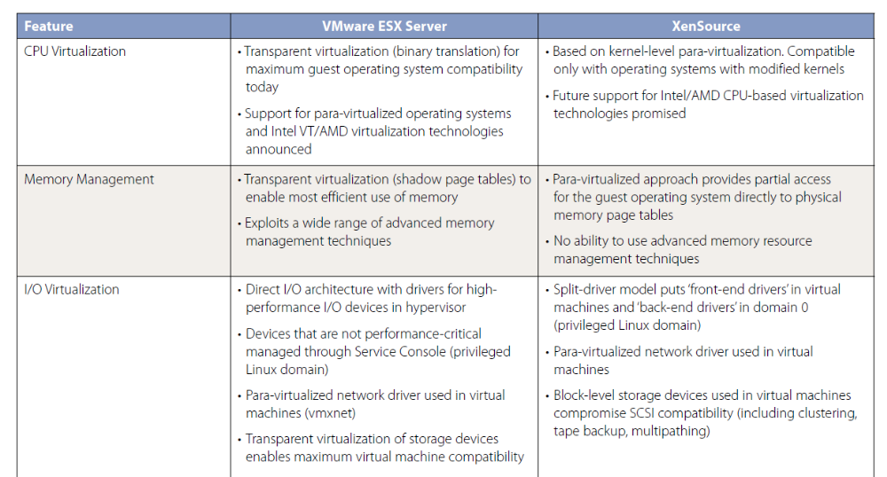

XenDesktop is Like RDP

Question 1: Describe a time when you were most effective at encouraging a person/group to think creatively. Were there any challenges with this person or group? If so, describe them and how you overcame them.

Question 2: Tell me about a time when your work was influenced by an internal or external customer’s need. How was your work influenced by the request, and what was the final product?

Answer 2:NARA large installation , OpenSM caching, Delay increased , Different scneriosu that normal customer use.
Tight budget so they utlilize system to max limit.

Question 3: Tell me about a time you had to change your point of view or your plans because of new information or changing priorities.
Answer 3:SMF changes , complete change from

iSCSI
target (ietd) and intiator (iscsiadm)

iSCSI Qualified Name (IQN

Netapp - Filerview
Openfiler

LUN -WWN WWPN zones

Intiator groups- FC or iSCSI

For ISCI - Enter IQN
For FC - Enter WWPN

Map LUNID with IQN or WWN

WWN identifies a device and the WWPN a specific port.
In simplified form lets say I have:
- 1 host/WWN with 2 HBAs/WWPNs, and

Memory virtualization of Xen/QEMU
shadow page tables that consume system memor

Process Virtualization - InteL -VT /AMD -D
Memory - AMD ( Nested page table -NPT) and InteL Xtenden page table (EPT_
I/O- Direct I/O Intel-VT-d and AMD -IOMMU

Both AMD and Intel have
announced future development roadmaps, including hardware support for memory virtualization
(AMD Nested Page Tables [NPT] and Intel Extended Page Tables [EPT]) as well as hardware
support for device and I/O virtualization (Intel VT-d, AMD IOMMU).

Dom 0 - Back end driver
Dom U - Guest OS front ednd driver (inf

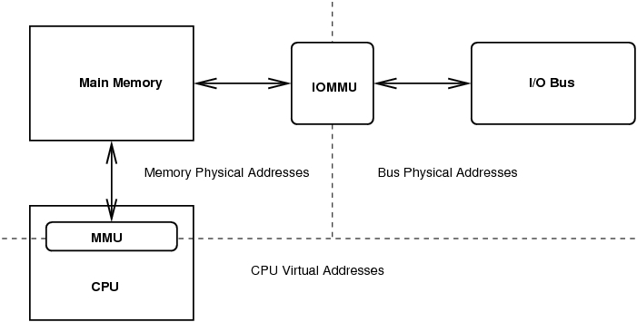

What is an IOMMU?
An I/O Memory Management Unit (IOMMU) is a hardware component that
provides two main functions: I/O Translation and Device Isolation.
● The IOMMU translates memory addresses presented by devices from “I/O
space” to “machine space” to allow a particular device to access physical
memory potentially out of its range. It does this by providing an “in range”
address to the device and translating the “in range” address to the physical
memory address on the fly.

Why do we need an IOMMU?
– 32bit DMA capable, nonDAC devices cannot access physical
memory addresses higher than 4GB.
– IOMMUs can be programmed so that the memory region appears to
be contiguous to the device on the bus (scatter/gather coalescing).

DMA mask is not required in case IOMMU is used.

SWIOTLB
● Linux includes swiotlb which is a software implementation of the translation
function of an IOMMU. Also known as “bounce buffers”.
● Linux always uses swiotlb on IA64 systems which have no hardware IOMMU,
and can use it on x8664 when told to do so or when a system has too much
memory and not enough IOMMU

\

Low latencny
1.Mellanox VMA
2.Solarflare OpenOnload
3.Myricom DBA

If you set LD_PRELOAD to the path of a shared object, that file will be loaded before any other library (including the C runtime, libc.so). So to run ls with your special malloc() implementation, do this:
$ LD_PRELOAD=/path/to/my/malloc.so /bin/ls

Mmap User Space
Copy file using MMAP
1.Two fs , Fdsrc and Fddst.
2.Mmap returns pointer to fd with size specified.
3.Memcpy two pointers.

src = mmap(NULL, sb.st_size, PROT_READ, MAP_PRIVATE, fdSrc, 0);
dst = mmap(NULL, sb.st_size, PROT_READ | PROT_WRITE, MAP_SHARED, fdDst, 0);
memcpy(dst, src, sb.st_size); /* Copy bytes between mappings */
msync(dst, sb.st_size, MS_SYNC)

msync() flushes changes made to the in-core copy of a file that was
mapped into memory using mmap(2) back to the filesystem. Without use
of this call there is no guarantee that changes are written back
before munmap(2) is called
EFI

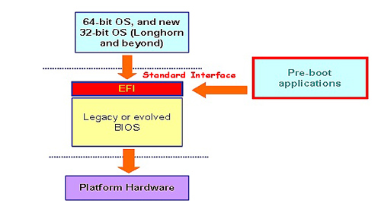

PC technology has advanced, more features requiring BIOS support have appeared, such as remote security management, temperature and power monitoring, and processor extensions such as virtualisation and Turbo Boost.
The BIOS was never designed to be extended ad infinitum in this way. At heart, it’s a 16-bit system, with very limited integration with the hardware and operating system, and it can access a maximum of only 1MB of memory. It’s becoming increasingly difficult to accommodate everything we expect from a modern computer within the old BIOS framework. A new approach is needed
You can think of it as a miniature operating system that sits on top of the motherboard’s firmware,
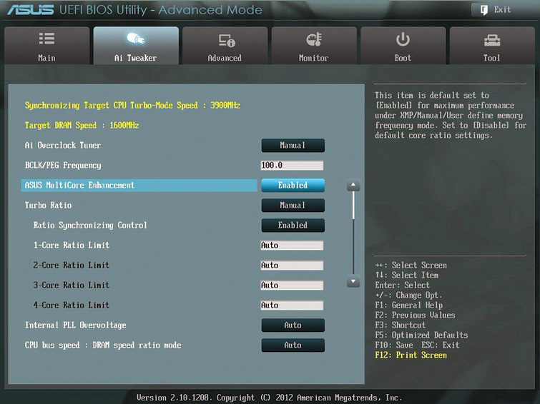

his means that UEFI can be just as powerful as a “real” OS. It can access all the memory installed in a system, and make use of its own little disk storage space – a sequestered area of onboard flash storage or hard disk space called the EFI System Partition. New modules can be easily added (hence “Extensible”); this includes device drivers for motherboard components and external peripherals, so user options can be presented in an attractive graphical front-end, controlled with the mouse. On touchscreen hardware, it’s possible to change system settings by swiping and tapping. It’s all a far cry from the clunky blue configuration screen of most BIOS implementations
However, UEFI provides more far-reaching benefits, too. A major one is the ability to work better with modern hard disks. The original PC BIOS system was designed to work with the Master Boot Record (MBR) partitioning system, which only supports disks of up to 2TB, and no more than four partitions per disk. This may have seemed like plenty of headroom back when the system was introduced in 1983, but today it feels restrictive.
UEFI brings full support for the newer GUID Partition Table (GPT) partitioning scheme. This system can accommodate up to 128 partitions per disk, with a total capacity of 8ZB – equivalent to eight billion terabytes. Some modern BIOS implementations can handle GPT disks, but with limitations: many are unable to boot from very large disks, limiting the usefulness of the latest 3TB drives.
UEFI also allows a generally closer degree of integration between the operating system and the pre-boot environment – something Windows 8 takes advantage of in its Advanced Startup Options. If you’re using a UEFI system, you can select a device to boot from directly within the Windows 8 interface

