Socket

Socket returns an Integer Descriptor.

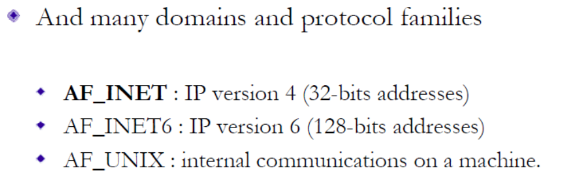

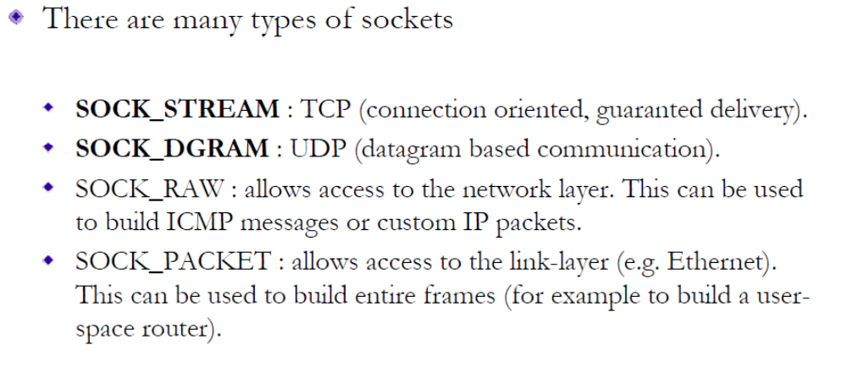

- Protocol
  - IPPROTO_TCP / IPROTO_UDP
  - Usually Set to 0 ( Default based on Socket type)

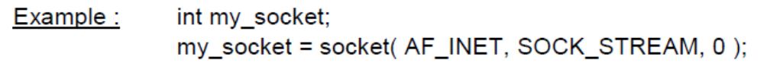

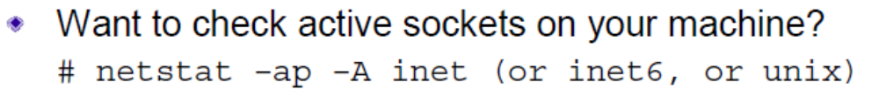

Socket Address Structure

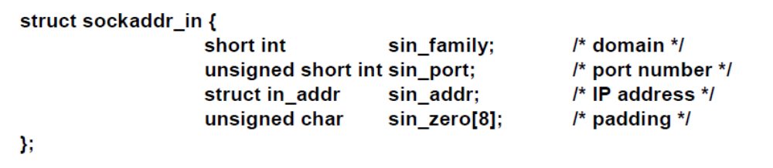

Byte Order
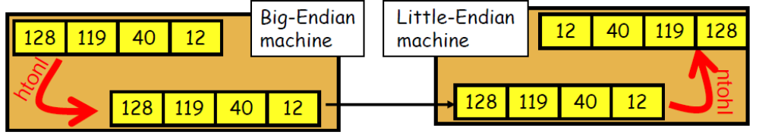

Host Byte Order = Little Endian ( X86) or Big Endian ( Sparc)
Network Byte Order = Always Big Endian

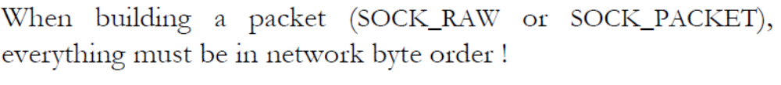
Functions
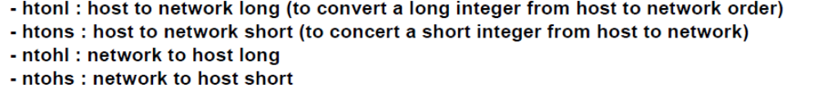

Bind Socket

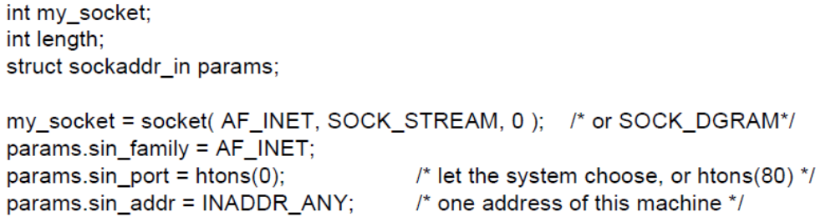

Own Address
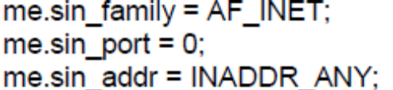

Destination Address
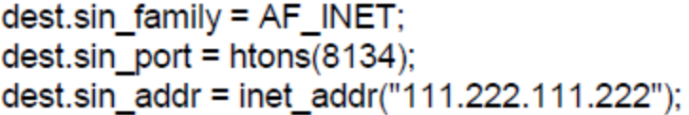

Bind

UDP Socket

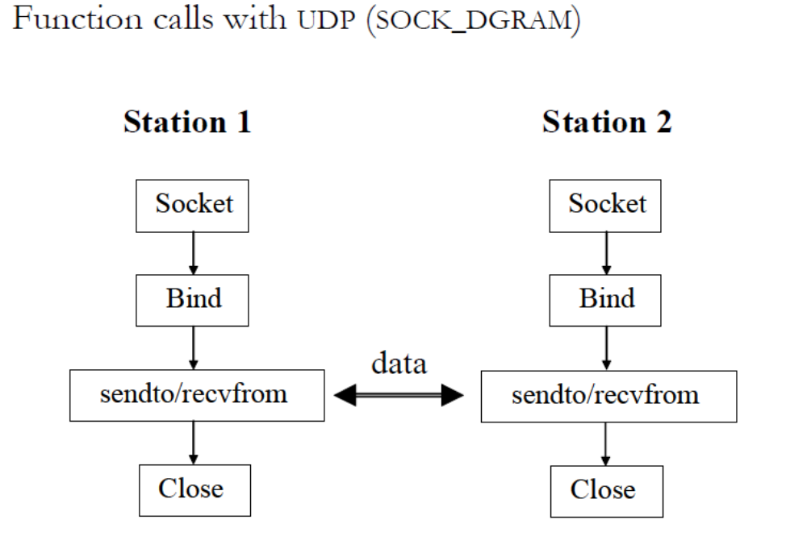

Send/Recieve
Sendto(my_socket,buffer,sockaddr_in(dest));
recvfrom(my_socket,buffer,sockaddr_in(dest));

TCP Sockets

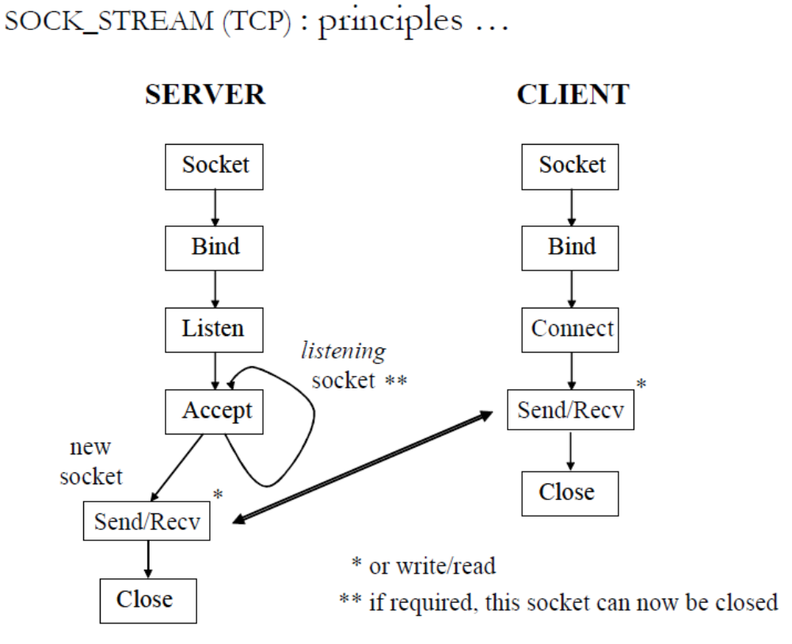

-Select monitor sets of FD for data
-Select is itself blocking but timeout value can be given

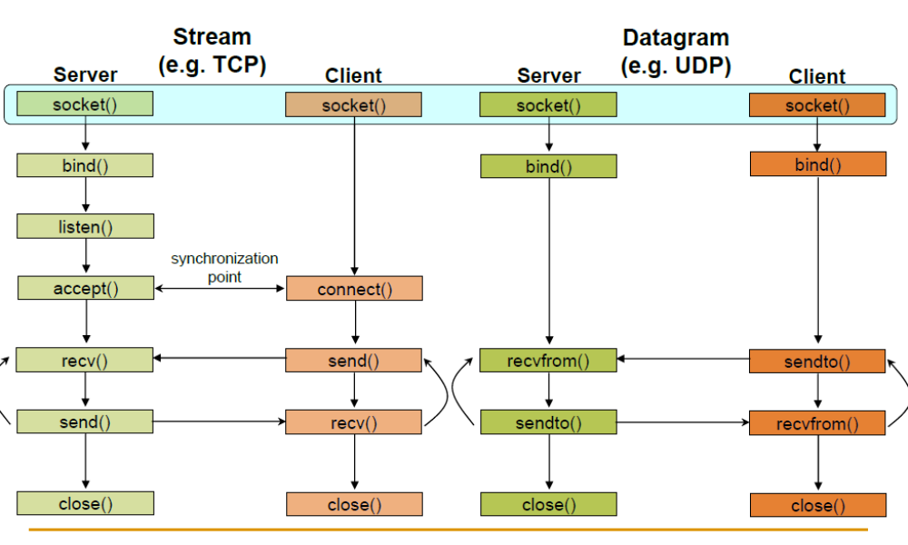

Sockets API
inet_addr() -- convert “dotted” character string form of IP address to internal binary form.
inet_ntoa() -- convert internal binary form of IP address to “dotted” character string form.

Non Blocking Sockets ( Asynchronous Sockets)
When you first create the socket descriptor with socket(), the kernel sets it to blocking. If you don't
want a socket to be blocking, you have to make a call to fcntl()

sockfd = socket(AF_INET, SOCK_STREAM, 0);
fcntl(sockfd, F_SETFL, O_NONBLOCK);

• If you try to read from a non-blocking socket and there's no data there, it's not allowed to block--it will return -1 and errno will be set to EWOULDBLOCK

Normal Sockets is Blocking Sockets and is Synchronous .

