Memory Technology Device (MTD)
A MTD is a type of device file in Linux for interacting with flash memory.
The MTD subsystem was created to provide an abstraction layer between the hardware-specific device drivers and higher-level applications.
Although character and block device files exists, their semantics don't map well to the way that flash memory devices operate.
USB, MMC, SD other popular removable devices should not be confused with MTDs. Although they contain flash memory, this is hidden behind a block device interface using a Flash translation layer.
When using an MTD, the use of JFFS2 or YAFFS is recommended as this is aware of MTD.

MTD-Utils
These are a collection of tools that allow the user to interact with the MTD sub-system in the kernel to perform operations on flash devices.
• flash_erase - Erases an erase block of flash
• flash_eraseall - Erases the entire flash device
• flashcp - Copies data into NOR flash
• flash_info - Displays information about Flash devices
• flash_lock - Lock flash pages to prevent writing
• flash_unlock - Unlock flash pages to allow writing
• mkfs.jffs2 - Create a JFFS2 file system image from an existing file system
• nandwrite - Write an input file (i.e. JFFS2 or YAFFS2 image) to the NAND Flash device

NAND Vs NOR
Important difference between NAND and NOR Flash is the bus interface.
NOR Flash is connected to an address / data bus direct like other memory devices as SRAM etc. NAND Flash uses a multiplexed I/O Interface with some additional control pins.
NAND flash is a sequential access device appropriate for mass storage applications, while NOR flash is a random access device appropriate for code storage application.
NOR Flash can be used for code storage and code execution (Execution-In-Place). Code stored on NAND Flash can't be executed from there. It must be loaded into RAM memory and executed from there.

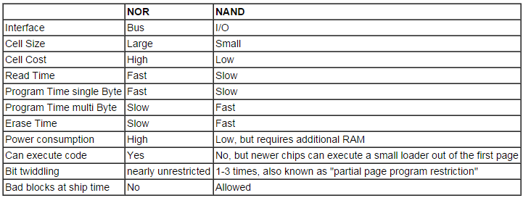

JFFS2 – mainly for NOR
JFFS2 provides a filesystem directly on the flash, rather than emulating a block device. Unlike some other file systems which may be stored on the Flash device and then copied into RAM during boot. JFFS2 actually resides on the Flash device and allows the user to read/write data to Flash.
JFFS mainly designed for use with NOR, while this can be used on NAND also. Flash devices it is not the best optimized file system for NAND. For NAND devices it is often best to use the YAFFS2 file system which was specifically designed for NAND devices.
Benefits of JFFS2
- JFFS2 allows data to be written back to Flash for persistent storage
- JFFS2 is optimized for Flash memory which must be erased in block size segments
- JFFS2 provides wear leveling for longer Flash memory life
- JFFS2 supports compression
- JFFS2 file systems do not need to be copied from Flash to RAM to be used

JFFS2 treats each erase block of the flash separately. It will never write nodes which cross from one erase block to another. Any node which crosses an erase block boundary will be ignored by JFFS2, and the data it contains will be lost, causing the file system to be corrupted.
If there's not enough space at the end of the current erase block to write a whole node, JFFS2 will leave it blank and continue writing to a new erase block.
Also, JFFS2 always starts writing at the beginning of an erase block, and does not expect to find free space in the middle. Any free space in an erase block should go all the way to the end of the erase block.

YAFFS2 – for NAND
Yaffs (Yet Another Flash File System) is an open-source file system specifically designed to be fast, robust and suitable for embedded use with NAND specially and NOR Flash also. It is widely used with Linux, RTOSs, or no OS at all, in consumer devices.
Yaffs 2 was to add support for the new NAND with 2kB pages instead of 512-byte pages and strictly sequential page writing order.
- Zero page rewrites means faster operation. (Yaffs1 uses a single rewrite in the spare area to delete a page).
- Ability to exploit simultaneous page programming on some chips.
- Improves performance relative to Yaffs1 speed(write:1.5x to 5x, delete: 4x, garbage collection: 2x)
- Lower RAM footprint (approx. 25% to 50% of Yaffs1).
- Can support Toshiba/Sandisk MLC parts.
UBI
"Unsorted Block Images". It is a volume management system for raw flash devices which manages multiple logical volumes on a single physical flash device and spreads the I/O load (i.e, wear-leveling) across whole flash chip.
UBI may be compared to the Logical Volume Manager (LVM). Whereas LVM maps logical sectors to physical sectors, UBI maps logical eraseblocks to physical eraseblocks. UBI implements global wear-leveling and transparent I/O errors handling.
An UBI volume is a set of consecutive logical eraseblocks (LEBs). Each logical eraseblock may be mapped to any physical eraseblock (PEB). This mapping is managed by UBI, it is hidden from users and it is the base mechanism to provide global wear-leveling
UBI volume size is specified when the volume is created and may later be changed (volumes are dynamically re-sizable).

There are 2 types of UBI volumes - dynamic volumes and static volumes. Static volumes are read-only and their contents are protected by CRC-32 checksums, while dynamic volumes are read-write and the upper layers (e.g., a file-system) are responsible for ensuring data integrity.

UBI is aware of bad eraseblocks (e.g., NAND flash may have them) and frees the upper layers from any bad block handling. UBI has a pool of reserved physical eraseblocks, and when a physical eraseblock becomes bad, it transparently substitutes it with a good physical eraseblock. UBI moves good data from the newly appeared bad physical eraseblocks to good ones. The result is that users of UBI volumes do not notice I/O errors as UBI takes care of them.

NAND flashes may have bit-flips which occur on read and write operations. Bit-flips are corrected by ECC checksums, but they may accumulate over time and cause data loss. UBI handles this by moving data from physical eraseblocks which have bit-flips to other physical eraseblocks. This process is called scrubbing.

Here is a comparison of MTD partitions and UBI volumes. They are somewhat because:
both consist of eraseblocks - logical eraseblocks in case of UBI volumes, and physical eraseblocks in case of MTD partitions; both support three basic operations - read, write, and erase.

UBIFS
UBIFS may be considered as the next generation of the JFFS2 file-system.
JFFS2 file system works on top of MTD devices, but UBIFS works on top of UBI volumes and cannot operate on top of MTD devices. In other words, there are 3 subsystems involved:
- MTD subsystem, which provides uniform interface to access flash chips. MTD provides an notion of MTD devices (e.g., /dev/mtd0) which basically represents raw flash;
- UBI subsystem, which is a wear-leveling and volume management system for flash devices; UBI works on top of MTD devices and provides a notion of UBI volumes; UBI volumes are higher level entities than MTD devices and they are devoid of many unpleasant issues MTD devices have (e.g., wearing and bad blocks);
- UBIFS file system, which works on top of UBI volumes.

Wear Leveling
Wear leveling is a technique for prolonging the service life of some kinds of erasable computer storage media, such as flash memory used in solid-state drives (SSDs) and USB flash drives.
Flash devices have individually erasable segments and the limited number of erase cycles before becoming unreliable (cannot be used). This is usually around 3,000/5,000.
Wear leveling attempts to work around these limitations by arranging data so that erasures and re-writes are distributed evenly across the medium. In this way, no single erase block prematurely fails due to a high concentration of write cycles. In flash memory, a single block on the chip is designed for longer life than the others so that the memory controller can store operational data with less chance of its corruption

Uboot and Xloader
The x-loader is a small stage-1 bootloader for ARM which resides in ROM area. The x-loader loads the U-Boot into memory and transfers control to it. U-Boot is a pretty advanced bootloader that is capable of loading the kernel and ramdisk image from the NAND, SD card, USB drive and even the Ethernet via bootp, DHCP and TFTP.
This sequence is more or less applicable to most embedded systems. The x-loader and U-Boot executables are stored in the files called MLO and uboot.img, respectively. These files are stored in a FAT32 partition.
Once the execution is handed over to U-Boot, it offers you a few seconds to interrupt the boot sequence. If you choose not to interrupt, U-Boot executes an environment variable called bootcmd. bootcmd holds the search sequence for a file called uImage. This is the kernel image. The kernel image is loaded into the memory, and the execution finally is transferred to the kernel
MLO - (x-loader with signGP, signGP is a small header appended at the last of the code, which is 8 bytes and the 4 bytes tells the length of the x-loader and the next 4 bytes tells where to load the binary)
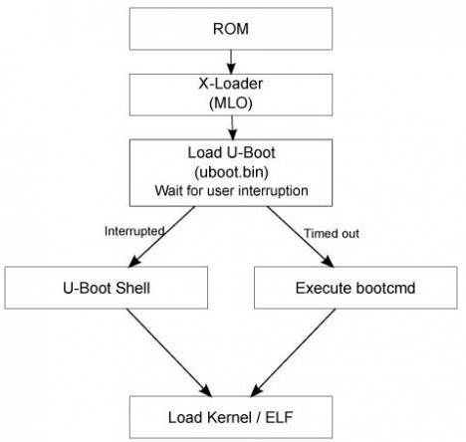
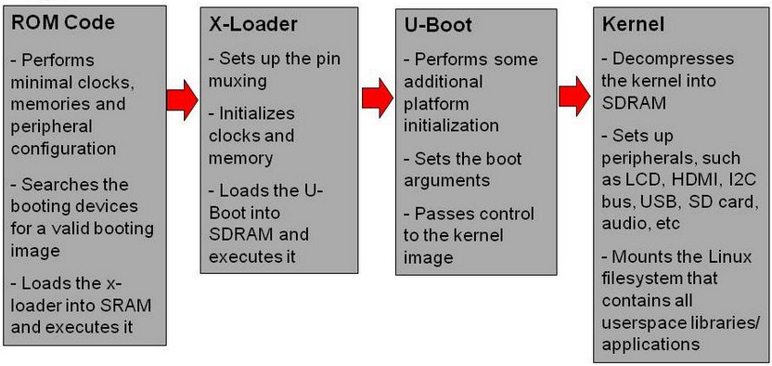

At a minimum an embedded boot loader provides the following features:
- Initializing the hardware, especially the memory controller.
- Providing boot parameters for the Linux kernel.
- Starting the Linux kernel.
Additionally, embedded boot loaders also provide features to simplify the development on the board:
- Reading and writing arbitrary memory locations.
- Uploading new binary images to the board's RAM via a serial line or Ethernet.
- Copying binary images from RAM to FLASH memory.

Note: MBR - The first sector of the hard-drive is master boot record (MBR). It includes the hard-drives boot code and partition table. The partition table contains the information about the partition layout of hard-disk. The size of the MBR will be 512 bytes, as is the size of every sector on an x86 machines hard-disk.
Tool-chain: A C/C++ compiler, an assembler, a linker/loader, associated binary utilities and header files for a specific architecture, like PowerPC or ARM

Difference between Android kernel and Linux kernel
Ashmem (Android Shared Memory), a file-based shared memory system.
Binder, an inter-process communication (IPC) and remote procedure call (RPC) system.
Logger, a high-speed, light weight in-kernel logging mechanism optimized for writes.
Paranoid Networking, a mechanism to restrict network I/O to certain processes.
pmem (Physical Memory), a driver for mapping large chunks of physical memory into user-space.
Low Memory Killer, a replacement OOM killer that implements Android’s “kill least recently used process” logic under low memory conditions.
wakelocks, Android’s unique power management solution, in which the default state of the device is sleep and explicit action is required (via a wakelock) to prevent from sleeping.
Power Management A light weight power management driver build on top of standard linux power management but optimized for embedded systems
Android alarm A driver which provides timers that can wake the device up from sleep and a monotonic time-base that runs while the device is asleep.

Processor microcode - is similar to processor firmware. The kernel is able to update the processor's firmware without the need to update it via a BIOS update.

