Advantages of SPARC
- Reduce the number of instructions that the processor has to perform
- (One idea of RISC is that a complex instruction in a conventional computer can be reduced to a series of simpler operations). This helps is designing a simple architecture and more compact microprocessor.
- Reduce the number of types of memory addresses that the processor needs to handle
- Put as little processor operation as possible in microcode, which requires clock speed-consuming time to access
- Provide language compilers that compile programs that are optimized for a SPARC microprocessor by being arranged in an order that the processor can handle more efficiently.

ARM RELATED
Load/Store architecture
Only load and store instructions access the memory
All other instructions use registers as operands.
Primary motivation is speedup –registers are faster.

The ARM is a 32-bit architecture.
Byte means 8 bits, Halfword means 16 bits (two bytes), Word means 32 bits (four bytes)
ARM’s implement two instruction sets
32-bit ARM Instruction Set
16-bit Thumb Instruction Set
Jazelle cores can also execute Java bytecode

Operating modes
  - User : unprivileged mode under which most tasks run
  - FIQ : entered when a high priority (fast) interrupt is raised
  - IRQ : entered when a low priority (normal) interrupt is raised
  - Supervisor : entered on reset and when a Software Interrupt instruction is executed
  - Abort : used to handle memory access violations
  - Undef : used to handle undefined instructions
  - System : privileged mode using the same registers as user mode

Accumulator is the single register stores the operand before the operation and stores result after operation.
Register set
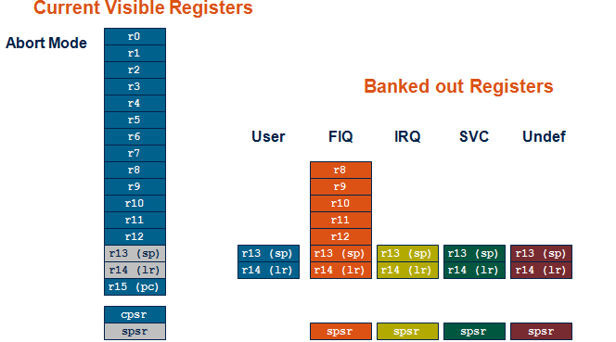
ARM has 37 registers all of which are 32-bits long.
  - 1 dedicated program counter
  - 1 dedicated current program status register
  - 5 dedicated saved program status registers
  - 30 general purpose registers

The current processor mode governs which of several banks is accessible. Each mode can access
  - a particular set of r0-r12 registers
  - a particular r13 (the stack pointer, sp) and r14 (the link register, lr)
  - the program counter, r15 (pc)
  - the current program status register, cpsr

Privileged modes (except System) can also access
  - a particular spsr (saved program status register)

Instruction set
- 3-address add r1, r2, r3 (r1 <- r2 + r3)
- 2-address add r1, r2 (r1 <- r1 + r2)
- 1-address add r1 (to the accumulator)
Registers in all the modes
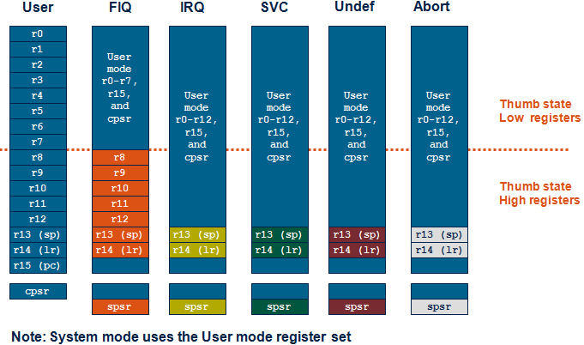

Program status register
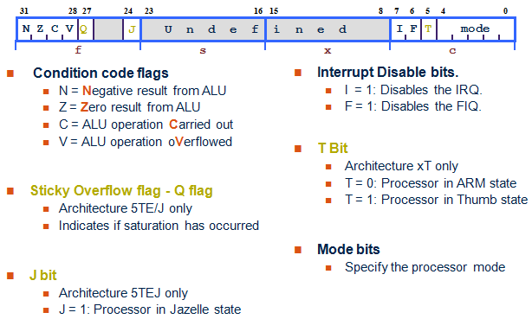

When an exception occurs, the ARM:
  - Copies CPSR into SPSR_<mode> & sets appropriate CPSR bits
    - Change to ARM state
    - Change to exception mode
    - Disable interrupts (if appropriate)
  - Stores the return address in LR_<mode>
  - Sets PC to vector address
To return, exception handler needs to:
  - Restore CPSR from SPSR_<mode>
  - Restore PC from LR_<mode>

Data processing Consist of:
  - Arithmetic: ADD ADC SUB SBC RSB RSC
  - Logical: AND ORR EOR BIC
  - Comparisons: CMP CMN TST TEQ
  - Data movement: MOV MVN

To allow larger constants to be loaded, the assembler offers a pseudo-instruction:
LDR rd, =const
LDR STR Word
LDRB STRB Byte
LDRH STRH Halfword
LDRSB Signed byte load
LDRSH Signed halfword load
Examples 1
ARM (RISC) Equivalent
CMP r3,#0 CMP r3,#0
BEQ skip ADDNE r0,r1,r2
ADD r0,r1,r2
skip

Example 2
AREA example, CODE
ENTRY
Start MOV R0, #10
MOV R1, #20
BL func
SWI 0x11
Func ADD R0, R0, R1
MOV PC, LR
END

Conditional example
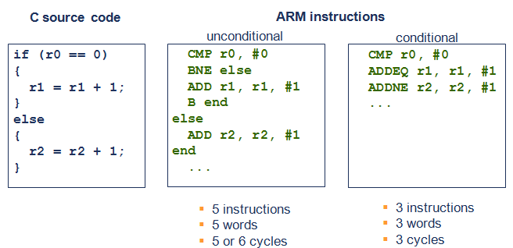
Load / Store example
array[10] = array[5] + y;

LDR r3, [r2, #5] ; r3 = array[5]
ADD r3, r3, r1 ; r3 = array[5] + y
STR r3, [r2, #10] ; array[5] + y = array[10]

ARM pipeling
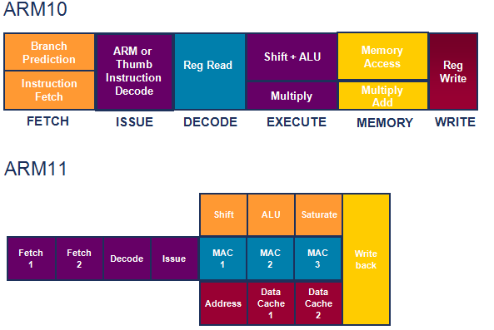
RISC Vs CISC Vs VLIW
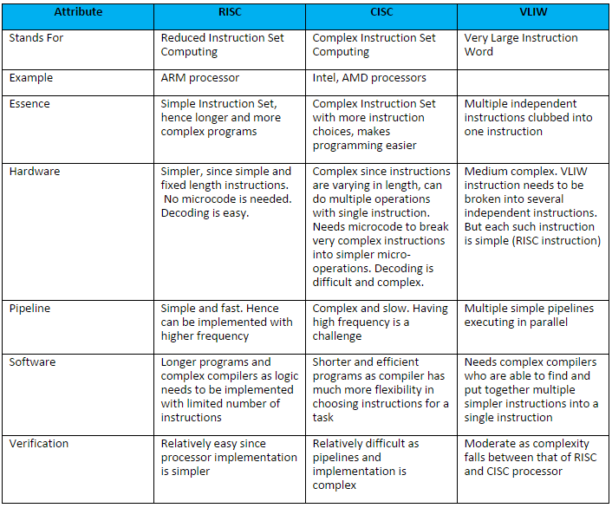
RISC - Reduced Instruction Set Computer
- Instructions that fetch or store operands do nothing else
- Fewer instructions in set
- reduces STRUCTURAL HAZARDS - allowing higher speedups with more pipelines and more stages per pipeline
- more instructions required to do the same work
- DESIGN TRADEOFF - RISC is less work per instruction, but supports more instructions per time unit with high pipeline speedups

CISC - Complex Instruction Set Computer
- Large set of instruction
- Instructions are complex, they can do many things and operate upon multiple operands
- Can execute instructions that also require operands from memory
- Increases cost/size/transistor count of the instruction decoder
- STRUCTURAL HAZARDs present with pipelines – Instruction Fetch & operand fetch

VLIW - Very Long Instruction Word
- Convert CISC instructions to RISC instructions
- Store converted instructions in VLIW
- Breaks VLIW to RISC execution core for execution on multiple pipelines

