Queuing in the Linux Networking stack
Reference: http://www.coverfire.com/articles/queueing-in-the-linux-network-stack/
Driver Queue (ring buffer)
Between the IP stack and the network interface controller (NIC) has the driver queue. This queue a first-in, first-out (FIFO) ring buffer – a fixed sized buffer. The driver queue does not contain packet data, Instead it consists of descriptors which point to other data structures called socket kernel buffers (SKBs) which hold the packet data and are used throughout the kernel.

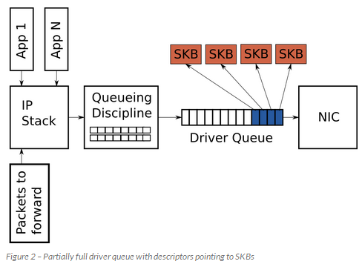
The input source for the driver queue is the IP stack. The packets may be generated locally or received by NIC to be routed out another when the device is functioning as an IP router. Packets added to the driver queue by the IP stack are dequeued by the hardware driver and sent across a data bus to the NIC hardware for transmission. The driver queue exists to ensure that when the system has data to transmit; the data is available to the NIC for immediate transmission.
Queueing discipline (QDisc) layer implements the traffic management capabilities, whether the transmit queue is empty or filled with packets. This also does the functioning of traffic classification, prioritization and rate shaping. The QDisc layer is configured through the somewhat opaque tc command. There are three components to know in the QDisc layer: QDiscs, classes and filters.
The QDisc is the Linux abstraction for traffic queues which are more complex than the standard FIFO queue. This interface allows the QDisc to carry out complex queue management behaviors without requiring the IP stack or the NIC driver.
The second concept which is closely related to the QDisc is the class. Individual QDiscs may implement classes in order to handle subsets of the traffic differently.
Filters (also called classifiers) are the mechanism used to classify traffic to a particular QDisc or class.

Huge Packets from the Stack
Most NICs have a fixed MTU which is the biggest frame which can be transmitted. The default MTU is 1,500 bytes but some Ethernet networks support Jumbo Frames of up to 9,000 bytes. In the IP stack, the MTU limits the size of the packets which can be sent to the device for transmission.
For example, if an application writes 2,000 bytes to a TCP socket then the IP stack needs to create two IP packets to keep the packet size less than or equal to a 1,500 MTU.
In order to avoid the overhead associated with a large number of packets on the transmit path, the Linux kernel implements several optimizations: TCP segmentation offload (TSO), UDP fragmentation offload (UFO) where hardware breaks the single large packet into smaller ones. In generic segmentation offload (GSO) software does this. All these optimizations allow the IP stack to create packets which are larger than the MTU of the outgoing NIC. For IPv4, packets as large as the IPv4 maximum of 65,536 bytes can be created and queued to the driver queue.
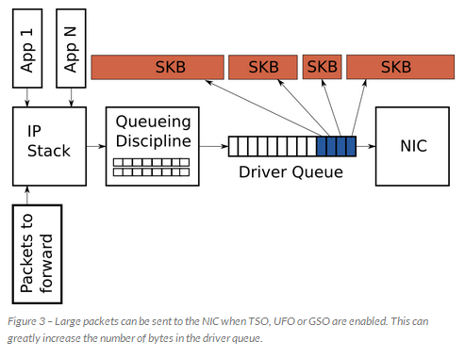
Linux also has receive-side optimizations. These optimizations also reduce per-packet overhead. Specifically, generic receive offload (GRO) allows the NIC driver to combine received packets into a single large packet which is passed to the IP stack. When forwarding packets, GRO allows for the original packets to be reconstructed maintaining the end-to-end nature of IP packets.
Starvation and Latency
If the NIC driver wakes and pull packets off of the queue for transmission and the queue is empty the hardware will miss a transmission opportunity, reducing the throughput of the system. This is referred to as starvation.
Large latencies are introduced by oversized, unmanaged buffers which is known as bufferbloat

Bufferbloat occurs in packet-switched networks, where excess buffering of packets causes high latency and packet delay variation (also known as jitter), as well as reducing the overall network throughput.

Note: If latency is required, disable the offloading schemes – TSO, UFO or GSO. If these features are enabled, packet sizes are huge and latency is high.

Dynamic queue Limits (DQL) & Byte Queue Limits (BQL)
Dynamic queue limits (DQL) library is a general purpose queue length controller and on top this Byte Queue Length (BQL) is implemented. The actual size of the driver queue is not changed by BQL. Rather BQL calculates how much data (in bytes) can be queued at the current time. Any bytes over this limit must be held or dropped by the layers above the driver queue. Since number of bytes queued approximates the time required to transmit.
Byte Queue Limits is a new feature in recent kernels (> 3.3.0) which attempts to solve the problem of driver queue sizing. This is by adding a layer which enables and disables queuing to the driver queue based on calculating the minimum buffer size required to avoid starvation under the current system conditions. Smaller the amount of queued data, the lower the maximum latency experienced by queued packets.
Byte queue limits work only at the device queue level, while the networking stack has other places—such as the queueing discipline level—where buffering can happen.

The state and configuration can be found in a /sys directory based on name of NIC. /sys/devices/pci0000:00/0000:00:14.0/net/eth0/queues/tx-0/byte_queue_limits/
The files in this directory are:
- hold_time: Time between modifying LIMIT in milliseconds.
- inflight: The number of queued but not yet transmitted bytes.
- limit: The LIMIT value calculated by BQL. 0 if BQL is not supported in the NIC driver.
- limit_max: Maximum value for LIMIT. Set this value lower to optimize for latency.
- limit_min: Minimum value for LIMIT. Set this value higher to optimize for throughput.
echo "3000" > limit_max
To use this in code, when queueing packets to the interface, drivers must call to one of:
void netdev_sent_queue(struct net_device *dev, unsigned int pkts, unsigned int bytes);
void netdev_tx_sent_queue(struct netdev_queue *dev_queue, unsigned int pkts,
unsigned int bytes);
Either of these functions will note that the given number of bytes have been queued to the given device. If the DQL code determines that queue is long enough after adding these bytes, it will tell the upper layers to pass no more data to the device for now.
Note: Here the tx_queue size is not changed, and BQL is changed to limit the number of byte packets can be transmitted.

The BQL mechanism operates when two events occur: when packets are enqueued to the driver queue and when a transmission to the wire has completed.
1)
if the number of queued bytes is over the current LIMIT value
disable the queueing of more data to the driver queue

2)
if the hardware was starved
increase LIMIT

else if the hardware was busy during the entire interval (not starved) and there are bytes to transmit
decrease LIMIT by the number of bytes not transmitted in the interval

if the number of queued bytes is less than LIMIT
enable the queueing of more data to the buffer

Buffering between transport layer and Queue disciplines
The latest (3.6.0) kernel has a new feature called TCP Small Queues which solves this problem for TCP, when there is huge amount of packets to transmit. TCP Small Queues adds a per TCP flow limit on the number of bytes which can be queued in the QDisc and driver queue. This has the interesting side effect of causing the kernel to push back on the application earlier which allows the application to more effectively prioritize writes to the socket.
It limits the amount of data that can be queued for transmission by any given socket regardless of where the data is queued, so it shouldn't be fooled by buffers in the queueing, traffic control, or netfilter code. The default value of this limit is 128KB and this could be set lower
The per-socket TCP queue limit can be viewed and controlled with the following /proc file:
/proc/sys/net/ipv4/tcp_limit_output_bytes
Another partial solution to transport layer flood problem is to use a QDisc which has many queues, ideally one per network flow.
How to manipulate the queue sizes in Linux
Driver Queue (Ring size/ hardware ring)
The ethtool command is used to control the driver queue size for NICs. ethtool also provides low level interface statistics and the ability to enable and disable IP stack and driver features.
The -g flag to ethtool displays the driver queue (ring) parameters:
[root@alpha net-next]# ethtool -g eth0
Ring parameters for eth0:
Pre-set maximums:
RX: 16384 (default value)
RX Mini: 0
RX Jumbo: 0
TX: 16384
Current hardware settings:
RX: 512 (current rx, can be increased till 16384)
RX Mini: 0
RX Jumbo: 0
TX: 256 (256 skbs)

NIC defaults to 256 descriptors in the transmission queue. Early in the Bufferbloat investigation it was often recommended to reduce the size of the driver queue in order to reduce latency. With the introduction of BQL there is no longer any reason to modify the driver queue size

Ethtool also allows you to manage optimization features such as TSO, UFO and GSO. The -k flag displays the current offload settings and -K modifies them.
[dan@alpha ~]$ ethtool -k eth0
Offload parameters for eth0:
rx-checksumming: off
tx-checksumming: off
scatter-gather: off
tcp-segmentation-offload: off
udp-fragmentation-offload: off
generic-segmentation-offload: off
generic-receive-offload: on
large-receive-offload: off
rx-vlan-offload: off
tx-vlan-offload: off
ntuple-filters: off
receive-hashing: off

What is txqueuelen?

The current size of the transmission queue can be obtained from the ip and ifconfig commands. Confusingly, these commands name the transmission queue length differently (bold text).

The length of the transmission queue in Linux defaults to 1,000 frames which is a large amount of buffering especially at low bandwidths.

The ethtool TX 256 refers to number of descriptors
[dan@alpha ~]$ ifconfig eth0
eth0 Link encap:Ethernet HWaddr 00:18:F3:51:44:10
inet addr:69.41.199.58 Bcast:69.41.199.63 Mask:255.255.255.248
inet6 addr: fe80::218:f3ff:fe51:4410/64 Scope:Link
UP BROADCAST RUNNING MULTICAST MTU:1500 Metric:1
RX packets:435033 errors:0 dropped:0 overruns:0 frame:0
TX packets:429919 errors:0 dropped:0 overruns:0 carrier:0
collisions:0 txqueuelen:1000
RX bytes:65651219 (62.6 MiB) TX bytes:132143593 (126.0 MiB)Interrupt:23

The length of the transmission queue is configured with the ip or ifconfig commands.
[root@alpha dan]# ip link set txqueuelen 500 dev eth0
Generic Segmentation Offload (GSO)
Generic segmentation Offload (GSO) is a performance optimization which is a generalization concept of TCP segment offload (TSO). Instead of modifying every NIC driver, a much easier way is to perform the segmentation just before the entry into the driver's xmit routine. This concept is called GSO.

Segmentation
During a system sends large chunks of data out over a computer network, the chunks first need breaking down into smaller segments. This process is referred to as segmentation.
Often, TCP protocol in the host computer performs this segmentation. Offloading this work to the NIC is called TCP segmentation offload (TSO).
The TSO is a technique for increasing outbound throughput of high-bandwidth network connections by reducing CPU overhead. It works by queuing up large buffers and letting NIC split them into separate packets. Also called Larger Segment Offload (LSO).

For example, a unit of 64kB (65,536 bytes) of data is usually segmented to 46 segments of 1448 bytes each before it is sent through the NIC and over the network.
With some intelligence in the NIC, the host CPU can hand over the 64 KB of data to the NIC in a single transmit-request, the NIC can break that data down into smaller segments of 1448 bytes, add the TCP, IP, and data link layer protocol headers - according to a template provided by the host's TCP/IP stack - to each segment, and send the resulting frames over the network. This significantly reduces the work done by the CPU.

Ideally the segmentation would occur inside each NIC driver where they would rip the super-packet apart and either produce SG lists which are directly fed to the hardware, or linearise each segment into pre-allocated memory to be fed to the NIC.

Unfortunately this requires modifying each and every NIC driver so it would take quite some time. A much easier solution is to perform the segmentation just before the entry into the driver's xmit routine. The best scenario is the case where the NIC supports SG. This means that we simply have to manipulate the SG entries and place them into individual skb's before passing them to the driver.

Recent implementation of LSO requires scatter-gather for operation, as packets bigger than MTU cannot be placed into pre-allocated buffers. If the driver does not fix the IP checksum in LSO packet, the host does not deliver packets

Note: segmentation is the term used in TCP layer. IP fragmentation is the term used in Network layer. Maximum segment size (MSS) is the term referred in the TCP layer, and Maximum Transmission Unit (MTU) is the term of Network layer.

The Internet Protocol (IP) implements datagram fragmentation, breaking it into smaller pieces, so that packets may be formed that can pass through a link with a smaller maximum transmission unit (MTU) than the original datagram size.

You can tell if a driver supports TSO by typing ifconfig and looking at the capabilities section of the interface output. It will have tso marked as one of its capabilities. A driver that wants to offer TSO needs to set the NETIF_F_TSO bit in the network device structure. In order for a device to support TSO, it needs to also support Net:TCP checksum offloading and Net:Scatter Gather.
The driver will then receive super-sized skb's. These are indicated to the driver by skb_shinfo(skb)-> gso_size being non-zero. The gso_size is the size the hardware should fragment the TCP data. TSO may change how and when TCP decides to send data.
If the driver has setup hooks in ETHTOOL_OPS() than TSO can be disabled with:
ethtool -K ethX tso off
and enabled with:
ethtool -K ethX tso on
Large Receive Offload (LRO)
The inbound counterpart of large segment offload is large receive offload.
LRO is a technique for increasing inbound throughput of high-bandwidth network connections by reducing CPU overhead.
It works by aggregating multiple incoming packets from a single stream into a larger buffer before they are passed higher up the networking stack, thus reducing the number of packets that have to be processed. In Linux, LRO can be used along with the New API (NAPI) to also reduce the number of interrupts.
LRO merging can be done either in the driver or in the hardware; even LRO emulation in the driver has performance benefits. LRO is widely supported by 10G drivers under Linux.

Optimizing the receive side is harder because packet reception is, in general meant to harder. However, when it is transmitting data, the kernel is in complete control and able to throttle sending processes if necessary. But incoming packets are entirely asynchronous events, under somebody else's control, and the kernel just has to cope with what it gets.

LRO should not be used on machines acting as routers, as it breaks the end-to-end principle and can significantly impact performance. As this merges everything in sight. This transformation is lossy; if there are important differences between the headers in incoming packets, those differences will be lost.
The best solution would be generic receive offload (GRO). In GRO, the criteria for which packets can be merged are greatly restricted; the MAC headers must be identical and only a few TCP or IP headers can differ. In fact, the set of headers which can differ is severely restricted: checksums are necessarily different, and the IP ID field is allowed to increment. Even the TCP timestamps must be identical, which is less of a restriction than it may seem; As a result of these restrictions, merged packets can be resegmented losslessly; as an added benefit, the GSO code can be used to perform resegmentation.

Unlike LRO, GRO is not limited to TCP/IPv4.

In general, current CPUs can keep up with a 1G data stream. There might be a benefit, though, in embedded systems which typically have slower processors. How does the kernel decide how long to wait for incoming packets before merging them? It turns out that there is no real need for any special waiting code: the NAPI API already has the driver polling for new packets occasionally and processing them in batches. GRO can simply be performed at NAPI poll time.

Code implementation of LRO done as below.
Reference: http://lwn.net/Articles/243949/
To support LRO, fill in an LRO manager structure which looks like this:
#include <linux/inet_lro.h>

struct net_lro_mgr {
struct net_device *dev;
struct net_lro_stats stats;

unsigned long features;

u32 ip_summed; /* Options to be set in generated SKB in page mode */
int max_desc; /* Max number of LRO descriptors */
int max_aggr; /* Max number of LRO packets to be aggregated */

struct net_lro_desc *lro_arr; /* Array of LRO descriptors */
/*
* Optimized driver functions
*
* get_skb_header: returns tcp and ip header for packet in SKB
*/
int (*get_skb_header)(struct sk_buff *skb, void **ip_hdr,
void **tcpudp_hdr, u64 *hdr_flags, void *priv);

/*
* get_frag_header: returns mac, tcp and ip header for packet in SKB
*
* @hdr_flags: Indicate what kind of LRO has to be done
* (IPv4/IPv6/TCP/UDP)
*/
int (*get_frag_header)(struct skb_frag_struct *frag, void **mac_hdr,
void **ip_hdr, void **tcpudp_hdr, u64 *hdr_flags,
void *priv);
};
In this structure, dev is the network interface for which LRO is to be implemented; stats contain some statistics which can be queried to see how well LRO is working. The features field controls how the LRO code should feed packets into the networking stack; it has two flags defined currently:
- LRO_F_NAPI says that the driver is NAPI compliant, and that, in particular, packets should be passed upward with netif_receive_skb().
- LRO_F_EXTRACT_VLAN_ID is for drivers with VLAN support.
Checksum information for the final packets should go into ip_summed. The maximum number of "LRO descriptors" should be stored in max_desc. Each descriptor describes one TCP stream, so the maximum limits the number of streams for which LRO can be done simultaneously. Increasing the maximum requires more memory and will slow things a bit, since packets are matched to streams by way of a linear search. max_aggr is the maximum number of incoming packets which will be aggregated into a single, larger packet. The lro_arr array contains the descriptors for tracking streams; the driver should provide it with enough memory for at least max_desc structures or very unpleasant things are likely to happen.
Finally, there are the get_skb_header() and get_frag_header() methods. Their job is to locate the IP and TCP headers in a packet as quickly as possible. Typically a driver will only provide one of the two functions, depending on how it feeds packets into the LRO aggregation code.
A driver which receives packets in fully-completed sk_buff structures would normally pass them up directly to the network stack with netif_rx() or netif_receive_skb(). If LRO is being done, instead, the packets should be handed to:
void lro_receive_skb(struct net_lro_mgr *lro_mgr,
struct sk_buff *skb,
void *priv);
This function will attempt to identify an LRO descriptor for the given packet, creating one if need be. Then it will try to join that packet with any others in the stream, making one large, fragmented packet. In the process, it will call the driver's get_skb_header() method, passing through the pointer given as priv. If the packet cannot be aggregated with others (it may not be a TCP packet or it could have TCP options which require it to be processed separately) it will be passed directly to the network stack. Either way, the driver can consider it delivered and move on to its next task.
Some drivers receive packets directly into memory represented by page structures, constructing the full sk_buff structure after reception. For such drivers, the interface is:
void lro_receive_frags(struct net_lro_mgr *lro_mgr,
struct skb_frag_struct *frags,
int len, int true_size,
void *priv, __wsum sum);
The LRO code will build the necessary sk_buff structure, perhaps aggregating fragments from several packets, and (sooner or later) feed the results to the network stack. It will call the driver's get_frag_header() method to locate the headers in the first element of the frags array; that method should also ensure that the packet is an IPv4 TCP packet and set LRO_IPV4 and LRO_TCP in the flags argument if so.
Combined packets will be pushed up into the network stack whenever max_aggr individual packets have been merged into them. Delaying data for too long while waiting for additional packets is not a good idea, though; occasionally packets should be sent on even if they are not as large as they could be. The function for this job is:
void lro_flush_all(struct net_lro_mgr *lro_mgr);
It will cause all packets to send on. A logical place for such a call might be at the end of a NAPI driver's poll() method. An individual stream can be flushed with:
void lro_flush_pkt(struct net_lro_mgr *lro_mgr,
struct iphdr *iph,
struct tcphdr *tcph);

This call will locate the stream associated with the given IP and TCP headers and send its accumulated data onward. It will not add any data associated with the given headers; the packet associated with those headers should have already been added with one of the receive functions if need be.
That is, for all practical purposes, the entire interface. One might well wonder how this code can improve performance, given that it is just aggregating packets which have already been received in the usual way by the driver. The answer is that it is reducing the number of packets that the network stack has to work with, cutting the per-packet overhead at higher levels in the stack. A clever driver can, using the struct page approach, also reduce the number of memory allocations required for each packet, which can be a big win.

Segmentation and Checksum Offloading: Turning Off with ethtool

Reference: http://sandilands.info/sgordon/segmentation-offloading-with-wireshark-and-ethtool
TCP/IP operations are offloaded to the Network Interface Card (NIC) by the operating system
TCP – segmentation
IP - fragmentation
Common operations for offloading are segmentation and checksum calculations. That is, instead of the OS using the CPU to segment TCP packets, it allows the NIC to use its own processor to perform the segmentation. This saves on the CPU and cuts down on the bus communications to/from the NIC.
Offloading to the NIC can produce performance gains inside your computer; however offloading doesn't change what is sent over the network.
On systems that support checksum offloading, IP, TCP, and UDP checksums are calculated on the NIC just before they're transmitted on the wire.
Consider the figure below illustrating the normal flow of data through a TCP/IP stack without offloading. Let’s assume the application data is 7,300 Bytes. TCP breaks this into five segments. Why five? The Maximum Transmission Unit (MTU) of Ethernet is 1500 Bytes. If we subtract the 20 Byte IP header and 20 Byte TCP header there is 1460 Bytes remaining for data in a TCP segment (this is the TCP Maximum Segment Size (MSS)). 7,300 Bytes can be conveniently segmented into five maximum sized TCP segments.
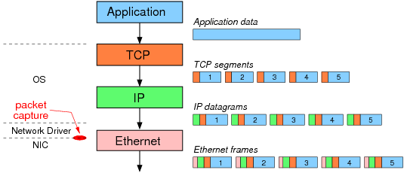

After IP adds a header to the TCP segments the resulting IP datagrams are sent one-by-one to the "Ethernet layer". Note that TCP/IP are part of operating system, and most functionality of Ethernet is implemented on the NIC. The network driver also performs some of the Ethernet functionality.
The network driver creates/receives Ethernet frames. So in the above example, assuming segmentation offloading is not used, the 7,300 Bytes of application data is segmented into 5 TCP/IP packets containing 1460 Bytes of data each. The network driver encapsulates each IP datagram in an Ethernet frame and sends the frames to the NIC. It is these Ethernet frames that Wireshark (and other packet capture software, like tcpdump) captures. The NIC then sends the frames, one-by-one, over the network.

Now consider when segmentation offloading is used (as in the figure below). The OS does not segment the application data, but instead creates one large TCP/IP packet and sends that to the driver. The driver creates a single Ethernet frame (which is captured by Wireshark) and sends it to the NIC. Now the NIC performs the segmentation. It uses the template headers to create 5 Ethernet frames with real TCP/IP/Ethernet headers. The 5 frames are then sent over the network
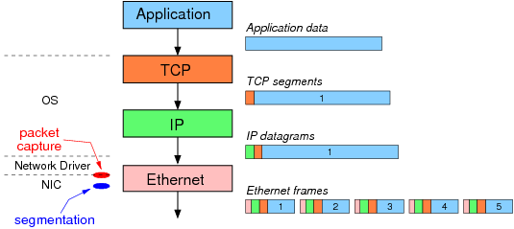
The result: although the same 5 Ethernet frames are sent over the network, Wireshark captures different data depending on the use of segmentation offloading. When not used, the 5 Ethernet frames are captured. When offloading is used, Wireshark only captures the single, large frame (containing 7,300 bytes of data).

tcpdump is used to see the captured IP packets, and in particular the size of the TCP segments.
ethtool is used to view and change the status of segmentation offloading (in this example, generic segmentation offload or GSO).

netcat in server mode is used to receive data:
sgordon@basil$ nc -l 5001

On ginger netcat in client mode is used to send 10,000 Bytes of data (stored in a file) to the server.
sgordon@ginger$ nc -p 5002 10.10.1.22 5001 < 10000bytes.txt

First note that ethtool shows us that generic segmentation offload is on.
sgordon@ginger$ sudo ethtool -k eth0
Offload parameters for eth0:
Cannot get device flags: Operation not supported
rx-checksumming: on
tx-checksumming: on
scatter-gather: on
tcp segmentation offload: off
udp fragmentation offload: off
generic segmentation offload: on
large receive offload: off

Now, after running the netcat client, lets see the output from tcpdump
sgordon@ginger$ sudo tcpdump -i eth0 -n 'not port 22'
tcpdump: verbose output suppressed, use -v or -vv for full protocol decode
listening on eth0, link-type EN10MB (Ethernet), capture size 96 bytes
18:33:02.644356 IP 192.168.1.2.5002 > 10.10.1.22.5001: S 3144010294:3144010294(0) win 5840
18:33:02.645427 IP 10.10.1.22.5001 > 192.168.1.2.5002: S 3901655238:3901655238(0) ack 3144010295 win 5792
18:33:02.645471 IP 192.168.1.2.5002 > 10.10.1.22.5001: . ack 1 win 92
18:33:02.645542 IP 192.168.1.2.5002 > 10.10.1.22.5001: . 1:1449(1448) ack 1 win 92
18:33:02.645558 IP 192.168.1.2.5002 > 10.10.1.22.5001: . 1449:2897(1448) ack 1 win 92
18:33:02.645567 IP 192.168.1.2.5002 > 10.10.1.22.5001: P 2897:4345(1448) ack 1 win 92
18:33:02.647415 IP 10.10.1.22.5001 > 192.168.1.2.5002: . ack 1449 win 68
18:33:02.647433 IP 192.168.1.2.5002 > 10.10.1.22.5001: . 4345:5793(1448) ack 1 win 92
18:33:02.647439 IP 192.168.1.2.5002 > 10.10.1.22.5001: . 5793:7241(1448) ack 1 win 92
18:33:02.648437 IP 10.10.1.22.5001 > 192.168.1.2.5002: . ack 2897 win 91
18:33:02.648446 IP 192.168.1.2.5002 > 10.10.1.22.5001: . 7241:8689(1448) ack 1 win 92
18:33:02.648451 IP 192.168.1.2.5002 > 10.10.1.22.5001: P 8689:10001(1312) ack 1 win 92
18:33:02.648460 IP 10.10.1.22.5001 > 192.168.1.2.5002: . ack 4345 win 114
18:33:02.650414 IP 10.10.1.22.5001 > 192.168.1.2.5002: . ack 5793 win 136
18:33:02.650428 IP 10.10.1.22.5001 > 192.168.1.2.5002: . ack 7241 win 159
18:33:02.651469 IP 10.10.1.22.5001 > 192.168.1.2.5002: . ack 8689 win 181
18:33:02.651476 IP 10.10.1.22.5001 > 192.168.1.2.5002: . ack 10001 win 204
Each line is showing a captured packet. The TCP segments containing data can be identified by the sequence numbers (I've made them bold). The number in parentheses indicates the number of bytes in this TCP segment. We can see from the capture that our 10,000 Bytes of data is broken into 5 segments containing: 2896, 1448, 2896, 1448, 1312 Bytes each. But wait ... 2896 Bytes in a TCP segment when the MSS is 1460? (in fact, with TCP header options, like SACK and timestamp, the MSS in this capture is 1448). This is Generic Segmentation Offloading going to work: the OS is sending large segments, as captured above, and letting the NIC do the real segmentation.

So now lets turn Generic Segmentation Offloading off using ethtool:
sgordon@ginger$ sudo ethtool -K eth0 gso off

And run the netcat transfer again and look at the tcpdump output this time:
sgordon@ginger$ sudo tcpdump -i eth0 -n 'not port 22'
tcpdump: verbose output suppressed, use -v or -vv for full protocol decode
listening on eth0, link-type EN10MB (Ethernet), capture size 96 bytes
18:33:02.644356 IP 192.168.1.2.5002 > 10.10.1.22.5001: S 3144010294:3144010294(0) win 5840
18:33:02.645427 IP 10.10.1.22.5001 > 192.168.1.2.5002: S 3901655238:3901655238(0) ack 3144010295 win 5792
18:33:02.645471 IP 192.168.1.2.5002 > 10.10.1.22.5001: . ack 1 win 92
18:33:02.645542 IP 192.168.1.2.5002 > 10.10.1.22.5001: . 1:1449(1448) ack 1 win 92
18:33:02.645558 IP 192.168.1.2.5002 > 10.10.1.22.5001: . 1449:2897(1448) ack 1 win 92
18:33:02.645567 IP 192.168.1.2.5002 > 10.10.1.22.5001: P 2897:4345(1448) ack 1 win 92
18:33:02.647415 IP 10.10.1.22.5001 > 192.168.1.2.5002: . ack 1449 win 68
18:33:02.647433 IP 192.168.1.2.5002 > 10.10.1.22.5001: . 4345:5793(1448) ack 1 win 92
18:33:02.647439 IP 192.168.1.2.5002 > 10.10.1.22.5001: . 5793:7241(1448) ack 1 win 92
18:33:02.648437 IP 10.10.1.22.5001 > 192.168.1.2.5002: . ack 2897 win 91
18:33:02.648446 IP 192.168.1.2.5002 > 10.10.1.22.5001: . 7241:8689(1448) ack 1 win 92
18:33:02.648451 IP 192.168.1.2.5002 > 10.10.1.22.5001: P 8689:10001(1312) ack 1 win 92
18:33:02.648460 IP 10.10.1.22.5001 > 192.168.1.2.5002: . ack 4345 win 114
18:33:02.650414 IP 10.10.1.22.5001 > 192.168.1.2.5002: . ack 5793 win 136
18:33:02.650428 IP 10.10.1.22.5001 > 192.168.1.2.5002: . ack 7241 win 159
18:33:02.651469 IP 10.10.1.22.5001 > 192.168.1.2.5002: . ack 8689 win 181
18:33:02.651476 IP 10.10.1.22.5001 > 192.168.1.2.5002: . ack 10001 win 204
Now this is what we expect to see - 7 TCP segments each no larger than 1448 Bytes

Normal Adapter Design
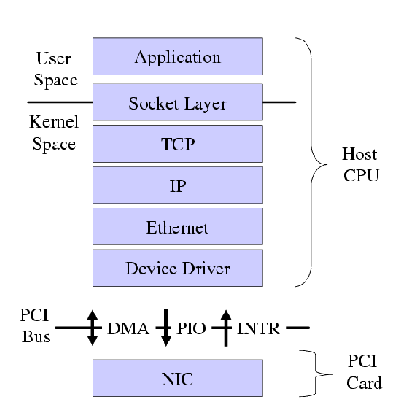

Offloaded Adapter Design
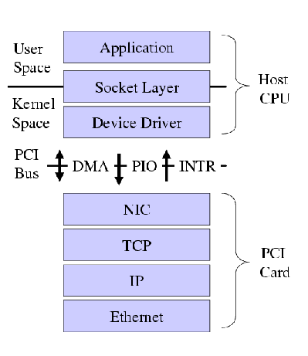

TCP offload engine

TCP offload engine or TOE is a technology used in network interface cards (NIC) to offload processing of the entire TCP/IP stack to the network controller.
It is primarily used with high-speed network interfaces, such as gigabit Ethernet and 10 Gigabit Ethernet, where processing overhead of the network stack becomes significant.

Purpose
The TCP software implementations on host systems require extensive computing power. Full duplex gigabit TCP communication using software processing alone is enough to consume more than 80% of a 2.4 GHz Pentium 4 processor, resulting in little or no processing resources left for the applications to run on the system.
As TCP is a connection-oriented protocol, this adds to the complexity and processing overhead of the protocol. These aspects include:
- Connection establishment using the "3-way handshake" (SYNchronize; SYNchronize-ACKnowledge; ACKnowledge).
- Acknowledgment of packets as they are received by the far end, adding to the message flow between the endpoints and thus the protocol load.
- Checksum and sequence number calculations - again a burden on a general purpose CPU to perform.
- Sliding window calculations for packet acknowledgement and congestion control.
- Connection termination.

Types of TCP/IP offload

Parallel-stack full offload
Parallel-stack full offload gets its name from the concept of two parallel TCP/IP Stacks.
The first is the main host stack which is included with the host OS.
The second or "parallel stack" is connected between theApplication Layer and the Transport Layer (TCP) using a "vampire tap"

HBA full offload
HBA full offload is found in iSCSI host adapters which present themselves as disk controllers to the host system while connecting (via TCP/IP) to an iSCSI storage device.
This type of TCP offload not only offloads TCP/IP processing but it also offloads the iSCSI initiator function

TCP chimney partial offload
TCP chimney offload addresses the major security criticism of parallel-stack full offload. In partial offload, the main system stack controls all connections to the host. After a connection has been established between the local host and a foreign host the connection and its state are passed to the TCP offload engine. The heavy lifting of data transmit and receive is handled by the offload device. Almost all TCP offload engines use some type of TCP/IP hardware implementation to perform the data transfer without host CPU intervention. When the connection is closed, the connection state is returned from the offload engine to the main system stack. Maintaining control of TCP connections allows the main system stack to implement and control connection security.

Enable and disable checksum offload
Checksum offloading can be enabled and disabled with the ethtool command.
To check:
ethtool --show-offload ethX
To disable:
ethtool --offload ethX rx off tx off
Or, with some 3Com cards (see 3c59x vortex docs):
rmmod 3c59x ; modprobe 3c59x hw_checksums=0

You can set these options using the "-K" (upper-case K) option to ethtool and specify which option you'd like to set. For example, to disable tcp-segmentation-offload for eth0:

ethtool -K eth0 tso off

You can set multiple options in one "ethtool" command, but this can be problematic if your card doesn't support all of the settings. To avoid this, you could invoke ethtool for each option like this:

ethtool -K eth0 rx off
ethtool -K eth0 tx off
ethtool -K eth0 sg off
ethtool -K eth0 tso off
ethtool -K eth0 ufo off
ethtool -K eth0 gso off
ethtool -K eth0 gro off
ethtool -K eth0 lro off
Or we could simply wrap the ethtool command in a for-loop like this:
for i in rx tx sg tso ufo gso gro lro; do ethtool -K eth0 $i off; done

These settings will remain in effect only while the OS is booted, so this needs to be applied at every boot. This can be done by adding the above for-loop as a "post-up" command for each of the interfaces in /etc/network/interfaces. If you're still using the graphical Network Manager to configure your interfaces, I've put together some documentation on disabling it and configuring interfaces and their offloading features via /etc/network/interfaces:
http://code.google.com/p/security-onion/wiki/NetworkConfiguration

Reference
=========
http://wiki.wireshark.org/CaptureSetup/Offloading

The TOE functions implemented in the TCP Offload Engine are as below.
Reference:
http://lwn.net/Articles/147289/
http://lwn.net/Articles/148697/

int (*open)(struct toedev *dev);
int (*close)(struct toedev *dev);
int (*can_offload)(struct toedev *dev, struct sock *sk);
int (*connect)(struct toedev *dev, struct sock *sk);
int (*send)(struct toedev *dev, struct sk_buff *skb);
int (*recv)(struct toedev *dev, struct sk_buff **skb, int n);
int (*ctl)(struct toedev *dev, unsigned int req, void *data);
void (*neigh_update)(struct net_device *lldev,
struct toedev *dev,
struct neighbour *neigh, int fl);

NOTES
LRO should be enabled only when RX checksum is enabled
SG should be enabled only when TX checksum is enabled
TSO is during transmission – break big packet to small
LRO is during reception – Merge small packets to big and send one packet to N/W stack
TSO x LRO (opposite in functioning)
TSO is only for TCP
GSO is similar to TSO, but applied to all UDP, DCCP, TCP. In GSO segmentation is done in the end just before transmission. Same is done in TSO also
GSO and GRO are the offload methods done by means of software.
TSO, LSO and LRO are the techniques handled in the hardware, i.e NIC

Settings of sysctl
The parameter net.ipv4.tcp_moderate_rcvbuf should be set to 1 to enable the below options

net.ipv4.tcp_rmem - The size (in bytes) of TCP receive buffer used by TCP sockets
net.ipv4.tcp_wmem - The memory (in bytes) reserved for TCP send buffers (TCP write buffers)
net.ipv4.tcp_mem - The total TCP buffer-space allocated in units of page
net.ipv4.tcp_window_scaling - Toggles the window scaling
net.ipv4.tcp_timestamps - Toggles TCP timestamp support
net.ipv4.tcp_sack – Toggles SACK support (selective algorithm)

The kernel file Documentation/network/ip-sysctl.txt
net.core.rmem_max - maximum size of rx socket buffer
net.core.wmem_max – maximum size of tx socket buffer
net.core.rmem_default – default rx size of socket buffer
net.core.wmem_default – default tx size of socket buffer
net.core.optmem_max – maximum amount of option memory buffers
net.core.netdev_max_backlog – unprocessed rx packets before kernel starts to drop them

Interrupt Coalescing
This is a technique in which events normally trigger a hardware interrupt are held back, until a certain amount of work is pending, or a timeout timer triggers. This technique can reduce interrupt load to the kernel in order to reduce per-packet overhead. Interrupt coalescing is typically combined with either a hardware FIFO or direct memory access, to allow for continued data throughput while interrupts are being held back. Interrupt coalescing is a common feature of modern network cards.

Window size
This is one of the flags in TCP header. This field is used by the receiver to indicate the sender, the amount of data that it can accept. This is calculated in terms of bytes.
Window size (bits) = bandwidth (bits) x delay (seconds).

Sliding window (windowing)
This is a method of flow control for transferring data over networks. TCP sends data across a network in packets and requires the receiver to send an ACK, when it successfully has received the packet, which tells the sender that another packet can be sent.
Window size is the number of data packets that can be sent without waiting for an ACK. With the sliding window method, the receiver can send a single ACK message for multiple packets of data sent in one window.
Within the acknowledgement message, there is information about the receiving device buffer size, which tells the sending device to increase or decrease the number of packets in the next transmission (this is "sliding"). If the application reading the data processes the packets at a slower rate than the sending device is transmitting them, it will tell the sending device to decrease the number of packets or temporarily cease transmission in order to free up room in the buffer. If the receiving application can process the packets faster than the sending device is transmitting them, it will tell the sending device to increase the number of packets in the next window as the application.

Checksum Flag
TCP Checksum field ensures that the data contained in the TCP segment reaches the destination without any errors. There is a little bit more information used apart from TCP header to calculate the checksum and it would include a portion of the IP Header. This extra piece of information is called pseudo-header.

NIC driver design in Multi-core CPU
1. Multiple descriptor queues
Multiple transmit and receive queues in the controllers allow network traffic streams to be distributed into queues. These queues can be associated with specific processor cores, allowing distribution of the workload and preventing data traffic processing from overwhelming a single core.
The packet queues can be accessed by driver threads running on different processor cores, such that multiple cores can process network packets in parallel. Packets can be directed to individual queues in two ways:
• RSS that map queues to processor cores
• VMDq, which filters data into queues based on MAC address or VLAN tags

2. Receive Side Scaling
Receive side scaling (RSS) is a network driver technology that enables the efficient distribution of network receive processing across multiple CPUs in multiprocessor systems.
Because hyper-threaded CPUs on the same core processor share the same execution engine, this doesn’t use multiple core processors. For this reason, RSS does not use hyper-threaded processors.
To process received data efficiently, a NIC driver's receive interrupt service function schedules a deferred procedure call (DPC). Without RSS all of the receive processing that is associated with the interrupt runs on the CPU where receive interrupt occurs.
With RSS, the NIC driver provides the ability to schedule receive deferred procedure call (DPCs) on other processors. Also, the RSS design ensures that the processing that is associated with a given connection stays on an assigned CPU. The NIC implements a hash function and the resulting hash value provides the means to select a CPU.
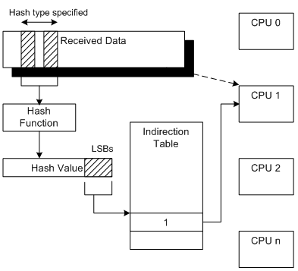
3. Virtual Machine Device Queues (VMDq)
With VMDq, the network adapter can create multiple separate queues, so that different processing cores can process each of the virtual queues, distributing the processing load and removing the VM manager’s processing bottleneck.
Intel’s VMDq technology provides multiple hardware queues and offload features that can be used to reduce the software overhead associated with sharing a single networking controller between multiple virtual machines. Prior to this technology, a network switch emulated in software by the virtualization platform sorted and routed the packets individually to the running VMs. This process introduced significant delays in the network packet processing.
With VMDq, individual hardware queues are associated with the simulated network interfaces of the running VMs, so the controller itself performs the routing of received packets, thereby substantially lowering the overhead. This technology is also used on outbound VM packets to provide transmit fairness and to avoid a single VM blocking access to the controller.

4. Extended Message-Signaled Interrupts
The ability to communicate efficiently between queues and particular processor cores is handled by MSI-X. MSI-X is the next generation of MSI, provides multiple interrupt vectors, which allow multiple interrupts to be handled simultaneously and load balanced across multiple cores. This improvement helps improve CPU utilization and lower latency.
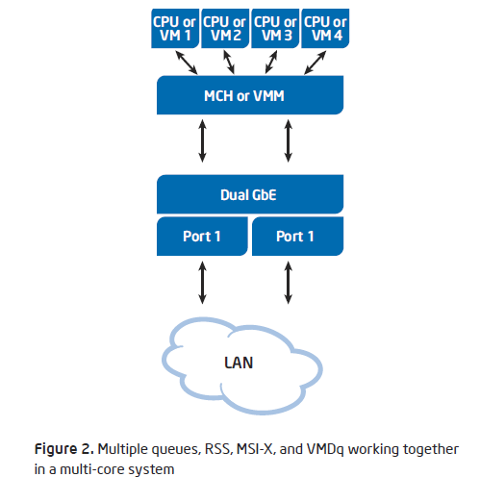
TCP congestion control
TCP should properly match the transmission rate of the sender and receiver over the network condition. It is important for the transmission to run at high rate in order to achieve good performance and protect against congestion and packet losses.
Congestion occurs when the traffic offered to a communication network exceeds its available transmission capacity. This is implemented in TCP using a concept called windows. The window size advertised by the receiver tells the sender how much data, can be sent without waiting for further acknowledgements. As data is sent by the sender and then acknowledged by the receiver, the window slides forward to cover more data in the byte stream. This is usually called sliding window.
The congestion control algorithm is basically dependent of network bandwidth, round trip time and packet loss rate. Therefore, depending on the characteristics of your network, an algorithm fits better than another. On Linux it is possible to change the congestion avoidance algorithm on the fly. To do so, a file called proc/sys/net/ipv4/tcp_available_congestion_control lists all the algorithms available to the system, as follows:
# cat /proc/sys/net/ipv4/tcp_available_
congestion_control
cubic reno
Also, it is possible to see what algorithm the system is currently using, looking into file
/proc/sys/net/ipv4/tcp_congestion_control.
To set a new algorithm, just echo one of those available algorithm names into this file, as follows:
# echo cubic > /proc/sys/net/ipv4/tcp_congestion_control
The most common TCP/IP collision avoidance algorithms are RENO, CUBIC, FAST
RENO - Its major change was the way in which it reacts when detects a loss through duplicate acknowledgements.
CUBIC – Its major change was the way in which it reacts when detects a loss through duplicate acknowledgements.
FAST – A FAST TCP flow seeks to maintain a constant number of packets in queues throughout the network. FAST is delay-based algorithms that try to maintain a constant number of packets in queue, and a constant window size, avoiding the oscillations inherent in loss-based algorithms,
as Reno. Also, it detects congestion earlier than loss-based algorithms. Based on it, if it shares
a network with loss-based “protocol,” the FAST algorithms tend to be less aggressive. In this way, FAST has the better Friendliness than CUBIC and Reno.

Networking – packet flow
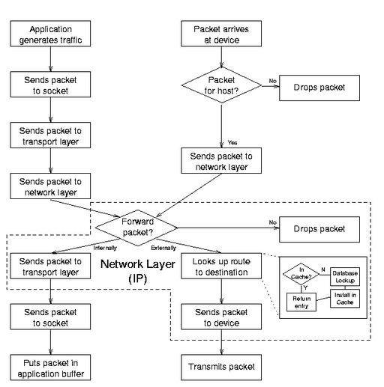

Multiqueues in Networking
The core networking code call a driver's hard_start_xmit() function to let the driver know that a packet is ready for transmission; and the driver's job to feed that packet into the hardware's transmit queue.
This is the traditional way of transmit queue implemented with a single queue and does not map well to devices which have multiple transmit queues.

The current code with multiple queues treats a network device as the fundamental unit which is managed by the outgoing packet scheduler and each transmit queue will be scheduled independently. So there is a new netdev_queue structure which encapsulates all of the information about a single transmit queue, and which is protected by its own lock. Multiqueue drivers then set up an array of these structures.
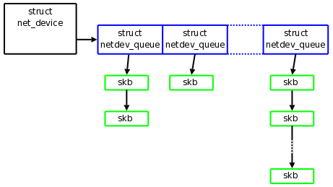
Drivers for single-queue devices need not be changed, and the addition of multiqueue support is relatively straightforward. The first step is to replace the alloc_etherdev() call with a call to:
struct net_device *alloc_etherdev_mq(int sizeof_priv,
unsigned int queue_count);

Where, queue_count -> maximum no. of queues.
The actual number of queues used should be stored in the real_num_tx_queue field of the net_device structure.
A multiqueue driver will get packets destined for any queue via the usual hard_start_xmit() function. To determine which queue to use, the driver should call

u16 skb_get_queue_mapping(struct sk_buff *skb);

The return value is index to the array of transmit queues. One might wonder how networking core decides which queue to use in the first place. That is handled via a new net_device callback:

u16 (*select_queue)(struct net_device *dev, struct sk_buff *skb);

Other change for multiqueue drivers is to inform the networking core about the status of specific queues.
struct netdev_queue *netdev_get_tx_queue(struct net_device *dev,
u16 index);

void netif_tx_start_queue(struct netdev_queue *dev_queue);
void netif_tx_wake_queue(struct netdev_queue *dev_queue);
void netif_tx_stop_queue(struct netdev_queue *dev_queue);
A call to netdev_get_tx_queue() will turn a queue index into the struct netdev_queue pointer required by the other functions, which can be used to stop and start the queue in the usual manner. If the driver needs to operate on all of the queues at once, below are the functions:
void netif_tx_start_all_queues(struct net_device *dev);
void netif_tx_wake_all_queues(struct net_device *dev);
void netif_tx_stop_all_queues(struct net_device *dev);

