MISC
=====

Change to root mode in Ubuntu

Su - (or) sudo –i (or) sudo -s

cx23882.h - https://github.com/haiku/haiku/blob/master/src/add-ons/kernel/drivers/dvb/cx23882/cx23882.h

__init and __devinit / __devexit difference
=================================

#ifdef CONFIG_HOTPLUG
# define __devinit
#else
# define __devinit __init
#endif

That is, without CONFIG_HOTPLUG defined, it pre-processes to nothing at all.
When CONFIG_HOTPLUG is defined though, it doesn’t turns into __init which is again a pre-processor macro:
#define __init __attribute__ ((__section__ (".init.text"))) (*)

this __attribute__ makes GCC emit the function into the specified section (.init.text) of the object file, and the linker later into the specified section of the executable -- the kernel or module in this case.

In this section, functions that are only needed at initialization time are placed so that the entire section can be tossed once the kernel is up and running (in the case of builtin code) or once the module has loaded and initialized in the case of a module. For the kernel proper, you see it discarding this section when it says:

"Freeing unused kernel memory: xxxk freed"

Near the end of the bootup. The advantage ofcourse is that you save xxxk of memory.

Now, the CONFIG_HOTPLUG difference is (was...) intended for hotpluggable hardware. Ofcourse, you can't toss the .init section upon loading the kernel or module if its for hotpluggable hardware, since the code it contains might still be needed later when you _do_ hotplug said hardware. So, with hotplug support enabled in the kernel, the functions just go to the regular kernel text section alongside all other normal functions.

These days CONFIG_HOTPLUG is a bit more generally applicable than just for hotpluggable hardware. Generally, you could for example simulate plugging and unplugging hardware by manipulating sysfs files. This means that you might see the __devinit annotation even on init functions for decidedly un-hotpluggable hardware such as ancient ISA stuff.

__devexit – Similar to the __devinit.

Reference
-------------
http://www.spinics.net/lists/newbies/msg29197.html

PCI bus family
============
- PCI - 32 bit bus, 33 or 66 MHz, 250 Mbyte/s
- MiniPCI - Smaller slot in laptops
- CardBus - External card slot in laptops
- PIX Extended - (PCIX) Wider slot than PCI, 64 bit, but can accept a standard PCI card
- PCI Express - (PCIe or PCIE) Current generation of PCI. Serial instead of parallel
- PCI Express Mini Card - Replaces MiniPCI in recent laptops
- Express Card - Replaces CardBus in recent laptops

PCI device types
============
Main types of devices found on the PCI bus
- Network cards (wired or wireless)
- SCSI adapters
- Bus controllers: USB, PCMCIA, I2C, FireWire, IDE
- Graphics and video cards
- Sound cards

PCI features
=========
Device resources (I/O addresses, IRQ lines) automatically assigned at boot time, either by the BIOS or by Linux itself (if configured).

The device driver just has to read the corresponding configurations somewhere in the system address space

Endianism: PCI device configuration information is Little Endian. Remember that in your drivers
(conversion taken care of by some kernel functions).

Each PCI device has a 256 byte address space containing configuration registers.

Device configuration can be displayed with lspci x

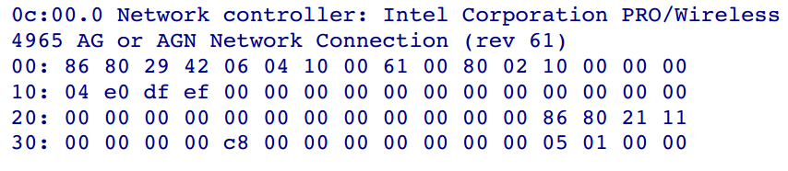

PCI device configuration

Standard information found in PCI configurations:
Offset 0: Vendor Id
Offset 2: Device Id
Offset 10: Class Id (network, display, bridge...)
Offsets 16 to 39: Base Address Registers (BAR) 0 to 5
Offset 44: Subvendor Id
Offset 46: Subdevice Id
Offsets 64 and up: up to the device manufacturer
Kernel sources: these offsets are defined in
include/linux/pci_regs.h

PCI device list (1) – lspci output

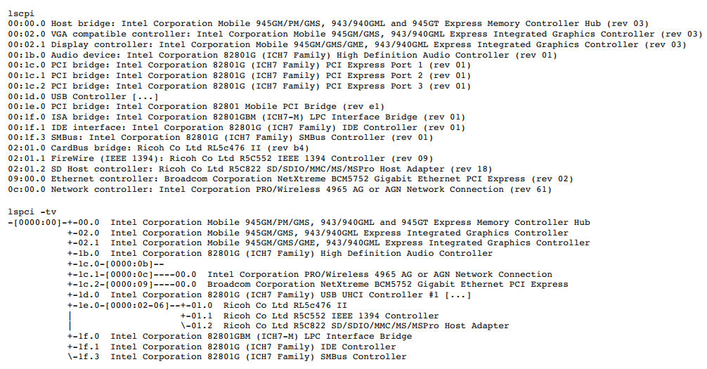

PCI device list (2) – lspci output

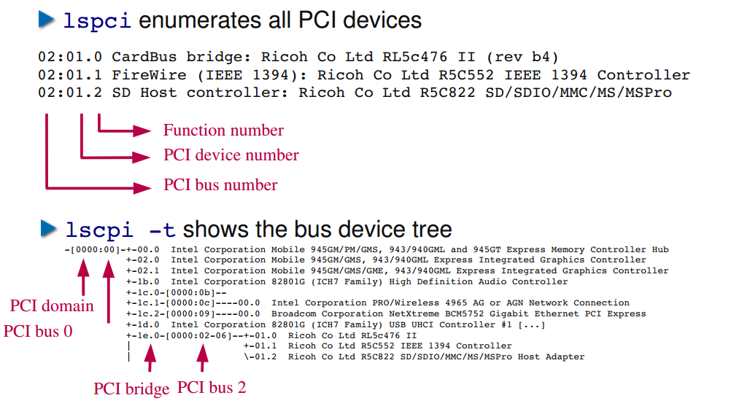

PCI device list (3) – lspci output

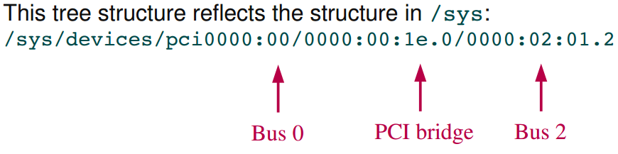

PCI skeleton driver
1 #include <linux/kernel.h>
2 #include <linux/module.h>
3 #include <linux/pci.h>
4 #include <linux/init.h>
5
6
7 static struct pci_device_id ids[] = {
8 { PCI_DEVICE(PCI_VENDOR_ID_INTEL, PCI_DEVICE_ID_INTEL_82801AA_3), },
9 { 0, }
10 };
11 MODULE_DEVICE_TABLE(pci, ids);
12
13 static unsigned char skel_get_revision(struct pci_dev *dev)
14 {
15 u8 revision;
16
17 pci_read_config_byte(dev, PCI_REVISION_ID, &revision);
18 return revision;
19 }
20
21 static int probe(struct pci_dev *dev, const struct pci_device_id *id)
22 {
23 int result;
24 /* Do probing type stuff here.
25 * Like calling request_region();
26 */
27 if ((result = pci_enable_device(dev)) < 0) {
28 return result;
29 }
30 if (skel_get_revision(dev) == 0x42)
31 return -ENODEV;
32 return 0;
33 }
34
35 static void remove(struct pci_dev *dev)
36 {
37 /* clean up any allocated resources and stuff here.
38 * like call release_region();
39 */
40 }
41
42 static struct pci_driver pci_driver = {
43 .name = "pci_skel",
44 .id_table = ids,
45 .probe = probe,
46 .remove = remove,
47 };
48
49 static int __init pci_skel_init(void)
50 {
51 return pci_register_driver(&pci_driver);
52 }
53
54 static void __exit pci_skel_exit(void)
55 {
56 pci_unregister_driver(&pci_driver);
57 }
58
59 MODULE_LICENSE("GPL");
60
61 module_init(pci_skel_init);
62 module_exit(pci_skel_exit);

==========================================================================

1) Remove the e1000 driver and insert sample driver pci_skel.ko
Doing rmmod e1000, the entry of e1000 will be removed from lsmod and even from the sysfs tree

insmod pci_skel.ko

dmesg output
[ 616.990645] *** inside init - (pci_my_skel) ***
[ 616.990743] *** inside probe - (pci_my_skel) ***
[ 616.990784] *** inside probe - (pci_my_skel) ***

Note: Probe is called as many times the matching devices are found.
In the above case, there are 2 eth interfaces, so the probe is called twice.

rmmod pci_skel

dmesg output
[ 758.033398] *** inside exit - (pci_my_skel) ***

==========================================================================
2) Remove the pci_skel.ko and insert the e1000 driver

To restore the e1000 driver, do insmod

cd /lib/modules/2.6.32-24-generic/kernel/drivers/net/e1000
insmod e1000.ko

sys class output for e1000 driver

root@ankit-laptop:/sys/bus/pci/drivers/e1000/0000:00:03.0/driver# ls
0000:00:03.0 0000:00:08.0 bind module new_id remove_id uevent unbind

root@ankit-laptop:/sys/bus/pci/drivers# tree e1000/
e1000/
|-- 0000:00:03.0 -> ../../../../devices/pci0000:00/0000:00:03.0
|-- 0000:00:08.0 -> ../../../../devices/pci0000:00/0000:00:08.0
|-- bind
|-- module -> ../../../../module/e1000
|-- new_id
|-- remove_id
|-- uevent
`-- unbind
3 directories, 5 files

Note: after the rmmod e1000, the entry in the /sys/class will be removed.
==========================================================================
3) After removing the e1000 inserted the pci_skel.ko

root@ankit-laptop:/sys/bus/pci/drivers# tree pci_my_skel/
pci_my_skel/
|-- 0000:00:03.0 -> ../../../../devices/pci0000:00/0000:00:03.0
|-- 0000:00:08.0 -> ../../../../devices/pci0000:00/0000:00:08.0
|-- bind
|-- module -> ../../../../module/pci_skel
|-- new_id
|-- remove_id
|-- uevent
`-- unbind

3 directories, 5 files

==========================================================================
When insmod e1000.ko is done, the output of dmesg

[ 1926.398706] Intel(R) PRO/1000 Network Driver - version 7.3.21-k5-NAPI
[ 1926.398717] Copyright (c) 1999-2006 Intel Corporation.
[ 1926.398862] e1000 0000:00:03.0: PCI INT A -> Link[LNKC] -> GSI 10 (level, low) -> IRQ 10
[ 1926.752561] e1000: 0000:00:03.0: e1000_probe: (PCI:33MHz:32-bit) 08:00:27:b5:14:82
[ 1926.797221] e1000: eth0: e1000_probe: Intel(R) PRO/1000 Network Connection
[ 1926.801154] e1000 0000:00:08.0: PCI INT A -> Link[LNKD] -> GSI 9 (level, low) -> IRQ 9
[ 1926.812834] udev: renamed network interface eth0 to eth2
[ 1927.165593] e1000: 0000:00:08.0: e1000_probe: (PCI:33MHz:32-bit) 08:00:27:01:bf:84
[ 1927.181571] ADDRCONF(NETDEV_UP): eth2: link is not ready
[ 1927.184973] e1000: eth2 NIC Link is Up 1000 Mbps Full Duplex, Flow Control: RX
[ 1927.186343] ADDRCONF(NETDEV_CHANGE): eth2: link becomes ready
[ 1927.306431] e1000: eth0: e1000_probe: Intel(R) PRO/1000 Network Connection
[ 1927.338036] udev: renamed network interface eth0 to eth3
[ 1927.348995] ADDRCONF(NETDEV_UP): eth3: link is not ready
[ 1927.352468] e1000: eth3 NIC Link is Up 1000 Mbps Full Duplex, Flow Control: RX
[ 1927.353789] ADDRCONF(NETDEV_CHANGE): eth3: link becomes ready

==========================================================================

root@ankit-laptop:/home/ankit/PCI# lspci | grep Ethernet
00:03.0 Ethernet controller: Intel Corporation 82540EM Gigabit Ethernet Controller (rev 02)
00:08.0 Ethernet controller: Intel Corporation 82540EM Gigabit Ethernet Controller (rev 02)

root@ankit-laptop:/usr/src/linux-headers-2.6.32-24/Documentation# lspci -tv
-[0000:00]-+-00.0 Intel Corporation 440FX - 82441FX PMC [Natoma]
+-01.0 Intel Corporation 82371SB PIIX3 ISA [Natoma/Triton II]
+-01.1 Intel Corporation 82371AB/EB/MB PIIX4 IDE
+-02.0 InnoTek Systemberatung GmbH VirtualBox Graphics Adapter
+-03.0 Intel Corporation 82540EM Gigabit Ethernet Controller
+-04.0 InnoTek Systemberatung GmbH VirtualBox Guest Service
+-05.0 Intel Corporation 82801AA AC'97 Audio Controller
+-06.0 Apple Computer Inc. KeyLargo/Intrepid USB
+-07.0 Intel Corporation 82371AB/EB/MB PIIX4 ACPI
+-08.0 Intel Corporation 82540EM Gigabit Ethernet Controller
+-0b.0 Intel Corporation 82801FB/FBM/FR/FW/FRW (ICH6 Family) USB2 EHCI Controller
\-0d.0 Intel Corporation 82801HBM/HEM (ICH8M/ICH8M-E) SATA AHCI Controller
root@ankit-laptop:/usr/src/linux-headers-2.6.32-24/Documentation#

==========================================================================
NOTE:
If a device is bind with the driver, and if new driver is inserted.
The probe will not execute, even though the device ID and the vendor ID of the driver matches with the device. In this case the new driver is just hooked to the kernel.

ex: when e1000 is not removed and we try to push pci_skel.ko, probe won’t be called. As there is a driver attached to the device e1000.
===========================================================================
bind and unbind a driver to a particular device
1) In sysfs tree, every driver now has bind and unbind files associated with it

Here we have two devices “0000:00:03.0” & “0000:00:08.0” bind with the module e1000

root@ankit-laptop:/# tree /sys/bus/pci/drivers/e1000/
/sys/bus/pci/drivers/e1000/
|-- 0000:00:03.0 -> ../../../../devices/pci0000:00/0000:00:03.0
|-- 0000:00:08.0 -> ../../../../devices/pci0000:00/0000:00:08.0
|-- bind
|-- module -> ../../../../module/e1000
|-- new_id
|-- remove_id
|-- uevent
`-- unbind

3 directories, 5 files

2) Unbinding a device from a driver. Write the bus id of the device to unbind file

echo 0000:00:08.0 > /sys/bus/pci/drivers/e1000/unbind

3) Now the device will no longer be bound to the driver

The device 0000:00:08.0 is now disappeared from the tree

root@ankit-laptop:/# tree /sys/bus/pci/drivers/e1000/
/sys/bus/pci/drivers/e1000/
|-- 0000:00:03.0 -> ../../../../devices/pci0000:00/0000:00:03.0
|-- bind
|-- module -> ../../../../module/e1000
|-- new_id
|-- remove_id
|-- uevent
`-- unbind

2 directories, 5 files

4) To bind a device to a driver, the device must first not be controlled by any other driver

To ensure this, look for the "driver" symlink in device directory
Also there is no driver field listed in the tree output
root@ankit-laptop:/# tree /sys/bus/pci/devices/0000\:00\:08.0
/sys/bus/pci/devices/0000:00:08.0
|-- broken_parity_status
|-- class
|-- config
|-- device
|-- enable
|-- irq
|-- local_cpulist
|-- local_cpus
|-- modalias
|-- msi_bus
|-- power
| `-- wakeup
|-- remove
|-- rescan
|-- reset
|-- resource
|-- resource0
|-- resource2
|-- subsystem -> ../../../bus/pci
|-- subsystem_device
|-- subsystem_vendor
|-- uevent
`-- vendor
2 directories, 21 files

5) To bind, simply write the bus id of the device into the bind file for that driver.

echo 0000:00:08.0 > /sys/bus/pci/drivers/pci_my_skel/bind

6) Check the binding has happened successfully or not
Now the binding has happened and the driver field has been displayed in the tree output
root@ankit-laptop:/# tree /sys/bus/pci/devices/0000\:00\:08.0/
/sys/bus/pci/devices/0000:00:08.0/
|-- broken_parity_status
|-- class
|-- config
|-- device
|-- driver -> ../../../bus/pci/drivers/pci_my_skel
|-- enable
|-- irq
|-- local_cpulist
|-- local_cpus
|-- modalias
|-- msi_bus
|-- power
| `-- wakeup
|-- remove
|-- rescan
|-- reset
|-- resource
|-- resource0
|-- resource2
|-- subsystem -> ../../../bus/pci
|-- subsystem_device
|-- subsystem_vendor
|-- uevent
3 directories, 21 files

