Sockets
A socket is an endpoint of communication between 2 systems on a network.
Socket address is a combination of IP address and port on one system. In each system a socket exists for a process interacting with the socket on the other system over network.
Today, most communication between computers is based on the Internet Protocol; therefore most network sockets are Internet sockets.
When socket is created, the address domain and socket type should be mentioned. Also 2 processes can communicate with each other only if their sockets are of the same type and same domain.
Socket pair: Communicating local and remote sockets are called socket pairs. Each socket pair is described by a unique 4-tuple consisting of source and destination IP addresses and port numbers, i.e. of local and remote socket addresses.
The address of a socket in the Unix domain is a character string which is basically an entry in the file system.
An Internet domain socket is characterized by a unique combination of the following:
- Local socket address: Local IP address and port number. Port numbers are 16 bit unsigned integers.
- Remote socket address: Only for established TCP sockets. This is necessary since a TCP server may serve several clients concurrently. The server creates one socket for each client, and these sockets share the same local socket address from the point of view of the TCP server.
- Protocol: A transport protocol (e.g., TCP, UDP, raw IP, or others). TCP port 53 and UDP port 53 are different sockets.

Internet socket types
- Datagram sockets, also known as connectionless sockets, which use User Datagram Protocol (UDP).
- Stream sockets, also known as connection-oriented sockets, which use Transmission Control Protocol (TCP) or Stream Control Transmission Protocol (SCTP).
- Raw sockets (or Raw IP sockets), typically available in routers and other network equipment. Here the transport layer is bypassed, and the packet headers are made accessible to the application.

Raw Sockets
A raw socket is a socket that takes packets, bypasses the normal TCP/IP processing, and sends them to the application. The application that's using the packet is now responsible for stripping off the headers, analyzing the packet, all the stuff that the TCP/IP stack in the kernel normally does.

Most programs find it easier to let the kernel do their packet mangling for them. But a lot of security programs can use raw sockets and write their own packets. The TCP/IP stack in the kernel is written so that it makes good packets, and sends out good packets appropriate to the connection. But sometimes you want to make bad packets, to see if your remote system can handle that without erroring horribly. For things like this, you want to bypass the kernel's TCP/IP stack.

Raw sockets are used in security related applications like nmap, packet-sniffer. One possible use case for raw sockets is the implementation of new transport-layer protocols in user space. Raw sockets are typically available in network equipment (routers), and used for routing protocols such as the Internet Group Management Protocol (IGMP) and Open Shortest Path First (OSPF), and in the Internet Control Message Protocol (ICMP, best known for the ping sub-operation).

An easy example is PING. Ping works by sending out an ICMP (IP protocol distinct from TCP or UDP) echo packet. The kernel has built-in code to respond to echo/ping packets; it has to in order to comply with the TCP/IP spec. It doesn't have code to generate these packets, because it isn't required. So, rather than create another system call with associated code in the kernel to accomplish this, the "ping packet generator" is a program in user space. It formats an ICMP echo packet and sends it out over a SOCK_RAW, waiting for a response. That's why ping runs as set-uid root.

Raw socket means you can determine every section of packet, either header or payload. Please note that raw socket is a general word. I categorize raw socket into: Network Socket and Data-Link Socket (or alternatively L3 Socket and L2 Socket)
In L3 Socket you can determine header and payload of packet in network layer. For example if network layer protocol is IPv4, you can determine IPv4 header and payload. Thus you can set transport layer header/payload, ICMP header/payload, Routing Protocols header/payload.
In L2 Socket you can set header and payload of packet in data link layer, i.e everything in packet. Thus you do everything done with L3 Socket + determine ARP header/payload, PPP header/payload, PPPOE header/payload.
Now in programming:
socket (AF_INET,RAW_SOCKET,...) means L3 socket , Network Layer Protocol = IPv4
socket(AF_IPX,RAW_SOCKET,...) means L3 socket , Network Layer Protocol = IPX
socket(AF_INET6,RAW_SOCKET,...) means L3 socket , Network Layer Protocol=IPv6
socket(AF_PACKET,RAW_SOCKET,...) means L2 socket , Data-link Layer Protocol= Ethernet
Third parameter specifies payload protocol.

Ports
- In the computer networks, two kinds of port we deal with – physical ports and logical ports
- Physical port refers to interface on a computer into which a device can be inserted. Ex: RJ45 port, serial port, USB port
- Logical port is an application specific or process specific serving as communication endpoint in a host OS. A port is associated with IP address and the protocol (TCP/UDP) used for communication. There are 65535 logical ports.
- Port numbers 1 to 1023 are well known ports for standard services.
- 1024 to 49151 registered ports – they can be registered to specific protocols by software corporations.
- 49152 to 65535 – dynamic or private ports can be used by anybody else.
- Client port numbers are known as ephemeral ports. Ephemeral means short lived. This is because a client may connect to server, do its work and disconnect. Clients need to know the servers port number to connect to them, so most of the servers run on standard ports.

The port number, added to a computer's IP address, completes the destination address for a communications session. That is, data packets are routed across the network to a specific destination IP address, and then, upon reaching the destination computer, are further routed to the specific process bound to the destination port number.
The combination of port and IP address number together must be globally unique. On a given host or interface UDP and TCP may use the same port number, or on a host with two interfaces, both addresses may be associated with a port having the same number.

• 20 & 21: File Transfer Protocol (FTP)
• 22: Secure Shell (SSH)
• 23: Telnet remote login service
• 25: Simple Mail Transfer Protocol (SMTP)
• 53: Domain Name System (DNS) service
• 80: Hypertext Transfer Protocol (HTTP) used in the World Wide Web
• 110: Post Office Protocol (POP3)
• 119: Network News Transfer Protocol (NNTP)
• 143: Internet Message Access Protocol (IMAP)
• 161: Simple Network Management Protocol (SNMP)
• 194: Internet Relay Chat (IRC)
• 443: HTTP Secure (HTTPS)
Port forwarding
Port forwarding is a name given to, translating the address or port number of a packet to a new destination by accepting the packets in a packet filter (firewall) and forwarding the packet according to the routing tables. Three types of port forwarding are,
Local
Remote
Dynamic
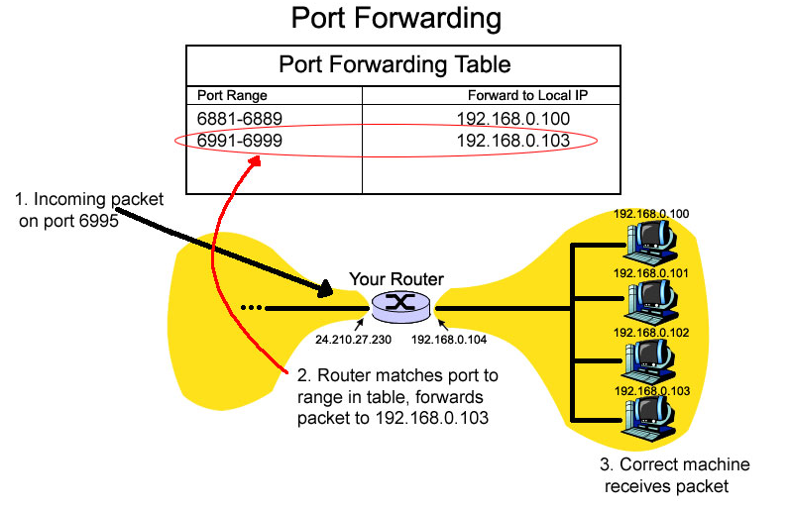
Port Scanning
A port scanner is a software application designed to probe a server for open ports. This is often used by administrators to verify security policies of their networks and by attackers to identify running services on a host with the view to compromise it.
A port scan can be defined as an attack that sends client requests to a range of server port addresses on a host, with the goal of finding an active port and exploiting a known vulnerability of that service, although the majority of uses of a port scan are not attacks and are simple probes to determine services available on a remote machine.
To portsweep is to scan multiple hosts for a specific listening port. The latter is typically used in searching for a specific service, for example, an SQL-based computer worm may portsweep looking for hosts listening on TCP port 1433
Look at the file ‘/etc/services’, you see most of the standard servers and the port on which they run.
$ cat /etc/services
systat 11/tcp users
daytime 13/udp
netstat 15/tcp
qotd 17/tcp quote
msp 18/udp
chargen 19/udp ttytst source
ftp-data 20/tcp
ftp 21/tcp
ssh 22/tcp
ssh 22/udp
telnet 23/tcp
...
...

Sockets bind to ports
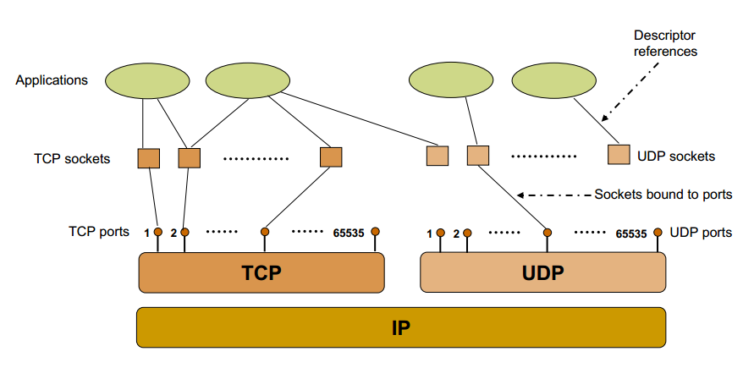
TCP and UDP socket flow

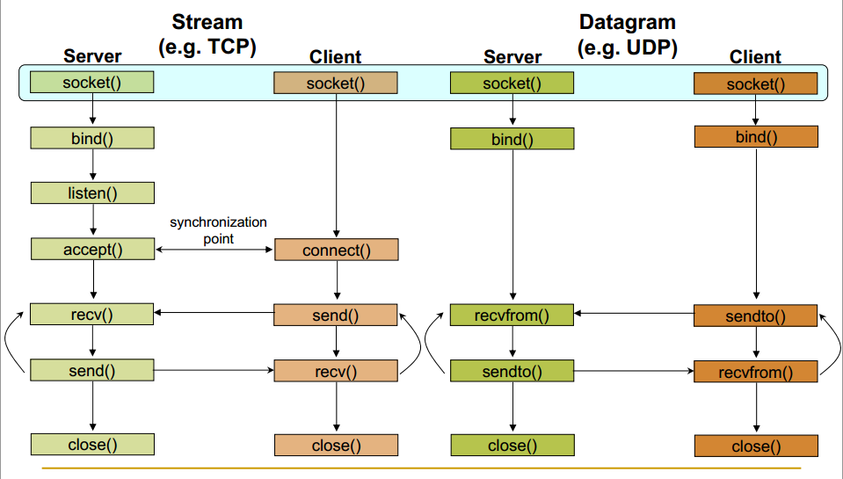

Socket – create a new communication end point
Bind – attach a local address to the socket
Listen – announce willingness to accept connections
Accept – block caller until a connection request arrives
Connect – actively attempt to establish a connection
Send – send data over the connection
Receive – receive data over the connection
Close – release the connection

PROTOTYPES
int socket(int <family>, int <socket_type>, int <default 0>);
int bind(int <sockfd>, const struct sockaddr * <serv address>, socklen_t <sizeof(serv address));
int listen(int <sockfd>, int <num of connections>);
int accept(int <sockfd>, struct sockaddr *restrict <client address>, socklen_t *restrict <sizeof(client address)>);
int connect(int <sockfd>, const struct sockaddr * <serv address>, socklen_t <sizeof(serv address)>);

Socket server program

#include <sys/socket.h>
#include <netinet/in.h>
#include <arpa/inet.h>
#include <stdio.h>
#include <stdlib.h>
#include <unistd.h>
#include <errno.h>
#include <string.h>
#include <sys/types.h>
#include <time.h>

int main(int argc, char *argv[])
{
int listenfd = 0, connfd = 0;
struct sockaddr_in serv_addr;

char sendBuff[1025];
time_t ticks;

listenfd = socket(AF_INET, SOCK_STREAM, 0);
memset(&serv_addr, '0', sizeof(serv_addr));
memset(sendBuff, '0', sizeof(sendBuff));

serv_addr.sin_family = AF_INET;
serv_addr.sin_addr.s_addr = htonl(INADDR_ANY);
serv_addr.sin_port = htons(5000);

bind(listenfd, (struct sockaddr*)&serv_addr, sizeof(serv_addr));

listen(listenfd, 10);

while(1)
{
/* int s= accept(sockid, &clientAddr, &addrLen); */
connfd = accept(listenfd, (struct sockaddr*)NULL, NULL);

ticks = time(NULL);
snprintf(sendBuff, sizeof(sendBuff), "%.24s\r\n", ctime(&ticks));
write(connfd, sendBuff, strlen(sendBuff));

close(connfd);
sleep(1);
}
}

- The call to the function ‘socket()’ creates an UN-named socket inside the kernel and returns an integer known as socket descriptor.
- This ‘socket()’ function takes domain/family as its first argument. For Internet family of IPv4 addresses we use AF_INET.
- The second argument ‘SOCK_STREAM’ specifies that the transport layer protocol that we want should be reliable ie it should have acknowledgement techniques. For example : TCP
- The third argument is generally left zero to let the kernel decide the default protocol to use for this connection. For connection oriented reliable connections, the default protocol used is TCP.
- The call to the function ‘bind()’ assigns the details specified in the structure ‘serv_addr’ to the socket created in the step above. The details include the family/domain, the interface to listen on and the port on which the server will wait for the client requests to come.
- The call to the function ‘listen()’ with second argument as ’10′ specifies maximum number of client connections that server will queue for this listening socket.
- After the call to listen(), this socket becomes a fully functional listening socket.
- In the call to accept(), the server is put to sleep and when for an incoming client request, the three way TCP handshake* is complete, the function accept () wakes up and returns the socket descriptor representing the client socket.
- The call to accept() is run in an infinite loop so that the server is always running and the delay or sleep of 1 sec ensures that this server does not eat up all of your CPU processing.
- As soon as server gets a request from client, it prepares the date and time and writes on the client socket through the descriptor returned by accept().
Three way handshake is the procedure that is followed to establish a TCP connection between two remote hosts.
Socket Client program
#include <sys/socket.h>
#include <sys/types.h>
#include <netinet/in.h>
#include <netdb.h>
#include <stdio.h>
#include <string.h>
#include <stdlib.h>
#include <unistd.h>
#include <errno.h>
#include <arpa/inet.h>

int main(int argc, char *argv[])
{
int sockfd = 0, n = 0;
char recvBuff[1024];
struct sockaddr_in serv_addr;

if(argc != 2)
{
printf("\n Usage: %s <ip of server> \n",argv[0]);
return 1;
}

memset(recvBuff, '0',sizeof(recvBuff));
if((sockfd = socket(AF_INET, SOCK_STREAM, 0)) < 0)
{
printf("\n Error : Could not create socket \n");
return 1;
}

memset(&serv_addr, '0', sizeof(serv_addr));

serv_addr.sin_family = AF_INET;
serv_addr.sin_port = htons(5000);

if(inet_pton(AF_INET, argv[1], &serv_addr.sin_addr)<=0)
{
printf("\n inet_pton error occured\n");
return 1;
}

/* int status = connect(sockid, &foreignAddr, addrlen); */
if( connect(sockfd, (struct sockaddr *)&serv_addr, sizeof(serv_addr)) < 0)
{
printf("\n Error : Connect Failed \n");
return 1;
}

while ( (n = read(sockfd, recvBuff, sizeof(recvBuff)-1)) > 0)
{
recvBuff[n] = 0;
if(fputs(recvBuff, stdout) == EOF)
{
printf("\n Error : Fputs error\n");
}
}

if(n < 0)
{
printf("\n Read error \n");
}

return 0;
}

- The client which will connect to the server and receive date and time from it.
- A socket is created through call to socket() function.
- Information like IP address of the remote host and its port is bundled up in a structure and a call to function connect() is made which tries to connect this socket with the socket (IP address and port) of the remote host.
- We have not bind our client socket on a particular port, as client generally use port assigned by kernel as client can have its socket associated with any port. But in case of server it has to be a well known socket, so known servers bind to a specific port like HTTP server runs on port 80 etc while there are no such restrictions on clients.
- Once the sockets are connected, the server sends the data (date+time) on clients socket through clients socket descriptor and client can read it through normal read call on the its socket descriptor.

Now execute the client as shown below.
$ ./newsc 127.0.0.1
Sun Dec 18 22:22:14 2011

We can see that we successfully got the date and time from server.
We need to send the IP address of the server as an argument for this example to run. If you are running both server and client example on the same machine for testing purpose, use the loop back ip address as shown above.

The socket structure for ipv4,
struct sockaddr {
unsigned short sa_family; /* address family: AF_INET */
char sa_data[14]; /* family-specific address info*/

struct sockaddr_in {
sa_family_t sin_family; /* address family: AF_INET */
in_port_t sin_port; /*port in network byte order */
struct in_addr sin_addr; /* internet address
};

/* Internet address. */
struct in_addr {
uint32_t s_addr; /* address in n/w byte order */
};

The socket structure changes for ipv6,
struct sockaddr_in6 {
sa_family_t sin6_family; /* AF_INET6 */
in_port_t sin6_port; /* port number */
uint32_t sin6_flowinfo; /* IPv6 flow information */
struct in6_addr sin6_addr; /* IPv6 address */
uint32_t sin6_scope_id; /* Scope ID (new in 2.4) */
};

Note : The scokaddr_in can be casted to a sockaddr. That’s what is done in server program in bind.

Host- byte ordering – the byte ordering used by a host (big or little endian)
Network byte ordering – the byte ordering used by the network (big endian)

U_long htonl(u_long num);
U_short htons(u_short num);

U_long ntohl(u_long num);
U_short ntohs(u_short num);

In the big endian machines, these routines do nothing.
In little endian machines, these routines reverse the byte order
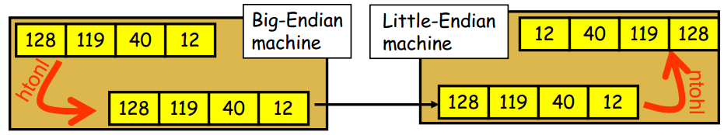

Netstat : Command line tool monitoring incoming and outgoing network connections. Print network connections, routing tables, interface statistics, masquerade connections, and multicast memberships

Running netstat –ntlp shows the socket running
This shows the list of open network ports and the processes that own them
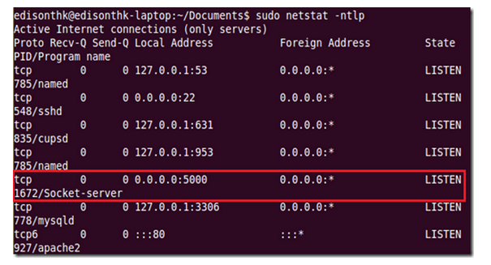
Netstat –r : Display the routing information maintained by the kernel.
$ netstat -r
Kernel IP routing table
Destination Gateway Genmask Flags MSS Window irtt Iface
192.168.1.0 * 255.255.255.0 U 0 0 0 wlan0
link-local * 255.255.0.0 U 0 0 0 wlan0
default 192.168.1.1 0.0.0.0 UG 0 0 0 wlan0

The flag 'U' indicates that this entry is up while the flag 'G' indicates that this entry is not a direct entry i.e. the destination indicated in this route entry is not on the same network.
Netstat –g: Display multicast group membership information
Netstat –i: display information related to all network interfaces
Netstat –s: Display summary statistics for each protocol
Netstat –at/ -au/ -ax: List all tcp, udp, unix port connections
Netstat –lt/ -lu / -lx: List all listening ports of tcp, udp and unix

Netcat – Featured networking utility for debugging and investigating the network. This can be used for creating TCP/IP connections and investigating by reading and writing data across network connections using TCP/IP protocol.

Netcat can be used in client/server architecture
- The netcat can be run in the server mode on a specified port listening for incoming connections
$nc -2389
- The netcat can be run in other terminal for client mode trying to connect on port 2389
$nc localhost 2389
- If we write something on client, this comes on the server terminal
$nc localhost 2389
Hi server

Netcat can be used to transfer files
Netcat supports IPV6 connectivity
Making any process a server
Port forwarding or Port mapping, proxying, port scanning
Netcat supports timeout – When we do not want a connection to remain open forever. In that case, through –w switch we can specify the timeout in a connection. So after the seconds specified by –w, the connection between the client and server is terminated.
Server: $nc –l 2389
Client: $nc –w 20 localhost 2389

sockstat: The sockstat command lists open Internet or UNIX domain sockets.

References for netcat
http://en.wikipedia.org/wiki/Netcat
http://www.thegeekstuff.com/2012/04/nc-command-examples/

References for socket
http://www.cs.rpi.edu/~moorthy/Courses/os98/Pgms/socket.html

