What is Virtualization?
In my opinion, the following three sentences are the most important points in defining virtualization:
- Virtualization allows a single physical server to simultaneously run multiple Virtual Machines (VMs).
- Each virtual machine is self-contained and protected from other VMs on the same server.
- Virtual machines appear to be real machines from the outside world.
- We can assume a virtual machine is made up of virtual hardware, on which you can install an operating system and applications.
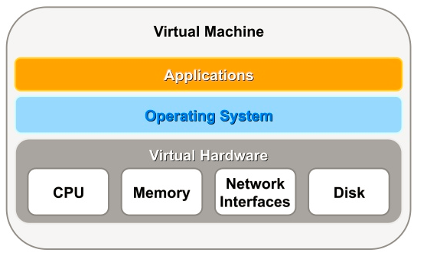

How Does Virtualization work?
In the early days of virtualization, vendors offered hardware virtualization, where the hardware itself was responsible for dividing resources between virtual machines and making sure system calls from multiple virtual machines could not interfere with each other.
An alternative to hardware virtualizaton is OS virtualization, where the operating system takes on the role of managing the host resources.
The final group to consider is software virtualization, where a program called a hypervisor is used to manage the resources on the physical server. Software virtualization on commodity hardware is probably the most common form of virtualization these days.
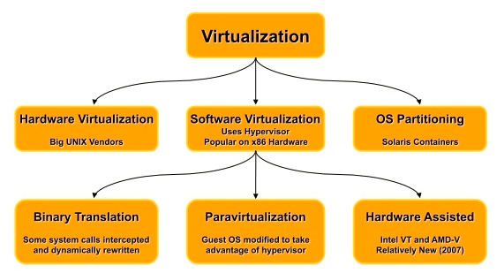

What Virtualization Products Are Available?
Bare-Metal (Type 1 Hypervisor): Theoretically hypervisor is installed and runs directly on the physical hardware and can exist without any accompanying operating system. In practice, the bare-metal hypervisors include an additional small operating system to help with tasks such as device management. The presence of this additional OS sometimes confuses people into believing bare-metal installations are not truly bare-metal. The fact that the hypervisor sits directly on the host hardware makes it more efficient for server virtualization in a data center environment.
Hosted or Desktop (Type 2 Hypervisor): In these products, a regular operating system (Linux, Windows etc) is installed on the hardware and the hypervisor runs on top of that operating system. The additional overhead and dependencies of the initial OS installation typically make hosted solutions less efficient, so they are often seen as desktop virtualization products.
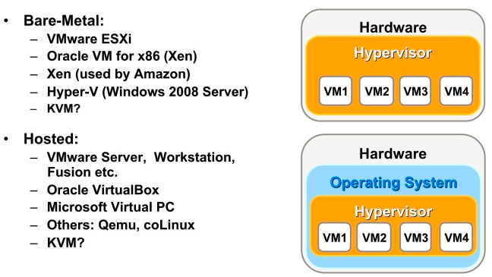
You will note that I've classified KVM in both groups. This is because in my opinion it doesn't fit neatly into either classification. On the one hand, it is totally dependent on the Linux installation, making it seems like a hosted solution, but it is so closely tied into the Linux operating system it is effectively turning the Linux installation on the host into a hypervisor. Depending on your virtualization politics, I think it is possible to justify it's inclusion in either category.

Three Kinds of Server Virtualization

Fully virtualization – uses hypervisor
This uses a special kind of software called a hypervisor such as VMware’s vSphere Hypervisor or Microsoft’s Hyper-V server. The hypervisor interacts directly with the physical server's CPU and disk space. This hypervisor allows multiple operating systems to run simultaneously on a host computer, while also monitoring the physical server’s resources and keeping each virtual server independent of other virtual servers running on the physical machine. Each guest server can run on its own operating system, such as both Linux and Windows.
The hypervisor keeps each virtual server completely independent and unaware of the other virtual servers running on the physical machine. The hypervisor monitors the physical server's resources.

Para-virtualization – Sharing the resources
The para-virtualization technique offers a software interface to virtual machines that is similar, but not identical to underlying hardware. Unlike full server virtualization, guest servers are aware of one another when using para-virtualization. A para-virtualization hypervisor does not need large amounts of processing power to manage guest operating systems because of this, as each OS is already aware of the demands placed on the physical server. The entire system works together as a cohesive unit.

OS-level virtualization – All the guests OS are same
This approach doesn't use a hypervisor at all. Instead, the virtualization capability is part of the host OS, which performs all the functions of a fully virtualized hypervisor. The biggest limitation of this approach is that all the guest servers must run the same OS. Each virtual server remains independent from all the others, but you can't mix and match operating systems among them. Because all the guest operating systems must be the same, this is called a homogeneous environment.

7.2. Virtualization Modes (Domain Types)
Virtual machines may run in one of two main modes, paravirtualized (PVM) or hardware virtualized (HVM). In paravirtualized mode, the kernel of the guest operating system is recompiled to be made aware of the virtual environment. This allows the paravirtualized guest to run at near native speed, since most memory, disk and network accesses are optimized for maximum performance.
If support for hardware virtualization is available (either Intel VT or AMD-V), the guest operating system may run completely unmodified. This hardware virtualized guest is carefully monitored and trapped by Oracle VM Server when any instruction is executed which would violate the isolation with other guests or dom0. In the current implementation, there may be performance penalty for certain types of guests and access types, but hardware virtualization also allows many Microsoft Windows™ operating systems and legacy operating systems to run unmodified.
The third virtualization mode is hardware virtualized, with paravirtualized drivers (PVHVM). This mode is identical to hardware virtualized, but with additional paravirtualized drivers installed in the guest's operating system to improve virtual machine performance.
Oracle recommends you create paravirtualized virtual machines if possible, as the performance of a paravirtualized virtual machine is superior to that of a hardware virtualized guest.
There are three virtual machine virtualization modes, or domain types, as shown in Table 7.1, “Domain Types”. When you create a virtual machine using the Virtual Machine wizard you must select which mode to use.
Table 7.1. Domain Types
Domain Type | Description
Hardware virtualized (HVM) | Hardware virtualization, or fully virtualized. When you create an HVM guest, you must supply an ISO file in a repository from which to create the virtual machine. See Section 7.5.5, “ISO Files (CD/DVD Images)” for information on importing an ISO file into a repository.  To create HVM guests, you may need to activate the hardware virtualization in the BIOS of the server on which you install the Oracle VM Server.
Hardware virtualized, with paravirtualized drivers (PVHVM) | Identical to HVM, but with additional paravirtualized drivers for improved performance of the virtual machine. See Section 7.11, “Installing Paravirtualized Drivers” for more information about using paravirtualized drivers. This Domain Type is used to run Microsoft Windows guest operating systems with an acceptable performance level.
Paravirtualized (PVM) | Paravirtualized. Enables you to select a location for the mounted ISO file from which to create the virtual machine. Before you create the virtual machine using the paravirtualized method, mount the ISO file on an NFS share, or HTTP or FTP server. You supply the location of the mounted ISO file in the Boot Options step of the wizard.  For information on creating a mounted ISO file, see Section 7.4, “Virtual Machine Installation Media”.

What is Amazon RDS for Oracle Database?
Amazon Relational Database Services (RDS) for Oracle is a Software as a Service (SaaS) model for Oracle databases, implemented using Oracle VM. It provides a number of features including:
- Preconfigured databases (11.2 only).
- Monitoring and Metrics.
- Automatic software patching (optional control).
- Automatic backups (user-initiated available also).
- Scalable CPU, memory and storage.
- Automatic Host Replacement (HA). If a host fails, the VM is automatically started on a new physical server.
- Standby (Multi-Availability Zone (AZ) Deployments). If a whole data center fails, the VM is automatically started in a different data center.

What's All This About Virtual Insanity?
Every environment, physical or virtual, can have its own set of problems, but most of the problems people encounter with virtualization tends to be because they don't size their physical hardware appropriately. Consider the following points when using virtualization:
- Virtual CPUs: Unless you use hard partitioning, virtual CPUs compete with each other for physical CPUs/cores. Placing many CPU intensive VMs on an under-powered physical host is not going to result in good performance.
- Memory: Don't over-allocate memory to the VMs or you may get swapping on the physical hardware. Some virtualization products don't support swapping. Some products support over-allocation of memory, allowing the VMs to "borrow" memory off each other. Using these features can be dangerous if the hypervisor does not truly understand what guest memory is free.
- Storage: Having multiple virtual disks on the same physical disks is not going to result in good performance for I/O intensive systems. Normal rules apply as far as I/O is concerned.
- Network: If you only have a single physical network adapter it must be shared between all VMs. If you know your VMs will be network intensive, you need multiple physical network adapters, allowing VMs to use dedicated network adapters.
- Time-Slippage: Always use NTP to keep the VM internal system clocks in sync. Some virtualization products have a long history of letting the system clocks in virtual machines slip compared to the host machine.
- Dynamic Resource Allocation: Although virtualized environments may be capable of providing dynamic resource allocation, not all software you run inside VMs can cope with this. For example, dynamically increasing the number of virtual CPUs associated with a VM will not guarantee Oracle can use them without a database restart. Likewise, trying to reduce virtual memory on a VM will present a problem if that memory is already allocated to a database instance running in the VM.
- Maintenance/Monitoring: VMs require the same amount of system administration and database administration work as physical servers. If you take 10 physical servers and consolidate them into 10 VMs, you still have 10 operating systems to patch. You still have 10 Oracle installations to administer and patch. You still need to install 10 grid control agents.
- A hybrid kernel is an operating system kernel architecture that attempts to combine aspects and benefits of microkernel and monolithic kernel architectures used in computer operating systems. The traditional kernel categories are monolithic kernels and microkernels (with nanokernels and exokernels). The "hybrid" category is controversial, due to the similarity of hybrid kernels and ordinary monolithic kernels; the term has been dismissed by Linus Torvalds as simple marketing.^{[1]}
- The idea behind a hybrid kernel is to have a kernel structure similar to that of a microkernel, but to implement that structure in the manner of a monolithic kernel. In contrast to a microkernel, all (or nearly all) operating system services in a hybrid kernel are still in kernel space. So there are none of the reliability benefits of having services in user space, as with a microkernel. However, just as with an ordinary monolithic kernel, there is none of the performance overhead for message passing and context switching between kernel and user mode that normally comes with a microkernel.

