Networking concepts
- FTP and TFTP
- Wake-on-LAN
- Loopback Address
- DMZ
- NAT and NAPT
- MAC cloning
- ARP, ARP table (or) ARP caching, Gratuitous ARP
- How ping works
- Public IP, Private IP and Global IP
- Hop count and time-to-live
- Promiscuous mode
- Power over Ethernet

File Transfer Protocol (FTP)
The FTP is a standard network protocol used to transfer computer files from one host to another host over a TCP-based network, such as the Internet.
FTP is built on client-server architecture and uses separate control and data connections between the client and the server. The command channel and the data channel, which are actually separate TCP connections. The command channel is for commands and responses; the data channel is for actually transferring files
FTP users may authenticate themselves using a clear-text sign-in protocol, normally in the form of a username and password, but can connect anonymously if the server is configured to allow it.
FTP was not designed to be a secure protocol, and has many security weaknesses. The problems with the FTP could be Brute force attacks, Bounce attacks, Packet capture, Port stealing, Spoof attacks, Username protection.
FTP does not encrypt its traffic; all transmissions are in clear text, and usernames, passwords, commands and data can be read by anyone able to perform packet capture (like wireshark) on the network.
For secure transmission that protects the username and password, and encrypts the content, FTP is often secured with SSL/TLS (FTPS). SSH File Transfer Protocol (SFTP) is sometimes also used instead, but is technologically different.

Two types of FTP exists
Active mode:
- Client opens up command channel from client port 2000(a) to server port 21(b).
- Client sends PORT 2001(a) to server and server acknowledges on command channel.
- Server opens up data channel from server port 20(b) to client port 2001(a).
- Client acknowledges on data channel.

Passive mode:
- Client opens up command channel from client port 2000(a) to server port 21(b).
- Client sends PASV to server on command channel.
- Server sends back (on command channel) PORT 1234(a) after starting to listen on that port.
- Client opens up data channel from client 2001(a) to server port 1234(a).
- Server acknowledges on data channel.

Active mode:
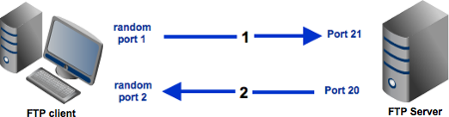

Passive mode:
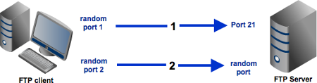
In an active mode configuration, the server will attempt to connect to a random client-side port. So chances are, that port wouldn't be one of those predefined ports. As a result, an attempt to connect to it will be blocked by the firewall and no connection will be established.
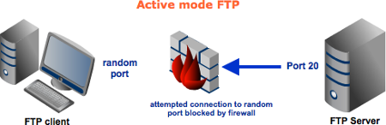
A passive configuration will not have this problem since the client will be the one initiating the connection. Of course, it's possible for the server side to have a firewall too. However, since the server is expected to receive many connection requests compared to a client, then it would be but logical for the server admin to adapt to the situation and open up ports to satisfy passive mode configurations.
So it would be best for you to configure server to support passive mode FTP. However, passive mode would make your system vulnerable to attacks because clients are supposed to connect to random server ports. Thus, to support this mode, not only should your server have to have multiple ports available, your firewall should also allow connections to all those ports to pass through!

Trivial File Transfer Protocol (TFTP)
TFTP is a simple file transfer protocol. Generally used for automated transfer of configuration or boot files between machines in a local environment.
Due to its simple design, TFTP can be implemented using a very small amount of memory.
- It is therefore useful for booting devices such as routers which may not have any data storage devices.
- It is also used in Pre-boot Execution Environment (PXE) network boot protocol, where it is implemented in the firmware ROM / NVRAM of the host's network card.
- It is also used to transfer small amount of data between hosts on a network, such as IP phone firmware or operating system images.
TFTP is a simple protocol for transferring files, implemented on top of the User Datagram Protocol using port 69.TFTP only reads and writes files from or to a remote server. It cannot list directories, and has no provisions for user authentication. The data transfer ports are chosen independently by the sender and receiver during initialization of the connection. The ports are chosen at random according to the parameters of the networking stack, typically from the range of ephemeral ports.

In TFTP, communication is initiated by the client issuing a request to read or write a file on the server. If the server grants the request, the connection is opened and the file is sent in fixed length blocks of 512 bytes. Each data packet contains one block of data, and must be acknowledged by an acknowledgment packet before the next packet can be sent. A data packet of less than 512 bytes signals termination of a transfer. And source sends 0 byte packet if the last sent packet is of 512 bytes. If a packet gets lost in the network, the intended recipient will timeout and may retransmit their last packet (which may be data or an acknowledgment), thus causing the sender of the lost packet to retransmit that lost packet. The sender has to keep just one packet on hand for retransmission, since the lock step acknowledgment guarantees that all older packets have been received. Notice that both machines involved in a transfer are considered senders and receivers. One sends data and receives acknowledgments; the other sends acknowledgments and receives data.

Wake-on-LAN
Wake-on-LAN, also known as 'wol', is the ability to switch on a computer that is connected to a network. It is important to note that Wake-on-LAN applies to the computers being physically connected (ie, not wireless systems).

**** Does my motherboard support Wake-on-LAN?
For Wake-on-LAN to work the target computer motherboard must support this feature and most of latest motherboards have this support.
Generally speaking, the Wake-on-LAN (non) ability of the target motherboard will be specified by the hardware manufacturer.
Sometimes, this ability is evident by browsing through said motherboard's BIOS and looking for something like 'PCI Power up'.

**** Ensure that Wake-on-LAN is enabled and survives a reboot
A common problem with the Wake-on-LAN in computers running Linux is that the network drivers have Wake-on-LAN switched off by default. To manually switch on the Wake-on-LAN feature on your driver, you will need to install ethtool.

- First query the driver to see if it's defaulted to 'on' by using ethtool:
# ethtool net0 | grep Wake-on
Supports Wake-on: pg
Wake-on: d

- We need a 'Wake-on' value of 'g' for WOL to work.
To enable the wol feature in the driver, simply run the following
# ethtool -s net0 wol g

- This command does not last beyond the next reboot. If using netctl, one can make this setting persistent by adding the following to your netctl profile:
/etc/netctl/PROFILE
ExecUpPost='/usr/bin/ethtool -s net0 wol g'

- For some network cards, you may also need the following command:
# echo enabled > /sys/class/net/net0/device/power/wakeup

***** With udev
udev is capable of running any command you desire as soon as a device is visible.
We want udev to turn on wake on LAN for our device. Put the following in /etc/udev/rules.d/50-wol.rules, replacing N with the number for your interface:
ACTION=="add", SUBSYSTEM=="net", KERNEL=="netN", RUN+="/usr/bin/ethtool -s %k wol g"

This tells udev to run "/usr/bin/ethtool -s netN wol g" as soon as the device netN exists. To turn on wake on lan for all new devices, replace the N with a '*':
ACTION=="add", SUBSYSTEM=="net", KERNEL=="net*", RUN+="/usr/bin/ethtool -s %k wol g"

***** With cron
A command can be run each time the computer is (re)booted using "@reboot" in a crontab.
First, make sure cron is enabled, and then edit a crontab for the root user that contains the following line:
@reboot /usr/bin/ethtool -s [net-device] wol g

Loopback address (virtual loopback interface)
Loopback address is that sends outgoing signals (packets) back to the same computer for testing. This is implemented entirely within the OS network stack and passes no packets to NIC. In a TCP/IP network, the loopback IP address is 127.0.0.1, and pinging this address will always return a reply unless the firewall prevents it. A loopback interface is put into no shutdown state when created.

Any IP datagram with a source or destination address set to a loopback address must not appear outside of a computing system, or be routed by any routing device. Packets received on an interface with a loopback destination address must be dropped. Such packets are sometimes referred to as Martian packet.

The range of addresses for loopback functionality is the range of 127.0.0.0 to 127.255.255.255. Similar to ping, loopback enables a user to test one’s own network to ensure the IP stack is functioning properly or not.

Loopback address for IPv6 is ::1 or sometimes written as [::1] or ::1/128

$ ifconfig lo
lo Link encap Local Loopback
inet addr 127.0.0.1 Bcast [NONE SET] Mask 255.0.0.0
UP BROADCAST LOOPBACK RUNNING MTU 2000 Metric 1
RX packets 0 errors 0 dropped 0 overrun 0
TX packets 0 errors 0 dropped 0 overrun 0

The loopback interface has been assigned a netmask of 255.0.0.0, since 127.0.0.1 is a class-A address. The interface doesn't have a broadcast address set, which isn't normally very useful for the loopback anyway. However, if you run the rwhod daemon on your host, you may have to set the loopback device's broadcast address in order for rwho to function properly.

DMZ - Demilitarized Zone
A DMZ (demilitarized Zone) is a network design where publicly accessible servers are placed on a separate, isolated network segment. The intention of a DMZ is to ensure that publicly accessible servers cannot contact other internal network segments, in the event that a server is compromised.
A Firewall is particularly relevant in DMZ implementation, since it is responsible for ensuring that proper policies are in place to protect local networks from the DMZ, while maintaining accessibility to the DMZ.
Due to the non-trivial nature of DMZ implementation, it is not recommended to attempt a DMZ unless you have a strong familiarity with networking. A DMZ is usually not a requirement, but is generally encouraged by security conscientious network administrators.

Broadband routers often implement a DMZ simply through additional firewall rules, meaning that incoming requests reach the firewall directly. In a true DMZ, incoming requests must first pass through a DMZ computer before reaching the firewall.
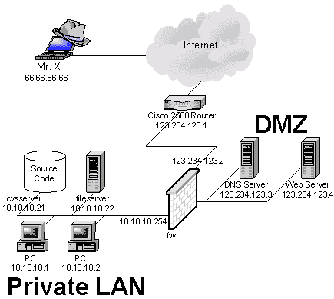

NAT – Network Address Translation
A computer to communicate with the other computers on the internet, it must have an IP address of the destination computer. IP address is just a 32-bit number and theoretically (2 power 32) unique addresses are available. Among these few addresses are segregated into classes, and some are set for multicasting, testing etc and can’t be used. So the IP addresses are very limitedly available. Hence to redesign the IP address format to allow more number of addresses, IPv6 is coming up which may take some more years. But the shortage of IP addresses is only one reason to use NAT. NAT acts as a router, between the internet (public network) and a local (private network). This means that only a single, unique IP address is required to represent an entire group of computers.

NAT enables a LAN to use one set of IP addresses for internal traffic and a second set of addresses for external traffic. NAT box is located where the LAN meets the Internet and makes all the necessary IP address translations. NAT serves the following purposes,
1) Provides a type of firewall by hiding internal IP addresses
2) Enables a company to use more internal IP addresses, as these are used internally. And there is no conflict with IP addresses used externally.
3) Allows a company to combine multiple ISDN connections into a single internet connection.

Static NAT – A type of NAT in which a private IP address is mapped to a public IP address, where the public address is always the same IP address (static address).
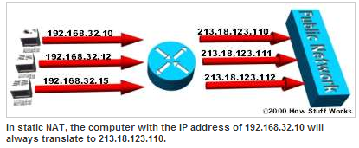

Dynamic NAT – A type of NAT in which a private IP address is mapped to a public address drawing from a pool of registered IP addresses. Typically, the NAT router in a network will keep a table of registered IP addresses, and when a private IP address requests access to the internet, the router chooses an IP address from the table that is not being used by another private IP address.
Dynamic NAT helps to secure a network as it masks the internal configuration of a private network and makes it difficult for someone outside the network to monitor individual usage patterns. Another advantage of dynamic NAT is that it allows a private network to use private IP addresses that are invalid on the Internet but useful as internal addresses.
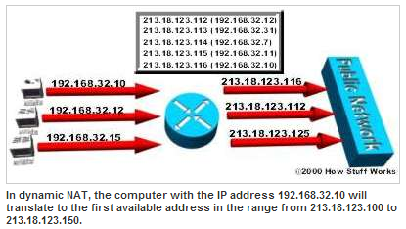
Overloading NAT – A type of NAT, which maps multiple private IP addresses to a single registered IP address by using different ports. This is also known as PAT (Port Address Translation), single address NAT or port-level multiplexed NAT.
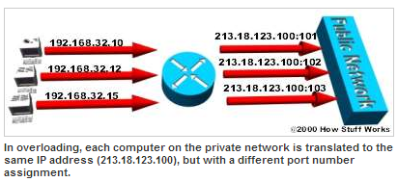
Overlapping NAT – When the IP addresses used on your internal network are registered IP addresses in use on another network, the router must maintain a lookup table of these addresses so that it can intercept them and replace them with registered unique IP addresses. It is important to note that the NAT router must translate the "internal" addresses to registered unique addresses as well as translate the "external" registered addresses to addresses that are unique to the private network. This can be done either through static NAT or by using DNS and implementing dynamic NAT.
DNAT - Destination network address translation (DNAT) is a technique for transparently changing the destination IP address of an end route packet and performing the inverse function for any replies. Any router situated between two endpoints can perform this transformation of the packet. DNAT is commonly used to publish a service located in a private network on a publicly accessible IP address. This use of DNAT is also called port forwarding.
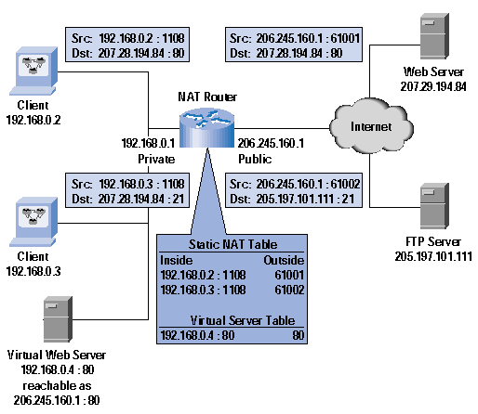

The web server IP should be 207.28.194.84 instead 207.29.194.84
NAPT
NAPT (Port NAT) NAPT maps a single public address to one or many internal addresses and all IP addresses on the private network are local and cannot be seen by the outside world. This would cause an ambiguity when routing the returned packets. To avoid this problem NAPT makes use of the TCP/ UDP port information in the outgoing traffic and maintains a translation table. This would allow routing the returned packets correctly to the requester.
NAT with Port Address Translation (PAT or NAPT), IP masquerading, NAT Overload and many-to-one NAT are the other names of NAPT.

NAT modifies IP address in a header of an IP packet, while it is travelling through a routing device and allows to use a different set of IP addresses to be used for traffic within a LAN than the set of IP addresses used for outside traffic, while NAPT is a special kind of NAT where multiple private IP addresses are mapped in to as single IP or a small group of public IP addresses. Therefore NAPT involves a many-to-one translation of IP addresses. NAPT is the most widely used NAT, therefore most of the time NAPT is referred as NAT.

Network address translation is not commonly used in IPv6 as one of its aims is to restore true host-to-host connectivity. NAT loopback is not commonly needed. Although still possible, the large addressing space of IPv6 obviates the need to conserve addresses and every device can be given a unique globally routable address.
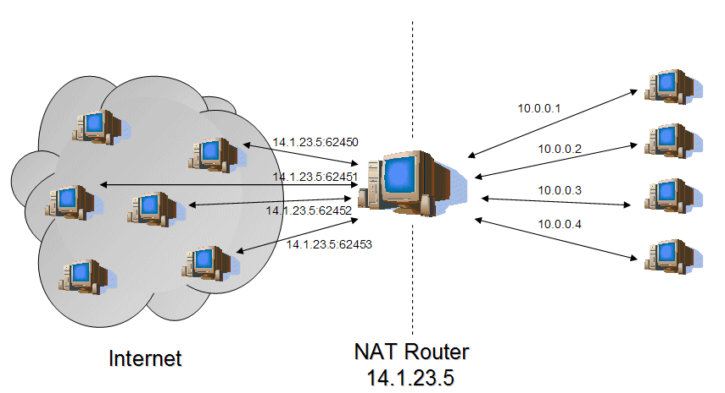

MAC Cloning
MAC cloning can only be done at your router providing it has those capabilities. Most ISPs assign their IPs based on the MAC address in your equipment. If the MAC address of your router is 00-11-22-33-44-55 and you connect to your ISP, the DHCP server records your MAC and assigns an IP. If you disconnect from the ISP, you lose your IP address. The next time you connect, the DHCP server sees your MAC, looks to see if it has assigned an IP address to you before. If it has and the lease time has not expired, it will most likely give you the same IP address you had before disconnecting. Why clone a MAC address? New MAC address most likely equals new IP. How to clone your MAC is dependent on the router itself. You’ll need to find the instructions on the manufacturer’s website.

Some ISP may register the MAC address of your computer when you dialing up to Internet for the first time via modem. If you add a router into your network to share your Internet connection, the ISP will not accept it. So you need to do MAC address clone on the router. Therefore the MAC of your computer is cloned to router.
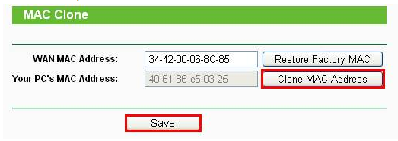
In many cases, it is absolutely unnecessary to use the MAC address clone. If you have a working internet connection through your router then there is no need to use the MAC address clone function.
Only when you find that you have a working internet connection on one computer directly on your modem but not when you connect through the router (or a different computer directly on the modem) then it is necessary to use the MAC address clone function.

MAC address is a 12-digit hexadecimal number (48 bits in length)

ARP (Type – 0x0806)
ARP is a function of the IP layer. It is necessary to translate the host IP address to its MAC address and ARP is used to determine the MAC address (hardware address). Another protocol RARP – Reverse ARP which translates a MAC address into IP address.

ARP table or ARP caching
IP networks maintain a mapping between the IP address of a device and its MAC address. This mapping is known as the ARP cache or ARP table.
Ethernet network adapters have the MAC address. Manufacturers ensure these 6-byte (48-bit) MAC addresses are unique, and Ethernet relies on these unique identifiers for message delivery. When any device wishes to send data to another target device over Ethernet, it must first determine the MAC address of that target given its IP address. These IP-to-MAC address mappings are derived from an ARP cache maintained on each device. If the given IP address does not appear in a device's cache, that device cannot directly message to that target until it obtains a new mapping. To do this, the initiating device first sends an ARP request broadcast message (with the dest MAC as ff:ff:ff:ff:ff:ff ) on the local subnet. The host with the given IP address sends an ARP reply in response to the broadcast, allowing the initiating device to update its cache and proceed to deliver messages directly to the target. The PC will put that entry into its local ARP cache and it will stay there until the entry has not been used and the ARP cache timeout has expired. Here is an ARP cache looks like,
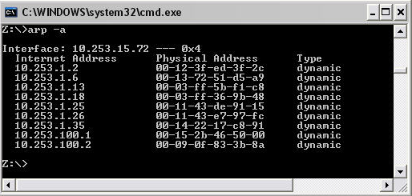
ARP is used to connect OSI Layer 3 (Network) to OSI Layer 2 (Data-Link). For most of us, that means that ARP is used to link our IP addressing to our Ethernet MAC Addressing.
Four types of ARP messages that can be sent by ARP protocol – ARP request, ARP reply, RARP request and RARP reply.
Static ARP – Manually enter the link between the Ethernet MAC address and the IP address
Dynamic ARP – ARP entry, which is the Ethernet MAC to IP address link, is kept on a device for some period of time, as long as it is being used. The dynamic ARP is created using the ARP protocol.

Gratuitous ARP – The network stack will issue gratuitous ARP if the IP or MAC address of a network interface changes, to inform other machines on LAN so that the others can report IP conflicts and update their ARP tables. A gratuitous ARP reply is a reply to which no request has been made. Gratuitous ARP is special ARP request packets with characteristics as,
** Both source and destination IP in the packet are the IP of the host issuing the Gratuitous ARP
** The dest MAC address is the broadcast MAC address (FF:FF:FF:FF:FF:FF) which means the packet is flooded to all hosts and switches.
** No reply is expected for this packet.

How ping works
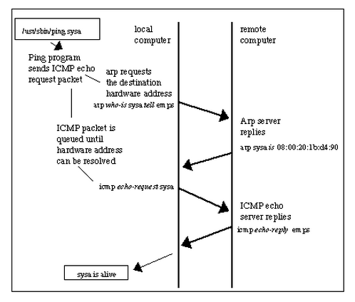
Ping sends ICMP echo request to destination host and expects the echo reply from it. If the destination host is unknown, then an ARP request to the destination host is made querying for the MAC address. Once the ARP reply is obtained from the destination host, ARP table on the source is updated with the destination MAC and IP details. Now the ICMP request from the source can be sent and reply is got from the destination host.

Public IP
A public IP address is any valid address that can be accessed over the Internet including web-sites, network servers and DNS servers or any computer connected to Internet. Internet standards groups, such as the Network Information Center (NIC) or the Internet Assigned Numbers Authority (IANA), are the organizations responsible for registering IP ranges and assigning them to organizations, such as Internet Service Providers (ISPs).
In the Cloud(n) system, a public IP address is an identifier assigned to a virtual router on the network. Any resources that will be available over the Internet will require a public IP address. Public IP addresses can be fixed or static IP addresses if they never change but most ISPs provide an IP address that can change from time to time which are dynamic addresses.
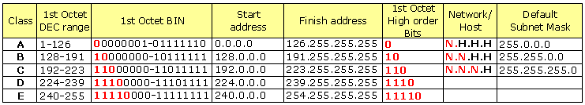

Private IP
A private IP address is any number or address assigned to a device on a private Local Area Network that is accessible only within the Local Area Network. For a resource inside the Local Area Network to be accessible over the Internet, a device within the Local Area Network must be connected to the Internet with a public IP address, and the networking must be appropriately configured. The same Internet standards organizations have reserved the following three IP address ranges that will never be registered publicly: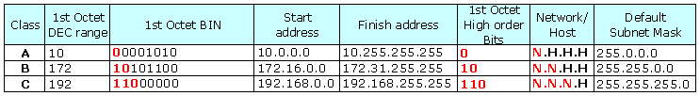

Global IP
Global IP address is assigned to a computer or modem by an ISP and can be communicated from anywhere on the internet. Global IP addresses can be provisioned in any data center on the SoftLayer network and moved to another facility if necessary. You can point it to a server in Dallas, and if you need to perform maintenance on the server in Dallas, you can move the IP address to a server in Amsterdam to seamlessly (and almost immediately) transition your traffic.
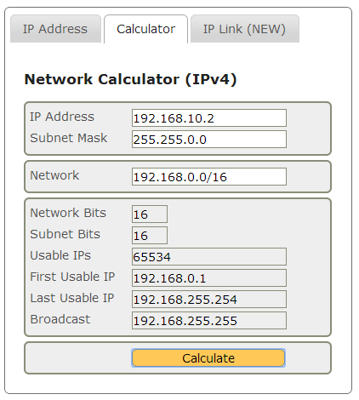

Hop count
In networking, the hop count represents the total number of devices a data packet passes through. The more hops data must traverse to reach their destination, the greater the transmission delay incurred.
Ping can be used to determine the hop count to a specific destination. Ping generates packets that include a field reserved for the hop count. Each time a capable device receives these packets, that device modifies the packet, incrementing the hop count by one. In addition, the device compares the hop count against a predetermined limit and discards the packet if its hop count is too high. This prevents packets from endlessly bouncing around the network due to routing errors. Both routers and bridges are capable of managing hop counts, but hubs cannot this.
Traceroute is a command used for displaying the route (hops) and measuring transit delays of packets across an IP network.
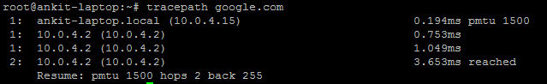
The above output shows the tracepath command executed on Ubuntu. This first column shows the TTL of the probe, followed by colon. The second column is the network hop, which replied to the probe. It is either address of the router or [LOCALHOST] if the probe was not sent to the network.
The rest of information about path to the corresponding network hop. The last line summarizes information about the entire path to the destination; it shows detected MTU, number of hops to the destination and hops from the destination to us.

Time-to-live (TTL) is a value in a packet that tells a network router whether or not the packet has been in the network too long and should be discarded.
Discard the packet after a certain time and send a message to the originator, who can decide whether to resend the packet. The initial TTL value is set default, in an 8-binary digit field of the packet header. The original idea of TTL was that it would specify a certain time span in seconds that, when exhausted, would cause the packet to be discarded. Since each router is required to subtract at least one count from the TTL field, the count is usually used to mean the number of router hops the packet is allowed before it must be discarded. Each router that receives a packet subtracts one from the count in the TTL field. When the count reaches zero, the router detecting it discards the packet and sends an Internet Control Message Protocol (ICMP) message back to the originating host.

Promiscuous mode
Promiscuous mode is a mode for wired or wireless NICs that cause the controller to pass all traffic it receives to the CPU rather than passing only the frames that the controller is intended to receive. This mode is normally used for packet sniffing that takes place on a router or on a computer connected to a hub (instead of a switch) or one being part of a WLAN.

Power over Ethernet (PoE)
Ethernet cables supply the power for network devices, at the same time as transmitting data in the normal way. Typical PoE users are VoIP phones in buildings for which power lines could be avoided.
- A device can send or receive power, but not both.
- The PSE supplies 15.4 watts of DC power (minimum 44 V DC and 350 mA) on 802.3af ports and 30Watts on 802.3at ports.
- The sender is a Power Sourcing device (PSE), while device that is powered is a Powered Device (PD)
- The electrical current must go into the data cable at the power-supply end, in such a way that the current is kept separate from the data signal so that neither interferes with the other.
- The current entering component is injector. If the device on the other end is PoE compatible, then that device will function properly without any modification. If the device is not PoE compatible, then a component called picker or tap must be installed to remove the current from the cable. This picked-off current is routed to the powered jack.
- Power sourcing equipment (PSE) is a device such as a switch that provides ("sources") power on the Ethernet cable.
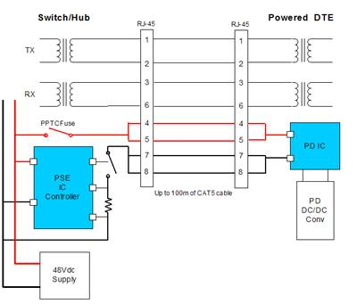

Network Process Unit (NPU)
