DBT (Data Build Tool) Tutorial: End-to-End Netflix Data Analysis Project
1. Project Overview and High-Level Architecture
Goal: Build an analytics pipeline for Netflix-like data using the MovieLens 20M dataset (20M ratings, 138K users, 27K movies, tags, genome scores). Learn DBT by transforming raw data into models for BI tools (e.g., Looker Studio, Power BI, Tableau).
Why This Project?
- Simulates real-world Netflix domain (ratings, tags, movies) for easy understanding.
- Focus: DBT for transformation (SQL-based ELT); basics of S3/Snowflake covered.
- Time: 3-4 hours; core on DBT (upskill for resume: models, snapshots, tests, docs).
- Output: Dashboards for stakeholders (e.g., top movies by rating, user trends).
Architecture Diagram (Simple Flow):
- Extract: Download CSVs from GroupLens.org/datasets/movielens/20m (ratings.csv, tags.csv, movies.csv, links.csv, genome-scores.csv, genome-tags.csv).
- Load (Raw Landing Zone): Upload to AWS S3 → COPY to Snowflake (RAW schema).
- Transform (DBT in DEV Schema): Staging (copy raw safely) → Models (dims/facts) → Snapshots/Tests/Docs/Macros.
- Serve: Connect to BI tools for reports/dashboards.
ELT vs. ETL Explanation:
- ETL: Extract → Transform (business logic: filter, mask, join) → Load (structured to warehouse).
- ELT: Extract → Load (raw to warehouse like Snowflake) → Transform (in-warehouse; scalable, handles unstructured data).
- DBT: Only transformation (no extract/load); uses SQL for modular pipelines.
Dataset Files (Brief):
- ratings.csv: user_id, movie_id, rating (0.5-5), timestamp (UTC).
- tags.csv: user_id, movie_id, tag (user metadata), timestamp.
- movies.csv: movie_id, title, genres (pipe-separated, e.g., Action|Adventure).
- links.csv: movie_id, imdb_id, tmdb_id (external links).
- genome-scores.csv: movie_id, tag_id, relevance (0-1 score).
- genome-tags.csv: tag_id, tag (user-generated tags).

Resources
- Notes: nodes.datawidia.com (interactive Obsidian notes with links, e.g., DBT installation, modern stack).
- Courses: SQL/Data Warehouse (links in video desc); Data Engineering Masterclass (YouTube playlist).
- Books: Principles (amzn.to/3HQJDyP), Deep Work (amzn.to/3IParkk), Rework (amzn.to/3HW981O).
Tips Before Starting:
- Use ChatGPT for errors (e.g., "DBT connection failed").
- Free: Snowflake 30-day trial, AWS free tier (no charges for this).
2. Prerequisites and DBT Fundamentals
What You Need:
- SQL Basics: SELECT, CTEs (e.g., WITH cte AS (SELECT ...) SELECT * FROM cte). If zero knowledge, watch creator's SQL course. Advanced optional.
- Snowflake Basics: Good-to-have; tutorial covers (warehouse, stages, COPY).
Deep dive: Creator's Snowflake course.
- Data Eng Foundations: Ingestion (Kafka), storage (S3), transform (Spark), serving (Presto). Review: YouTube Data Eng Masterclass (search channel).
What is DBT? (Core Explanation):
- Definition: Transformation tool; write modular SQL to turn raw data into analytics models (e.g., dims/facts).
- Key: SQL-only (no Python/Scala); focuses on ELT transformation/serving layer (post-load in warehouse).
- No ETL/EL Role: Doesn't extract/load; connects to warehouse (Snowflake/BigQuery/Redshift) via adapter.
- Power: Breaks 1000-line SQL into reusable chunks; auto-handles deps (run order), tests/docs.
- Where DBT Fits:
  - Raw data (S3/warehouse) → DBT (develop/test/doc/deploy) → Transformed (tables/views) → BI/ML.
  - Platforms: Stacks on Snowflake (data loaders → snapshots/transform/test/deploy/version/log/alert → transformed data).
Data Eng Lifecycle Recap (For Context):
- Generation: APIs/DBMS/websites/apps (e.g., MySQL, Cassandra, user behavior).
- Ingestion: Kafka (streaming).
- Storage: S3 (raw lake).
- Transformation: Spark (process).
- Serving: Presto (query) → Looker (dashboards) or reverse ETL (push to ads).
- Real Example: Dream11 app (MySQL/Kafka/Spark/S3/Presto/Looker).
- DBT: Only warehouse transformation (ignores upstream; assumes raw loaded).
Warehouse/Lake/ETL Deep Dive:
- Warehouse: Central repo for structured analysis (Snowflake: handles structured/semi/unstructured; ETL load).
- Lake: Raw dump (S3); ad-hoc query (Athena); no pre-transform.
- Lakehouse: Combines (structured + raw access).
- ETL: Transform pre-load (mask credit cards, join files).
- ELT: Load raw → Transform in-warehouse (DBT shines here; schema-on-read).
Modern Data Stack (Why DBT Wins):
- Legacy Issues: Manual SQL (no VC), ETL complexity (Airflow/Spark expensive), multi-lang (Python/SQL/Scala hard to maintain/collaborate).
- Modern: Sources (Fivetran/Stitch/Hever → direct from Stripe/Google Analytics/Postgres), Storage (S3/Delta/Iceberg), Transform (DBT), Query (Athena/Trino), Streaming (Kinesis), Output (Looker/Tableau), Orchestrate (Prefect/Airflow/Dagster).
- Architecture Example: App sources (Razorpay/Stripe/Google Ads) → Fivetran → Snowflake/DBT (landing/staging/warehouse/mart) → Looker + reverse ETL (to Facebook Ads).
DBT vs. Legacy:
- Modularity: Chunk SQL by use case.
- Reusability: Reuse patterns (e.g., genre array).
- Testing: Built-in (no nulls, data types).
- Docs: Auto-generate from code.
- Deps: Auto-order execution.
- Workflow: Dev/prod envs.
3. Project Setup: Hands-On Steps
Step 1: Data Prep (Extract):
- Download ZIP from grouplens.org/datasets/movielens/20m (5-10 min).
- Extract: README explains files (ignore for now; focus on CSVs).
- Domain: Treat as Netflix (ratings = views, tags = feedback, genres = categories).
Step 2: AWS S3 (Load Raw):
- Create account: aws.amazon.com (credit card for verification; free tier).
- IAM: Users → Add user (e.g., snowflake-netflix-user; no console access) → Attach S3 full access → Security credentials → Create access key → Download CSV (access_key_id, secret_access_key; secure – delete after).
- Bucket: S3 → Create bucket (name: netflix-dbt-learning-[yourname]; unique globally; region: e.g., ap-south-1 Mumbai; block public access).
- Upload: Drag CSVs (skip README); e.g., movies.csv (27K rows), ratings.csv (500MB – takes time).
Real-World Note: In production, data streams from Kafka/Spark to S3 (e.g., stock market project: sources → Kafka → Spark → S3). Here, manual upload simulates raw landing.
Step 3: Snowflake Setup:
- Sign up: snowflake.com (trial; first/last name, email, student/exploring, school: e.g., University of Mumbai, enterprise, AWS, nearest region).
- Login: Use email/password; UI: Home (recent worksheets), Projects (worksheets/notebooks), Data (dbs/tables), Products (AI/monitoring).
- SQL Worksheet: Create → New worksheet.
- Run as ADMIN role:

Challenge: Load all files yourself (open CSV for schema: INT for IDs, STRING for text, FLOAT/TIMESTAMP for scores/time).
Step 4: DBT Installation and Init:
- Terminal: pip install virtualenv (if needed).
- Virtual Env:
  - Mac/Linux: virtualenv venv; source venv/bin/activate.
  - Windows: virtualenv venv; venv\Scripts\activate.
- Install DBT: pip install dbt-snowflake==1.9.* (DBT + Snowflake adapter; Python 3.9+ compatible).
- VS Code: code .; Extensions: DBT Power User (syntax), DBT Formatter (auto-format), VS Code Icons (folder icons).
- Test Connection: dbt debug (should pass).

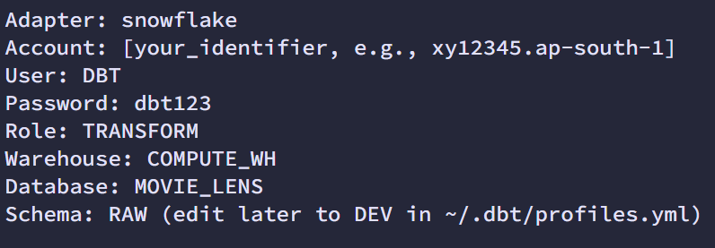
4.DBT Hands-On: Core Features with Syntax and Explanations

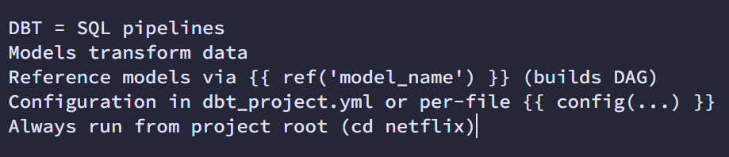

4.1 Models: SQL Scripts for Transformation
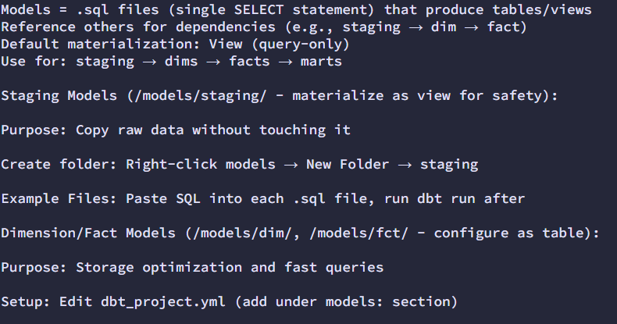

DBT [DATA BUILD TOOL]
What are DBT Models?
DBT models are SQL select statements that transform your data. Each model:
- Is defined in a .sql file
- Contains a single SELECT statement
- Produces a table or view in your data warehouse
- Can reference other models, creating a dependency graph
Models are the core building blocks of DBT projects and represent the transformations applied to your data.
Proper concepts of each Terminology :
Introduction to DBT - Data Vidhya Notes - Obsidian Publish

