Movie Management System

Problem Statement
A digital media company wants to build a centralized web-based application to manage its movie catalog. Currently, movie records are stored manually, leading to data redundancy and inconsistencies.
You are required to develop a Spring MVC-based web application that performs complete CRUD (Create, Read, Update, Delete) operations on movie records.
The application must follow proper Spring MVC layered architecture.

Objective
Implement a Movie Management System that allows administrators to:
- Add a new movie
- View all movies
- Update existing movie details
- Delete a movie

Technical Constraints
Your solution must:
- Use Spring MVC architecture
- Follow layered structure:
Controller → Service → Repository (DAO) → Database
- Use the following annotations where appropriate:
  - @Controller
  - @RequestMapping
  - @GetMapping
  - @PostMapping
  - @PathVariable
  - @ModelAttribute
- Use JPA/Hibernate for persistence
- Use MySQL as the database
- Use JSP or Thymeleaf as the view technology

Entity Specification
Create a Movie entity mapped to a database table named movies with the following fields:
- id (Primary Key, Auto-generated)
- title
- genre
- director
- releaseYear
- rating
The database table must be generated automatically using JPA entity mapping.
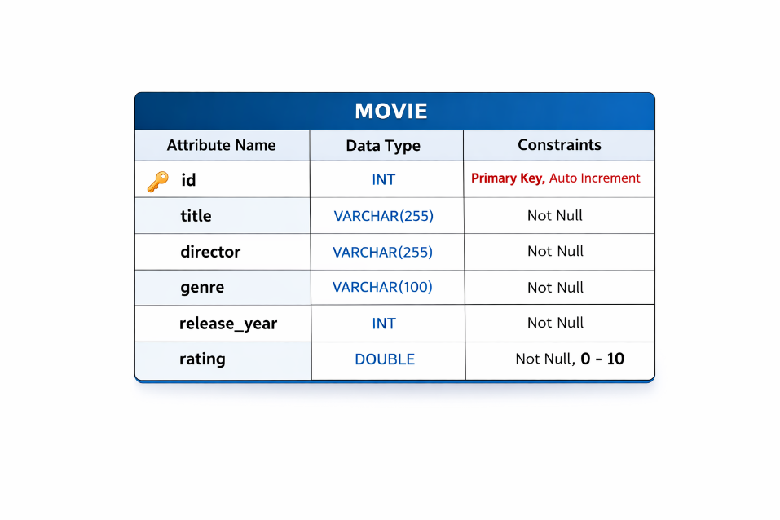

Functional Requirements

Create Movie
- Accept movie details from a form.

Read Movies
- Display all movies in tabular format.
- Each record must contain Edit and Delete options.

Update Movie
- Fetch movie by ID.
- Allow modification and save updated details.

Delete Movie
- Delete movie by ID.
- Redirect to updated movie list.

Input/Output Specification
- Input: HTML form submission
- Output: Rendered JSP/Thymeleaf pages
- HTTP Methods:
  - GET → Fetch data
  - POST → Submit data
  - PUT→ Update data
  - DELETE→ Delete data
Submission Instructions:
Read the assessment questions carefully and complete the implementation on your local machine.
Push the specified/relevant source files along with the output screenshot to your GitHub repository as instructed.
Ensure the required files are uploaded and the project runs successfully before submission.

