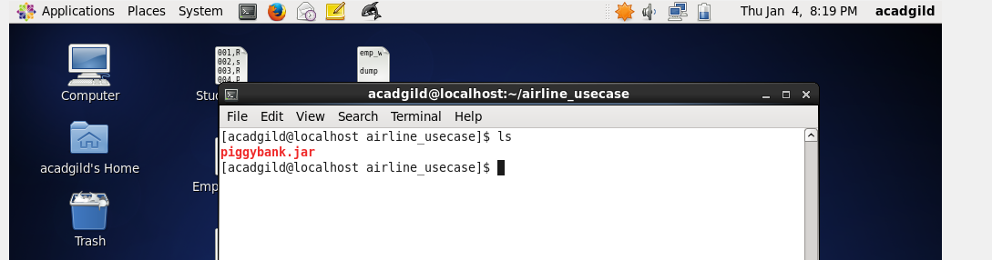

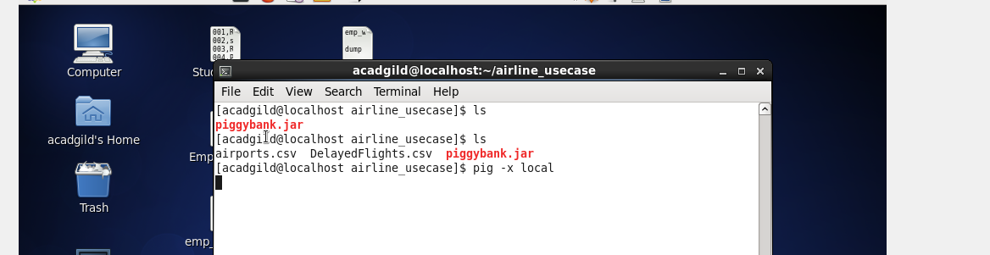

REGISTER '/home/acadgild/airline_usecase/piggybank.jar';

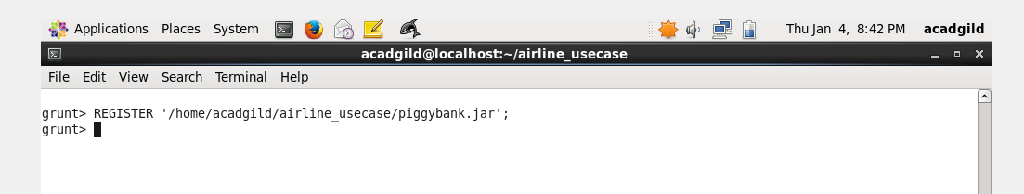

A = load '/home/acadgild/airline_usecase/DelayedFlights.csv' USING org.apache.pig.piggybank.storage.CSVExcelStorage(',','NO_MULTILINE','UNIX','SKIP_INPUT_HEADER');

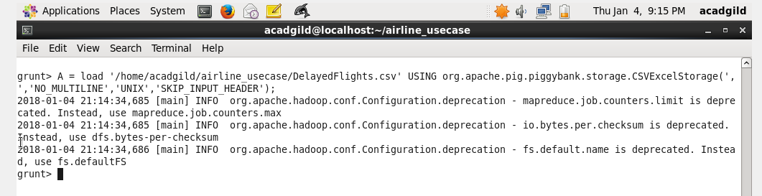

B = foreach A generate (int)$2 as month,(int)$10 as flight_num,(int)$22 as cancelled,(chararray)$23 as cancel_code;

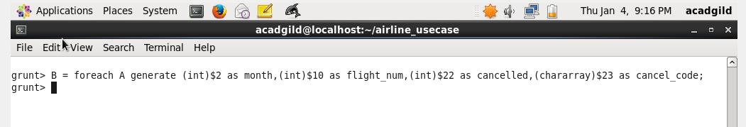

C = filter B by cancelled == 1 AND cancel_code =='B';

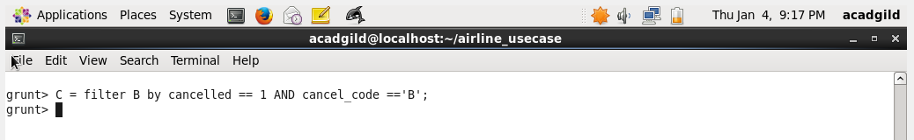

D = group C by month;

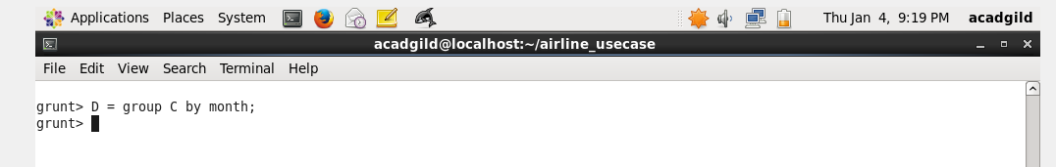

E = foreach D generate group, COUNT(C.cancelled);

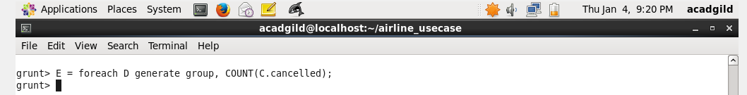

F= order E by $1 DESC;

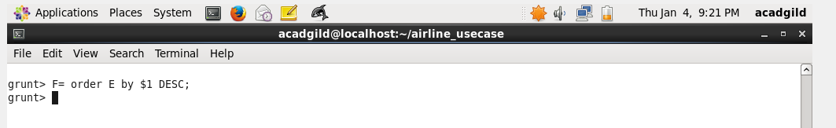

Result = limit F 1;

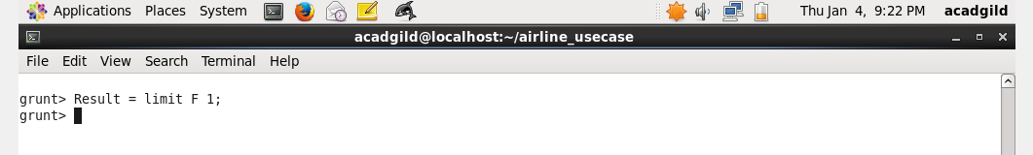

dump Result;

