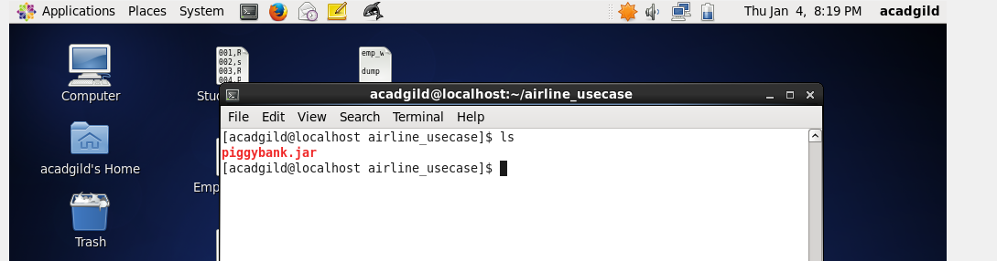

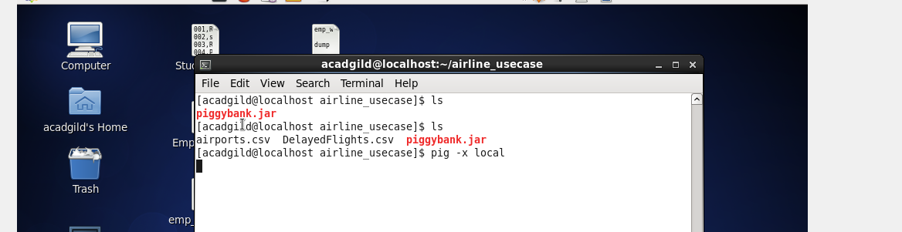

REGISTER '/home/acadgild/airline_usecase/piggybank.jar';

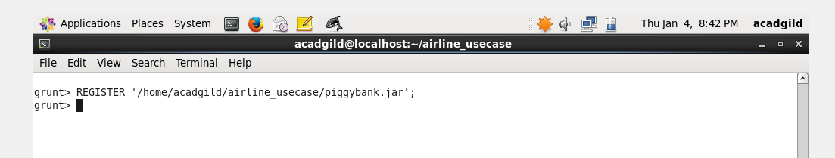

A = load '/home/acadgild/airline_usecase/DelayedFlights.csv' USING org.apache.pig.piggybank.storage.CSVExcelStorage(',','NO_MULTILINE','UNIX','SKIP_INPUT_HEADER');

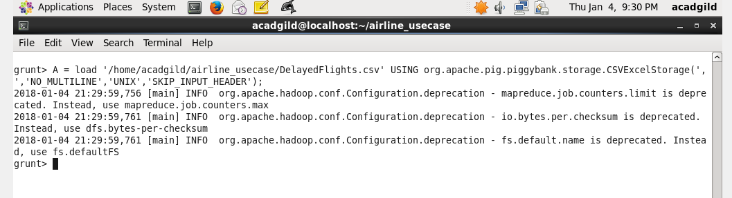

B1 = foreach A generate (int)$16 as dep_delay, (chararray)$17 as origin;

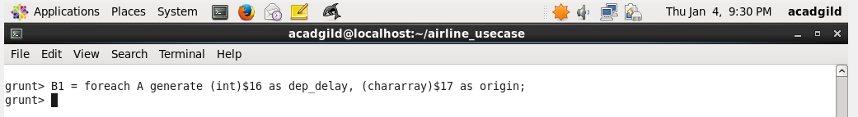

C1 = filter B1 by (dep_delay is not null) AND (origin is not null);

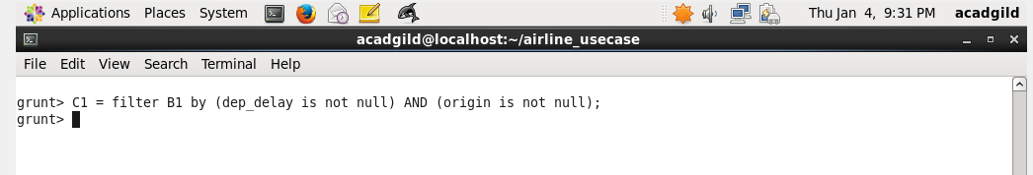

D1 = group C1 by origin;

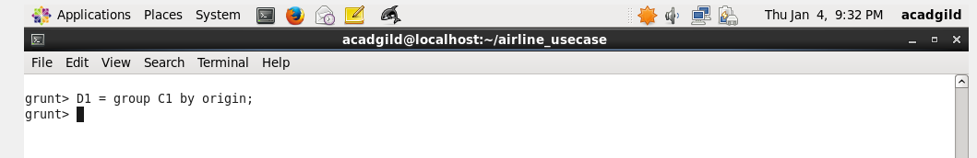

E1 = foreach D1 generate group, AVG(C1.dep_delay);

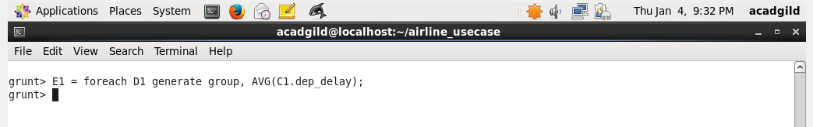

Result = order E1 by $1 DESC;

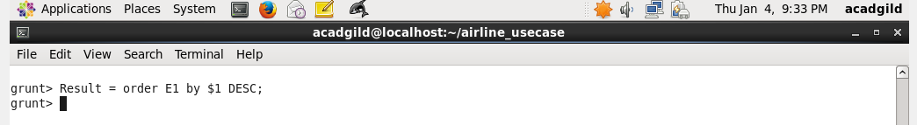

Top_ten = limit Result 10;

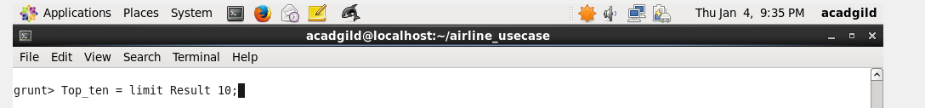

Lookup = load '/home/acadgild/airline_usecase/airports.csv' USING org.apache.pig.piggybank.storage.CSVExcelStorage(',','NO_MULTILINE','UNIX','SKIP_INPUT_HEADER');

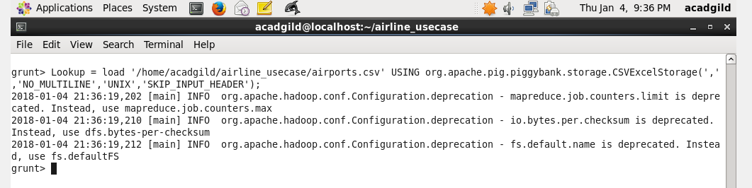

Lookup1 = foreach Lookup generate (chararray)$0 as origin, (chararray)$2 as city, (chararray)$4 as country;

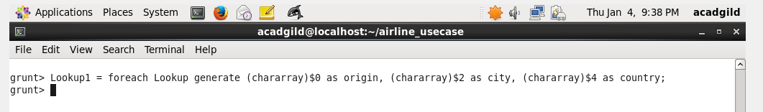

Joined = join Lookup1 by origin, Top_ten by $0;

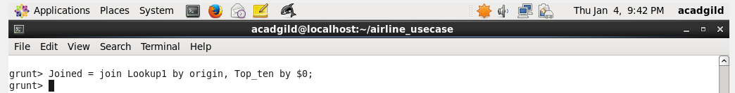

Final = foreach Joined generate $0,$1,$2,$4;

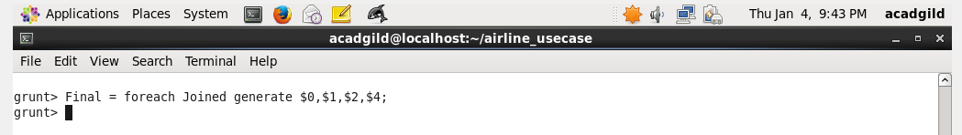

Final_Result = ORDER Final by $3 DESC;

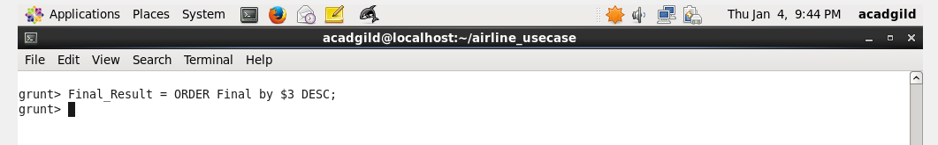

dump Final_Result;

