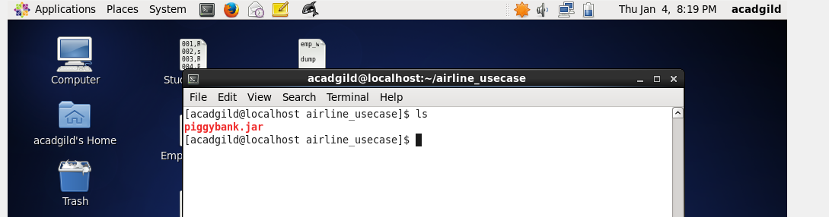

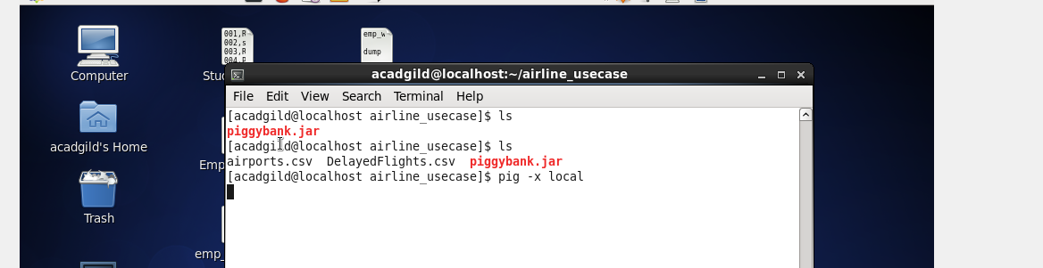

REGISTER '/home/acadgild/airline_usecase/piggybank.jar';

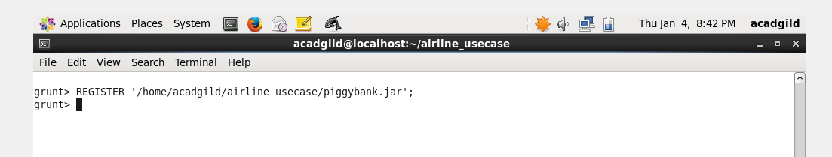

A = load '/home/acadgild/airline_usecase/DelayedFlights.csv' USING org.apache.pig.piggybank.storage.CSVExcelStorage(',','NO_MULTILINE','UNIX','SKIP_INPUT_HEADER');

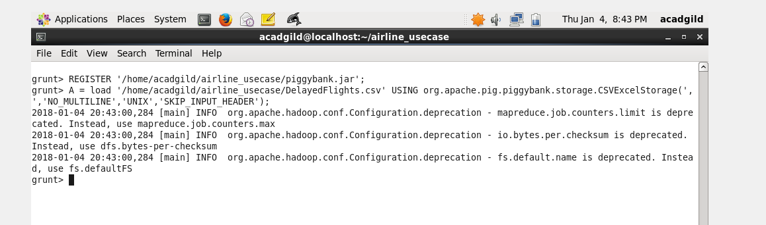

B = foreach A generate (int)$1 as year, (int)$10 as flight_num, (chararray)$17 as origin,(chararray) $18 as dest;

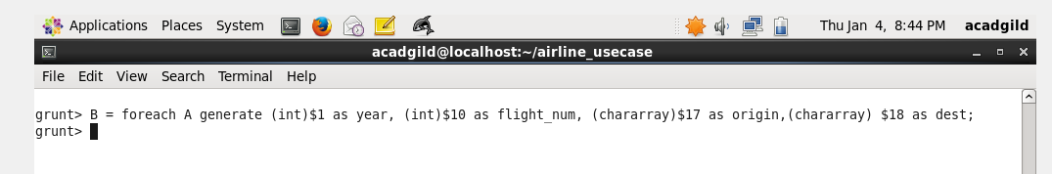

C = filter B by dest is not null;

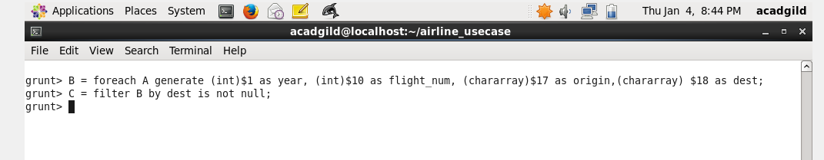

D = group C by dest;

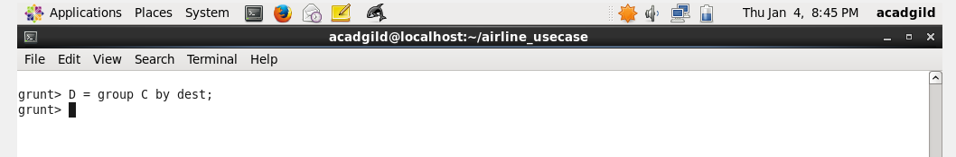

E = foreach D generate group, COUNT(C.dest);

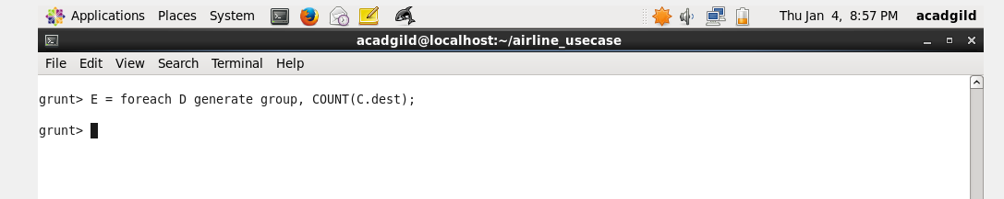

F = order E by $1 DESC;

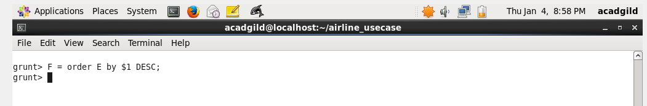

Result = LIMIT F 5;

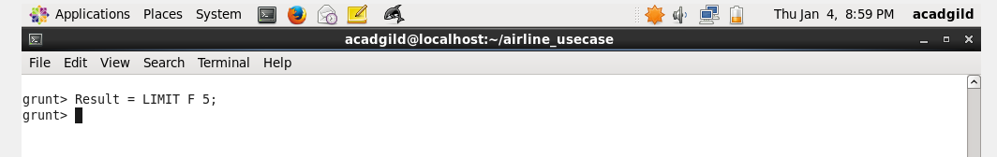

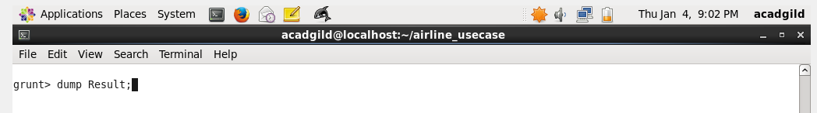

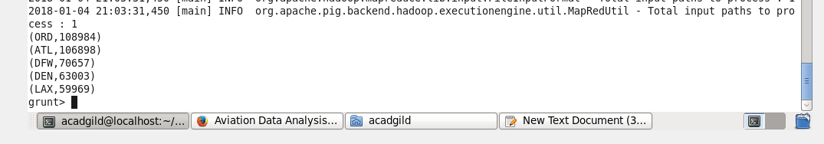

A1 = load '/home/acadgild/airline_usecase/airports.csv' USING org.apache.pig.piggybank.storage.CSVExcelStorage(',','NO_MULTILINE','UNIX','SKIP_INPUT_HEADER');

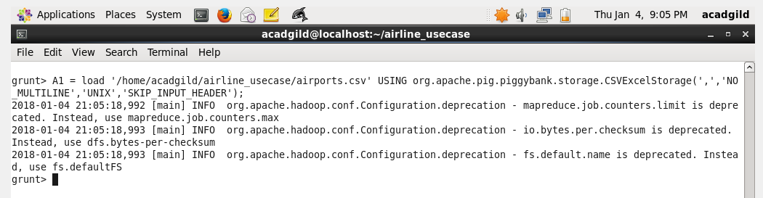

A2 = foreach A1 generate (chararray)$0 as dest, (chararray)$2 as city, (chararray)$4 as country;

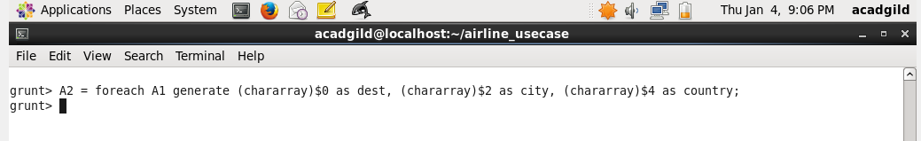

joined_table = join Result by $0, A2 by dest;

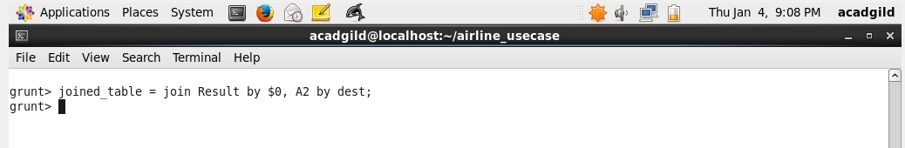

dump joined_table;

