REGISTER '/home/acadgild/assignment5.3/piggybank.jar';

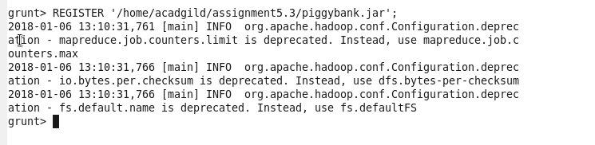

Load_Data = LOAD ‘/home/acadgild/Downloads/Pokemon.csv’ USING PigStorage(‘,’) AS(Sno:int,Name:chararray,Type1:chararray,Type2:chararray,Total:int,HP:int,Attack:int,Defense:int,SpAtk:int,SpDef:int,Speed:int);

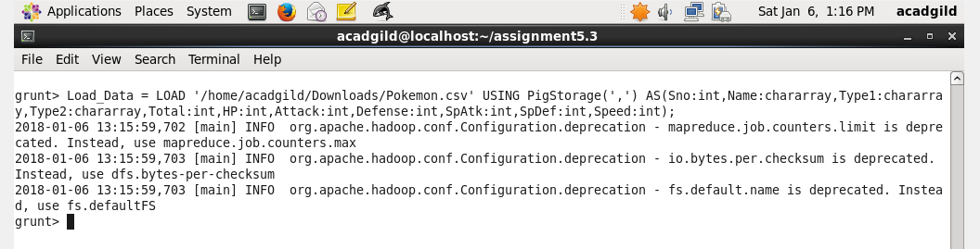

selected_list = FILTER Load_Data BY Defense>55;

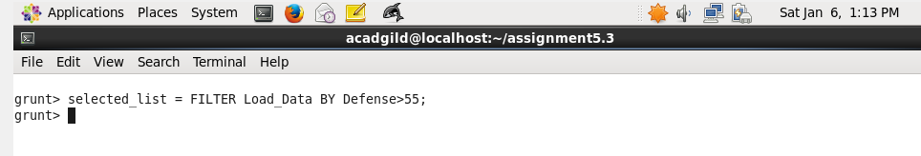

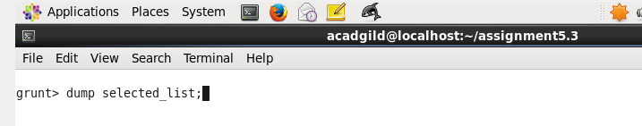

gourp_selcted_list = Group selected_list All;

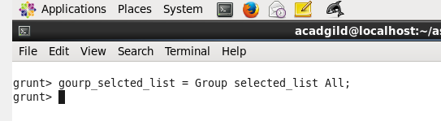

count_selcted_list = foreach gourp_selcted_list GENERATE COUNT(selected_list);

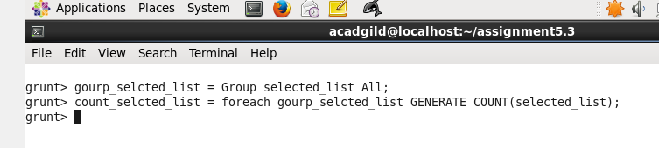

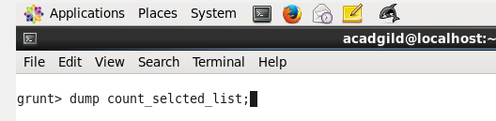

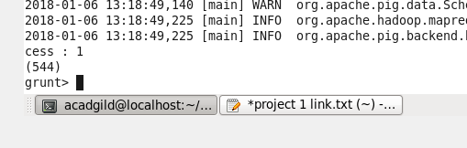

random_include1 = foreach selected_list GENERATE RANDOM(),Name,Type1,Type2,Total,HP,Attack,Defense,SpAtk,SpDef,Speed;

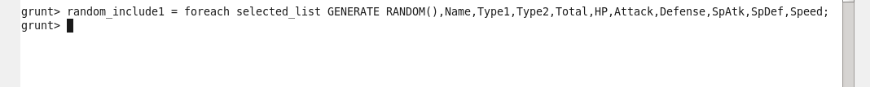

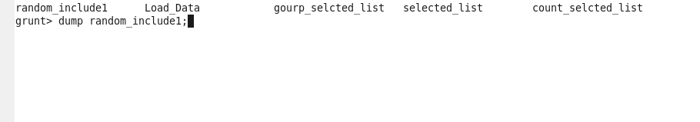

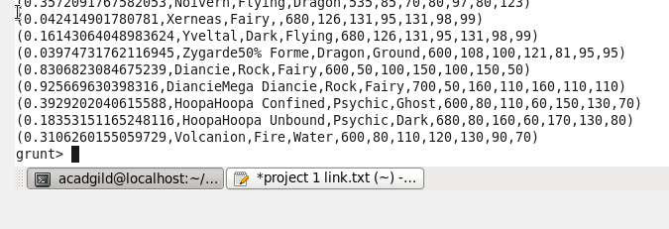

random1_desending = ORDER random_include1 BY $0 DESC;

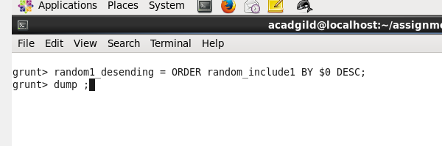

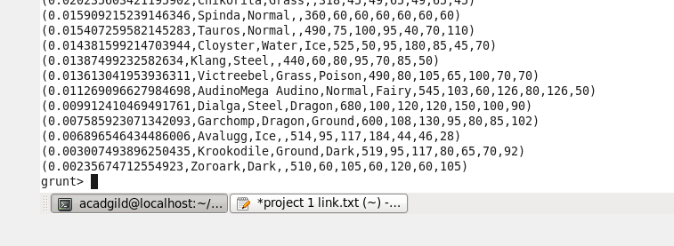

random_include2 = foreach selected_list GENERATE RANDOM(),Name,Type1,Type2,Total,HP,Attack,Defense,SpAtk,SpDef,Speed;

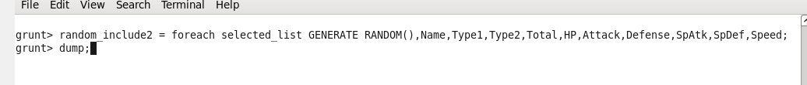

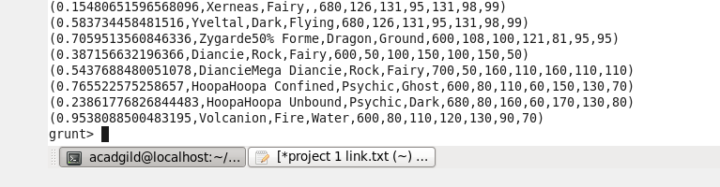

random2_desending = ORDER random_include2 BY $0 DESC;

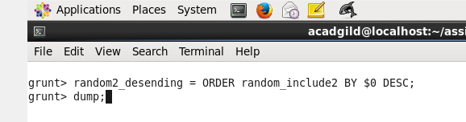

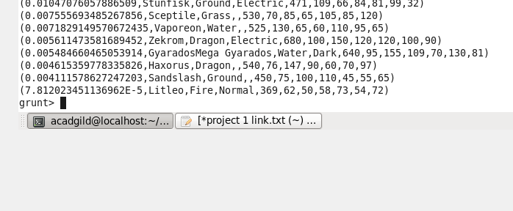

limit_data_random1_desending = LIMIT random1_desending 5 ;

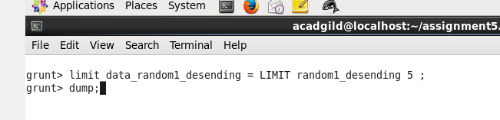

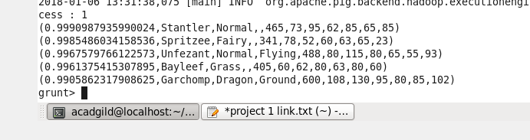

limit_data_random2_desending = LIMIT random2_desending 5 ;

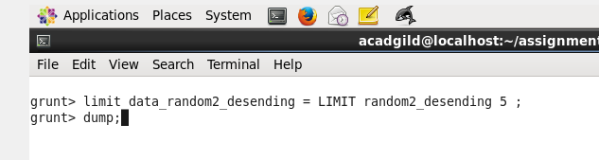

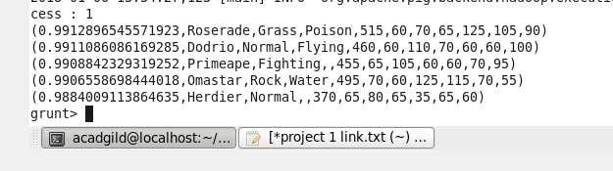

filter_only_name1 = foreach limit_data_random1_desending Generate ($1,HP);

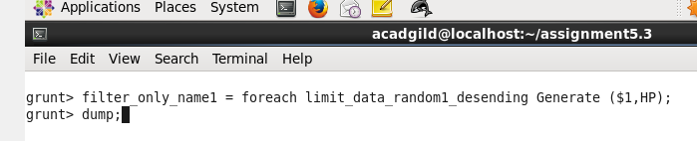

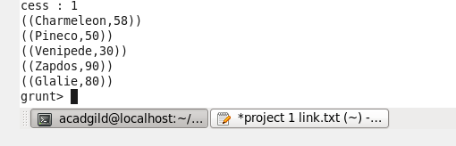

filter_only_name2 = foreach limit_data_random2_desending Generate ($1,HP);

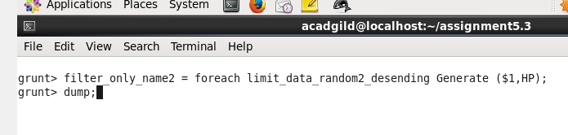

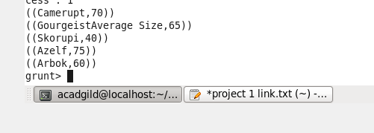

STORE limit_data_random1_desending INTO ‘/home/acadgild/Documents/prateek/PIG/player1.txt’;

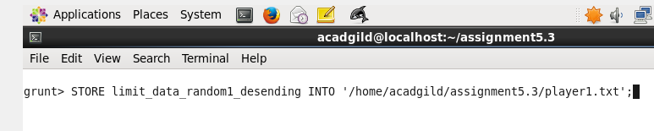

STORE limit_data_random2_desending INTO ‘/home/acadgild/Documents/prateek/PIG/player2.txt’;

