

Alok Sharma

June 26, 2025

Renewable Energy Trading System

This report documents the design, implementation, and testing of an AI-based renewable energy trading system. The system is composed of microservices: a weather service, a forecast engine using ML, a trading logic service, a cron-based scheduler, and a visualization dashboard.
Technologies used include Docker, FastAPI, Streamlit, scikit-learn, cron, and Python. The key challenge was orchestrating real-time forecasting and data-driven decisions across containers. The trading service evaluates predicted energy output and price to decide whether to buy, sell, or hold energy. The dashboard visualizes forecasts and cumulative profits.
To reproduce the system, follow the installation guide. The project has been tested on a local Docker environment. Future improvements include training with real-world data, dynamic pricing strategies, and cloud deployment.
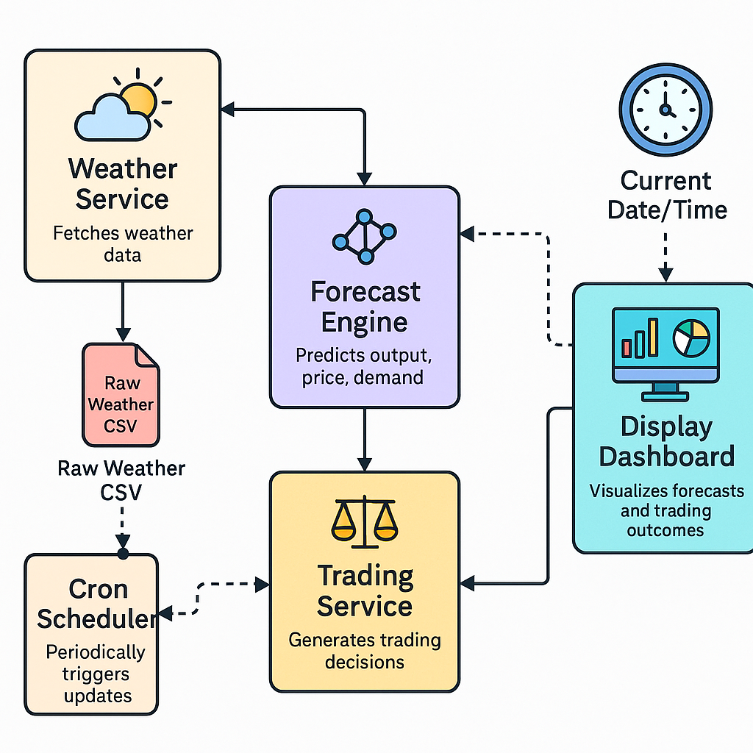

Core Workflow (Top to Bottom):
- Cron Job (Scheduler)
  - Triggers updates at regular intervals (e.g., every 15 minutes).
- Weather Service (API Fetcher)
  - Fetches real-time data (temperature, irradiance, wind speed) from OpenWeatherMap.
  - Writes to raw_weather.csv.
- Forecast Engine (ML Models)
  - Reads raw weather data.
  - Applies ML models (energy generation, market price, grid demand).
  - Outputs forecast to a timestamped forecast_*.csv.
- Trading Service (Decision Maker)
  - Consumes each forecasted row.
  - Applies buy/sell/hold logic.
  - Calculates quantity and profit.
- Dashboard (Streamlit App)
  - Visualizes predictions, decisions, and cumulative profits.
  - Provides an interactive UI to trigger updates or inspect trading logic.

Data Movement:
- Arrows between services indicate data flow and HTTP-based communication (e.g., FastAPI endpoints).
- Files like raw_weather.csv and forecast_*.csv act as intermediate data artifacts shared across services.

Purpose of Diagram:
This diagram shows not just who talks to whom, but what each service internally contains (e.g., ML models, profit logic, data fetcher)

System Components and Workflow
The system is designed using a modular microservices architecture. Each service has a specific role and communicates with others to form a complete renewable energy trading platform.

1. Forecast Engine using Machine Learning
This service is responsible for generating predictions based on weather inputs. It uses pre-trained machine learning models (e.g., scikit-learn RandomForest or XGBoost models) to forecast:
- Renewable energy generation (MW)
- Market electricity price (USD/MWh)
- Grid load demand (MW)
Input: A batch of weather data rows (temperature, wind speed, irradiance) in CSV format.
Process: Each row is passed to the ML models which return predicted values.
Output: A timestamped CSV file saved in a 'processed' folder containing all the predictions.

2. Trading Logic Service
This service receives forecasted values and decides whether to Buy, Sell, or Hold electricity based on predefined rules:
- Buy if price < $35
- Sell if price > $80
- Hold otherwise
Input: predicted_output (MW), predicted_price (USD/MWh), interval (e.g., 5 min).
Process: It calculates the energy quantity (in MWh) using the formula:
quantity = predicted_output × (interval / 60)
Then calculates profit:
Buy → -price × quantity (cost)
Sell → price × quantity (revenue)
Output: A JSON response with decision, reason, quantity traded, and profit/loss.

3. Cron-Based Scheduler
This is a lightweight container that uses a Linux cron job to automate forecast generation.
Input: None (runs every hour by default).
Process: Makes an HTTP POST request to the forecast engine’s `/forecast/batch` endpoint.
Output: Triggers batch predictions and saves them as new forecast files for the dashboard to display.

4. Visualization Dashboard (Streamlit)
This is a user-facing dashboard built using Streamlit. It allows users to:
- Manually trigger forecast updates
- View forecasted energy output, prices, and grid demand
- See buy/sell decisions and reasons
- Track profit over time using cumulative plots
Input: Forecast files generated by the batch engine
Process: Reads the latest CSV, calls the trading service for each row, and aggregates the results
Output: Interactive charts and tables displaying predictions, trading actions, and profits

Docker and Microservice Deployment
Each service in the system is containerized using Docker and orchestrated via Docker Compose. This ensures modularity, isolation, and ease of deployment. Below is a summary of what's inside each Dockerfile and how Docker Compose links the services together.

Dockerfile Contents by Service
1. forecast_service:
- Base image: python:3.10-slim
- Installs dependencies like scikit-learn, pandas, FastAPI, and uvicorn
- Copies model files and `main.py`
- Runs a FastAPI server on port 8002 using uvicorn
2. trading_service:
- Base image: python:3.10-slim
- Installs FastAPI and dependencies
- Contains `main.py` with trading logic
- Exposes port 8003
3. weather_service:
- Optional microservice to simulate or fetch weather data (if used)
- Similar structure to forecast/trading services
- Runs on port 8001
4. dashboard:
- Base image: python:3.10-slim
- Installs Streamlit and visualization dependencies
- Copies `app.py`
- Runs the Streamlit dashboard on port 8501
5. forecast_cron:
- Installs `curl` and `cron`
- Adds a cron job to call the forecast batch endpoint every hour
- Keeps the cron process alive using CMD ['cron', '-f']

How Docker Compose Connects Everything
Docker Compose is used to orchestrate all services together. It:
- Builds each container from its Dockerfile
- Assigns fixed ports to access services locally
- Creates an internal network so services can communicate by name (e.g., forecast → trading)
- Mounts shared volumes for persistent forecast files
- Starts the cron container to schedule batch forecasting
Each service is defined under the `services:` block of the `docker-compose.yml` file and can be independently rebuilt and restarted.

Real-Time Forecasting Pipeline
The project has been extended to support a real-time pipeline that automates weather data collection, forecasting, trading decisions, and visualization using microservices and a cron-based scheduler.

Automated Flow
1. A cron job runs every 15 minutes to trigger the weather microservice.
2. The `weather_service` fetches current weather conditions (temperature, wind speed, irradiance) from OpenWeatherMap API and saves them into `data/raw_weather.csv`.
3. Immediately afterward, the cron job also triggers the `/forecast/batch` endpoint of the forecast microservice.
4. The `forecast_service` loads the latest weather data, runs predictions using ML models, and saves the output to a timestamped `forecast_*.csv` file.
5. The Streamlit dashboard reads this forecast file, sends each row to the `trading_service`, and displays trading decisions, reasoning, and cumulative profits.
6. The entire system runs via Docker Compose, allowing each component to scale or restart independently.
This architecture ensures that new forecasts and trading evaluations are made available every 15 minutes, based on the most current weather data. It closely mimics how real-world renewable energy trading platforms operate with streaming weather inputs and continuous re-evaluation of trading decisions.

Deployment Note
While the system was designed using a fully modular microservices architecture and Docker containers with the intent to be cloud-hosted (e.g., on AWS EC2), I hosted the system locally due to cost constraints — as t2.medium instances (required for multi-container workloads) are not part of AWS’s free tier.
However, all services are containerized and networked using Docker Compose, and the architecture is directly portable to any cloud provider. The structure adheres to cloud deployment best practices, enabling easy migration to AWS, GCP, or Azure with minimal modification.
Snapshots:
