
7,043
Customer records
2
Classification models
21
Dataset attributes

Customer Churn Prediction
Using Machine Learning

Decision Tree • SVM • K-Means
Data Mining & Machine Learning – Final Project Spring 2026

Done by : Mohammad Al-Omari , Asem Jabri
Dr. Bashar Tahaineh

Project Objective & Workflow

Predict whether a telecom customer will churn or stay.
Apply the full data mining pipeline from
preprocessing to evaluation.
Compare Decision Tree and SVM, then use K- Means to discover customer groups.

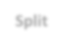
Dataset
Preprocess
Split
Train
Evaluate
Compare

Dataset Overview



5,174
No churn customers

1,869
Churn customers

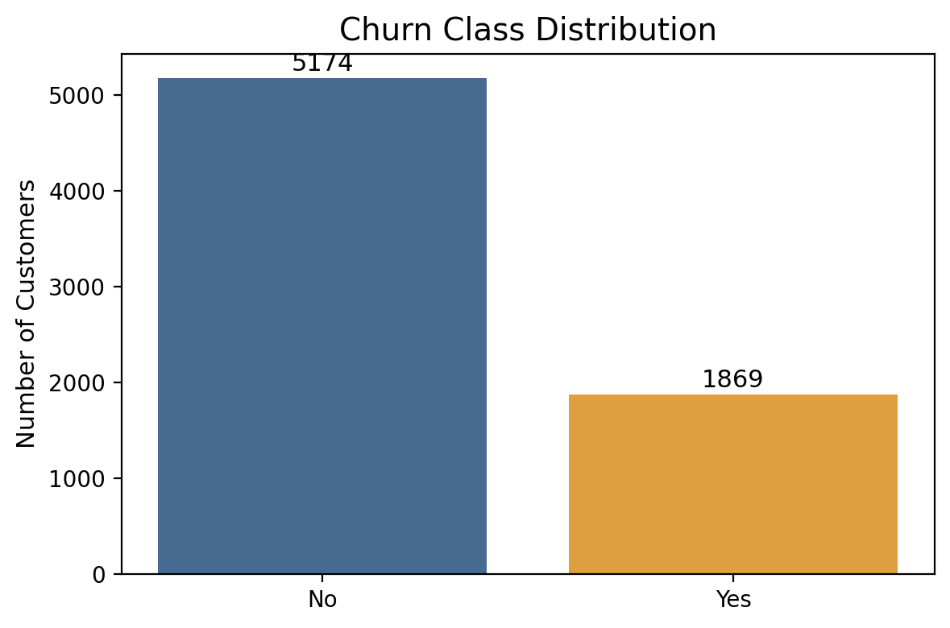
Target variable: Churn (Yes/No).
The dataset is imbalanced: non-churn customers
are the majority.
This makes recall and F1-score more informative than accuracy alone.

Data Preprocessing

Removed customerID because it is only an identifier. Mapped Churn: Yes = 1, No = 0.
Converted categorical variables using one-hot
encoding.
Applied StandardScaler for SVM and K-Means. Important final note: convert TotalCharges to numeric
before encoding.


X
Input features
y
Target label

Clean data → reliable model
Numerical data → required by ML
algorithms

4

Sampling Strategy & Evaluation Metrics

70%
Training data

30%
Testing data

Training set teaches the model patterns. Testing set measures performance on unseen
data.
random_state = 42 keeps the experiment reproducible.
Accuracy: total correct predictions.
Precision: when the model predicts churn, how often is it correct?
Recall: how many real churn customers were detected?
F1-score: balance between precision and recall.

5

Decision Tree Results


0.7785
Accuracy
0.61
Precision (Churn)
0.51
Recall (Churn)
0.55
F1 (Churn)

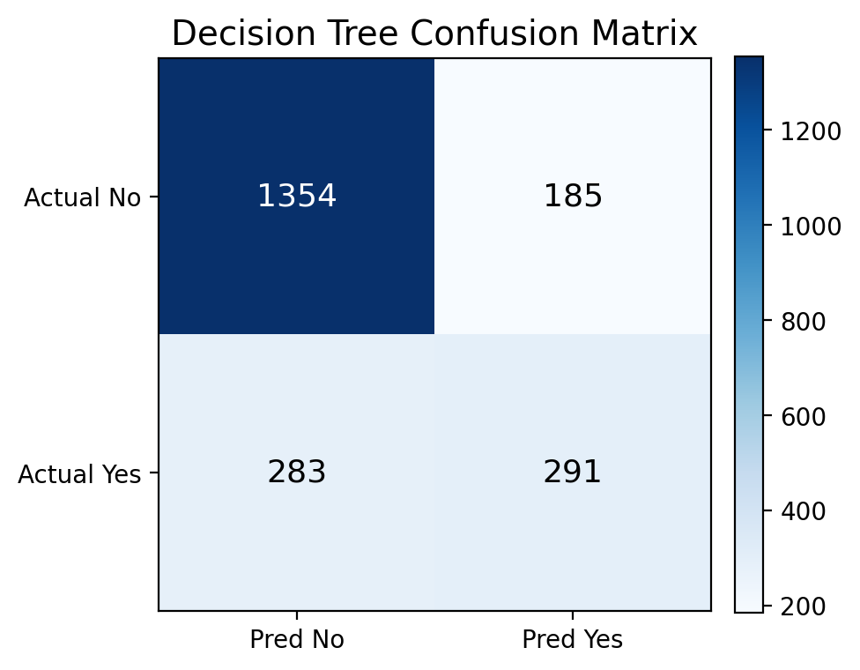
Higher overall accuracy. Interpretable model.
Missed 283 actual churn customers.

6

SVM Results


0.7643
Accuracy
0.56
Precision (Churn)
0.60
Recall (Churn)
0.58
F1 (Churn)

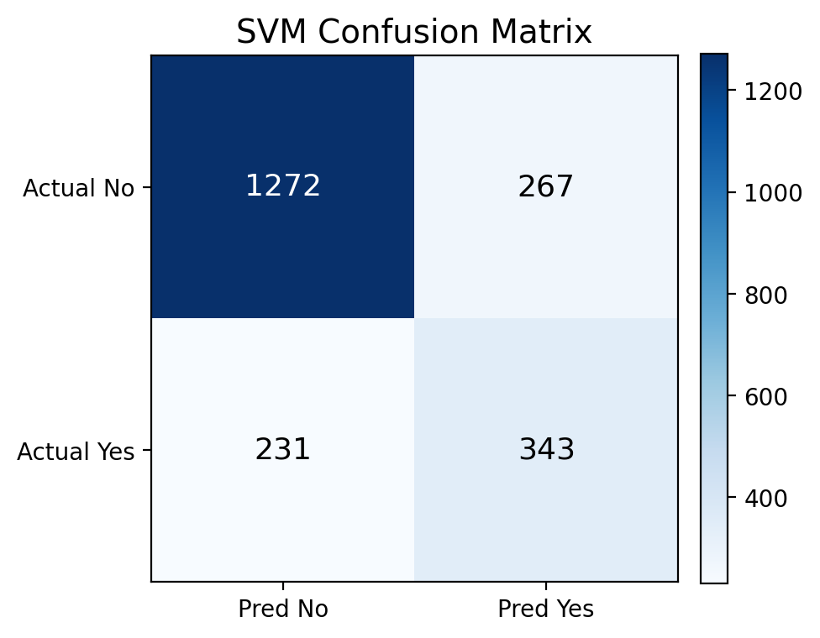
Detected more churn customers than Decision Tree. Lower false negatives: 231 instead of 283.
Better choice when churn detection is the priority.

7

Model Comparison

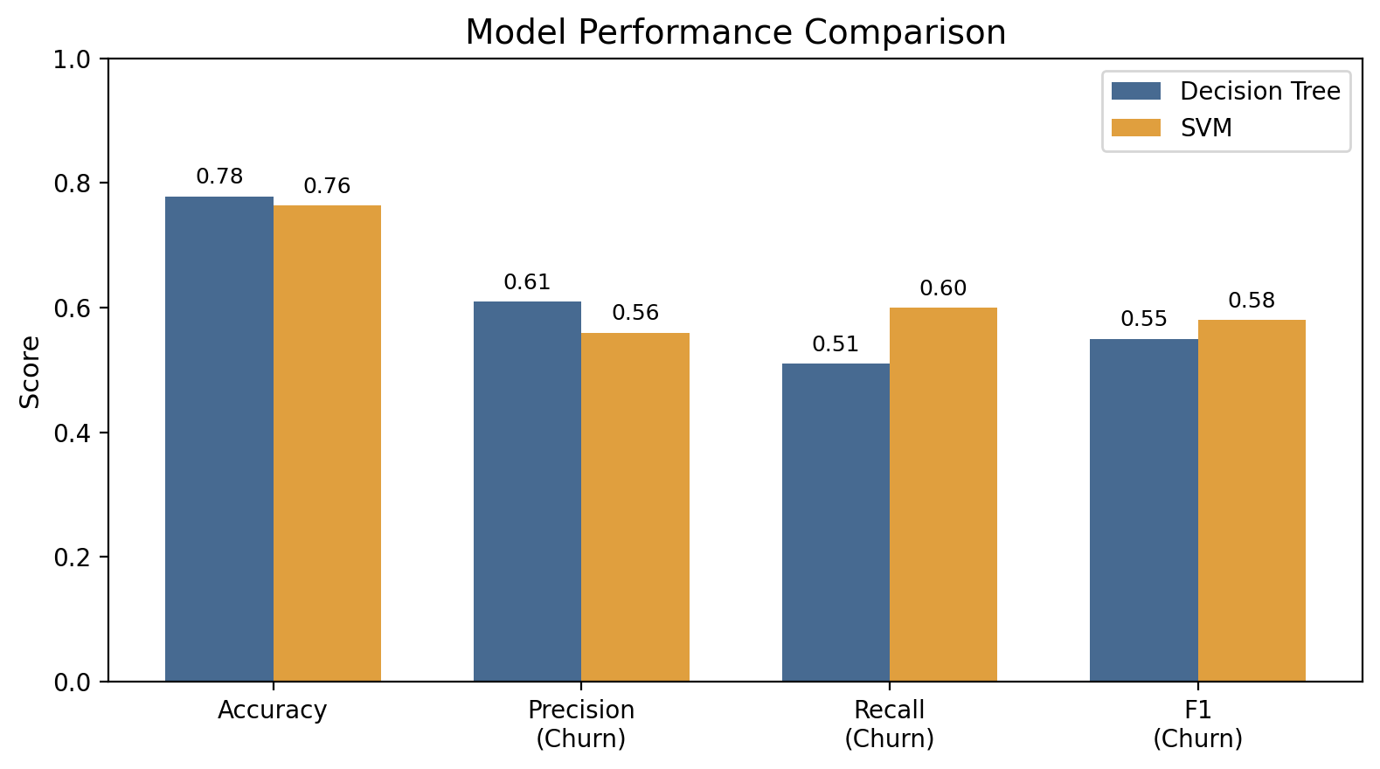
Decision Tree: higher accuracy and precision.
SVM: higher recall for churn customers.
For business retention, recall is more important because missed churn customers are costly.

8

Feature Analysis & Dimensionality

Important churn-related features include tenure, contract type, monthly charges, internet service, and support services.
Tenure
Key behavior feature
Contract
Customer commitment
Decision Tree feature_importances_ was added to print the strongest predictors.
One-hot encoding increases dimensionality by creating binary columns for categories.
Charges
Billing behavior
Support
Service quality
High dimensionality can increase model complexity and
overfitting risk.
TotalCharges should be numeric; otherwise it may create thousands of dummy columns.

9

K-Means Clustering Insights

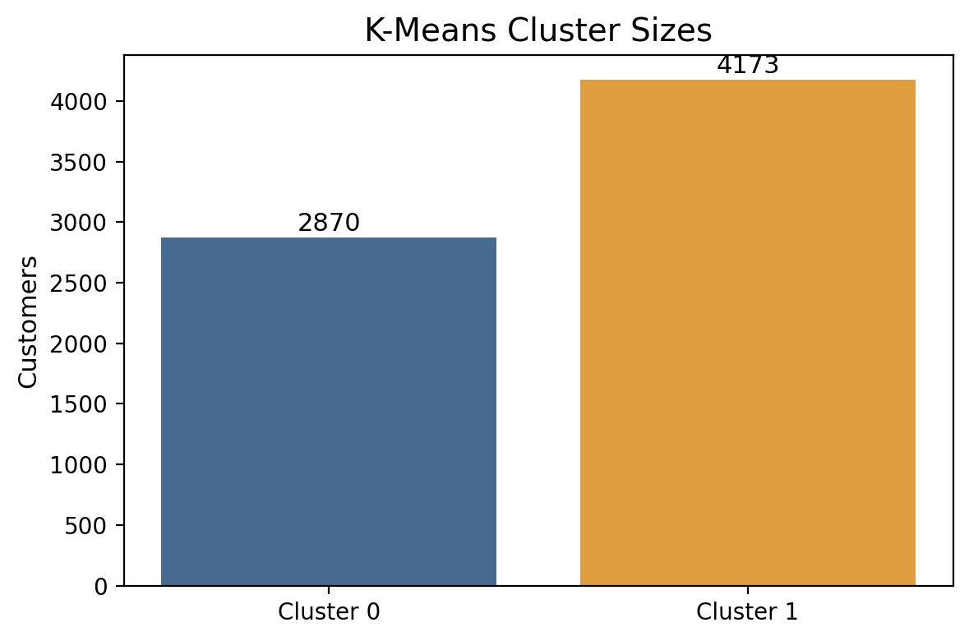
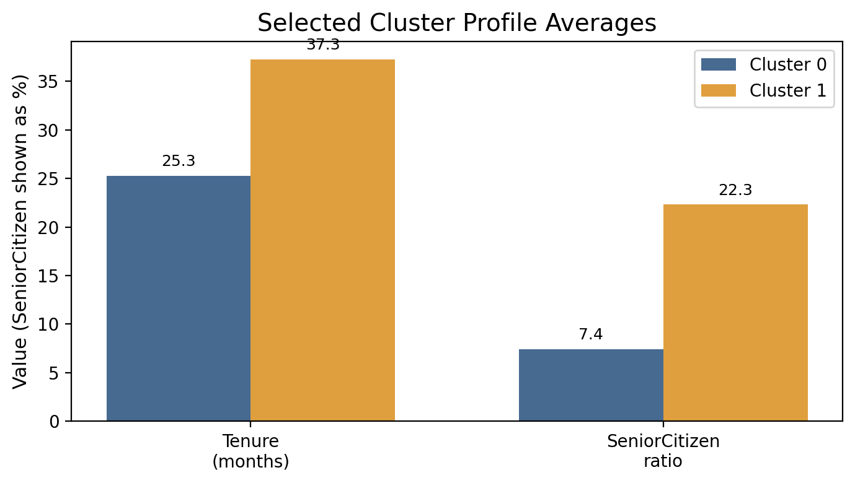

Cluster 0: 2,870 customers, lower average tenure (25.26).
Cluster 1: 4,173 customers, higher average tenure (37.26). Short-tenure customers may require more retention effort.

10

Discussion

Accuracy alone is not enough because the target classes are imbalanced.

FN ↓
SVM reduces missed churn
False negatives are costly: the company misses customers who are about to leave.
SVM improves churn recall, so it is better aligned with the business goal.

Recall ↑
Better churn detection
K-Means supports the analysis by showing customer
groups based on behavior.

Clusters
Useful customer segments

11

Conclusion & Recommendation

A complete machine learning pipeline was implemented for churn prediction.

SVM
Recommended for recall
Decision Tree achieved the highest accuracy: 77.85%.
SVM achieved better churn recall: 60%.
Recommended model: SVM when the priority is detecting at- risk customers.

77–78%
Overall accuracy range
Future work: hyperparameter tuning, class weights/SMOTE,
Random Forest, and better feature selection.

60%
Best churn recall

12

Added Feature Importance Analysis
This completes the Feature Analysis requirement by showing which variables most affected the Decision Tree predictions.



Why this matters
- Identifies the strongest churn predictors.
- Supports the discussion about dimensionality.
- Makes the model more explainable for the report.
- Common important features: tenure, contract,
charges, and service options.

Code added
importances = dt_model.feature_importances_
for feature, importance in zip(X.columns, importances):
if importance > 0.01: print(feature, ":", importance)
Report statement: Feature importance showed that customer behavior and contract-related features are major factors in churn prediction.

13

