**Report for the project “Is it safe in India?”**

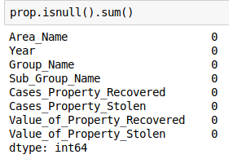

The first thing after choosing the topic of the project was to find datasets to work with. So I found 3 datasets in kaggle and they were CSV files. The next step was to import them to Jupyter Notebook, convert to the DataFrames and also to import different modules. Then I started to read information and I wanted to clean data that is not valid. It was a surprise but all data was valid. So I’ve chosen a very good datasets.

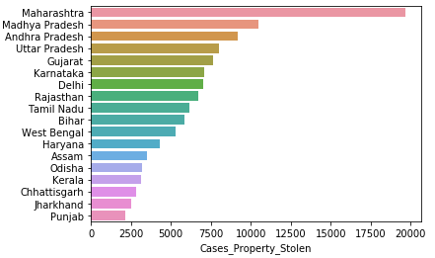

Next point was to count how many cases of property stolen were in each region of India. In general, there were 35 regions. But a lot of regions didn’t have much property stolen so I counted what was 1% of general property robbery in the country and I’ve got only half of the regions (18). Seaborn plot is showing the regions and numbers of cases for each region.

Also, Internet research says that “In India, crime and location are directly related. According to the National Crime Re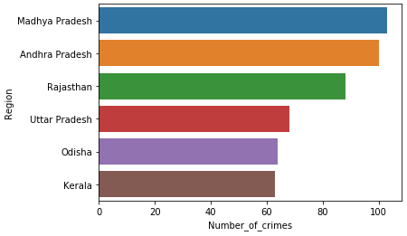cords Bureau, Uttar Pradesh is the most dangerous state in India”. But according to my research, you can see that this region takes 4th place by property stolen.

There was also another dataset with names of regions and types of crimes. So another plot was made. But I found out that the names of regions are duplicating and they are written in different ways. That’s why I made a small DataFrame by hand just to save time and to visualize the result from another dataset. The result is the same as previous: Uttar Pradesh is in 4th place.

While summing numbers of crimes appear a lot of float numbers. They were rounded and then transformed into integers to remove the points.

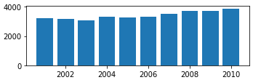

The next step was to count how many properties were robbed by different years. Aggregating columns, reset indexes, sort, and round the values were a part of the process. The plot is showing that the numbers of crimes are rising. I have an opinion that it’s rising because the number of population is rising and appear new buildings.

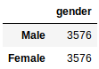I was trying to found out who is going more often to prison: male or female but the dataset showed me that it’s only the sample because the number of men and women was equal to each other.

And I decided to count the amount of crimes made by these groups. The percentage, as a result, you can see in the picture (4.1% - Female, 95.9% - Male).

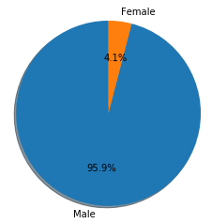

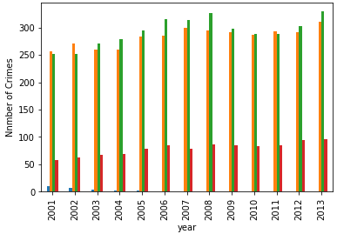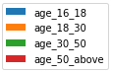Another research was based on the ages of people who went to jail. Summarising data and transforming to integers was part of the work. The statistics show us that young people are making less crimes than all the other categories and the people of age around 18-50 years are more usual to went to prison. Also, there are more people in India with the age of 18-50 years. For sure more than people over 50 and people under 18 years (also this group of people are not physically able to do crime before a certain age).

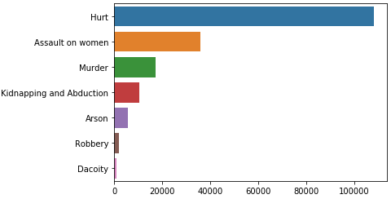Then I started to analyze what kind of crime is more usual in India. I created the plot that shows us that “hurt” takes the first place (Indian law says: Whoever does any **act** with the intention of thereby causing **hurt** to any person, or with the knowledge that he is likely thereby to cause **hurt** to any person, and does thereby cause **hurt** to any person, is said "voluntarily to cause **hurt**"). The 2nd place takes rape of women.

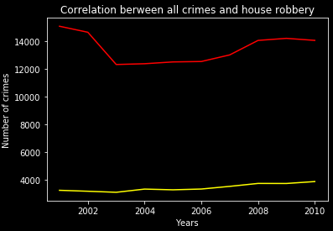

As I already had some interesting cleaned data so I decided to try to find out some correlation between all crimes and property robbery over the years. I merged two datasets by years and I discovered that there is no correlation.

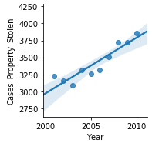

But I also discover that there is a correlation between cases of property stolen and years. With time the number of cases is growing.

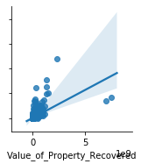Another correlation that I found was between the value of property stolen and the value of property recovered.

The link for my presentation you can find here:

https://www.canva.com/design/DADlXQqc6vY/IJwdtFbWzkU5jbYziu8v1Q/edit