**Solution Midterm**

Dias Seisenbek, 2 course, Digital Engineering

**Project Structure:**

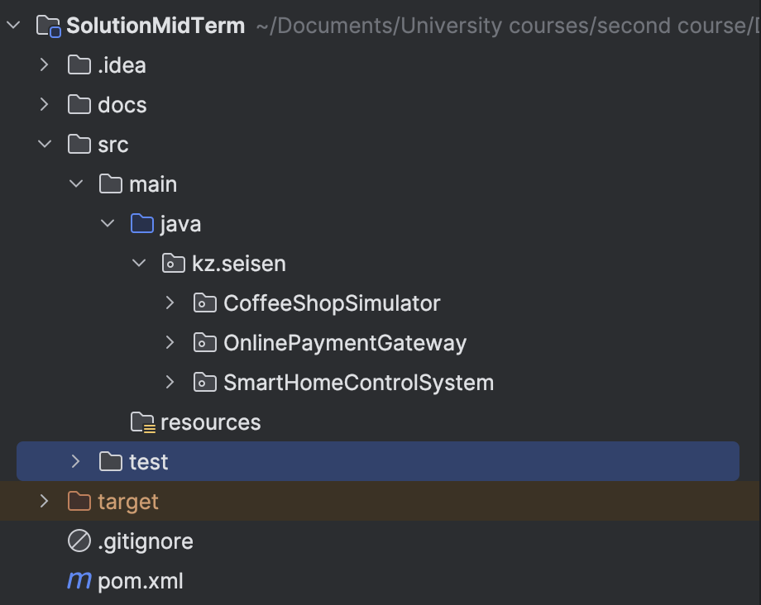

**Smart Home Control System**

**Project Structure:**

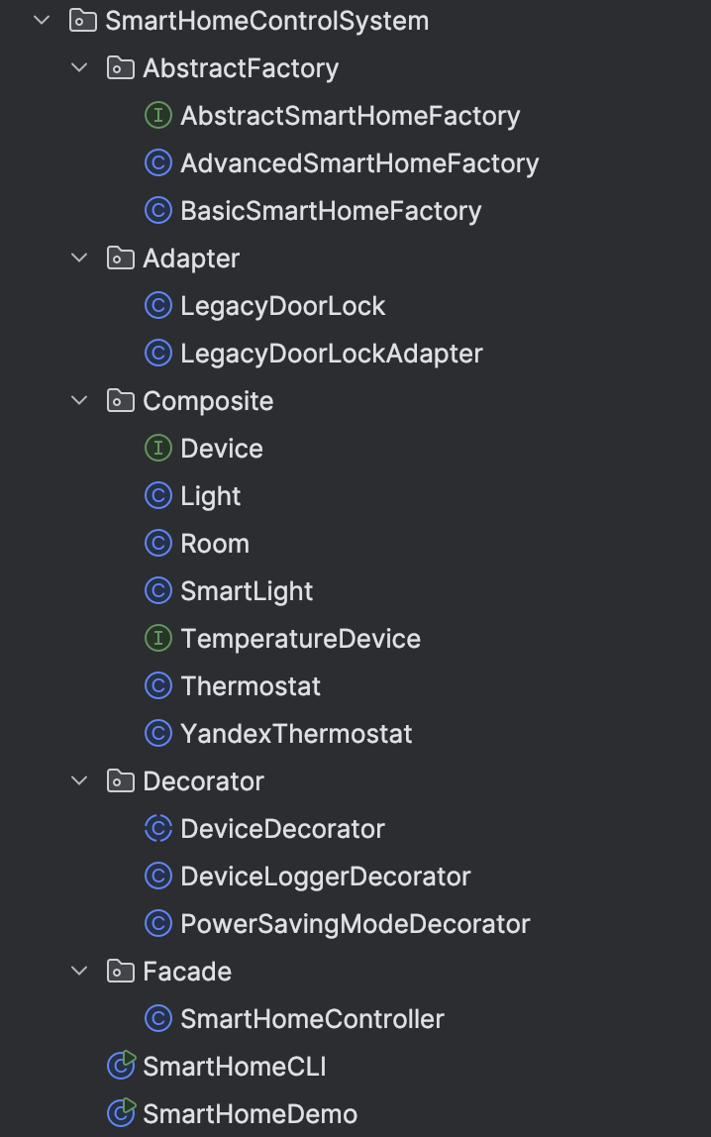

*SmartHomeDemo*if you don’t want to follow each steps of CLI to check that everything works. You can just run it and see the results.

*SmartHomeCLI* if you want to check it directly by following each step.

**SmartHomeDemo** result:

|  |  |
| --- | --- |
|  |  |

**SmartHomeCLI** output:

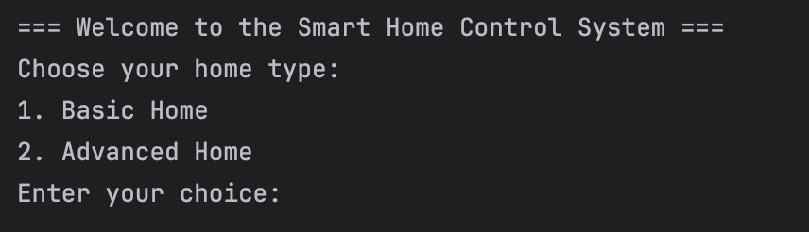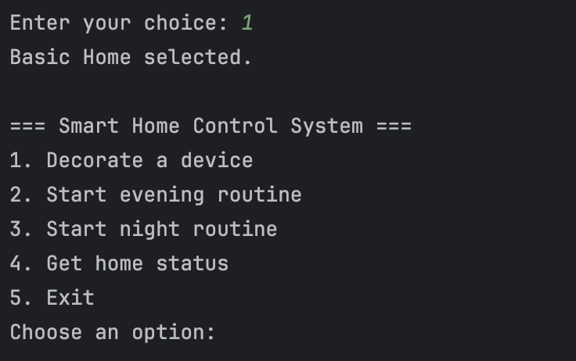

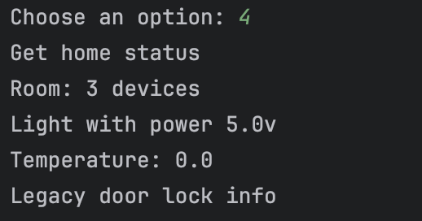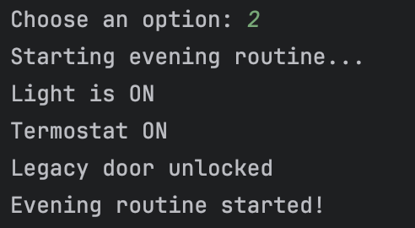

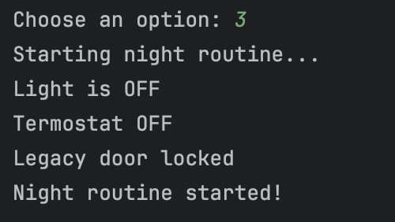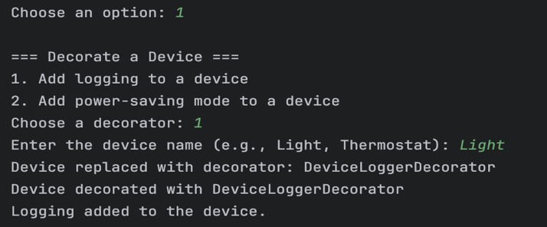

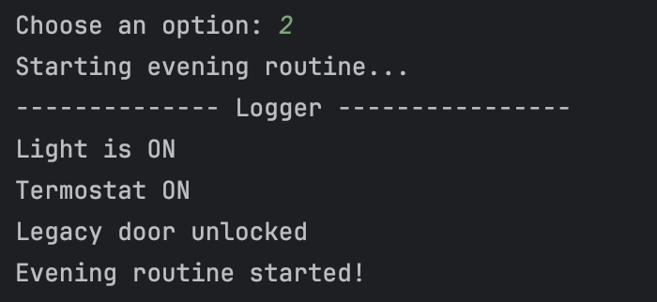

**Online Payment Gateway**

**Project Structure:**

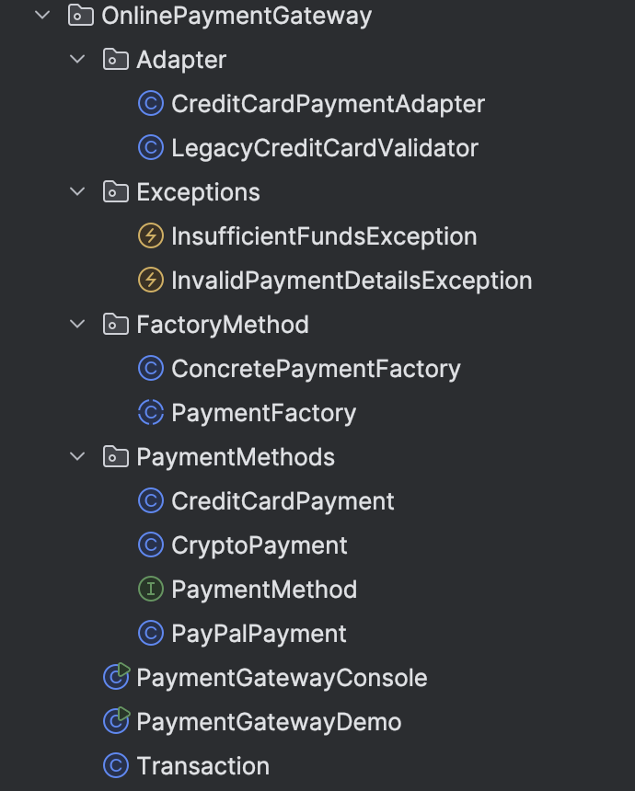

*PaymentGatewayDemo*for case if you don’t want waste your time.

**PaymentGatewayDemo** output:

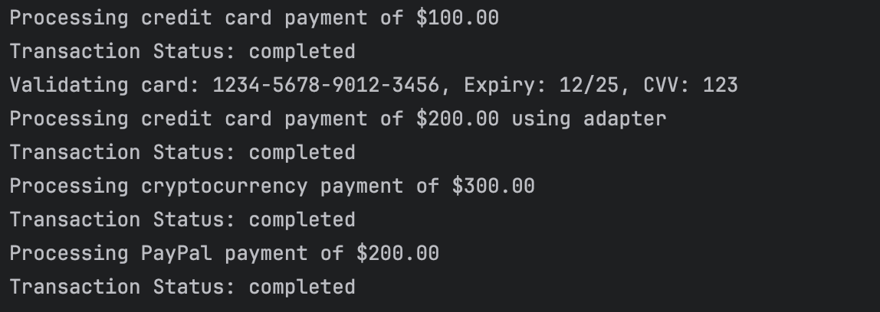

This show that everything works properly and without any problem.

**PaymentGatewayConsole** output:

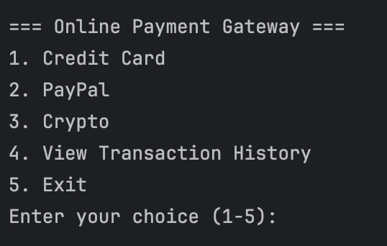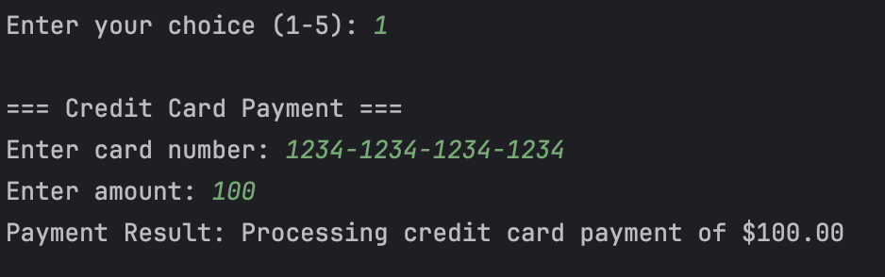

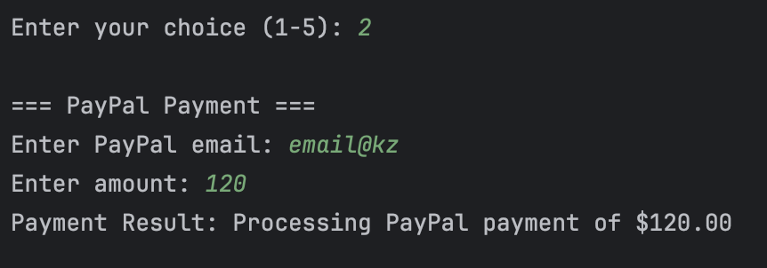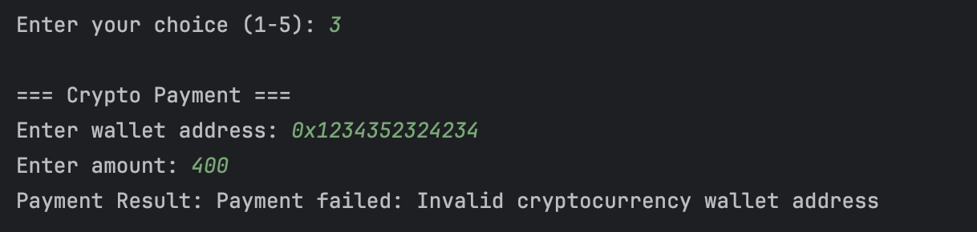

This error occurs because of the wrong wallet address. There is some exceptions for case if your info details is incorrect and if you don’t have enough money:

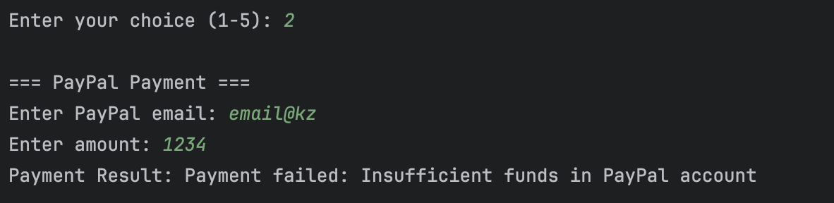

And Also it storages your actions in Transaction History (even failed payments as in large bank’s systems)

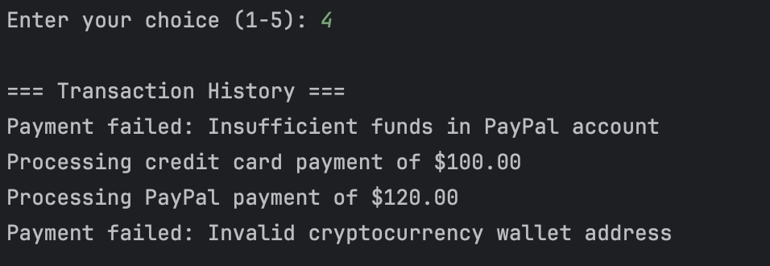

**Coffee Shop Simulator**

**Project Structure:**

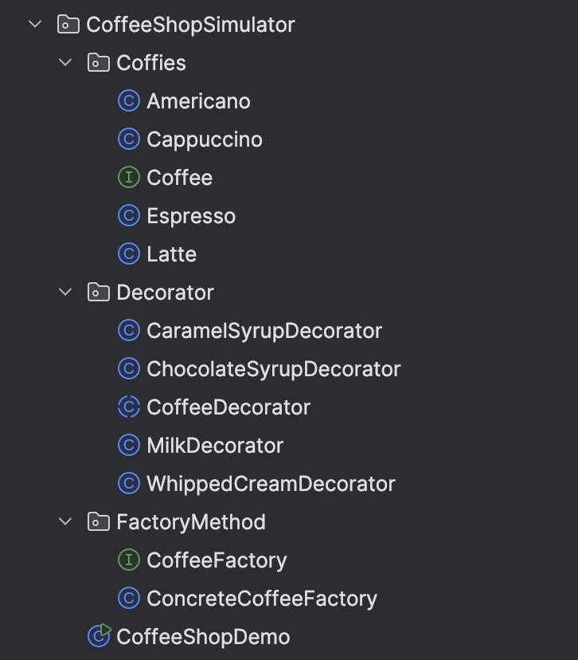

**CoffeeShopDemo:**

