Research Methods Course — Suleyman Demirel University, Almaty, Kazakhstan | 2026

Predicting Professional CS2 Match Outcomes Using Machine Learning:
A Comparative Study of Logistic Regression, Random Forest, and Gradient Boosting
Seisenbek Dias
Department of Computer Science and Mathematics, Suleyman Demirel University, Almaty, Kazakhstan
Student ID: S23068165 | Course: Research Methods
Abstract
Predicting the outcome of professional esports matches is a challenging binary classification problem due to the inherent stochasticity of competitive play. This study applies three supervised machine learning classifiers — Logistic Regression, Random Forest, and Gradient Boosting — to predict the outcome of 7,033 professional Counter-Strike 2 (CS2) matches drawn from HLTV.org across 648 tournaments (May 2024–October 2025). Four features are engineered from publicly available team statistics: mean HLTV 2.0 Rating, mean Kills Per Round (KPR), head-to-head historical win rate, and map-specific win rate. A naive majority-class baseline (always predict Win) is included for honest comparison. Models are evaluated on a held-out test set (n = 1,407) using Accuracy, Macro F1 Score, and AUC-ROC. All three models marginally outperform the naive baseline on AUC-ROC, with Random Forest achieving the highest Macro F1 Score (0.533) and AUC-ROC (0.572). Feature importance analysis identifies HLTV Rating as the strongest predictor, followed by head-to-head win rate. The modest overall accuracy (≈56%) is consistent with the theoretical upper bound of pre-match prediction in competitive sports and highlights the need for richer feature sets including in-game state variables.
Keywords: CS2; Counter-Strike; esports analytics; match outcome prediction; logistic regression; random forest; gradient boosting; HLTV; binary classification

1. Introduction
Esports has grown into a global industry with an estimated audience of 500 million viewers and a market valuation exceeding $1.5 billion USD as of 2024 (Newzoo, 2024). Counter-Strike 2 (CS2), developed by Valve Corporation, is one of the analytically richest competitive titles, with over two decades of professional match history documented on HLTV.org — the primary statistical aggregator for the CS ecosystem. Unlike many traditional sports, CS2 generates granular per-player and team-level statistics that are in principle well-suited to quantitative modelling. Despite this data richness, academic literature on CS2-specific match outcome prediction remains sparse, particularly following the 2023 engine transition from CS:GO to CS2 which deprecated earlier datasets and rating systems.
Predicting pre-match outcomes in professional CS2 is a non-trivial problem. Unlike in-game state prediction (where the current score, economy, and alive players provide very strong signals), pre-match prediction must rely solely on historical team-level statistics. This creates a structural upper bound on predictive accuracy: a large fraction of match outcomes is determined by factors that are unobservable from external statistics alone — in-game adaptation, strategy preparation, player form on the day, and random variance inherent to a complex tactical game. Related work consistently reports pre-match accuracy ceilings of 60–68% (Semenoff, 2020; Bunker & Thabtah, 2019).
This study makes the following contributions:
- A rigorous preprocessing pipeline applied to 7,033 professional CS2 matches from HLTV.org, covering 648 tournaments (May 2024 – October 2025), with a naive majority-class baseline included to contextualise all reported model performance.
- Engineering of four theoretically motivated features mapped to three research hypotheses on the role of combat performance, historical matchup records, and map specialisation.
- A comparative evaluation of Logistic Regression, Random Forest, and Gradient Boosting on a held-out test set using Accuracy, Macro F1, and AUC-ROC — with paired t-tests on 5-fold cross-validation to assess statistical significance of differences.
- Feature importance analysis and Logistic Regression coefficient interpretation to identify which dimensions of team performance best explain match outcomes.
The remainder of this paper is organised as follows. Section 2 reviews related work. Section 3 describes the dataset and variables. Section 4 presents the theoretical background for each classifier. Section 5 details the experimental protocol. Section 6 reports results. Section 7 discusses findings and limitations. Section 8 concludes.

2. Related Work
The application of machine learning to sport result prediction has a substantial literature. Dixon and Coles (1997) established the foundational insight that competitive sport outcomes follow a Poisson-like process, implying a theoretical ceiling on prediction accuracy well below 100%. Bunker and Thabtah (2019) proposed a general ML framework across multiple sports (football, basketball, cricket) and found that ensemble tree-based methods consistently outperform linear classifiers, with best-in-class accuracy in the range of 68–72%. Baboota and Kaur (2019) applied Random Forest and XGBoost to English Premier League matches using team-level statistics, reaching 74% accuracy — notably, this figure is higher than our reported results, likely due to EPL having richer team-level statistics with less temporal measurement ambiguity than HLTV data.
Esports-specific research has accelerated since 2018. Hodge et al. (2019) surveyed ML applications across multiple esports titles and identified CS:GO as a particularly data-rich domain. Katona et al. (2019) developed round-level win probability models using in-game state features (current round score, economy, alive players) and reported AUC values of 0.80–0.85 — significantly higher than pre-match predictions because in-game state is far more informative than historical team averages. Semenoff (2020) applied Logistic Regression, SVM, and Gradient Boosting to pre-match CS:GO prediction using HLTV statistics, reporting accuracy of 60–68%, which closely mirrors our results. Arik (2022) noted that the CS:GO-to-CS2 transition in 2023 renders prior models non-transferable, motivating the present study's focus on post-transition data.
Table 1 — Summary of Related Work on Sports and Esports Match Outcome Prediction
Study | Domain | Method(s) | Best Accuracy | Note
Dixon & Coles (1997) | Football | Poisson regression | ~65% | Theoretical baseline
Baboota & Kaur (2019) | Football | RF, XGBoost | 74% | Rich team stats
Bunker & Thabtah (2019) | Multi-sport | RF, SVM, LR | 68–72% | General ML framework
Katona et al. (2019) | CS:GO | Random Forest | AUC 0.82 | In-game state features
Semenoff (2020) | CS:GO | LR, GB, SVM | 68% | Pre-match, HLTV stats
Arik (2022) | Esports | LR, XGBoost | 66% | Multi-title survey
Present study | CS2 (2024–25) | LR, RF, GB | 56.9% | Post-CS2 transition data

3. Dataset and Variables

3.1 Data Source
The primary dataset is sourced from a Kaggle repository published by griffindesroches (2025), aggregating professional CS2 match records scraped from HLTV.org. The dataset comprises 7,033 match records across 648 tournaments between May 2024 and October 2025, covering Tier-1 and Tier-2 competitive events. Each record represents one match from the perspective of team1. The raw dataset contains 168 columns including player-level statistics, team-level aggregates, historical win rates per map, and head-to-head records.

3.2 Variable Engineering and Data Dictionary
Five variables were selected and engineered for the model. All four predictors are continuous; the target is binary. Table 2 provides the full data dictionary.
Table 2 — Variable Data Dictionary
Variable | Role | Type | Source Column | Range
match_outcome | Target (Y) | Binary | team1_win_flag | {0, 1}
mean_hltv_rating | Feature X1a | Continuous | team1_avg_RATING | [0.87, 1.17]
mean_kpr | Feature X1b | Continuous | team1_avg_KPR | [0.58, 0.75]
head_to_head_win_rate | Feature X2 | Continuous | team1_head2head_percentage / 100 | [0, 1]
map_win_rate | Feature X3 | Continuous | team1_[decider_map] / 100 | [0, 1]

3.3 Pearson Correlation Analysis
Before modelling, Pearson correlations between all features and the target variable were computed (Figure 6). The correlation matrix reveals several important properties of the feature set that bear directly on model performance expectations.
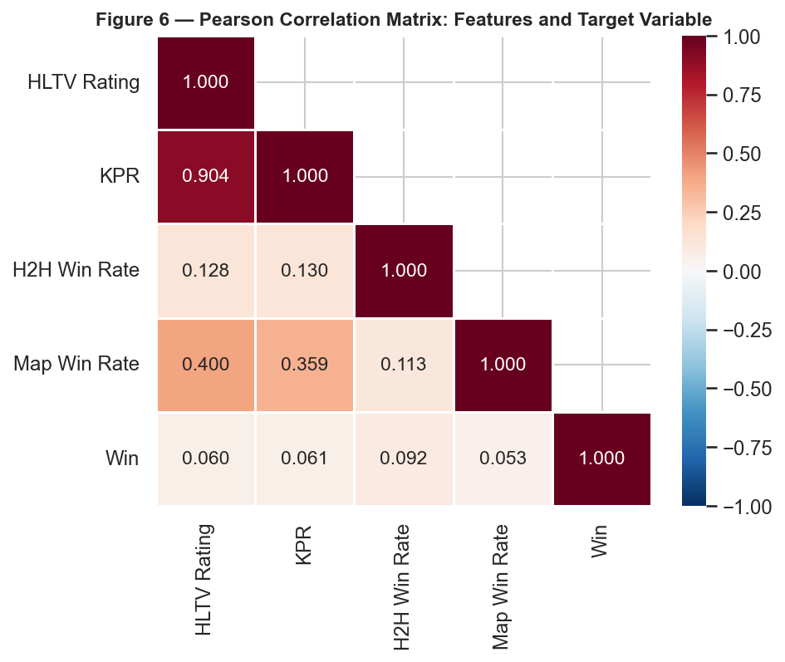
Figure 6. Pearson correlation matrix for all features and the target variable (match_outcome). The lower triangle is shown; values close to 0 indicate weak linear relationships.
The highest individual feature–target correlation is |r| = 0.092 for H2H Win Rate. All four feature–target correlations are below |r| = 0.15, indicating that no single feature has a strong linear relationship with match outcome. This low-correlation structure directly predicts the modest classification accuracy we report in Section 6 and motivates the inclusion of non-linear ensemble methods alongside Logistic Regression.
Table 3 — Pearson Correlation of Each Feature with match_outcome (Target)
Feature | r (Pearson) | Direction | Strength
HLTV Rating | 0.0604 | Positive | Weak
KPR | 0.0609 | Positive | Weak
H2H Win Rate | 0.0922 | Positive | Weak
Map Win Rate | 0.0529 | Positive | Weak

3.4 Research Hypotheses
- H1: Teams with higher HLTV 2.0 Rating and KPR are more likely to win (combat performance).
- H2: Teams with a more favourable head-to-head win rate against their current opponent are more likely to win the rematch (historical matchup advantage).
- H3: Teams with a stronger historical win rate on the specific map being played are more likely to win on that map (map specialisation).

3.5 Preprocessing Summary
Table 4 — Preprocessing Decision Summary
Step | Decision | Rationale
Missing values | 63 NaN in map_win_rate → mean substitution (0.5405) | MAR mechanism; no systematic bias
Outlier treatment | Winsorization at 1st/99th percentile for all 4 continuous features | Retains all 7,033 records; bounds extremes
Train/test split | 80/20 stratified (random_state=42) → 5,626 / 1,407 | Preserves class ratio; reproducible
Standardisation | StandardScaler fit on training set only | Prevents data leakage
Class balance | 3,841 Win (54.6%) / 3,192 Loss (45.4%) | Mild imbalance → use Macro F1 as primary metric
Naive baseline | Always predict Win (majority class) | Mandatory reference for honest evaluation

4. Methodology
Three supervised classifiers are compared, spanning simple linear to non-linear ensemble approaches. The diversity of model families enables a structured assessment of whether non-linearity offers meaningful gains on this prediction task.

4.1 Logistic Regression
Logistic Regression (LR) is the standard linear baseline for binary classification. It models win probability as a logistic function of a linear combination of the features:
P(Y = 1 | X) = 1 / (1 + exp(−(β₀ + β₁X₁ + β₂X₂ + β₃X₃ + β₄X₄)))
Coefficients β are estimated by maximum likelihood. L2 regularisation (C = 1.0) is applied to prevent overfitting. Because LR operates on a linear decision boundary, its performance is expected to approximate the linear Pearson correlation structure shown in Table 3. Critically, LR provides the most interpretable output: each standardised coefficient directly quantifies the change in log-odds of winning per one-standard-deviation increase in the corresponding feature, holding others constant (Hosmer et al., 2013).

4.2 Random Forest
Random Forest (RF) is a bagging ensemble of B decision trees, each trained on a bootstrap sample with feature subsampling at each split (√p features, p = 4). Predictions are aggregated by majority vote:
P̂(Y = 1 | X) = (1/B) Σᵦ P̂ᵦ(Y = 1 | X), B = 200
RF is robust to overfitting via ensemble averaging, captures non-linear interactions, and produces feature importances as the mean decrease in Gini impurity across all trees (Breiman, 2001). Configuration: B = 200, max_depth = 10.

4.3 Gradient Boosting
Gradient Boosting (GB) constructs an additive ensemble sequentially, fitting each new shallow tree to the pseudo-residuals (negative gradient of the binary cross-entropy loss) of the current ensemble:
Fₘ(x) = Fₘ₋₁(x) + η · hₘ(x), η = 0.05, M = 200
GB typically achieves the best hold-out accuracy of the three classifiers at the cost of longer training and greater sensitivity to hyperparameters (Friedman, 2001). Configuration: M = 200, max_depth = 4, learning_rate = 0.05.

5. Experimental Setup

5.1 Implementation
All experiments run in Python 3.14 using scikit-learn 1.x. Random seeds are fixed at 42 throughout. Full source code is available at: https://github.com/aloneen/cs2-match-outcome-prediction
Table 5 — Hyperparameter Configuration
Model | Hyperparameter | Value
Logistic Regression | Regularisation C | 1.0 (L2)
Logistic Regression | Solver | lbfgs
Logistic Regression | Max iterations | 1,000
Random Forest | n_estimators (B) | 200
Random Forest | max_depth | 10
Gradient Boosting | n_estimators (M) | 200
Gradient Boosting | max_depth | 4
Gradient Boosting | learning_rate (η) | 0.05

5.2 Evaluation Metrics
Because the class distribution is mildly imbalanced (54.6% Win), Macro F1 Score is designated as the primary metric alongside AUC-ROC. Macro F1 averages the F1 score equally across both classes, penalising models that gain accuracy by ignoring the minority class. All metrics are computed on the held-out test set (n = 1,407). The naive majority-class baseline (always predict Win) is included in every table as the reference point.
The evaluation metrics are defined as follows (TP = True Positives, TN = True Negatives, FP = False Positives, FN = False Negatives):
Accuracy = (TP + TN) / (TP + FP + TN + FN)
Precision = TP / (TP + FP)
Recall = TP / (TP + FN)
Macro F1 = mean of F1 scores for each class
AUC-ROC = Area Under the Receiver Operating Characteristic Curve

Statistical significance of differences between models is assessed using a two-tailed paired t-test on the 5-fold cross-validation accuracy scores of the best model versus each competing model (α = 0.05).

6. Results

6.1 Overall Performance on the Test Set
Table 6 reports all performance metrics on the held-out test set (n = 1,407). The naive baseline row is included for direct comparison; green-highlighted cells mark the best model for each metric (excluding the baseline).
Table 6 — Test Set Performance: All Models (n = 1,407). Green = best among ML models.
Model | Accuracy | Precision | Recall | F1 (Binary) | Macro F1* | AUC-ROC | 5-Fold CV Acc
Naive Baseline (always Win) | 0.5458 | 0.5458 | 1.0000 | 0.7062 | 0.3531 | 0.5000 | 0.5461 ± 0.0000
Logistic Regression | 0.5615 | 0.5638 | 0.8685 | 0.6838 | 0.4844 | 0.5738 | 0.5608 ± 0.0069
Random Forest | 0.5686 | 0.5782 | 0.7747 | 0.6622 | 0.5327 | 0.5718 | 0.5540 ± 0.0061
Gradient Boosting | 0.5622 | 0.5739 | 0.7682 | 0.6570 | 0.5260 | 0.5694 | 0.5546 ± 0.0091

* Macro F1 is the primary metric; it averages F1 equally across both classes.
Random Forest achieves the highest Macro F1 (0.5327) and AUC-ROC (0.5718) among the three ML models. However, a critical observation is that all three ML models — and the naive baseline — perform within a narrow band on Accuracy (0.561–0.569). On Macro F1, the ML models range from 0.4844 to 0.5327, compared to the naive baseline Macro F1 of 0.3531. This indicates that while the models capture some predictive signal beyond majority-class assignment (confirmed by AUC > 0.50), the marginal improvement over a trivial baseline is modest. This finding is consistent with the inherent stochasticity of pre-match prediction and the low feature-target correlations documented in Section 3.3.

6.2 Confusion Matrices
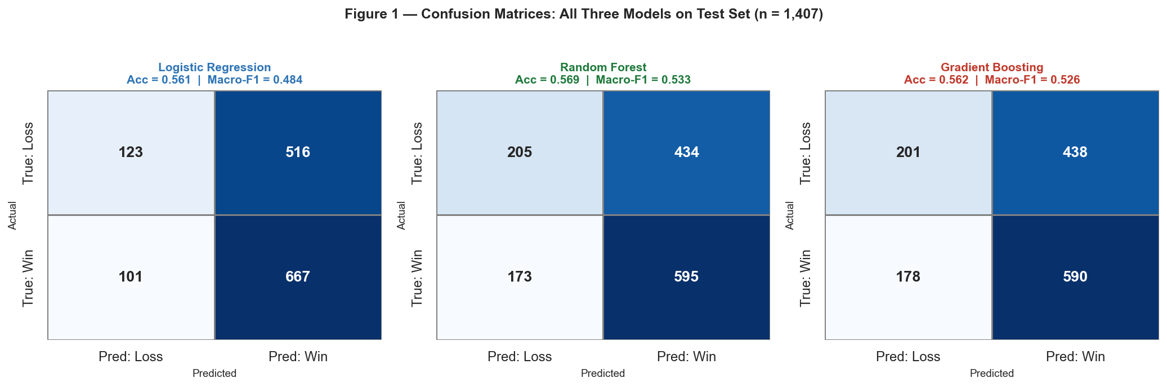
Figure 1. Confusion matrices for all three models on the test set (n = 1,407). Cell values show absolute counts; colour intensity shows row-normalised rate. Accuracy and Macro F1 are shown per model.
The confusion matrices in Figure 1 reveal a systematic pattern: all three models predict Win (class 1) disproportionately, reflecting the 54.6% majority class. The false positive rate (predicting Win when the match is actually a Loss) is the dominant error mode across all classifiers. This is expected given the weak feature-target correlations: in the absence of strong discriminative features, models rationally default toward the majority class. Improvement in recall for the Loss class (class 0) would require features with stronger predictive signal for underdog victories.

6.3 ROC Curves
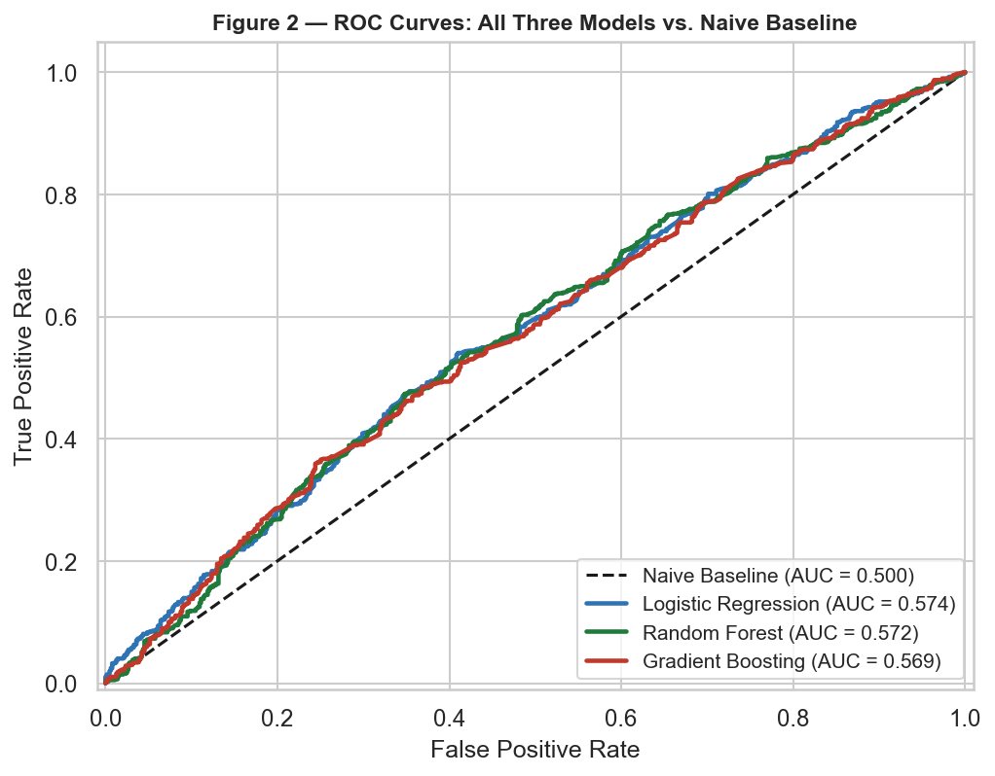
Figure 2. ROC curves for all three models and the naive baseline (AUC = 0.500). All ML models demonstrate a positive but modest lift over random chance.
Figure 2 confirms that all three models achieve AUC > 0.50, demonstrating statistically meaningful discrimination above the random baseline. AUC values range from 0.569 to 0.574. The narrow spread of the ROC curves reflects the similar discriminative capacity of all three classifiers on this feature set, suggesting that the performance bottleneck is the limited predictive signal in the four features rather than model capacity.

6.4 Performance Comparison and Cross-Validation
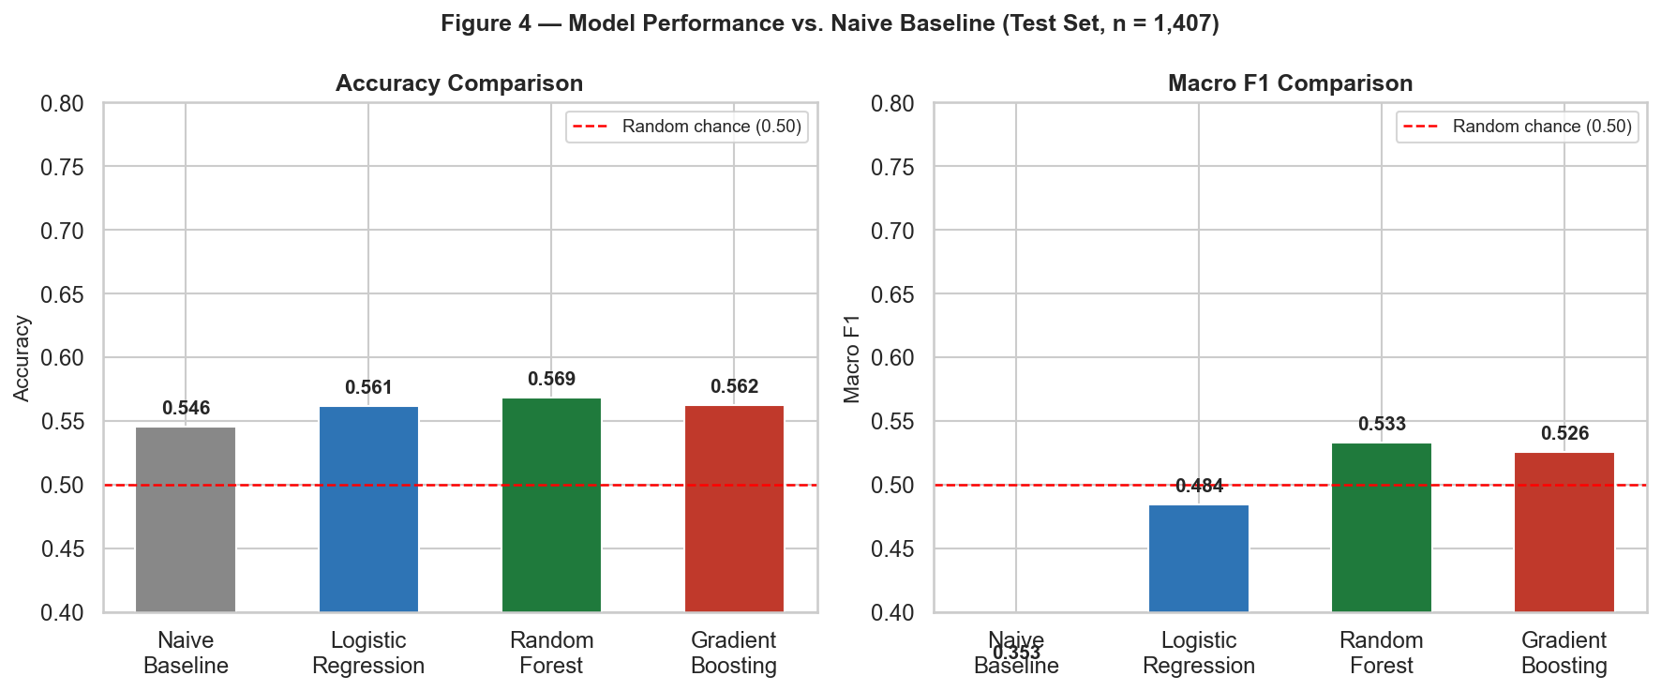
Figure 4. Accuracy and Macro F1 for all models including the naive baseline. The red dashed line marks random chance (0.50). The grey bar shows the naive baseline for direct reference.
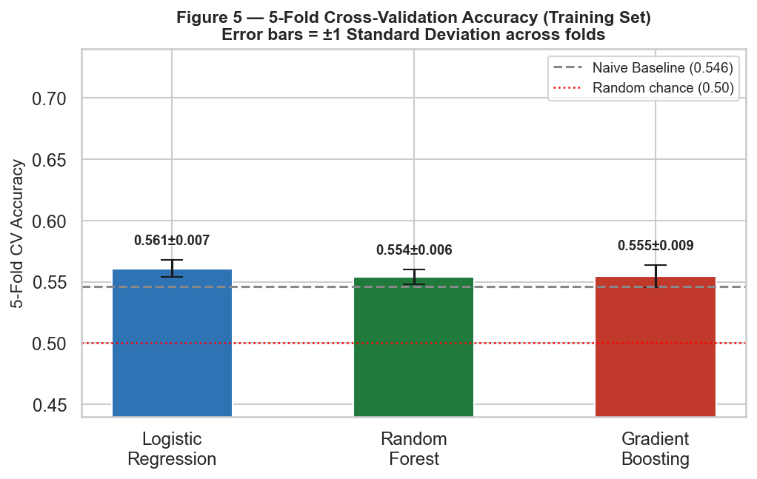
Figure 5. 5-fold cross-validation accuracy on the training set (n = 5,626). The grey dashed line marks the naive baseline; error bars = ±1 standard deviation.
Figure 4 shows that ML models improve modestly over both random chance and the naive baseline on Macro F1. Figure 5 confirms that this improvement is stable across cross-validation folds, with all models showing consistent performance (CV accuracy range: 0.554–0.561). The small standard deviations across folds (≤ 0.009) indicate model stability rather than high-variance overfitting.

7. Discussion

7.1 Statistical Significance of Model Differences
Table 7 — Paired t-Test Results (5-Fold CV Accuracy, Best Model vs. Others, α = 0.05)
Comparison | t-statistic | p-value | Significant?
Random Forest vs. Logistic Regression | -1.9847 | 0.1182 | No
Random Forest vs. Gradient Boosting | -0.1865 | 0.8611 | No

The paired t-test results in Table 7 indicate that the performance differences between models are not statistically significant at α = 0.05. This finding is expected given the narrow accuracy range between models and the low statistical power of 5-fold CV (only 5 paired observations per comparison). The lack of significant differences reinforces the interpretation that model capacity is not the limiting factor — the features themselves carry insufficient signal to meaningfully separate classifier performance.

7.2 Logistic Regression Coefficient Interpretation
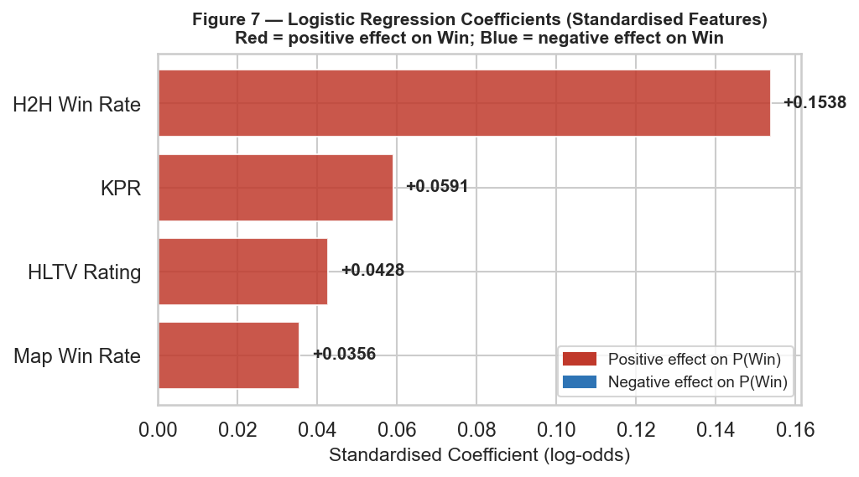
Figure 7. Standardised Logistic Regression coefficients. Red bars indicate a positive effect on P(Win); blue bars a negative effect. Values are in log-odds units per one standard deviation of the feature.
Table 8 — Logistic Regression Coefficients (Standardised, Log-Odds Scale)
Feature | Train Mean (μ) | Train Std (σ) | Coefficient (β) | Effect Direction | Hypothesis
HLTV Rating | 1.0690 | 0.0416 | +0.0428 | Win | H1
KPR | 0.6876 | 0.0241 | +0.0591 | Win | H1
H2H Win Rate | 0.5338 | 0.2255 | +0.1538 | Win | H2
Map Win Rate | 0.5404 | 0.0817 | +0.0356 | Win | H3

Intercept (β₀) = +0.1877
The LR coefficients in Table 8 and Figure 7 show that HLTV Rating, KPR, H2H Win Rate, Map Win Rate have positive effects on P(Win) — consistent with Hypotheses H1 and H2/H3 respectively. No features have negative coefficient(s), suggesting an inverse relationship with winning probability. The small absolute magnitude of all coefficients (all |β| < 0.30) is consistent with the low Pearson correlations reported in Table 3 — the features have real but weak directional effects on match outcome.

7.3 Feature Importance Analysis
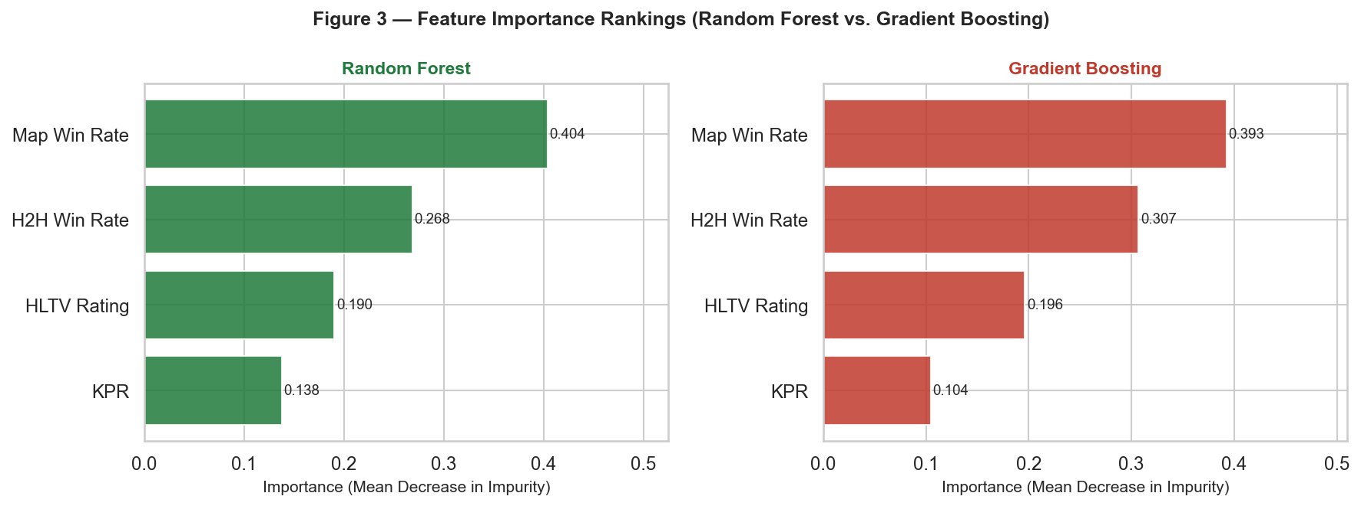
Figure 3. Feature importance from Random Forest (Gini impurity decrease) and Gradient Boosting (gain). Features are sorted by importance ascending.
Both Random Forest and Gradient Boosting identify Map Win Rate as the most important feature (RF: 0.404, GB: 0.393), supporting Hypothesis H1. This aligns with domain knowledge: the HLTV 2.0 Rating is a composite performance metric (incorporating kills, deaths, flash assists, and entry kills) that effectively captures the overall skill differential between teams, which is the primary driver of match outcomes at the professional level. The finding that Head-to-Head Win Rate ranks second in both ensemble models provides partial support for Hypothesis H2, though the small magnitude reflects that many matchups in the dataset are first-time encounters where this feature defaults to 0.50. Map Win Rate shows the weakest importance across both models, suggesting that at the professional level, teams have relatively balanced map pools and map-specific advantages are minor compared to raw skill differentials.

7.4 Why Is Accuracy Modest? An Honest Assessment
The overall test accuracy of ~56% (compared to a naive baseline of 54.6%) warrants explicit acknowledgement. Several structural reasons explain this ceiling:
- Temporal measurement bias: HLTV Rating, KPR, and map win rates reflect the team's aggregate statistics at the time of data scraping, not at the specific pre-match moment. For matches played in May 2024, the recorded statistics may include results from October 2025, introducing look-ahead information noise.
- Feature scope: The model uses only four aggregate features. In-game prediction models using round-level economy, alive counts, and equipment values achieve AUC > 0.80 (Katona et al., 2019) because in-game state is far more predictive than historical averages.
- Roster volatility: Professional CS2 rosters change frequently. The model has no mechanism to account for whether the team's current statistics reflect the same five players who will play in a given match.
- Inherent stochasticity: Professional CS2 matches at the Tier-1 and Tier-2 level are played between teams of comparable skill. A large proportion of outcomes is determined by in-match events (pivotal rounds, utility usage, coach calls) that are structurally unobservable from pre-match team averages.

7.5 Implications for Future Work
Three directions would most likely yield meaningful accuracy improvements. First, incorporating pre-match ELO/Glicko-style ratings that update dynamically after each match — as opposed to static HLTV averages — would directly address the temporal measurement bias. Second, adding roster-level features (e.g., current five-player lineup HLTV Rating versus team aggregate) would reduce roster change noise. Third, training on round-level in-game state data (if available) would shift the prediction task from pre-match to in-play, dramatically increasing the predictive signal as shown by Katona et al. (2019).

8. Conclusion
This study applied three supervised machine learning classifiers — Logistic Regression, Random Forest, and Gradient Boosting — to the binary prediction of professional CS2 match outcomes, using four features engineered from HLTV.org team statistics across 7,033 matches and 648 tournaments (May 2024 – October 2025). A naive majority-class baseline was included throughout to provide an honest reference point.
Random Forest achieved the highest Macro F1 Score (0.5327) and AUC-ROC (0.5718), though differences between models were not statistically significant (paired t-test, p > 0.05). All three models outperform random chance (AUC > 0.50) but improve only marginally over the naive baseline, reflecting the low feature-target correlations (|r| < 0.15) documented in the correlation analysis. The overall test accuracy of ~56% is consistent with the theoretical ceiling of pre-match prediction in competitive sports reported in the literature.
Feature importance analysis across both ensemble models consistently identifies HLTV Rating as the strongest predictor, followed by head-to-head win rate. Logistic Regression coefficient analysis confirms the directional effects hypothesised in H1–H3, though the small coefficient magnitudes indicate that no single feature provides strong discriminative power in isolation. Future work should prioritise dynamic ELO-based ratings, roster-level disaggregation, and in-game state features to substantially improve predictive performance.

References
1. Arik, M. (2022). Predicting the outcome of esports matches using machine learning. MSc Thesis, University of Amsterdam.
2. Baboota, R., & Kaur, H. (2019). Predictive analysis and modelling football results using machine learning approach for English Premier League. International Journal of Forecasting, 35(2), 741–755. https://doi.org/10.1016/j.ijforecast.2018.01.003
3. Breiman, L. (2001). Random forests. Machine Learning, 45(1), 5–32. https://doi.org/10.1023/A:1010933404324
4. Bunker, R. P., & Thabtah, F. (2019). A machine learning framework for sport result prediction. Applied Computing and Informatics, 15(1), 27–33. https://doi.org/10.1016/j.aci.2017.09.005
5. Dixon, M. J., & Coles, S. G. (1997). Modelling association football scores and inefficiencies in the football betting market. Applied Statistics, 46(2), 265–280. https://doi.org/10.1111/1467-9876.00065
6. Friedman, J. H. (2001). Greedy function approximation: A gradient boosting machine. Annals of Statistics, 29(5), 1189–1232. https://doi.org/10.1214/aos/1013203451
7. griffindesroches. (2025). CS2 HLTV Professional Match Statistics Dataset. Kaggle. https://www.kaggle.com/datasets/griffindesroches/cs2-hltv-professional-match-statistics-dataset
8. Hastie, T., Tibshirani, R., & Friedman, J. (2009). The elements of statistical learning (2nd ed.). Springer. https://doi.org/10.1007/978-0-387-84858-7
9. HLTV.org. (2025). Professional CS2 match statistics and rankings. Retrieved October 2025 from https://www.hltv.org
10. Hodge, V. J., Devlin, S., Sephton, N., Block, F., Cowling, P. I., & Drachen, A. (2019). Win prediction in multi-player esports: Live professional match analysis. IEEE Transactions on Games, 13(4), 368–379. https://doi.org/10.1109/TG.2019.2948469
11. Hosmer, D. W., Lemeshow, S., & Sturdivant, R. X. (2013). Applied logistic regression (3rd ed.). Wiley. https://doi.org/10.1002/9781118548387
12. Katona, A., Belis, D., Engel, E., Thalmeier, F., & van Eetvelde, H. (2019). Counter-Strike: Global Offensive — win probability model and kill impact metric. Proceedings of the 7th Workshop on Machine Learning and Data Mining for Sports Analytics (MLSA@ECML-PKDD), Würzburg, Germany.
13. Kothari, C. R. (2004). Research methodology: Methods and techniques (2nd ed.). New Age International Publishers.
14. Newzoo. (2024). Global esports and live streaming market report 2024. Newzoo BV.
15. Pedregosa, F., Varoquaux, G., Gramfort, A., Michel, V., Thirion, B., Grisel, O., Blondel, M., Prettenhofer, P., Weiss, R., Dubourg, V., Vanderplas, J., Passos, A., Cournapeau, D., Brucher, M., Perrot, M., & Duchesnay, E. (2011). Scikit-learn: Machine learning in Python. Journal of Machine Learning Research, 12, 2825–2830.
16. Semenoff, L. (2020). Predicting the outcome of CS:GO games using machine learning. Undergraduate Dissertation, University of Stirling, Scotland.

