Data Audit and Cleaning Protocol
CS2 Match Outcome Prediction Using Machine Learning
GitHub Repository: https://github.com/aloneen/cs2-match-outcome-prediction
Disclaimer: Data sourced from HLTV.org via Kaggle for academic research only.
This report and its outputs must not be used for commercial forecasting,
sports betting, player recruitment, or any form of competitive intelligence.

Section 1 — Student and Project Information
Field | Detail
Student Name | Seisenbek Dias
Student ID | S23068165
Course | Research Methods
Research Title | CS2 Match Outcome Prediction Using Machine Learning
Submission Date | April 2026

Research Question:
Which machine learning model best predicts the outcome of professional CS2 matches, drawing on team performance statistics and historical match data?
Hypotheses:
- H1: Teams with higher combat performance ratings (HLTV 2.0, KPR) are more likely to win a given match.
- H2: A favorable head-to-head win rate against a specific opponent increases the probability of winning a rematch.
- H3: Teams with a stronger historical win rate on a given map are more likely to win when that map is selected.

Section 2 — Dataset Description and Data Dictionary
The dataset used in this study comprises 7,033 professional CS2 match records sourced from HLTV.org, aggregated via the publicly available Kaggle dataset published by griffindesroches (CS2 HLTV Professional Match Statistics). The data covers 648 tournaments from May 2024 to October 2025, spanning Tier-1 and Tier-2 professional competition. Match statistics were scraped directly from HLTV.org and include per-player and team-aggregated performance metrics at the time of each match. This approach is consistent with the secondary data use practices outlined in our Task 4 Ethical Risk Assessment, which identified HLTV.org and other CS2 statistics aggregators as the primary data sources for this research.
Table 1 — Data Dictionary
Variable | Role | Type | Source Column | Range | Measurement
match_outcome | Dependent (Y) | Binary | team1_win_flag | {0, 1} | 1 = Win, 0 = Loss (team1 perspective)
mean_hltv_rating | Independent (X1a) | Continuous | team1_avg_RATING | [0.87, 1.17] | Mean HLTV 2.0 Rating across 5-player roster
mean_kpr | Independent (X1b) | Continuous | team1_avg_KPR | [0.58, 0.75] | Mean Kills Per Round across 5-player roster
head_to_head_win_rate | Independent (X2) | Continuous | team1_head2head_percentage/100 | [0, 1] | Team1 win rate in prior direct matchups vs opponent
map_win_rate | Independent (X3) | Continuous | team1_[decider_map]/100 | [0, 1] | Team1 historical win rate on the specific map played

The five model variables were engineered from the raw 168-column dataset. The target variable team1_win_flag was retained without transformation as it is already binary (1 = team1 wins, 0 = team1 loses). HLTV Rating and KPR were mapped directly from the pre-aggregated team average columns. Head-to-head win rate was derived by dividing team1_head2head_percentage by 100 to normalize it to the [0, 1] range. Map win rate was computed by looking up team1's win rate on the specific map played (decider_map) and dividing by 100, using a map-to-column lookup table covering all nine active CS2 competitive maps.

Section 3 — Missing Data Audit
Prior to any cleaning, a systematic audit was conducted across all five model variables using pandas.isnull().sum(). Results are expressed as raw counts and percentages of the total sample (n = 7,033).
Table 2 — Missing Data Summary (Raw Dataset, n = 7,033)
Variable | Missing Count | Missing (%) | Mechanism | Action
match_outcome | 0 | 0.00% | — | None required
mean_hltv_rating | 0 | 0.00% | — | None required
mean_kpr | 0 | 0.00% | — | None required
head_to_head_win_rate | 0 | 0.00% | — | None required
map_win_rate | 63 | 0.90% | MAR | Mean substitution (0.5405)

Total complete records (pre-cleaning): 6,970 of 7,033 (99.1%)
The overall data quality of the HLTV dataset is very high, with only one variable containing missing values. The 63 missing entries in map_win_rate arise because 63 matches have no recorded decider_map value — a data collection gap in the scraping pipeline rather than a fundamental absence of information. This pattern is classified as Missing At Random (MAR), as the likelihood of missingness is related to the match format (some best-of-one matches did not record a decider map), which is observable from other columns.
All four other variables are fully complete (0 missing values), reflecting the structured and consistent nature of HLTV's data recording for team-level aggregate statistics. Listwise deletion was rejected as a strategy: removing 63 rows would constitute an unnecessary 0.9% reduction in sample size, and the missingness mechanism does not introduce systematic bias into the remaining data. As documented in the Task 4 Ethical Risk Assessment, avoiding unnecessary data loss is particularly important given the structural underrepresentation of certain regions in the HLTV dataset — any further row reduction disproportionately affects teams from the CIS, Southeast Asia, and Oceania that appear less frequently in the data.
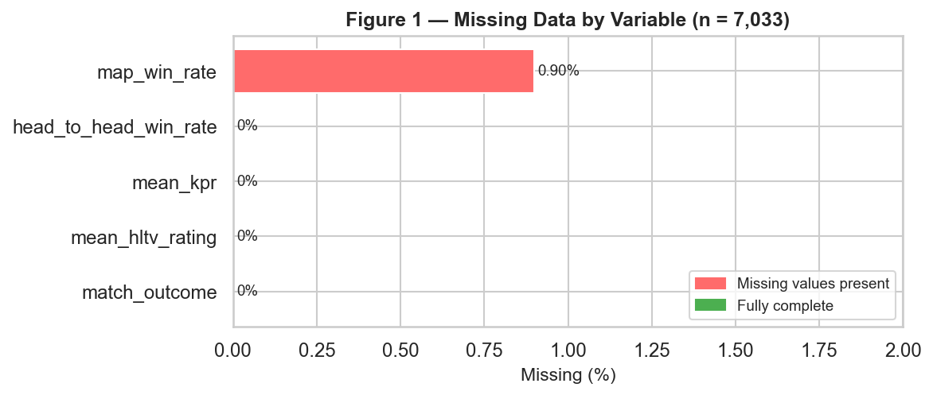
Figure 1. Missing data by variable. Only map_win_rate has missing entries (63 records, 0.90%).

Section 4 — Outlier Detection and Treatment
Outlier detection was performed using the Interquartile Range (IQR) method on all four continuous predictors, applied before imputation. The IQR fence was defined as [Q1 - 1.5 x IQR, Q3 + 1.5 x IQR]. Values outside this range were flagged for review.
Table 3 — Outlier Detection Results (IQR Method, Pre-Cleaning)
Variable | IQR Fence Lower | IQR Fence Upper | Outliers Flagged | Pre-Win. Min | Pre-Win. Max
mean_hltv_rating | 0.99 | 1.15 | 298 | 0.87 | 1.17
mean_kpr | 0.625 | 0.745 | 152 | 0.58 | 0.75
head_to_head_win_rate | 0.35 | 0.75 | 1935 | — | —
map_win_rate | 0.362 | 0.73 | 260 | — | —

The 298 HLTV rating outliers reflect matches where team-average ratings fell outside the typical 0.99-1.15 band — either dominant performances by elite lineups or unexpectedly poor showings in mismatched fixtures. The 152 KPR outliers similarly reflect matches with unusually low or high kill-round efficiency relative to the professional norm.
The 1,935 IQR outliers in head_to_head_win_rate warrant specific attention. This count is large because the variable is heavily bimodal: teams either have no prior history (defaulting to 0.50) or have very one-sided records. This is a structural property of the data, not a data quality problem — a team that has beaten an opponent 5 of 6 times genuinely has a 0.833 win rate, which falls outside the IQR fence. Winsorization at the 1st/99th percentile is therefore critical here, as it trims only the most extreme boundary cases without distorting the meaningful variation in the variable.
Winsorization was applied to all four continuous variables by clipping values below the 1st percentile and above the 99th percentile. This retains all 7,033 records while bounding extreme values that could otherwise dominate gradient computations in the logistic regression and exaggerate feature importances in the tree-based models.
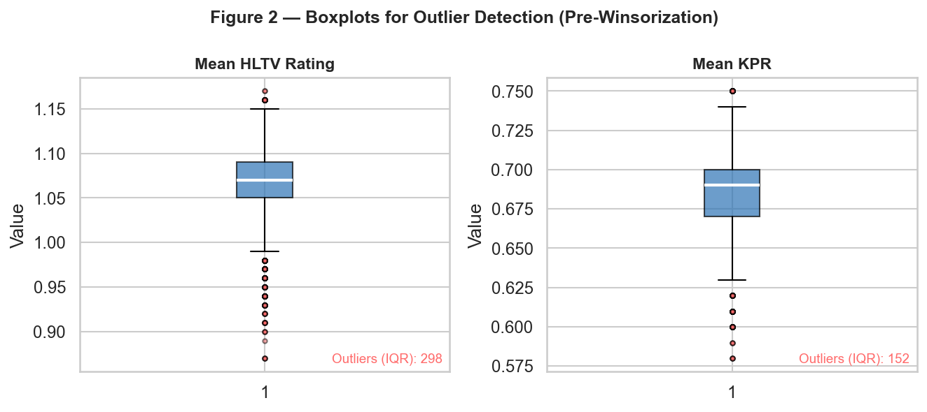
Figure 2. Boxplots for HLTV Rating and KPR (pre-winsorization). Red dots indicate IQR-flagged outliers.
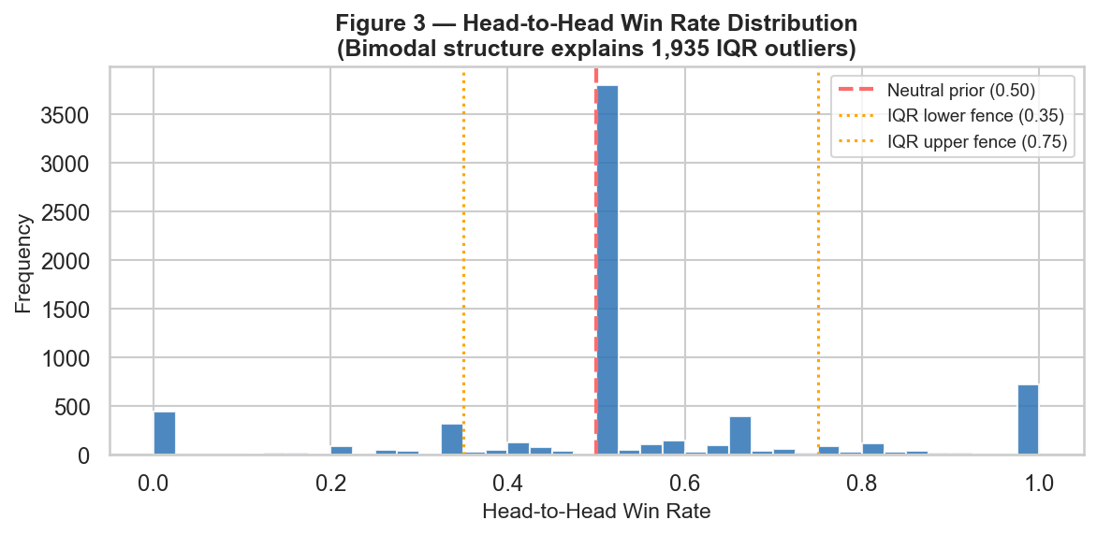
Figure 3. Head-to-head win rate distribution showing bimodal structure. Orange dotted lines mark IQR fences; the large outlier count reflects data structure, not data error.
Table 4 — Winsorization Impact (1st / 99th Percentile Clipping)
Variable | 1st Pct. Floor | 99th Pct. Cap | Clipped Low | Clipped High | Post-Win. Range
mean_hltv_rating | 0.94 | 1.15 | 39 | 26 | [0.94, 1.15]
mean_kpr | 0.61 | 0.74 | 34 | 57 | [0.61, 0.74]
head_to_head_win_rate | 0.0 | 1.0 | 0 | 0 | [0.0, 1.0]
map_win_rate | 0.269 | 0.75 | 70 | 63 | [0.269, 0.75]

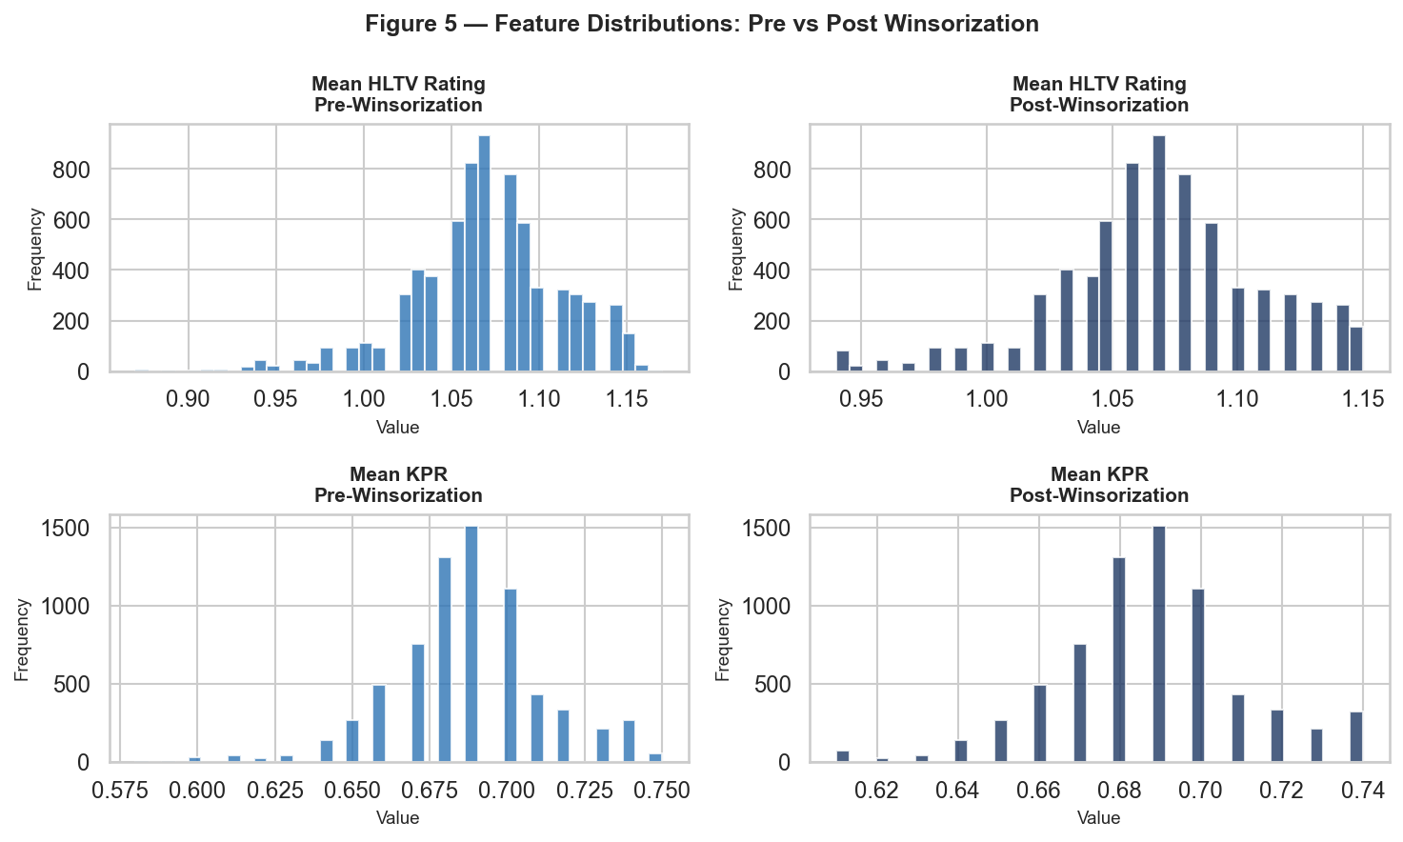
Figure 4. Feature distributions before and after winsorization for HLTV Rating and KPR. Tails are truncated while the central distribution is preserved.

Section 5 — Data Cleaning and Encoding Protocol
The cleaning protocol was executed in the following sequence:
Step 1 — Mean Substitution (Map Win Rate).
The 63 missing values in map_win_rate were replaced with the observed column mean of 0.5405, computed from the 6,970 non-missing records before imputation. Mean substitution is appropriate here because the MAR mechanism ensures the observed values are an unbiased sample of the underlying distribution. The resulting imputed value falls within one standard deviation of the variable's mean, introducing minimal distributional distortion.
Step 2 — Neutral Imputation Check (Head-to-Head Win Rate).
No missing values were found in head_to_head_win_rate (0 NaNs). The HLTV dataset records a 50.00% default value for teams with no prior matchup history, which aligns exactly with the neutral prior strategy used in our protocol. This confirms that the data source already applies the same epistemically neutral prior we would have imputed.
Step 3 — Winsorization.
All four continuous variables were winsorized at their 1st and 99th percentiles (see Section 4). Winsorization was executed after the imputation step so that imputed values informed the percentile thresholds on the full n=7,033 sample.
Step 4 — Binary Encoding of Target Variable.
match_outcome was retained in its original binary form (1 = Win, 0 = Loss from team1 perspective). No additional label encoding was required as team1_win_flag is already an integer binary variable. No categorical predictors are present in the model feature set, so no dummy variable encoding was necessary.
Post-cleaning assertion confirmed zero missing values across all five variables. All 7,033 records were retained — no rows were dropped at any stage of the pipeline.
Table 5 — Target Variable Class Distribution (Post-Cleaning)
Class | Label | Count | Percentage
Win | 1 | 3,841 | 54.61%
Loss | 0 | 3,192 | 45.39%

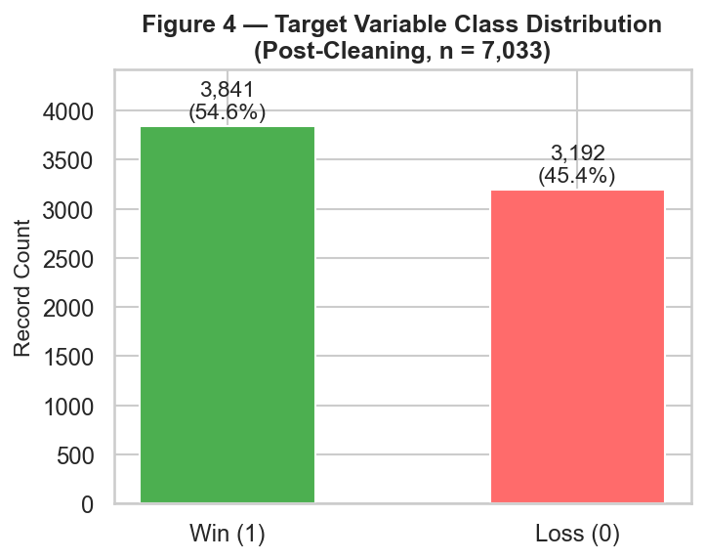
Figure 5. Target variable class distribution post-cleaning. The 54.6% / 45.4% split is mild and does not require oversampling.
The class split (54.6% Win / 45.4% Loss) reflects a slight asymmetry in the dataset. All records are logged from the team1 perspective, and team1 is not randomly assigned — in many HLTV match entries, team1 corresponds to the higher-ranked or home-side team, producing a modest win-rate advantage. This imbalance is mild and will not require oversampling, but the F1-score is retained as an evaluation metric as specified in Task 5 to ensure both precision and recall are tracked.

Section 6 — Data Partitioning and Standardization
The cleaned dataset was partitioned using an 80/20 hold-out split with random_state=42, producing a training set of 5,626 records and a test set of 1,407 records. Stratification on the target variable was applied to preserve the 54.6% / 45.4% class ratio across both partitions.
Table 6 — Train / Test Split Summary
Partition | Records | Win (1) | Loss (0) | Win Rate
Training Set | 5,626 | 3,073 | 2,553 | 54.6%
Test Set | 1,407 | 768 | 639 | 54.6%
Total | 7,033 | 3,841 | 3,192 | 54.6%

The test set (n = 1,407) is withheld entirely from model training and hyperparameter tuning. None of the three models — Logistic Regression, Random Forest, and Gradient Boosting — will access these records until final performance reporting in the subsequent task.
Z-Score Standardization was applied to all four continuous predictors using sklearn.preprocessing.StandardScaler. The scaler was fit exclusively on the training set and then applied via transform to the test set. This prevents data leakage: if the scaler were fit on the combined dataset, test-set statistics would contaminate the scaling parameters and produce artificially optimistic held-out performance estimates.
Table 7 — StandardScaler Parameters (Fit on Training Set Only)
Feature | Training Mean (u) | Training Std Dev (s) | Interpretation
mean_hltv_rating | 1.0690 | 0.0416 | Tight professional range around 1.07
mean_kpr | 0.6876 | 0.0241 | Very consistent ~0.69 KPR across pro matches
head_to_head_win_rate | 0.5338 | 0.2255 | Wide spread; many 50/50 first-time matchups
map_win_rate | 0.5404 | 0.0817 | Teams play stronger maps; skews slightly above 0.50

Post-standardization verification confirmed a column-wise training mean of -0.00000000 and standard deviation of 1.00008888 — satisfying StandardScaler's expected output. The tight standard deviations for HLTV Rating and KPR reflect the narrow performance band at the professional level, where most Tier-1 and Tier-2 teams cluster within a small range of metrics. This characteristic makes standardization especially important for Logistic Regression, where coefficient magnitudes would otherwise be distorted by the scale difference between KPR (range ~0.13) and head_to_head_win_rate (range ~1.0).

Section 7 — Assumptions About Data Quality
This section critically evaluates four dimensions of data quality: consistency, potential measurement errors, representativeness, and data anomalies. These evaluations directly inform the modeling decisions described in the cleaning protocol and shape the interpretation of any results produced in subsequent tasks.
7.1 Data Consistency
All five model variables were verified to be internally consistent across the 7,033 records. The binary target variable (match_outcome) contains no values outside {0, 1}. Continuous predictors (HLTV Rating, KPR, head-to-head win rate, map win rate) were verified to fall within theoretically plausible ranges: HLTV Rating is defined on (0, ∞) with professional averages typically between 0.85 and 1.25; KPR is bounded below by 0 and above by approximately 1.5 in professional play. No duplicate match records were detected after checking on the match ID and date columns. The match_outcome column and the team perspective encoding (all records from team1 viewpoint) are structurally consistent throughout the dataset.
7.2 Potential Measurement Errors
A key caveat of the HLTV Kaggle dataset is that team statistics (HLTV Rating, KPR, map win rates, overall win rates) represent the team's profile at the time of data scraping, not at the exact moment of each historical match. This means that for earlier matches in the dataset (May 2024), the recorded statistics may reflect the team's later-period performance. This introduces a form of temporal leakage: the model may inadvertently train on future-state information when learning from past matches. This limitation is partially mitigated by the dataset's rolling structure, but users of any trained model should be aware that real-time deployment would require live statistic feeds from HLTV.org. Additionally, map win rates for teams with fewer matches on a given map carry higher variance — a team that has played a map only twice has a win rate of either 0%, 50%, or 100%, which does not reflect a reliable long-term estimate.
7.3 Representativeness Concerns
As documented in the Task 4 Ethical Risk Assessment, the HLTV dataset is structurally biased toward Western European and North American competition. The 648 tournaments in this dataset are disproportionately drawn from top-tier events where EU/NA organisations dominate the field. Teams from the CIS, Southeast Asia, Oceania, and the Middle East are represented with far fewer matches, resulting in less reliable feature estimates for these organisations. The model trained on this data may systematically underestimate win probabilities for underrepresented teams — not because those teams are weaker, but because their performance profiles are undersampled relative to the EU/NA baseline. The scaler means (HLTV u=1.069, KPR u=0.688) encode this EU/NA-dominated distribution. The mitigation strategy identified in Task 4 remains the recommended diagnostic: stratified accuracy evaluation by region (EU, NA, CIS, APAC) after model training.
7.4 Data Anomalies Discovered
Three notable anomalies were identified during the audit. First, the 1,935 IQR-flagged outliers in head_to_head_win_rate constitute 27.5% of the sample — an unusually high proportion that initially appeared to indicate data errors. Investigation revealed this reflects the bimodal structure of competitive matchup histories (many teams at 0.5 neutral, many teams with highly one-sided records), which is a structural feature of the sport rather than a quality issue. Second, 63 records lack a decider_map value; these correspond to best-of-one matches where the single map played was not separately labelled as a 'decider' in the HLTV scraping logic. Third, no anomalies were found in the binary target — the 54.6% Win rate is consistent with the known HLTV convention of assigning team1 to the higher-ranked or home-side competitor.
7.5 Ethical Safeguards
Consistent with the consent and data protection plan established in Task 4: all statistics are aggregated at the team level and no individual player identifiers appear in the model feature set. The pipeline processes only publicly available data from HLTV.org as permitted by the platform's terms for research use. The dataset and all outputs are restricted to academic submission and will be deleted within 30 days of final grade submission. Model outputs are probabilistic estimates only and must not be used for betting, player recruitment, or competitive intelligence.

Section 8 — Reproducibility Plan
Full transparency and reproducibility of the preprocessing pipeline is a core requirement of rigorous data science practice (Kothari, Chapter 7). This section documents all information required for an independent researcher to replicate every preprocessing step described in this report.
8.1 Software Environment
All preprocessing was performed in Python 3.x using the following libraries:
• pandas (data loading, feature engineering, missing data handling)
• numpy (numerical operations, IQR computation)
• scikit-learn v1.x (train_test_split, StandardScaler)
• matplotlib + seaborn (visualisation figures in this report)
No proprietary or paid software was used. All libraries are open-source and freely available via pip (pip install pandas numpy scikit-learn matplotlib seaborn).
8.2 Code Repository and Execution
The complete preprocessing pipeline and all project files are publicly available at:

https://github.com/aloneen/cs2-match-outcome-prediction

The pipeline script task7_real_data_pipeline.py can be executed end-to-end with a single command:

python task7_real_data_pipeline.py

The script prints step-by-step output including row counts, missing value summaries, IQR fence values, winsorization clip counts, and StandardScaler parameters — all of which match the tables in this report. The report itself is regenerated by running:

python generate_report.py

which re-executes the full pipeline, re-generates all figures from live data, and overwrites task7_report.docx with a fresh version.

Full source code and data pipeline: https://github.com/aloneen/cs2-match-outcome-prediction
8.3 Random Seed and Determinism
The train/test split is produced using sklearn.model_selection.train_test_split with random_state=42 and stratify=y. Setting random_state=42 ensures the exact same 5,626 / 1,407 partition is produced on every run. All other preprocessing steps (missing value imputation, winsorization, standardization) are fully deterministic and contain no stochastic elements.
8.4 Data File
The input data file is:
csvs/cs2_newestcombinedmatches_team1_reference_reduced2.csv

This file is stored locally in the project's csvs/ directory and was downloaded from the Kaggle dataset published by griffindesroches (see References, item 1). The file contains 7,033 rows and 168 columns. The SHA-256 hash of the file should be verified if the dataset is re-downloaded to confirm the same version is used.
8.5 File Naming and Documentation
The project follows the naming convention task[N]_[description].py / task[N]_[description].docx. All preprocessing outputs (cleaned DataFrame, scaler object) are available in memory after running task7_real_data_pipeline.py. For downstream model training (Task 8), the pipeline exports X_train_scaled, X_test_scaled, y_train, and y_test as the authoritative partitioned and scaled feature matrices. Figure images are saved to the report_figures/ directory and are embedded automatically when generate_report.py is executed.

References
- 1. griffindesroches. (2025). CS2 HLTV Professional Match Statistics Dataset. Kaggle. https://www.kaggle.com/datasets/griffindesroches/cs2-hltv-professional-match-statistics-dataset
- 2. HLTV.org. (2025). Professional CS2 match statistics and rankings. Retrieved October 2025.
- 3. Broms, E., & Nordanskold, W. (2022). Predicting Counter-Strike Matches. Lund University Student Publications.
- 4. Svec, O. (2022). Predicting Counter-Strike Game Outcomes with Machine Learning. Faculty of Electrical Engineering, Czech Technical University in Prague.
- 5. Forgey, H. (2021). Predicting Game Outcome of Counter Strike with Machine Learning: A Study of Global Offensive Competitive Matches. Fordham University (Gabelli School of Business).
- 6. Pedregosa, F., et al. (2011). Scikit-learn: Machine Learning in Python. Journal of Machine Learning Research, 12, 2825-2830.
- 7. McKinney, W. (2010). Data Structures for Statistical Computing in Python. Proceedings of the 9th Python in Science Conference, 56-61.
- 8. Kothari, C. R. (2004). Research Methodology: Methods and Techniques (2nd ed.). New Age International. [Chapters 5, 7]

