**1. Genre analysis in EAP context: rhetorical move annotation**

**1.1 What is an academic genre?**

* Published research articles, doctoral dissertations, conference abstracts…

**1.2 How can we demonstrate the features of an academic genre?**

* **Methodology: Move-step analysis (Swales, 1990; Biber et al., 2007)**
* **Find the moves:** Dissecting and describing the rhetorical structure of a genre through manual annotation of “moves” (distinctive communicative units in a text with specific communicative purposes).
* **Find the steps:** Dissecting and annotating smaller text segments that build up a move and help fulfill the move’s purpose.
* **Example:** research article

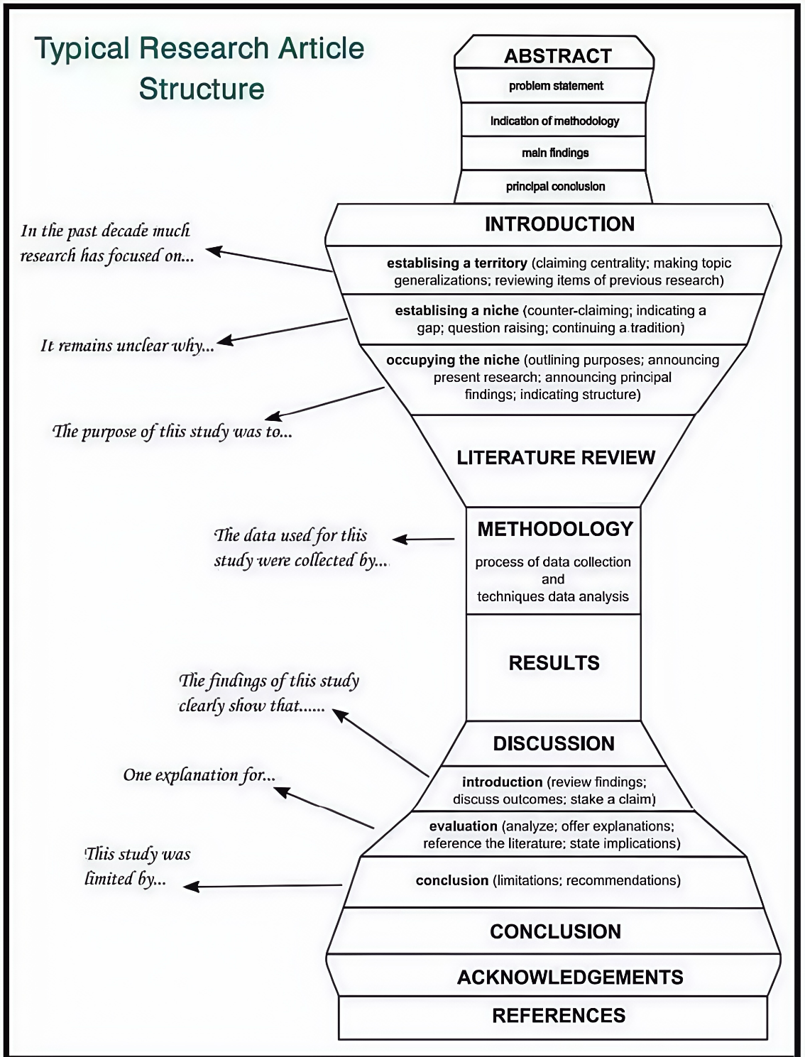

* **Rhetorical moves in academic article abstracts:**
* Hyland, K. (2000). *Disciplinary Discourses: Social Interactions in Academic Writing*. Longman. (P67)

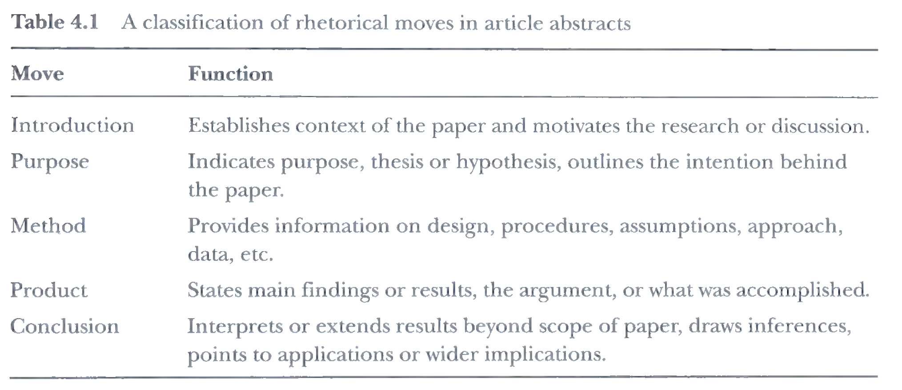

* Dos Santos. M. B. (1996). The textual organization of research paper abstracts in applied linguistics. *Text - Interdisciplinary Journal for the Study of Discourse*, 16(4), 481–500. (P485)

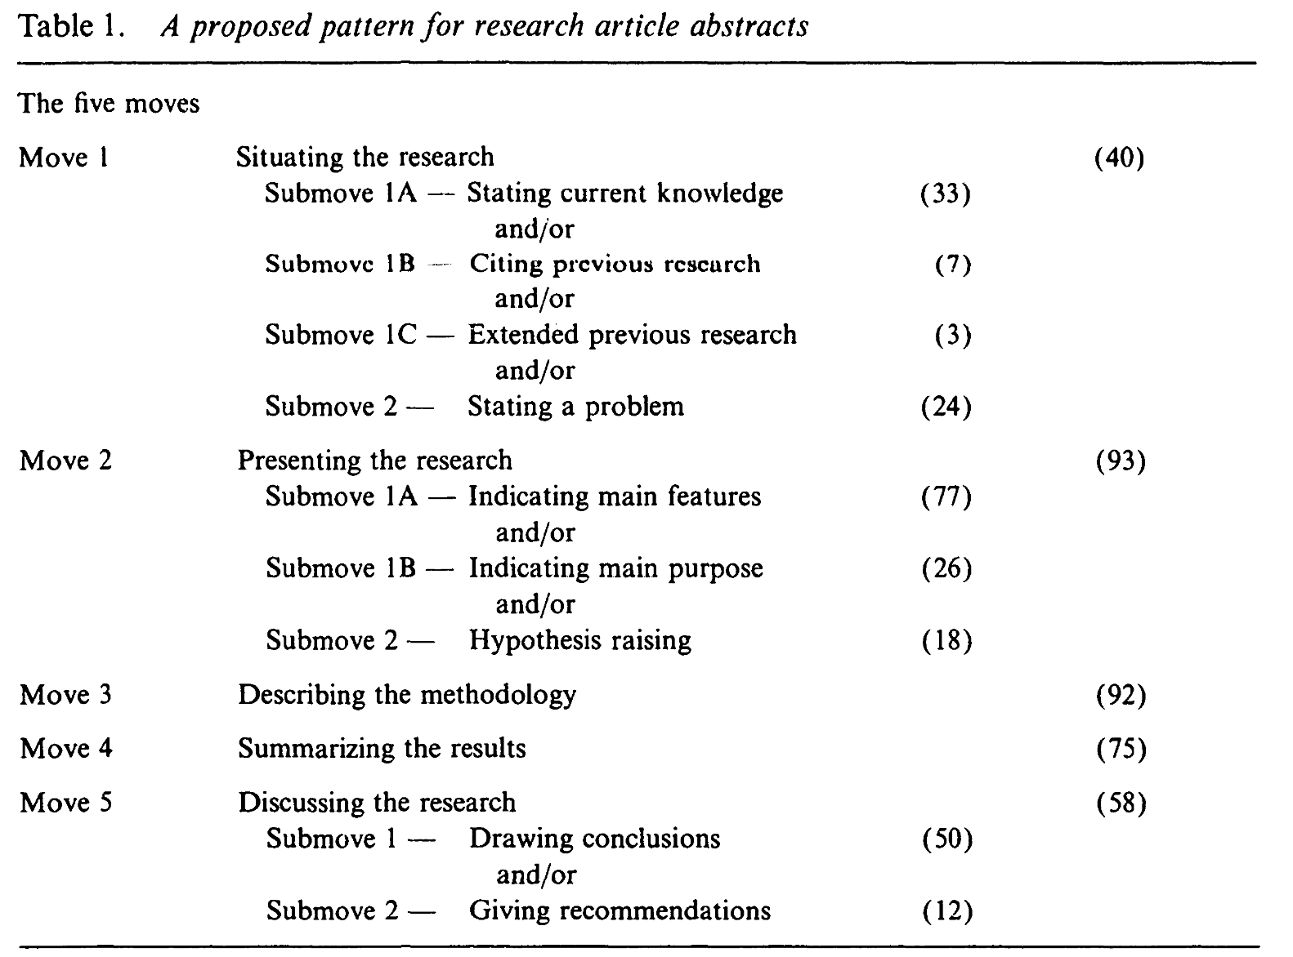

Prompt: You are an expert in genre analysis. The task is dissecting and annotating the texts of research abstracts into moves and steps following the framework of Dos Santos (1996). In this framework, research abstracts are categorized into five moves, [Move 1: situating the research], [Move 2: presenting the research], [Move 3: describing the methodology], [Move 4: summarizing the results] and [Move 5: discussing the research]. For the communicative function of [Move 1: situating the research], there are two steps: Step 1 includes [Step 1A: stating current knowledge], [Step 1B: Citing previous research], [Step 1C: Extended previous research] and Step 2 [Step 2: stating a problem]. For [Move 2: Presenting the research], there are two steps: Step 1 includes [Step 1A: indicating main features] and [Step 1B: indicating main purpose], and Step 2 [Step 2: hypothesis raising]. For [Move 5: discussing the research], there are two steps: [Step 1: drawing conclusions] and [Step 2: giving recommendations]. Please analyze the following texts and provide in-text annotations. Moves and steps should be placed in brackets before text segments. For instance: [Move 1: Situating the research] [Step 1A: Stating current knowledge] The widespread adoption of ChatGPT, an AI language model, has the potential to bring about significant changes to the research, teaching, and learning of foreign languages. [Move 2: Presenting the research] [Step 1B: Indicating main purpose] The present study aims to leverage this technology to perform automated essay scoring (AES) and evaluate its reliability and accuracy…

Text 1:

Rhetorical move-step analysis has wielded considerable influence in the fields of English for Academic/Specific Purposes. To explore the potential of using ChatGPT for automated move-step analysis, this study examines the impact of few-shot learning, prompt refinement, and base model fine-tuning on its accuracy in move-step annotation. Our dataset consisted of the introduction sections of 100 research articles in the field of applied linguistics that have been manually annotated for move-steps based on a modified version of Swales’ (1990) Create-a-Research-Space model, with 80 for training, 10 for validation, and 10 for testing. We formulated an initial prompt that instructed the base model to perform move-step annotation, evaluated it in a zero-shot setting on the validation set, and subsequently refined it with greater specificity. We also fine-tuned the base model on the training set. Evaluation results on the test set showed that few-shot learning and prompt refinement both led to significant albeit relatively small performance improvements, while fine-tuning the base model achieved substantially higher accuracies (92.3% for move and 80.2% for step annotation). Our results highlight the potential of using ChatGPT for discourse-level annotation tasks and have useful implications for EAP pedagogy. They also provide key recommendations for employing ChatGPT in research.

Text 2:

Massive text collections are the backbone of large language models, the main ingredient of the current significant progress in artificial intelligence. However, as these collections are mostly collected using automatic methods, researchers have few insights into what types of texts they consist of. Automatic genre identification is a text classification task that enriches texts with genre labels, such as promotional and legal, providing meaningful insights into the composition of these large text collections. In this paper, we evaluate machine learning approaches for the genre identification task based on their generalizability across different datasets to assess which model is the most suitable for the downstream task of enriching large web corpora with genre information. We train and test multiple fine-tuned BERT-like Transformer-based models and show that merging different genre-annotated datasets yields superior results. Moreover, we explore the zero-shot capabilities of large GPT Transformer models in this task and discuss the advantages and disadvantages of the zero-shot approach. We also publish the best-performing fine-tuned model that enables automatic genre annotation in multiple languages. In addition, to promote further research in this area, we plan to share, upon request, a new benchmark for automatic genre annotation, ensuring the non-exposure of the latest large language models.

* **Rhetorical moves in research article introductions**
* Lu, X., Yoon, J., Kisselev, O., Casal, J. E., Liu, Y., Deng, J., & Nie, R. (2021). Rhetorical and phraseological features of research article introductions: Variation among five social science disciplines. *System, 100*, 102543.

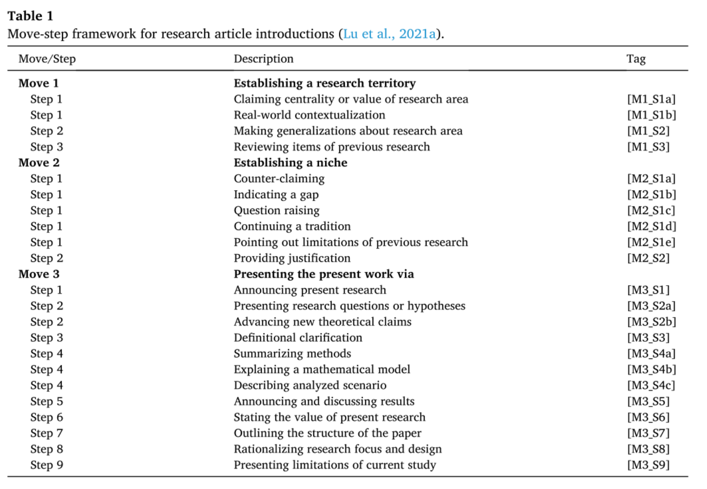

Prompt: You are an expert in genre analysis. The task is dissecting and annotating the texts of research introductions into moves and steps. In this framework, research introductions are categorized into three moves, [Move 1: Establishing a research territory], [Move 2: Establishing a niche], [Move 3: Presenting the present work via]. For the communicative function of [Move 1: Establishing a research territory], there are three steps: Step 1 includes [M1_S1a: Claiming centrality or value of research area], [M1_S1b: Real-world contextualization], Step 2 [M1_S2: Making generalizations about research area] and Step 3 [M1_S3: Reviewing items of previous research]. Move 2 includes two steps: Step 1 consists of [M2_S1a: Counter-claiming], [M2_S1b: Indicating a gap], [M2_S1c: Question raising], [M2_S1d: Continuing a tradition], [M2_S1e: Pointing out limitations of previous research], and Step 2 [M2_S2: Providing justification]. Move 3 includes 9 steps: [M3_S1a: Announcing present research], [M3_S2a: Presenting research questions or hypotheses], [M3_S2b: Advancing new theoretical claims], [M3_S3: Definitional clarification], [M3_S4a: Summarizing methods], [M3_S4b: Explaining a mathematical model], [M3_S4c: Describing analyzed scenario], [M3_S5: Announcing and discussing results], [M3_S6: Stating the value of present research], [M3_S7: Outlining the structure of the paper], [M3_S8: Rationalizing research focus and design] and [M3_S9: Presenting limitations of current study]. Please analyze the following texts and provide in-text annotations. Moves and steps should be placed in brackets before text segments.

Text:

Written corrective feedback (WCF) refers to written information, markings, or codes teachers provide on writing to correct errors at local (i.e., sentence level grammar) or global (i.e., larger content and organization) levels, aiming to improve learners’ writing skills and promote (second) language acquisition (Montgomery & Baker, 2007; Crosthwaite, Ningrum, & Lee, 2022). WCF may be provided through direct or indirect forms, with direct WCF consisting of the provision of correct target forms while indirect WCF involves markings or comments guiding learners to identify and/or locate errors, leaving responsibility for revision to the author (L’opez, 2021). Forms of direct WCF include error correction and/or reformulation, while indirect WCF involves error indication with/without precise location, metalinguistic information, and/or error codes. WCF also varies in scope, i.e., dealing with errors in a focused (selective) or unfocused (comprehensive, or ‘all errors’) manner (Ellis, 2008).

Although L2 writing research has not achieved consensus on WCF’s effectiveness, it is widely regarded as an important pedagogical practice (Bitchener & Storch, 2016). As feedback providers, teachers’ WCF practices positively impact students’ subsequent revision of their work (Leki, 1991), while research has provided recommendations regarding the ideal focus, scope, and forms of WCF for different student groups (Lee, 2008, 2019). However, teachers face difficulties over the time spent on feedback provision, pressure from large automate this laborious pedagogical task (Yan et al., 2023).

Automated writing evaluation (AWE) software provides immediate computerized feedback-including WCF, also known as automated written corrective feedback (AWCF) (Heift & Hegelheimer, 2017; Ranalli, 2018). Various AWCF systems exist for assessment and instructional purposes, e.g., MyAccess (Chen & Cheng, 2008) and Criterion (Dikli & Bleyle, 2014). Using natural language processing (NLP), AWCF tools also offer feedback on lexical and syntactical complexity, grammar, discourse features, and content development, supporting teachers in providing quality feedback in a timely fashion (Li et al., 2015). However, AWCF has been criticized for providing formulaic and/or redundant feedback, leading to confusion (Chen & Cheng, 2008). Moreover, lacking in-depth understanding of a complete text, AWCF primarily attends to surface-level issues without addressing larger erroneous propositional content (Li et al., 2015).

Despite these issues, researchers point out AWE/AWCF and teachers’ WCF can complement each other, with AWE considered excellent for addressing low-level concerns (e.g., grammar, spelling, mechanics, language expression) while allowing teachers to spend more time addressing higher-order skills, e.g., idea and content development (Wilson & Czik, 2016). Empirical evidence suggests AWCF enables teachers to better manage and be more selective in feedback provision, subsequently improving learners’ motivation and promoting long-term writing skill development (Link et al., 2022). Successful incorporation of AWCF technology within teacher practice therefore requires greater understanding of teachers’ and tools’ respective capabilities in feedback provision while improving instructional and pedagogical design for more desirable learning outcomes (Chen & Cheng, 2008).

Recently, significant advancements in generative artificial intelligence and large language models (LLMs) have led to several innovations for automating pedagogical work (Yan et al., 2023). Generative Pre-trained Transformers (GPT) are transformer-based applications comprised of large language models fine-tuned with massive amounts of corpus text data, performing natural language tasks e.g., text generation and question response in a human-like manner with little prior knowledge of coding or NLP required. GPT’s self-attention mechanism within its transformer architecture (Vaswani et al., 2017) enables it to attend to different sections of input texts with better predictions of relationships among the textual nodes, fostering a deeper understanding of semantic, syntactic, and contextual patterns across larger text spans (Min et al., 2021). LLMs like GPT3-4 have already demonstrated impressive capabilities for reflective essay writing (Li et al., 2023), automated essay scoring (Mizumoto & Eguchi, 2023) and writing analysis and feedback (Kasneci et al., 2023).

Although studies have investigated LLMs for automating feedback in general, GPT’s performance and capabilities for AWCF remain unclear. To bridge the integration of this technology into teachers’ practice, this study investigates GPT’s WCF production, identifying differences in GPT-generated WCF and teacher-provided WCF while exploring their respective strengths and potential limitations-including the accuracy and redundancy of the feedback they each produce. In doing so, future integration of AI into teachers’ WCF practice may thus be optimized. We now provide a review of teachers’ WCF practice, differences between AWCF and teacher feedback, and GPT’s feedback performance. This is followed by a description of the methods for addressing the study’s research question.

Text source:

Lin, S., & Crosthwaite, P. (2024). The grass is not always greener: Teacher vs. GPT-assisted written corrective feedback. *System*, 127, 103529.

* **Evaluation: How well does the model perform? Compare with human annotations.**
* **Three metrics:** Recall, Precision and Accuracy

|  |  |  |  |
| --- | --- | --- | --- |
|  | **LLM: Annotated 🤖** | **LLM: Not Annotated 🤖** | **Row Total** |
| Human: Annotated 🧑‍🏫 | **8** (🧑‍🏫🤖) | 4 (🧑‍🏫 only) | 12 |
| Human: Not Annotated 🧑‍🏫 | 2 (🤖 only) | 10 (neither) | 12 |
| **Column Total** | 10 | 14 | 24 |

* **Further analysis:** Comparison between undergraduates and graduates; between human-written and AI-written texts; the analysis of book review/ conclusion…

**2. Subjectivity analysis:**

* **How do writers/speakers encode their opinions and assessments in their language**
* Stance (e.g., Biber and Finegan, 1989)
* Evidentiality (e.g., Chafe, 1986)
* Affect (e.g., Ochs and Schieffelin, 1989)
* Hedging (e.g., Hyland, 1998)
* Evaluation (e.g., Thompson and Hunston, 2000)
* Appraisal (e.g., Martin, 2000)

Personal feeling/attitude/assessment ←→ Comment on the epistemic status of an entity

(happy/ hate/ good) (certainty/doubt)

* Stance markers: Biber (2006: 101-102)

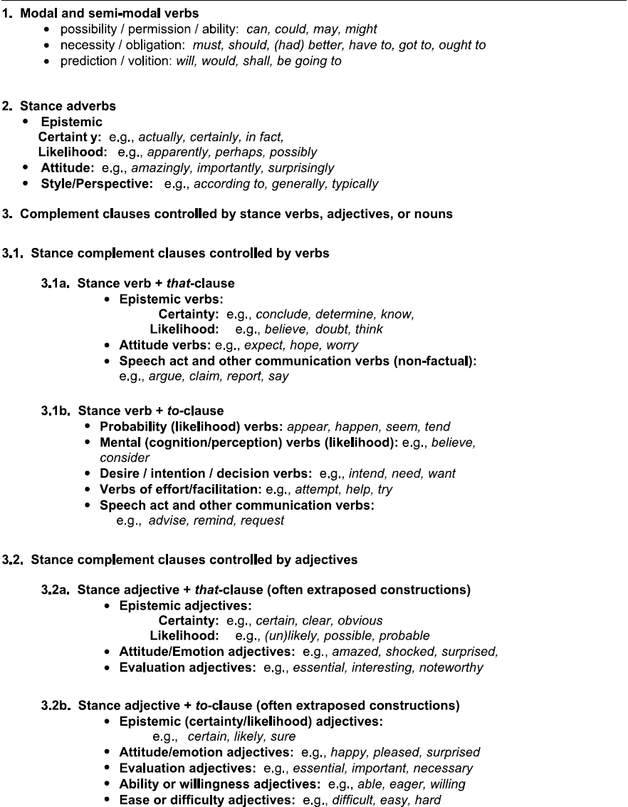

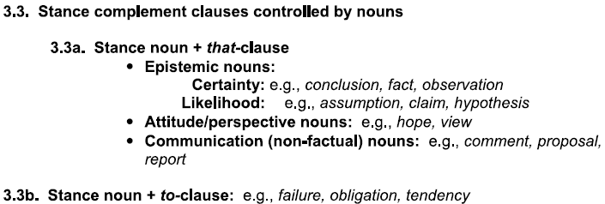

**Prompt:** You are an expert linguist in stance analysis, specializing in identifying the stance markers used by the writers/speakers to encode their personal attitudes, assessments and comments on the epistemic status of an entity of a proposition. Your task is to analyze the texts, identify the stance markers and annotate the stance marker type. There are five types of stance markers: 1) [Modal and semi-modal] to show the speaker’s possibility/ permission/ ability/ necessity/ obligation/ prediction/ volition and so on; 2) [Stance adverb] to show epistemic certainty/ likelihood/ attitude/ perspective and so on; 3) [Verb: Stance complement clause] such as “verb + that clause” and “verb + to clause” to show epistemic certainty/ likelihood/ attitude/ speech act/desire/ intention/ decision/ effort/ facilitation and so on; 4) [Adjective: Stance complement clause] such as “adjective + that clause” and “adjective + to clause” to indicate epistemic certainty/ likelihood/ attitude/ emotion/ evaluation/ ability/ willingness/ ease/ difficulty and so on; 5) [Noun: Stance complement clause] such as “noun + that clause” and “noun + to clause” to show epistemic certainty/ likelihood/ attitude/ perspective/ communication and so on. Once the identification work is finished, provide a table to summarize of the stance marker type and the respective examples with full sentences.

Written Text:

The death penalty a step back .I think only few of Chinese are in favor of it ; while mostly are not.People who support it since they believe guilty people who are sentenced to be shot is such a cruel thing in modern society .However,those who oppose it hold that the death penalty is vital to ease social unrest.Only shooting these who committed ,can prevent others from doing the same sort of things again .Is the death penalty a step back?I am support it,and believe the death penalty will be vanished someday.With the high rising of social progress,China is concerning more about people's rights ,also for the guilty people. Human beings are emotional and sentimental,yet may become shortcomings in daily life.We are likely to do illegal behaviors on an impulse when compelled by others' insult words or behaviors.If one committed or killed someone at this circumstance, should he be sentenced to death ,as the saying goes: eye for an eye and tooth for a tooth? As far as I am concerned, death penalty is not justice to them.Things should be considerate thoroughly and death penalty is not the only way to punish people.Moreover,we are members of the society,and we all have parents ,brothers and sisters in the world.What's your feeling when your family member committed and sentenced to death?Actually, it would be so cruel to the family members,especially their parents who may feel full of losing in their rest of life.Last but not least,it is a fact that there are many countries which have banned death penalty .For example, England in which most people were avoid of banning death penalty at first.It is obvious that people now are caring more about criminals' feelings,as criminals can be executed in a painless way,such as injection,which has been accepted by several countries. On the whole,the death penalty is not an essential way to reduce crimes and ease social unrest.And I believe it would be disappear someday .

Text source: TECCL00024

Spoken Text:

(er) I was in in the States a few years ago in nineteen ninety five . and there I spent (er) three months and a half . it was . the summer vacation . I spent: . (er) my time in (er) Washington D C . and . the most important thing I I did was sightseeing . (er) in fact all the museums that could be seen . (er) the National Museum the History Museum the White House . and that was may= probably the most impressive thing visiting the White House . (er) what I liked most was the Green Room the Red Room . I couldn't see the Oval Office but I saw the Blue Room that's underneath it . it was very very beautiful and . (er) everything the furniture the the[i:] atmosphere it suggested greatness . (er) I liked also Washington Memorial . I took some very good pictures from the top . from all the four directions . and one of them is (er) . with Jefferson Memorial the other one is with Lincoln Memorial . also the Capitol . I couldn't go to . to the Capitol inside . the very the very Capitol . I I went to the Capitol library . and . I read for (er) a few hours some very good books . I also . went to . amusement park . I went to the roller-coaster the famous roller-coaster that was (er) . an incredible experience . (er) I couldn't go exactly to . New York I only . (er) I was traveling by car . so I . we passed through the Alexander bridge . and I saw Manhattan but: it was a distant view . and then I took my plane back to Bulgaria . from the J F K airport . and the flight was . very good it was . ten hours but it . passed like . (er) like a couple of hours . I couldn't feel the time.

Text source: LINDSEI_BG004

Textbook:

You may feel overwhelmed by the wealth of courses available to you. You will not be able to experience them all, but sample them widely! College offers many things to do and to learn, and each of them offers a different way to see the world. If I could give you only one piece of advice about selecting courses, it would be this: Challenge yourself! Don’t assume that you know in advance what fields will interest you the most. Take some courses in fields you have never tried before. You will not only emerge as a more broadly-educated person, but also stand a better chance of discovering an unsuspected passion that will help to shape your future. A wonderful example of this is Leonardo da Vinci, who originally studied painting and sculpture. Over time, Leonardo da Vinci paired his studies in art with his love of science and nature, which made him a famous painter, sculptor, draftsman, engineer, scientist, and architect. Here at the university, it may not always be pleasant to have so many new experiences all at once. In your dorm, the student next door may repeatedly play the one song, which gives you a giant headache. You may be an early bird while your roommate is a night owl. And still, you and your roommate may become best friends. Don’t worry if you become a little uncomfortable with some of your new experiences. I promise you that the happy experiences will outweigh the unpleasant ones. And I promise that virtually all of them will provide you with valuable lessons which will enrich your life. So, with a glow in your eyes and a song in your heart, step forward to meet these new experiences! We have confidence that your journey toward self-discovery and your progress toward finding your own passion will yield more than personal advancement. We believe that as you become members of our community of scholars, you will soon come to recognize that with the abundant opportunities for self-enrichment provided by the university, there also come responsibilities. A wise man said: “Education is simply the soul of a society as it passes from one generation to another.” You are the inheritors of the hard work of your families and the hard work of many countless others who came before you. They built and transmitted the knowledge you will need to succeed. Now it is your turn. What knowledge will you acquire? What passions will you discover? What will you do to build a strong and prosperous future for the generations that will come after you?

Text source: 《新视野大学英语》（第四版）读写教程_Unit 1_Text A

**3. From monomodal to multimodal: Analysis of images**

**话语分析标注**

**衔接连贯标注**

|  |
| --- |
| **[提示语]** |
| Could you analyze the provided conversation using the Cohesion and Coherence framework by Halliday and Hasan (1976), and conduct annotations focusing on Reference, Substitution, Ellipsis, Conjunction, and Lexical Cohesion?  Here is the text:  For most Chinese consumers, the annual "Double 11" festival, the Chinese equivalent of Black Friday, means a simple tap on a mobile phone to buy goods at attractive prices and then wait for their arrival. For deliverymen like Feng Haibin in Yangquan, Shanxi province, the annual shopping spree has meant long hours and countless packages. But this year's Nov 11 shopping spree has been made easier with the addition of a new team member — a driverless delivery vehicle similar in size to a Smart car from Mercedes-Benz. |

**零形回指标注**

|  |
| --- |
| **[提示语]** |
| Please conduct an in-text annotation focusing on zero anaphora within the following text. Insert Ø at instances of zero anaphora considering the context.  The text is as follows:  近几年来，父亲和我都是东奔西走，家中光景是一日不如一日。他少年出外谋生，独力支持，做了许多大事。哪知老境却如此颓唐！他触目伤怀，自然情不能自已。情郁于中，自然要发之于外；家庭琐屑便往往触他之怒。他待我渐渐不同往日。但最近两年不见，他终于忘却我的不好，只是惦记着我，惦记着我的儿子。我北来后，他写了一信给我，信中说道：“我身体平安，惟膀子疼痛厉害，举箸提笔，诸多不便，大约大去之期不远矣。”我读到此处，在晶莹的泪光中，又看见那肥胖的、青布棉袍黑布马褂的背影。唉！我不知何时再能与他相见！ |

**会话结构标注**

|  |
| --- |
| **[提示语]** |
| Could you apply the Initiation-Response-Feedback (IRF) framework to analyze the conversation provided and annotate the text in XML format?  老师：涵涵，这头上这里是怎么啦？  涵涵：我在家不小心撞到了。  老师：哦，磕到了，是吧？  涵涵：我昨晚为了去关灯，不小心撞到晾衣架上了。不过，没事的，你不碰它，它自己就会好的。 |

**叙事结构标注**

|  |
| --- |
| **[提示语]** |
| Using Labov and Waletzky’s 1967 narrative structure framework, could you analyze the given text? Please identify and illustrate elements such as the Abstract, Orientation, Complicating Action, Evaluation, Resolution, and Coda, providing specific examples from the text to support your analysis  Here is the text:  "Oh, little snake. Why aren"t you at home in such cold weather? Look, you"re freezing. Poor you!"  The farmer thought some more to himself. "What can I do for you? Make a fire to warm you? No, it"s snowing so hard, and I have only a very small bundle of wood. Besides, my family is waiting for the wood to cook."  …  But the farmer was already poisoned and was dying. Only at this time did he realize that he had done something wrong. "I took pity on him, but he bit me in return." |

**言语行为标注**

|  |
| --- |
| **[提示语]** |
| Could you analyze the provided conversations using Austin's 1962 Speech Act Theory, identifying and categorizing each segment into locutionary act, illocutionary act, and perlocutionary acts.  Here are the two conversations:  【对话1】  学生A: 这份市场分析报告好难啊。  学生B: 我来帮你看看。你哪一部分看不懂？  学生A: 主要是关于消费者行为的那节。  学生B: 好的，我来看看。  【对话2】  女朋友：这道菜太辣了，我一口都吃不下去。  男朋友：真的吗？我让他们再做一份吧。  男朋友：服务员！  服务员：您好！  男朋友：您好，感觉这个菜太辣了，能让后厨再回锅做个不那么辣的吗？  服务员：好的，我去问一问。 |

**评价理论标注**

|  |
| --- |
| **[提示语]** |
| Please conduct in-text annotations on the provided text utilizing the Appraisal Theory framework (Martin, 2020; Martin & White, 2005). The focus should be on identifying and highlighting the three primary categories of the theory and their respective subcategories. These categories and subcategories are: engagement (proclaim, entertain, and disclaim); attitude (affect, judgement, and appreciation); and graduation (force and focus).  Here is the text:  The total amount of express deliveries was 2.03 billion pieces over the first four days of this month, a year-on-year increase of 16.1 percent, a record high for the just-passed "Double 11" shopping spree. The total amount spent is not known yet. But it will certainly be a rise on last year.  This was the 15th "Double 11" shopping gala, which has evolved from a one-day sales promotion into a shopping carnival spanning two months. It has released the consumption potential of residents and reflected the resilience and vitality of China's consumer market. The total transaction volume during the "Double 11" period exceeded 1 trillion yuan ($137.2 billion) in 2022.  … |

**概念隐喻标注**

|  |
| --- |
| **[提示语]** |
| Can you annotate the conceptual metaphor cases in the following text?  Here is the text:  However little known the feelings or views of such a man may be on his first entering a neighbourhood, this truth is so well fixed in the minds of the surrounding families, that he is considered as the rightful property of someone or other of their daughters. |