Anas+Alon
Step 5 — Decide the exact software architecture
Done
Step 6 — Choose the tech stack
Done
Step 7 — Implement the Question Selection module
A preliminary console-based Question Selection component was implemented in Python/Colab to validate the supported question flow and parameter handling. The final user interface will later be integrated into the Streamlit frontend.
Step 7 logic = already done
Final Streamlit UI = later
Step 9 — Implement the Code Generation module
Done
Code_generator.py file
Step 10 — Implement the Execution module
Done for now
Execution.py
currently implemented and tested using mock data/function.
later it will be connected to the real dataset functions instead of mock functions.
Step 11 — Implement the Validation module
Future note (important)
Just like Step 10, Step 11 is currently tested using sample/mock DataFrames.
Later we must:
Connect validation to the real outputs
returned by Hala & Dana's data-preparation functions
and test all 5 supported question types.

Step 12 — Implement the Correction module
Step 12 completed — basic rule-based correction is working successfully. Future integration needed with real project functions.

Step 13 completed — basic result presentation working.

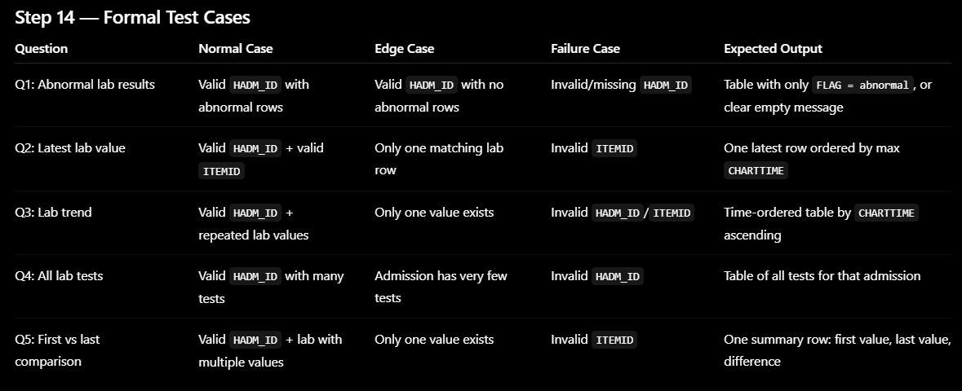
Step 14 test-case plan completed.
Later: run the formal tests on the real cleaned dataset during integration.

For every test, check:
1. Generated code matches the selected question.
2. Execution returns success or clear failure.
3. Output has the expected columns.
4. Output is not empty when data should exist.
5. Validation returns the correct status.
6. Correction runs only when needed.

✅ Step 15 completed — first full end-to-end MVP pipeline working.

Before step 16 im creating the Streamlit UI, because Step 15 already connected the real dataset and pipeline.

